Supplementary information

Supplementary figure 1
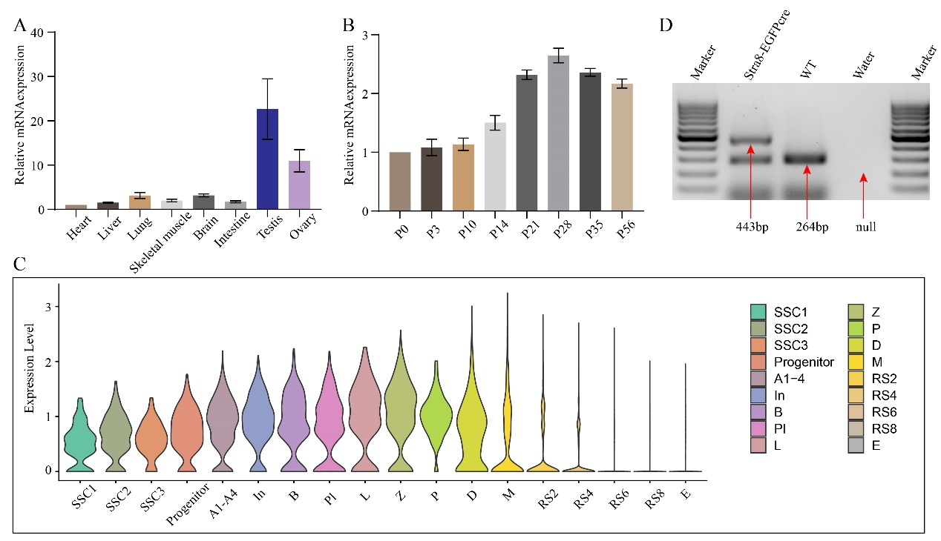
Supplementary figure 1: expression pattern of hnRNPM in mouse testes. A: Expressions of hnRNPM mRNA in adult wildtype mouse multiple organs by RT-qPCR. Gapdh was performed as control. Biologically independent mice (n=3) were tested in three separate experiments. B: Levels of hnRNPM mRNA in developing testes at postnatal day 0 (P0), P3, P10, P14, P21, P28, P35, and P56. Gapdh was performed as control. Biologically independent mice (n=3) were tested in three separate experiments. C: The data and figure showed the expression of hnRNPM in different germ cells, which derived from Male Health Atlas. D: Genotyping images of tails from different mice, including Stra8-EGFPCre and wild-type.

Supplementary figure 2
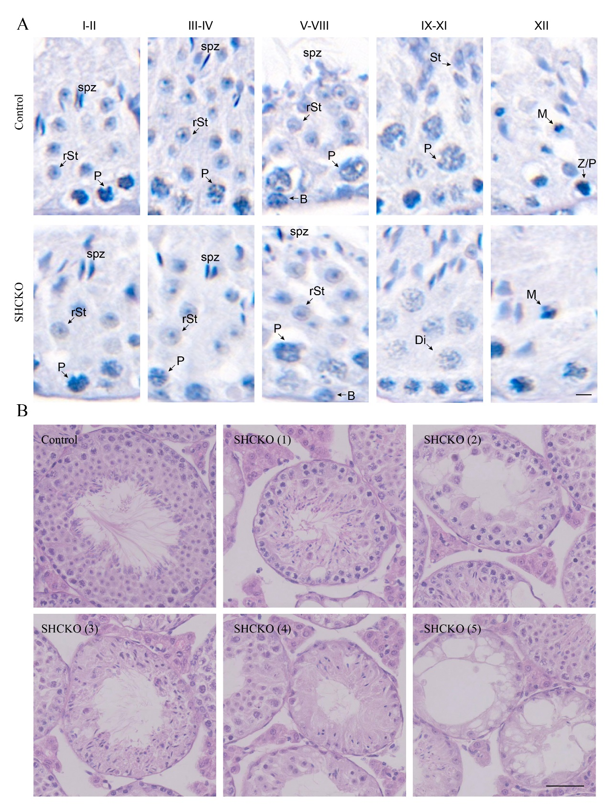
Supplementary figure 2: Lack of hnRNPM lead to absence of germ cells. A: SHCKO mice showed the normal procedure of spermatogenesis. B: SHCKO gradually lost some specific-stage cells, such as absent round spermatids but spermatocytes and elongated spermatids existence [SHCKO (1)], lack round spermatids and elongating-like spermatids [SHCKO (2)], lack spermatocytes and round spermatids but elongated-like spermatids existence [SHcKO (3) and SHCKO (4)], and lost most germ cell only with a layer of cells existence [SHCKO (5)]. Scale bars = 50 μm.
Supplementary figure 3
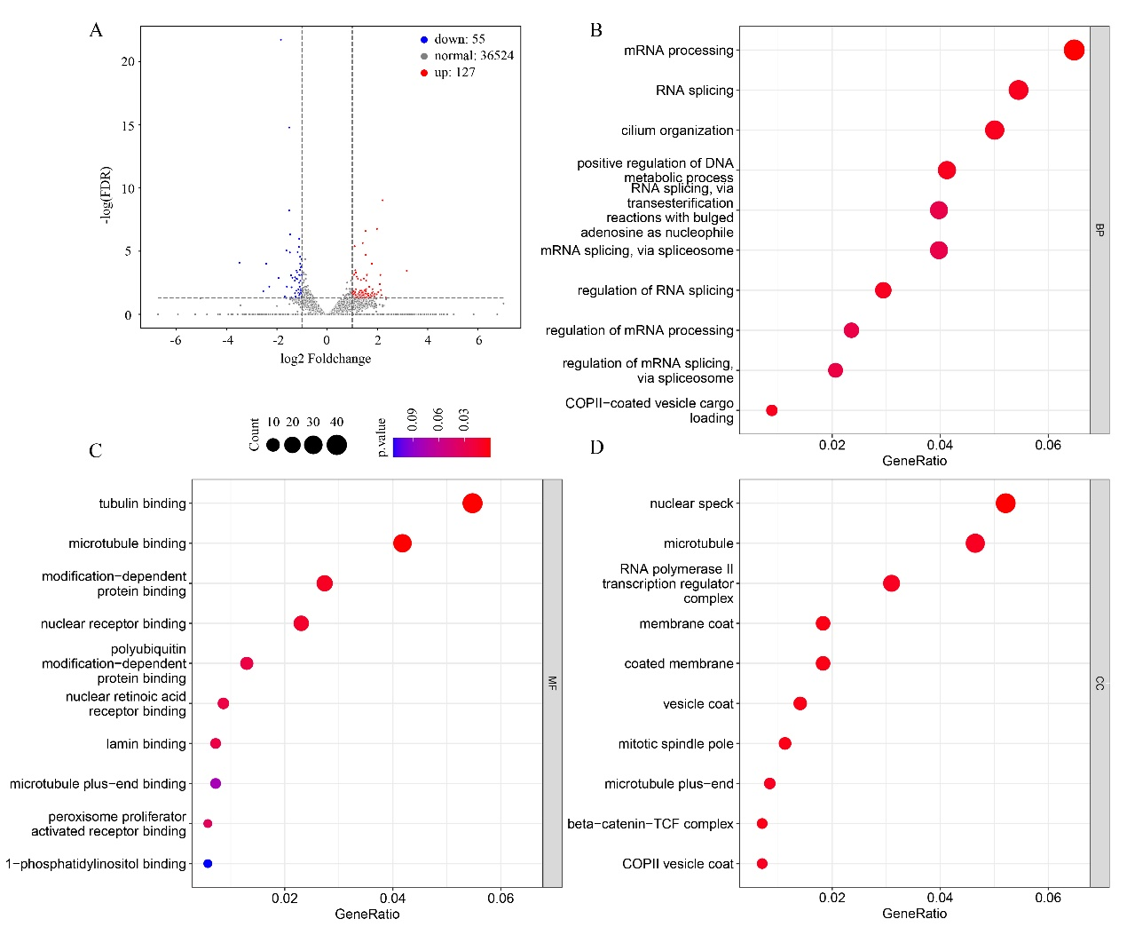
Supplementary figure 3: Abnormal alternative splicing in hnRNPM-deficient mouse. A: Volcano map of genes differentially expressed between male control and SHCKO mice as determined by RNA-seq. B: GO analysis of biological process of differentially alternative splicing events. C: GO analysis of molecular function of differentially alternative splicing events. D: GO analysis of cellular component of differentially alternative splicing events.

Supplementary figure 4: The full Blots and Gels image
