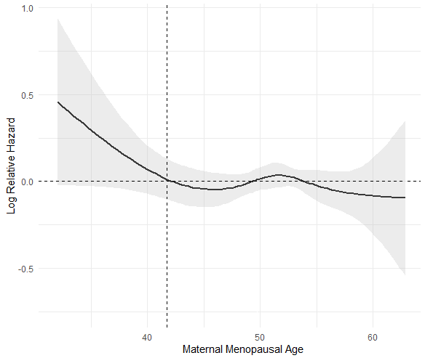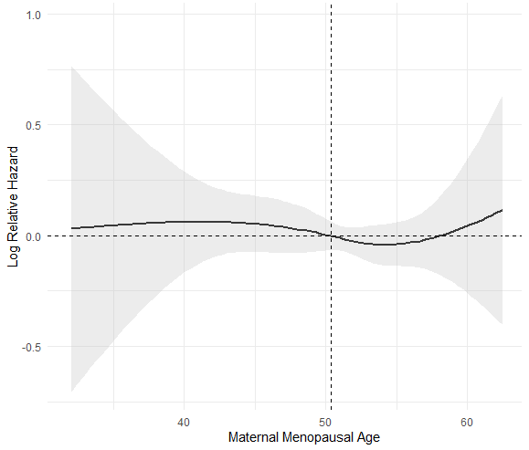
(a) (b)

Nonlinear relationship between maternal menopausal age and log relative hazard of type 2 diabetes mellitus (T2DM) (a), and abnormal glucose tolerance (b) in offspring by cubic spline regression model

