Supplementary Table 1. Correlation matrix of umbilical blood cord hormonal levels with newborn size parameters in women with endometriosis and controls after matching (n=65).

- Controls (n=49)

Variables | (1) | (2) | (3) | (4) | (5) | (6) | (7) | (8) | (9) | (10) | (11) | (12) | (13) | (14) | (15) | (16) | (17)
(1) Newborn length | 1.000
(2) Newborn weight | 0.716  *** | 1.000
(3) WLR | 0.543  *** | 0.968*** | 1.000
(4) WLR_centileª | 0.465  ** | 0.872*** | 0.909*** | 1.000
(5) Cortisol | 0.077 | 0.060 | 0.059 | -0.127 | 1.000
(6) Aldosterone | 0.240 | 0.167 | 0.116 | 0.002 | 0.272 | 1.000
(7) Cortisone | 0.239 | 0.227 | 0.199 | 0.017 | 0.663  *** | 0.418* | 1.000
(8) 11-DeoxyCortisol | 0.019 | 0.207 | 0.242 | 0.176 | -0.028 | 0.221 | 0.226 | 1.000
(9) Corticosterone | 0.071 | 0.003 | 0.005 | -0.166 | 0.767*** | 0.559*** | 0.689*** | 0.101 | 1.000
(10) 11-DeoxyCorticosterone | 0.256 | 0.288 | 0.284 | 0.155 | 0.296 | 0.438* | 0.303 | 0.267 | 0.486  ** | 1.000
(11) 17-OHProgesterone | 0.147 | 0.221 | 0.226 | 0.046 | 0.388* | 0.406* | 0.603*** | 0.596*** | 0.528*** | 0.527*** | 1.000
(12) Progesterone | 0.092 | 0.253 | 0.274 | 0.140 | 0.240 | 0.439* | 0.630*** | 0.526*** | 0.402* | 0.519** | 0.686*** | 1.000
(13) Testosterone | 0.042 | 0.066 | 0.045 | -0.075 | 0.364* | 0.330 | 0.427* | 0.112 | 0.479** | 0.310 | 0.430* | 0.375* | 1.000
(14) Androstenedione | 0.231 | 0.083 | 0.036 | -0.065 | 0.521** | -0.003 | 0.415  * | -0.242 | 0.514** | 0.156 | 0.286 | -0.021 | 0.431* | 1.000
(15) DHEA | -0.086 | -0.068 | -0.066 | -0.096 | 0.483** | 0.054 | 0.393  * | -0.087 | 0.487** | 0.213 | 0.391* | 0.203 | 0.362* | 0.665*** | 1.000
(16) DHEAS | 0.138 | 0.199 | 0.187 | 0.029 | 0.170 | 0.113 | 0.106 | 0.250 | 0.177 | 0.152 | 0.451** | 0.219 | 0.416* | 0.240 | 0.185 | 1.000
(17) Estradiol | 0.110 | 0.303 | 0.307 | 0.190 | 0.029 | 0.154 | 0.046 | 0.473** | -0.046 | 0.191 | 0.364* | 0.297 | 0.241 | -0.152 | -0.102 | 0.469 | 1.000
*p≤0.01; **p≤0.001; ***p≤0.0001.

- Endometriosis (n=16)

Variables | (1) | (2) | (3) | (4) | (5) | (6) | (7) | (8) | (9) | (10) | (11) | (12) | (13) | (14) | (15) | (16) | (17)
(1) Newborn length | 1.000
(2) Newborn weight | 0.650* | 1.000
(3) WLR | 0.490 | 0.965*** | 1.000
(4) WLR_centileª | 0.222 | 0.759** | 0.865*** | 1.000
(5) Cortisol | 0.385 | 0.629* | 0.600* | 0.638** | 1.000
(6) Aldosterone | 0.668* | 0.494 | 0.406 | 0.294 | 0.444 | 1.000
(7) Cortisone | 0.829** | 0.685* | 0.515 | 0.265 | 0.494 | 0.666** | 1.000
(8) 11-DeoxyCortisol | 0.579* | 0.800** | 0.732** | 0.476 | 0.374 | 0.235 | 0.547 | 1.000
(9) Corticosterone | 0.681* | 0.630* | 0.500 | 0.381 | 0.776** | 0.643* | 0.826** | 0.375 | 1.000
(10) 11-DeoxyCorticosterone | 0.225 | 0.182 | 0.118 | -0.076 | 0.059 | 0.018 | 0.247 | 0.209 | 0.237 | 1.000
(11) 17-OHProgesterone | 0.283 | 0.279 | 0.144 | -0.150 | 0.297 | 0.114 | 0.538 | 0.332 | 0.386 | 0.182 | 1.000
(12) Progesterone | 0.561 | 0.132 | -0.009 | -0.338 | -0.038 | 0.182 | 0.512 | 0.150 | 0.337 | 0.618* | 0.506 | 1.000
(13) Testosterone | 0.383 | 0.459 | 0.375 | 0.239 | 0.236 | 0.244 | 0.342 | 0.551 | 0.253 | 0.068 | 0.353 | -0.093 | 1.000
(14) Androstenedione | -0.286 | -0.056 | -0.074 | -0.021 | 0.268 | 0.204 | -0.071 | -0.156 | 0.250 | -0.103 | 0.006 | -0.421 | 0.094 | 1.000
(15) DHEA | 0.012 | -0.250 | -0.315 | -0.297 | 0.118 | -0.061 | -0.109 | -0.059 | -0.019 | -0.209 | 0.015 | -0.182 | 0.246 | 0.212 | 1.000
(16) DHEAS | -0.099 | 0.056 | 0.103 | 0.138 | 0.353 | -0.146 | -0.224 | 0.232 | -0.029 | -0.500 | 0.185 | -0.379 | 0.246 | 0.244 | 0.509 | 1.000
(17) Estradiol | 0.302 | 0.056 | -0.021 | 0.006 | 0.388 | 0.058 | 0.162 | 0.232 | 0.199 | -0.406 | 0.376 | 0.044 | 0.239 | -0.100 | 0.509 | 0.726* | 1.000
*p≤0.01; **p≤0.001; ***p≤0.0001.

Tables report Spearman’s rho (correlation coefficient), with significant p-values indicated by asterisks. Two observations on newborn size outcomes were missing in the control group and one in the endometriosis group.
Abbreviations: WLR, Weight/Length Ratio.
Note: ªCalculated according to GA at delivery using the INTERGROWTH-21st calculator for WLR at birth.
Supplementary Figure 1. Correlation plots of 11-deoxycortisol levels with newborn size in women with endometriosis and controls after matching with sensitivity analysis restricted to pregnancies without complications.

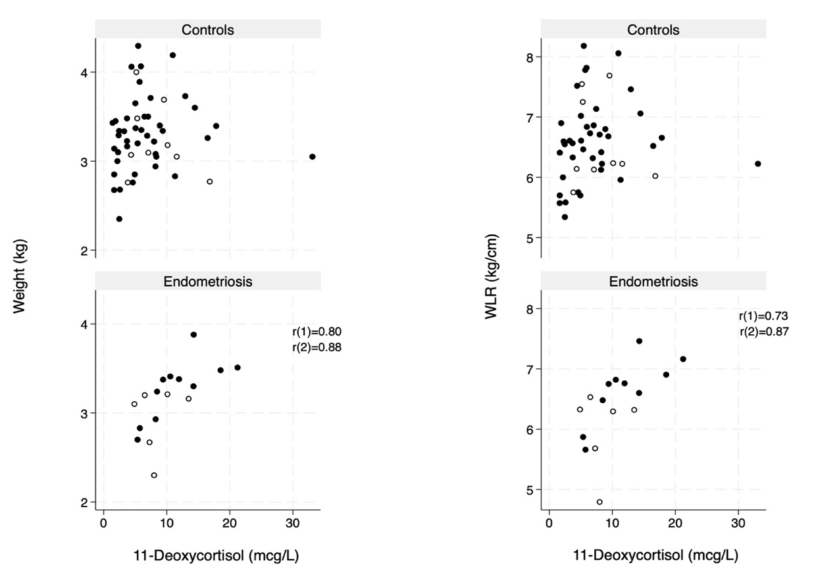

Abbreviations: WLR, Weight/Length Ratio.
Notes: Black dots represent all pregnancies, while white circles represent the sensitivity analysis restricted to pregnancies without complications. As shown in the graph, in women with endometriosis, 11-deoxycortisol levels correlated strongly with newborn weight (lower left panel) and WLR (lower right panel). r₁ and r₂ indicate the correlation coefficients for the total cohort and the sensitivity analysis restricted to pregnancies without complications, respectively.
No significant correlations were observed in controls between 11-deoxycortisol levels and newborn size (upper left and right panels).

