Supplementary Table I Search strategy for the MEDLINE Database
1. "humans"[Mesh] OR human*[TW] OR "patients"[Mesh] OR patient*[TW] OR subject*[TW] OR "women"[Mesh] OR women*[TW] OR woman*[TW] OR girl*[TW]
2. ("ovary"[Mesh] OR ovar*[TW]) AND (tissue*[TW] OR cortex[TW]) AND ("fertility preservation"[Mesh] OR preserv*[TW] OR "cryopreservation"[Mesh] OR cryopreserv*[TW] OR cryoconserv*[TW] OR cryofixat*[TW] OR "vitrification"[Mesh] OR vitrifi*[TW] OR freez*[TW] OR froze*[TW]) AND ("tissue transplantation"[Mesh] OR "transplantation, autologous"[Mesh] OR "transplantation, heterotopic"[Mesh] OR orthotopic*[TW] OR heterotopic*[TW] OR autotransplant*[TW] OR transplant*[TW] OR graft*[TW] OR autograft*[TW] OR implant*[TW] OR reimplant*[TW])
3. "Live Birth"[Mesh] OR “live birth*”[ALL] OR (live[ALL] AND birth*[ALL]) OR "Pregnancy Outcome"[Mesh] OR pregnan*[ALL] OR "Infant, Newborn"[Mesh] OR infant*[ALL] OR newborn*[ALL] OR Neonate*[ALL] OR baby[ALL] OR babies[ALL] OR reproduct*[ALL] OR stillbirth*[ALL] OR miscarriage*[ALL] OR "Delivery, Obstetric"[Mesh] OR deliver*[ALL]
4. English [LA]
5. 2000/01/01:2024/03/01[DP]
6. 1 AND 2 AND 3 AND 4 AND 5

Author, year | Answers for the checklist |  |  |  |  |  |  |  |  |  | Overall risk  of bias
Author, year | A | B | C | D | E | F | G | H | I | J | Overall risk  of bias
Barral,2023 | Yes | Yes | Unclear | Yes | Yes | No | Unclear | Yes | Yes | NA | Low
Beckmann,2017 | No | Yes | Unclear | Yes | Yes | Yes | Yes | Yes | No | NA | Medium
Bystrova,2019 | Yes | Yes | Yes | Unclear | Unclear | Yes | Yes | Yes | No | NA | Low
Colmorn,2022 | Yes | Yes | Yes | Yes | Unclear | No | Yes | Yes | Yes | NA | Low
Diaz-Garcia,2018 | Yes | Yes | Yes | Yes | Yes | No | Yes | Yes | Yes | NA | Low
Dueholm Hjorth,2020 | Unclear | Yes | Yes | Yes | Yes | No | Yes | Yes | No | NA | Medium
Gook,2021 | No | Yes | Yes | Unclear | Unclear | Yes | Yes | Yes | No | NA | Medium
Greve,2012 | No | Yes | Yes | Unclear | Unclear | Yes | Yes | Yes | No | NA | Medium
Hoekman,2020 | Yes | Yes | Yes | Unclear | Unclear | Yes | Yes | Yes | Yes | NA | Low
Imbert,2014 | Yes | Yes | Yes | Yes | No | Yes | Yes | Yes | Yes | NA | Low
Lotz,2022 | Yes | Yes | Yes | Yes | Unclear | Yes | Yes | Yes | Yes | NA | Low
Oktay,2023 | Yes | Yes | Yes | Yes | Yes | Yes | Yes | Yes | Unclear | NA | Low
Poirot,2019 | Yes | Yes | Yes | Unclear | Unclear | Yes | Yes | Yes | No | NA | Low
Pretalli,2019 | Yes | Yes | Yes | Unclear | Unclear | Yes | Yes | Yes | Yes | NA | Low
Rozen,2021 | Unclear | Yes | Yes | Yes | Yes | Yes | Yes | Yes | No | NA | Low
Shapira,2020 | Yes | Yes | Yes | Yes | Yes | Unclear | Unclear | Yes | Yes | NA | Low
Silber,2022 | Unclear | Yes | Yes | Yes | Yes | Yes | Yes | Yes | Yes | NA | Low
Vatel,2021 | Unclear | Yes | Yes | No | No | Yes | Yes | Yes | Unclear | NA | Medium
Supplementary Table II Risk of bias assessment for the included studies using the Joanna Briggs Institute’s Critical Appraisal Tool (n = 18)
- Were there clear criteria for inclusion in the case series?
- Was the condition measured in a standard, reliable way for all participants included in the case series?
- Were valid methods used for identification of the condition for all participants included in the case series?
- Did the case series have consecutive inclusion of participants?
- Did the case series have complete inclusion of participants?
- Was there clear reporting of the demographics of the participants in the study?
- Was there clear reporting of clinical information of the participants?
- Were the outcomes or follow up results of cases clearly reported?
- Was there clear reporting of the presenting site(s)/clinic(s) demographic information?
- Was statistical analysis appropriate?

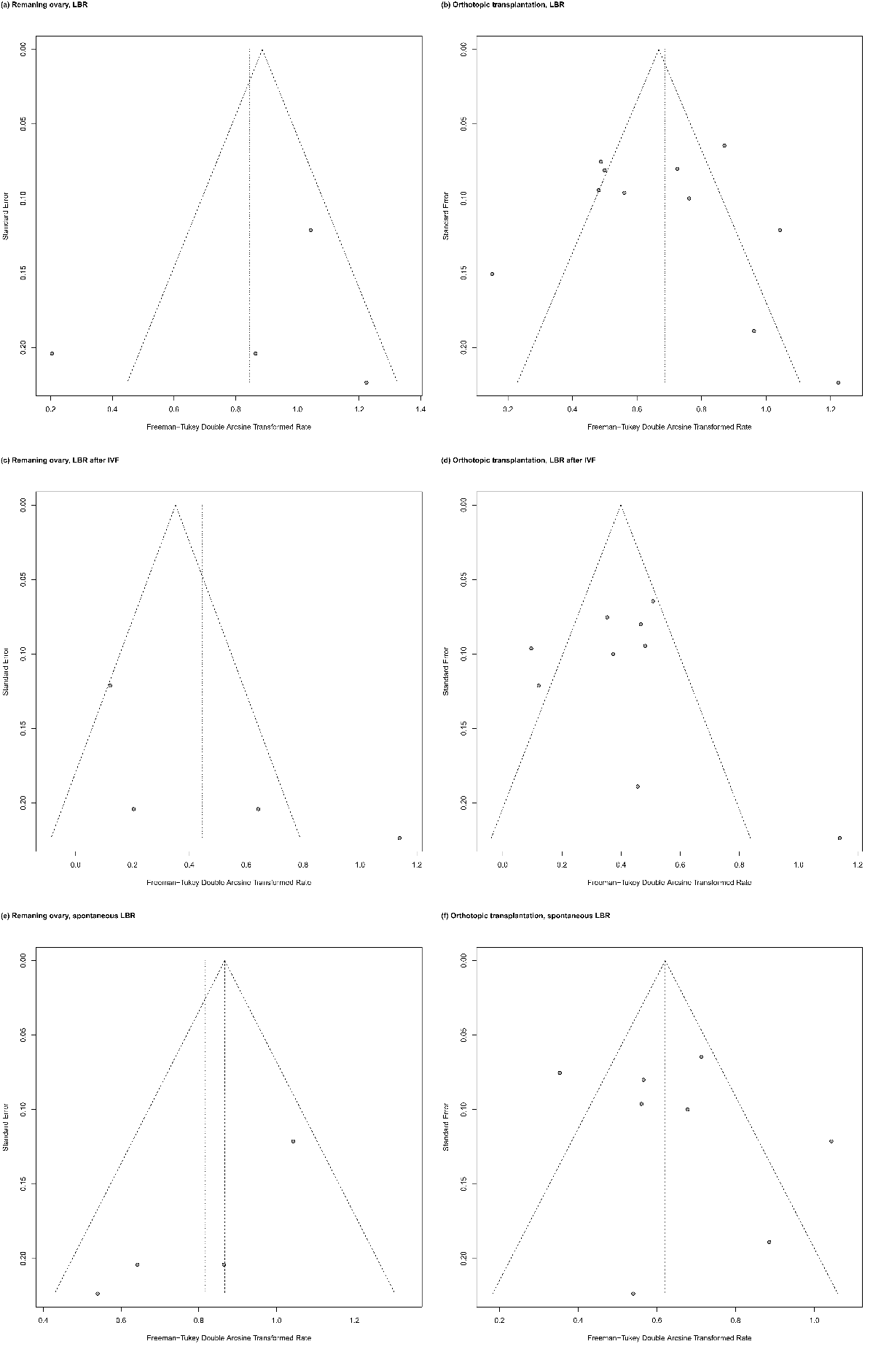
Supplementary figure S1. Funnel plots for live birth rates. (a) Remaining ovary, LBR, (b) Orthotopic transplantation, LBR, (c) Remaining ovary, LBR after IVF, (d) Orthotopic transplantation, LBR after IVF, (e) Remaining ovary, spontaneous LBR, (f) Orthotopic transplantation, spontaneous LBR.

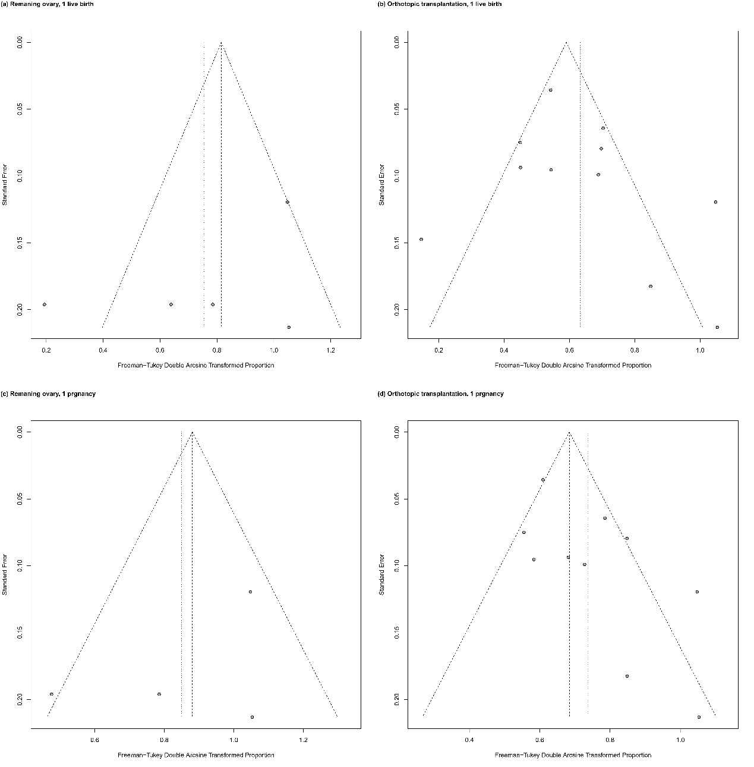
Supplementary figure S2. Funnel plots for proportions. (a) Remaining ovary, at least 1 live birth, (b) Orthotopic transplantation, at least 1 live birth, (c) Remaining ovary, at least 1 pregnancy, (d) Orthotopic transplantation, at least 1 pregnancy.

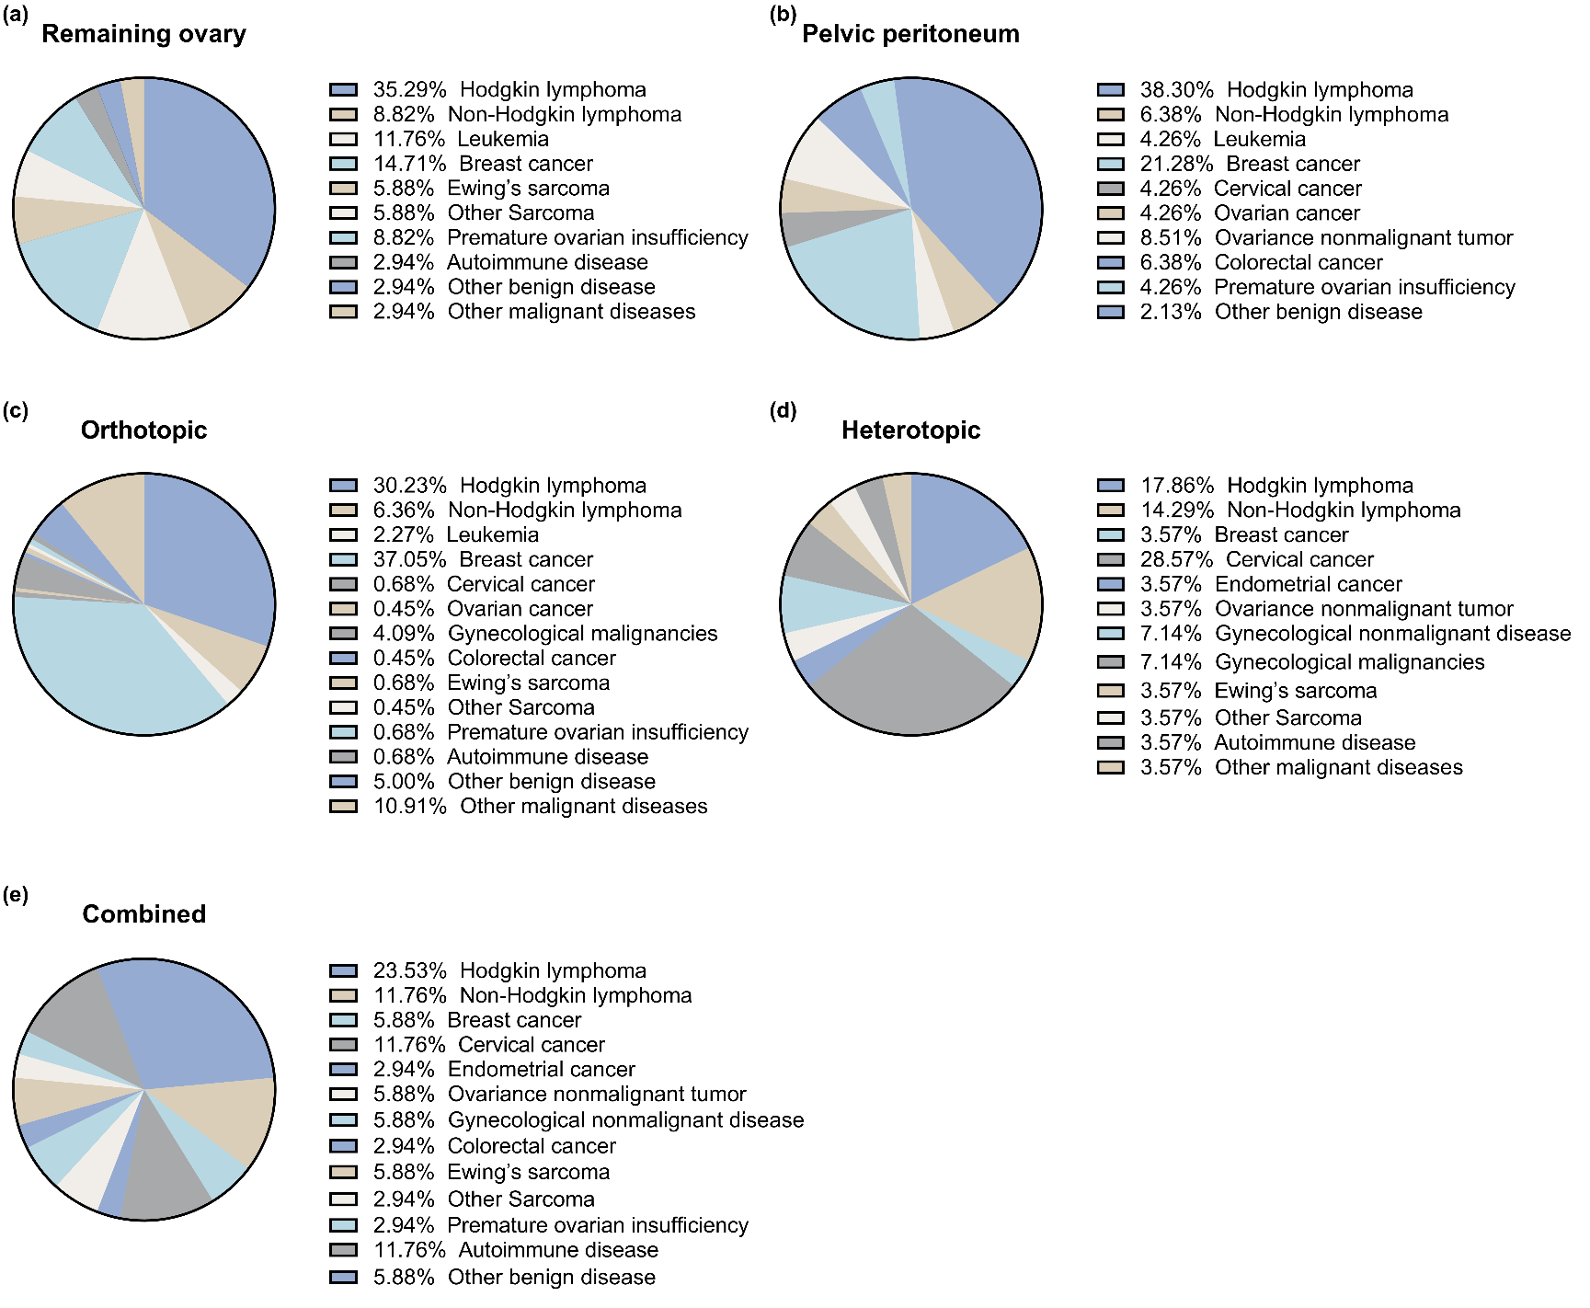
Supplementary figure S3. Patients’ diagnosis according to different grafting sites. (a) Remaining ovary, (b) Pelvic peritoneum, (c) Orthotopic transplantation, (d) Heterotopic transplantation, (e) Orthotopic combined with heterotopic transplantation.

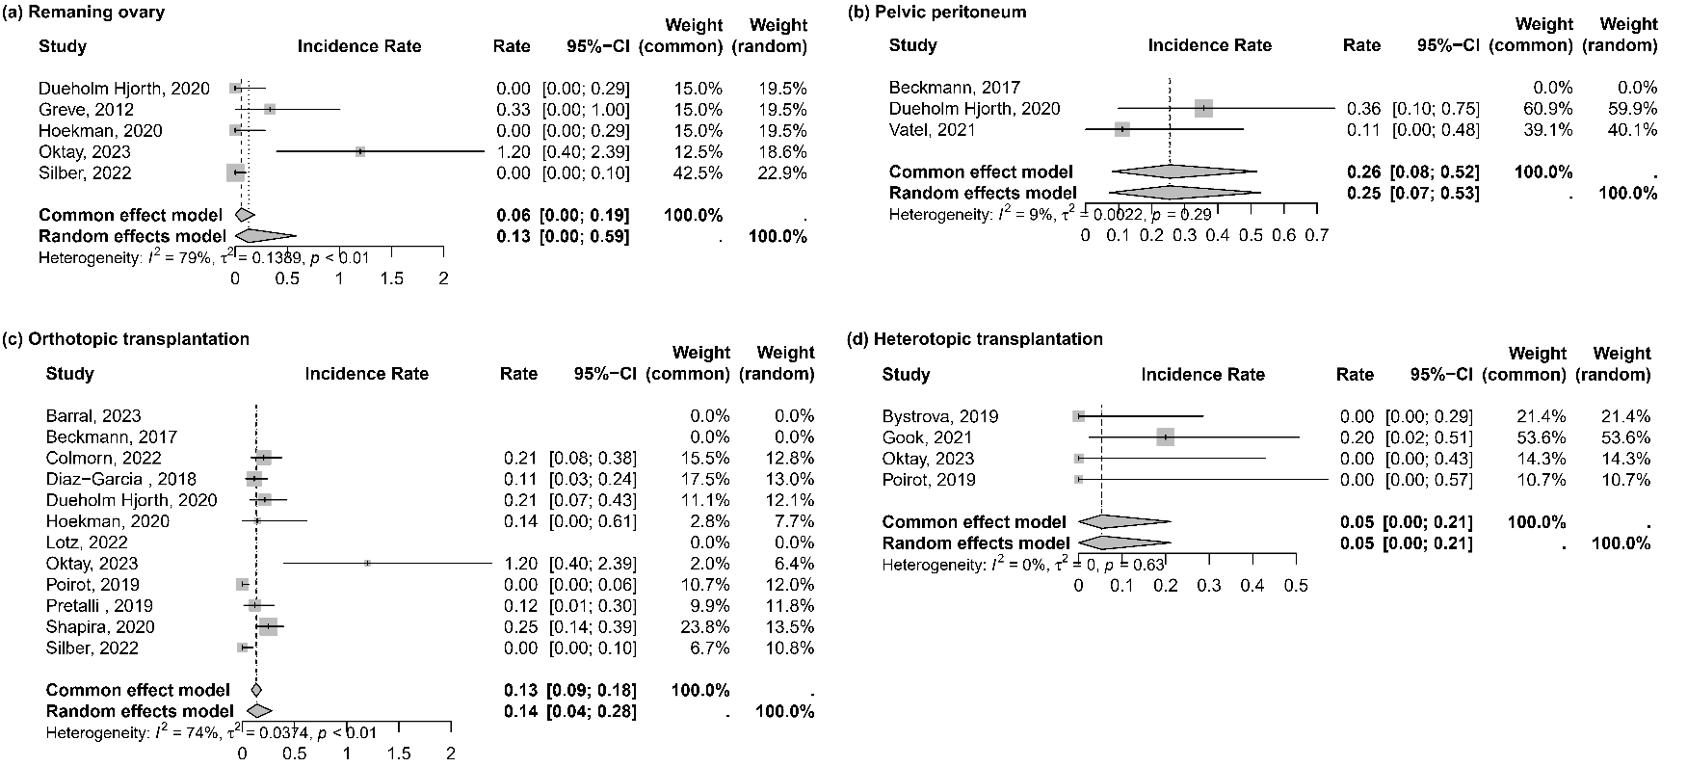
Supplementary figure S4. Live birth rate after IVF-ET following ovarian tissue cryopreservation and transplantation in different grafting sites. (a) Remaining ovary, (b) Pelvic peritoneum, (c) Orthotopic transplantation, (d) Heterotopic transplantation. The results of the fixed-effects model should be adopted only when I² equals 0.

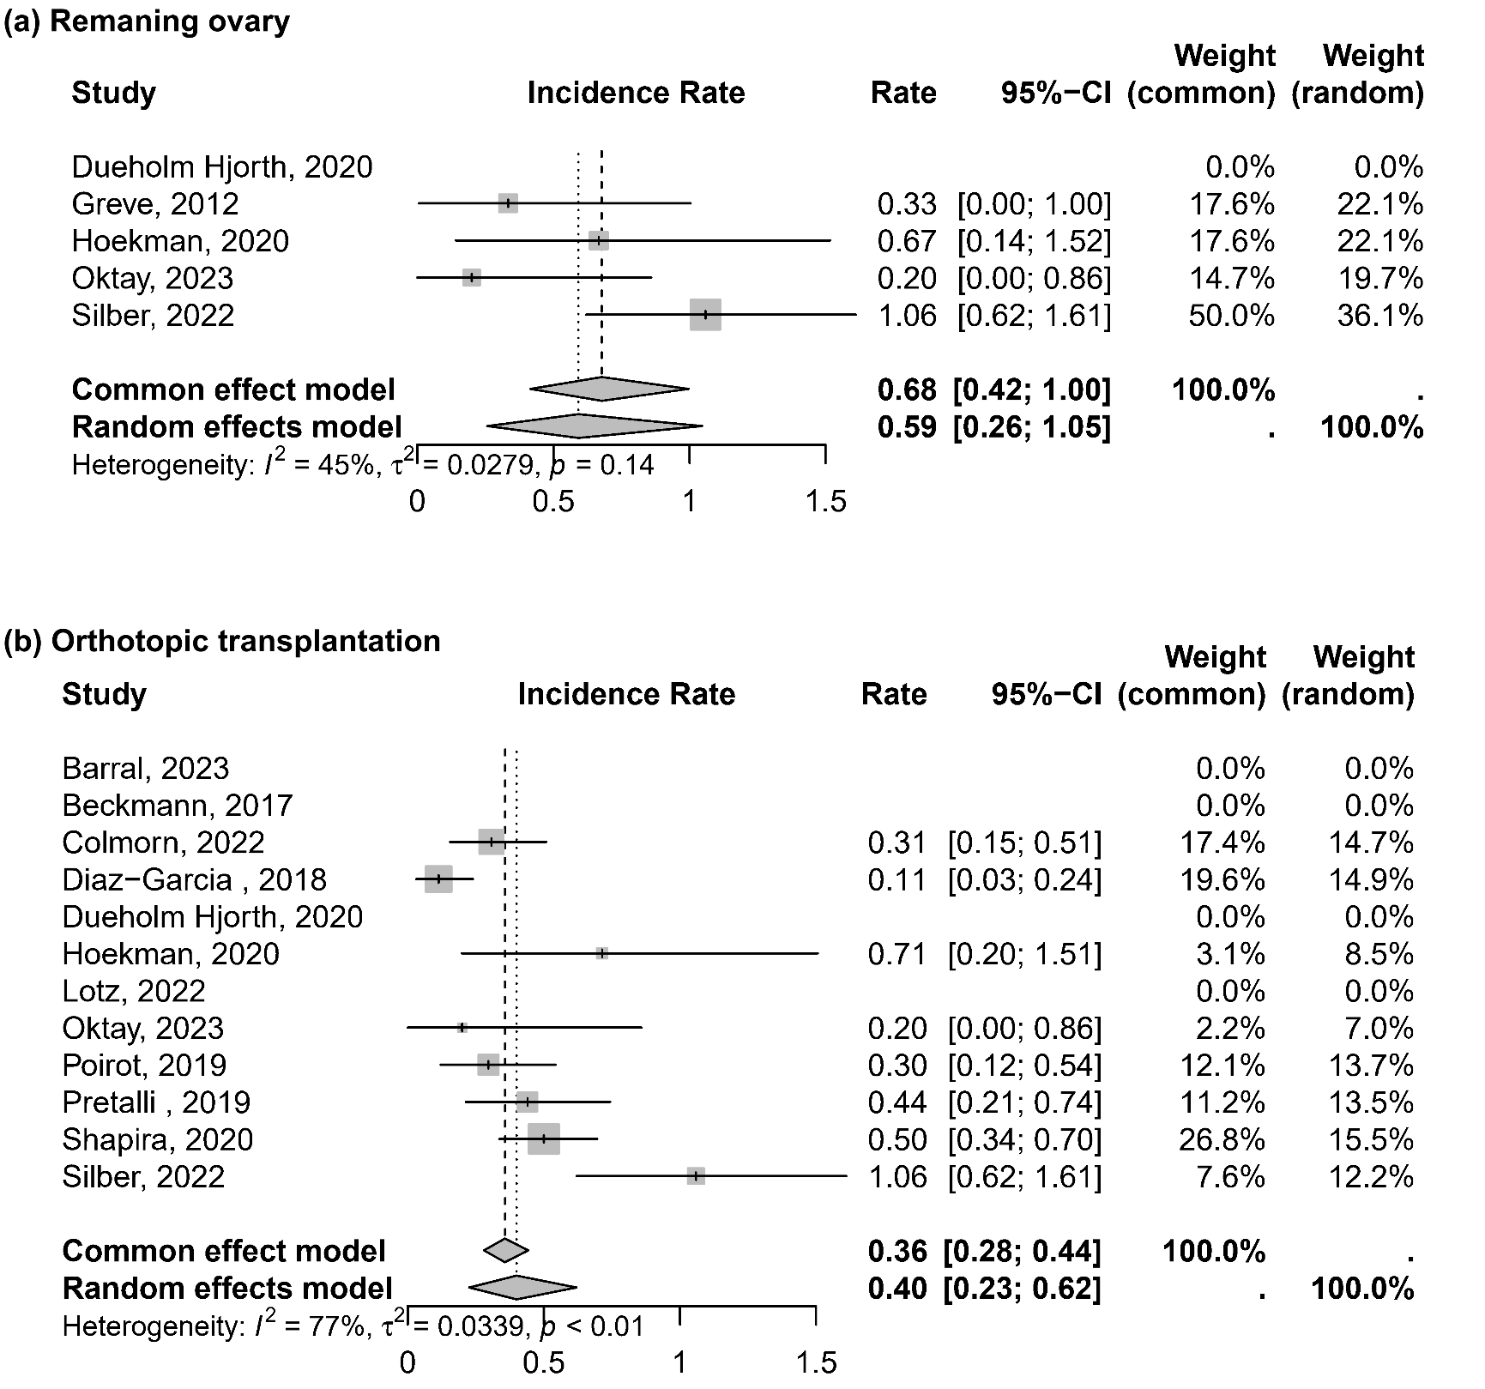
Supplementary figure S5. Spontaneous live birth rate following ovarian tissue cryopreservation and transplantation in different grafting sites. (a) Remaining ovary, (b) Orthotopic transplantation. The results of the fixed-effects model should be adopted only when I² equals 0.

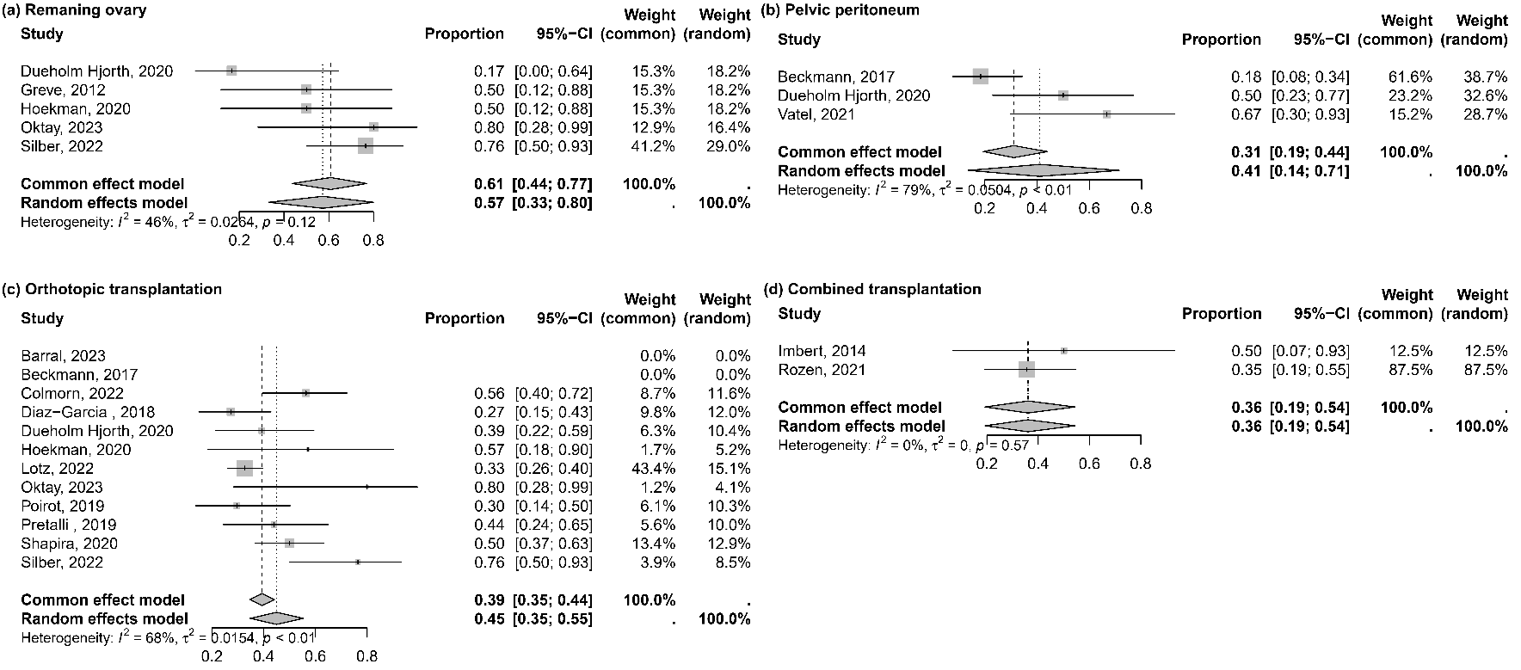
Supplementary figure S6. Percentage of women who had at least one pregnancy after ovarian tissue cryopreservation and transplantation in different grafting sites. (a) Remaining ovary, (b) Pelvic peritoneum, (c) Orthotopic transplantation, (d) Orthotopic combined with heterotopic transplantation. The results of the fixed-effects model should be adopted only when I² equals 0.

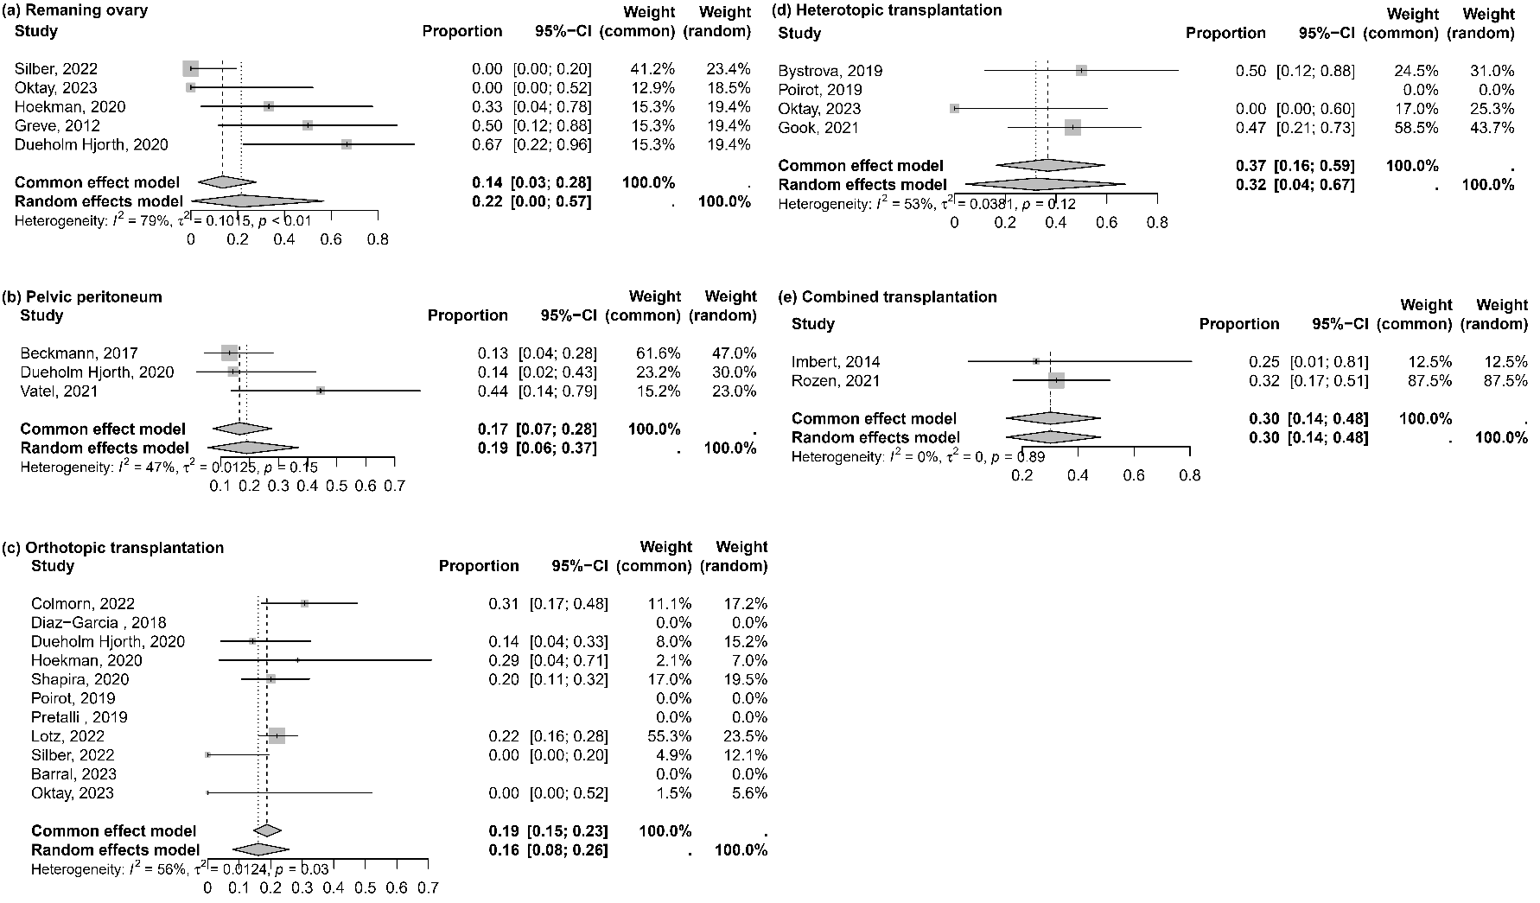
Supplementary figure S7. Percentage of women who received repeated transplantation after ovarian tissue cryopreservation and transplantation in different grafting sites. (a) Remaining ovary, (b) Pelvic peritoneum, (c) Orthotopic transplantation, (d) Heterotopic transplantation, (e) Orthotopic combined with heterotopic transplantation. The results of the fixed-effects model should be adopted only when I² equals 0.

