Figure S1
Incidence of pulmonary embolism in Greece from 1999 to 2008 (A) and 2009-2012 (B)

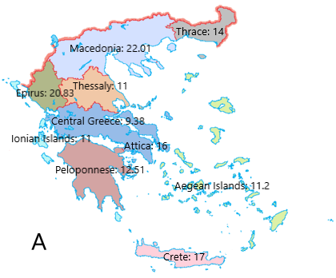
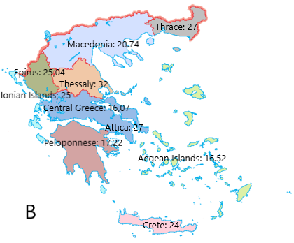

Figure S2
Distribution of PE between the two genders during the periods 1999 to 2007.

-
Figure S3
Percentage of PE cases in females (A) and males (B) throughout the years 1999 to 2007

Table S1
Number of deaths and Mortality from PE during the years 1999-2007
Number of Deaths |  |  |  | Mortality
Year | Male | Female | Total | Male | Female | Total
1999 | 97 | 129 | 226 | 1,79 | 2,34 | 2,07
2000 | 97 | 128 | 225 | 1,79 | 2,32 | 2,06
2001 | 72 | 104 | 176 | 1,33 | 1,88 | 1,61
2002 | 25 | 144 | 169 | 0,46 | 2,61 | 1,55
2003 | 97 | 67 | 164 | 1,79 | 1,21 | 1,50
2004 | 96 | 136 | 232 | 1,77 | 2,46 | 2,12
2005 | 168 | 112 | 280 | 3,10 | 2,03 | 2,56
2006 | 72 | 184 | 256 | 1,33 | 3,33 | 2,34
2007 | 112 | 144 | 256 | 2,07 | 2,61 | 2,34

