A prediction model for left ventricular thrombus persistence/recurrence: based on a prospective study and a retrospective study

Figure and Table Legends 2
Supplementary Figure 3
Supplementary Table 9

Figure and Table Legends
Fig.S1 LASSO coefficient profiles of the 44 variables. A coefficient profile plot was produced against the log (Lambda) sequence.
Fig.S2 ROC curves of Model 1 and Model 2 for predicting the risk of LV thrombus persistence/recurrence at 3 months. (A) Training set. (B) Validation set. The black curve represents the model discrimination ability of Model 1 either in the training set or the validation set. The red curve represents the model discrimination ability of Model 2 either in the training set or the validation set. The grey curve represents that a model has no model discrimination ability. No differences were found in the comparison of the two models’ AUC in the training set (P = 0.838) and the validation set (P = 0.734). LV, left ventricular; ROC, receiver operating characteristic; AUC, area under the ROC.
Fig.S3 DCA of the nomogram for predicting the risk of LV thrombus persistence/recurrence at 3 months in Model 1. (A) Training set. (B) Validation set. X-axis: cut-off probability; Y-axis: net benefit, which is calculated across a range of threshold probabilities. The blue line represents Model 1. The grey line represents the assumption that all patients have thrombus persistence/recurrence. The black line represents the assumption that no patients have thrombus persistence/recurrence. LV, left ventricular; DCA, decision curve analysis.
Fig.S4 DCA of the nomogram for predicting the risk of LV thrombus persistence/recurrence at 3 months in Model 1 and Model 2. (A) Training set. (B) Validation set. X-axis: cut-off probability; Y-axis: net benefit, which is calculated across a range of threshold probabilities. The blue line represents Model 1. The red line represents Model 2. The grey line represents the assumption that all patients have thrombus persistence/recurrence. The black line represents the assumption that no patients have thrombus persistence/recurrence. LV, left ventricular; DCA, decision curve analysis.
Fig.S5 Calibration plots for predicting the risk of LV thrombus persistence/recurrence at 3 months in Model 2. (A) Training set. (B) Validation set. X-axis: predicted thrombus persistence/recurrence risk; Y-axis: actual thrombus persistence/recurrence rate. Estimates above the grey solid line represent underestimates; those below the grey solid line represent overestimates. The vertical bars represent 95%CIs. LV, left ventricular; CI, confidence interval.
Fig.S6 Restricted cubic spline curve. We observed a linear relationship between LV thrombus persistence/recurrence at 3 months and continuous variables including (A) D-dimer levels and (B) thickness of thrombi (all p for nonlinear > 0.05). The p values for overall association were less than 0.05 for thrombus persistence/recurrence. Both models were adjusted for cofounders in Model 1 including diagnosis, antiplatelet therapy, thrombus morphology, and ventricular aneurysm. ORs are indicated by solid lines and 95%CIs by shaded areas. LV, left ventricular; OR, odds ratio; CI, confidence interval.
Table S1. Secondary outcomes at 3-month follow-up [N = 172]
Abbreviations: N, number of patients, CI, confidence interval.

Supplementary Figure
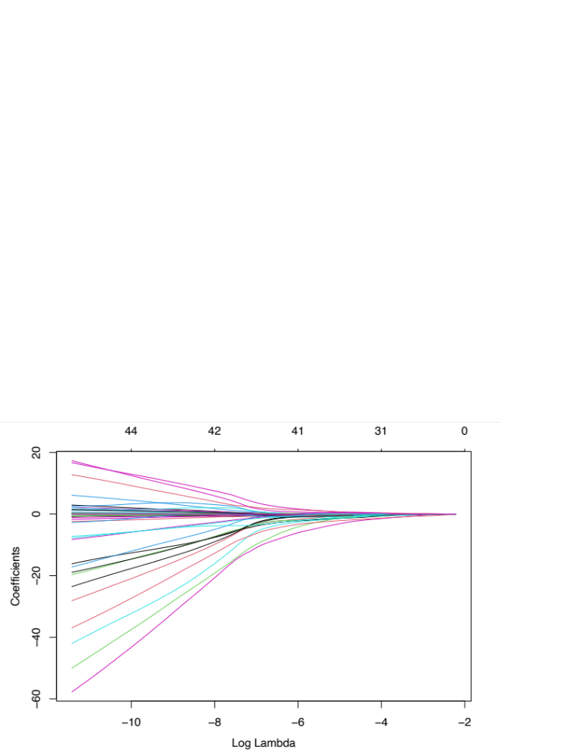

Fig.S1 LASSO coefficient profiles of the 44 variables. A coefficient profile plot was produced against the log (Lambda) sequence.

(B)
(A)
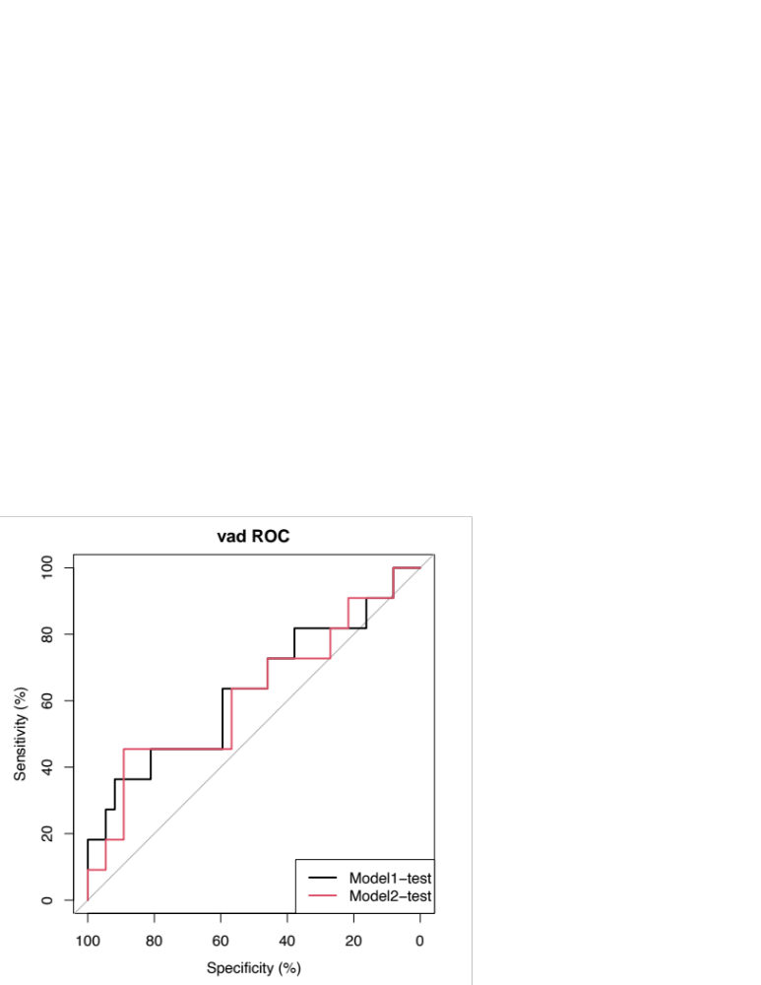
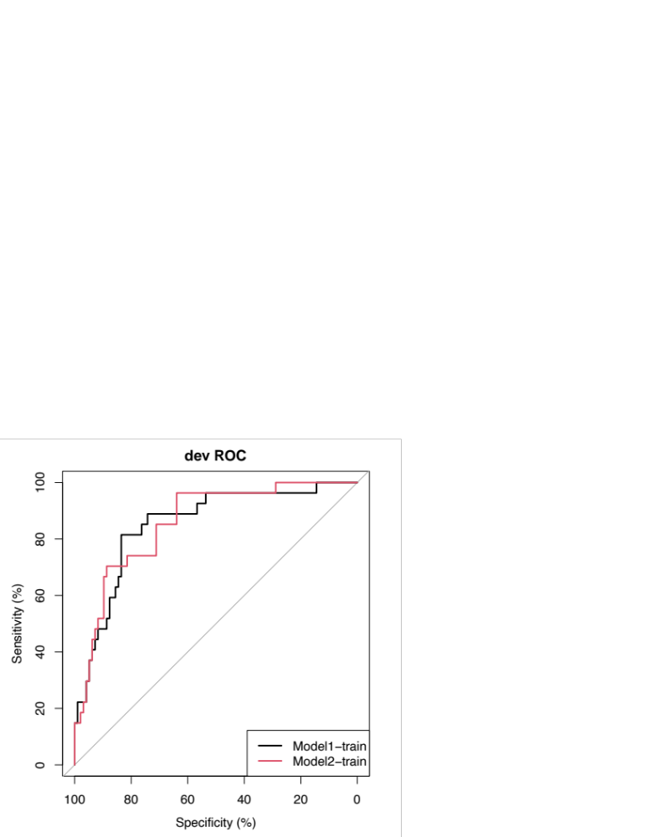

Fig.S2 ROC curves of Model 1 and Model 2 for predicting the risk of LV thrombus persistence/recurrence at 3 months. (A) Training set. (B) Validation set. The black curve represents the model discrimination ability of Model 1 either in the training set or the validation set. The red curve represents the model discrimination ability of Model 2 either in the training set or the validation set. The grey curve represents that a model has no model discrimination ability (AUC = 0.500). No differences were found in the comparison of the two models’ AUC in the training set (P = 0.838) and the validation set (P = 0.734). LV, left ventricular; ROC, receiver operating characteristic; AUC, area under the ROC.

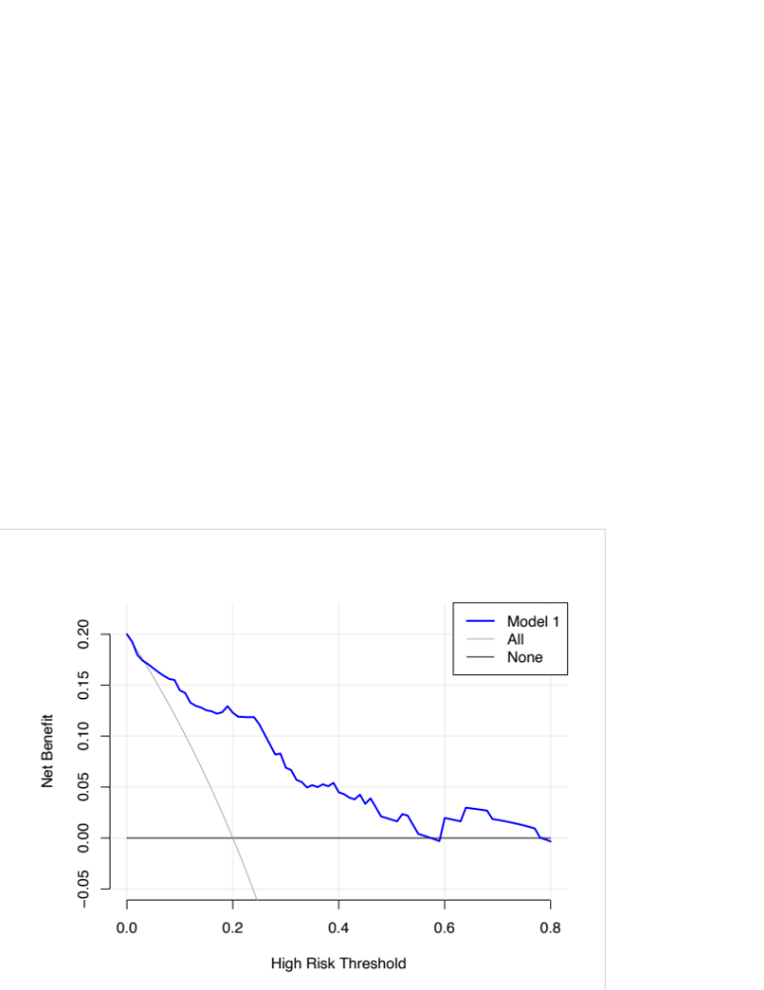
(A)
(B)

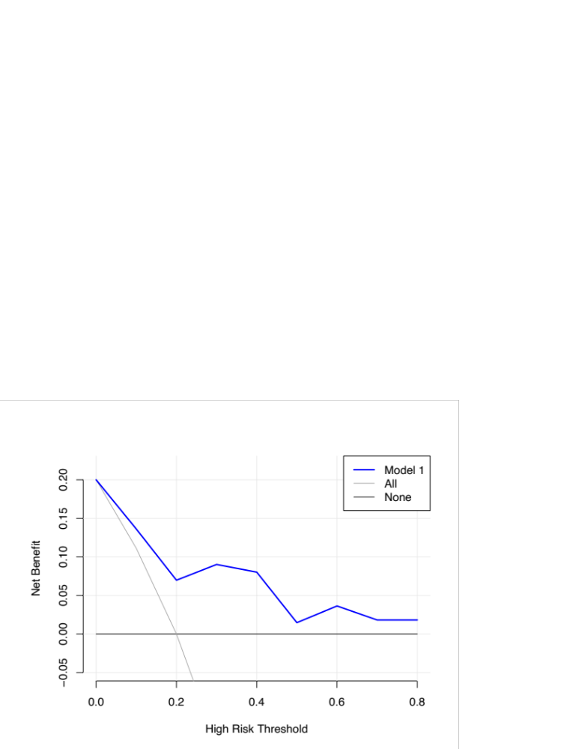

Fig.S3 DCA of the nomogram for predicting the risk of LV thrombus persistence/recurrence at 3 months in Model 1. (A) Training set. (B) Validation set. X-axis: cut-off probability; Y-axis: net benefit, which is calculated across a range of threshold probabilities. The blue line represents Model 1. The grey line represents the assumption that all patients have thrombus persistence/recurrence. The black line represents the assumption that no patients have thrombus persistence/recurrence. LV, left ventricular; DCA, decision curve analysis.
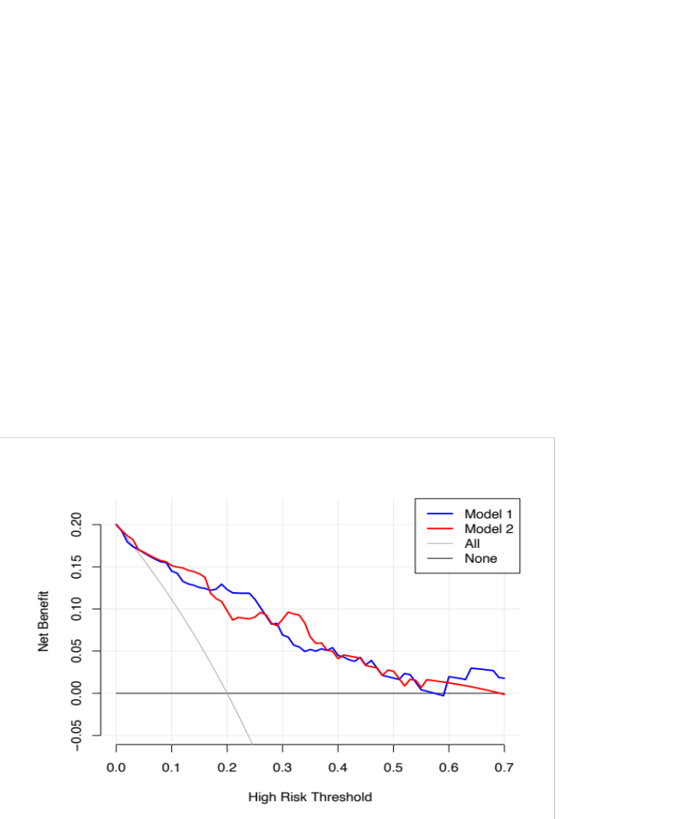
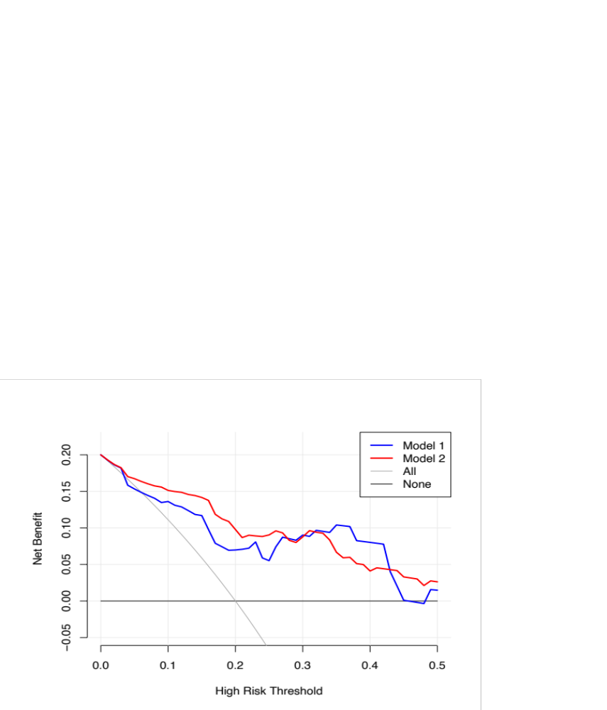
(A)
(B)

Fig.S4 DCA of the nomogram for predicting the risk of LV thrombus persistence/recurrence at 3 months in Model 1 and Model 2. (A) Training set. (B) Validation set. X-axis: cut-off probability; Y-axis: net benefit, which is calculated across a range of threshold probabilities. The blue line represents Model 1. The red line represents Model 2. The grey line represents the assumption that all patients have thrombus persistence/recurrence. The black line represents the assumption that no patients have thrombus persistence/recurrence. LV, left ventricular; DCA, decision curve analysis.
(A)
(B)

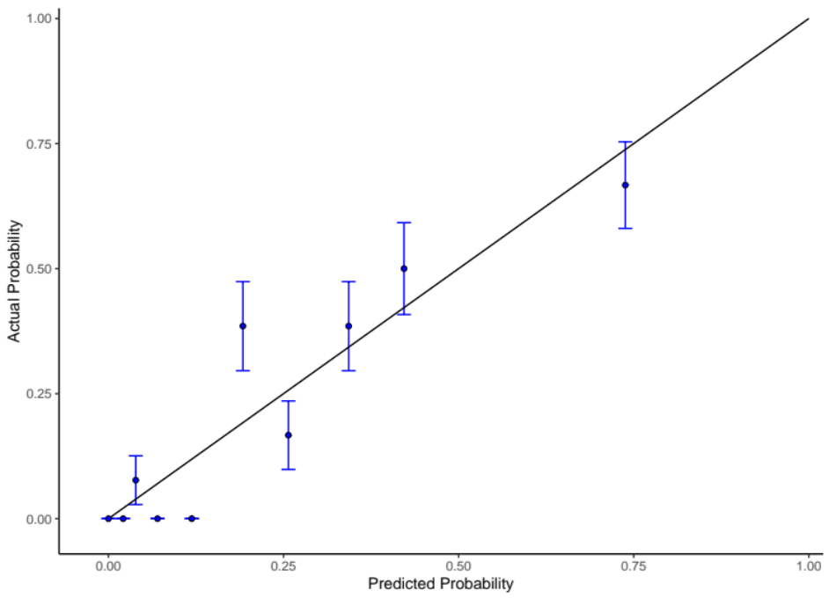

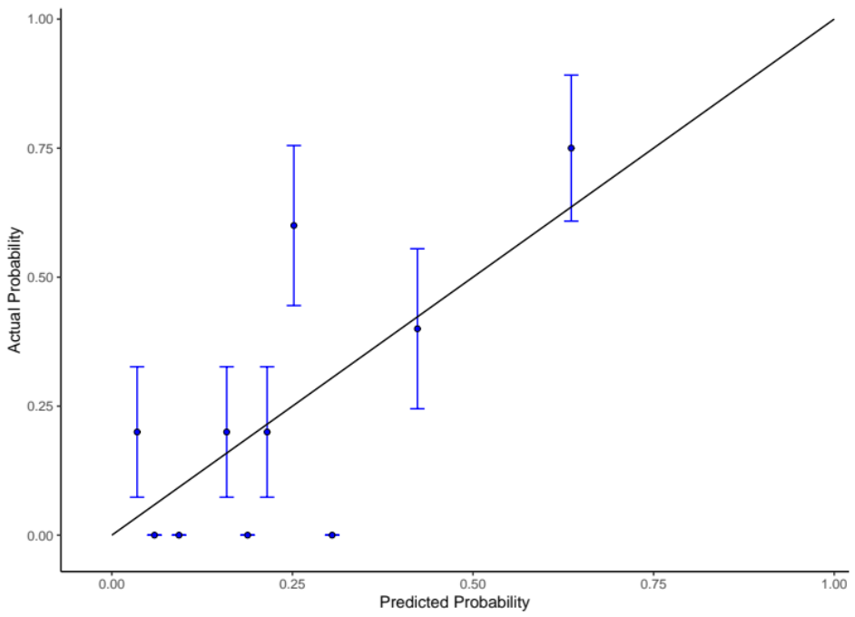

Fig.S5 Calibration plots for predicting the risk of LV thrombus persistence/recurrence at 3 months in Model 2. (A) Training set. (B) Validation set. X-axis: predicted thrombus persistence/recurrence risk; Y-axis: actual thrombus persistence/recurrence rate. Estimates above the grey solid line represent underestimates; those below the grey solid line represent overestimates. The vertical bars represent 95%CIs. LV, left ventricular; CI, confidence interval.

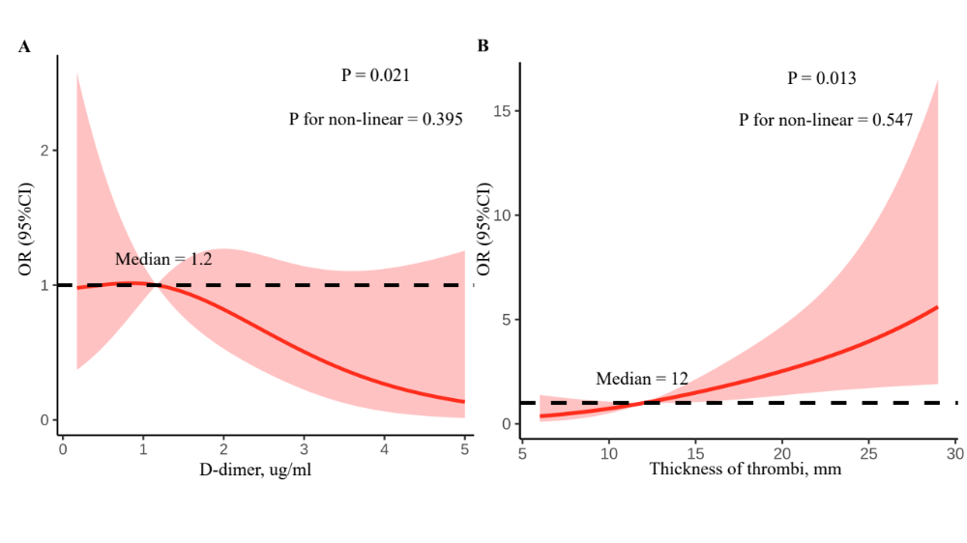

Fig.S6 Restricted cubic spline curve. We observed a linear relationship between LV thrombus persistence/recurrence at 3 months and continuous variables including (A) D-dimer levels and (B) thickness of thrombi (all p for non-linear > 0.05). The p values for overall association were less than 0.05 for thrombus persistence/recurrence. Both models were adjusted for cofounders in Model 1 including diagnosis, antiplatelet therapy, thrombus morphology, and ventricular aneurysm. ORs are indicated by solid lines and 95%CIs by shaded areas. LV, left ventricular; OR, odds ratio; CI, confidence interval.

Supplementary Table

Table S1. Secondary outcomes at 3-month follow-up [N = 172]
 | N | % | 95% CI
Thrombus resolution | 134 | 77.9 | 71.0-83.9
Safety outcome | 3 | 1.7 | 0.4-5.0
Major bleeding | 1 | 0.6 | 0.01-3.2
Clinically relevant non-major bleeding | 2 | 1.2 | 0.1-4.1
Stroke/embolism | 9 | 5.2 | 2.4-9.7
Abbreviations: N, number of patients, CI, confidence interval.

