Supplementary Table 1.PRISMA 2020 Checklist for the Present Systematic Review and Meta-analysis
Section | Item No. | Checklist Item | Reported on Page(s)
Title | 1 | Identify the report as a systematic review and/or meta-analysis | Title page
Abstract | 2 | Provide a structured summary including background, objectives, data sources, eligibility criteria, participants, interventions, methods, results, limitations, conclusions, and funding | Abstract
Introduction | 3 | Describe the rationale for the review in the context of existing knowledge | Introduction
 | 4 | Provide an explicit statement of the objectives or questions addressed with reference to participants, interventions, comparisons, outcomes, and study design (PICOS) | Introduction
Methods | 5 | Specify the inclusion and exclusion criteria for the review and how studies were grouped for syntheses | Methods (Eligibility criteria)
 | 6 | Specify all information sources (e.g., databases, registers) and the date when each was last searched | Methods (Literature search)
 | 7 | Present the full search strategies for all databases, including any filters and limits used | Supplementary Table 2
 | 8 | Describe the process for selecting studies (screening, eligibility, inclusion) | Methods (Study selection)
 | 9 | Describe the process for data collection and methods of obtaining or confirming data from investigators | Methods (Data extraction)
 | 10a | List and define all outcomes for which data were sought | Methods (Outcomes)
 | 10b | List and define all other variables for which data were sought (e.g., participant characteristics, risk factors) | Methods (Risk factors)
 | 11 | Describe the methods used for assessing risk of bias in included studies | Methods (Quality assessment)
 | 12 | Specify the effect measures used for each outcome (e.g., incidence, HR, OR) | Methods (Statistical analysis)
 | 13a | Describe the processes used to decide which studies were eligible for each synthesis | Methods (Data synthesis)
 | 13b | Describe any methods required to prepare the data for presentation or synthesis | Methods (Data synthesis)
 | 13c | Describe the methods used to synthesize results and provide a rationale for the choice of model | Methods (Statistical analysis)
 | 13d | Describe any methods used to assess heterogeneity | Methods (Statistical analysis)
 | 13e | Describe any sensitivity analyses conducted | Methods (Statistical analysis; Sensitivity analysis)
 | 14 | Describe any methods used to assess reporting bias | Methods (Statistical analysis)
 | 15 | Describe any methods used to assess certainty of evidence | Not performed
Results | 16a | Describe the results of the search and study selection process, ideally using a flow diagram | Results; Figure 1
 | 16b | Cite studies that appeared to meet inclusion criteria but were excluded and explain why | Figure 1
 | 17 | Present characteristics of included studies | Table 1
 | 18 | Present assessments of risk of bias for each included study | Table 2; Table 3
 | 19 | Present results of individual studies for all outcomes | Results section
 | 20a | Present results of all statistical syntheses conducted | Figures 2–8
 | 20b | Present results of investigations of heterogeneity | Results section
 | 20c | Present results of sensitivity analyses | Supplementary Figures S1–S13
 | 21 | Present assessments of reporting bias | Not assessable (<10 studies per analysis)
 | 22 | Present assessments of certainty of evidence | Not performed
Discussion | 23a | Provide a general interpretation of the results in the context of other evidence | Discussion
 | 23b | Discuss limitations of the evidence included in the review | Discussion (Limitations)
 | 23c | Discuss implications of the results for practice, policy, and future research | Discussion
Other Information | 24a | Provide registration information for the review | Methods (Registration: PROSPERO CRD420261303039)
 | 24b | Indicate where the review protocol can be accessed | PROSPERO
 | 24c | Describe any amendments to the protocol | Not applicable
 | 25 | Describe sources of support (financial or non-financial) | Funding statement
 | 26 | Declare competing interests | Conflict of interest statement
 | 27 | Describe availability of data, code, and other materials | Data availability statement

Supplementary Table 2. Full database-specific search strategies and dates of final search
Database | Date of final search | Full search strategy
PubMed | January 31, 2026 | ("Stomach Neoplasms"[Mesh] OR gastric cancer[Title/Abstract] OR stomach cancer[Title/Abstract] OR gastric neoplasm*[Title/Abstract] OR stomach neoplasm*[Title/Abstract] OR gastric carcinoma*[Title/Abstract] OR stomach carcinoma*[Title/Abstract] OR gastric adenocarcinoma*[Title/Abstract]) AND ("Venous Thromboembolism"[Mesh] OR "Venous Thrombosis"[Mesh] OR "Pulmonary Embolism"[Mesh] OR venous thromboembolism[Title/Abstract] OR VTE[Title/Abstract] OR deep vein thrombosis[Title/Abstract] OR DVT[Title/Abstract] OR pulmonary embolism[Title/Abstract] OR PE[Title/Abstract])
Embase | January 31, 2026 | ('stomach cancer'/exp OR 'gastric cancer':ti,ab OR 'stomach cancer':ti,ab OR 'gastric neoplasm*':ti,ab OR 'stomach neoplasm*':ti,ab OR 'gastric carcinoma*':ti,ab OR 'stomach carcinoma*':ti,ab OR 'gastric adenocarcinoma*':ti,ab) AND ('venous thromboembolism'/exp OR 'venous thrombosis'/exp OR 'pulmonary embolism'/exp OR 'venous thromboembolism':ti,ab OR VTE:ti,ab OR 'deep vein thrombosis':ti,ab OR DVT:ti,ab OR 'pulmonary embolism':ti,ab OR PE:ti,ab)
Web of Science | January 31, 2026 | TS=(  ("gastric cancer" OR "stomach cancer" OR "gastric neoplasm*" OR "stomach neoplasm*" OR "gastric carcinoma*" OR "stomach carcinoma*" OR "gastric adenocarcinoma*")  AND  ("venous thromboembolism" OR VTE OR "deep vein thrombosis" OR DVT OR "pulmonary embolism" OR PE)  )
Cochrane Library | January 31, 2026 | ("gastric cancer" OR "stomach cancer" OR "gastric neoplasm*" OR "stomach neoplasm*" OR "gastric carcinoma*" OR "stomach carcinoma*" OR "gastric adenocarcinoma*")  AND  ("venous thromboembolism" OR VTE OR "deep vein thrombosis" OR DVT OR "pulmonary embolism" OR PE)  in Title Abstract Keyword

Supplementary Figure S1. Leave-one-out sensitivity analysis for the pooled incidence of VTE in patients with gastric cancer
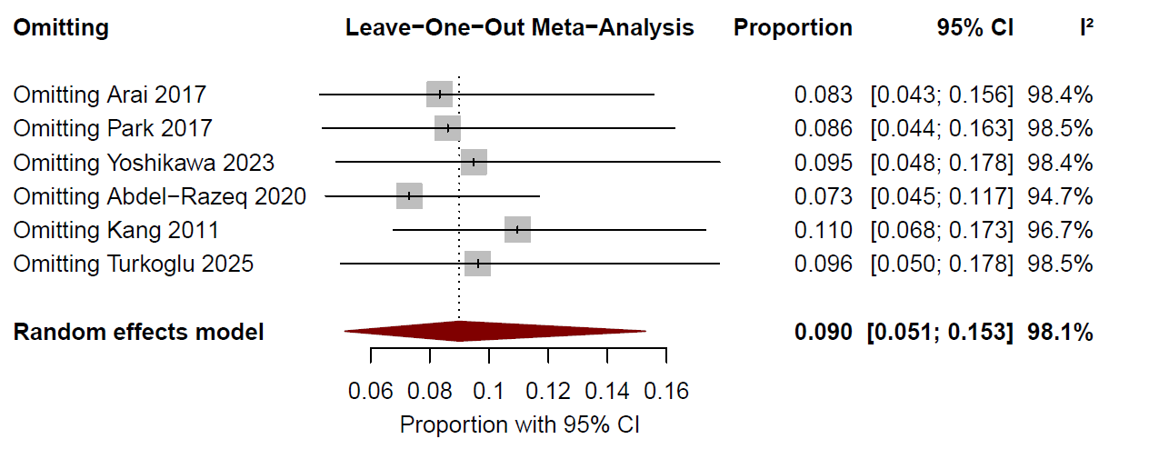

Supplementary Figure S2: Fixed-effect model analysis for the pooled incidence of VTE in patients with gastric cancer

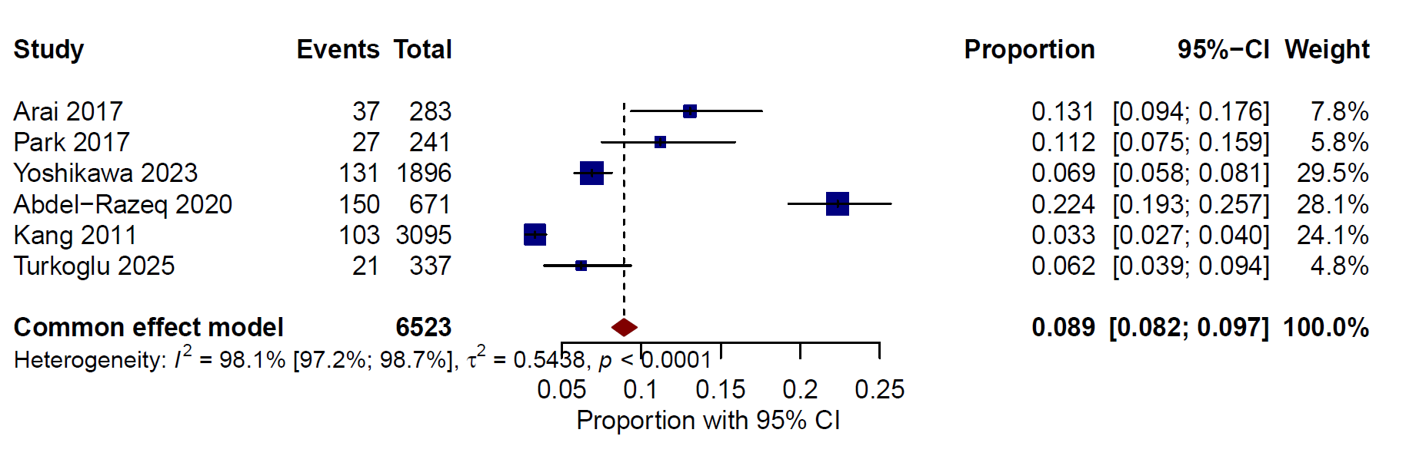

Supplementary Figure S3: Leave-one-out sensitivity analysis for the association between female sex and VTE risk
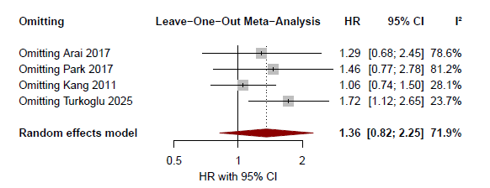

Supplementary Figure S4:Fixed-effect model analysis for the association between female sex and VTE risk
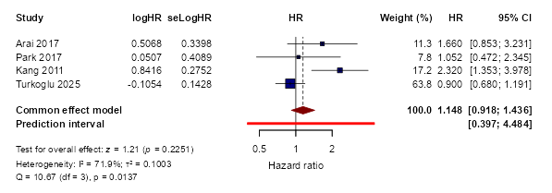

Supplementary Figure S5: Leave-one-out sensitivity analysis for the association between BMI ≥25 kg/m² and VTE risk
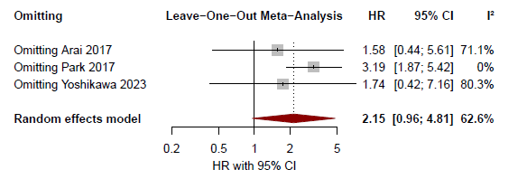

Supplementary Figure S6: Fixed-effect model analysis for the association between BMI ≥25 kg/m² and VTE risk
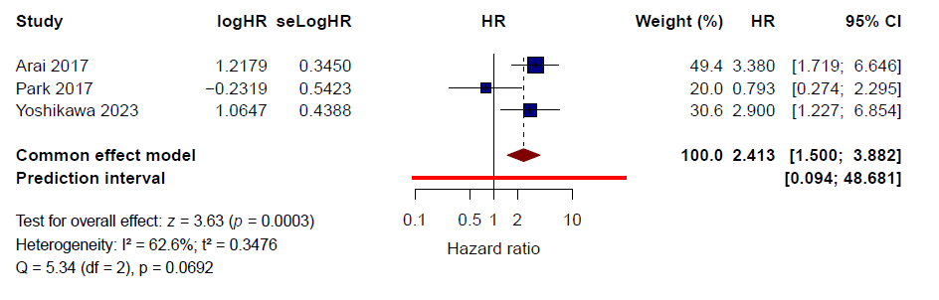

Supplementary Figure S7: Leave-one-out sensitivity analysis for the association between peritoneal metastasis and VTE risk

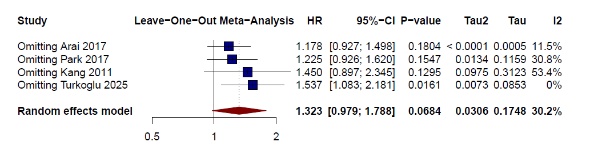

Supplementary Figure S8: Fixed-effect model analysis for the association between peritoneal metastasis and VTE risk
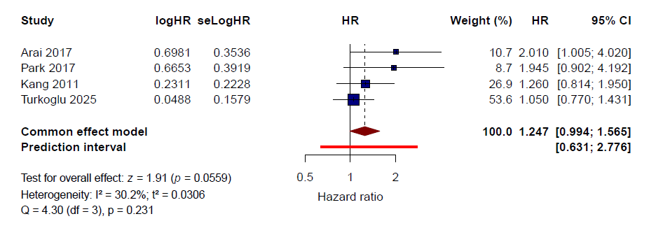

Supplementary Figure S9: Leave-one-out sensitivity analysis for the association between lung metastasis and VTE risk
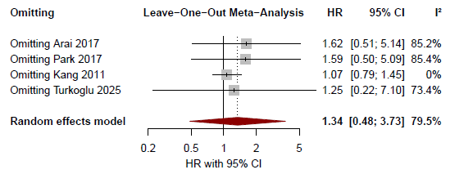

Supplementary Figure S10: Fixed-effect model analysis for the association between lung metastasis and VTE risk
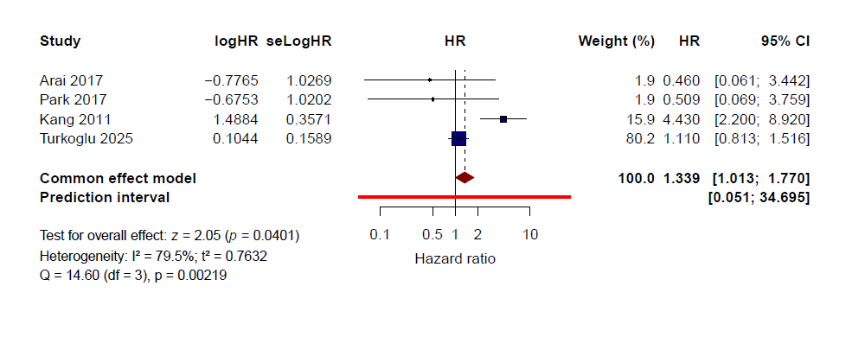

Supplementary Figure S11: Leave-one-out sensitivity analysis for the association between bone metastasis and VTE risk
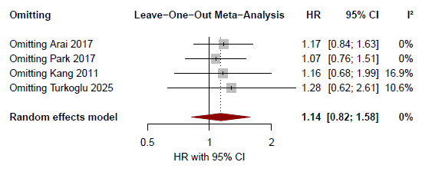

Supplementary Figure S12: Fixed-effect model analysis for the association between bone metastasis and VTE risk
