sFigure1: Decision curve analysis (DCA) of the prediction model
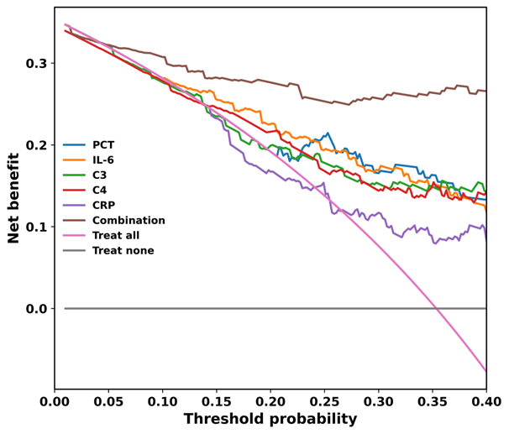
sFigure 1: F, DCA was used to evaluate the predictive performance of the indicators.
sFigure2: Serum levels of CRP, PCT, IL-6, C3, and C4

