Additional file 7: Compared working conditions (visualised)
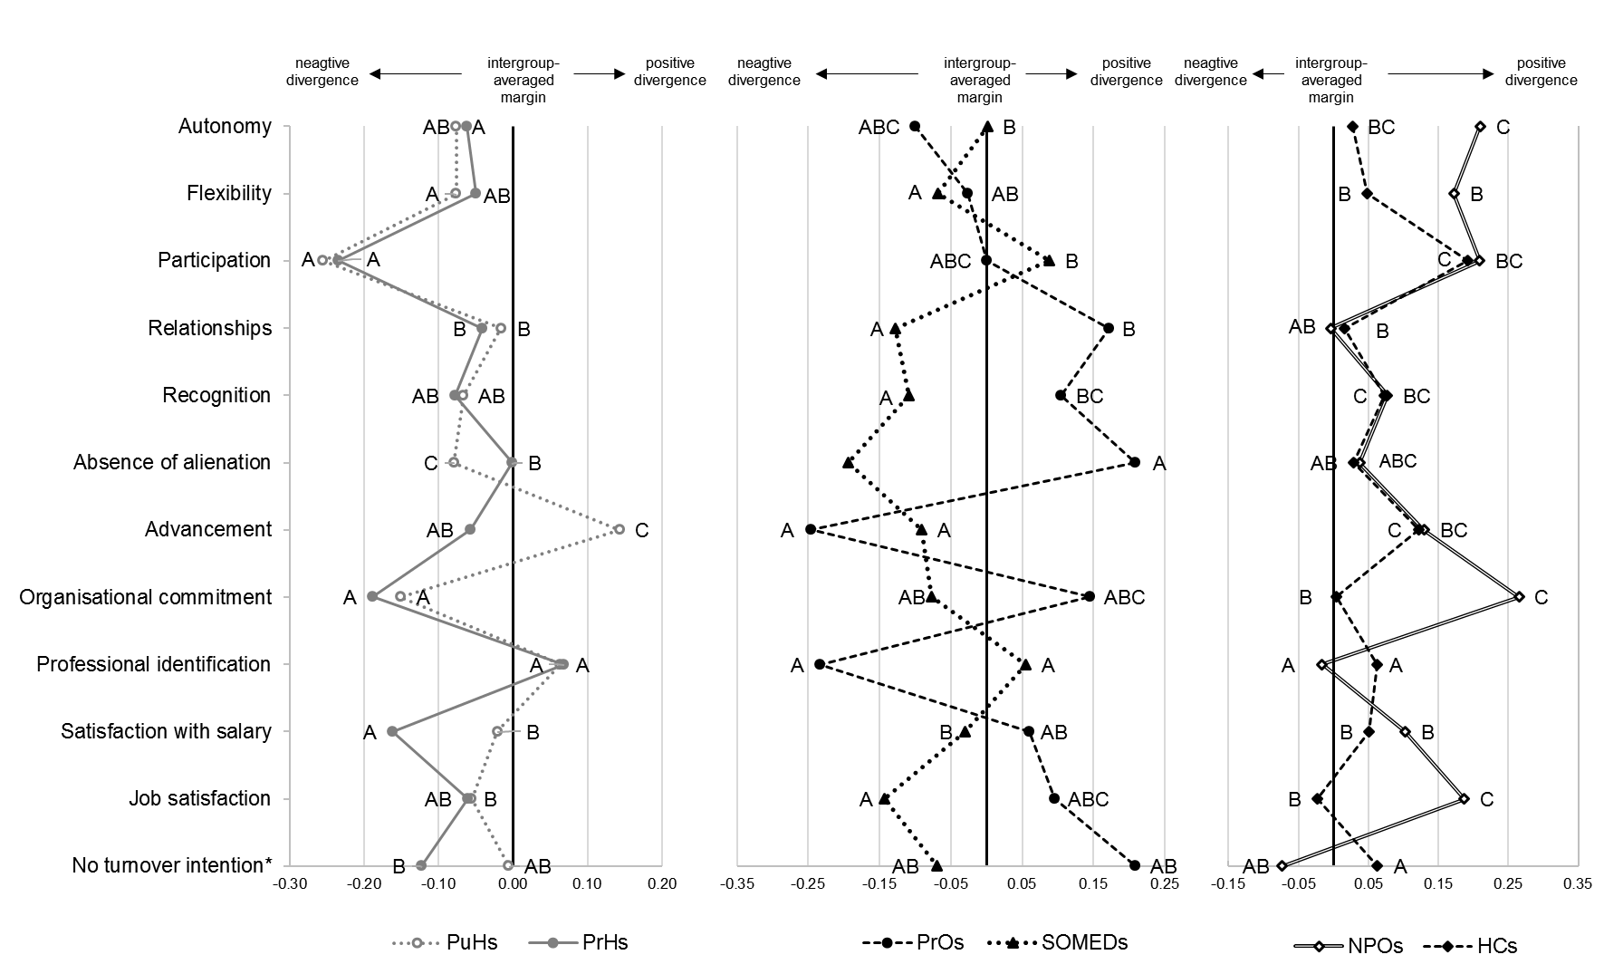

Notes: Cluster-robust multivariate linear regressions. Nurses included in the analyses with a workload of at least on full day per week and job tenure of at least one month. The institutional effects on each dependent variable are displayed as deviations from the intergroup-averaged marginal linear prediction. Data points sharing a letter in the label are not significantly different at the 5-percent significance level (Bonferroni-adjusted). Variables included in the model, but not shown are sex, age, diploma, workload, job tenure and currency of the job episode. * only assessed for the current work episode

