ADDITIONAL FILE 1
Table S1: Output from GEE Model (Overall Health Worker Density)
Variable | Estimate | lb | ub | p.value
(Intercept) | 104.62 | 84.199 | 129.994 | 0.0000
time | 1.003 | 1 | 1.006 | 0.0634
provinceCABO DELGADO | 0.745 | 0.565 | 0.984 | 0.0379
provinceGAZA | 0.958 | 0.747 | 1.228 | 0.7340
provinceINHAMBANE | 0.943 | 0.736 | 1.208 | 0.6420
provinceMANICA | 0.687 | 0.519 | 0.908 | 0.0085
provinceMAPUTO CIDADE | 0.658 | 0.474 | 0.913 | 0.0124
provinceNAMPULA | 0.612 | 0.458 | 0.819 | 0.0009
provinceNIASSA | 0.616 | 0.472 | 0.804 | 0.0004
provinceSOFALA | 0.92 | 0.728 | 1.162 | 0.4820
provinceTETE | 0.55 | 0.418 | 0.722 | 0.0000
provinceZAMBEZIA | 0.598 | 0.46 | 0.777 | 0.0001
hf_typeCS | 1.053 | 0.945 | 1.174 | 0.3510
hf_typeHP | 3.899 | 3.133 | 4.853 | 0.0000
hf_typeHC | 4.497 | 3.725 | 5.429 | 0.0000
I(ie_avail_c/10000) | 0.816 | 0.731 | 0.911 | 0.0003
time.after24 | 1 | 0.996 | 1.005 | 0.8790
as.factor(month)2 | 0.999 | 0.995 | 1.003 | 0.6650
as.factor(month)3 | 1 | 0.996 | 1.005 | 0.9170
as.factor(month)4 | 1.017 | 1.011 | 1.022 | 0.0000
as.factor(month)5 | 1.012 | 1.006 | 1.017 | 0.0000
as.factor(month)6 | 1.012 | 1.006 | 1.017 | 0.0001
as.factor(month)7 | 1.007 | 1.001 | 1.013 | 0.0159
as.factor(month)8 | 0.991 | 0.985 | 0.998 | 0.0089
as.factor(month)9 | 1.001 | 0.997 | 1.006 | 0.5840
as.factor(month)10 | 1.001 | 0.996 | 1.006 | 0.6630
as.factor(month)11 | 1.006 | 1.001 | 1.011 | 0.0176
as.factor(month)12 | 1.006 | 1.002 | 1.011 | 0.0101
time:provinceCABO DELGADO | 1.008 | 1.004 | 1.011 | 0.0000
time:provinceGAZA | 1.001 | 0.997 | 1.005 | 0.6380
time:provinceINHAMBANE | 1.005 | 1.001 | 1.008 | 0.0045
time:provinceMANICA | 1 | 0.996 | 1.005 | 0.9080
time:provinceMAPUTO CIDADE | 1.015 | 1.003 | 1.028 | 0.0163
time:provinceNAMPULA | 1.004 | 1 | 1.009 | 0.0320
time:provinceNIASSA | 1.006 | 1.001 | 1.01 | 0.0100
time:provinceSOFALA | 1 | 0.996 | 1.003 | 0.8660
time:provinceTETE | 1.002 | 0.998 | 1.005 | 0.3860
time:provinceZAMBEZIA | 1.001 | 0.997 | 1.004 | 0.7810
provinceCABO DELGADO:time.after24 | 0.996 | 0.991 | 1.001 | 0.1100
provinceGAZA:time.after24 | 0.996 | 0.989 | 1.003 | 0.2840
provinceINHAMBANE:time.after24 | 0.994 | 0.989 | 0.998 | 0.0072
provinceMANICA:time.after24 | 1 | 0.993 | 1.006 | 0.9200
provinceMAPUTO CIDADE:time.after24 | 0.983 | 0.969 | 0.996 | 0.0131
provinceNAMPULA:time.after24 | 0.998 | 0.992 | 1.003 | 0.4500
provinceNIASSA:time.after24 | 0.993 | 0.988 | 0.998 | 0.0058
provinceSOFALA:time.after24 | 0.997 | 0.992 | 1.002 | 0.1830
provinceTETE:time.after24 | 1 | 0.994 | 1.005 | 0.9160
provinceZAMBEZIA:time.after24 | 0.996 | 0.991 | 1 | 0.0782
Estimated Scale Parameters: 0.0902; Estimated Correlation Parameters: alpha 0.995
Table S2: Output from GEE Model (Maternal and Child Health Nurse Density)
Variable | Estimate | lb | ub | p.value
(Intercept) | 76.4900 | 57.9890 | 100.8950 | 0.0000
time | 1.0020 | 0.9970 | 1.0060 | 0.4300
provinceCABO DELGADO | 0.6670 | 0.4870 | 0.9140 | 0.0117
provinceGAZA | 0.8300 | 0.6150 | 1.1200 | 0.2230
provinceINHAMBANE | 1.0530 | 0.7690 | 1.4400 | 0.7490
provinceMANICA | 0.6230 | 0.4440 | 0.8750 | 0.0063
provinceMAPUTO CIDADE | 0.7270 | 0.4840 | 1.0920 | 0.1240
provinceNAMPULA | 0.5680 | 0.4140 | 0.7790 | 0.0005
provinceNIASSA | 0.6180 | 0.4550 | 0.8410 | 0.0022
provinceSOFALA | 0.8110 | 0.5960 | 1.1040 | 0.1830
provinceTETE | 0.4920 | 0.3580 | 0.6760 | 0.0000
provinceZAMBEZIA | 0.4790 | 0.3500 | 0.6550 | 0.0000
hf_typeCS | 1.2680 | 1.1410 | 1.4080 | 0.0000
hf_typeHP | 3.5540 | 2.6620 | 4.7460 | 0.0000
hf_typeHC | 4.1440 | 3.3670 | 5.0990 | 0.0000
I(ie_avail_c/10000) | 0.8120 | 0.7470 | 0.8830 | 0.0000
time.after24 | 1.0020 | 0.9960 | 1.0070 | 0.5560
as.factor(month)2 | 0.9990 | 0.9940 | 1.0040 | 0.7040
as.factor(month)3 | 1.0040 | 0.9980 | 1.0090 | 0.2180
as.factor(month)4 | 1.0190 | 1.0130 | 1.0260 | 0.0000
as.factor(month)5 | 1.0140 | 1.0070 | 1.0210 | 0.0000
as.factor(month)6 | 1.0160 | 1.0090 | 1.0240 | 0.0000
as.factor(month)7 | 1.0120 | 1.0050 | 1.0200 | 0.0015
as.factor(month)8 | 0.9980 | 0.9910 | 1.0060 | 0.6830
as.factor(month)9 | 1.0110 | 1.0030 | 1.0180 | 0.0040
as.factor(month)10 | 1.0080 | 1.0020 | 1.0150 | 0.0094
as.factor(month)11 | 1.0100 | 1.0030 | 1.0160 | 0.0022
as.factor(month)12 | 1.0110 | 1.0050 | 1.0170 | 0.0004
time:provinceCABO DELGADO | 1.0020 | 0.9970 | 1.0070 | 0.4590
time:provinceGAZA | 1.0010 | 0.9960 | 1.0070 | 0.6960
time:provinceINHAMBANE | 1.0050 | 1.0000 | 1.0100 | 0.0526
time:provinceMANICA | 0.9970 | 0.9910 | 1.0040 | 0.4420
time:provinceMAPUTO CIDADE | 0.9970 | 0.9840 | 1.0110 | 0.6920
time:provinceNAMPULA | 1.0030 | 0.9970 | 1.0090 | 0.2950
time:provinceNIASSA | 1.0060 | 0.9990 | 1.0130 | 0.1130
time:provinceSOFALA | 0.9990 | 0.9940 | 1.0040 | 0.7610
time:provinceTETE | 1.0010 | 0.9950 | 1.0060 | 0.8580
time:provinceZAMBEZIA | 1.0030 | 0.9970 | 1.0080 | 0.3970
provinceCABO DELGADO:time.after24 | 1.0050 | 0.9980 | 1.0120 | 0.1560
provinceGAZA:time.after24 | 0.9980 | 0.9910 | 1.0050 | 0.5400
provinceINHAMBANE:time.after24 | 0.9920 | 0.9850 | 0.9980 | 0.0120
provinceMANICA:time.after24 | 1.0000 | 0.9910 | 1.0090 | 0.9470
provinceMAPUTO CIDADE:time.after24 | 0.9960 | 0.9810 | 1.0120 | 0.6410
provinceNAMPULA:time.after24 | 1.0000 | 0.9930 | 1.0080 | 0.9940
provinceNIASSA:time.after24 | 0.9900 | 0.9820 | 0.9970 | 0.0075
provinceSOFALA:time.after24 | 0.9980 | 0.9920 | 1.0040 | 0.4850
provinceTETE:time.after24 | 1.0010 | 0.9930 | 1.0100 | 0.7360
provinceZAMBEZIA:time.after24 | 0.993 | 0.986 | 1 | 0.0611
Estimated Scale Parameters: 0.22; Estimated Correlation Parameters: alpha 0.997

Table S3: Output from GEE model (Physician Density)
Variable | Estimate | lb | ub | p.value
(Intercept) | 3.8470 | 2.9630 | 4.9950 | 0.0000
time | 1.0090 | 0.9980 | 1.0210 | 0.0992
provinceCABO DELGADO | 0.5760 | 0.4020 | 0.8260 | 0.0027
provinceGAZA | 0.9350 | 0.6440 | 1.3580 | 0.7250
provinceINHAMBANE | 0.9990 | 0.7390 | 1.3500 | 0.9940
provinceMANICA | 0.4730 | 0.3510 | 0.6380 | 0.0000
provinceMAPUTO CIDADE | 0.8200 | 0.4880 | 1.3800 | 0.4550
provinceNAMPULA | 0.4840 | 0.3320 | 0.7070 | 0.0002
provinceNIASSA | 0.5180 | 0.3390 | 0.7900 | 0.0023
provinceSOFALA | 0.7170 | 0.5210 | 0.9870 | 0.0416
provinceTETE | 0.4190 | 0.2830 | 0.6180 | 0.0000
provinceZAMBEZIA | 0.4610 | 0.3320 | 0.6390 | 0.0000
hf_typeCS | 0.9470 | 0.7970 | 1.1250 | 0.5380
hf_typeHP | 8.2160 | 6.5980 | 10.2320 | 0.0000
hf_typeHC | 11.3410 | 8.5350 | 15.0680 | 0.0000
I(ie_avail_c/10000) | 0.8200 | 0.7440 | 0.9030 | 0.0001
time.after24 | 1.0000 | 0.9840 | 1.0160 | 0.9820
as.factor(month)2 | 1.0040 | 0.9940 | 1.0130 | 0.4560
as.factor(month)3 | 0.9980 | 0.9870 | 1.0090 | 0.7150
as.factor(month)4 | 1.0120 | 0.9960 | 1.0280 | 0.1460
as.factor(month)5 | 1.0120 | 0.9970 | 1.0280 | 0.1230
as.factor(month)6 | 1.0170 | 1.0000 | 1.0350 | 0.0477
as.factor(month)7 | 1.0050 | 0.9870 | 1.0240 | 0.5690
as.factor(month)8 | 0.9760 | 0.9590 | 0.9920 | 0.0047
as.factor(month)9 | 0.9730 | 0.9580 | 0.9880 | 0.0005
as.factor(month)10 | 0.9740 | 0.9590 | 0.9900 | 0.0013
as.factor(month)11 | 0.9800 | 0.9670 | 0.9930 | 0.0027
as.factor(month)12 | 0.9840 | 0.9720 | 0.9970 | 0.0134
time:provinceCABO DELGADO | 0.9910 | 0.9770 | 1.0040 | 0.1720
time:provinceGAZA | 0.9930 | 0.9790 | 1.0080 | 0.3790
time:provinceINHAMBANE | 0.9880 | 0.9740 | 1.0030 | 0.1170
time:provinceMANICA | 0.9930 | 0.9780 | 1.0080 | 0.3340
time:provinceMAPUTO CIDADE | 1.0100 | 0.9940 | 1.0260 | 0.2280
time:provinceNAMPULA | 0.9950 | 0.9780 | 1.0120 | 0.5460
time:provinceNIASSA | 0.9960 | 0.9800 | 1.0120 | 0.6240
time:provinceSOFALA | 0.9920 | 0.9770 | 1.0080 | 0.3210
time:provinceTETE | 0.9930 | 0.9780 | 1.0080 | 0.3390
time:provinceZAMBEZIA | 0.9980 | 0.9830 | 1.0130 | 0.7730
provinceCABO DELGADO:time.after24 | 1.0060 | 0.9860 | 1.0260 | 0.5580
provinceGAZA:time.after24 | 0.9930 | 0.9690 | 1.0170 | 0.5580
provinceINHAMBANE:time.after24 | 1.0100 | 0.9890 | 1.0320 | 0.3640
provinceMANICA:time.after24 | 1.0090 | 0.9870 | 1.0330 | 0.4190
provinceMAPUTO CIDADE:time.after24 | 0.9850 | 0.9670 | 1.0040 | 0.1240
provinceNAMPULA:time.after24 | 1.0060 | 0.9830 | 1.0300 | 0.6100
provinceNIASSA:time.after24 | 0.9990 | 0.9800 | 1.0180 | 0.9000
provinceSOFALA:time.after24 | 1.0020 | 0.9790 | 1.0240 | 0.8910
provinceTETE:time.after24 | 1.0060 | 0.9840 | 1.0290 | 0.5870
provinceZAMBEZIA:time.after24 | 0.9920 | 0.9730 | 1.0130 | 0.4570
Estimated Scale Parameters: 0.591; Estimated Correlation Parameters: alpha 0.993

Table S4: Output from GEE model (CHW Density)

 | Estimate | Std.err | Pr(>|W|)
(Intercept) | 0.3676 | 0.1717 | 0.0323
time | 0.0896 | 0.0346 | 0.00954
provinceCABO DELGADO | 0.3354 | 0.2003 | 0.09397
provinceGAZA | 0.0875 | 0.2156 | 0.68479
provinceINHAMBANE | -0.0703 | 0.1875 | 0.70757
provinceMANICA | 0.1875 | 0.2762 | 0.4972
provinceNAMPULA | 0.1311 | 0.1998 | 0.5118
provinceNIASSA | 0.2893 | 0.2061 | 0.16039
provinceSOFALA | -0.2831 | 0.2151 | 0.18801
provinceTETE | -0.4428 | 0.2295 | 0.05368
provinceZAMBEZIA | -0.4114 | 0.2145 | 0.05516
relevel(hf_type, ref = "HD")CS | 0.4655 | 0.0936 | 6.60E-07
relevel(hf_type, ref = "HD")HP | -0.6784 | 0.1392 | 1.10E-06
I(ie_avail/10000) | -0.2823 | 0.0919 | 2.12E-03
time.after2 | -0.0380 | 0.0320 | 0.2344
time:provinceCABO DELGADO | -0.0957 | 0.0344 | 0.00544
time:provinceGAZA | -0.1051 | 0.0345 | 0.00233
time:provinceINHAMBANE | -0.0656 | 0.0356 | 0.06523
time:provinceMANICA | 0.0496 | 0.0712 | 0.48641
time:provinceNAMPULA | 0.2549 | 0.0447 | 1.20E-08
time:provinceNIASSA | -0.0680 | 0.0368 | 6.48E-02
time:provinceSOFALA | 0.1617 | 0.0431 | 0.00018
time:provinceTETE | 0.2898 | 0.0504 | 9.20E-09
time:provinceZAMBEZIA | 0.2978 | 0.0411 | 4.10E-13
provinceCABO DELGADO:time.after2 | 0.1514 | 0.0347 | 1.30E-05
provinceGAZA:time.after2 | 0.1808 | 0.0501 | 3.10E-04
provinceINHAMBANE:time.after2 | 0.0406 | 0.0409 | 0.3201
provinceMANICA:time.after2 | -0.0572 | 0.0944 | 0.54459
provinceNAMPULA:time.after2 | -0.2124 | 0.0457 | 3.40E-06
provinceNIASSA:time.after2 | 0.0599 | 0.0360 | 9.65E-02
provinceSOFALA:time.after2 | -0.1231 | 0.0489 | 1.19E-02
provinceTETE:time.after2 | -0.1092 | 0.0589 | 6.40E-02
provinceZAMBEZIA:time.after2 | -0.1437 | 0.0417 | 5.70E-04

Table S5: Output from GEE Model (Sex Ratio)
Variable | Estimate | lb | ub | p.value
(Intercept) | 0.5600 | 0.4860 | 0.6460 | 0.0000
I(time/12) | 0.9780 | 0.9560 | 1.0000 | 0.0537
provinceCABO DELGADO | 2.9040 | 2.5250 | 3.3410 | 0.0000
provinceGAZA | 1.2650 | 1.0150 | 1.5770 | 0.0365
provinceINHAMBANE | 1.2010 | 0.9910 | 1.4540 | 0.0619
provinceMANICA | 2.3140 | 1.9790 | 2.7040 | 0.0000
provinceMAPUTO CIDADE | 0.9720 | 0.8600 | 1.0970 | 0.6420
provinceNAMPULA | 2.3100 | 1.9800 | 2.6950 | 0.0000
provinceNIASSA | 3.0930 | 2.5980 | 3.6840 | 0.0000
provinceSOFALA | 2.1090 | 1.7610 | 2.5260 | 0.0000
provinceTETE | 2.0640 | 1.6090 | 2.6480 | 0.0000
provinceZAMBEZIA | 2.6120 | 2.2190 | 3.0740 | 0.0000
hf_typeCS | 0.9860 | 0.8880 | 1.0950 | 0.7920
hf_typeHP | 0.6250 | 0.5510 | 0.7090 | 0.0000
hf_typeHC | 0.6130 | 0.5580 | 0.6740 | 0.0000
I(time.after24/12) | 0.9660 | 0.9250 | 1.0080 | 0.1080
I(time/12):provinceCABO DELGADO | 1.0330 | 0.9940 | 1.0730 | 0.0992
I(time/12):provinceGAZA | 1.0290 | 0.9720 | 1.0890 | 0.3230
I(time/12):provinceINHAMBANE | 0.9980 | 0.9550 | 1.0430 | 0.9320
I(time/12):provinceMANICA | 0.9740 | 0.9360 | 1.0120 | 0.1780
I(time/12):provinceMAPUTO CIDADE | 1.0390 | 0.9870 | 1.0930 | 0.1450
I(time/12):provinceNAMPULA | 0.9600 | 0.9290 | 0.9910 | 0.0129
I(time/12):provinceNIASSA | 1.0030 | 0.9670 | 1.0410 | 0.8610
I(time/12):provinceSOFALA | 1.0370 | 0.9940 | 1.0830 | 0.0912
I(time/12):provinceTETE | 1.0050 | 0.9720 | 1.0400 | 0.7620
I(time/12):provinceZAMBEZIA | 0.9620 | 0.9120 | 1.0140 | 0.1490
provinceCABO DELGADO:I(time.after24/12) | 0.9620 | 0.9010 | 1.0270 | 0.2470
provinceGAZA:I(time.after24/12) | 0.9970 | 0.9210 | 1.0800 | 0.9460
provinceINHAMBANE:I(time.after24/12) | 1.0580 | 0.9870 | 1.1330 | 0.1120
provinceMANICA:I(time.after24/12) | 1.0260 | 0.9490 | 1.1100 | 0.5130
provinceMAPUTO CIDADE:I(time.after24/12) | 1.0210 | 0.9500 | 1.0970 | 0.5790
provinceNAMPULA:I(time.after24/12) | 1.0470 | 0.9900 | 1.1080 | 0.1070
provinceNIASSA:I(time.after24/12) | 1.0320 | 0.9790 | 1.0880 | 0.2370
provinceSOFALA:I(time.after24/12) | 0.9600 | 0.9040 | 1.0190 | 0.1770
provinceTETE:I(time.after24/12) | 1.0180 | 0.9670 | 1.0720 | 0.5040
provinceZAMBEZIA:I(time.after24/12) | 1.0450 | 0.9800 | 1.1140 | 0.1760
Estimated Scale Parameters: 0.0144; Estimated Correlation Parameters: alpha 0.937

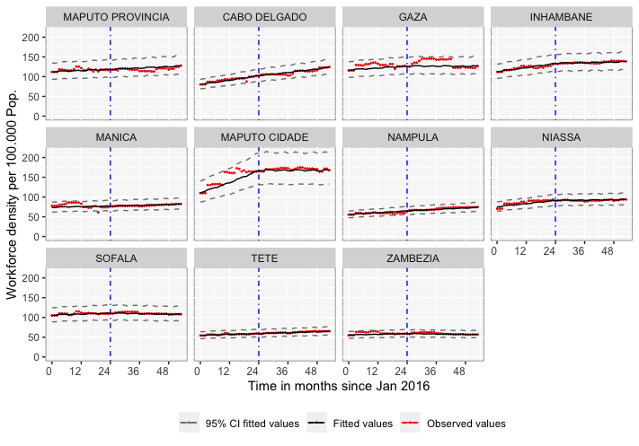
Figure S1: Province specific workforce density trend January 2016 to June 2020)

Figure S2: Sex Ratio in January 2016 (results adjusted for existing type of referral hospital)

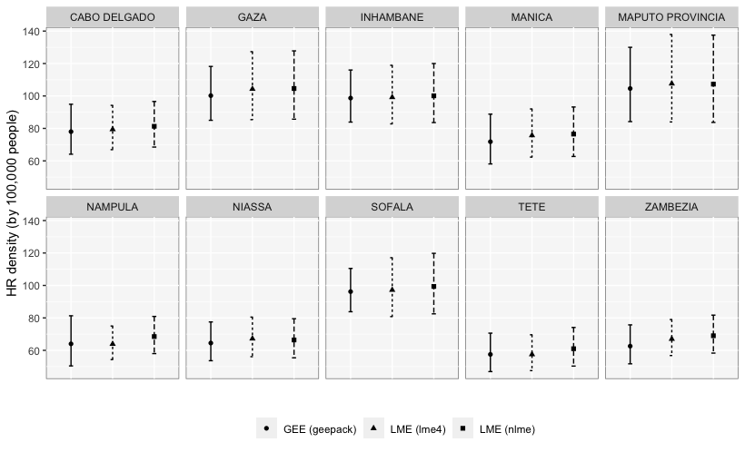
Figure S3: Model Stability for HR Density. Comparing Results (Exponentiated Betas) from GEE and Linear Mixed Models

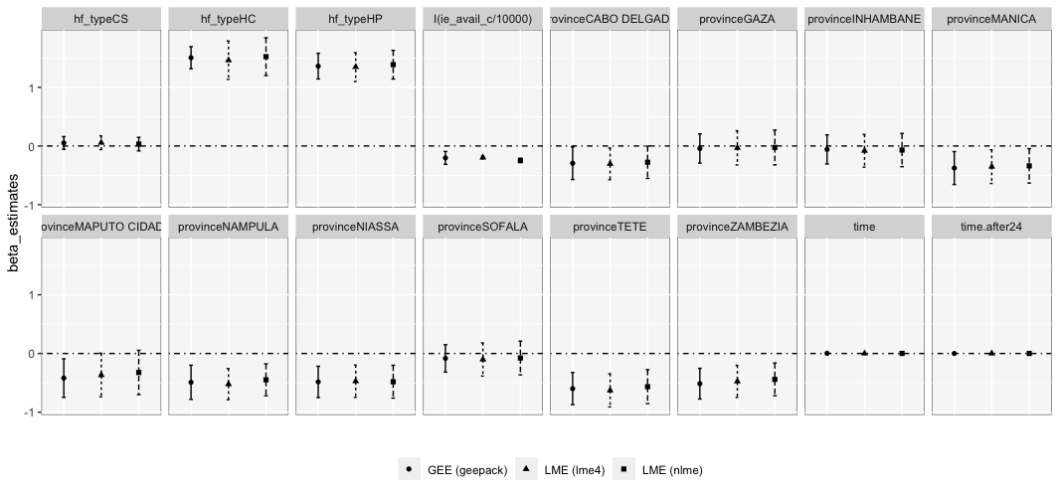
Figure S4: Model Stability for HR Density (comparing betas from GEE and Linear Mixed Models)

