Supplementary materials

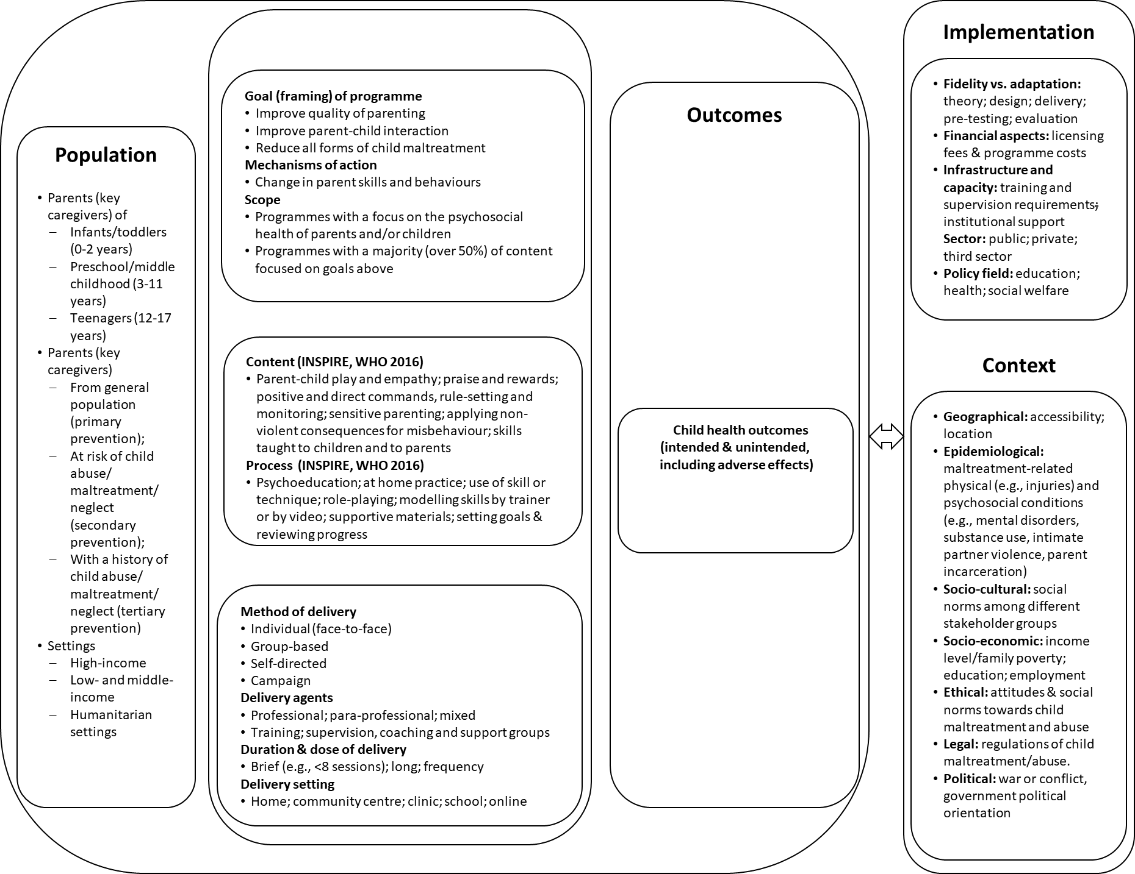
Figure S1: System-based logic model used to scope WHO parenting guidelines

