Article title: Peer-learning and support among Health Policy and Systems Research actors in West Africa: A social network analysis
Author’s information: Selina Defor^{1, 2,} Fidele Kanyimbu Mukinda¹, Fadima Yaya Bocoum², Ermel Johnson^{2,} Irene A. Agyepong ³ and Uta Lehmann¹

1School of Public Health, University of the Western Cape, Cape Town, South Africa
2West African Network of Emerging Leaders in Health Policy and Systems (WANEL)
3Public Health Faculty, Ghana College of Physicians and Surgeons
Corresponding author: Selina Defor E-mail: sellydel@yahoo.com

Additional file 2: Cross-disciplinary collaboration and advice sharing

Additional file 2 : Cross-disciplinary collaboration and advice sharing

Fig 1a cross -disciplinary collaboration network
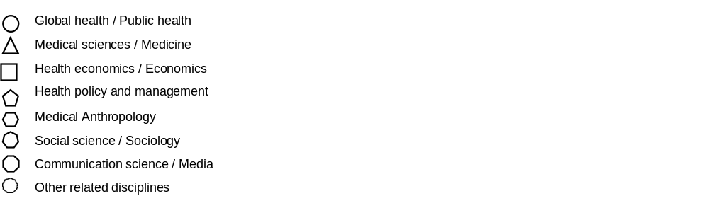
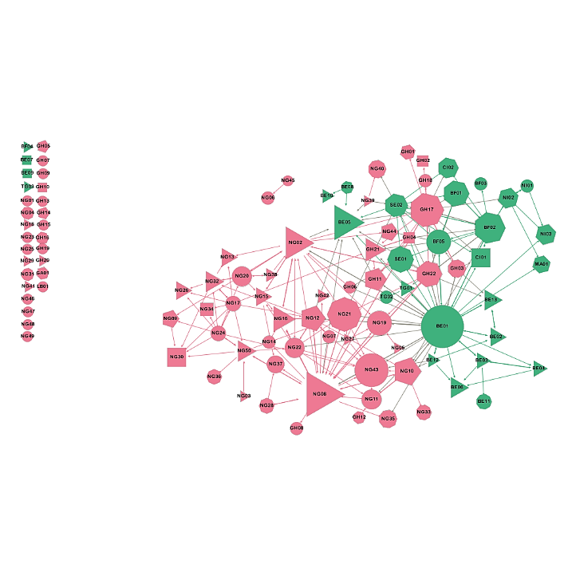

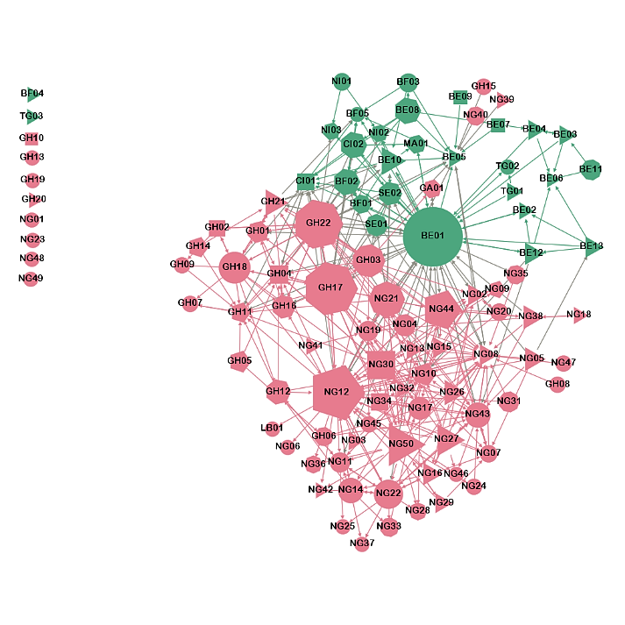
Fig 1b cross -disciplinary advice network

