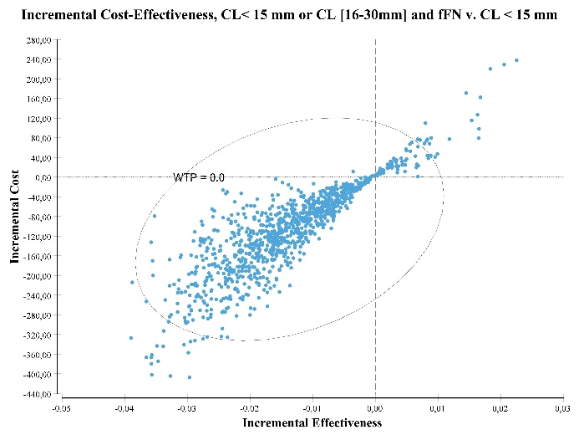
A: Scatter plot comparing S₇ to S₆ at 24- 27GA.
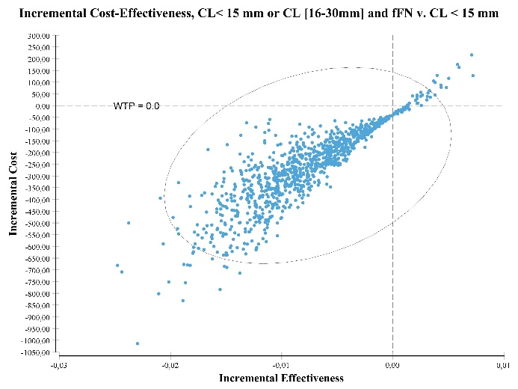
B: Scatter plot comparing S₇ to S₆ at 28- 31GA.
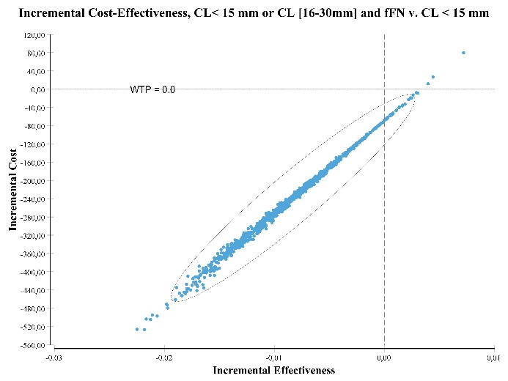
C: Scatter plot comparing S₇ to S₆ at 32- 34 GA.
Additional files. Supplement B. Scatter plots showing proportions (%) of pairs of incremental cost and incremental severe adverse neonatal events associated with CL< 15 mm or CL [16-30mm] and fFN qualitative compared to strategy 3 and 6 according to GA.

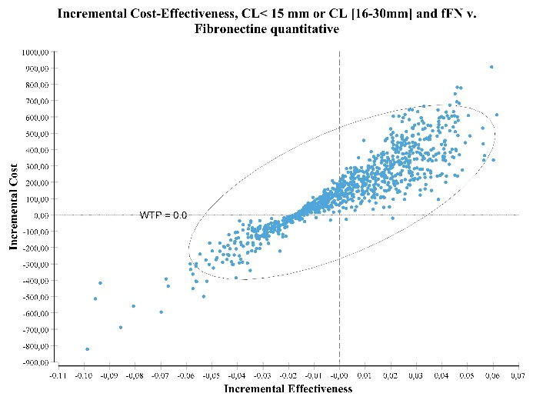
D: Scatter plot comparing S₇ to S₃ at 24- 27GA.
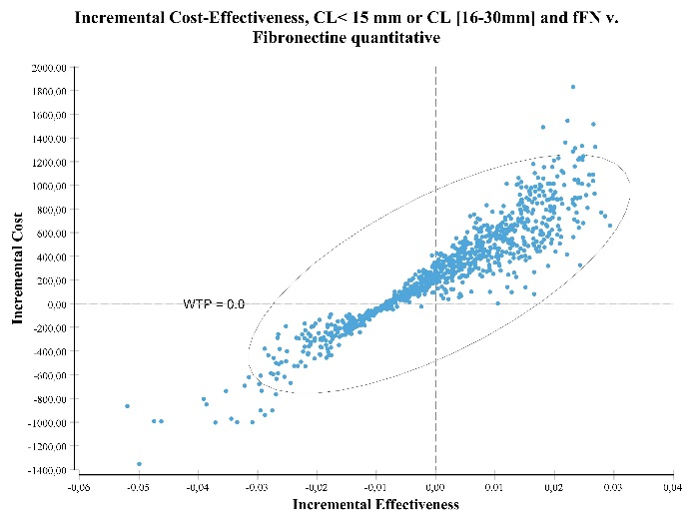
E: Scatter plot comparing S₇ to S₃ at 28- 31GA.
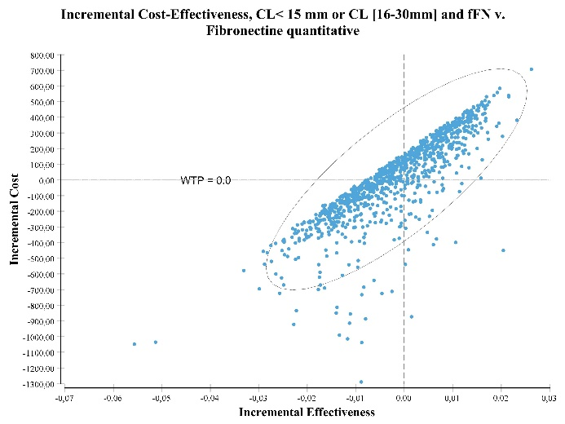
F: Scatter plot comparing S₇ to S₃ at 32- 34GA.

