Supplementary Table 1. Distribution and parameters used for the Probabilistic Sensitivity Analysis
 | Distribution | AIC | Shape | Scale
Costs treatment | Gamma | 1206.3 | 2.51 | 393.08
Costs control | Weibull | 955.7 | 0.31 | 131.56
0.417-QALY treatment | Weibull | -178.5 | 1.47 | 0.14
0.417-QALY control | Weibull | -185.1 | 1.53 | 0.14

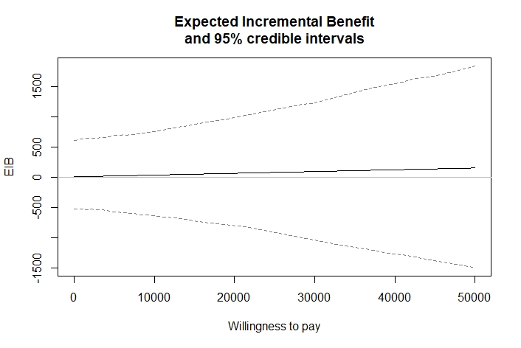
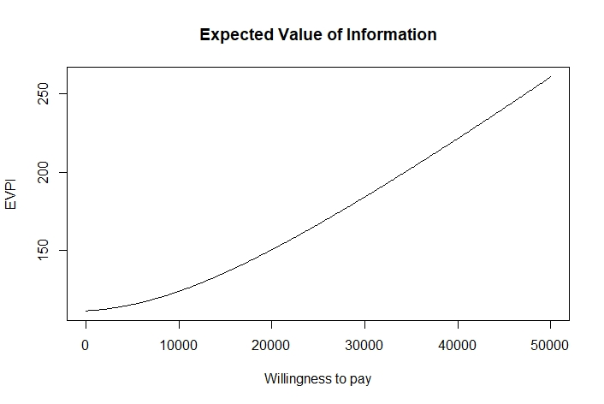
Supplementary Figure 1. Expected Incremental Benefit (on the left) and Expected Value of Perfect Information (on the right)

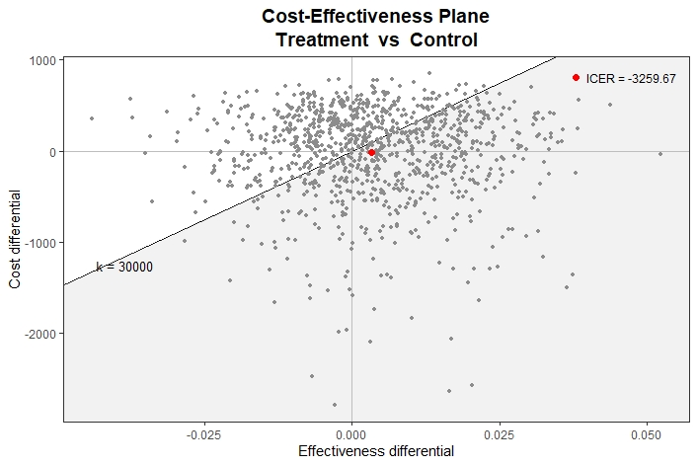
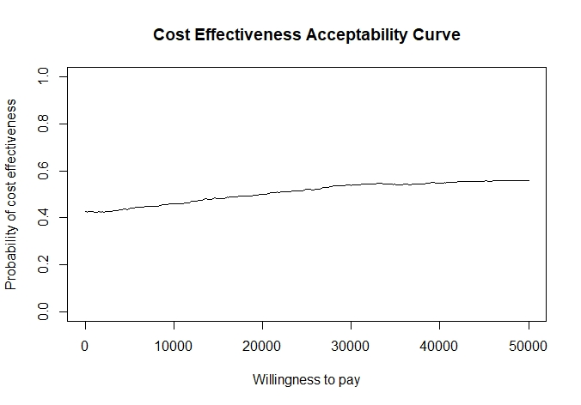
Supplementary Figure 2. PSA results: Cost Effectiveness Plane (on the left) at a WTP=€30,000/QALY and Acceptability Curve (on the right)

