Supplementary Information:

A long-term cost-effectiveness analysis of cardiac resynchronisation therapy with or without defibrillator based on health claims data

Moritz Hadwiger^{1*}, Laura Schumann¹, Nora Eisemann¹, Nikolaos Dagres^{2,3}, Gerhard Hindricks^{2,3}, Janina Haug⁴, Michael Wolf⁴, Ursula Marschall⁵, Alexander Katalinic¹, Fabian-Simon Frielitz¹

¹ Institute of Social Medicine and Epidemiology, University of Lübeck, Ratzeburger Allee 160, 23538 Lübeck, Germany
² Department of Electrophysiology, Heart Center Leipzig at University of Leipzig, Leipzig, Germany
³ Leipzig Heart Institute, Russenstraβe 69A, 04289 Leipzig, Germany
⁴ The Clinical Research Institute, Munich, Germany
⁵ BARMER, Wuppertal, Germany

*corresponding author: e-mail address: moritz.hadwiger@uksh.de; telephone number: 0049-451-500-51236

Supplementary information

Tables
Table SI1: Regression results for death without a heart failure hospitalisation after CRT implantation (exponential model)
Variables | Estimate | Lower 95 | Upper 95
Rate | (1.04e-05) | (2.69e-06) | (3.99e-05)
 | HR | Lower 95% | Upper 95%
Device, CRT-P | 1.24 | 0.98 | 1.58
Sex, (ref. female) | 1.72 | 1.35 | 2.19
Age, in years | 1.06 | 1.05 | 1.08
Non-ischemic (ref. ischemic) | 0.96 | 0.72 | 1.27
Hospital visits 1 year before implantation (reference 0 hospitalisations)
1 | 1.79 | 0.83 | 3.87
2 | 2.05 | 0.95 | 4.42
>2 | 2.72 | 1.27 | 5.85
Diabetes (ref. no diabetes) | 1.46 | 1.18 | 1.82
Renal dysfunction stage 3 (ref. no rn¹) | 1.06 | 0.83 | 1.35
Renal dysfunction stage 4 (ref. no rn¹) | 2.43 | 1.68 | 3.51
Atrial fibrillation (ref. no atrial fibrillation) | 1.36 | 1.09 | 1.70
Hazard ratios were reported; Abbreviations: CRT-P = cardiac biventricular pacemaker; CRT-D = cardiac biventricular defibrillator; ¹ rn= renal dysfunction

Table SI2: Regression results for death with a heart failure hospitalisation after CRT implantation (Gompertz model)
Variables | Estimate | Lower 95% | Upper 95%
Shape | 0.01147 | 0.00546 | 0.01748
Rate | 0.00709 | 0.00021 | 0.00240
 | HR | Lower 95% | Upper 95%
Device, CRT-P | 1.34 | 1.03 | 1.73
Sex, (ref. female) | 1.33 | 1.05 | 1.68
Age, in years | 1.03 | 1.01 | 1.04
Non-ischemic (ref. ischemic) | 1.16 | 0.88 | 1.53
Hospital visits 1 year before implantation (reference 0 hospitalisations)
1 | 1.13 | 0.57 | 2.26
2 | 1.10 | 0.55 | 2.19
>2 | 1.40 | 0.70 | 2.77
Diabetes (ref. no diabetes) | 1.15 | 0.93 | 1.41
Renal dysfunction stage 3 (ref. no rn¹) | 1.39 | 1.11 | 1.75
Renal dysfunction stage 4 (ref. no rn¹) | 1.87 | 1.29 | 2.72
Atrial fibrillation (ref. no atrial fibrillation) | 1.00 | 0.81 | 1.24
Hazard ratios were reported; Abbreviations: CRT-P = cardiac biventricular pacemaker; CRT-D = cardiac biventricular defibrillator, ¹ rn= renal dysfunction

Table SI3: Regression results for the first heart failure hospitalisation after CRT implantation (Weibull model)
Variables | Estimate | Lower 95 | Upper 95
Shape | 0.79689 | 0.75132 | 0.84522
Scale | 0.00176 | 0.00082 | 0.00377
 | HR | Lower 95 | Upper 95
Device, CRT-P | 0.84 | 0.71 | 1.00
Sex, (ref. female) | 1.13 | 0.97 | 1.30
Age, in years | 1.02 | 1.01 | 1.03
Non-ischemic (ref. ischemic) | 0.87 | 0.73 | 1.04
Hospital visits 1 year before implantation (reference 0 hospitalisations)
1 | 1.14 | 0.76 | 1.72
2 | 1.31 | 0.87 | 1.96
>2 | 1.49 | 1.00 | 2.24
Diabetes (ref. no diabetes) | 1.32 | 1.14 | 1.51
Renal dysfunction stage 3 (ref. no rn¹) | 1.52 | 1.31 | 1.77
Renal dysfunction stage 4 (ref. no rn¹) | 2.11 | 1.62 | 2.74
Atrial fibrillation (ref. no atrial fibrillation) | 1.33 | 1.16 | 1.54
Hazard ratios were reported; Abbreviations: CRT-P = cardiac biventricular pacemaker; CRT-D = cardiac biventricular defibrillator, ¹ rn= renal dysfunction

Table SI4: Regression results for further heart failure hospitalisations after the first heart failure hospitalisation (Gompertz model)
Variables | Estimate | Lower 95 | Upper 95
Shape | 0.00688 | 0.00250 | 0.01126
Rate | 0.00511 | 0.00210 | 0.01238
 | HR | Lower 95 | Upper 95
Device, CRT-P | 0.92 | 0.75 | 1.14
Sex, (ref. female) | 1.24 | 1.05 | 1.46
Age, in years | 1.01 | 1.00 | 1.02
Non-ischemic (ref. ischemic) | 1.07 | 0.88 | 1.30
Hospital visits 1 year before implantation (reference 0 hospitalisations)
1 | 1.77 | 0.98 | 3.17
2 | 1.61 | 0.90 | 2.88
>2 | 1.81 | 1.01 | 3.25
Diabetes (ref. no diabetes) | 1.21 | 1.05 | 1.40
Renal dysfunction stage 3 (ref. no rn¹) | 1.33 | 1.14 | 1.55
Renal dysfunction stage 4 (ref. no rn¹) | 1.44 | 1.08 | 1.92
Atrial fibrillation (ref. no atrial fibrillation) | 1.02 | 0.88 | 1.18
Hazard ratios were reported; Abbreviations: CRT-P = cardiac biventricular pacemaker; CRT-D = cardiac biventricular defibrillator, ¹ rn= renal dysfunction

Table SI5: Input parameter for deterministic sensitivity analysis
Variable | Baseline Value |  | DSA values
 |  | lower |  | upper
Discount rate | 3 % | 0 % |  | 5 %
Cost HF hospitalisation | 4,077 | 1,465 |  | 6,689
Cost CRT-D implantation | 16,648 | 13,791 |  | 19,505
Cost CRT-P implantation | 11,092 | 8,285 |  | 13,889
Cost CRT-D replacement | 8,095 | 6,971 |  | 9,219
Cost CRT-P replacement | 5,644 | 4,434 |  | 6,853
Cost ambulant care (per quartal) | 49 | 1 |  | 97
Cost medication | 181 | 0 |  | 386
Device runtime CRT-D | 72 | 72 |  | 73
Device runtime CRT-P | 98 | 95 |  | 103
HR death without HF hospitalisation | 1.24 | 0.98 |  | 1.58
HR death after HF hospitalisation | 1.34 | 1.03 |  | 1.73
HR first HF hospitalisation | 0.84 | 0.71 |  | 1.00
HR further HF hospitalisation | 0.92 | 0.75 |  | 1.14
Abbreviations: CRT-P = cardiac biventricular pacemaker; CRT-D = cardiac biventricular defibrillator, DSA = deterministic sensitivity analysis, HF = heart failure, HR = hazard ratio

Table SI6: Observed CRT-D survival and model predicted CRT-D survival
Time in month | Survival CRT-D (Kaplan-Meier curve) | Survival CRT-D (model) | Survival CRT-P (model)
6 | 0.97 | 0.98 | 0.98
12 | 0.93 | 0.96 | 0.95
24 | 0.88 | 0.91 | 0.89
36 | 0.82 | 0.85 | 0.82
48 | 0.76 | 0.78 | 0.75
60 | 0.70 | 0.71 | 0.66
71 | 0.65 | 0.63 | 0.59
120 | - | 0.33 | 0.31
180 | - | 0.11 | 0.11
Abbreviations: CRT-P = cardiac biventricular pacemaker; CRT-D = cardiac biventricular defibrillator

Figures
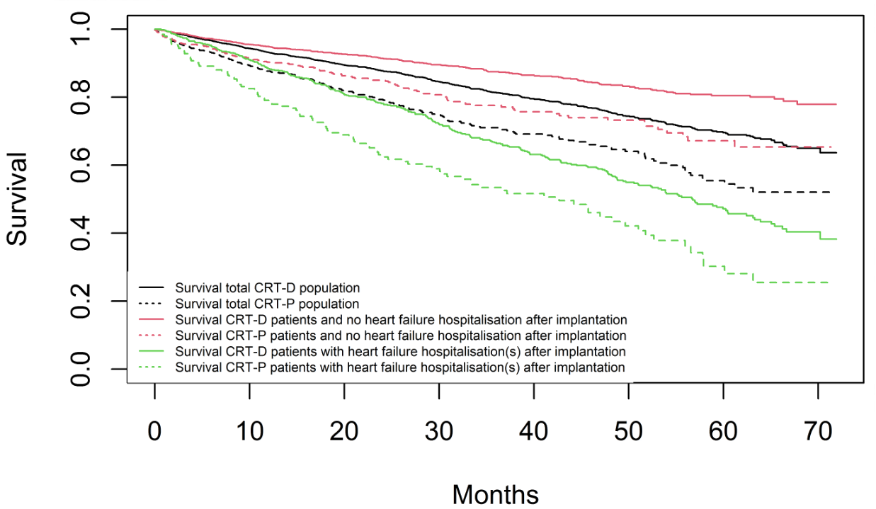
Figure SI1: Kaplan-Meier survival curves by heart failure hospitalisation after CRT implantation;
CRT = cardiac resynchronisation therapy, CRT-P = cardiac biventricular pacemaker; CRT-D = cardiac biventricular defibrillator (overall population N = 3,569)

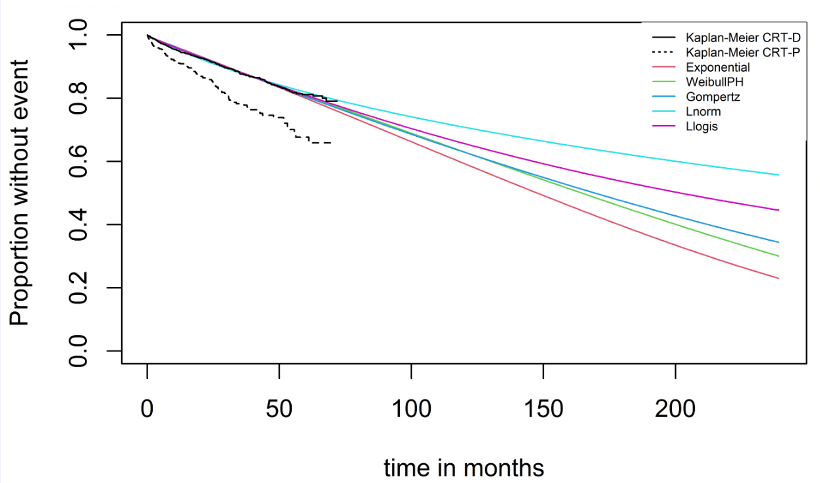
FigureSI2: CRT-D Kaplan-Meier curve for death in patients without any HF hospitalisation and estimated parametric survival curves for CRT-D patients for different distributions (n=2,726)
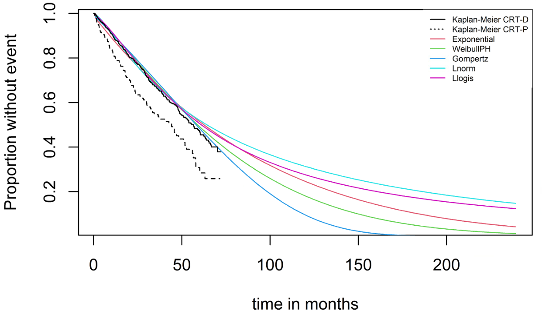
FigureSI3: CRT-D Kaplan-Meier curve for death in patients with one HF hospitalisation after CRT implantation and computed survival for CRT-D patients for different distributions (n=843)
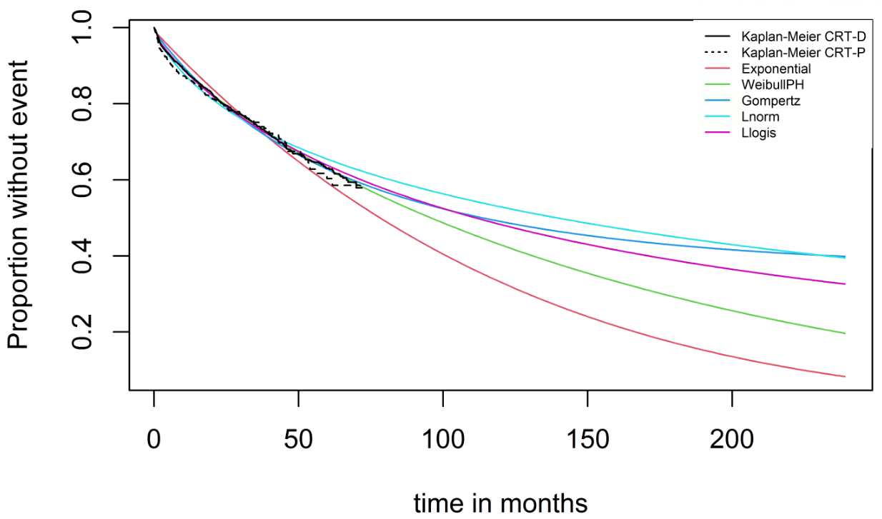
Figure SI4: CRT-D Kaplan-Meier curve for the first heart failure hospitalisation after CRT implantation and computed time for the first hospitalisation for CRT-D patients for different distributions (n=3,569)

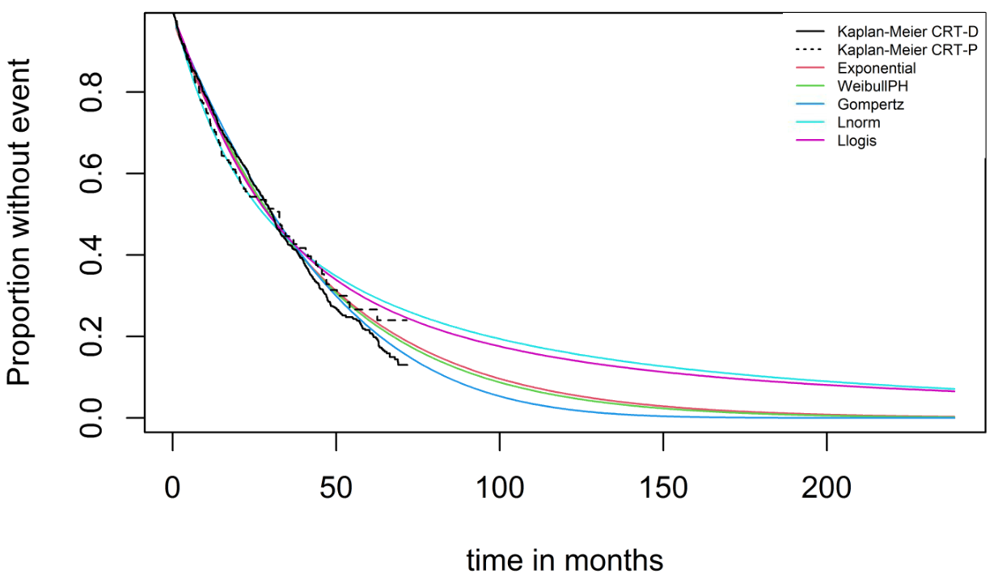
Figure SI5: CRT-D Kaplan-Meier curve for further heart failure hospitalisations after the first HF hospitalisation and computed time for further hospitalisation for CRT-D patients for different distributions (n=843)

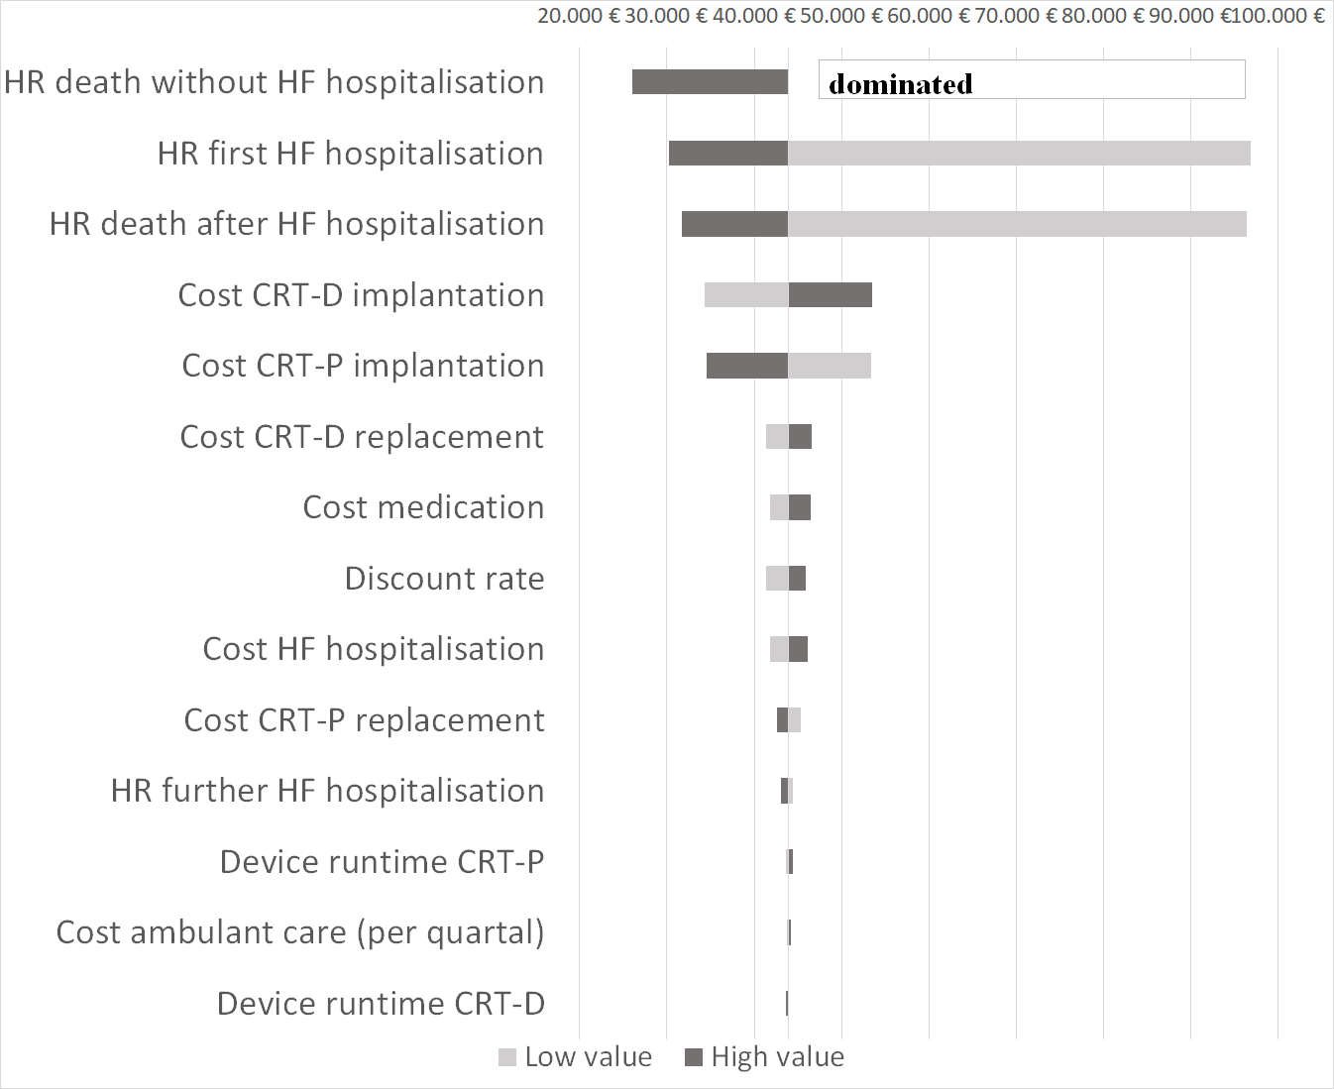
Figure SI6: Tornado chart
Abbreviations: CRT-P = cardiac biventricular pacemaker; CRT-D = cardiac biventricular defibrillator, HR = hazard ratio

