Supplementary Tables and Figures
Table S1. Cost-effectiveness analysis results for various changes in deceased donor kidney transplantation probability
Percent change | Strategy | Cost | ∆ Cost | QALYs | ∆QALYs | ICUR ($/QALY)
-10% | Deemed consent | $305,780 | $2,386 | 3.76 | 0.10 | 24,785
-10% | Expressed consent | $308,167 | $2,386 | 3.85 | 0.10 | 24,785
-5% | Deemed consent | $306,908 | $1,259 | 3.81 | 0.05 | 27,955
-5% | Expressed consent | $308,167 | $1,259 | 3.85 | 0.05 | 27,955
1% | Expressed consent | $308,167 | $349 | 3.85 | 0.01 | 32,629
1% | Deemed consent | $308,516 | $349 | 3.86 | 0.01 | 32,629
6% | Expressed consent | $308,167 | $2,407 | 3.85 | 0.07 | 34,021
6% | Deemed consent | $310,573 | $2,407 | 3.92 | 0.07 | 34,021
12% | Expressed consent | $308,167 | $4,695 | 3.85 | 0.13 | 35,332
12% | Deemed consent | $312,861 | $4,695 | 3.99 | 0.13 | 35,332
18% | Expressed consent | $308,167 | $7,227 | 3.85 | 0.20 | 36,625
18% | Deemed consent | $315,393 | $7,227 | 4.05 | 0.20 | 36,625
23% | Expressed consent | $308,167 | $10,019 | 3.85 | 0.26 | 37,904
23% | Deemed consent | $318,186 | $10,019 | 4.12 | 0.26 | 37,904
29% | Expressed consent | $308,167 | $13,087 | 3.85 | 0.33 | 39,165
29% | Deemed consent | $321,254 | $13,087 | 4.19 | 0.33 | 39,165
40% | Expressed consent | $308,167 | $20,128 | 3.85 | 0.48 | 41,634
40% | Deemed consent | $328,295 | $20,128 | 4.34 | 0.48 | 41,634
45% | Expressed consent | $308,167 | $24,345 | 3.85 | 0.57 | 43,019
45% | Deemed consent | $332,512 | $24,345 | 4.42 | 0.57 | 43,019
56% | Expressed consent | $308,167 | $34,446 | 3.85 | 0.75 | 45,918
56% | Deemed consent | $342,613 | $34,446 | 4.60 | 0.75 | 45,918
62% | Expressed consent | $308,167 | $40,314 | 3.85 | 0.85 | 47,317
62% | Deemed consent | $348,481 | $40,314 | 4.70 | 0.85 | 47,317
73% | Expressed consent | $308,167 | $53,584 | 3.85 | 1.07 | 49,873
73% | Deemed consent | $361,751 | $53,584 | 4.93 | 1.07 | 49,873
78% | Expressed consent | $308,167 | $61,076 | 3.85 | 1.20 | 51,056
78% | Deemed consent | $369,243 | $61,076 | 5.05 | 1.20 | 51,056
84% | Expressed consent | $308,167 | $69,218 | 3.85 | 1.33 | 52,192
84% | Deemed consent | $377,384 | $69,218 | 5.18 | 1.33 | 52,192
89% | Expressed consent | $308,167 | $78,053 | 3.85 | 1.46 | 53,280
89% | Deemed consent | $386,219 | $78,053 | 5.32 | 1.46 | 53,280
95% | Expressed consent | $308,167 | $87,639 | 3.85 | 1.61 | 54,324
95% | Deemed consent | $395,806 | $87,639 | 5.47 | 1.61 | 54,324
100% | Expressed consent | $308,167 | $98,043 | 3.85 | 1.77 | 55,328
100% | Deemed consent | $406,210 | $98,043 | 5.62 | 1.77 | 55,328
Table S2. Cost-effectiveness analyses result for various percentage changes in living donor kidney transplantation probability, assuming a 1% increase in deceased donor kidney transplantation probability
Percent change | Strategy | Cost | ∆ Cost | QALYs | ∆QALYs | ICUR ($/QALY)
-100% | Expressed consent | $308,167 | $9,071 | 3.85 | -0.63 | Deemed consent dominated
-100% | Deemed consent | $317,238 | $9,071 | 3.22 | -0.63 | Deemed consent dominated
-95% | Expressed consent | $308,167 | $8,227 | 3.85 | -0.59 | Deemed consent dominated
-95% | Deemed consent | $316,393 | $8,227 | 3.26 | -0.59 | Deemed consent dominated
-90% | Expressed consent | $308,167 | $7,418 | 3.85 | -0.56 | Deemed consent dominated
-90% | Deemed consent | $315,584 | $7,418 | 3.29 | -0.56 | Deemed consent dominated
-80% | Expressed consent | $308,167 | $5,903 | 3.85 | -0.49 | Deemed consent dominated
-80% | Deemed consent | $314,070 | $5,903 | 3.36 | -0.49 | Deemed consent dominated
-75% | Expressed consent | $308,167 | $5,197 | 3.85 | -0.46 | Deemed consent dominated
-75% | Deemed consent | $313,364 | $5,197 | 3.40 | -0.46 | Deemed consent dominated
-70% | Expressed consent | $308,167 | $4,525 | 3.85 | -0.42 | Deemed consent dominated
-70% | Deemed consent | $312,692 | $4,525 | 3.43 | -0.42 | Deemed consent dominated
-65% | Expressed consent | $308,167 | $3,886 | 3.85 | -0.39 | Deemed consent dominated
-65% | Deemed consent | $312,052 | $3,886 | 3.46 | -0.39 | Deemed consent dominated
-50% | Expressed consent | $308,167 | $2,165 | 3.85 | -0.30 | Deemed consent dominated
-50% | Deemed consent | $310,332 | $2,165 | 3.56 | -0.30 | Deemed consent dominated
-45% | Expressed consent | $308,167 | $1,656 | 3.85 | -0.27 | Deemed consent dominated
-45% | Deemed consent | $309,823 | $1,656 | 3.59 | -0.27 | Deemed consent dominated
-40% | Expressed consent | $308,167 | $1,218 | 3.85 | -0.24 | Deemed consent dominated
-40% | Deemed consent | $309,384 | $1,218 | 3.62 | -0.24 | Deemed consent dominated
-35% | Expressed consent | $308,167 | $842 | 3.85 | -0.20 | Deemed consent dominated
-35% | Deemed consent | $309,009 | $842 | 3.65 | -0.20 | Deemed consent dominated
-30% | Expressed consent | $308,167 | $499 | 3.85 | -0.18 | Deemed consent dominated
-30% | Deemed consent | $308,666 | $499 | 3.68 | -0.18 | Deemed consent dominated
-25% | Expressed consent | $308,167 | $223 | 3.85 | -0.15 | Deemed consent dominated
-25% | Deemed consent | $308,390 | $223 | 3.71 | -0.15 | Deemed consent dominated
-20% | Expressed consent | $308,167 | $80 | 3.85 | -0.11 | Deemed consent dominated
-20% | Deemed consent | $308,247 | $80 | 3.74 | -0.11 | Deemed consent dominated
-15% | Expressed consent | $308,167 | $24 | 3.85 | -0.08 | Deemed consent dominated
-15% | Deemed consent | $308,191 | $24 | 3.77 | -0.08 | Deemed consent dominated
-10% | Expressed consent | $308,167 | $2 | 3.85 | -0.05 | Deemed consent dominated
-10% | Deemed consent | $308,169 | $2 | 3.80 | -0.05 | Deemed consent dominated
-5% | Expressed consent | $308,167 | $129 | 3.85 | -0.02 | Deemed consent dominated
-5% | Deemed consent | $308,296 | $129 | 3.83 | -0.02 | Deemed consent dominated
0% | Expressed consent | $308,167 | $349 | 3.85 | 0.01 | 32,629
0% | Deemed consent | $308,516 | $349 | 3.86 | 0.01 | 32,629

Table S3. Cost-effectiveness analyses result for various percentage changes in living donor kidney transplantation probability, assuming a 26% increase in deceased donor kidney transplantation probability
Percent change | Strategy | Cost | ∆ Cost | QALYs | ∆QALYs | ICUR ($/QALY)
-100% | Expressed consent | $308,167 | $8,126 | 3.85 | -0.39 | Deemed consent dominated
-100% | Deemed consent | $316,292 | $8,126 | 3.46 | -0.39 | Deemed consent dominated
-95% | Expressed consent | $308,167 | $7,641 | 3.85 | -0.36 | Deemed consent dominated
-95% | Deemed consent | $315,808 | $7,641 | 3.50 | -0.36 | Deemed consent dominated
-90% | Expressed consent | $308,167 | $7,192 | 3.85 | -0.32 | Deemed consent dominated
-90% | Deemed consent | $315,359 | $7,192 | 3.53 | -0.32 | Deemed consent dominated
-80% | Expressed consent | $308,167 | $6,421 | 3.85 | -0.26 | Deemed consent dominated
-80% | Deemed consent | $314,587 | $6,421 | 3.60 | -0.26 | Deemed consent dominated
-75% | Expressed consent | $308,167 | $6,178 | 3.85 | -0.22 | Deemed consent dominated
-75% | Deemed consent | $314,345 | $6,178 | 3.63 | -0.22 | Deemed consent dominated
-70% | Expressed consent | $308,167 | $6,078 | 3.85 | -0.19 | Deemed consent dominated
-70% | Deemed consent | $314,244 | $6,078 | 3.66 | -0.19 | Deemed consent dominated
-65% | Expressed consent | $308,167 | $6,013 | 3.85 | -0.15 | Deemed consent dominated
-65% | Deemed consent | $314,180 | $6,013 | 3.70 | -0.15 | Deemed consent dominated
-50% | Expressed consent | $308,167 | $6,302 | 3.85 | -0.05 | Deemed consent dominated
-50% | Deemed consent | $314,468 | $6,302 | 3.80 | -0.05 | Deemed consent dominated
-45% | Expressed consent | $308,167 | $6,651 | 3.85 | -0.02 | Deemed consent dominated
-45% | Deemed consent | $314,818 | $6,651 | 3.84 | -0.02 | Deemed consent dominated
-40% | Expressed consent | $308,167 | $7,047 | 3.85 | 0.02 | 362,812
-40% | Deemed consent | $315,214 | $7,047 | 3.87 | 0.02 | 362,812
-35% | Expressed consent | $308,167 | $7,482 | 3.85 | 0.05 | 136,354
-35% | Deemed consent | $315,649 | $7,482 | 3.91 | 0.05 | 136,354
-30% | Expressed consent | $308,167 | $7,957 | 3.85 | 0.09 | 88,172
-30% | Deemed consent | $316,123 | $7,957 | 3.94 | 0.09 | 88,172
-25% | Expressed consent | $308,167 | $8,471 | 3.85 | 0.13 | 67,472
-25% | Deemed consent | $316,638 | $8,471 | 3.98 | 0.13 | 67,472
-20% | Expressed consent | $308,167 | $9,026 | 3.85 | 0.16 | 56,122
-20% | Deemed consent | $317,192 | $9,026 | 4.01 | 0.16 | 56,122
-15% | Expressed consent | $308,167 | $9,621 | 3.85 | 0.20 | 49,065
-15% | Deemed consent | $317,787 | $9,621 | 4.05 | 0.20 | 49,065
-10% | Expressed consent | $308,167 | $10,258 | 3.85 | 0.23 | 44,337
-10% | Deemed consent | $318,425 | $10,258 | 4.08 | 0.23 | 44,337
-5% | Expressed consent | $308,167 | $10,937 | 3.85 | 0.27 | 41,011
-5% | Deemed consent | $319,103 | $10,937 | 4.12 | 0.27 | 41,011
0% | Expressed consent | $308,167 | $11,657 | 3.85 | 0.30 | 38,594
0% | Deemed consent | $319,824 | $11,657 | 4.15 | 0.30 | 38,594

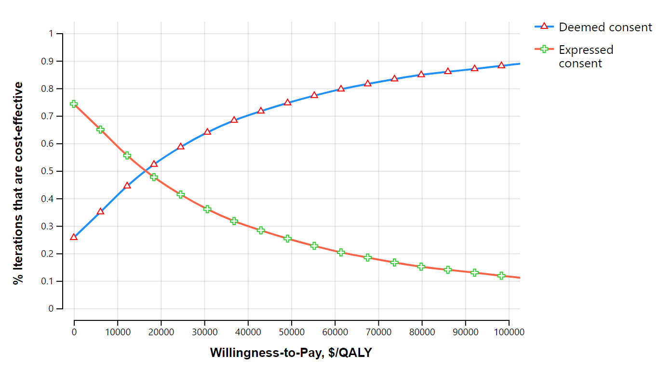
Figure S1. Cost-effectiveness acceptability curve for a 26% increase in deceased donor kidney transplantation probability.

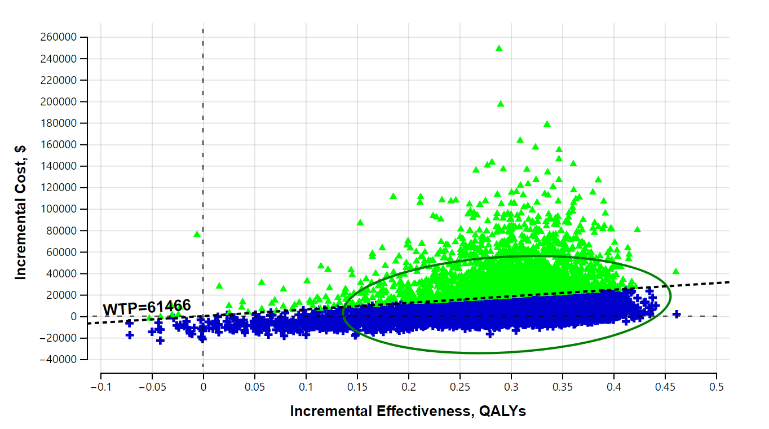
Figure S2. Cost-effectiveness plane for a 26% increase in deceased donor kidney transplantation probability.

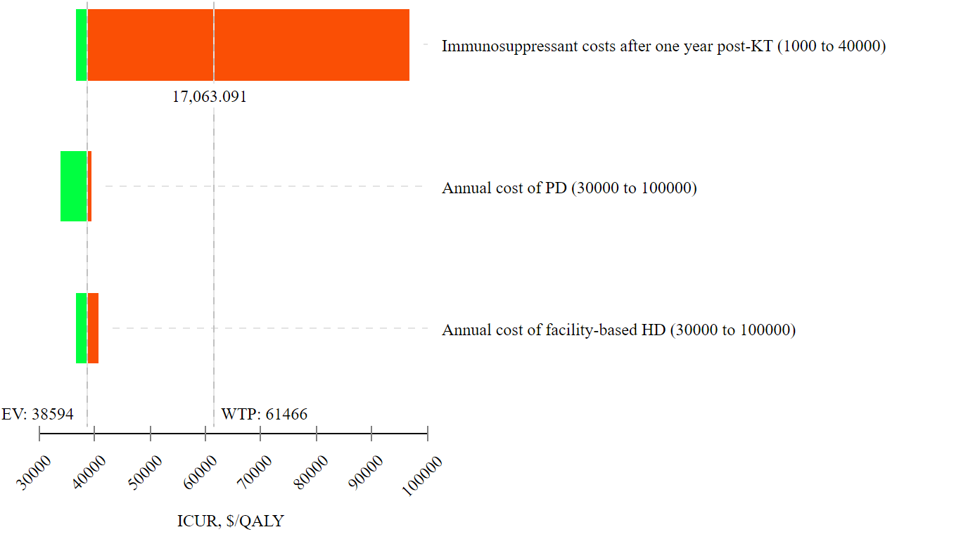

Figure S3. The sensitivity of ICUR to changes in dialysis and maintenance immunosuppressant drug costs for a 26% increase in deceased donor KT probability. ICUR, incremental cost-utility ratio; QALY, quality-adjusted life-year; WTP, willingness to pay; KT, kidney transplantation; HD, hemodialysis; PD, peritoneal dialysis; EV expected value.

