Supplement 1
Figure 1. Creation of Markov Model in Treeage Program
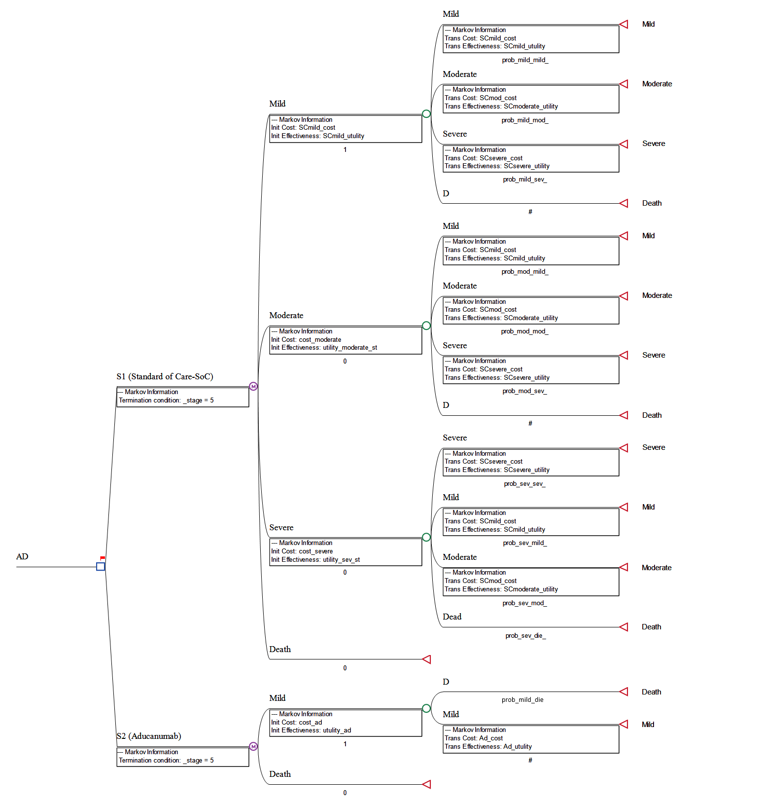

Figure 2. Acceptability of Aducanumab at Different Thresholds

