ADDITIONAL FILES
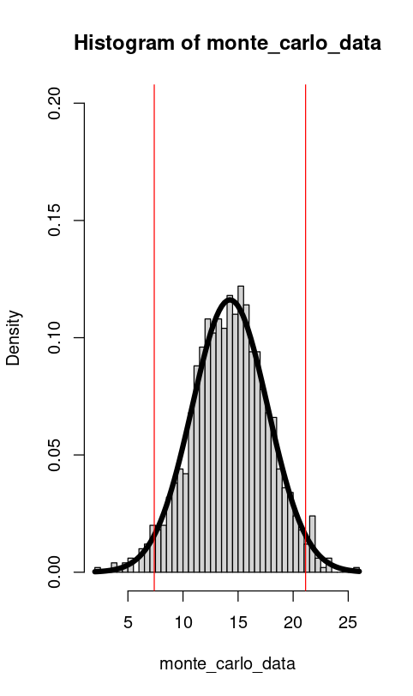
Additional file 1 Histogram of Monte-Carlo-Simulation for SG

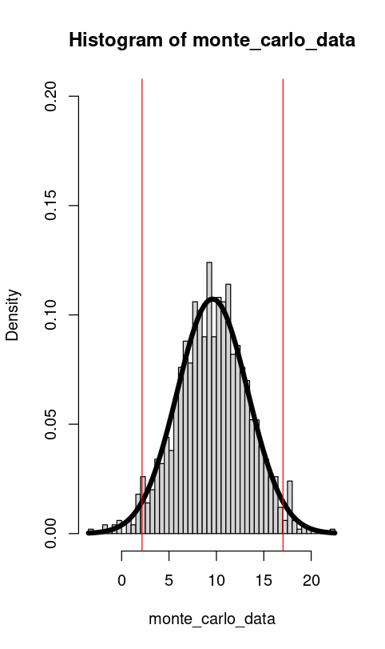
Additional file 2 Histogram of Monte-Carlo-Simulation for eribulin

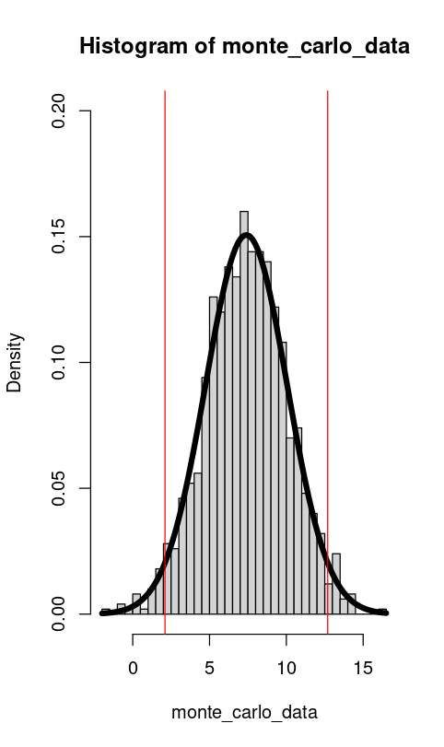
Additional file 3 Histogram of Monte-Carlo-Simulation for capecitabine

Additional file 4 Patient characteristics
Authors  [Reference] | Total study population [n] | Study population Triple negative [n] | Age [median (range)] | Gender | Lines of prior therapies [median (range)] | ECOG performance-status | Number of metastatic sites | Germline BRCA1 or BRCA2 mutation status
Bardia, A. et al. [6] | 529 | 529 | 54 (27-82) | 233 female, 2 male  (Without Brain metastasis) | Not specified | 0 = 108  1 = 127  (Without Brain metastasis) | Not specified | BRCA 1/2 mutation  negative = 133  positive = 16  (Without Brain metastasis)
Bardia, A. et al. [26] | 69 | 69 | 56 (31-81) | 68 female, 1 male | 5 (1-12) | 0 = 23  1 = 46 | Lymph node = 43  Lung = 35  Liver = 30  Chest = 28  Bone = 21  Skin = 7 | All BRCA1
Sari, M. et al. [36] | 28 | 7 | 52.5 (29-72) | All female | 4 (1–7) | 1 (0-2) [median, range] | 3 (1-4) | Not specified
Krasniqi, E. et al. [27] | 44 | 40 | 51 (35-81) | All female | Not specified | 0 = 17  1 = 24  2= 2  unknown = 1 | Number of metastatic sites  1 = 13  2 = 20  > 2= 11 | BRCA 1/2 mutation  Yes = 1  No = 26 Unknown = 17

Kazmi, S. et al. [28] | 443 | 66 (Eribulin)  20 (Capecitabine)  36 (Gemcitabin) | 55.0 (8.63) (Eribulin)  55.9 (9.49) (Gemcitabin) 55.5 (9.7) (Capecitabine | All female | Not specified | 0= 39  1=119  2=53  3= 12  4= 1  unknown = 5  (Eribulin)  0= 15  1= 63  2= 43  3= 9  4=0  Unknown= 4  (Gemcitabine)  0= 23  1= 34  2= 9  3= 5  4= 1  Unknown= 8  (Capecitabine) | Not specified | Not specified
Ates, O. et al. [37] | 66 | 7 | 50 (28-67) | All female | 4 (2-7) | 0 = 29  1 = 30  2 = 7 | Bone = 58  Lung = 51  Brain = 19  Liver = 38  Local recurrence = 7 | Not specified
Mougalian, SS. et al. [29] | 252 | 127 | 53 | All female | 4 (1-6) | 0 = 40  1 = 156  2 = 56  3/4 = 0 | Bone=151  Liver=110  Lymph nodes=114  Lung=127  Brain=11  Other=14 | Not specified

Miyoshi, Y. et al [30] | 751 | 92 | <65 years = 604  ≥65 years = 147 | Not specified | ≤ 3 = 351  > 3 = 397 | 0 = 317  ≥ 1 = 423 | Number of organs involved  ≤2 =531  >2 = 212 | Not specified
Valerio, M.R. et al. [31] | 90 | 38 | 62 (38-72) | All female | Not specified | 0-1 = 82  2 = 8 | Sites of disease Breast = 12 Node/soft tissue = 34  Lung/pleura = 27  Liver = 36  Bone = 45  Brain = 5 | Not specified
Decker, T. et al. [39] | 133 | 60 | 61.9 (Arm1, n = 68))  60.7 (Arm2, n = 65) | All female | Not specified | 0 = 66  1 = 60  2 = 6 | 1 = 35  2 = 50  ≥3 = 45 | Not specified
Pedersini, R. et al. [38] | 53 | 8 | 62 (30–79) | All female | 4 (2–7) | 0-1 = 41  2 = 12 | Sites of metastases  Liver = 30  Lung = 11  Bone = 9  Others = 3 | Not specified
Aogi, K. et al. [32] | 80 | 22 | 54.0 (31–72) | All female | 3 (1-5) | 0 = 58  1 = 21  2 = 1 | No. of organs involved,  1 = 7  2 = 15  3 = 23  4 = 21  5 = 14 | Not specified

Mougalian, SS. et al. [33] | 513 | 256 | 57.0 (16.0) | All female | 3=225  4=25  5=6 | 0/1 = 168  ≥ 2 =88  Unknown = 0 | Sites of metastases at initiation of eribulin (n, %) Adrenal gland = 26  Brain = 15  Local lymph node(s)= 40  Gastrointestinal system = 1  Genitourinary system = 4  Ovary = 5  Liver = 159  Lung = 179  Lytic or mixed lytic-blastic bone = 33  Pleura, pericardial, and/or peritoneal cavity = 16  Othera = 3 | Not specified
Twelves, C. et al. [34] | 438 (Eribulin)  444 (Capecitabine) | 106 (Eribulin)  102 (Capecitabine) | Not specified | All female | Not specified | Not specified | Not specified | Not specified
Chan, A. et al. [35] | 266 | 51 | 49.8 (25–77) | Not specified | 4 (1–14) | Not specified | 1 = 54 (20)  2 = 85 (32)  3 = 55 (21)  ≥ 4 = 72 (27) | Not specified

Abbreviations: ECOG, Eastern Cooperative Oncology Group; PS, performance status

