Supplement 2
Table S1 Baseline characteristics of patients in NAPOLI-3 2
Table S2 The goodness-of-fit results 2
Figure S1 Goodness-of-Fit (Visual Validation) of Survival Curves 3
Table S3 List of subsequent treatment options selected 6
Table S4 Summary results for scenario analyses 7
Table S5 Summary results for subgroup analyses 7
Figure S2 Results of price simulation 8

Table S1 Baseline characteristics of patients in NAPOLI-3
 | NALIRIFOX  (n=383) | Nab-paclitaxel and gemcitabine (n=387)
Age, median (range), years | 64 (20-85) | 65 (36-82)
Aged<65 (rate) | 193 (50%) | 191 (49%)
Sex
Male | 179 (47%) | 157 (41%)
Female | 204 (53%) | 230 (59%)
Region
North America | 120 (31%) | 122 (31%)
Rest of the world | 263 (69%) | 265 (69%)
Main pancreatic tumor location
Head | 147 (38%) | 156 (40%)
Other | 236 (62%) | 231 (60%)
ECOG performance status score
0 | 160 (42%) | 168 (43%)
1 | 222 (58%) | 219 (57%)
2 | 1 (<1%) | 0
Number of metastatic sites
1 | 114 (30%) | 138 (36%)
2 | 120 (31%) | 108 (28%)
≥3 | 149 (39%) | 141 (36%)
Presence of liver metastases at baseline
Yes | 309 (81%) | 309 (80%)
No | 74 (19%) | 78 (20%)
Baseline CA 19-9
<37 U/ml | 60 (16%) | 71 (18%)
≥37 U/ml | 321 (84%) | 316 (82%)
Note: This table was extracted from NAPOLI-3.

Table S2 The goodness-of-fit results
Model | LnL | Params | AIC | LnL | Params | AIC | LnL | Params | AIC | LnL | Params | AIC
Model | NALIRIFOX PFS |  |  | Nab-paclitaxel and gemcitabine PFS |  |  | NALIRIFOX OS |  |  | Nab-paclitaxel and gemcitabine OS
RP-hazard-2 | -62.15 | 6 | 136.30 | -43.96 | 6 | 99.91 | -56.93 | 6 | 125.87 | -59.24 | 2 | 122.48
RP-normal-2 | -61.86 | 6 | 135.71 | -44.11 | 6 | 100.23 | -55.98 | 7 | 125.96 | -56.41 | 5 | 122.83
RP-odds-2 | -62.18 | 6 | 136.35 | -44.26 | 6 | 100.53 | -55.91 | 7 | 125.83 | -56.76 | 4 | 121.52
FP1-2 | -63.38 | 2 | 130.76 | -48.78 | 2 | 101.55 | -62.39 | 2 | 128.79 | -59.07 | 2 | 122.14
FP1-1 | -62.83 | 2 | 129.66 | -49.64 | 2 | 103.27 | -61.45 | 2 | 126.91 | -58.62 | 2 | 121.23
RP-hazard-1 | -61.83 | 5 | 133.65 | -45.31 | 7 | 104.61 | -56.20 | 7 | 126.41 | -56.80 | 5 | 123.61
RP-normal-1 | -61.76 | 5 | 133.53 | -45.66 | 7 | 105.32 | -56.45 | 6 | 124.90 | -57.17 | 4 | 122.35
RP-odds-1 | -61.97 | 5 | 133.94 | -45.73 | 7 | 105.47 | -56.35 | 6 | 124.70 | -55.81 | 5 | 121.62
FP2-2 | -62.52 | 3 | 131.05 | -49.85 | 3 | 105.71 | -59.30 | 3 | 124.62 | -58.62 | 3 | 123.25
gamma | -62.57 | 2 | 129.15 | -51.05 | 2 | 106.09 | -60.77 | 2 | 125.54 | -59.05 | 2 | 122.10
gengamma | -63.29 | 3 | 132.60 | -50.27 | 3 | 106.54 | -59.77 | 3 | 125.55 | -59.19 | 3 | 124.38
FP2-1 | -62.52 | 3 | 131.05 | -50.44 | 3 | 106.88 | -59.45 | 3 | 124.91 | -58.62 | 3 | 123.24
genf | -63.30 | 4 | 134.61 | -50.28 | 4 | 108.55 | -56.72 | 4 | 121.44 | -59.19 | 4 | 126.38
weibull | -62.35 | 2 | 128.70 | -52.50 | 2 | 109.00 | -60.15 | 2 | 124.31 | -59.24 | 2 | 122.48
lnorm | -70.63 | 2 | 145.27 | -52.58 | 2 | 109.16 | -72.37 | 2 | 148.74 | -65.59 | 2 | 135.17
llogis | -67.93 | 2 | 139.86 | -53.49 | 2 | 110.98 | -66.22 | 2 | 136.44 | -62.05 | 2 | 128.09
RCS2 | -62.55 | 4 | 133.09 | -53.68 | 4 | 115.37 | -55.68 | 4 | 119.37 | -57.76 | 4 | 123.53
RCS1 | -62.58 | 3 | 131.18 | -55.45 | 3 | 116.91 | -58.74 | 3 | 123.49 | -58.51 | 3 | 123.02
gompertz | -63.16 | 2 | 130.31 | -58.41 | 2 | 120.83 | -59.65 | 2 | 123.31 | -61.53 | 2 | 127.07
exp | -66.78 | 1 | 135.57 | -67.84 | 1 | 137.67 | -63.68 | 1 | 129.38 | -65.47 | 1 | 132.95
Note: PFS, progression-free survival; OS, overall survival; LnL, log likelihood; Params, Parameters; AIC, Akaike information criterion; Exp, exponential; lnorm, log normal; llogis, log logistic; gengamma, generalized gamma; FP, fractional polynomial; RCS, restricted cubic spline models; RP, Royston-Parmar models.
Bold data means that this AIC value is one of the smallest top three in this set of data. Bold and red data means that this model is the model we finally selected.

Figure S1 Goodness-of-Fit (Visual Validation) of Survival Curves
A: PFS for Nab-paclitaxel and gemcitabine

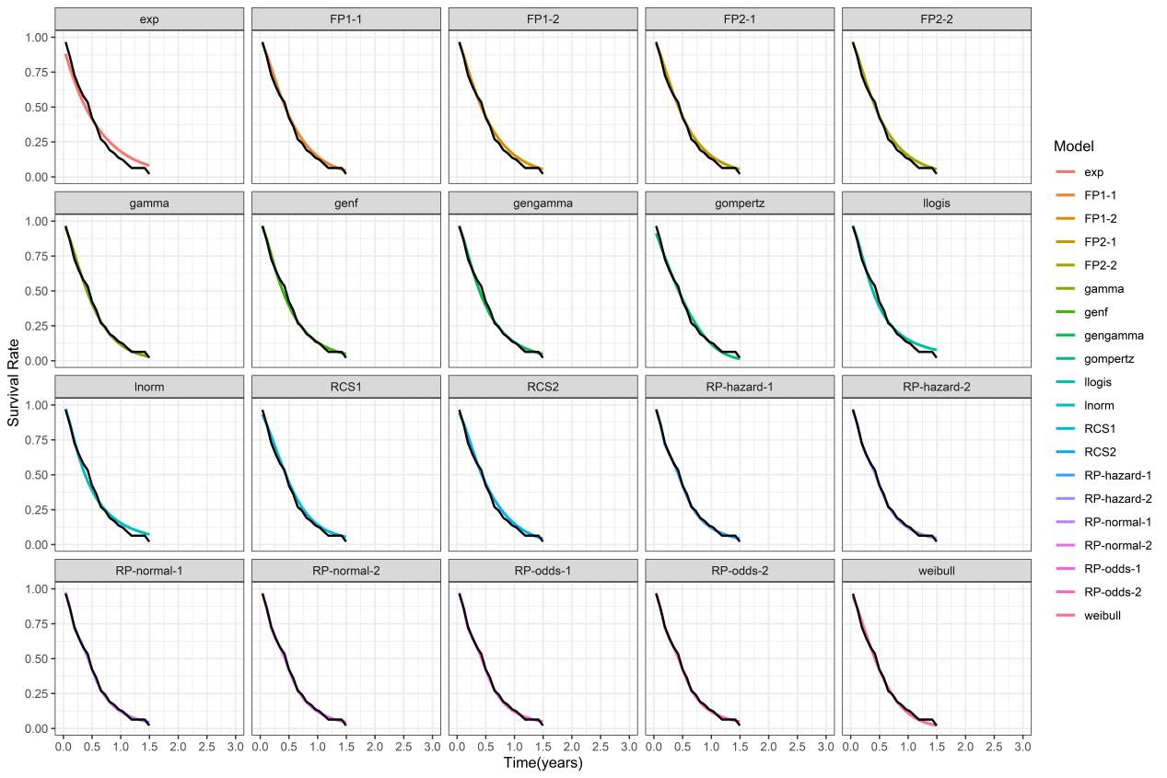

B: PFS for NALIRIFOX
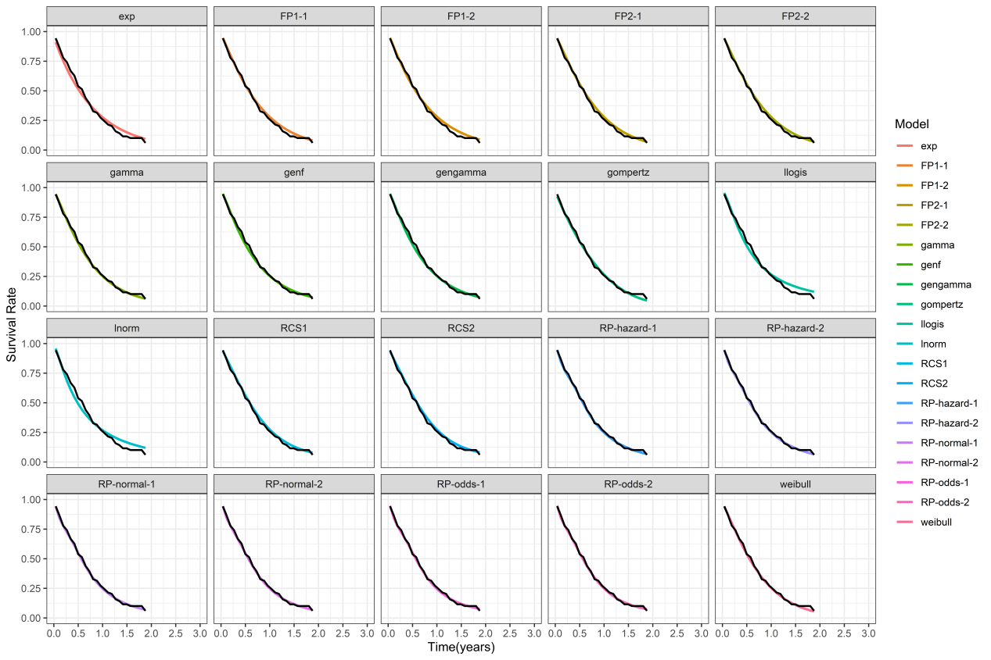

C: OS for Nab-paclitaxel and gemcitabine
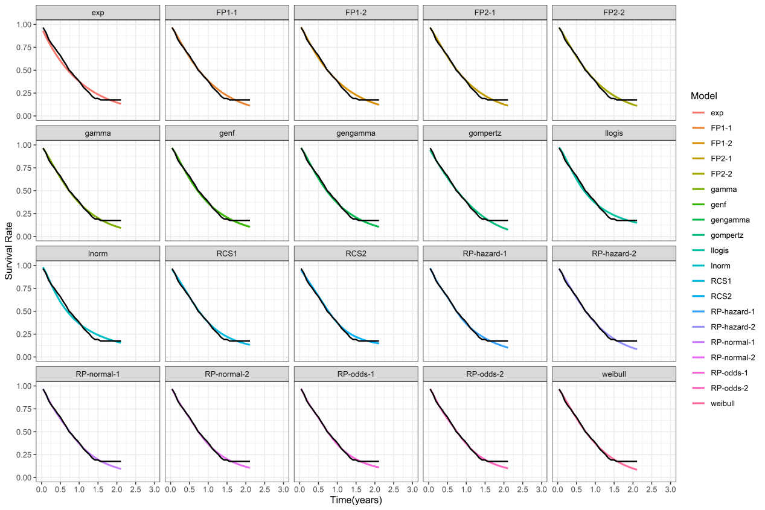

D: OS for NALIRIFOX
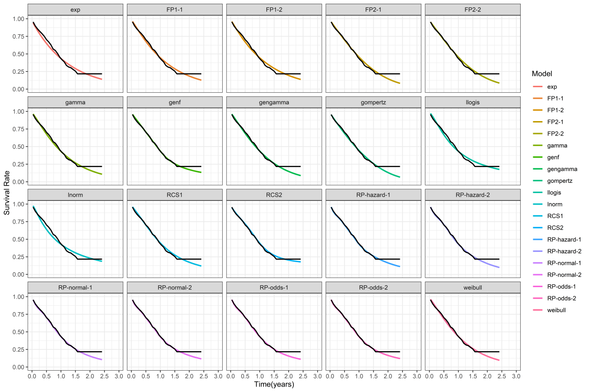
Note: PFS: progression-free survival; OS: overall survival;
Black line shows the original KM curves.

Table S3 List of subsequent treatment options selected
NALIRIFOX | nab-paclitaxel and gemcitabine
1.Gemcitabine: 1000mg/m², days 1,8,15 every 28 days. | - FOLFIRINOX: oxaliplatin at a dose of 85 mg/m², given as a 2-hour intravenous infusion, immediately followed by leucovorin at a dose of 400 mg/m², given as a 2-hour intravenous infusion, with the addition, after 30 minutes, of irinotecan at a dose of 180 mg /m², given as a 90-minute intravenous infusion, biweekly.
2.FOLFIRI-1: irinotecan 180 mg/m² on day 1 and leucovorin 400 mg/m² followed by 5-fluorouracil (5-FU) 400 mg/m² bolus, then 5-FU 2400 mg/m² as a 46-h infusion, biweekly | 2. an intravenous infusion of liposomal irinotecan over 90 min at a dose of 80 mg/m², followed by folinic acid 400 mg/m² over 30 min, then fluorouracil 2400 mg/m²over 46 h, every 2 weeks[19].
2.FOLFIRI-3: irinotecan 100 mg/m² on day 1 and leucovorin 400 mg/m², then 5-FU 2400 mg/m² as a 46-h infusion and irinotecan 100 mg/m² repeated on day 3, biweekly
3.mFOLFOX: oxaliplatin 85mg/m²; day 1, leucovorin 400mg/m²; day 1, and 5-FU 2000 mg/m²; days 1 and 2 every 2 weeks.
Note: The cheapest subsequent treatments of NALIRIFOX is Gemcitabine, and the most expensive is mFOLFOX. The cheapest of subsequent treatments for nab-paclitaxel and gemcitabine is FOLFIRINOX and the most expensive is nab-paclitaxel and gemcitabine + 5-FU + leucovorin + liposomal irinotecan

Table S4 Summary results for scenario analyses
Scenario | Utility of NALIRIFOX | Cost of  NALIRIFOX | Utility of nab-paclitaxel and gemcitabine | Cost of nab-paclitaxel and gemcitabine | ICER ($/QALY)
1 | 0.94 | $216,397.03 | 0.65 | $156,558.23 | 206,340.69
2 | 0.94 | $216,397.03 | 0.65 | $210,197.51 | 21,377.66
3 | 0.94 | $228,628.99 | 0.65 | $156,558.23 | 248,519.86
4 | 0.94 | $228,628.99 | 0.65 | $210,197.51 | 63,556.83
Note: Scenario 1: NALIRIFOX--gemcitabine vs nab-paclitaxel and gemcitabine--FOLFIRINOX
Scenario 2: NALIRIFOX--gemcitabine vs nab-paclitaxel and gemcitabine--5-FU+ leucovorin+ liposomal irinotecan
Scenario 3: NALIRIFOX--mFOLFOX vs nab-paclitaxel and gemcitabine--FOLFIRINOX
Scenario 4: NALIRIFOX--mFOLFOX vs nab-paclitaxel and gemcitabine--5-FU+ leucovorin+ liposomal irinotecan

Table S5 Summary results for subgroup analyses
Subgroup | ICER $/QALY | Cost-effectiveness  probability of NALIRIFOX at  a WTP of 200,000 | Cost-effectiveness  probability of NALIRIFOX at  a WTP of 150,000
Age
<65 | 208,592.6 | 44.1% | 15.6%
≥65 | 211,341.2 | 43.8% | 15.7%
Sex
male | 212,450.3 | 43.0% | 13.2%
female | 208,246.2 | 44.3% | 15.7%
Race
White | 210,264.0 | 43.7% | 16.0%
Region
North America | 209,970.0 | 45.3% | 17.4%
Rest of the world | 214,298.8 | 40.4% | 15.0%
Baseline ECOG performance status
0 | 211,680.9 | 41.1% | 14.3%
1 | 210,583.3 | 45.3% | 17.0%
Number of metastatic sites
1 | 208,715.4 | 44.6% | 16.4%
2 | 210,782.6 | 43.2% | 14.9%
≥3 | 211,980.3 | 43.5% | 15.5%
Presence of liver metastases at baseline
Yes | 208,184.4 | 46.1% | 15.9%
No | 209,786.3 | 43.8% | 15.0%
Main pancreatic tumor location
Head | 212,229.2 | 43.3% | 13.5%
Other | 211,028.6 | 44.0% | 15.1%
Baseline CA 19-9
<37 U/ml | 211,507.9 | 44.2% | 13.8%
≥37 U/ml | 208,446.0 | 44.4% | 15.7%

Figure S2 Results of price simulation
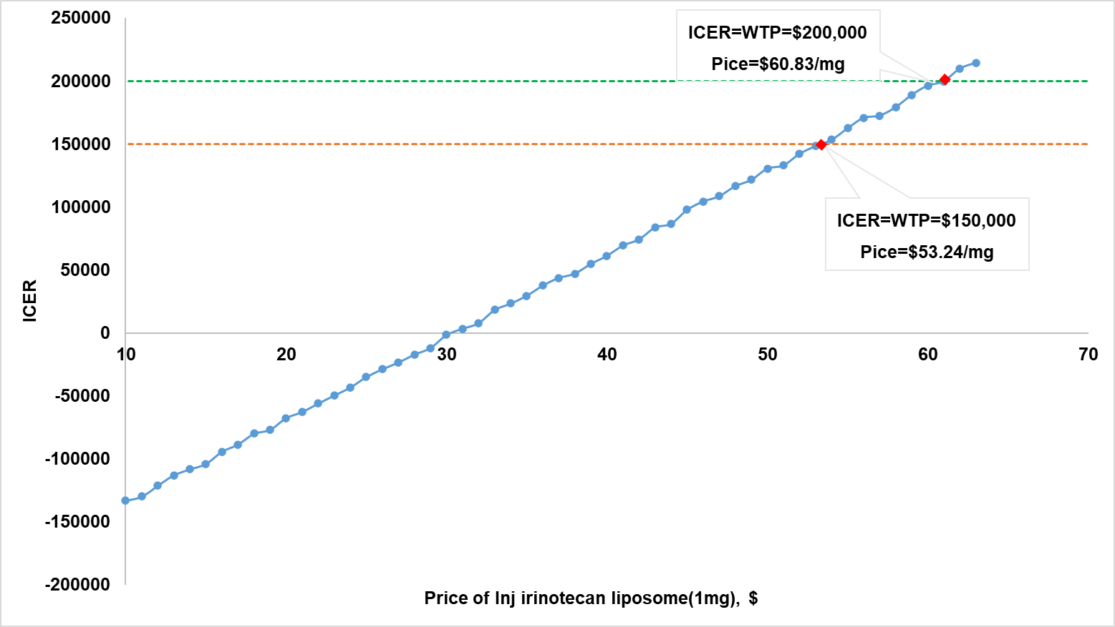
Note: ICER, incremental cost-effectiveness ratio

