Table 1. Baseline Model’s cohort characteristic
Population baseline characteristic |  | Primary Source
Age (years) | 71 | (9)
Proportion of male (%) | 63.6% | (9)
Proportion of MI history (%) | 16.6% | (9)
CHADS₂ distribution (%)
CHADS₂ 0 | 2.5% | (9)
CHADS₂ 1 | 29.4% | (9)
CHADS₂ 2 | 35.6% | (9)
CHADS₂ 3 | 20.2% | (9)
CHADS₂ 4 | 8.9% | (9)
CHADS₂ 5 | 2.9% | (9)
CHADS₂ 6 | 0.5% | (9)
History of previous stroke by CHADS ₂
CHADS₂ 0 | 0.0% | (9)
CHADS₂ 1 | 0.0% | (9)
CHADS₂ 2 | 5.9% | (9)
CHADS₂ 3 | 37.4% | (9)
CHADS₂ 4 | 81.1% | (9)
CHADS₂ 5 | 100.0% | (9)
CHADS₂ 6 | 100.0% | (9)

Table 2. Factor Xa inhibitors Price discount scenario analysis
10% price discount
 | Incremental costs (discounted) | Incremental QALYs (discounted) | ICER | Incremental Net health benefit
Dabigatran | $ 4,669 | 0.42 | 11,042 | 0.15
Rivaroxaban | $ 4,671 | 0.29 | Dominated | Dominated
Apixaban | $ 5,279 | 0.41 | 12,763 | 0.11
15% price discount
 | Incremental costs (discounted) | Incremental QALYs (discounted) | ICER | Incremental Net health benefit
Dabigatran | $ 4,669 | 0.42 | 11,042 | 0.15
Rivaroxaban | $ 4,271 | 0.29 | 14,515 | 0.05
Apixaban | $ 4,774 | 0.41 | 11,542 | 0.14
20% price discount
 | Incremental costs (discounted) | Incremental QALYs (discounted) | ICER | Incremental Net health benefit
Dabigatran | $ 4,669 | 0.42 | 11,042 | 0.15
Rivaroxaban | $ 3,910 | 0.29 | 13,291 | 0.07
Apixaban | $ 4,319 | 0.41 | 10,443 | 0.16
Established Chilean threshold of USD 17.200 (1 GDP per capita)

Figure 1. Probabilistic sensitivity analysis Incremental Cost-effectiveness planes of DOACs versus acenocoumarol
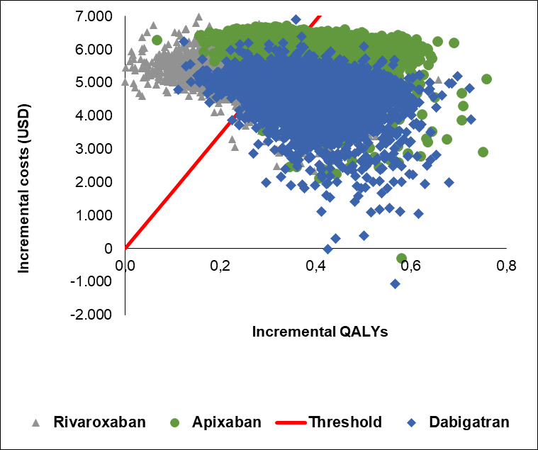

Figure 1. One-way sensitivity analysis dabigatran vs acenocoumarol
