Exploring the cost-effectiveness of 3-D-guided versus traditional 2-D corrective osteotomy in patients with a distal radius malunion
Anne J.H. Vochteloo¹, Camiel J. Smees^{1,2}, Quinty Teggeler^{1,3}, Judith olde Heuvel¹, Michelle M.A. Kip³, Xavier G.L.V. Pouwels ³
¹ Centre for Orthopaedic Surgery and Sports Medicine, OCON, Hengelo, The Netherlands, Hengelo, the Netherlands
² Biomedical Device Design and Production Technology, University of Twente, Enschede, The Netherlands.
³ Section Health Technology and Services Research, Technical Medical Centre, Faculty of Behavioural, Management, and Social Sciences, University of Twente, Enschede, The Netherlands.
Corresponding author: c.smees@ocon.nl

Supplementary Materials
Table S1. To include parameter uncertainty surrounding the surgery duration of a) the 3-D guided surgery, b) R1, and c) hardware removal, multiple parametric distributions were fitted to the empirical data collected at [Blinded]: Weibull, Poisson, normal, gamma, and log-normal. The best fitting distribution, using the Akaike Information Criterium, was used for each of these parameters in the probabilistic analysis. This resulted in the following distributions being used for the different surgery durations:
Surgery | Distribution | Parameter 1 | Parameter
2D | Normal | Mean: 96.9 | Standard error: 7.8*
3D | Gamma | Shape: 14.175 | Rate: 0.174
R1 | Weibull | Shape: 1.326 | Scale: 77.190
Hardware removal | Weibull | Shape: 2.813 | Scale: 38.178
* Calculated based on reported data in Buijze et al., 2018 (32.3 / √17)
Abbreviations: 3-D = 3-D-guided surgery; R1 = revision type 1

Table S2: Disaggregated costs per strategy and category
Category | Strategy | Mean | 95%CI | Mean difference | Difference 95%CI
HR | Soc 2-D | €241 | €100 - €444 | NA | NA
HR | Soc 3-D | €225 | €100 - €396 | €-16 | €-107 - €55
R1 | Soc 2-D | €2,527 | €804 - €4,576 | NA | NA
R1 | Soc 3-D | €1,321 | €402 - €2,478 | €-1,206 | €-2,333 - €-332
R2 | Soc 2-D | €557 | €109 - €1,308 | NA | NA
R2 | Soc 3-D | €613 | €127 - €1,365 | €56 | €-192 - €319
Surgery | Soc 2-D | €11,461 | €8,381 - €14,509 | NA | NA
Surgery | Soc 3-D | €12,408 | €9,321 - €15,460 | €947 | €722 - €1,168

HR -Hardware removal, NA – not applicable, R1 - Revision, R2 - Revision 2, Soc 2-D – Societal costs 2-Dy, Soc 3-D – Societal costs 3D

Table S3. Model inputs changed for each scenario analyses compared to the base-case
Scenario analysis | Model input | Value base  case | Value  scenario analysis | Reference value scenario  analysis
1. Hospital  perspective | Price per kilometer  Parking costs hospital  Productivity costs per hour | €0.27  €4.07  €41.41 | €0  €0  €0
2. Time horizon of 5 years | Number of cycles | 12 | 20
3. Alternative  transition probabilities 2D approach | Relative risk NP to AP month 0-3  Relative risk AP to NP month 0-3  Relative risk NP to AP month 3-12  Relative risk AP to NP month 3-12 | 0  0  0  0 | 0.71  1.35  0.77  1.47 | (Buijze et al., 2018)
4. Alternative  surgery duration | Surgery duration 3D  Surgery duration 2D | 90.26 min  96.9 min | 108 min  140 min | (Bauer et al., 2017)
5. Disutilities | Disutility revision 1  Disutility revision 2  Disutility Hardware removal | 0  0  0 | 0.08  0.11  0.04 | (Franovic et al., 2023)
6. Alternative 3D  surgery duration | Surgery duration 3D | 90.26 min | 81.55 min
7. Alternative 3D  costs | Costs 3D analysis  Costs 3D license per patient  Costs printing 3D guides and models  Costs CT  Costs plate and screws  Total costs 3D | €558.50  €231.15  €100.00  €195.21  €666.17  €1751.03 | Range total costs  between €1,800 and  €4,000 | (Buijze et al., 2018; Schindele et al., 2024)

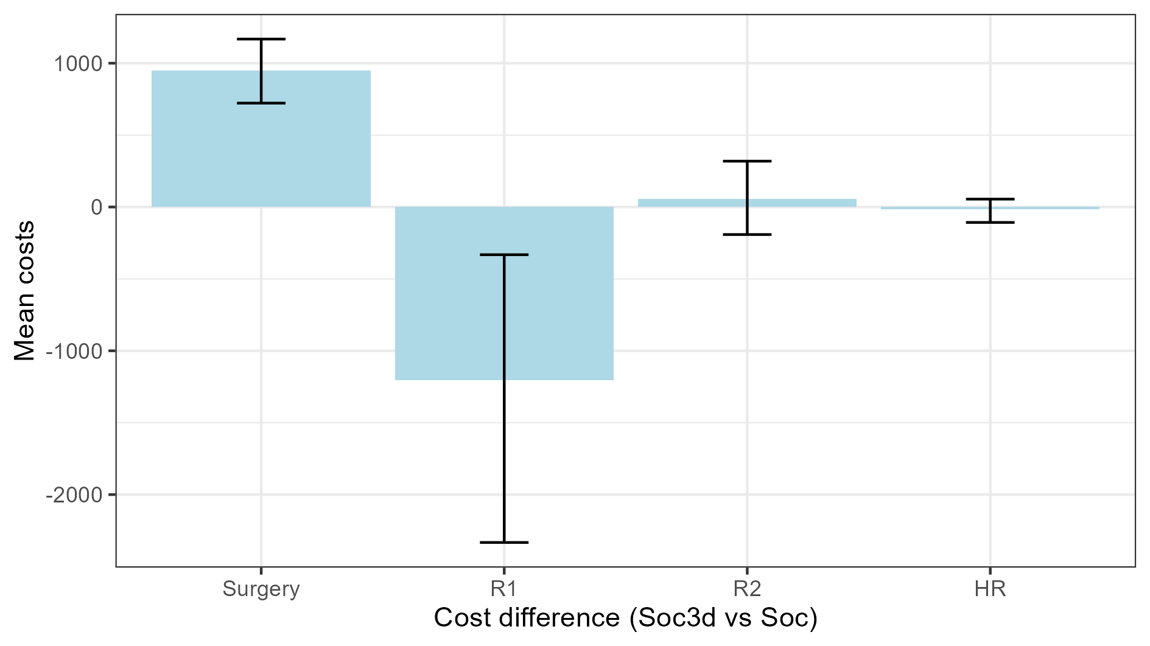
Fig. S1 Difference disaggregated costs per strategy. HR -Hardware removal, R1 - Revision, R2 - Revision 2, Soc – Societal costs 2-D, Soc 3D – Societal costs 3-D

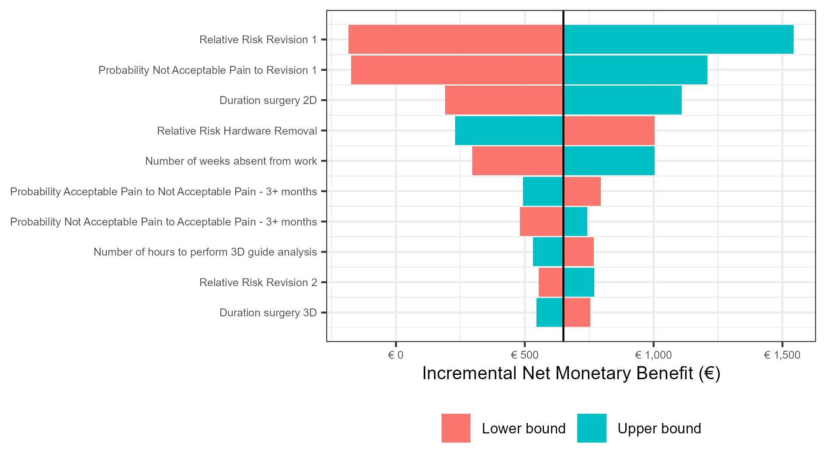
Fig. S2 Tornado diagram one-way deterministic sensitivity analyses

