Appendix 1
Figure S1: Model structure
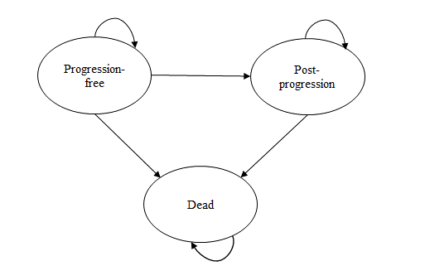

Figure S2: A comparison of observed and model-predicted PFS for bevacizumab plus FOLFIRI and FOLFIRI alone in the first-line setting

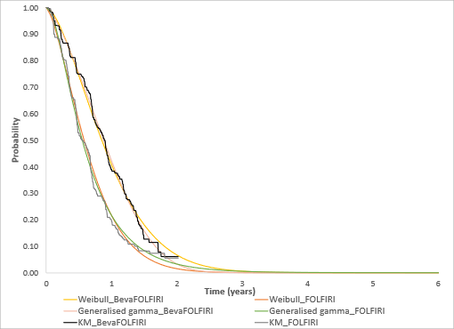
Beva: bevacizumab; FOLFIRI: folinic acid plus fluorouracil plus irinotecan; KM: Kaplan-Meier; PFS: progression-free survival; Base case – Weibull model (both arms), Scenario analysis – generalised gamma (both arms)
Figure S3: A comparison of observed and model-predicted OS for bevacizumab plus FOLFIRI and FOLFIRI alone in the first-line setting

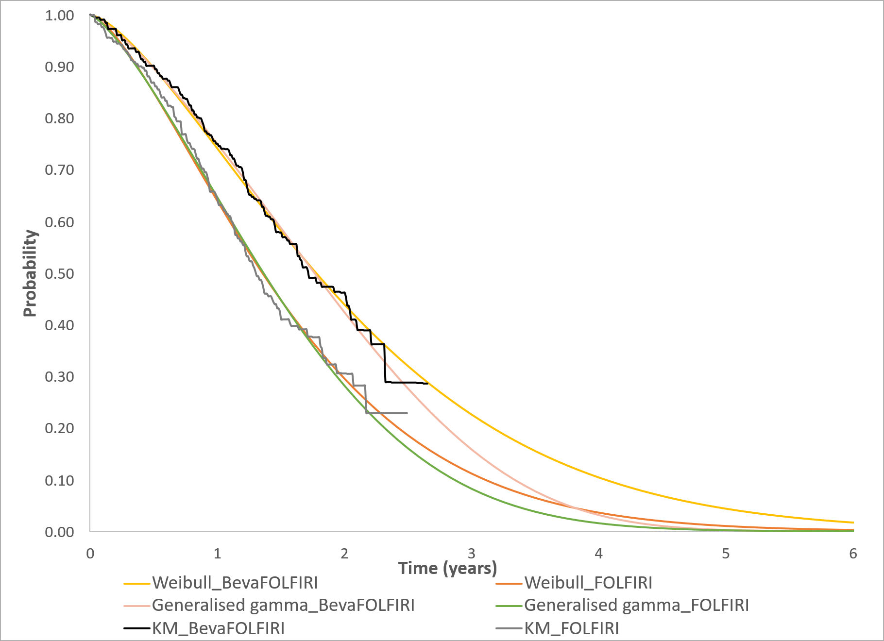
Beva: bevacizumab; FOLFIRI: folinic acid plus fluorouracil plus irinotecan; KM: Kaplan-Meier; OS: overall survival;
Base case – Weibull model (both arms), Scenario analysis – generalised gamma (both arms)

