Additional File
1 eMethod RCT Search Strategy 2
2 eMethod Physician Preference Search Strategy 4
3 eMethod Periodic Transition Probability 5
4 eMethod Probabilistic sensitivity analysis 7
5 eMethod Calculation and Standardization of the Physician Preference Weighting System 8
Table S1 Baseline characteristics of included RCT 9
Table S2 Baseline characteristics of Patients 15
Table S3 Utility Values for Adverse Reactions​ 19
Table S4 Drug Prices 21
Table S5 Costs of Adverse Reactions​ 22
Table S6 Results of Total Costs, QALY and NMB for Sequential Pathways 23
Table S7 Pooled Survival Data: Results from MetaSurv methodology 25
Table S8 Parametric Fitting Effects of Survival Curves Across Treatment Regimens 28
Table S9 Physician Preferences for treatment of NSCLC: Adjusted Preference Weight Version 32
Table S10 Normalized Performance Metrics and Selection Probabilities Under Physician Preferences 33
Table S11 Normalized Performance Metrics and Selection Probabilities Under Patient Preferences 35
Table S12 Incremental Cost-Effectiveness Ratios (ICERs) for Selected Sequential Strategies 37
Table S13 Scenario Analysis on Extrapolation Methods for Key Sequential Strategies 38
Figure S1 Visualization and Evidence Synthesis for Treatment Strategies and Sequential Pathways 39
Figure S2 Modeled Relative Efficacy between Sequential Therapies Based on Survival Data 40
Figure S3 Sequential Pathways Structure 43
Figure S4 Cost-Effectiveness Results 44

1 eMethod RCT Search Strategy
- PubMed Search Strategy
#1 ("Carcinoma, non-small cell lung"[Mesh] OR "carcinomas, non-small cell lung" OR "lung carcinoma, non-small cell" OR "lung carcinomas, non-small cell" OR "non-small cell lung carcinomas" OR "nonsmall cell lung cancer" OR "non-small-cell lung carcinoma" OR "non small cell lung carcinoma" OR "carcinoma, non-small cell lung" OR "non-small cell lung cancer")
#2 ("rearrangement" OR "anaplastic lymphoma kinase" OR "ALK-mutant rearrangement patients" OR "patients with ALK mutations" OR "NPM-ALK" OR "ALK Kinase" OR "CD246 Antigen")
#3 (randomized controlled trial[pt] OR controlled clinical trial[pt] OR randomized[tiab] OR placebo[tiab] OR clinical trials as topic[mesh:noexp] OR randomly[tiab] OR trial[ti])
#4 (animals[mh] NOT humans[mh])
#5 #1 AND #2 AND #3
#6 #5 NOT #4

- Embase
#1 'Anaplastic Lymphoma Kinase':ti,ab,kw,de,tn OR 'ALK Tyrosine Kinase Receptor':ti,ab,kw,de,tn OR 'Anaplastic Lymphoma Receptor Tyrosine Kinase':ti,ab,kw,de,tn OR 'Nucleophosmin-Anaplastic Lymphoma Kinase':ti,ab,kw,de,tn OR 'Nucleophosmin Anaplastic Lymphoma Kinase':ti,ab,kw,de,tn OR 'ALK Kinase':ti,ab,kw,de,tn OR 'CD246 Antigen':ti,ab,kw,de,tn
#2 'Carcinoma, Non-Small-Cell Lung':ti,ab,kw,de,tn OR 'Carcinoma, Non Small Cell Lung':ti,ab,kw,de,tn OR 'Carcinomas, Non-Small-Cell Lung':ti,ab,kw,de,tn OR 'Lung Carcinoma, Non-Small-Cell':ti,ab,kw,de,tn OR 'Lung Carcinomas, Non-Small-Cell':ti,ab,kw,de,tn OR 'Non-Small-Cell Lung Carcinomas':ti,ab,kw,de,tn OR 'Non-Small-Cell Lung Carcinoma':ti,ab,kw,de,tn OR 'Non Small Cell Lung Carcinoma':ti,ab,kw,de,tn OR 'Carcinoma, Non-Small Cell Lung': ti,ab,kw,de,tn OR 'Non-Small Cell Lung Carcinoma':ti,ab,kw,de,tn OR 'Non-Small Cell Lung Cancer':ti,ab,kw,de,tn OR 'Nonsmall Cell Lung Cancer':ti,ab,kw,de,tn
#3 'Randomized Controlled Trial':ti,ab,kw,de,tn OR 'Clinical Trials, Randomized':ti,ab,kw,de,tn OR 'Trials, Randomized Clinical':ti,ab,kw,de,tn OR ' Controlled Clinical Trials, Randomized':ti,ab,kw,de,tn
#4 #1 AND #2 AND #3
- The Cochrane Central Register of Controlled Trials (CENTRAL)
#1 (Anaplastic Lymphoma Kinase or ALK Tyrosine Kinase Receptor or Anaplastic Lymphoma Receptor Tyrosine Kinase or Nucleophosmin-Anaplastic Lymphoma Kinase or Nucleophosmin Anaplastic Lymphoma Kinase or ALK Kinase or CD246 Antigen)

#2 (Carcinoma, Non-Small-Cell Lung or Carcinoma, Non Small Cell Lung or Carcinoma, Non Small Cell Lung or Lung Carcinomas, Non-Small-Cell or Non-Small-Cell Lung Carcinomas or Non-Small-Cell Lung Carcinoma or Non Small Cell Lung Carcinoma or Carcinoma, Non-Small Cell Lung or Non-Small Cell Lung Carcinoma or Carcinoma, Non-Small Cell Lung or Non-Small Cell Lung Carcinoma or Non-Small Cell Lung Cancer or Nonsmall Cell Lung Cancer):ti,ab,kw

#3 (Randomized Controlled Trial or Clinical Trials, Randomized or Trials, Randomized Clinical or Controlled Clinical Trials, Randomized):ti,ab,kw *(Randomized controlled trials were defaulted in CENTRAL of The Cochrane Library Central Register)

2 eMethod Physician Preference Search Strategy
（1）PubMed Search Strategy
#1 physician*[ti] OR doctor[ti] OR hospitalist*[ti] OR oncologist*[ti] OR clinician*[ti] OR mediciner*[ti] OR provider*[ti]
#2 neoplasm*[mesh] OR cancer*[ti] OR tumor*[ti] OR oncology[ti] OR mesothelioma[ti] OR lymphoma[ti] OR leukemia[ti] OR melanoma[ti] OR malignan*[ti]
#3 choice*[ti] OR preference*[ti] OR attitude*[ti]
#4 #1 AND #2 AND #3

（2）Embase
#1 physician*.ti. OR doctor.ti. OR hospitalist*.ti. OR oncologist*.ti. OR clinician*.ti. OR mediciner*.ti. OR provider*.ti.
#2 exp neoplasm/ OR cancer.ti. OR tumor.ti. OR oncology.ti. OR mesothelioma.ti. OR lymphoma.ti. OR leukemia.ti. OR melanoma.ti. OR malignan*.ti.
#3 choice*.ti. OR preference*.ti. OR attitude*.ti.
#4 #1 AND #2 AND #3

- Inclusion Criteria:​​
The study subjects are physicians, or both physicians and patients.
The study focuses on measuring physicians’ preferences in cancer treatment, rather than cancer screening or diagnosis.
- ​​Exclusion Criteria:​​
Literature not published in Chinese or English.
Duplicate publications.
Reviews and conference abstracts.
Literature for which the full text is unavailable.

3 eMethod Periodic Transition Probability
We adapted the core principles of partitioned survival modeling to calculate cumulative PFS and mortality rates at each time point. These estimates were then used to derive the periodic transition probabilities for the microsimulation. For both first- and second-line treatments, a competing risks model was applied to estimate cycle-specific transition probabilities for disease progression and death. These probabilities were calculated as follows:
- First-line Treatment Phase (PFS State in the Model)​
·​Probability of remaining in PFS at cycle T (PFS to PFS transition):​
$$P_{aT}=\frac{S_{aT}}{S_{aT-1}}$$
Where $S_{aT}$is the cumulative progression-free survival probability derived from the first-line PFS survival curve.
·​​​Probability of transitioning from PFS to first PD at cycle T (PFS to PD transition):​
$$P_{bT}=1-\frac{S_{aT}}{S_{aT-1}}$$
·Probability of transitioning from PFS to Death at cycle T (PFS to Death transition):​
$$P_{cT}=\frac{ND_{T}}{ND_{T-1}}$$
In this context, $ND_{T}$ represents the natural mortality rate for a specific age and gender at period T, while $ND_{T-1}$ indicates the natural mortality rate for the same age and gender at period T-1. The period natural mortality rate is derived from the annual natural mortality rate, and it is assumed that the natural mortality rate changes exponentially, calculated as follows:
$$N_{T}=1-\exp\left(-Y_{T}×\left(T/365.25\right)\right)$$
The annual all-cause mortality rate for patients in year T is denoted as $Y_{T}$.
- First-line Post-Treatment Phase (First PD and Terminal PD)​
·Probability of remaining in First PD at cycle T (First PD to First PD transition):​​
$$P_{cT}=S_{bT}/S_{bT-1}$$
Where $S_{bT}$ is the cumulative progression-free survival probability derived from the second-line PFS curve.
·Probability of transitioning from First PD to Second PD at cycle T (First PD to Second PD transition):​
$$P_{dT}=1-S_{bT}/S_{bT-1}$$
·Probability of transitioning from First or Second PD to Death at cycle T (PD to Death transition):​
$$P_{eT}=1-S_{cT}/S_{cT-1}$$
Where $S_{cT}$ is the cumulative overall survival probability derived from the second-line overall survival (OS) curve.
Microsimulation was implemented with time-resetting to accommodate time-varying transition probabilities. The occurrence of each event was determined via a random process (first-order uncertainty), in which the event probability was compared against a value drawn from a uniform distribution $X∼U[0,1]$ to determine whether the event would occur in a given cycle[1]. Patients began in the first-line PFS state and could experience one of two mutually exclusive risk events: disease progression or death, with death assigned higher priority. Similarly, after the first disease progression, patients also face competing risks of further progression and death. Once surviving patients exit the PFS state, they will enter the first cycle of second-line treatment. In Microsoft Excel, the "COUNTIF" function was used to calculate cumulative time in each health state, and the "Lookup" function retrieved cycle-specific transition probabilities for state transitions.

4 eMethod Probabilistic sensitivity analysis
To assess the impact of parameter uncertainty on the model outcomes, a probabilistic sensitivity analysis (PSA) was conducted. Theoretical probability distributions were assigned to key parameters, and Monte Carlo simulation was used to iteratively sample parameter values. The model was run 10,000 times to reflect the joint uncertainty across all parameters. The Gamma distribution was selected for cost, the Beta distribution for probability, proportion, and utilities. All the parameters were adjusted within the reported 95% confidence intervals or assuming reasonable ranges of the base-case values.
Results were presented using cost-effectiveness acceptability curves (CEACs), which show the probability of each treatment strategy being cost-effective across a range of willingness-to-pay thresholds.

5 eMethod Calculation and Standardization of the Physician Preference Weighting System
To construct the integrated decision model incorporating both physician and patient preferences, we required a unified weighting system that includes "treatment cost" and ensures the sum of the relative importance across all attributes equals 100%.
In the multicenter discrete choice experiment (DCE) by Sun Hui et al. (2020), "treatment cost" was modeled as a continuous variable (regression coefficient = -0.039), and the relative importance of attributes was not presented as a percentage-based weighting system inclusive of cost. To generate standardized weights applicable for the physician-patient comparison in our study, we recalculated the weights based on the original regression model results using a "Max-Min Coefficient Range" approach. The specific steps were as follows:
Step 1: Determining the Coefficient Range for the Cost Attribute
To reasonably quantify the preference span for cost, we adopted the clinical cost evaluation interval predefined in the original DCE design by Sun Hui et al. (i.e., 10,000 to 50,000 RMB per month). By multiplying this cost range (40 units of 1,000 RMB) by the absolute value of the continuous cost coefficient from the original model (|-0.039| per 1,000 RMB), we derived the maximum coefficient range for the cost attribute in our context, which equaled 1.56 (i.e., 40 × |-0.039|).
Step 2: Re-scaling the Weighting System
We calculated the maximum coefficient differences for all categorical attributes from the original study (e.g., the coefficient range for progression-free survival [PFS] is the difference between its highest and lowest coefficients). The coefficient ranges of all categorical attributes were summed and combined with the newly derived cost coefficient range (1.56) to yield an augmented "total coefficient range," which served as the new denominator for the weight calculations.
Step 3: Calculating the Standardized Relative Importance
By dividing the individual coefficient range of each attribute by the new total coefficient range, we obtained the standardized relative importance weight (as a percentage) for each attribute. Crucially, this process reasonably incorporated the cost attribute while objectively preserving the proportional relative importance among the original categorical attributes. The original coefficients, coefficient ranges, and final calculated weights are detailed in Table S9.

Table S1 Baseline characteristics of included RCT
Trial information | Intervention | Total patients | Region | HR for OS (95% CI) | HR for PFS (95% CI) | ORR (95% CI, %) | Grade 3+ AE rate (%) | Median  follow-up  (months)
ALTA[2] | Brigatinib(90 mg once daily) VS Brigatinib(180 mg once daily) | 112 VS 110 | Global | NA | NA | 51 G2:G62(41-61) VS 56 (47-66) | NA | 19.6(range: 0.1-35.2) VS 24.3(range: 0.1-39.2)
ASCEND-2[3] | Ceritinib | 140 | Global | NA | NA | 39(31-47) | 71.4 | 11.3(range: 0.1-19.4)
ASCEND-3[4] | Ceritinib | 124 | Global | NA | NA | 64 (55-72) | 87.9 | 52.1(range: 48.4-60.1)
ASCEND-6[5] | Ceritinib | 103 | Asia | NA | NA | 32.0(23.2-42.0) | 65 | 11.6(range: 4.8-23.0)
ASCEND-9[6] | Ceritinib | 20 | Asia | NA | NA | 25 (9-49) | 70 | 11.6(range: 4.8-23.0)
INTELLECT[7] | Iruplinalkib | 146 | Asia | NA | NA | 70 (62-77) | 30.8 | 18.2(95% CI 16.8-18.8)
J-ALTA[8] | Brigatinib | 47 | Asia | NA | NA | 34 (21-49) | 64 | 12.4(range: 1.5-20.0)
NCT03909971[9] | Lorlatinib | 67 VS 42 | Asia | NA | NA | 70 (58-81) VS 48(32-64) | 59.7 VS 63.2 | 11.0(95% CI 9.7-11.1) VS 9.7(95% CI 8.2-12.4)
Kim2017[10] | Brigatinib (90 mg once daily) VS Brigatinib(180 mg once daily) | 112 VS 110 | Global | NA | NA | 45 (34-56) VS 54 (43-65) | NA | 7.8(range: 0.1-16.7) VS 8.3(range :0.1-20.2)
Yang2017[11] | Ensartinib | 156 | Asia | NA | NA | 52 (43-60) | 26 | 9.8(IQR 4.2-14)
NCT01970865[12] | Lorlatinib | 28（EXP3B） | Global | NA | NA | 32 (16-52) | 5.5 | 7∙0 (IQR 5·6–8·3)
NCT01970865[12] | Lorlatinib | 59（EXP2-3A） | Global | NA | NA | 70 (56-81) | 5.5 | 6∙9 (IQR 4·2–7∙0)
NCT01970865[12] | Lorlatinib | 111（EXP4-5） | Global | NA | NA | 39 (30-49) | 5.5 | 7∙2 (IQR 5·6–9·8)
AF-001JP[13] | Low-dose alectinib (300 mg twice daily) | 46 | Asia | NA | NA | 93.5（82-99） | 27.6 | 36
SAI-HONG[14] | Alectinib (600 mg twice daily) | 138 | Global | NA | NA | 50（41-59） | NA | 30(range: 2-53)
ROFILE- 1014[15] | Crizotinib VS Pemetrexed + Cisplatin/Carboplatin | 172 VS 171 | Global | 0.76（0.55-1.05） | 0.45 (0.35-0.60)# | 74 (67-81) VS 45 (37-53) | 50.3 VS 53.3 | 45.7(95% CI 42.7-48.8) VS 45.5(95% CI 43.4-49.1)
CROWN[16] | Lorlatinib VS Crizotinib | 149 VS 147 | Global | 0.72（0.41-1.25） | 0.27 (0.18-0.39)# | 77 (70-84) VS 59 (50-67) | 49.7 VS 38.8 | 36.7(IQR 31.3-41.9) VS 29.3(IQR 10.8-35)
 |  |  |  |  | 0.19 (0.13-0.27)* | 77 (70-84) VS 59 (50-67) | 49.7 VS 38.8 | 36.7(IQR 31.3-41.9) VS 29.3(IQR 10.8-35)
ALEX[17] | Alectinib (600 mg twice daily) VS Crizotinib | 152 VS 151 | Global | 0.67 (0.46-0.98) | 0.67 (0.46-0.98)# | 83 (76-89) VS 76 (68-82) | 52 VS 56.3 | 27.8(range: 0.5-38.7) VS 22.8(range: 0.3-36.7)
 |  |  |  |  | 0.43 (0.32-0.58)* | 83 (76-89) VS 76 (68-82) | 52 VS 56.3 | 27.8(range: 0.5-38.7) VS 22.8(range: 0.3-36.7)
eXalt3[18] | Ensartinib VS Crizotinib | 143 VS 147 | Global | 0.91 (0.54-1.54) | 0.50 (0.36-0.71)# | 74 (66-81) VS 67 (58-74) | 49.7 VS 39.7 | 23.8(range: 0-44) VS 20.2(range: 0-38)
ASCEND-4[19] | Ceritinib VS Pemetrexed + Cisplatin/Carboplatin | 189 VS 187 | Global | 0.73 (0.50-1.08) | 0.55 (0.42-0.73)# | 73 (66-79) VS 27 (21-34) | 78 VS 62 | 19.4
 |  |  |  |  | 0.49 (0.37-0.64)* | 73 (66-79) VS 27 (21-34) | 78 VS 62 | 19.4
PROFILE 1029[20] | Crizotinib VS Pemetrexed + Cisplatin/Carboplatin | 104 VS 103 | Asia | 0.90 (0.56–1.44) | 0.40 (0.29-0.57)# | 88 (80-93) VS 46 (36-56) | NA | 22.5(95% CI 20.5-23.3) VS 21.6(95% CI 20.7-23.0)
J-ALEX[21] | Low-dose alectinib (300 mg twice daily) VS Crizotinib | 103 VS 104 | Asia | 1.03 (0.67-1.58) | 0.34 (0.17-0.71)# | 92 (86-98) VS 79 (71-87) | 26 VS 52 | 68.6(range: 6-81) VS 68(range: 2-79)
 |  |  |  |  | 0.34 (0.21 -0.54)* | 92 (86-98) VS 79 (71-87) | 26 VS 52 | 68.6(range: 6-81) VS 68(range: 2-79)
ALESIA[22] | Alectinib (600 mg twice daily) VS Crizotinib | 125 VS 62 | Asia | 0.60 (0.37–0.99) | 0.37 (0.22-0.61)# | 91 VS 77 | 48 VS 54.8 | 16.2(IQR 13.7-17.6) VS 15(IQR12.5-17.3)
 |  |  |  |  | 0.33 (0.23-0.49)* | 91 VS 77 | 48 VS 54.8 | 16.2(IQR 13.7-17.6) VS 15(IQR12.5-17.3)
TQ-B3139[23] | Envonalkib VS Crizotinib | 131 VS 133 | Asia | NA | 0.47 (0.34-0.64)# | 82 VS 71 | 63 VS 55 | 28.48 (95% CI 26.58–30.32) VS 28.55 (95% CI 26.64–32.13)
ALUR[24] | Alectinib (600 mg twice daily) VS Pemetrexeor Docetaxel | 72 VS 35 | Global | 0.91 (0.49-1.70) | 0.32 (0.17-0.59)# | 27 (26-50) VS 1 (0-15) | 37.7 VS 43.2 | 22.7 VS 22.4
 |  |  |  |  | 0.20 (0.12-0.33)* | 27 (26-50) VS 1 (0-15) | 37.7 VS 43.2 | 22.7 VS 22.4
ASCEND-5[25] | Ceritinib VS Pemetrexed or Docetaxel | 115 VS 116 | Global | 1.0 (0.67–1.49) | 0.49 (0.36-0.67)# | 39 (30-49) VS 7 (3-13) | NA | 16.5 (IQR 11.5-21.4) VS 16.6(IRQ 11.4-21.4)
ALTA-3[26] | Brigatinib VS Alectinib (600 mg twice daily) | 125 VS 123 | Global | NA | 0.97 (0.66-1.42)# | 52 (43-61) VS 61 (52-70) | 44 VS 18 | 15.9(range: 1.1-33.2) VS 16.9(range: 0.2-32.7)
 |  |  |  |  | 1.23 (0.86-1.76)* | 52 (43-61) VS 61 (52-70) | 44 VS 18 | 15.9(range: 1.1-33.2) VS 16.9(range: 0.2-32.7)
Profile 1007[27] | Crizotinib VS Pemetrexed or Docetaxel | 173 VS 174 | Global | 1.02 (0.68–1.54) | 0.49 (0.37-0.64)# | 65 (58−72) VS 20 (14−26) | 56 VS 46 | 12.2 VS 12.1
ALTA-1L[28] | Brigatinib VS Crizotinib | 137 VS 138 | Global | 0.81 (0.53-1.22) | 0.48 (0.35-0.66)# | 71 (62-78) VS 60 (51-68) | 70 VS 56 | 40.4(range: 0-52.4) VS 15.2(range: 0.1-51.7)
 |  |  |  |  | 0.43 (0.31-0.58)* | 71 (62-78) VS 60 (51-68) | 70 VS 56 | 40.4(range: 0-52.4) VS 15.2(range: 0.1-51.7)
# Blind Independent Central Review data; *Investigator-assessed data; AE, Adverse event; HR, hazards ratios; OS, overall survival; PFS, progression-free survival.

Table S2 Baseline characteristics of Patients
Total | N=215
 |  | Number | Proportion
Gender​
 | Male | 143 |  | 66.51%
 | Female | 72 |  | 33.49%
Age
 | MEAN±SD | 58.02
 | 18-30 | 3 |  | 1.40%
 | 31-45 | 37 |  | 17.21%
 | 46-60 | 72 |  | 33.49%
 | 61-75 | 100 |  | 46.51%
 | 76+ | 3 |  | 1.40%
Region
 | Eastern Region | 73 |  | 33.95%
 | Central Region | 67 |  | 31.16%
 | Western Region | 75 |  | 34.88%
Education Level​
 | Primary School and Below | 59 |  | 27.44%
 | Old-Style Private School | 1 |  | 0.47%
 | Junior High School | 45 |  | 20.93%
 | High School / Specialized Secondary School | 48 |  | 22.33%
 | Junior College (Associate Degree) / Bachelor's Degree and Above | 62 |  | 28.84%
Work Status​
 | Full-time Employment | 49 |  | 22.79%
 | Part-time Employment | 16 | 7.44%
 | Retired | 84 | 39.07%
 | Unemployed/Student/Other | 66 | 30.70%
Medical insurance
 | Urban Employee Basic Medical Insurance | 114 | 53.02%
 | Urban and Rural Resident Basic Medical Insurance | 97 | 45.12%
 | Commercial Health Insurance | 8 | 3.72%
 | Other | 10 | 4.65%
 | Uninsured | 2 | 0.93%
Annual Disposable Income​
 | In Debt | 11 | 5.12%
 | ≤ ¥20,000 | 48 | 22.33%
 | ¥20,001 - ¥50,000/year | 67 | 31.16%
 | ¥50,001 - ¥100,000/year | 63 | 29.30%
 | ＞ ¥100,000/year | 26 | 12.09%
Annual Lung Cancer-Related Treatment Expenditure​
 | ¥0 - ¥50,000/year | 93 | 43.26%
 | ¥50,001 - ¥100,000/year | 87 | 40.47%
 | ¥100,001 - ¥200,000/year | 31 | 14.42%
 | ＞ ¥200,000/year | 4 | 1.86%
Source of Lung Cancer Expenditure​
 | Out-of-Pocket Payment | 146 | 67.91%
 | Financial Assistance from Others | 69 | 32.09%
Lung Cancer Stage​
 | Stage IIIB | 91 | 42.33%
 | Stage IV | 124 | 57.67%
Duration of Lung Cancer Illness​
 | ≤ 12 months | 67 | 31.16%
 | 13 - 24 months | 60 | 27.91%
 | 25 - 36 months | 24 | 11.16%
 | 37 - 48 months | 27 | 12.56%
 | ≥ 49 months | 37 | 17.21%
Severe Adverse Reactions​
 | Yes | 98 | 45.58%
 | No | 117 | 54.42%
Previous Medication History
 | Chemotherapy Drugs | 131 | 60.93%
 | Targeted Therapy Drugs | 159 | 73.95%
 | Immunotherapy Drugs | 72 | 33.49%
Number of Previous Medication Types​
 | 1 type | 81 | 37.67%
 | 2 type | 67 | 31.16%
 | 3 type | 38 | 17.67%
 | ≥ 4 types | 29 | 13.49%
Treatment Regimen​
 | Oral | 169 | 78.60%
 | Subcutaneous Injection | 27 | 12.56%
 | Intravenous Injection | 125 | 58.14%
Hospital Level for Prescription​
 | Primary Hospital | 18 | 8.37%
 | Secondary Hospital | 20 | 9.30%
 | Tertiary Hospital | 177 | 82.33%
Outlook on Future Life​
 | Very Negative | 3 | 1.40%
 | Somewhat Negative | 26 | 12.09%
 | Neutral | 65 | 30.23%
 | Somewhat Optimistic | 81 | 37.67%
 | Very Optimistic | 40 | 18.60%

Table S3 Utility Values for Adverse Reactions​
Adverse Reaction | Disutility Value | Variation range | Source
Increased blood creatine kinase | 0.16 | 0.11~0.20 | [29]
Lipase increased | 0.16 | 0.11~0.20 | [30]
Hypertension | 0.08 | 0.06~0.10 | [31]
Amylase increased | 0.16 | 0.11~0.20 | [30]
Pneumonia | 0.05 | 0.04~0.06 | [31]
Alanine aminotransferase increased | 0.16 | 0.13~0.19 | [32]
Blood alkaline phosphatase increased | 0.16 | 0.11~0.20 | [30]
Aspartate aminotransferase increased | 0.16 | 0.13~0.19 | [32]
Gamma-glutamyl transferase increased | 0.16 | 0.11~0.20 | [30]
Fatigue | 0.07 | 0.06~0.09 | [33]
Vomiting | 0.12 | 0.10~0.14 | [29]
Dyspnea | 0.16 | 0.11~0.20 | [30]
Rash | 0.10 | 0.08~0.12 | [29]
Neutrophil count decreased | 0.20 | 0.16~0.24 | [34]
Anemia | 0.07 | 0.06~0.08 | [34]
Diarrhea | 0.16 | 0.11~0.20 | [30]
Decreased appetite | 0.20 | 0.16~0.24 | [35]
Hyponatremia | 0.09 | 0.07~0.11 | [33]
Hypercholesterolemia | 0.16 | 0.11~0.20 | [35]
Hypertriglyceridemia | 0.16 | 0.11~0.20 | [30]
Weight increased | 0.16 | 0.11~0.20 | [30]
Mild adverse reaction | 0.01 | 0.08~0.12 | [32]

Table S4 Drug Prices
Drug (Generic Name) | Originator Price ($) | Specification | Dosage | Source
Crizotinib | 23.80 | 250mg | 500 mg/day | 2024 NRDL Listed Price
Alectinib | 7.89 | 150mg | 1200 mg/day | 2024 NRDL Listed Price
Brigatinib | 47.02 | 180mg | 90 mg/day for the first 7 days; then 180 mg/day | 2024 NRDL Listed Price
Ceritinib | 15.01 | 150mg | 450 mg/day | 2024 NRDL Listed Price
Ensartinib | 19.69 | 100mg | 225 mg/day | 2024 NRDL Listed Price
Lorlatinib | 73.07 | 100mg | 100 mg/day | 2024 NRDL Listed Price
Pemetrexed | 7.63 | 100mg | 500 mg/m² | Lowest Centralized Procurement Price (Past Year)​
Docetaxel | 3.13 | 20mg | 75 mg/m² | Lowest Centralized Procurement Price (Past Year)​
Cisplatin | 1.69 | 20mg | 75 mg/m² | Lowest Centralized Procurement Price (Past Year)​
Iruplinalkib | 20.11 | 60mg | 180 mg/day | 2024 NRDL Listed Price
Envonalkib | 3.80 | 100mg | 1200 mg/day | 2024 NRDL Listed Price

Table S5 Costs of Adverse Reactions​
Adverse Reaction | Mean Cost ($) | Variation range | Source
Increased blood creatine kinase | 362.17 | 271.63–452.71 | [36]
Lipase increased | 44.3 | 35.44~53.16 | [37]
Hypertension | 10 | 8~12 | [28]
Amylase increased | 362.17 | 271.63–452.71 | [36]
Pneumonia | 1229.23 | 983.38~1475.08 | [36]
Alanine aminotransferase increased | 292.59 | 234.07~351.11 | [38]
Blood alkaline phosphatase increased | 362.17 | 271.63–452.71 | [36]
Aspartate aminotransferase increased | 292.59 | 234.07~351.11 | [38]
Gamma-glutamyl transferase increased | 362.17 | 271.63–452.71 | [36]
Fatigue | 99 | 79.2~118.8 | [29]
Vomiting | 54 | 43.2~64.8 | [29]
Dyspnea | 8949.61 | 7159.69~10739.53 | [29]
Rash | 37.9 | 30.4~45.5 | [39]
Neutrophil count decreased | 1094.28 | 875.42~1313.14 | [38]
Anemia | 2150.12 | 1720.10~2580.14 | [38]
Diarrhea | 339.64 | 271.71~407.57 | [38]
Decreased appetite | 825 | 660~990 | [40]
Hyponatremia | 316.83 | 253.46~380.20 | [38]
Hypercholesterolemia | 362.17 | 271.63–452.71 | [36]
Hypertriglyceridemia | 362.17 | 271.63–452.71 | [36]
Weight increased | 362.17 | 271.63–452.71 | [36]

Table S6 Results of Total Costs, QALY and NMB for Sequential Pathways
Sequential path | Total Costs($) | QALY | NMB($)
Ale+Ens+BSC | 155960.3(90941.1～330260.4) | 5.2(0.7～12.9) | -20678.0(-72730.0～5343.8)
Ens+Ale+BSC | 129345.9(77365.5～308761.4) | 4.9(0.6～12.9) | -1868.3(-61756.0～26842.8)
Lor+Ale+BSC | 300331.8(149654.4～335614.0) | 8.4(0.7～12.9) | -81798.8(-131443.3～-9.8)
Env+Ens+BSC | 87251.5(23648.5～277979.7) | 3.6(0.8～11.5) | 6405.5(-2835.8～21202.3)
Cer+Ale+BSC | 92614.7(85784.6～238857.1) | 3.3(0.6～9.7) | -6762.5(-70175.1～13496.5)
Cer+Ens+BSC | 75054.3(18574.1～230338.5) | 3.1(0.6～9.5) | 5594.8(-2964.6～16811.9)
Bri+Ale+BSC | 131027.5(84178.0～313725.0) | 4.9(0.7～12.9) | -3549.9(-65966.9～21879.2)
Bri+Ens+BSC | 115024.6(17972.1～313718.7) | 4.7(0.6～12.9) | 7249.8(-2362.6～21885.5)
Che+Ale+BSC | 155367.2(129451.0～280579.6) | 4.9(1～11.5) | -27889.6(-103435.2～18602.4)
Ale+Bri+BSC | 152450.2(164383.1～324032.2) | 4.8(0.4～14) | -27574.2(-153976.8～40189.4)
Lor+Che+BSC | 276769.1(142297.0～325100.5) | 7.8(0.4～12.9) | -73845.6(-131890.7～10503.7)
Lor+Bri+BSC | 288773.1(149960.5～332828.7) | 8.2(0.7～12.9) | -75443.3(-131749.4～2775.5)
Ens+Bri+BSC | 111561.7(20025.5～309067.4) | 4.6(0.6～12.9) | 8111.1(-4416.0～26536.8)
Ale+Lor+BSC | 154871.1(88648.6～333877.3) | 4.9(0.6～12.9) | -27393.5(-73039.1～1726.9)
Env+Bri+BSC | 85123.7(23233.0～277739.5) | 3.5(0.7～11.5) | 5931.7(-5021.9～21442.5)
Cer+Bri+BSC | 70586.3(18817.9～220174.1) | 2.9(0.5～9.1) | 4859.6(-5810.0～16570.0)
Ens+Lor+BSC | 107341.3(44363.9～309064.1) | 4.2(0.6～12.9) | 1925.2(-28754.4～26540.1)
Ale+Cer+BSC | 140319.8(88759.5～329924.5) | 4.6(0.6～12.9) | -20647.0(-73150.0～5679.7)
Crz+Ale+BSC | 105643.3(87211.4～317224.3) | 3.8(0.6～12.9) | -6783.1(-71601.9～18379.9)
Lor+Cer+BSC | 278108.0(144864.9～331372.7) | 7.8(0.5～12.9) | -75184.5(-131857.0～4231.5)
Env+Lor+BSC | 79174.8(50368.5～215674.1) | 3(0.7～9) | -1127.3(-32157.4～18468.4)
Che+Che+BSC | 25445.8(4826.1～66029.7) | 1.6(0.3～4.6) | 16179.5(2978.6～53643.1)
Crz+Iru+BSC | 99800.4(51135.2～317497.1) | 3.7(0.7～12.9) | -3541.8(-32924.1～18107.1)
Ens+Cer+BSC | 94909.3(12509.8～309175.3) | 4(0.5～12.9) | 9154.0(498.1～26428.9)
Crz+Ens+BSC | 89069.9(17605.6～317218.0) | 3.6(0.5～12.9) | 4587.1(-4597.7～18386.2)
Crz+Bri+BSC | 92497.6(20089.5～317530.1) | 3.7(0.6～12.9) | 3761.0(-4480.0～18074.1)
Cer+Lor+BSC | 67299.5(46616.2～155495.5) | 2.5(0.5～6.5) | -2259.9(-33608.3～13607.4)
Bri+Lor+BSC | 108720.0(45050.2～314027.8) | 4.2(0.6～12.9) | 546.5(-29440.7～21576.4)
Che+Cer+BSC | 92696.3(18022.5～270767.7) | 3.9(0.6～11.6) | 8765.4(-2413.0～31015.9)
Env+Cer+BSC | 65773.5(15110.1～212523.4) | 2.8(0.6～9) | 7070.8(499.4～21619.1)
Crz+Lor+BSC | 119775.1(119931.8～317149.6) | 4(0.6～12.9) | -15711.8(-104322.3～18454.6)
Bri+Cer+BSC | 99704.8(13865.2～314138.7) | 4.1(0.5～12.9) | 6960.1(-857.3～21465.5)
Che+Crz+BSC | 34750.6(13241.5～66530.4) | 1.7(0.5～3.8) | 9476.3(-233.6～32329.8)
Crz+Che+BSC | 64317.6(8999.8～316374.6) | 2.8(0.4～12.9) | 8526.7(1406.5～19229.6)
Crz+Cer+BSC | 72928.2(13190.1～317638.0) | 3(0.5～12.9) | 5119.3(-182.2～17966.2)
Ale, Alectinib; Bri, Brigatinib; Cer, Ceritinib; Che, Chemotherapy; Cri, Crizotinib; Ens, Ensartinib; Env, Envonalkib; Iru, Iruplinalkib; Lor, Lorlatinib; BSC,Best Supportive Care; median OS, median overall survival; NMB, net monetary benefit; QALY, quality-adjusted life-year.

Table S7 Pooled Survival Data: Results from MetaSurv methodology
Treatment |  | Studies |  |  | Patients，N | Median Progression-Free Survival​ (month,95% CI) | 12-month survival rate(%, 95% CI) | 120-month LYs(month) | I2 (%)
First-line
Alectinib |  | ALEX,ALESIA,J-ALEX,AF-001JP |  |  | 427 | 37.42 (20.78-40.7) | 77.5 | 53.85 | 18.4
Brigatinib |  | ALTA-1L |  |  | 137 | 24.0 (18.5-43.2) | 85.9 | 47.13 | NA
Ensartinib |  | eXalt3 |  |  | 121 | 25.8 (21.8-NR) | 73.1 | 51.19 | NA
Lorlatinib |  | CROWN,NCT01970865 |  |  | 179 | NR | 75.7 | 77.97 | 0
Crizotinib |  | PROFILE 1014,PROFILE 1029,ALEX,ALESIA,J-ALEX,ALTA-1L,CROWN,eXalt3,TQ-B3139 |  |  | 1156 | 11.71 (9.97-12.97) | 49.0 | 27.21 | 8.1
Chemotherapy |  | PROFILE 1014,PROFILE 1029,ASCEND 4 |  |  | 358 | 7.22 (5.81-8.63) | 22.3 | 9.81 | 7.7
Ceritinib |  | ASCEND 4,ASCEND 8 |  |  | 387 | 17.99 (12.85-22.58) | 63.0 | 25.33 | 0
Envonalkib |  | TQ-B3139 |  |  | 131 | 24.87 (15.64-30.36) | 65.8 | 32.85 | NA
Second-line (crizotinib resistance)
Alectinib |  | ALUR,ALTA-3L,Sai-Hong 2015 | 333 |  |  | 11.77 (5.63-16.98) | 49.8 | 25.76 | 16.7
Brigatinib |  | NCT01449461,ALTA,ALTA-3L | 569 |  |  | 15.02 (9.57-18.69) | 54.1 | 24.01 | 23.5
Lorlatinib |  | NCT01970865,NCT0390997 | 126 |  |  | NR | 64.8 | 26.07 | 0
Ceritinib |  | ASCEND 2,ASCEND 5,ASCEND 6 | 358 |  |  | 6.68 (4.15-7.83) | 26 | 12 | 28.2
Iruplinalkib |  | INTELLECT | 146 |  |  | 14.5 (11.7-20.0) | 56.9 | 23.66 | NA
Ensartinib |  | NCT03215693 | 156 |  |  | 9.6 (7.4-11.6) | 38.4 | 19.97 | NA
Chemotherapy |  | ALUR,ASCEND 5 | 151 |  |  | 1.4 (1.2-1.6) | 5.7 | 4.88 | 0
Second-line (chemotherapy resistance)
Alectinib |  | AF-001JP | 46 |  |  | NR (33.1-NR) | 83.6 | 64.21 | NA
Ceritinib |  | ASCEND 3 |  | 124 |  | 16.6 (11.0-23.2) | 62.2 | 43.39 | NA
Crizotinib |  | PROFILE 1007 |  | 173 |  | 7.7 | 31.5 | 10.54 | 0
Chemotherapy |  | PROFILE 1007 |  | 174 |  | 3 | 12.1 | 7.98 | 0
Second-line (Alectinib resistance)
Brigatinib | J-ALTA |  |  | 47 |  | 7.3 (3.7-9.3) | 32.9 | 17.63 | NA
Lorlatinib | NCT01970865,NCT0390997 |  |  | 71 |  | 5.93 (2.93-7.91) | 31.9 | 10.79 | 0
Ceritinib | ASCEND 9 |  |  | 20 |  | 3.7 (1.9–5.3) | 12.7 | 5.73 | NA
# resistance to second-generation ALK-TKIs in trials; NR, not reported; NA, not available; LYs, Life-Years

Table S8 Parametric Fitting Effects of Survival Curves Across Treatment Regimens
PFS of first-line
Brigatinib |  | Ensartinib |  | Alectinib |  | Ceritinib |  | Lorlatinib |  | Crizotinib |  | Chemotherapy |  | Envonalkib
Model | AIC | Model | AIC | Model | AIC | Model | AIC | Model | AIC | Model | AIC | Model | AIC | Model | AIC
lnorm | 162.8 | lnorm | 98.3 | RP-normal-1 | 173.0 | RP-hazard-1 | 143.3 | genf | 103.7 | FP2-2 | 197.1 | RP-odds-1 | 146.9 | RP-normal-1 | 80.8
RP-normal-1 | 162.8 | RP-normal-1 | 98.3 | lnorm | 173.0 | RP-hazard-2 | 143.7 | weibull | 115.8 | RP-odds-2 | 200.7 | RP-hazard-1 | 147.3 | FP2-1 | 80.6
gompertz | 164.1 | gompertz | 99.3 | FP2-2 | 173.9 | RP-odds-1 | 144.5 | gamma | 117.1 | RP-hazard-2 | 201.0 | RP-normal-2 | 147.8 | lnorm | 80.8
RP-normal-2 | 164.5 | llogis | 99.6 | FP2-1 | 174.3 | RP-normal-1 | 144.6 | lnorm | 109.6 | FP2-1 | 201.2 | RP-odds-2 | 148.2 | FP2-2 | 80.9
gengamma | 164.5 | RP-odds-2 | 99.6 | llogis | 174.5 | RP-normal-2 | 144.8 | gompertz | 105.8 | RP-normal-2 | 201.4 | RP-normal-1 | 148.6 | gengamma | 81.5
llogis | 164.6 | FP2-2 | 99.7 | RP-odds-1 | 174.5 | RP-odds-2 | 145.2 | llogis | 113.1 | RP-odds-1 | 201.8 | RP-hazard-2 | 150.7 | RP-odds-1 | 81.6
RP-odds-1 | 165.0 | FP2-1 | 99.8 | gompertz | 174.6 | lnorm | 149.0 | gengamma | 105.6 | RP-hazard-1 | 202.4 | genf | 159.6 | RP-hazard-1 | 81.7
RP-hazard-2 | 165.2 | RCS1 | 100.2 | RP-odds-2 | 175.1 | gengamma | 150.0 | exp | 123.0 | RP-normal-1 | 203.1 | RCS1 | 159.7 | FP1-2 | 82.3
FP2-2 | 165.3 | RP-normal-2 | 100.3 | RP-hazard-1 | 175.6 | genf | 152.0 | FP1-1 | 122.2 | genf | 203.2 | gengamma | 160.5 | genf | 82.7
FP2-1 | 165.9 | gengamma | 100.5 | RCS1 | 175.7 | llogis | 154.3 | FP1-2 | 125.0 | gengamma | 204.0 | FP1-2 | 160.8 | RCS1 | 82.8
RP-hazard-1 | 166.0 | RP-odds-1 | 100.6 | gengamma | 175.9 | exp | 154.4 | FP2-1 | 104.2 | lnorm | 211.1 | gamma | 161.2 | RP-normal-2 | 82.8
RP-odds-2 | 166.1 | exp | 100.6 | genf | 176.9 | gamma | 156.2 | FP2-2 | 103.1 | RCS2 | 227.4 | RCS2 | 161.5 | RP-hazard-2 | 82.9
genf | 166.5 | RP-hazard-1 | 100.8 | RCS2 | 177.6 | gompertz | 156.3 | RCS1 | 107.2 | llogis | 229.1 | FP2-1 | 162.1 | RP-odds-2 | 82.9
RCS1 | 167.0 | weibull | 101.6 | RP-hazard-2 | 177.6 | weibull | 156.4 | RCS2 | 109.2 | RCS1 | 272.7 | FP1-1 | 162.7 | llogis | 83.6
weibull | 168.0 | gamma | 102.0 | weibull | 179.5 | FP2-2 | 156.7 | RP-hazard-1 | 105.2 | FP1-2 | 275.6 | llogis | 162.8 | RCS2 | 83.9
RCS2 | 168.9 | RCS2 | 102.2 | gamma | 180.4 | RCS2 | 156.8 | RP-hazard-2 | 103.9 | FP1-1 | 300.6 | FP2-2 | 162.8 | FP1-1 | 84.3
gamma | 169.0 | FP1-1 | 102.2 | exp | 180.5 | FP1-2 | 156.9 | RP-odds-1 | 104.9 | gompertz | 307.7 | weibull | 165.4 | gamma | 85.3
exp | 169.9 | FP1-2 | 102.4 | FP1-1 | 181.8 | FP1-1 | 159.4 | RP-odds-2 | 103.8 | gamma | 309.1 | lnorm | 167.3 | weibull | 86.9
FP1-1 | 171.8 | genf | 102.5 | FP1-2 | 182.4 | FP2-1 | 159.6 | RP-normal-1 | 104.6 | weibull | 317.9 | gompertz | 181.3 | exp | 90.8
FP1-2 | 173.0 | RP-hazard-2 | 103.2 |  |  | RCS1 | 161.2 | RP-normal-2 | 104.3 | exp | 318.3 | exp | 188.4 | gompertz | 91.6
PFS of second-line, crizotinib resistance
Alectinib |  | Brigatinib |  | Ensartinib |  | Chemotherapy |  | Lorlatinib |  | Ceritinib |  | Iruplinalkib
Model | AIC | Model | AIC | Model | AIC | Model | AIC | Model | AIC | Model | AIC | Model | AIC
RP-normal-1 | 129.2 | RP-hazard-1 | 256.0 | gengamma | 100.8 | RCS2 | 64.5 | lnorm | 56.9 | llogis | 136.7 | lnorm | 115.1
weibull | 134.6 | lnorm | 258.8 | RP-normal-2 | 101.1 | RP-normal-1 | 69.0 | RP-normal-1 | 56.9 | RP-odds-2 | 136.7 | RP-normal-1 | 115.1
gamma | 135.3 | gengamma | 260.1 | RP-hazard-1 | 101.3 | RP-odds-1 | 69.7 | FP1-2 | 57.0 | FP2-1 | 139.1 | RP-hazard-1 | 116.6
lnorm | 129.2 | RP-odds-2 | 260.8 | RP-odds-1 | 101.5 | RP-odds-2 | 69.7 | gengamma | 57.4 | FP2-2 | 139.8 | RP-odds-1 | 116.7
gompertz | 131.2 | RP-odds-1 | 261.0 | lnorm | 101.7 | RP-hazard-1 | 70.2 | FP2-2 | 58.5 | RP-odds-1 | 139.9 | llogis | 116.7
llogis | 129.5 | llogis | 261.0 | RP-normal-1 | 101.7 | FP2-2 | 73.8 | RP-normal-2 | 58.6 | RP-normal-1 | 141.5 | RP-odds-2 | 116.7
gengamma | 131.1 | RP-normal-2 | 261.1 | genf | 102.8 | RP-hazard-2 | 73.9 | FP1-1 | 58.7 | genf | 141.8 | gengamma | 117.0
genf | 132.9 | genf | 262.7 | FP2-2 | 104.9 | FP2-1 | 78.5 | llogis | 59.1 | RCS2 | 143.1 | RP-normal-2 | 117.0
FP1-1 | 137.7 | FP2-2 | 264.1 | FP1-2 | 105.6 | llogis | 81.3 | RP-odds-1 | 59.1 | RP-hazard-2 | 143.1 | FP1-2 | 117.7
FP1-2 | 137.8 | RP-normal-1 | 264.3 | RP-hazard-2 | 105.9 | lnorm | 85.5 | RP-odds-2 | 59.1 | lnorm | 143.2 | RP-hazard-2 | 118.1
FP2-1 | 132.0 | RP-hazard-2 | 265.3 | RP-odds-2 | 106.4 | gompertz | 86.3 | FP2-1 | 59.2 | gengamma | 144.3 | gamma | 118.4
FP2-2 | 131.6 | exp | 266.0 | llogis | 106.8 | gengamma | 88.4 | RP-hazard-1 | 59.3 | RCS1 | 147.2 | FP2-2 | 118.8
RCS1 | 133.8 | FP2-1 | 267.0 | FP2-1 | 107.2 | exp | 90.6 | genf | 59.4 | FP1-2 | 148.1 | FP2-1 | 118.9
RCS2 | 135.5 | gompertz | 267.2 | FP1-1 | 109.4 | RP-normal-2 | 91.1 | gamma | 59.6 | RP-normal-2 | 148.5 | genf | 119.0
RP-hazard-1 | 131.3 | gamma | 267.8 | gamma | 109.9 | weibull | 91.5 | exp | 60.1 | RP-hazard-1 | 149.3 | FP1-1 | 119.3
RP-hazard-2 | 133.2 | weibull | 268.2 | RCS2 | 110.7 | gamma | 93.1 | weibull | 60.1 | gamma | 150.9 | RCS2 | 120.3
RP-odds-1 | 129.5 | FP1-2 | 268.6 | weibull | 111.4 | RCS1 | 93.7 | RP-hazard-2 | 60.2 | FP1-1 | 151.7 | weibull | 120.6
RP-odds-2 | 131.0 | FP1-1 | 271.9 | exp | 113.1 | FP1-2 | 102.0 | gompertz | 61.6 | weibull | 153.6 | RCS1 | 124.3
exp | 133.8 | RCS2 | 273.4 | gompertz | 114.4 | FP1-1 | 102.7 | RCS1 | 61.9 | exp | 154.2 | gompertz | 127.7
RP-normal-2 | 131.2 | RCS1 | 274.6 | RCS1 | 117.0 |  |  | RCS2 | 63.9 | gompertz | 155.8 | exp | 130.7
PFS of second-line, chemotherapy resistance |  |  |  |  |  |  |  | PFS of second-line, alectinib resistance
Alectinib |  | Crizotinib |  | Chemotherapy |  | Ceritinib |  | Lorlatinib |  | Ceritinib |  | Brigatinib
Model | AIC | Model | AIC | Model | AIC | Model | AIC | Model | AIC | Model | AIC | Model | AIC
exp* | 77.7 | FP1-2 | 85.4 | gengamma | 69.2 | gengamma | 157.2 | RP-normal-1 | 56.1 | FP1-2 | 28.1 | gengamma | 54.7
lnorm | 77.9 | FP1-1 | 87.3 | FP2-2 | 71.0 | RP-normal-1 | 157.6 | lnorm | 56.1 | lnorm | 28.5 | lnorm | 55.0
RP-normal-1 | 77.9 | lnorm | 87.6 | genf | 71.2 | RP-odds-1 | 159.0 | llogis | 57.8 | RP-normal-1 | 28.5 | RP-normal-1 | 55.0
FP1-2 | 78.3 | RP-normal-1 | 87.6 | lnorm | 72.1 | RP-hazard-2 | 159.2 | RP-odds-1 | 57.8 | FP2-2 | 28.7 | RP-normal-2 | 55.1
RP-odds-1 | 78.6 | FP2-2 | 88.3 | FP2-1 | 73.0 | genf | 159.2 | gengamma | 58.0 | FP2-1 | 29.1 | FP2-2 | 55.4
llogis | 78.6 | RP-odds-1 | 88.7 | llogis | 74.3 | RP-normal-2 | 161.8 | RP-hazard-1 | 58.0 | RP-odds-1 | 29.2 | FP2-1 | 55.7
FP1-1 | 78.8 | llogis | 88.7 | RCS2 | 77.8 | RP-odds-2 | 162.5 | FP1-2 | 58.2 | llogis | 29.2 | RP-odds-2 | 55.8
gamma | 79.0 | FP2-1 | 89.0 | RCS1 | 81.1 | RP-hazard-1 | 162.6 | FP2-2 | 58.2 | FP1-1 | 29.4 | RP-odds-1 | 56.3
weibull | 79.2 | RP-normal-2 | 89.1 | gompertz | 81.3 | lnorm | 164.2 | RP-odds-2 | 58.2 | gengamma | 29.7 | llogis | 56.3
RP-hazard-1 | 79.2 | gengamma | 89.3 | exp | 82.4 | FP2-2 | 164.7 | RP-hazard-2 | 58.6 | RP-normal-2 | 29.8 | RP-hazard-1 | 56.3
gompertz | 79.7 | gamma | 89.6 | FP1-2 | 84.6 | FP2-1 | 168.0 | exp | 58.8 | RP-odds-2 | 30.4 | genf | 57.1
gengamma | 79.7 | RP-hazard-1 | 89.9 | RP-hazard-2 | 85.1 | llogis | 169.4 | FP2-1 | 59.1 | RP-hazard-1 | 30.4 | exp | 57.3
RP-normal-2 | 79.7 | RP-odds-2 | 90.8 | weibull | 85.9 | RCS2 | 172.3 | FP1-1 | 59.5 | gamma | 30.9 | RP-hazard-2 | 57.8
FP2-2 | 80.0 | weibull | 91.3 | FP1-1 | 86.4 | gompertz | 173.2 | gamma | 59.6 | genf | 31.7 | gompertz | 58.2
RP-odds-2 | 80.0 | genf | 91.4 | gamma | 86.5 | FP1-2 | 173.9 | genf | 60.0 | weibull | 32.1 | RCS1 | 58.3
FP2-1 | 80.1 | RP-hazard-2 | 91.7 | RP-odds-2 | 86.9 | exp | 174.0 | weibull | 60.1 | RP-hazard-2 | 32.1 | FP1-2 | 59.3
RP-hazard-2 | 80.2 | RCS1 | 94.3 | RP-normal-2 | 87.2 | weibull | 175.9 | gompertz | 60.8 | RCS1 | 32.3 | gamma | 59.4
RCS1 | 81.5 | RCS2 | 94.4 | RP-normal-1 | 111.7 | gamma | 176.1 | RCS1 | 62.4 | RCS2 | 32.3 | weibull | 59.5
genf | 81.7 | gompertz | 96.6 | RP-odds-1 | 119.2 | RCS1 | 176.5 | RCS2 | 62.9 | exp | 32.6 | RCS2 | 60.1
RCS2 | 83.3 | exp | 98.6 | RP-hazard-1 | 120.0 | FP1-1 | 176.8 |  |  | gompertz | 34.0 | FP1-1 | 60.2
OS of third-line, BSC
RP-hazard-2 | 65.3
RP-odds-2 | 65.4
RP-normal-1 | 65.4
exp | 66.8
lnorm | 68.1
RCS1 | 68.2
FP1-2 | 68.4
FP1-1 | 68.5
weibull | 68.6
gamma | 68.6
gompertz | 68.7
llogis | 69.3
gengamma | 70.0
FP2-2 | 70.0
RCS2 | 70.2
FP2-1 | 70.3
genf | 72.0
RP-normal-2 | 78.7
* Discrepancies in Extrapolated Survival Curves; NR, not reported; NA, not available; OS, overall survival; PFS, progression-free survival

Table S9 Physician Preferences for treatment of NSCLC: Adjusted Preference Weight Version
Attributes | Levels | Coefficient | P | MAX-MIN | Adjusted Relative Importance
Progression-free survival (PFS) | 11 months | 1.283 | <0.001 | 2.505 | 0.390
Progression-free survival (PFS) | 8 months | -0.061 | 0.175
Progression-free survival (PFS) | 5 months | -1.222 | <0.001
Disease control rate (DCR) | 90% | 0.371 | <0.001 | 0.733 | 0.114
Disease control rate (DCR) | 75% | -0.01 | 0.829
Disease control rate (DCR) | 60% | -0.362 | <0.001
Risk of mild adverse events | 50% | -0.336 | <0.001 | 0.772 | 0.120
Risk of mild adverse events | 25% | -0.1 | 0.463
Risk of mild adverse events | 10% | 0.436 | <0.001
Risk of severe adverse events | 8% | -0.131 | 0.141 | 0.639 | 0.099
Risk of severe adverse events | 5% | -0.378 | 0.005
Risk of severe adverse events | 2% | 0.508 | <0.001
Route  of administration | Infusion | -0.109 | <0.001 | 0.218 | 0.034
Route  of administration | Oral | 0.109 | <0.001
Treatment cost* | 50 | -0.56 | <0.001 | 1.56 | 0.243
Treatment cost* | 10 | 1
*The unit of cost is expressed in thousands (e.g., 10 represents ￥10,000 )

Table S10 Normalized Performance Metrics and Selection Probabilities Under Physician Preferences
Treatment Line | Sequence | PFS | X1 | AE3 | X2 | AE1 | X3 | DCR | X4 | MODE | X5 | COST | X6 | Composite  Score | Soft  Probability | Sequence Probability | Rank
First-line | Crz | 27.21 | 0.255 | 0.55 | 0.703 | 0.87 | 0.899 | 0.87 | 0.615 | 1 | 1.000 | 280154 | 0.778 | 0.57 | 13.33% | / | /
First-line | Ale | 53.9 | 0.646 | 0.42 | 1.000 | 0.98 | 0.131 | 0.97 | 1.000 | 1 | 1.000 | 735376 | 0.406 | 0.61 | 13.90% | / | /
First-line | Bri | 47.13 | 0.548 | 0.73 | 0.291 | 0.99 | 0.071 | 0.73 | 0.000 | 1 | 1.000 | 413523 | 0.669 | 0.45 | 11.82% | / | /
First-line | Cer | 25.33 | 0.228 | 0.86 | 0.000 | 0.86 | 1.000 | 0.91 | 0.743 | 1 | 1.000 | 246664 | 0.805 | 0.51 | 12.56% | / | /
First-line | Ens | 51.19 | 0.607 | 0.71 | 0.337 | 0.99 | 0.100 | 0.93 | 0.849 | 1 | 1.000 | 511588 | 0.589 | 0.55 | 13.02% | / | /
First-line | Env | 32.85 | 0.338 | 0.63 | 0.519 | 0.99 | 0.054 | 0.92 | 0.790 | 1 | 1.000 | 324032 | 0.742 | 0.49 | 12.29% | / | /
First-line | Che | 9.81 | 0.000 | 0.58 | 0.637 | 0.98 | 0.132 | 0.74 | 0.034 | 0 | 0.000 | 8133 | 1.000 | 0.33 | 10.52% | / | /
First-line | Lor | 77.97 | 1.000 | 0.76 | 0.223 | 1.00 | 0.000 | 0.88 | 0.637 | 1 | 1.000 | 1232238 | 0.000 | 0.51 | 12.56% | / | /
Second-line | Crz-Ale | 25.8 | 0.985 | 0.2527 | 1.000 | 0.89 | 0.547 | 0.82 | 0.764 | 1 | 1.000 | 351779 | 0.147 | 0.71 | 16.02% | 2.136% | 29
Second-line | Crz-Bri | 24.0 | 0.903 | 0.44 | 0.546 | 0.92 | 0.387 | 0.73 | 0.620 | 1 | 1.000 | 244182 | 0.409 | 0.66 | 15.19% | 2.024% | 32
Second-line | Crz-Cer | 12.0 | 0.336 | 0.6654 | 0.000 | 0.99 | 0.000 | 0.77 | 0.686 | 1 | 1.000 | 116856 | 0.719 | 0.41 | 11.85% | 1.580% | 35
Second-line | Crz-Iru | 23.7 | 0.886 | 0.308 | 0.866 | 0.93 | 0.318 | 0.97 | 1.000 | 1 | 1.000 | 308763 | 0.252 | 0.68 | 15.51% | 2.067% | 31
Second-line | Crz-Ens | 20.0 | 0.712 | 0.26 | 0.982 | 0.91 | 0.445 | 0.93 | 0.942 | 1 | 1.000 | 199578 | 0.518 | 0.70 | 15.81% | 2.108% | 30
Second-line | Crz-Che | 4.9 | 0.000 | 0.3767 | 0.700 | 0.81 | 1.000 | 0.34 | 0.000 | 0 | 0.000 | 1724 | 1.000 | 0.44 | 12.27% | 1.636% | 34
Second-line | Crz-Lor | 26.1 | 1.000 | 0.597 | 0.166 | 0.98 | 0.030 | 0.84 | 0.803 | 1 | 1.000 | 412010 | 0.000 | 0.53 | 13.34% | 1.778% | 33
Second-line | Ale-Bri | 17.63 | 0.836 | 0.64 | 0.136 | 1.00 | 0.000 | 0.79 | 0.504 | 1 | 1.000 | 179297 | 0.141 | 0.46 | 24.90% | 3.460% | 9
Second-line | Ale-Lor | 10.79 | 0.355 | 0.63 | 0.155 | 0.98 | 0.200 | 0.65 | 0.000 | 1 | 1.000 | 170525 | 0.202 | 0.26 | 20.46% | 2.843% | 16
Second-line | Ale-Cer | 5.73 | 0.000 | 0.70 | 0.000 | 1.00 | 0.000 | 0.70 | 0.184 | 1 | 1.000 | 55799 | 1.000 | 0.30 | 21.12% | 2.936% | 15
Second-line | Ale-Ens | 20.0 | 1.000 | 0.26 | 1.000 | 0.91 | 1.000 | 0.93 | 1.000 | 1 | 1.000 | 199578 | 0.000 | 0.76 | 33.52% | 4.659% | 1
Second-line | Bri-Lor | 10.79 | 0.253 | 0.63 | 0.152 | 0.98 | 0.167 | 0.65 | 0.000 | 1 | 1.000 | 170525 | 0.612 | 0.32 | 19.99% | 2.363% | 25
Second-line | Bri-Ale | 25.8 | 1.000 | 0.2527 | 1.000 | 0.89 | 1.000 | 0.82 | 0.607 | 1 | 1.000 | 351779 | 0.000 | 0.72 | 29.80% | 3.524% | 8
Second-line | Bri-Cer | 5.73 | 0.000 | 0.70 | 0.000 | 1.00 | 0.000 | 0.70 | 0.184 | 1 | 1.000 | 55799 | 1.000 | 0.30 | 19.52% | 2.309% | 27
Second-line | Bri-Ens | 20.0 | 0.711 | 0.26 | 0.984 | 0.91 | 0.835 | 0.93 | 1.000 | 1 | 1.000 | 199578 | 0.514 | 0.75 | 30.69% | 3.629% | 6
Second-line | Cer-Lor | 10.79 | 0.000 | 0.63 | 0.021 | 0.98 | 0.167 | 0.65 | 0.000 | 1 | 1.000 | 170525 | 1.000 | 0.30 | 18.64% | 2.341% | 26
Second-line | Cer-Ale | 25.76 | 1.000 | 0.25 | 1.000 | 0.89 | 1.000 | 0.82 | 0.607 | 1 | 1.000 | 351779 | 0.000 | 0.72 | 28.34% | 3.559% | 7
Second-line | Cer-Bri | 17.63 | 0.457 | 0.64 | 0.000 | 1.00 | 0.000 | 0.79 | 0.504 | 1 | 1.000 | 179297 | 0.952 | 0.49 | 22.63% | 2.842% | 17
Second-line | Cer-Ens | 20.0 | 0.613 | 0.26 | 0.981 | 0.91 | 0.835 | 0.93 | 1.000 | 1 | 1.000 | 199578 | 0.840 | 0.79 | 30.39% | 3.817% | 5
Second-line | Ens-Lor | 10.79 | 0.253 | 0.63 | 0.152 | 0.98 | 0.167 | 0.65 | 0.000 | 1 | 1.000 | 170525 | 0.612 | 0.32 | 21.08% | 2.746% | 18
Second-line | Ens-Ale | 25.76 | 1.000 | 0.25 | 1.000 | 0.89 | 1.000 | 0.82 | 1.000 | 1 | 1.000 | 351779 | 0.000 | 0.76 | 32.68% | 4.256% | 2
Second-line | Ens-Bri | 17.63 | 0.594 | 0.64 | 0.134 | 1.00 | 0.000 | 0.79 | 0.829 | 1 | 1.000 | 179297 | 0.583 | 0.50 | 25.39% | 3.307% | 11
Second-line | Ens-Cer | 5.73 | 0.000 | 0.70 | 0.000 | 1.00 | 0.000 | 0.70 | 0.304 | 1 | 1.000 | 55799 | 1.000 | 0.31 | 20.84% | 2.714% | 19
Second-line | Env-Lor | 10.79 | 0.355 | 0.63 | 0.155 | 0.98 | 0.200 | 0.65 | 0.000 | 1 | 1.000 | 170525 | 0.202 | 0.26 | 20.46% | 2.513% | 23
Second-line | Env-Bri | 17.63 | 0.836 | 0.64 | 0.136 | 1.00 | 0.000 | 0.79 | 0.504 | 1 | 1.000 | 179297 | 0.141 | 0.46 | 24.90% | 3.059% | 13
Second-line | Env-Cer | 5.73 | 0.000 | 0.70 | 0.000 | 1.00 | 0.000 | 0.70 | 0.184 | 1 | 1.000 | 55799 | 1.000 | 0.30 | 21.12% | 2.595% | 20
Second-line | Env-Ens | 19.97 | 1.000 | 0.26 | 1.000 | 0.91 | 1.000 | 0.93 | 1.000 | 1 | 1.000 | 199578 | 0.000 | 0.76 | 33.52% | 4.118% | 3
Second-line | Che-Crz | 10.54 | 0.046 | 0.56 | 0.529 | 1.00 | 0.000 | 0.84 | 0.000 | 1 | 1.000 | 108520 | 0.879 | 0.33 | 20.86% | 2.195% | 28
Second-line | Che-Ale | 64.21 | 1.000 | 0.28 | 1.000 | 0.97 | 0.850 | 0.97 | 1.000 | 1 | 1.000 | 876852 | 0.000 | 0.74 | 31.54% | 3.318% | 10
Second-line | Che-Cer | 43.4 | 0.630 | 0.88 | 0.000 | 1.00 | 0.000 | 0.86 | 0.183 | 1 | 1.000 | 422532 | 0.520 | 0.42 | 23.02% | 2.421% | 24
Second-line | Che-Che | 7.98 | 0.000 | 0.46 | 0.695 | 0.96 | 1.000 | 0.90 | 0.478 | 0 | 0.000 | 2819 | 1.000 | 0.49 | 24.58% | 2.585% | 21
Second-line | Lor-Che | 4.88 | 0.000 | 0.38 | 0.723 | 0.81 | 1.000 | 0.34 | 0.000 | 0 | 0.000 | 1724 | 1.000 | 0.45 | 23.72% | 2.981% | 14
Second-line | Lor-Ale | 25.76 | 1.000 | 0.2527 | 1.000 | 0.89 | 0.578 | 0.82 | 1.000 | 1 | 1.000 | 351779 | 0.000 | 0.71 | 30.80% | 3.870% | 4
Second-line | Lor-Bri | 17.63 | 0.611 | 0.64 | 0.134 | 1.00 | 0.000 | 0.79 | 0.938 | 1 | 1.000 | 179297 | 0.493 | 0.50 | 25.06% | 3.148% | 12
Second-line | Lor-Cer | 5.73 | 0.041 | 0.70 | 0.000 | 1.00 | 0.000 | 0.70 | 0.749 | 1 | 1.000 | 105073 | 0.705 | 0.30 | 20.42% | 2.565% | 22
* PFS, progression-free survival; AE3, severe adverse events (grade≥3); AE1, mild adverse events (grade 1–2); DCR, disease control rate; MODE, route of administration; COST, treatment cost.X1–X6 represent the min-max normalized values for their respective adjacent clinical attributes. Ale, Alectinib; Bri, Brigatinib; Cer, Ceritinib; Che, Chemotherapy; Cri, Crizotinib; Ens, Ensartinib; Env, Envonalkib; Iru, Iruplinalkib; Lor, Lorlatini.

Table S11 Normalized Performance Metrics and Selection Probabilities Under Patient Preferences
Treatment Line | Sequence | PFS | X1 | AE3 | X2 | AE1 | X3 | DCR | X4 | MODE | X5 | COST | X6 | Composite  Score | Soft  Probability | Sequence Probability | Rank
First-line | Crz | 27.21 | 0.255 | 0.55 | 0.703 | 0.87 | 0.899 | 0.87 | 0.615 | 1 | 1.000 | 280154 | 0.778 | 0.58 | 14.05% | / | /
First-line | Ale | 53.9 | 0.646 | 0.42 | 1.000 | 0.98 | 0.131 | 0.97 | 1.000 | 1 | 1.000 | 735376 | 0.406 | 0.59 | 14.28% | / | /
First-line | Bri | 47.13 | 0.548 | 0.73 | 0.291 | 0.99 | 0.071 | 0.73 | 0.000 | 1 | 1.000 | 413523 | 0.669 | 0.36 | 11.31% | / | /
First-line | Cer | 25.33 | 0.228 | 0.86 | 0.000 | 0.86 | 1.000 | 0.91 | 0.743 | 1 | 1.000 | 246664 | 0.805 | 0.51 | 13.09% | / | /
First-line | Ens | 51.19 | 0.607 | 0.71 | 0.337 | 0.99 | 0.100 | 0.93 | 0.849 | 1 | 1.000 | 511588 | 0.589 | 0.47 | 12.67% | / | /
First-line | Env | 32.85 | 0.338 | 0.63 | 0.519 | 0.99 | 0.054 | 0.92 | 0.790 | 1 | 1.000 | 324032 | 0.742 | 0.38 | 11.56% | / | /
First-line | Che | 9.81 | 0.000 | 0.58 | 0.637 | 0.98 | 0.132 | 0.74 | 0.034 | 0 | 0.000 | 8133 | 1.000 | 0.19 | 9.58% | / | /
First-line | Lor | 77.97 | 1.000 | 0.76 | 0.223 | 1.00 | 0.000 | 0.88 | 0.637 | 1 | 1.000 | 1232238 | 0.000 | 0.53 | 13.45% | / | /
Second-line | Crz-Ale | 25.8 | 0.985 | 0.2527 | 1.000 | 0.89 | 0.547 | 0.82 | 0.764 | 1 | 1.000 | 351779 | 0.147 | 0.80 | 17.38% | 2.442% | 19
Second-line | Crz-Bri | 24.0 | 0.903 | 0.44 | 0.546 | 0.92 | 0.387 | 0.73 | 0.620 | 1 | 1.000 | 244182 | 0.409 | 0.66 | 15.18% | 2.133% | 26
Second-line | Crz-Cer | 12.0 | 0.336 | 0.6654 | 0.000 | 0.99 | 0.000 | 0.77 | 0.686 | 1 | 1.000 | 116856 | 0.719 | 0.28 | 10.36% | 1.456% | 35
Second-line | Crz-Iru | 23.7 | 0.886 | 0.308 | 0.866 | 0.93 | 0.318 | 0.97 | 1.000 | 1 | 1.000 | 308763 | 0.252 | 0.71 | 15.90% | 2.234% | 23
Second-line | Crz-Ens | 20.0 | 0.712 | 0.26 | 0.982 | 0.91 | 0.445 | 0.93 | 0.942 | 1 | 1.000 | 199578 | 0.518 | 0.70 | 15.74% | 2.211% | 25
Second-line | Crz-Che | 4.9 | 0.000 | 0.3767 | 0.700 | 0.81 | 1.000 | 0.34 | 0.000 | 0 | 0.000 | 1724 | 1.000 | 0.42 | 11.92% | 1.674% | 34
Second-line | Crz-Lor | 26.1 | 1.000 | 0.597 | 0.166 | 0.98 | 0.030 | 0.84 | 0.803 | 1 | 1.000 | 412010 | 0.000 | 0.55 | 13.53% | 1.900% | 31
Second-line | Ale-Bri | 17.63 | 0.836 | 0.64 | 0.136 | 1.00 | 0.000 | 0.79 | 0.504 | 1 | 1.000 | 179297 | 0.141 | 0.45 | 23.99% | 3.427% | 10
Second-line | Ale-Lor | 10.79 | 0.355 | 0.63 | 0.155 | 0.98 | 0.200 | 0.65 | 0.000 | 1 | 1.000 | 170525 | 0.202 | 0.26 | 19.91% | 2.844% | 14
Second-line | Ale-Cer | 5.73 | 0.000 | 0.70 | 0.000 | 1.00 | 0.000 | 0.70 | 0.184 | 1 | 1.000 | 55799 | 1.000 | 0.12 | 17.17% | 2.452% | 18
Second-line | Ale-Ens | 20.0 | 1.000 | 0.26 | 1.000 | 0.91 | 1.000 | 0.93 | 1.000 | 1 | 1.000 | 199578 | 0.000 | 0.93 | 38.92% | 5.559% | 1
Second-line | Bri-Lor | 10.79 | 0.253 | 0.63 | 0.152 | 0.98 | 0.167 | 0.65 | 0.000 | 1 | 1.000 | 170525 | 0.612 | 0.24 | 17.95% | 2.031% | 28
Second-line | Bri-Ale | 25.8 | 1.000 | 0.2527 | 1.000 | 0.89 | 1.000 | 0.82 | 0.607 | 1 | 1.000 | 351779 | 0.000 | 0.90 | 34.62% | 3.915% | 7
Second-line | Bri-Cer | 5.73 | 0.000 | 0.70 | 0.000 | 1.00 | 0.000 | 0.70 | 0.184 | 1 | 1.000 | 55799 | 1.000 | 0.12 | 15.85% | 1.793% | 32
Second-line | Bri-Ens | 20.0 | 0.711 | 0.26 | 0.984 | 0.91 | 0.835 | 0.93 | 1.000 | 1 | 1.000 | 199578 | 0.514 | 0.80 | 31.58% | 3.572% | 8
Second-line | Cer-Lor | 10.79 | 0.000 | 0.63 | 0.021 | 0.98 | 0.167 | 0.65 | 0.000 | 1 | 1.000 | 170525 | 1.000 | 0.14 | 16.06% | 2.103% | 27
Second-line | Cer-Ale | 25.76 | 1.000 | 0.25 | 1.000 | 0.89 | 1.000 | 0.82 | 0.607 | 1 | 1.000 | 351779 | 0.000 | 0.90 | 34.09% | 4.464% | 5
Second-line | Cer-Bri | 17.63 | 0.457 | 0.64 | 0.000 | 1.00 | 0.000 | 0.79 | 0.504 | 1 | 1.000 | 179297 | 0.952 | 0.33 | 19.33% | 2.532% | 16
Second-line | Cer-Ens | 20.0 | 0.613 | 0.26 | 0.981 | 0.91 | 0.835 | 0.93 | 1.000 | 1 | 1.000 | 199578 | 0.840 | 0.79 | 30.52% | 3.997% | 6
Second-line | Ens-Lor | 10.79 | 0.253 | 0.63 | 0.152 | 0.98 | 0.167 | 0.65 | 0.000 | 1 | 1.000 | 170525 | 0.612 | 0.24 | 19.68% | 2.494% | 17
Second-line | Ens-Ale | 25.76 | 1.000 | 0.25 | 1.000 | 0.89 | 1.000 | 0.82 | 1.000 | 1 | 1.000 | 351779 | 0.000 | 0.93 | 39.39% | 4.991% | 2
Second-line | Ens-Bri | 17.63 | 0.594 | 0.64 | 0.134 | 1.00 | 0.000 | 0.79 | 0.829 | 1 | 1.000 | 179297 | 0.583 | 0.41 | 23.35% | 2.959% | 13
Second-line | Ens-Cer | 5.73 | 0.000 | 0.70 | 0.000 | 1.00 | 0.000 | 0.70 | 0.304 | 1 | 1.000 | 55799 | 1.000 | 0.13 | 17.57% | 2.227% | 24
Second-line | Env-Lor | 10.79 | 0.355 | 0.63 | 0.155 | 0.98 | 0.200 | 0.65 | 0.000 | 1 | 1.000 | 170525 | 0.202 | 0.26 | 19.91% | 2.302% | 21
Second-line | Env-Bri | 17.63 | 0.836 | 0.64 | 0.136 | 1.00 | 0.000 | 0.79 | 0.504 | 1 | 1.000 | 179297 | 0.141 | 0.45 | 23.99% | 2.774% | 15
Second-line | Env-Cer | 5.73 | 0.000 | 0.70 | 0.000 | 1.00 | 0.000 | 0.70 | 0.184 | 1 | 1.000 | 55799 | 1.000 | 0.12 | 17.17% | 1.985% | 30
Second-line | Env-Ens | 19.97 | 1.000 | 0.26 | 1.000 | 0.91 | 1.000 | 0.93 | 1.000 | 1 | 1.000 | 199578 | 0.000 | 0.93 | 38.92% | 4.500% | 4
Second-line | Che-Crz | 10.54 | 0.046 | 0.56 | 0.529 | 1.00 | 0.000 | 0.84 | 0.000 | 1 | 1.000 | 108520 | 0.879 | 0.18 | 18.06% | 1.729% | 33
Second-line | Che-Ale | 64.21 | 1.000 | 0.28 | 1.000 | 0.97 | 0.850 | 0.97 | 1.000 | 1 | 1.000 | 876852 | 0.000 | 0.90 | 36.82% | 3.525% | 9
Second-line | Che-Cer | 43.4 | 0.630 | 0.88 | 0.000 | 1.00 | 0.000 | 0.86 | 0.183 | 1 | 1.000 | 422532 | 0.520 | 0.34 | 21.15% | 2.025% | 29
Second-line | Che-Che | 7.98 | 0.000 | 0.46 | 0.695 | 0.96 | 1.000 | 0.90 | 0.478 | 0 | 0.000 | 2819 | 1.000 | 0.47 | 23.97% | 2.295% | 22
Second-line | Lor-Che | 4.88 | 0.000 | 0.38 | 0.723 | 0.81 | 1.000 | 0.34 | 0.000 | 0 | 0.000 | 1724 | 1.000 | 0.42 | 23.46% | 3.156% | 11
Second-line | Lor-Ale | 25.76 | 1.000 | 0.2527 | 1.000 | 0.89 | 0.578 | 0.82 | 1.000 | 1 | 1.000 | 351779 | 0.000 | 0.83 | 35.02% | 4.712% | 3
Second-line | Lor-Bri | 17.63 | 0.611 | 0.64 | 0.134 | 1.00 | 0.000 | 0.79 | 0.938 | 1 | 1.000 | 179297 | 0.493 | 0.42 | 23.40% | 3.148% | 12
Second-line | Lor-Cer | 5.73 | 0.041 | 0.70 | 0.000 | 1.00 | 0.000 | 0.70 | 0.749 | 1 | 1.000 | 105073 | 0.705 | 0.17 | 18.11% | 2.437% | 20
* PFS, progression-free survival; AE3, severe adverse events (grade≥3); AE1, mild adverse events (grade 1–2); DCR, disease control rate; MODE, route of administration; COST, treatment cost.X1–X6 represent the min-max normalized values for their respective adjacent clinical attributes. Ale, Alectinib; Bri, Brigatinib; Cer, Ceritinib; Che, Chemotherapy; Cri, Crizotinib; Ens, Ensartinib; Env, Envonalkib; Iru, Iruplinalkib; Lor, Lorlatini.

Table S12 Incremental Cost-Effectiveness Ratios (ICERs) for Selected Sequential Strategies
Sequential Strategy | sequential path types | Total Costs ($) | QALYs | Incremental Cost ($) | Incremental QALYs | ICER ($/QALY)
Che+Che+BSC | Most Cost-Effective | 25,445.8 | 1.6 | - | - | -
Ale+Ens+BSC | Highest Physician-Patient Preference | 155,960.3 | 5.2 | 130,514.5 | 3.6 | 36,254
Lor+Ale+BSC | Highest Clinical Effectiveness | 300,331.8 | 8.4 | 274,886.0 | 6.8 | 40,424
* ICER calculations were performed pairwise against the most cost-effective baseline strategy (Che+Che+BSC). ICER, incremental cost-effectiveness ratio; QALY, quality-adjusted life-year; BSC, best supportive care; Che, Chemotherapy; Ale, Alectinib; Ens, Ensartinib; Lor, Lorlatinib.

Table S13 Scenario Analysis on Extrapolation Methods for Key Sequential Strategies
Sequential Strategy | Extrapolation Method | QALYs | NMB
Che+Che+BSC | Base-case | 1.58 | 16180
Che+Che+BSC | Conservative (Weibull) | 1.38 | 13751
Ale+Ens+BSC | Base-case | 5.26 | -20678
Ale+Ens+BSC | Conservative (Weibull) | 3.91 | -13875
Lor+Ale+BSC | Base-case | 8.41 | -81799
Lor+Ale+BSC | Conservative (Weibull) | 6.03 | -54434
*The Base-case utilized flexible parametric models selected via AIC/BIC, while the Conservative Scenario applied the traditional Weibull distribution to restrict long-term survival tails.

Figure S1 Visualization and Evidence Synthesis for Treatment Strategies and Sequential Pathways
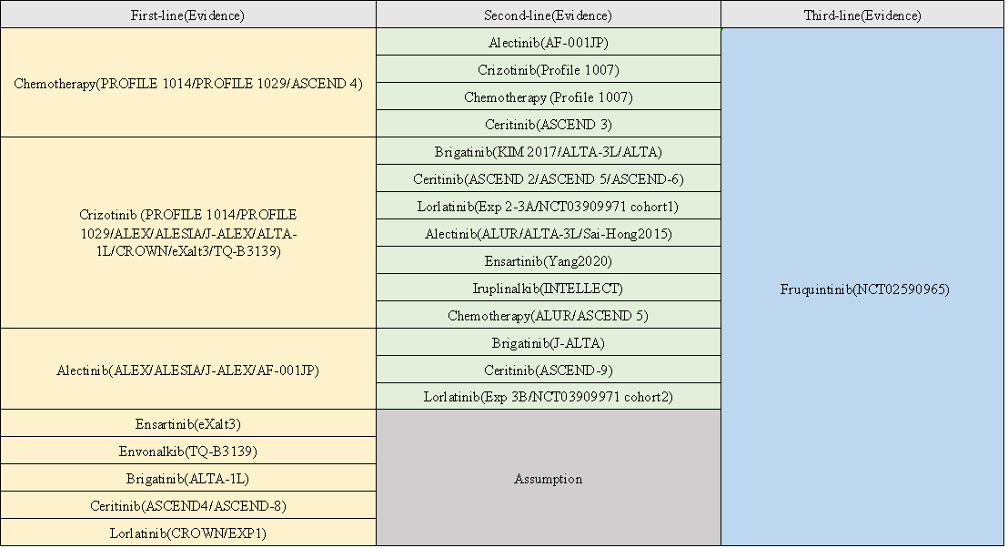
Note: Evidence source refer to Table S1.

Figure S2 Modeled Relative Efficacy between Sequential Therapies Based on Survival Data
OS
A
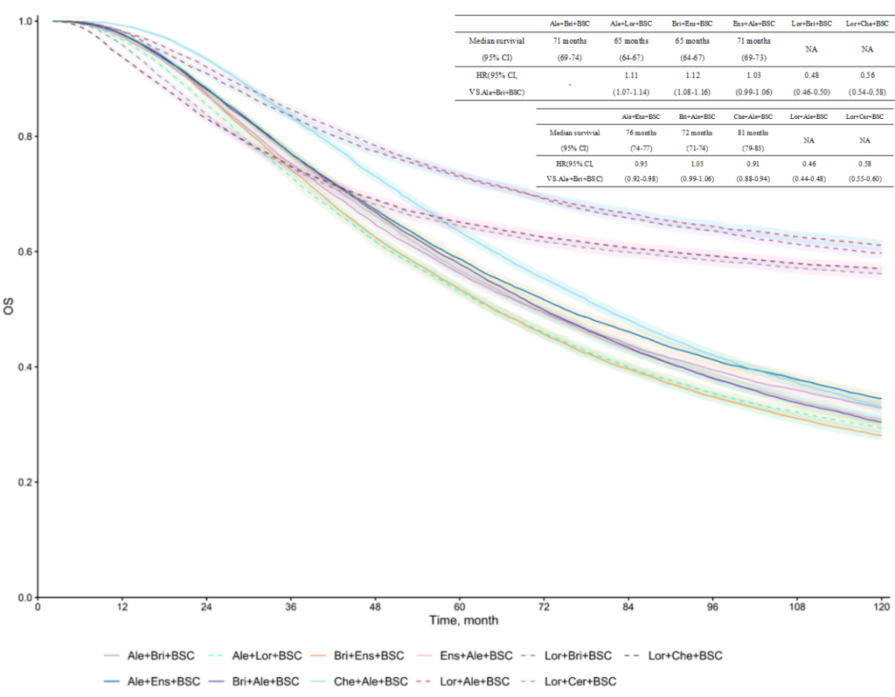
B
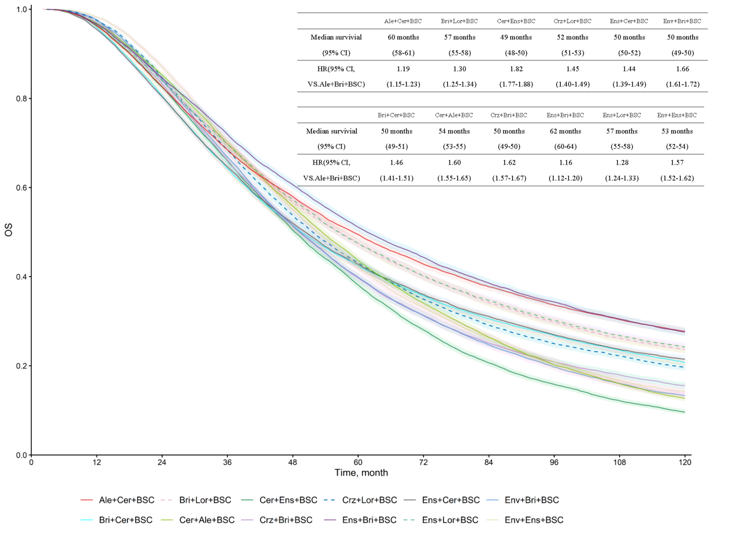
C
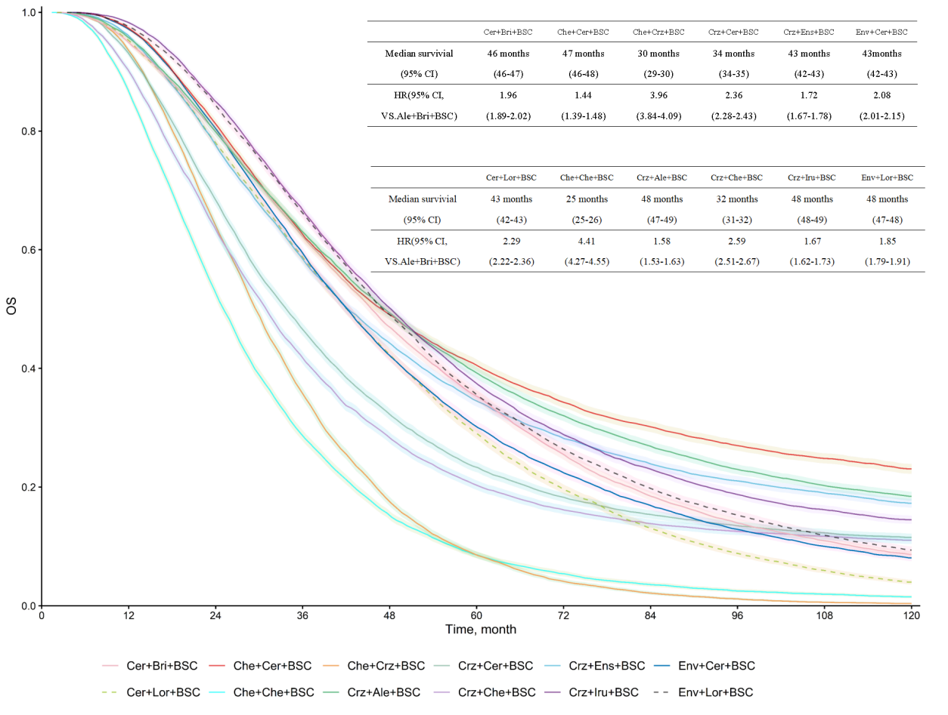
* Due to the large number of 35 sequential pathways, we divided them into three groups based on their median overall survival (median OS): Group A comprised the top 11 pathways with the highest median OS, Group B included pathways ranked 12 to 23, and Group C consisted of pathways ranked 24 to 35 with the lowest median OS（OS, overall survival; Ale, Alectinib; Bri, Brigatinib; Cer, Ceritinib; Che, Chemotherapy; Cri, Crizotinib; Ens, Ensartinib; Env, Envonalkib; Iru, Iruplinalkib; Lor, Lorlatinib; BSC,Best Supportive Care.）

Figure S3 Sequential Pathways Structure
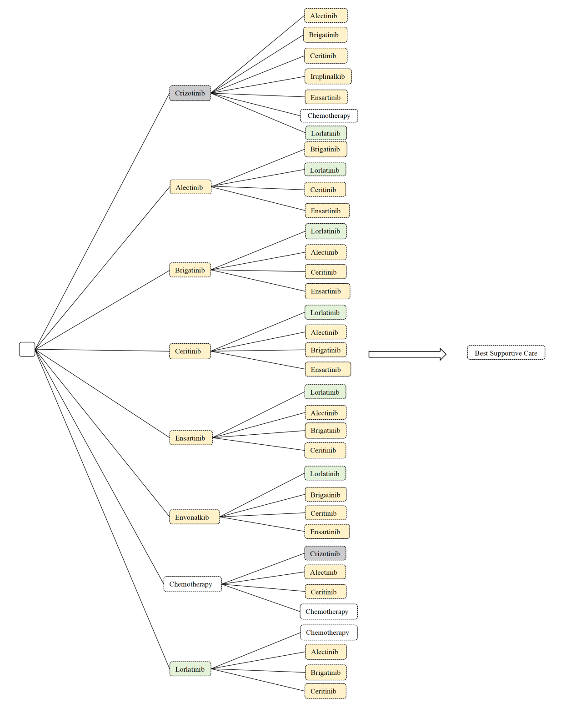

Figure S4 Cost-Effectiveness Results
A
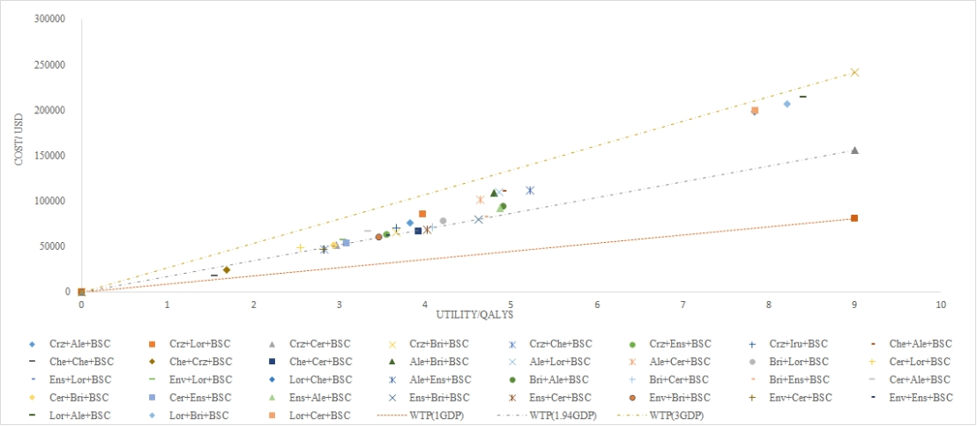
B
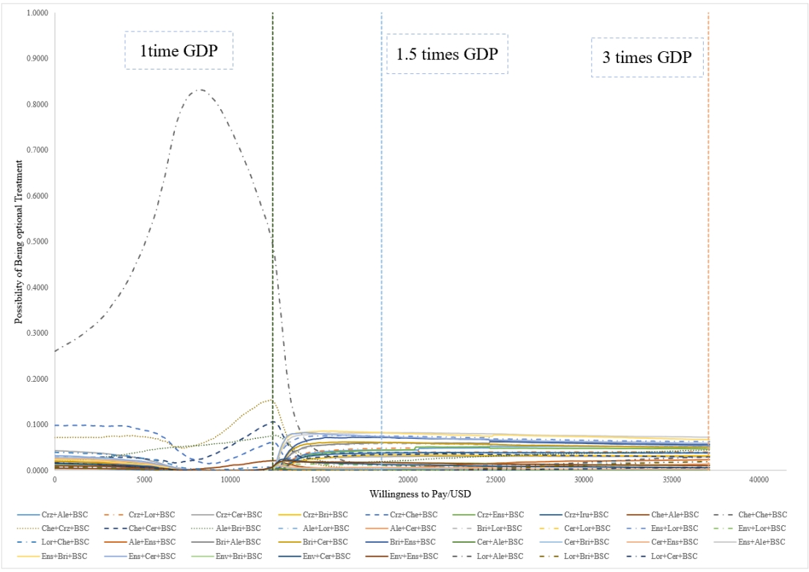
- scatter plot (B) Cost-Effectiveness Acceptability Curves
Ale, Alectinib; Bri, Brigatinib; Cer, Ceritinib; Che, Chemotherapy; Cri, Crizotinib; Ens, Ensartinib; Env, Envonalkib; Iru, Iruplinalkib; Lor, Lorlatinib; BSC,Best Supportive Care; median OS, median overall survival;; QALY, quality-adjusted life-year.

References
1. Pollock RF, Norrbacka K, Boye KS, Osumili B, Valentine WJ. The PRIME Type 2 Diabetes Model: a novel, patient-level model for estimating long-term clinical and cost outcomes in patients with type 2 diabetes mellitus. J Med Econ. 2022;25(1):393–402.
2. Huber RM, Hansen KH, Paz-Ares Rodríguez L, West HL, Reckamp KL, Leighl NB, et al. Brigatinib in Crizotinib-Refractory ALK+ NSCLC: 2-Year Follow-up on Systemic and Intracranial Outcomes in the Phase 2 ALTA Trial. J Thorac Oncol Off Publ Int Assoc Study Lung Cancer. 2020 Mar;15(3):404–15.
3. Crinò L, Ahn MJ, De Marinis F, Groen HJM, Wakelee H, Hida T, et al. Multicenter Phase II Study of Whole-Body and Intracranial Activity With Ceritinib in Patients With ALK-Rearranged Non-Small-Cell Lung Cancer Previously Treated With Chemotherapy and Crizotinib: Results From ASCEND-2. J Clin Oncol Off J Am Soc Clin Oncol. 2016 Aug 20;34(24):2866–73.
4. Nishio M, Felip E, Orlov S, Park K, Yu CJ, Tsai CM, et al. Final Overall Survival and Other Efficacy and Safety Results From ASCEND-3: Phase II Study of Ceritinib in ALKi-Naive Patients With ALK-Rearranged NSCLC. J Thorac Oncol Off Publ Int Assoc Study Lung Cancer. 2020 Apr;15(4):609–17.
5. Wu YL, Shi Y, Tan DSW, Xiaoqing L, Cheng Y, Zhou J, et al. Phase 1/2 study of ceritinib in Chinese patients with advanced anaplastic lymphoma kinase-rearranged non-small cell lung cancer previously treated with crizotinib: Results from ASCEND-6. Lung Cancer Amst Neth. 2020 Dec;150:240–6.
6. Hida T, Seto T, Horinouchi H, Maemondo M, Takeda M, Hotta K, et al. Phase II study of ceritinib in alectinib-pretreated patients with anaplastic lymphoma kinase-rearranged metastatic non-small-cell lung cancer in Japan: ASCEND-9. Cancer Sci. 2018 Sep;109(9):2863–72.
7. Shi Y, Chen J, Zhang H, Zhang Z, Zhang Y, Wang Z, et al. Efficacy and safety of iruplinalkib (WX-0593) in ALK-positive crizotinib-resistant advanced non-small cell lung cancer patients: a single-arm, multicenter phase II study (INTELLECT). BMC Med. 2023 Feb 24;21(1):72.
8. Nishio M, Yoshida T, Kumagai T, Hida T, Toyozawa R, Shimokawaji T, et al. Brigatinib in Japanese Patients With ALK-Positive NSCLC Previously Treated With Alectinib and Other Tyrosine Kinase Inhibitors: Outcomes of the Phase 2 J-ALTA Trial. J Thorac Oncol Off Publ Int Assoc Study Lung Cancer. 2021 Mar;16(3):452–63.
9. Lu S, Zhou Q, Liu X, Du Y, Fan Y, Cheng Y, et al. Lorlatinib for Previously Treated ALK-Positive Advanced NSCLC: Primary Efficacy and Safety From a Phase 2 Study in People’s Republic of China. J Thorac Oncol Off Publ Int Assoc Study Lung Cancer. 2022 Jun;17(6):816–26.
10. Kim DW, Tiseo M, Ahn MJ, Reckamp KL, Hansen KH, Kim SW, et al. Brigatinib in Patients With Crizotinib-Refractory Anaplastic Lymphoma Kinase-Positive Non-Small-Cell Lung Cancer: A Randomized, Multicenter Phase II Trial. J Clin Oncol Off J Am Soc Clin Oncol. 2017 Aug 1;35(22):2490–8.
11. Yang Y, Zhou J, Zhou J, Feng J, Zhuang W, Chen J, et al. Efficacy, safety, and biomarker analysis of ensartinib in crizotinib-resistant, ALK-positive non-small-cell lung cancer: a multicentre, phase 2 trial. Lancet Respir Med. 2020 Jan;8(1):45–53.
12. Solomon BJ, Besse B, Bauer TM, Felip E, Soo RA, Camidge DR, et al. Lorlatinib in patients with ALK-positive non-small-cell lung cancer: results from a global phase 2 study. Lancet Oncol. 2018 Dec;19(12):1654–67.
13. Tamura T, Kiura K, Seto T, Nakagawa K, Maemondo M, Inoue A, et al. Three-Year Follow-Up of an Alectinib Phase I/II Study in ALK-Positive Non-Small-Cell Lung Cancer: AF-001JP. J Clin Oncol Off J Am Soc Clin Oncol. 2017 May 10;35(14):1515–21.
14. Ou SHI, Ahn JS, De Petris L, Govindan R, Yang JCH, Hughes B, et al. Alectinib in Crizotinib-Refractory ALK-Rearranged Non-Small-Cell Lung Cancer: A Phase II Global Study. J Clin Oncol Off J Am Soc Clin Oncol. 2016 Mar 1;34(7):661–8.
15. Solomon BJ, Kim DW, Wu YL, Nakagawa K, Mekhail T, Felip E, et al. Final Overall Survival Analysis From a Study Comparing First-Line Crizotinib Versus Chemotherapy in ALK-Mutation-Positive Non-Small-Cell Lung Cancer. J Clin Oncol Off J Am Soc Clin Oncol. 2018 Aug 1;36(22):2251–8.
16. Shaw AT, Bauer TM, de Marinis F, Felip E, Goto Y, Liu G, et al. First-Line Lorlatinib or Crizotinib in Advanced ALK-Positive Lung Cancer. N Engl J Med. 2020 Nov 19;383(21):2018–29.
17. Mok T, Camidge DR, Gadgeel SM, Rosell R, Dziadziuszko R, Kim DW, et al. Updated overall survival and final progression-free survival data for patients with treatment-naive advanced ALK-positive non-small-cell lung cancer in the ALEX study. Ann Oncol Off J Eur Soc Med Oncol. 2020 Aug;31(8):1056–64.
18. Horn L, Wang Z, Wu G, Poddubskaya E, Mok T, Reck M, et al. Ensartinib vs Crizotinib for Patients With Anaplastic Lymphoma Kinase-Positive Non-Small Cell Lung Cancer: A Randomized Clinical Trial. JAMA Oncol. 2021 Nov 1;7(11):1617–25.
19. Soria JC, Tan DSW, Chiari R, Wu YL, Paz-Ares L, Wolf J, et al. First-line ceritinib versus platinum-based chemotherapy in advanced ALK-rearranged non-small-cell lung cancer (ASCEND-4): a randomised, open-label, phase 3 study. Lancet Lond Engl. 2017 Mar 4;389(10072):917–29.
20. Wu YL, Lu S, Lu Y, Zhou J, Shi YK, Sriuranpong V, et al. Results of PROFILE 1029, a Phase III Comparison of First-Line Crizotinib versus Chemotherapy in East Asian Patients with ALK-Positive Advanced Non-Small Cell Lung Cancer. J Thorac Oncol Off Publ Int Assoc Study Lung Cancer. 2018 Oct;13(10):1539–48.
21. Hida T, Nokihara H, Kondo M, Kim YH, Azuma K, Seto T, et al. Alectinib versus crizotinib in patients with ALK-positive non-small-cell lung cancer (J-ALEX): an open-label, randomised phase 3 trial. Lancet Lond Engl. 2017 Jul 1;390(10089):29–39.
22. Zhou C, Kim SW, Reungwetwattana T, Zhou J, Zhang Y, He J, et al. Alectinib versus crizotinib in untreated Asian patients with anaplastic lymphoma kinase-positive non-small-cell lung cancer (ALESIA): a randomised phase 3 study. Lancet Respir Med. 2019 May;7(5):437–46.
23. Yang Y, Min J, Yang N, Yu Q, Cheng Y, Zhao Y, et al. Envonalkib versus crizotinib for treatment-naive ALK-positive non-small cell lung cancer: a randomized, multicenter, open-label, phase III trial. Signal Transduct Target Ther. 2023 Aug 14;8(1):301.
24. Wolf J, Helland Å, Oh IJ, Migliorino MR, Dziadziuszko R, Wrona A, et al. Final efficacy and safety data, and exploratory molecular profiling from the phase III ALUR study of alectinib versus chemotherapy in crizotinib-pretreated ALK-positive non-small-cell lung cancer. ESMO Open. 2022 Feb;7(1):100333.
25. Shaw AT, Kim TM, Crinò L, Gridelli C, Kiura K, Liu G, et al. Ceritinib versus chemotherapy in patients with ALK-rearranged non-small-cell lung cancer previously given chemotherapy and crizotinib (ASCEND-5): a randomised, controlled, open-label, phase 3 trial. Lancet Oncol. 2017 Jul;18(7):874–86.
26. Yang JCH, Liu G, Lu S, He J, Burotto M, Ahn MJ, et al. Brigatinib Versus Alectinib in ALK-Positive NSCLC After Disease Progression on Crizotinib: Results of Phase 3 ALTA-3 Trial. J Thorac Oncol Off Publ Int Assoc Study Lung Cancer. 2023 Dec;18(12):1743–55.
27. Shaw AT, Kim DW, Nakagawa K, Seto T, Crinó L, Ahn MJ, et al. Crizotinib versus chemotherapy in advanced ALK-positive lung cancer. N Engl J Med. 2013 Jun 20;368(25):2385–94.
28. Camidge DR, Kim HR, Ahn MJ, Yang JCH, Han JY, Hochmair MJ, et al. Brigatinib Versus Crizotinib in ALK Inhibitor-Naive Advanced ALK-Positive NSCLC: Final Results of Phase 3 ALTA-1L Trial. J Thorac Oncol Off Publ Int Assoc Study Lung Cancer. 2021 Dec;16(12):2091–108.
29. Guan H, Wang C, Chen C, Han S, Zhao Z. Cost-Effectiveness of 12 First-Line Treatments for Patients With Advanced EGFR Mutated NSCLC in the United Kingdom and China. Front Oncol. 2022;12:819674.
30. Zhao M, Pan X, Yin Y, Hu H, Wei J, Bai Z, et al. Cost-Effectiveness Analysis of Five Systemic Treatments for Unresectable Hepatocellular Carcinoma in China: An Economic Evaluation Based on Network Meta-Analysis. Front Public Health. 2022;10:869960.
31. Shao T, Zhao M, Tang W. Cost-effectiveness analysis of sintilimab vs. placebo in combination with chemotherapy as first-line therapy for local advanced or metastatic oesophageal squamous cell carcinoma. Front Oncol. 2022;12:953671.
32. Cortés J, Kim SB, Chung WP, Im SA, Park YH, Hegg R, et al. Trastuzumab Deruxtecan versus Trastuzumab Emtansine for Breast Cancer. N Engl J Med. 2022 Mar 24;386(12):1143–54.
33. Bullement A, Nathan P, Willis A, Amin A, Lilley C, Stapelkamp C, et al. Cost Effectiveness of Avelumab for Metastatic Merkel Cell Carcinoma. PharmacoEconomics - Open. 2019 Sep;3(3):377–90.
34. Shao T, Zhao M, Liang L, Tang W. Serplulimab Plus Chemotherapy vs Chemotherapy for Treatment of US and Chinese Patients with Extensive-Stage Small-Cell Lung Cancer: A Cost-Effectiveness Analysis to Inform Drug Pricing. BioDrugs Clin Immunother Biopharm Gene Ther. 2023 May;37(3):421–32.
35. Li Y, Liang X, Yang T, Guo S, Chen X. Pembrolizumab vs cemiplimab for the treatment of advanced non-small cell lung cancer with PD-L1 expression levels of at least 50%: A network meta-analysis and cost-effectiveness analysis. Front Oncol. 2022;12:878054.
36. Liu M, Zhang L, Huang Q, Li N, Zheng B, Cai H. Cost-Effectiveness Analysis Of Ceritinib And Alectinib Versus Crizotinib In The Treatment Of Anaplastic Lymphoma Kinase-Positive Advanced Non-Small Cell Lung Cancer. Cancer Manag Res. 2019;11:9195–202.
37. Shu Y, Ding Y, Zhang Q. Cost-Effectiveness of Nivolumab Plus Chemotherapy vs. Chemotherapy as First-Line Treatment for Advanced Gastric Cancer/Gastroesophageal Junction Cancer/Esophagel Adenocarcinoma in China. Front Oncol. 2022;12:851522.
38. Luo X, Zhou Z, Zeng X, Peng L, Liu Q. Cost-effectiveness of ensartinib, crizotinib, ceritinib, alectinib, brigatinib and lorlatinib in patients with anaplastic lymphoma kinase-positive non-small cell lung cancer in China. Front Public Health. 2022;10:985834.
39. Liu Q, Luo X, Zhou Z, Peng L, Yi L, Wan X, et al. PD-L1 Test-Based Strategy With Nivolumab as the Second-Line Treatment in Advanced NSCLC： A Cost-Effectiveness Analysis in China. Front Oncol. 2021;11:745493.
40. Lin YT, Liu TX, Chen J, Wang C, Chen Y. Cost-Effectiveness of Nivolumab Immunotherapy vs. Paclitaxel or Docetaxel Chemotherapy as Second-Line Therapy in Advanced Esophageal Squamous Cell Carcinoma in China. Front Public Health. 2022;10:923619.

