Appendix
Table 1A: SCIM III subdomains (1)
SCIM III Domain | Description | Higher score indicates
Respiration | Breathing (ability to breathe independently) | Can breathe without assistance (no ventilator needed)
Sphincter management | Bladder management | Can control bladder or perform catheterisation independently
Sphincter management | Bowel management | Can manage bowel movements independently
Sphincter management | Use of toilet | Can transfer and use toilet without help
Mobility – outdoors | Mobility outdoors | Can move independently outdoors or in community
Mobility – indoors | Mobility indoors | Can move independently inside the house
Mobility – moderate distance | Mobility for medium distances (walking or wheelchair) | Can move 10–100 m without assistance
Mobility – transfers | Transfer into/out of a car | Can enter and exit a car independently
Mobility – transfers | Transfer from floor | Can transfer from floor to chair/bed independently
Mobility – stairs | Climbing stairs | Can go up/downstairs independently
Mobility – bed | Bed mobility | Can move and turn independently in bed
Mobility – transfers | Transfer bed ↔ wheelchair | Can move between bed and wheelchair without help
Mobility – transfers | Transfer to toilet | Can move to and from toilet independently
Self-care | Dressing upper body | Can dress upper body without assistance
Self-care | Dressing lower body | Can dress lower body without assistance
Self-care | Grooming/face washing | Can wash face, shave, brush teeth independently
Self-care | Feeding | Can eat independently
Self-care | Washing upper body | Can wash upper body independently
Self-care | Washing lower body | Can wash lower body independently

Table 2A. Item-level descriptive statistics
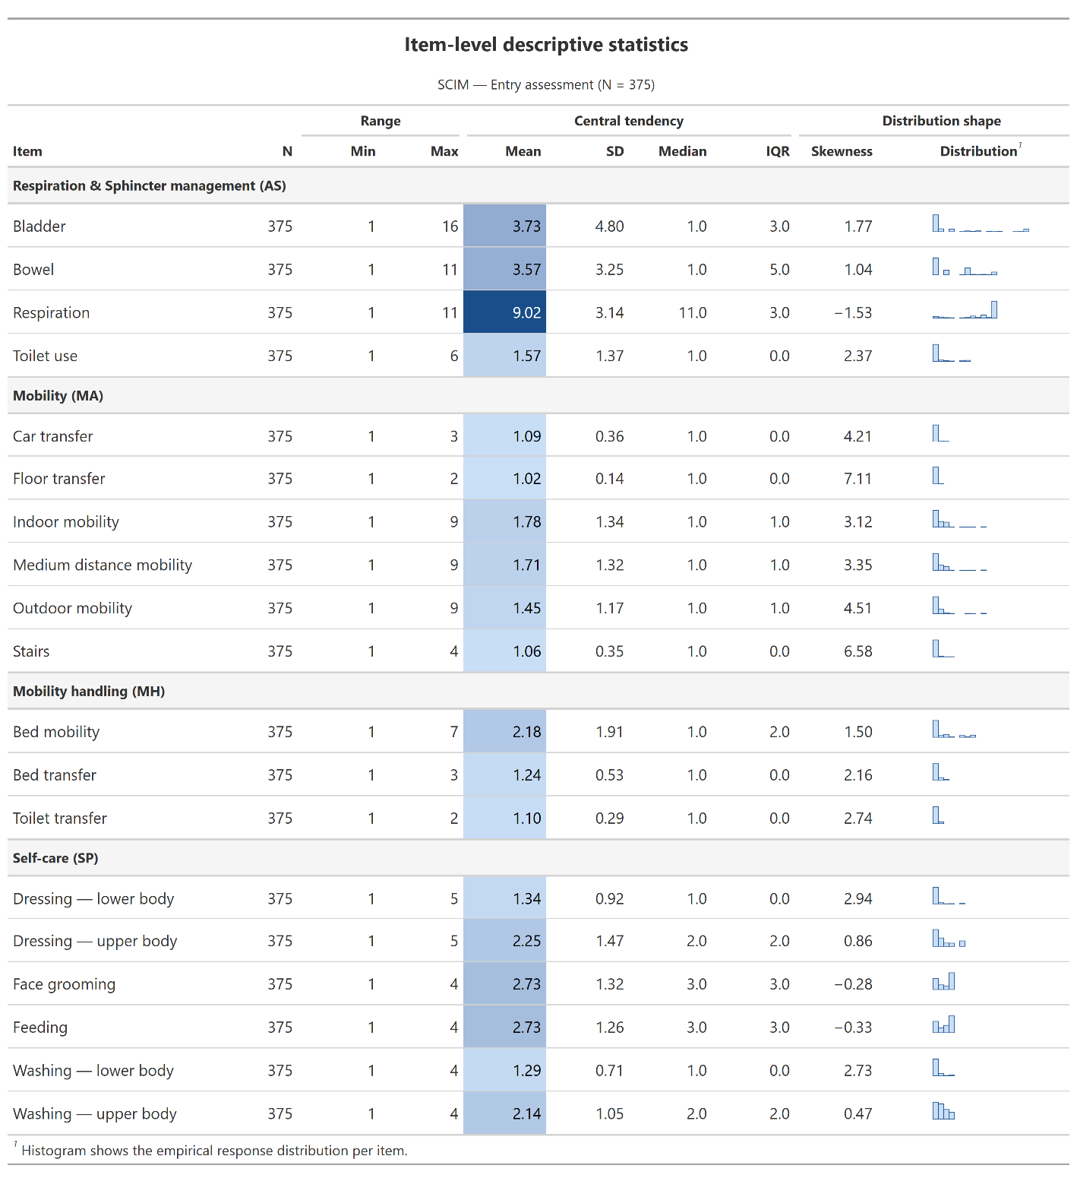
Table 3A. Regression results
Predictors | ORª | CI^{b} 2.5% | CI^{b} 97.5% | p value^{c}
Intercept | 2.48 | 0.61 | 9.86 | 0.20
Latent Class 1 vs. 3 (ref.) | 5.59 | 1.92 | 17.7 | 0.00
Latent Class 2 vs. 3 (ref.) | 18.8 | 7.37 | 53.9 | 0.00
Age at admission (years) | 0.96 | 0.94 | 0.97 | 0.00
Female vs. male | 0.99 | 0.54 | 1.78 | 0.96
AIS D vs. Paraplegia | 1.93 | 1.03 | 3.69 | 0.04
C1–C4, AIS A–C vs. Paraplegia | 0.40 | 0.04 | 0.63 | 0.18
C5-C8 AIS A–C vs. Paraplegia | 0.14 | 0.04 | 0.43 | 0.24
Number of comorbidities | 0.79 | 0.67 | 0.94 | 0.06
ªOdds ratio
^{b}Confidence interval
^{c}P-value from Kruskal–Wallis rank-sum test.

This model shows which factors are associated with lower or higher likelihood of efficiency, meaning good recovery at a low cost. Patients in latent Class 2 have the highest chance of being efficient, while those in latent Class 1 show lower chances of being efficient (odds ratio (OR) = 18.8 and 5.59, respectively) compared to latent Class 3, which serves as the reference group and has the lowest odds of efficiency.
Some clinical factors also reduce efficiency. Older patients had lower chances to be in the efficient quadrant (OR = 0.96 per year). People with severe cervical injuries (C1–C4 or C5–C8) also have much lower odds of success. More comorbidities also reduce the chance of efficiency.
Finally, a higher total cost always reduces efficiency. For every additional 1,000 CHF spent, the chance of being efficient becomes lower (OR = 0.98). This means that good results depend both on the patient’s condition at the start and on keeping costs under control.

References
1. Catz A, Itzkovich M. Spinal Cord Independence Measure: comprehensive ability rating scale for the spinal cord lesion patient. J Rehabil Res Dev. 2007;44(1):65-8.

