Additional Files
Table of Contents
1 Fertility model 1
2 Mortality model 2
3 MCMC procedure 3
4 Model code 3
5 References 9
6 Table AF1. Fertility data. 10
7 Table AF2. Mortality data. 13
8 Table AF3. Educational attainment data. 17
9 Table AF4. Migration data. 18
10 Table AF5. Population size data. 22
11 Table AF6. Fitted model parameters. 23
12 Table AF7. Comparison of models. 24
13 Table AF8. Relative risk of death, by education level 25
14 Figure AF1: Probability distributions of fitted parameters. 26
15 Figure AF2: Model fit to fertility data 27
16 Figure AF3: Model fits to mortality data 51
17 Figure AF4: Model fits to migration data 99
18 Figure AF5: Model fits to education data 132
19 Figure AF6: Model fits to life expectancy data 140

Text AF1

This Additional File text provides further details on the mathematical modeling approach described in the main text, including model code and relevant methodological details.

1 Fertility model
As noted in the main text, a Gompertz-Pasupuleti model (G-P) was used to model age-specific cumulative fertility (mean number of births experienced by a mother by age of the mother, over the age range 16-49 years) across three waves of NFHS data for which such fertility information was available (wave 1: 1992-3, wave 2: 1998-9, and wave 3: 2005-6). As part of the process of model selection for the fertility model, we fit and compared three alternative statistical models (a standard gamma distribution model, a standard negative binomial distribution model, and the G-P model) to describe the cumulative age-specific fertility rate in each survey wave for groups disaggregated by birth cohort, urban/rural residence and educational attainment level (data shown in Table AF1).
We selected the G-P model as it minimized Akaike’s Information Criterion (AIC) [1], a model selection criterion that selects a model with best fit using the least number of parameters (as an equivalent to DIC for use in ordinary least squares as opposed to MCMC fitting). The model fits to all available, fully disaggregated fertility data across all available years are provided in Figure AF2.

2 Mortality model
We estimated mortality rates stratified by age, urban/rural status, calendar year, and educational attainment. In estimating the relative risk of death by educational attainment, a challenge we faced was that in extant data sets describing deaths, the educational attainment level of the deceased is not reported. To overcome this data limitation and estimate the relationship between female educational attainment and mortality, we designed and tested a multistep process described in the main text. First, we predicted female educational attainment level based on household characteristics, using ordinal logistic regression to estimate the relationship between category of educational attainment of women alive in DLHS households. The regression model included: age of the woman, religion of household head, household wealth index, urban/rural residence, total number of marriages in the household, household size and squared household size, and whether the household belonged to a scheduled tribe or scheduled caste.
Second, using the results of this regression, we predicted the likelihood of being in each educational attainment category for women from all households in DLHS, including those who had died and therefore whose actual educational attainment was unobserved. Since the sample was large, we drew a random number to singly impute the educational attainment category for each woman.
Third, we estimated a logistic regression on the likelihood that a given woman had died based on the fully interacted model of predicted educational attainment category, woman’s age, and her urban/rural residential status. For each age and urban/rural birth cohort, the educational attainment-specific relative risk of death was computed as the predicted marginal probability of death for a given group compared to the category of women with the lowest level of educational attainment (equation 3 in the main text).
The fully disaggregated mortality rate estimates are provided in Table AF2. We fitted a Lee-Carter-type model to the log mortality rate [2], by fitting a constant, a parameter multiplied by calendar year, and a parameter multiplied by age to log-mortality rates. We fit the log mortality rates in three age clusters, <1 year olds, 1-10 year olds, >10 year olds, because the log mortality rates have clear breakpoints at these age divisions, allowing for simple decomposition of the rates into three linear models. The model fits to the fully disaggregated data are provided in Figure AF3.

3 MCMC procedure
To perform Markov Chain Monte Carlo (MCMC) estimation of parameter values fitting the overall model to (simultaneously) all available data (Tables SI1-SI5), we used a standard MCMC approach that involves an efficient implementation of an adaptive Metropolis sampler with delayed rejection [3]. We specifically used the freely-available MCMC package in the program MATLAB (version R2013b, The Mathworks, Cambridge, MA, USA), which samples from multi-dimensional prior distributions for the parameters being fitted, and uses a rejection algorithm to sample increasingly from joint probability regions where the posterior probability is high by determining whether the model output of a new parameter sample is closer or farther away from the 95% confidence interval of the target data. See details in reference [3]. Installation instructions are provided with the model code below. We started with flat prior distributions defined as inverse chi-squared distributions with mean zero and infinite standard deviation. The algorithm was run over 100,000 iterations after a 10,000 iteration burn-in period and 1:10 thinning to generate a joint posterior distribution for the parameters, illustrated in Figure AF1 and detailed further in Table AF6. We used standard Geweke criteria to test for convergence [4], the results of which are also provided in Table AF6.
To ensure stability of our estimates, we repeated the process from ten randomly-initiated start points for all parameters, sampling randomly from the flat prior distributions and ensuring stable convergence to the same joint posterior distribution to three decimal place values for all parameters.
In order to produce population demographic and life expectancy estimates from the model, we sampled 10,000 times from the joint posterior probability distribution of the parameters (Figure AF1 and Table AF6) and re-ran the model using each of these 10,000 parameter sets.

4 Model code
The model code is organized as a series of MATLAB functions, with instructions and labels provided as comments designated by the percent (%) symbol. Note that the code is designed for readability and easy interpretability by other users, but is not necessarily the most efficient possible code; in areas, labeled below, multiple lines of code or functions can be consolidated as indicated in order to produce more parsimonious and efficient simulations, although we provide the long-hand code here for ease of interpretability. We recommend that the code be run on computers with at least 4GB RAM and 1GB free memory; please note that the MCMC procedure can require several minutes to complete, and we recommend closing other applications during its execution.
The code performs the following functions: (a) the data provided in Tables SI1-SI5 are imported (requires an Internet connection) and the model specifies parameters to be fit; (b) the model calls a function to simulate fertility, mortality, educational attainment and migration over time periods specified by the user, using a stochastic discrete-time microsimulation approach with user-specified time intervals; (c) the model processes population size estimates by cohort (where cohorts are defined by all combinations of current urban/rural residence, educational attainment in the four categories described in the main text, and age in categories of 0-4, 5-9, 10-14, 15-19, 20-24, 25-44, 45-64, 65-79, and 80+ years); (d) the fitted parameters are displayed as joint posterior probability distributions with summary statistics and associated figures; and (e) the distributions are sampled to generate life expectancy estimates for simulated cohorts over user-specified time scales.
A copy of the sourcecode for the anthropometric model, along with a link to example data to which it can be applied is available at: https://github.com/sanjaybasu/SPOKE
% (Licensed under a Creative Commons Attribution-NonCommercial-ShareAlike 4.0 International License by Basu & Goldhaber-Fiebert, 2014)
function anthroex
clear; clc;
% load data
data = urlread('http:// www.stanford.edu/~basus/spoke/india-anthropom.txt'); % data available concurrent with publication
model.ssfun = @anthross;
% load MCMC package: http://helios.fmi.fi/~lainema/mcmc/mcmcstat.zip
% Define parameter sampling constraints if any.
% {'name', start, [min,max], N(mu,s^2)}
params = {data.TabS6}; % initial parameters loaded, see Table AF6 for descriptions
% default prior distribution is sigma2 ~ invchisq(S20,N0), the inverse chi
% squared distribution (see for example Gelman et al.). The
% components (female urban, female rural) all have separate variances.
model.S20 = std(data.ydata);
model.N0 = mean(data.ydata);
% First generate an initial chain.
options.nsimu = 1000; % burn-in period
[results, chain, s2chain]= mcmcrun(model,data,params,options);
% Then re-run starting from the results of the previous run;
% this may take several minutes
options.nsimu = 10000;
[results, chain, s2chain] = mcmcrun(model,data,params,options, results);
% Chain plots should reveal that the chain has converged and we can
% use the results for estimation and predictive inference.
figure
mcmcplot(chain,[],results,'pairs');
figure
mcmcplot(chain,[],results,'denspanel',2);
% Function |chainstats| calculates mean and std from the chain and
% estimates the Monte Carlo error of the estimates. Number |tau| is
% the integrated autocorrelation time and |geweke| is a test
% for a null hypothesis that the chain has converged.
chainstats(chain,results)
% In order to use the |mcmcpred| function we need
% function |modelfun| with input arguments given as
% |modelfun(xdata,theta)|. We construct this as an anonymous function.
modelfun = @(d,th) anthrofunpred(data,th);
% We sample parameter realizations from |chain| and |s2chain|
% and calculate the predictive plots.
nsample = 10000;
out = mcmcpred(results,chain,s2chain,data.ydata,modelfun,nsample);
figure
% add the 'y' observations to the plot
hold on
for i=1:55 % distinct data columns being fitted
subplot(56/4,4,i)
hold on
plot(data.ydata(:,i),'o');
hold off
end
mcmcpredplot(out);
function ss = anthross(theta,data)
ydata = data.ydata;
ymodel = anthrofun(theta);
ss = (sum((ymodel - ydata).^2));
% ydata = [{'fertdata92'}, {'fertdata98'}, {'fertdata05'},{'urbandeathdata'},{'ruraldeathdata'},{'unpopproj'},{'edprev'}]
% organization of the data are as follows, by column:
% fertdata92 = NFHS1 rows age 16-49, columns 1-4 urban, 5-8 rural, 1/2/3/4/1/2/3/4 ed levels
% fertdata98 = NFHS2
% fertdata05 = NFHS3
% urbandeathdata = rows = age (0-65 by increments of 5), columns = years
% ruraldeathdata
% unpopproject = 1992 - 2025 un projections female urban, then female rural (2nd col)
% edprevdata = [edprev 1992; 1998; 2005; 2008];
function ydot=anthrofun(theta)
% individuals are defined by age, sex, urban/rural, and education level (none, primary, secondary, more)
% sex = 0 if male, 1 if female
% urban/rural = 1 if urban, 2 if rural
% education = 0, 1, 2, 3 in order of increasing ed (0 years, 1-6 yrs, 6-12 yrs, >12 yrs)
% cohorts = 1-8, first four urban, second four rural; first four education 0/1/2/3, second four education 0/1/2/3
dt=1/365; %time step, default set to 1 day
yrs=[user-defined starting year]:dt:[user defined ending year]; % time range simulated; note, change starting conditions below (labeled) if changing years of simulation period
% fertility rate by age and cohort, GP fertility model of NFHS data
% cumulative fertility rate =f.*0.5.^((log(0.95)/log(0.05)).^((maternal age -a)/b));
% f is the saturation level (cumulative total fertility rate)
% a is median age of fertility (age of giving birth to half of the total number of children)
% b is length of the age interval during which the fertility level rises from 5% to 95% of the saturation level
f=repmat(theta(1),8,length(yrs));
a=repmat(theta(2),8,length(yrs));
b=repmat(theta(3),8,length(yrs));
rrf=[1 theta(17) theta(18) theta(19) theta(20) theta(21) theta(22) theta(23)]; % RR of fertility by cohort
for age=14:50;
ctfr(:,:,age)=(f.*0.5.^((log(0.95)/log(0.05)).^((age-a)./b))+repmat(theta(24)*yrs,8,1)).*repmat(rrf',1,length(yrs)); % cum tot fert rate by year, SG model
end
birthrate(:,:,15:50)=ctfr(:,:,15:50)-ctfr(:,:,14:49); % birth rate by cohort (rows), year (columns), and maternal age (depth)
for age=16:49
fertmodel92(age-15,:)=ctfr(:,1,age)'; % generate output vectors for fitting fertility outcomes to three survey waves
fertmodel98(age-15,:)=ctfr(:,7,age)';
fertmodel05(age-15,:)=ctfr(:,14,age)';
end
rrm=[1 theta(11) theta(12) theta(13) theta(35) theta(11)*theta(35) theta(12)*theta(35) theta(13)*theta(35)]; % RR of death by cohort (urban/rural and ed category)
for age = 1:1 % infant deaths
mdr(:,:,age)=exp(repmat(theta(25),8,length(yrs))+repmat(theta(26)*yrs,8,1)).*repmat(rrm',1,length(yrs));
fdr(:,:,age)=exp(repmat(theta(27),8,length(yrs))+repmat(theta(28)*yrs,8,1)).*repmat(rrm',1,length(yrs));
end
for age = 2:10 % older deaths
mdr(:,:,age)=exp(repmat(theta(29),8,length(yrs))+repmat(theta(30),8,length(yrs))*age+repmat(theta(31)*yrs,8,1)).*repmat(rrm',1,length(yrs));
fdr(:,:,age)=exp(repmat(theta(32),8,length(yrs))+repmat(theta(33),8,length(yrs))*age+repmat(theta(34)*yrs,8,1)).*repmat(rrm',1,length(yrs));
end
for age = 11:100 % older deaths
mdr(:,:,age)=exp(repmat(theta(4),8,length(yrs))+repmat(theta(5),8,length(yrs))*age+repmat(theta(6)*yrs,8,1)).*repmat(rrm',1,length(yrs));
fdr(:,:,age)=exp(repmat(theta(7),8,length(yrs))+repmat(theta(8),8,length(yrs))*age+repmat(theta(9)*yrs,8,1)).*repmat(rrm',1,length(yrs));
end
clear umd rmd ufd rfd
edage=[starting dist of ed prev for starting year];
% sorting to match data matrices for fitting
for age=5:5:65
umd(1+age/5,:)=sum(mdr(1:4,:,age).*repmat(edage(1:4),1,length(yrs)));
rmd(1+age/5,:)=sum(mdr(5:8,:,age).*repmat(edage(1:4),1,length(yrs)));
ufd(1+age/5,:)=sum(fdr(1:4,:,age).*repmat(edage(1:4),1,length(yrs)));
rfd(1+age/5,:)=sum(fdr(5:8,:,age).*repmat(edage(1:4),1,length(yrs)));
end
umd(1,:)=sum(mdr(1:4,:,1).*repmat(edage(1:4),1,length(yrs)));
rmd(1,:)=sum(mdr(5:8,:,1).*repmat(edage(1:4),1,length(yrs)));
ufd(1,:)=sum(fdr(1:4,:,1).*repmat(edage(1:4),1,length(yrs)));
rfd(1,:)=sum(fdr(5:8,:,1).*repmat(edage(1:4),1,length(yrs)));
umd=umd';rmd=rmd';ufd=ufd';rfd=rfd';
umd=[umd(1,:);umd(4,:);umd(5,:);umd(8:16,:)];
rmd=[rmd(1,:);rmd(4,:);rmd(5,:);rmd(8:16,:)];
ufd=[ufd(1,:);ufd(4,:);ufd(5,:);ufd(8:16,:)];
rfd=[rfd(1,:);rfd(4,:);rfd(5,:);rfd(8:16,:)];
udmodel=[umd; ufd];
udmodel(25:34,:)=zeros(10,14);
rdmodel=[rmd; rfd];
rdmodel(25:34,:)=zeros(10,14);
% create initial population in starting year
pop=[user defined initial pop for starting year]; % pop size total
sexratio=[user defined sex ratio for starting year]; % proportion female at birth
urban=[user defined urban ratio for starting year]; % proportion urban in starting year
distage=[user defined age ratio for starting year]; % starting distribution of females into age groups
fempop=repmat([distage.*pop.*sexratio]',8,1); % fem pop size, cohorts in rows, columns are age groups, 0-4, 5-9, 10-14, 15-19, 20-24, 25-44, 45-64, 65-79, 80+
fempop=fempop.*repmat(edage,1,length(fempop));
fempop(1:4,:)=fempop(1:4,:)*urban; % create urban/rural distribution for starting year
fempop(5:8,:)=fempop(5:8,:)*(1-urban);
% pop change in each year of simulation: births, deaths, aging
for time=1:length(yrs) births(:,time)=dt.*(birthrate(:,time,2).*fempop(:,1)+birthrate(:,time,7).*fempop(:,2)+birthrate(:,time,12).*fempop(:,3)+birthrate(:,time,17).*fempop(:,4)+birthrate(:,time,22).*fempop(:,5)+birthrate(:,time,35).*fempop(:,6)+birthrate(:,time,50).*fempop(:,7));
fempop(:,1)=fempop(:,1)+sexratio.*births(:,time);
deathf(:,:,time)=dt.*[fdr(:,time,1).*fempop(:,1) fdr(:,time,7).*fempop(:,2) fdr(:,time,12).*fempop(:,3) fdr(:,time,17).*fempop(:,4) fdr(:,time,22).*fempop(:,5) fdr(:,time,35).*fempop(:,6) fdr(:,time,55).*fempop(:,7) fdr(:,time,72).*fempop(:,8) fdr(:,time,90).*fempop(:,9)];
fempop=fempop-deathf(:,:,time);
% aging across cohorts
fempop(:,1)=fempop(:,1)-dt.*fempop(:,1)/5;
fempop(:,2)=fempop(:,2)+dt.*fempop(:,1)/5-dt.*fempop(:,2)/5;
fempop(:,3)=fempop(:,3)+dt.*fempop(:,2)/5-dt.*fempop(:,3)/5;
fempop(:,4)=fempop(:,4)+dt.*fempop(:,3)/5-dt.*fempop(:,4)/5;
fempop(:,5)=fempop(:,5)+dt.*fempop(:,4)/5-dt.*fempop(:,5)/5;
fempop(:,6)=fempop(:,6)+dt.*fempop(:,5)/5-dt.*fempop(:,6)/20;
fempop(:,7)=fempop(:,7)+dt.*fempop(:,6)/20-dt.*fempop(:,7)/20;
fempop(:,8)=fempop(:,8)+dt.*fempop(:,7)/20-dt.*fempop(:,8)/15;
fempop(:,9)=fempop(:,9)+dt.*fempop(:,8)/15;
% education secular trends across cohorts
fempop(1,:)=fempop(1,:)-dt.*theta(14).*fempop(1,:);
fempop(2,:)=fempop(2,:)+dt.*theta(14).*fempop(1,:)-dt.*theta(15).*fempop(2,:);
fempop(3,:)=fempop(3,:)+dt.*theta(15).*fempop(2,:)+dt.*theta(16).*fempop(3,:);
fempop(4,:)=fempop(4,:)+dt.*theta(16).*fempop(3,:);
fempop(5,:)=fempop(5,:)-dt.*theta(14).*fempop(5,:);
fempop(6,:)=fempop(6,:)+dt.*theta(14).*fempop(5,:)-dt.*theta(15).*fempop(6,:);
fempop(7,:)=fempop(7,:)+dt.*theta(15).*fempop(6,:)+dt.*theta(16).*fempop(7,:);
fempop(8,:)=fempop(8,:)+dt.*theta(16).*fempop(7,:);
% rural-urban migration; can disaggregate by ed category as described in main text
fempop(1:4,:)=fempop(1:4,:)+dt.*fempop(1:4,:)*theta(10);
fempop(5:8,:)=fempop(5:8,:)-dt.*fempop(1:4,:)*theta(10);
deaths(:,time)=sum(deathf(:,:,time)');
finalfempop(:,time)=sum(fempop')';
fitunurban(:,time)=sum(sum(fempop(1:4,:))');
fitunrural(:,time)=sum(sum(fempop(5:8,:))');
edprev(:,time)=[(sum(fempop(1:4,:)')./sum(sum(fempop(1:4,:)')))'; sum(fempop(5:8,:)')./sum(sum(fempop(5:8,:)')))'];
end
edprevmodel=[edprev(:,1);edprev(:,7);edprev(:,19);edprev(:,22)];
edprevmodel(33:34)=[0;0];
unmodel=[fitunurban;fitunrural]'; % sorting data to match UN pop size estimates
% overall data matrix output to fit against data
ydot=[fertmodel92 fertmodel98 fertmodel05 udmodel rdmodel unmodel edprevmodel];
% simulate estimated life expectancy
init=[user defined base year life exp by male/female urban/rural];
pars=[birth/death/ed trend/migration matrix by user for starting year];
popsize=[user defined starting pop size for simulated starting year];
for year=[starting year]:[ending year]
pop=zeros(3,popsize);
% urban
for age=0:65
if age<1 deathrate=exp((pars(1,9)*edprev(1)+pars(2,9)*edprev(2)+pars(3,9)*edprev(3)+pars(4,9)*edprev(4))*year+(pars(1,10)*edprev(1)+pars(2,10)*edprev(2)+pars(3,10)*edprev(3)+pars(4,10)*edprev(4)));
elseif age>=1 && age<10 deathrate=exp((pars(1,11)*edprev(1)+pars(2,11)*edprev(2)+pars(3,11)*edprev(3)+pars(4,11)*edprev(4))+(pars(1,12)*edprev(1)+pars(2,12)*edprev(2)+pars(3,12)*edprev(3)+pars(4,12)*edprev(4))*age+(pars(1,13)*edprev(1)+pars(2,13)*edprev(2)+pars(3,13)*edprev(3)+pars(4,13)*edprev(4))*year);
elseif age>=10
deathrate=exp((pars(1,14)*edprev(1)+pars(2,14)*edprev(2)+pars(3,14)*edprev(3)+pars(4,14)*edprev(4))+(pars(1,15)*edprev(1)+pars(2,15)*edprev(2)+pars(3,15)*edprev(3)+pars(4,15)*edprev(4))*age+(pars(1,16)*edprev(1)+pars(2,16)*edprev(2)+pars(3,16)*edprev(3)+pars(4,16)*edprev(4))*year);
end
prob=rand(1,length(pop));
pop(1,pop(1,:)==0&prob<deathrate)=1; % row 1 = death if =1, alive if =0
pop(2,pop(2,:)==0&prob<deathrate)=year; % row 2 = year of death
pop(3,pop(3,:)==0&prob<deathrate)=age; % row 3 = age of death
end
dle(year,3) = mean(pop(3,pop(3,:)>0));
clear pop;
% rural
pop=zeros(3,popsize);
for age=0:100
if age<1
deathrate=exp((pars(5,9)*edprev(1)+pars(6,9)*edprev(2)+pars(7,9)*edprev(3)+pars(8,9)*edprev(4))*year+(pars(5,10)*edprev(1)+pars(6,10)*edprev(2)+pars(7,10)*edprev(3)+pars(8,10)*edprev(4)));
elseif age>=1 && age<10
deathrate=exp((pars(5,11)*edprev(1)+pars(6,11)*edprev(2)+pars(7,11)*edprev(3)+pars(8,11)*edprev(4))+(pars(5,12)*edprev(1)+pars(6,12)*edprev(2)+pars(7,12)*edprev(3)+pars(8,12)*edprev(4))*age+(pars(5,13)*edprev(1)+pars(6,13)*edprev(2)+pars(7,13)*edprev(3)+pars(8,13)*edprev(4))*year);
elseif age>=10
deathrate=exp((pars(5,14)*edprev(1)+pars(6,14)*edprev(2)+pars(7,14)*edprev(3)+pars(8,14)*edprev(4))+(pars(5,15)*edprev(1)+pars(6,15)*edprev(2)+pars(7,15)*edprev(3)+pars(8,15)*edprev(4))*age+(pars(5,16)*edprev(1)+pars(6,16)*edprev(2)+pars(7,16)*edprev(3)+pars(8,16)*edprev(4))*year);
end
prob=rand(1,length(pop));
pop(1,pop(1,:)==0&prob<deathrate)=1; % row 1 = death if =1, alive if =0
pop(2,pop(2,:)==0&prob<deathrate)=year; % row 2 = year of death
pop(3,pop(3,:)==0&prob<deathrate)=age; % row 3 = age of death
end
dle(year,4) = mean(pop(3,pop(3,:)>0));
end
% final LE matrices
results=dle([starting year]:[ending year],:)-repmat(dle([starting year],:),length(dle([starting year]:[ending year],:)),1)+repmat(init,length(dle([starting year]:[ending year],:)),1);

5 References
1. Akaike H (1974) A new look at the statistical model identification. IEEE Trans Autom Control 19: 716–723.
2. Lee R (2000) The Lee-Carter method for forecasting mortality, with various extensions and applications. North Am Actuar J 4: 80–91.
3. Haario H, Laine M, Mira A, Saksman E (2006) DRAM: Efficient adaptive MCMC. Stat Comput 16: 339–354. doi:10.1007/s11222-006-9438-0.
4. Cowles MK, Carlin BP (1996) Markov chain Monte Carlo convergence diagnostics: a comparative review. J Am Stat Assoc 91: 883–904.
5. International Institute for Population Sciences (1995) National Family Health Survey, India 1992-93. Bombay: IIPS.
6. International Institute for Population Sciences (2001) National Family Health Survey, India 1998-99. Bombay: IIPS.
7. International Institute for Population Sciences (2008) National Family Health Survey, India 2005-06. Bombay: IIPS.
8. Ministry of Home Affairs (2011) Sample Registration System. New Delhi: Office of the Registrar General & Census Commissioner, India.
9. International Institute for Population Sciences (2010) District Level Household and Facility Survey 2007-08. Bombay: IIPS.
10. United Nations (2013) World Population Prospects: The 2012 Revision. Geneva: UN.

6 Table AF1. Fertility data.
(A) Cumulative total fertility rate (CTFR), recorded in the National Family Health Survey wave 1, 1992-1993 [5]. Educational categories are: 0: none; 1: 1 to 6 years; 2: >6 to 12 years; 3: >12 years.
Urban/Rural status: | Urban |  |  |  | Rural
Educational attainment: | 0 | 1 | 2 | 3 | 0 | 1 | 2 | 3
Age of mother | CTFR
16 | 0.334 | 0.422 | 0.217 | 0.000 | 0.377 | 0.283 | 0.196 | 0.000
17 | 0.750 | 0.505 | 0.410 | 0.000 | 0.545 | 0.510 | 0.390 | 0.000
18 | 0.701 | 0.578 | 0.369 | 0.000 | 0.677 | 0.664 | 0.535 | 0.000
19 | 1.017 | 0.990 | 0.481 | 0.276 | 0.996 | 0.837 | 0.585 | 0.000
20 | 1.144 | 0.824 | 0.792 | 0.279 | 1.258 | 1.133 | 0.836 | 0.532
21 | 1.625 | 1.364 | 1.044 | 0.510 | 1.568 | 1.462 | 1.131 | 0.270
22 | 1.705 | 1.738 | 1.237 | 0.662 | 1.802 | 1.536 | 1.257 | 0.456
23 | 2.192 | 1.813 | 1.451 | 0.689 | 2.172 | 1.995 | 1.517 | 0.362
24 | 2.567 | 2.079 | 1.681 | 0.647 | 2.486 | 2.202 | 1.790 | 1.006
25 | 2.672 | 2.275 | 1.671 | 0.903 | 2.657 | 2.415 | 1.841 | 0.834
26 | 2.995 | 2.830 | 2.053 | 1.181 | 3.059 | 2.437 | 2.161 | 1.058
27 | 3.030 | 2.659 | 2.179 | 1.247 | 3.244 | 2.768 | 2.217 | 1.335
28 | 3.509 | 2.879 | 2.229 | 1.378 | 3.326 | 2.982 | 2.449 | 1.112
29 | 3.673 | 3.074 | 2.442 | 1.628 | 3.698 | 3.131 | 2.598 | 1.405
30 | 3.491 | 3.092 | 2.286 | 1.841 | 3.794 | 3.260 | 2.578 | 2.106
31 | 3.917 | 3.147 | 2.550 | 1.767 | 4.094 | 3.480 | 2.820 | 1.611
32 | 3.885 | 3.302 | 2.689 | 1.944 | 4.177 | 3.632 | 3.092 | 1.740
33 | 4.228 | 3.426 | 2.918 | 1.944 | 4.499 | 3.736 | 3.177 | 1.891
34 | 4.353 | 3.692 | 2.908 | 1.936 | 4.685 | 4.087 | 3.243 | 2.619
35 | 4.328 | 3.811 | 3.004 | 2.123 | 4.423 | 3.762 | 3.129 | 2.461
36 | 4.604 | 3.577 | 3.020 | 2.128 | 4.724 | 3.886 | 3.375 | 1.858
37 | 4.402 | 3.804 | 2.944 | 2.186 | 4.799 | 3.916 | 3.204 | 2.684
38 | 5.051 | 3.742 | 2.944 | 2.221 | 4.923 | 4.180 | 3.545 | 2.175
39 | 4.784 | 4.204 | 3.004 | 2.360 | 5.126 | 4.252 | 3.786 | 2.757
40 | 4.360 | 3.817 | 3.222 | 2.113 | 4.825 | 4.385 | 3.425 | 2.774
41 | 5.441 | 4.347 | 3.327 | 2.324 | 5.134 | 4.617 | 3.624 | 2.355
42 | 4.721 | 4.706 | 3.514 | 2.268 | 5.340 | 4.525 | 3.954 | 2.246
43 | 4.859 | 4.334 | 3.488 | 2.416 | 5.303 | 4.841 | 3.572 | 2.346
44 | 5.234 | 4.487 | 3.113 | 2.868 | 5.524 | 4.661 | 4.351 | 2.441
45 | 4.948 | 4.258 | 3.317 | 2.293 | 5.242 | 4.644 | 4.105 | 2.781
46 | 5.511 | 4.256 | 3.398 | 2.278 | 5.519 | 4.992 | 4.121 | 1.520
47 | 5.447 | 4.345 | 3.602 | 2.362 | 5.666 | 5.009 | 3.847 | 2.483
48 | 5.456 | 4.941 | 3.595 | 2.966 | 5.518 | 4.976 | 4.078 | 3.256
49 | 5.567 | 4.846 | 3.299 | 2.677 | 5.790 | 4.874 | 4.059 | 1.755
(B) Cumulative total fertility rate (CTFR), recorded in the National Family Health Survey wave 2, 1998-1999 [6].
Urban/Rural status: | Urban |  |  |  | Rural
Educational attainment: | 0 | 1 | 2 | 3 | 0 | 1 | 2 | 3
Age of mother | CTFR
16 | 0.482 | 0.538 | 0.462 | 0.000 | 0.407 | 0.413 | 0.202 | 0.000
17 | 0.619 | 0.620 | 0.313 | 0.193 | 0.622 | 0.479 | 0.356 | 0.068
18 | 0.862 | 0.548 | 0.395 | 0.034 | 0.715 | 0.710 | 0.509 | 0.192
19 | 1.223 | 0.914 | 0.575 | 0.371 | 1.056 | 0.937 | 0.638 | 0.400
20 | 1.272 | 1.197 | 0.865 | 0.477 | 1.314 | 1.243 | 0.962 | 0.643
21 | 1.557 | 1.443 | 1.203 | 0.621 | 1.703 | 1.468 | 1.195 | 0.825
22 | 1.986 | 1.727 | 1.145 | 0.666 | 1.902 | 1.754 | 1.403 | 0.965
23 | 2.129 | 1.978 | 1.496 | 0.954 | 2.238 | 2.056 | 1.713 | 1.083
24 | 2.628 | 2.126 | 1.633 | 0.966 | 2.537 | 2.243 | 1.828 | 1.104
25 | 2.381 | 2.154 | 1.874 | 1.115 | 2.633 | 2.424 | 2.046 | 1.444
26 | 2.999 | 2.491 | 2.039 | 1.365 | 3.101 | 2.625 | 2.103 | 1.638
27 | 3.047 | 2.668 | 2.231 | 1.312 | 3.371 | 2.730 | 2.257 | 1.703
28 | 3.319 | 2.835 | 2.122 | 1.524 | 3.374 | 2.873 | 2.342 | 1.690
29 | 3.422 | 2.858 | 2.383 | 1.713 | 3.618 | 3.092 | 2.587 | 1.871
30 | 3.577 | 3.031 | 2.411 | 1.715 | 3.652 | 3.350 | 2.769 | 1.793
31 | 3.752 | 3.151 | 2.441 | 1.813 | 3.980 | 3.367 | 2.925 | 2.176
32 | 3.946 | 3.470 | 2.469 | 1.839 | 4.146 | 3.483 | 2.777 | 2.195
33 | 4.145 | 3.348 | 2.727 | 2.035 | 4.313 | 3.440 | 2.734 | 2.233
34 | 3.938 | 3.284 | 2.667 | 2.067 | 4.281 | 3.541 | 2.992 | 2.208
35 | 4.117 | 3.567 | 2.765 | 2.106 | 4.267 | 3.441 | 2.889 | 2.376
36 | 4.365 | 3.857 | 2.993 | 2.226 | 4.497 | 3.676 | 3.030 | 2.233
37 | 4.613 | 3.718 | 3.131 | 1.988 | 4.498 | 3.861 | 3.254 | 2.377
38 | 4.437 | 3.769 | 3.090 | 2.298 | 4.504 | 3.747 | 3.158 | 2.481
39 | 4.461 | 3.722 | 3.174 | 2.238 | 4.790 | 3.988 | 3.157 | 2.834
40 | 4.427 | 3.561 | 3.122 | 2.218 | 4.850 | 4.006 | 3.307 | 2.015
41 | 4.651 | 3.878 | 3.213 | 2.395 | 4.889 | 4.202 | 3.667 | 2.518
42 | 5.060 | 4.049 | 3.267 | 2.548 | 5.012 | 4.004 | 3.561 | 3.147
43 | 4.730 | 4.325 | 3.036 | 2.344 | 5.093 | 4.387 | 3.183 | 3.366
44 | 5.061 | 4.735 | 3.477 | 2.430 | 5.056 | 4.640 | 3.465 | 2.799
45 | 4.702 | 4.103 | 3.500 | 2.249 | 5.259 | 4.302 | 3.872 | 2.448
46 | 4.931 | 4.077 | 3.528 | 2.861 | 5.205 | 4.240 | 3.450 | 2.886
47 | 5.284 | 4.204 | 3.489 | 2.785 | 5.435 | 4.504 | 3.773 | 2.489
48 | 4.881 | 4.202 | 3.492 | 2.618 | 5.175 | 4.491 | 3.727 | 2.780
49 | 4.762 | 4.586 | 3.375 | 2.900 | 5.387 | 4.624 | 3.857 | 2.085

(C) Cumulative total fertility rate (CTFR), recorded in the National Family Health Survey wave 3, 2005-2006 [7].
Urban/Rural status: | Urban |  |  |  | Rural
Educational attainment: | 0 | 1 | 2 | 3 | 0 | 1 | 2 | 3
Age of mother | CTFR
16 | 0.141 | 0.073 | 0.005 | 0.000 | 0.123 | 0.082 | 0.016 | 0.000
17 | 0.115 | 0.074 | 0.015 | 0.000 | 0.259 | 0.181 | 0.057 | 0.000
18 | 0.382 | 0.230 | 0.076 | 0.000 | 0.445 | 0.319 | 0.142 | 0.018
19 | 0.721 | 0.425 | 0.178 | 0.007 | 0.818 | 0.515 | 0.336 | 0.029
20 | 0.947 | 0.722 | 0.424 | 0.018 | 1.037 | 0.854 | 0.500 | 0.116
21 | 1.328 | 0.971 | 0.598 | 0.057 | 1.539 | 1.203 | 0.761 | 0.150
22 | 1.464 | 1.469 | 0.833 | 0.104 | 1.760 | 1.537 | 1.048 | 0.216
23 | 1.888 | 1.609 | 1.056 | 0.249 | 2.195 | 1.703 | 1.217 | 0.428
24 | 2.396 | 1.775 | 1.244 | 0.355 | 2.517 | 2.074 | 1.554 | 0.516
25 | 2.445 | 1.953 | 1.409 | 0.480 | 2.535 | 2.143 | 1.720 | 0.675
26 | 2.801 | 2.243 | 1.646 | 0.669 | 2.973 | 2.473 | 1.919 | 0.837
27 | 3.022 | 2.402 | 1.861 | 0.825 | 3.243 | 2.578 | 1.991 | 1.003
28 | 2.983 | 2.451 | 1.996 | 0.945 | 3.334 | 2.674 | 2.204 | 1.380
29 | 3.364 | 2.545 | 2.073 | 1.090 | 3.512 | 2.852 | 2.274 | 1.393
30 | 3.432 | 2.561 | 2.145 | 1.308 | 3.575 | 2.957 | 2.395 | 1.662
31 | 3.777 | 3.021 | 2.324 | 1.461 | 3.905 | 2.965 | 2.573 | 1.591
32 | 3.595 | 3.070 | 2.211 | 1.467 | 3.949 | 3.232 | 2.650 | 1.671
33 | 3.661 | 3.322 | 2.300 | 1.603 | 4.019 | 3.038 | 2.697 | 1.785
34 | 3.799 | 3.060 | 2.391 | 1.619 | 4.155 | 3.363 | 2.761 | 1.582
35 | 3.513 | 3.012 | 2.342 | 1.650 | 3.964 | 3.076 | 2.700 | 1.843
36 | 4.036 | 3.313 | 2.395 | 1.783 | 4.456 | 3.345 | 2.843 | 1.992
37 | 3.973 | 3.485 | 2.597 | 1.786 | 4.545 | 3.360 | 2.860 | 1.934
38 | 4.191 | 3.272 | 2.412 | 1.895 | 4.586 | 3.567 | 3.007 | 1.841
39 | 4.473 | 3.386 | 2.733 | 1.991 | 4.604 | 3.717 | 2.963 | 1.948
40 | 4.090 | 3.248 | 2.657 | 2.007 | 4.422 | 3.451 | 3.036 | 2.831
41 | 4.380 | 3.307 | 2.693 | 1.901 | 4.584 | 3.613 | 3.012 | 2.254
42 | 4.529 | 3.522 | 2.794 | 1.686 | 4.793 | 3.755 | 2.816 | 2.099
43 | 4.510 | 3.367 | 2.631 | 2.078 | 4.868 | 4.182 | 3.116 | 2.478
44 | 4.563 | 3.600 | 2.693 | 2.269 | 5.016 | 3.838 | 2.942 | 2.162
45 | 4.305 | 3.395 | 2.846 | 1.975 | 4.650 | 3.718 | 3.309 | 1.813
46 | 4.678 | 3.508 | 2.786 | 2.017 | 4.923 | 3.866 | 3.004 | 2.608
47 | 4.644 | 3.579 | 2.703 | 2.022 | 5.130 | 3.915 | 2.645 | 2.095
48 | 4.841 | 3.800 | 3.084 | 2.165 | 4.885 | 4.019 | 3.365 | 2.217
49 | 4.989 | 3.498 | 3.207 | 2.160 | 5.173 | 4.352 | 3.379 | 2.781

7 Table AF2. Mortality data.
Estimated death rates by age, year, urban/rural residence and education [8]. Educational categories are: 0: none; 1: 1 to 6 years; 2: >6 to 12 years; 3: >12 years.
- Urban, educational category 0
 | Years
Age | 1993 | 1996 | 1997 | 2000 | 2001 | 2002 | 2003 | 2004 | 2005 | 2006 | 2007 | 2008
<1 | 0.0727 | 0.0687 | 0.0658 | 0.0638 | 0.0646 | 0.0641 | 0.0646 | 0.0632 | 0.0633 | 0.0599 | 0.0599 | 0.0573
1-<5 | 0.0079 | 0.0076 | 0.0073 | 0.0051 | 0.0048 | 0.0046 | 0.0044 | 0.0042 | 0.0043 | 0.0042 | 0.0039 | 0.0036
5-<10 | 0.0018 | 0.0021 | 0.0021 | 0.0016 | 0.0013 | 0.0013 | 0.0012 | 0.0012 | 0.0012 | 0.0012 | 0.0011 | 0.0010
10-<15 | 0.0013 | 0.0012 | 0.0011 | 0.0011 | 0.0011 | 0.0011 | 0.0011 | 0.0011 | 0.0010 | 0.0010 | 0.0010 | 0.0010
15-<20 | 0.0019 | 0.0020 | 0.0019 | 0.0017 | 0.0019 | 0.0019 | 0.0020 | 0.0020 | 0.0021 | 0.0019 | 0.0017 | 0.0016
20-<25 | 0.0027 | 0.0023 | 0.0023 | 0.0025 | 0.0023 | 0.0020 | 0.0021 | 0.0020 | 0.0019 | 0.0022 | 0.0021 | 0.0020
25-<30 | 0.0027 | 0.0026 | 0.0024 | 0.0028 | 0.0027 | 0.0025 | 0.0024 | 0.0022 | 0.0022 | 0.0021 | 0.0020 | 0.0021
30-<35 | 0.0030 | 0.0028 | 0.0025 | 0.0023 | 0.0023 | 0.0023 | 0.0023 | 0.0024 | 0.0025 | 0.0023 | 0.0022 | 0.0023
35-<40 | 0.0033 | 0.0030 | 0.0031 | 0.0031 | 0.0031 | 0.0028 | 0.0028 | 0.0026 | 0.0026 | 0.0025 | 0.0027 | 0.0027
40-<45 | 0.0039 | 0.0039 | 0.0041 | 0.0040 | 0.0038 | 0.0036 | 0.0037 | 0.0029 | 0.0028 | 0.0030 | 0.0029 | 0.0029
45-<50 | 0.0053 | 0.0059 | 0.0064 | 0.0056 | 0.0052 | 0.0051 | 0.0050 | 0.0056 | 0.0056 | 0.0059 | 0.0057 | 0.0059
50-<55 | 0.0094 | 0.0099 | 0.0102 | 0.0102 | 0.0099 | 0.0095 | 0.0092 | 0.0083 | 0.0081 | 0.0081 | 0.0081 | 0.0081
55-<60 | 0.0151 | 0.0161 | 0.0171 | 0.0168 | 0.0157 | 0.0157 | 0.0143 | 0.0138 | 0.0137 | 0.0142 | 0.0137 | 0.0140
60-<65 | 0.0269 | 0.0281 | 0.0317 | 0.0248 | 0.0238 | 0.0243 | 0.0238 | 0.0243 | 0.0248 | 0.0255 | 0.0255 | 0.0253
>65 | 0.0393 | 0.0394 | 0.0451 | 0.0443 | 0.0431 | 0.0421 | 0.0419 | 0.0401 | 0.0377 | 0.0378 | 0.0384 | 0.0393

- Urban, educational category 1
 | Years
Age | 1993 | 1996 | 1997 | 2000 | 2001 | 2002 | 2003 | 2004 | 2005 | 2006 | 2007 | 2008
<1 | 0.0727 | 0.0687 | 0.0658 | 0.0638 | 0.0646 | 0.0641 | 0.0646 | 0.0632 | 0.0633 | 0.0599 | 0.0599 | 0.0573
1-<5 | 0.0079 | 0.0076 | 0.0073 | 0.0051 | 0.0048 | 0.0046 | 0.0044 | 0.0042 | 0.0043 | 0.0042 | 0.0039 | 0.0036
5-<10 | 0.0018 | 0.0021 | 0.0021 | 0.0016 | 0.0013 | 0.0013 | 0.0012 | 0.0012 | 0.0012 | 0.0012 | 0.0011 | 0.0010
10-<15 | 0.0013 | 0.0012 | 0.0011 | 0.0011 | 0.0011 | 0.0011 | 0.0011 | 0.0011 | 0.0010 | 0.0010 | 0.0010 | 0.0010
15-<20 | 0.0019 | 0.0020 | 0.0019 | 0.0017 | 0.0019 | 0.0019 | 0.0020 | 0.0020 | 0.0021 | 0.0019 | 0.0017 | 0.0016
20-<25 | 0.0027 | 0.0023 | 0.0023 | 0.0025 | 0.0023 | 0.0020 | 0.0021 | 0.0020 | 0.0019 | 0.0022 | 0.0021 | 0.0020
25-<30 | 0.0027 | 0.0026 | 0.0024 | 0.0028 | 0.0027 | 0.0025 | 0.0024 | 0.0022 | 0.0022 | 0.0021 | 0.0020 | 0.0021
30-<35 | 0.0030 | 0.0028 | 0.0025 | 0.0023 | 0.0023 | 0.0023 | 0.0023 | 0.0024 | 0.0025 | 0.0023 | 0.0022 | 0.0023
35-<40 | 0.0033 | 0.0030 | 0.0031 | 0.0031 | 0.0031 | 0.0028 | 0.0028 | 0.0026 | 0.0026 | 0.0025 | 0.0027 | 0.0027
40-<45 | 0.0039 | 0.0039 | 0.0041 | 0.0040 | 0.0038 | 0.0036 | 0.0037 | 0.0029 | 0.0028 | 0.0030 | 0.0029 | 0.0029
45-<50 | 0.0053 | 0.0059 | 0.0064 | 0.0056 | 0.0052 | 0.0051 | 0.0050 | 0.0056 | 0.0056 | 0.0059 | 0.0057 | 0.0059
50-<55 | 0.0094 | 0.0099 | 0.0102 | 0.0102 | 0.0099 | 0.0095 | 0.0092 | 0.0083 | 0.0081 | 0.0081 | 0.0081 | 0.0081
55-<60 | 0.0151 | 0.0161 | 0.0171 | 0.0168 | 0.0157 | 0.0157 | 0.0143 | 0.0138 | 0.0137 | 0.0142 | 0.0137 | 0.0140
60-<65 | 0.0269 | 0.0281 | 0.0317 | 0.0248 | 0.0238 | 0.0243 | 0.0238 | 0.0243 | 0.0248 | 0.0255 | 0.0255 | 0.0253
>65 | 0.0393 | 0.0394 | 0.0451 | 0.0443 | 0.0431 | 0.0421 | 0.0419 | 0.0401 | 0.0377 | 0.0378 | 0.0384 | 0.0393

- Urban, educational category 2
 | Years
Age | 1993 | 1996 | 1997 | 2000 | 2001 | 2002 | 2003 | 2004 | 2005 | 2006 | 2007 | 2008
<1 | 0.0433 | 0.0409 | 0.0392 | 0.0380 | 0.0385 | 0.0382 | 0.0384 | 0.0376 | 0.0377 | 0.0357 | 0.0357 | 0.0341
1-<5 | 0.0047 | 0.0045 | 0.0043 | 0.0030 | 0.0028 | 0.0028 | 0.0026 | 0.0025 | 0.0026 | 0.0025 | 0.0023 | 0.0021
5-<10 | 0.0010 | 0.0012 | 0.0012 | 0.0010 | 0.0008 | 0.0008 | 0.0007 | 0.0007 | 0.0007 | 0.0007 | 0.0007 | 0.0006
10-<15 | 0.0008 | 0.0007 | 0.0007 | 0.0006 | 0.0007 | 0.0007 | 0.0007 | 0.0006 | 0.0006 | 0.0006 | 0.0006 | 0.0006
15-<20 | 0.0012 | 0.0012 | 0.0011 | 0.0010 | 0.0011 | 0.0012 | 0.0012 | 0.0012 | 0.0012 | 0.0011 | 0.0010 | 0.0010
20-<25 | 0.0016 | 0.0014 | 0.0014 | 0.0015 | 0.0014 | 0.0012 | 0.0012 | 0.0012 | 0.0011 | 0.0013 | 0.0013 | 0.0012
25-<30 | 0.0016 | 0.0015 | 0.0014 | 0.0016 | 0.0016 | 0.0015 | 0.0014 | 0.0013 | 0.0013 | 0.0012 | 0.0012 | 0.0012
30-<35 | 0.0018 | 0.0017 | 0.0015 | 0.0013 | 0.0014 | 0.0014 | 0.0014 | 0.0014 | 0.0015 | 0.0014 | 0.0013 | 0.0013
35-<40 | 0.0020 | 0.0018 | 0.0018 | 0.0018 | 0.0018 | 0.0017 | 0.0016 | 0.0016 | 0.0016 | 0.0015 | 0.0016 | 0.0016
40-<45 | 0.0023 | 0.0023 | 0.0025 | 0.0024 | 0.0022 | 0.0021 | 0.0022 | 0.0017 | 0.0017 | 0.0018 | 0.0017 | 0.0017
45-<50 | 0.0031 | 0.0035 | 0.0038 | 0.0033 | 0.0031 | 0.0030 | 0.0030 | 0.0033 | 0.0033 | 0.0035 | 0.0034 | 0.0035
50-<55 | 0.0056 | 0.0059 | 0.0060 | 0.0060 | 0.0059 | 0.0057 | 0.0055 | 0.0050 | 0.0048 | 0.0048 | 0.0048 | 0.0048
55-<60 | 0.0090 | 0.0096 | 0.0102 | 0.0100 | 0.0094 | 0.0094 | 0.0085 | 0.0082 | 0.0082 | 0.0085 | 0.0081 | 0.0083
60-<65 | 0.0160 | 0.0167 | 0.0189 | 0.0148 | 0.0141 | 0.0144 | 0.0142 | 0.0145 | 0.0148 | 0.0152 | 0.0152 | 0.0150
>65 | 0.0234 | 0.0235 | 0.0268 | 0.0264 | 0.0256 | 0.0251 | 0.0249 | 0.0239 | 0.0224 | 0.0225 | 0.0229 | 0.0234

- Urban, educational category 3
 | Years
Age | 1993 | 1996 | 1997 | 2000 | 2001 | 2002 | 2003 | 2004 | 2005 | 2006 | 2007 | 2008
<1 | 0.0299 | 0.0282 | 0.0270 | 0.0262 | 0.0265 | 0.0263 | 0.0265 | 0.0260 | 0.0260 | 0.0246 | 0.0246 | 0.0235
1-<5 | 0.0032 | 0.0031 | 0.0030 | 0.0021 | 0.0020 | 0.0019 | 0.0018 | 0.0017 | 0.0018 | 0.0017 | 0.0016 | 0.0015
5-<10 | 0.0007 | 0.0008 | 0.0009 | 0.0007 | 0.0005 | 0.0005 | 0.0005 | 0.0005 | 0.0005 | 0.0005 | 0.0005 | 0.0004
10-<15 | 0.0005 | 0.0005 | 0.0005 | 0.0004 | 0.0005 | 0.0005 | 0.0005 | 0.0004 | 0.0004 | 0.0004 | 0.0004 | 0.0004
15-<20 | 0.0008 | 0.0008 | 0.0008 | 0.0007 | 0.0008 | 0.0008 | 0.0008 | 0.0008 | 0.0008 | 0.0008 | 0.0007 | 0.0007
20-<25 | 0.0011 | 0.0009 | 0.0010 | 0.0010 | 0.0009 | 0.0008 | 0.0008 | 0.0008 | 0.0008 | 0.0009 | 0.0009 | 0.0008
25-<30 | 0.0011 | 0.0011 | 0.0010 | 0.0011 | 0.0011 | 0.0010 | 0.0010 | 0.0009 | 0.0009 | 0.0009 | 0.0008 | 0.0009
30-<35 | 0.0012 | 0.0012 | 0.0010 | 0.0009 | 0.0010 | 0.0010 | 0.0009 | 0.0010 | 0.0010 | 0.0009 | 0.0009 | 0.0009
35-<40 | 0.0013 | 0.0012 | 0.0013 | 0.0013 | 0.0013 | 0.0012 | 0.0011 | 0.0011 | 0.0011 | 0.0010 | 0.0011 | 0.0011
40-<45 | 0.0016 | 0.0016 | 0.0017 | 0.0016 | 0.0015 | 0.0015 | 0.0015 | 0.0012 | 0.0012 | 0.0012 | 0.0012 | 0.0012
45-<50 | 0.0022 | 0.0024 | 0.0026 | 0.0023 | 0.0022 | 0.0021 | 0.0021 | 0.0023 | 0.0023 | 0.0024 | 0.0023 | 0.0024
50-<55 | 0.0039 | 0.0041 | 0.0042 | 0.0042 | 0.0041 | 0.0039 | 0.0038 | 0.0034 | 0.0033 | 0.0033 | 0.0033 | 0.0033
55-<60 | 0.0062 | 0.0066 | 0.0070 | 0.0069 | 0.0065 | 0.0065 | 0.0059 | 0.0057 | 0.0056 | 0.0058 | 0.0056 | 0.0058
60-<65 | 0.0111 | 0.0116 | 0.0130 | 0.0102 | 0.0098 | 0.0100 | 0.0098 | 0.0100 | 0.0102 | 0.0105 | 0.0105 | 0.0104
>65 | 0.0162 | 0.0162 | 0.0185 | 0.0182 | 0.0177 | 0.0173 | 0.0172 | 0.0165 | 0.0155 | 0.0155 | 0.0158 | 0.0162

- Rural, educational category 0
 | Years
Age | 1993 | 1996 | 1997 | 2000 | 2001 | 2002 | 2003 | 2004 | 2005 | 2006 | 2007 | 2008
<1 | 0.1011 | 0.0987 | 0.0967 | 0.0912 | 0.0913 | 0.0908 | 0.0902 | 0.0870 | 0.0843 | 0.0800 | 0.0765 | 0.0730
1-<5 | 0.0093 | 0.0117 | 0.0115 | 0.0094 | 0.0084 | 0.0080 | 0.0077 | 0.0073 | 0.0073 | 0.0072 | 0.0070 | 0.0067
5-<10 | 0.0027 | 0.0031 | 0.0031 | 0.0026 | 0.0024 | 0.0022 | 0.0022 | 0.0021 | 0.0020 | 0.0019 | 0.0018 | 0.0017
10-<15 | 0.0015 | 0.0016 | 0.0016 | 0.0015 | 0.0014 | 0.0014 | 0.0013 | 0.0013 | 0.0013 | 0.0013 | 0.0013 | 0.0012
15-<20 | 0.0021 | 0.0025 | 0.0025 | 0.0026 | 0.0025 | 0.0024 | 0.0023 | 0.0022 | 0.0021 | 0.0021 | 0.0020 | 0.0019
20-<25 | 0.0026 | 0.0034 | 0.0029 | 0.0034 | 0.0032 | 0.0031 | 0.0030 | 0.0029 | 0.0028 | 0.0027 | 0.0026 | 0.0026
25-<30 | 0.0031 | 0.0035 | 0.0032 | 0.0034 | 0.0033 | 0.0032 | 0.0031 | 0.0029 | 0.0027 | 0.0026 | 0.0026 | 0.0025
30-<35 | 0.0037 | 0.0036 | 0.0035 | 0.0034 | 0.0032 | 0.0032 | 0.0030 | 0.0029 | 0.0028 | 0.0028 | 0.0027 | 0.0027
35-<40 | 0.0045 | 0.0037 | 0.0035 | 0.0038 | 0.0037 | 0.0037 | 0.0036 | 0.0035 | 0.0032 | 0.0032 | 0.0032 | 0.0032
40-<45 | 0.0062 | 0.0047 | 0.0047 | 0.0044 | 0.0043 | 0.0041 | 0.0040 | 0.0034 | 0.0034 | 0.0033 | 0.0033 | 0.0033
45-<50 | 0.0098 | 0.0064 | 0.0063 | 0.0063 | 0.0062 | 0.0061 | 0.0059 | 0.0068 | 0.0065 | 0.0065 | 0.0061 | 0.0061
50-<55 | 0.0146 | 0.0107 | 0.0106 | 0.0093 | 0.0091 | 0.0084 | 0.0082 | 0.0079 | 0.0078 | 0.0074 | 0.0076 | 0.0077
55-<60 | 0.0223 | 0.0150 | 0.0153 | 0.0154 | 0.0151 | 0.0146 | 0.0144 | 0.0139 | 0.0135 | 0.0131 | 0.0126 | 0.0122
60-<65 | 0.0346 | 0.0260 | 0.0255 | 0.0237 | 0.0231 | 0.0226 | 0.0225 | 0.0225 | 0.0227 | 0.0223 | 0.0223 | 0.0220
>65 | 0.0509 | 0.0385 | 0.0383 | 0.0390 | 0.0383 | 0.0369 | 0.0361 | 0.0356 | 0.0348 | 0.0343 | 0.0355 | 0.0361

- Rural, educational category 1
 | Years
Age | 1993 | 1996 | 1997 | 2000 | 2001 | 2002 | 2003 | 2004 | 2005 | 2006 | 2007 | 2008
<1 | 0.1011 | 0.0987 | 0.0967 | 0.0912 | 0.0913 | 0.0908 | 0.0902 | 0.0870 | 0.0843 | 0.0800 | 0.0765 | 0.0730
1-<5 | 0.0093 | 0.0117 | 0.0115 | 0.0094 | 0.0084 | 0.0080 | 0.0077 | 0.0073 | 0.0073 | 0.0072 | 0.0070 | 0.0067
5-<10 | 0.0027 | 0.0031 | 0.0031 | 0.0026 | 0.0024 | 0.0022 | 0.0022 | 0.0021 | 0.0020 | 0.0019 | 0.0018 | 0.0017
10-<15 | 0.0015 | 0.0016 | 0.0016 | 0.0015 | 0.0014 | 0.0014 | 0.0013 | 0.0013 | 0.0013 | 0.0013 | 0.0013 | 0.0012
15-<20 | 0.0021 | 0.0025 | 0.0025 | 0.0026 | 0.0025 | 0.0024 | 0.0023 | 0.0022 | 0.0021 | 0.0021 | 0.0020 | 0.0019
20-<25 | 0.0026 | 0.0034 | 0.0029 | 0.0034 | 0.0032 | 0.0031 | 0.0030 | 0.0029 | 0.0028 | 0.0027 | 0.0026 | 0.0026
25-<30 | 0.0031 | 0.0035 | 0.0032 | 0.0034 | 0.0033 | 0.0032 | 0.0031 | 0.0029 | 0.0027 | 0.0026 | 0.0026 | 0.0025
30-<35 | 0.0037 | 0.0036 | 0.0035 | 0.0034 | 0.0032 | 0.0032 | 0.0030 | 0.0029 | 0.0028 | 0.0028 | 0.0027 | 0.0027
35-<40 | 0.0045 | 0.0037 | 0.0035 | 0.0038 | 0.0037 | 0.0037 | 0.0036 | 0.0035 | 0.0032 | 0.0032 | 0.0032 | 0.0032
40-<45 | 0.0062 | 0.0047 | 0.0047 | 0.0044 | 0.0043 | 0.0041 | 0.0040 | 0.0034 | 0.0034 | 0.0033 | 0.0033 | 0.0033
45-<50 | 0.0098 | 0.0064 | 0.0063 | 0.0063 | 0.0062 | 0.0061 | 0.0059 | 0.0068 | 0.0065 | 0.0065 | 0.0061 | 0.0061
50-<55 | 0.0146 | 0.0107 | 0.0106 | 0.0093 | 0.0091 | 0.0084 | 0.0082 | 0.0079 | 0.0078 | 0.0074 | 0.0076 | 0.0077
55-<60 | 0.0223 | 0.0150 | 0.0153 | 0.0154 | 0.0151 | 0.0146 | 0.0144 | 0.0139 | 0.0135 | 0.0131 | 0.0126 | 0.0122
60-<65 | 0.0346 | 0.0260 | 0.0255 | 0.0237 | 0.0231 | 0.0226 | 0.0225 | 0.0225 | 0.0227 | 0.0223 | 0.0223 | 0.0220
>65 | 0.0509 | 0.0385 | 0.0383 | 0.0390 | 0.0383 | 0.0369 | 0.0361 | 0.0356 | 0.0348 | 0.0343 | 0.0355 | 0.0361

- Rural, educational category 2
 | Years
Age | 1993 | 1996 | 1997 | 2000 | 2001 | 2002 | 2003 | 2004 | 2005 | 2006 | 2007 | 2008
<1 | 0.0736 | 0.0718 | 0.0704 | 0.0664 | 0.0665 | 0.0661 | 0.0657 | 0.0633 | 0.0614 | 0.0582 | 0.0557 | 0.0531
1-<5 | 0.0068 | 0.0085 | 0.0083 | 0.0068 | 0.0061 | 0.0058 | 0.0056 | 0.0053 | 0.0053 | 0.0053 | 0.0051 | 0.0049
5-<10 | 0.0020 | 0.0022 | 0.0022 | 0.0019 | 0.0018 | 0.0016 | 0.0016 | 0.0015 | 0.0015 | 0.0014 | 0.0013 | 0.0012
10-<15 | 0.0011 | 0.0011 | 0.0012 | 0.0011 | 0.0011 | 0.0010 | 0.0010 | 0.0009 | 0.0009 | 0.0009 | 0.0009 | 0.0009
15-<20 | 0.0015 | 0.0018 | 0.0018 | 0.0019 | 0.0018 | 0.0017 | 0.0017 | 0.0016 | 0.0016 | 0.0015 | 0.0015 | 0.0014
20-<25 | 0.0019 | 0.0025 | 0.0021 | 0.0025 | 0.0024 | 0.0023 | 0.0022 | 0.0021 | 0.0020 | 0.0020 | 0.0019 | 0.0019
25-<30 | 0.0022 | 0.0025 | 0.0023 | 0.0024 | 0.0024 | 0.0023 | 0.0022 | 0.0021 | 0.0020 | 0.0019 | 0.0019 | 0.0018
30-<35 | 0.0027 | 0.0026 | 0.0025 | 0.0025 | 0.0023 | 0.0023 | 0.0021 | 0.0021 | 0.0020 | 0.0021 | 0.0020 | 0.0020
35-<40 | 0.0033 | 0.0027 | 0.0026 | 0.0028 | 0.0027 | 0.0027 | 0.0026 | 0.0026 | 0.0023 | 0.0023 | 0.0023 | 0.0023
40-<45 | 0.0045 | 0.0034 | 0.0034 | 0.0032 | 0.0031 | 0.0030 | 0.0029 | 0.0025 | 0.0024 | 0.0024 | 0.0024 | 0.0024
45-<50 | 0.0071 | 0.0047 | 0.0046 | 0.0046 | 0.0045 | 0.0045 | 0.0043 | 0.0050 | 0.0047 | 0.0047 | 0.0044 | 0.0044
50-<55 | 0.0106 | 0.0078 | 0.0078 | 0.0068 | 0.0066 | 0.0061 | 0.0060 | 0.0057 | 0.0056 | 0.0054 | 0.0055 | 0.0056
55-<60 | 0.0162 | 0.0109 | 0.0111 | 0.0112 | 0.0110 | 0.0107 | 0.0105 | 0.0101 | 0.0098 | 0.0095 | 0.0092 | 0.0089
60-<65 | 0.0252 | 0.0189 | 0.0186 | 0.0173 | 0.0168 | 0.0165 | 0.0164 | 0.0163 | 0.0165 | 0.0162 | 0.0162 | 0.0160
>65 | 0.0370 | 0.0280 | 0.0279 | 0.0284 | 0.0279 | 0.0269 | 0.0263 | 0.0259 | 0.0254 | 0.0249 | 0.0259 | 0.0263

- Rural, educational category 3
 | Years
Age | 1993 | 1996 | 1997 | 2000 | 2001 | 2002 | 2003 | 2004 | 2005 | 2006 | 2007 | 2008
<1 | 0.0527 | 0.0514 | 0.0504 | 0.0475 | 0.0475 | 0.0473 | 0.0470 | 0.0453 | 0.0439 | 0.0416 | 0.0399 | 0.0380
1-<5 | 0.0048 | 0.0061 | 0.0060 | 0.0049 | 0.0044 | 0.0042 | 0.0040 | 0.0038 | 0.0038 | 0.0038 | 0.0036 | 0.0035
5-<10 | 0.0014 | 0.0016 | 0.0016 | 0.0014 | 0.0013 | 0.0012 | 0.0011 | 0.0011 | 0.0010 | 0.0010 | 0.0010 | 0.0009
10-<15 | 0.0008 | 0.0008 | 0.0008 | 0.0008 | 0.0008 | 0.0007 | 0.0007 | 0.0007 | 0.0007 | 0.0007 | 0.0007 | 0.0006
15-<20 | 0.0011 | 0.0013 | 0.0013 | 0.0013 | 0.0013 | 0.0012 | 0.0012 | 0.0011 | 0.0011 | 0.0011 | 0.0010 | 0.0010
20-<25 | 0.0014 | 0.0018 | 0.0015 | 0.0018 | 0.0017 | 0.0016 | 0.0016 | 0.0015 | 0.0014 | 0.0014 | 0.0014 | 0.0013
25-<30 | 0.0016 | 0.0018 | 0.0017 | 0.0017 | 0.0017 | 0.0016 | 0.0016 | 0.0015 | 0.0014 | 0.0014 | 0.0013 | 0.0013
30-<35 | 0.0019 | 0.0019 | 0.0018 | 0.0018 | 0.0017 | 0.0016 | 0.0015 | 0.0015 | 0.0015 | 0.0015 | 0.0014 | 0.0014
35-<40 | 0.0024 | 0.0019 | 0.0018 | 0.0020 | 0.0019 | 0.0019 | 0.0018 | 0.0018 | 0.0017 | 0.0017 | 0.0017 | 0.0017
40-<45 | 0.0032 | 0.0025 | 0.0025 | 0.0023 | 0.0022 | 0.0021 | 0.0021 | 0.0018 | 0.0017 | 0.0017 | 0.0017 | 0.0017
45-<50 | 0.0051 | 0.0034 | 0.0033 | 0.0033 | 0.0032 | 0.0032 | 0.0031 | 0.0036 | 0.0034 | 0.0034 | 0.0032 | 0.0032
50-<55 | 0.0076 | 0.0056 | 0.0055 | 0.0049 | 0.0047 | 0.0044 | 0.0043 | 0.0041 | 0.0040 | 0.0039 | 0.0039 | 0.0040
55-<60 | 0.0116 | 0.0078 | 0.0080 | 0.0080 | 0.0078 | 0.0076 | 0.0075 | 0.0072 | 0.0070 | 0.0068 | 0.0066 | 0.0064
60-<65 | 0.0180 | 0.0135 | 0.0133 | 0.0124 | 0.0120 | 0.0118 | 0.0117 | 0.0117 | 0.0118 | 0.0116 | 0.0116 | 0.0115
>65 | 0.0265 | 0.0201 | 0.0200 | 0.0203 | 0.0199 | 0.0192 | 0.0188 | 0.0185 | 0.0181 | 0.0178 | 0.0185 | 0.0188

8 Table AF3. Educational attainment data.
Proportion of females aged 20-24 years old in each educational attainment category [5–7,9]. Educational categories are: 0: none; 1: 1 to 6 years; 2: >6 to 12 years; 3: >12 years.

- Urban
 | Year
Educational attainment category | 1992-1993 | 1998-1999 | 2005-2006 | 2008-2009
0 | 0.332 | 0.332 | 0.248 | 0.192
1 | 0.140 | 0.140 | 0.146 | 0.118
2 | 0.448 | 0.448 | 0.506 | 0.534
3 | 0.081 | 0.081 | 0.100 | 0.156

- Rural

 | Year
Educational attainment category | 1992-1993 | 1998-1999 | 2005-2006 | 2008-2009
0 | 0.661 | 0.552 | 0.397 | 0.414
1 | 0.128 | 0.158 | 0.155 | 0.164
2 | 0.201 | 0.275 | 0.391 | 0.388
3 | 0.010 | 0.015 | 0.057 | 0.035

9 Table AF4. Migration data.
The proportion of women currently residing in an urban or rural zone who report having lived in a rural or urban zone within the last several years [6,7].
- as of 1998, among women aged 20-24 years old:
Current residence  (0: rural, 1: urban) | Education category | Time of migration  (within X years) | % who changed zones  (rural to urban or vice versa)
0 | 0 | 6 | 0.84%
0 | 0 | 12 | 3.00%
0 | 0 | 22 | 3.94%
0 | 1 | 6 | 2.55%
0 | 1 | 12 | 6.84%
0 | 1 | 22 | 8.38%
0 | 2 | 6 | 6.02%
0 | 2 | 12 | 13.80%
0 | 2 | 22 | 15.56%
0 | 3 | 6 | 33.03%
0 | 3 | 12 | 41.79%
0 | 3 | 22 | 42.10%
1 | 0 | 6 | 15.66%
1 | 0 | 12 | 41.54%
1 | 0 | 22 | 56.90%
1 | 1 | 6 | 13.75%
1 | 1 | 12 | 39.19%
1 | 1 | 22 | 46.85%
1 | 2 | 6 | 15.25%
1 | 2 | 12 | 32.46%
1 | 2 | 22 | 35.15%
1 | 3 | 6 | 11.75%
1 | 3 | 12 | 14.27%
1 | 3 | 22 | 15.18%

- as of 1998, among women aged 25-29 years old:
Current residence  (0: rural, 1: urban) | Education category | Time of migration  (within X years) | % who changed zones  (rural to urban or vice versa)
0 | 0 | 6 | 0.86%
0 | 0 | 12 | 1.62%
0 | 0 | 27 | 4.86%
0 | 1 | 6 | 1.91%
0 | 1 | 12 | 4.25%
0 | 1 | 27 | 10.47%
0 | 2 | 6 | 3.52%
0 | 2 | 12 | 9.67%
0 | 2 | 27 | 17.30%
0 | 3 | 6 | 14.44%
0 | 3 | 12 | 27.03%
0 | 3 | 27 | 30.15%
1 | 0 | 6 | 8.51%
1 | 0 | 12 | 20.62%
1 | 0 | 27 | 57.36%
1 | 1 | 6 | 7.46%
1 | 1 | 12 | 20.89%
1 | 1 | 27 | 45.72%
1 | 2 | 6 | 6.61%
1 | 2 | 12 | 20.81%
1 | 2 | 27 | 32.31%
1 | 3 | 6 | 5.19%
1 | 3 | 12 | 10.29%
1 | 3 | 27 | 12.56%

- as of 2005, among women aged 20-24 years old:
Current residence  (0: rural, 1: urban) | Education category | Time of migration  (within X years) | % who changed zones  (rural to urban or vice versa)
0 | 0 | 6 | 2.28%
0 | 0 | 12 | 6.02%
0 | 0 | 22 | 7.50%
0 | 1 | 6 | 3.71%
0 | 1 | 12 | 8.84%
0 | 1 | 22 | 10.55%
0 | 2 | 6 | 7.79%
0 | 2 | 12 | 15.30%
0 | 2 | 22 | 16.55%
0 | 3 | 6 | 17.46%
0 | 3 | 12 | 23.67%
0 | 3 | 22 | 24.62%
1 | 0 | 6 | 16.25%
1 | 0 | 12 | 41.48%
1 | 0 | 22 | 51.85%
1 | 1 | 6 | 12.10%
1 | 1 | 12 | 36.34%
1 | 1 | 22 | 41.79%
1 | 2 | 6 | 14.95%
1 | 2 | 12 | 29.26%
1 | 2 | 22 | 31.42%
1 | 3 | 6 | 9.99%
1 | 3 | 12 | 12.62%
1 | 3 | 22 | 13.46%

- as of 2005, among women aged 25-29 years old:
Current residence  (0: rural, 1: urban) | Education category | Time of migration  (within X years) | % who changed zones  (rural to urban or vice versa)
0 | 0 | 6 | 2.28%
0 | 0 | 12 | 6.02%
0 | 0 | 27 | 7.50%
0 | 1 | 6 | 3.71%
0 | 1 | 12 | 8.84%
0 | 1 | 27 | 10.55%
0 | 2 | 6 | 7.79%
0 | 2 | 12 | 15.30%
0 | 2 | 27 | 16.55%
0 | 3 | 6 | 17.46%
0 | 3 | 12 | 23.67%
0 | 3 | 27 | 24.62%
1 | 0 | 6 | 16.25%
1 | 0 | 12 | 41.48%
1 | 0 | 27 | 51.85%
1 | 1 | 6 | 12.10%
1 | 1 | 12 | 36.34%
1 | 1 | 27 | 41.79%
1 | 2 | 6 | 14.95%
1 | 2 | 12 | 29.26%
1 | 2 | 27 | 31.42%
1 | 3 | 6 | 9.99%
1 | 3 | 12 | 12.62%
1 | 3 | 27 | 13.46%

10 Table AF5. Population size data.
Estimates of total Indian female population size by urban/rural residence, in 1000’s [10].
Year | Urban | Rural
1992 | 113008 | 322125
1993 | 116125 | 327389
1994 | 119276 | 332613
1995 | 122463 | 337804
1996 | 125685 | 342957
1997 | 128938 | 348064
1998 | 132225 | 353130
1999 | 135548 | 358161
2000 | 138906 | 363159
2001 | 142822 | 367610
2002 | 146789 | 372007
2003 | 150796 | 376318
2004 | 154824 | 380503
2005 | 158862 | 384534
2006 | 163040 | 388256
2007 | 167227 | 391817
2008 | 171433 | 395249
2009 | 175678 | 398602
2010 | 179976 | 401905

11 Table AF6. Fitted model parameters.
Summary statistics on posterior joint distributions of the fitted model parameters, which are also visually displayed in Figure AF1. Geweke is a test for a null hypothesis that the chain has converged (as shown, demonstrates convergence) [4]. RR: relative risk.

Parameter | Definition | Mean | Std dev. | Geweke
1 | Cumulative total fertility rate, urban ed category 0, year 1992 (reference group) | 3.884 | 0.0003430 | 0.9998
2 | Median age of fertility, ref group | 25.582 | 0.0006441 | 0.9999
3 | Length of the age interval, ref group | 21.160 | 0.0004353 | 0.9999
4 | RR fertility urban ed cat 1 vs ref group | 0.837 | 0.0002408 | 0.9999
5 | RR fertility urban ed cat 2 vs ref group | 0.648 | 0.0008320 | 0.9974
6 | RR fertility urban ed cat 3 vs ref group | 0.429 | 0.0018994 | 0.9910
7 | RR fertility rural ed cat 0 vs ref group | 1.056 | 0.0003004 | 0.9994
8 | RR fertility rural ed cat 1 vs ref group | 0.884 | 0.0005077 | 0.9989
9 | RR fertility rural ed cat 2 vs ref group | 0.720 | 0.0019655 | 0.9943
10 | RR fertility rural ed cat 3 vs ref group | 0.434 | 0.0005240 | 0.9975
11 | Secular trend in cumulative total fertility rate | -0.001 | 0.0000121 | 0.9896
12 | Mortality model constant, ages <1, ref group | 31.098 | 0.0007677 | 0.9999
13 | Mortality model parameter multiplied by calendar year, ages <1, ref group | -0.017 | 0.0000162 | 0.9992
14 | Mortality model constant, ages 1-10, ref group | 64.218 | 0.0000230 | 0.9999
15 | Mortality model parameter multiplied by age, ages 1-10, ref group | -0.338 | 0.0003625 | 0.9978
16 | Mortality model parameter multiplied by calendar year, ages >10, ref group | -0.035 | 0.0000230 | 0.9993
17 | Mortality model constant, ages >10, ref group | 21.140 | 0.0002711 | 0.9999
18 | Mortality model parameter multiplied by age, ages >10, ref group | 0.058 | 0.0009145 | 0.9676
19 | Mortality model parameter multiplied by calendar year, ages >10, ref group | -0.014 | 0.0000183 | 0.9979
20 | RR death, urban ed cat 1 vs ref group | 0.912 | 0.0003319 | 0.9992
21 | RR death, urban ed cat 2 vs ref group | 0.659 | 0.0001221 | 0.9997
22 | RR death, urban ed cat 3 vs ref group | 0.485 | 0.0005366 | 0.9977
23 | RR death, rural vs urban | 1.340 | 0.0000169 | 0.9999
24 | Annual proportion of pop moving from ed cat 0 to 1 | 0.012 | 0.0001088 | 0.9848
25 | Annual proportion of pop moving from ed cat 1 to 2 | 0.024 | 0.0010627 | 0.9093
26 | Annual proportion of pop moving from ed cat 2 to 3 | 0.027 | 0.0000847 | 0.9933
27 | Net annual rural-to-urban migration probability, reference group | 0.026 | 0.0081102 | 0.9758
28 | RR migration with increase in each ed category | 1.172 | 0.0003721 | 0.9758

12 Table AF7. Comparison of models.

Comparisons of three calibrated models reveal that one incorporating secular trends is more consistent with the observed data. A model incorporating both education and migration rates best explains the variance in the data, even when penalizing the use of more parameters using the deviance information criterion (DIC). Note that lower DIC scores are considered better (reflecting better fit to data and fewer parameters to accomplish the fitting), and a >10 point difference is considered meaningful (Bolker 2008).

Model | Components | ΔDIC when fit against Table 1 data sources
1 | Age, sex, urban/rural residence, fertility, mortality | Reference
2 | Age, sex, urban/rural residence, fertility, mortality, educational attainment | +5.2 versus model 1
3 | Age, sex, urban/rural residence, fertility, mortality, educational attainment, migration | -259.1 versus model 2

13 Table AF8. Relative risk of death, by education level

The estimated relative risk of death declines significantly with education. Estimated mean relative risk of death by educational attainment category is listed with 95% confidence intervals in parentheses.

Educational level | RR of death – urban | RR of death – rural
0 years | 0.92 (0.87-0.97) | 1.00 (referent)
>0-6 years | 0.76 (0.62-0.90) | 0.89 (0.85-0.95)
>6-12 years | 0.55 (0.48-0.63) | 0.72 (0.68-0.76)
>12 years | 0.38 (0.19-0.56) | 0.56 (0.41-0.71)

14 Figure AF1: MCMC results.

(A) Probability distributions of fitted parameters.

Parameter labels (numbers above each graph) correspond to column 1 of Table AF6.

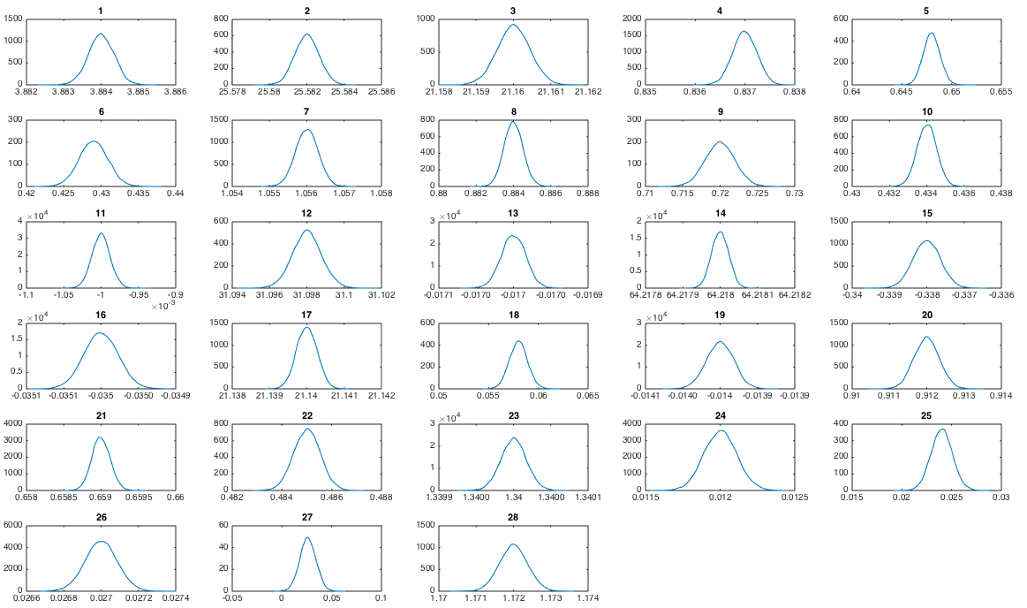

(B) Traceplots of MCMC iterations.

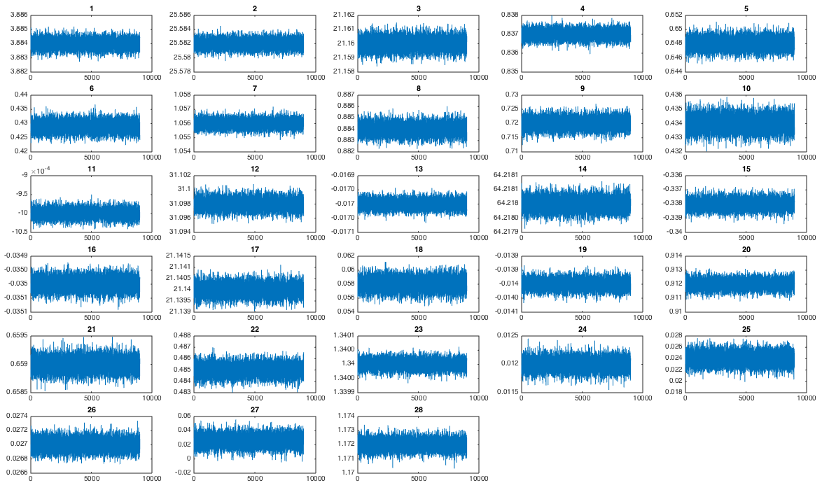

15 Figure AF2: Model fit to fertility data
Fertility data are provided in Table AF1. Educational categories are: 0: none; 1: 1 to 6 years; 2: >6 to 12 years; 3: >12 years. In all plots, gray shaded areas are results of 10,000 repeated samples from the posterior joint distribution of the fitted model (Figure 1C), with samples from the interquartile range as black lines and data displayed as dashed blue lines or circles reflecting the 95% confidence intervals of the input datasets.

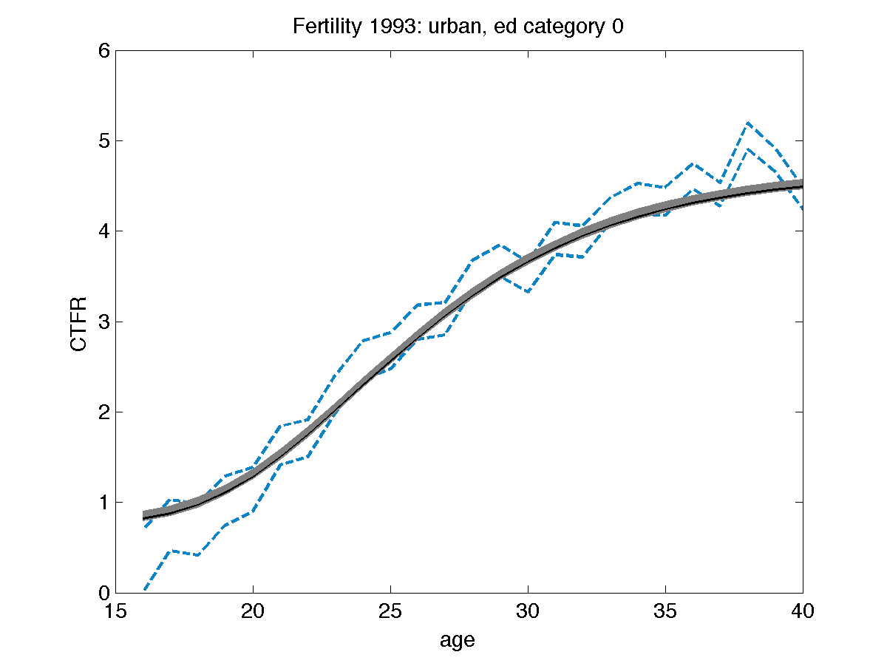
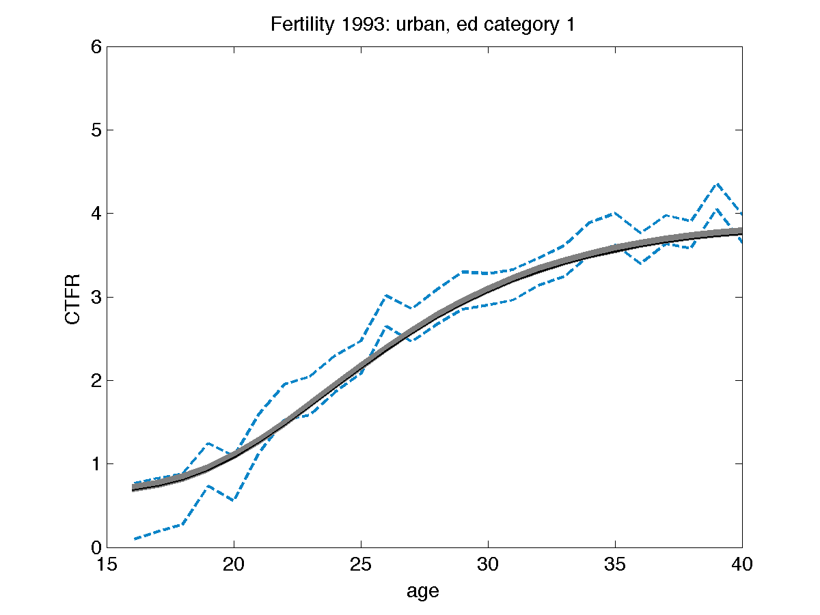
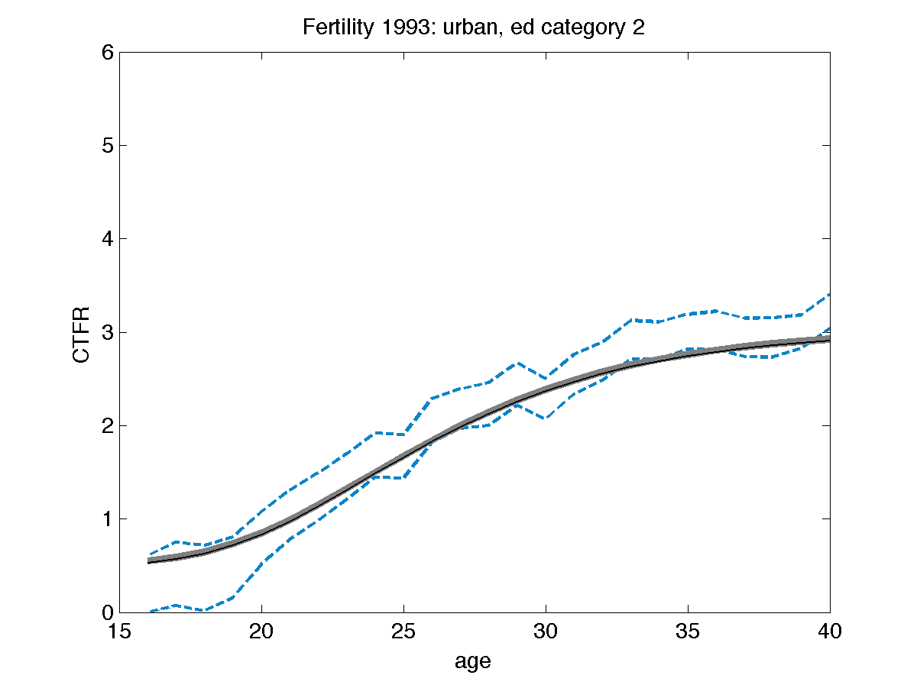
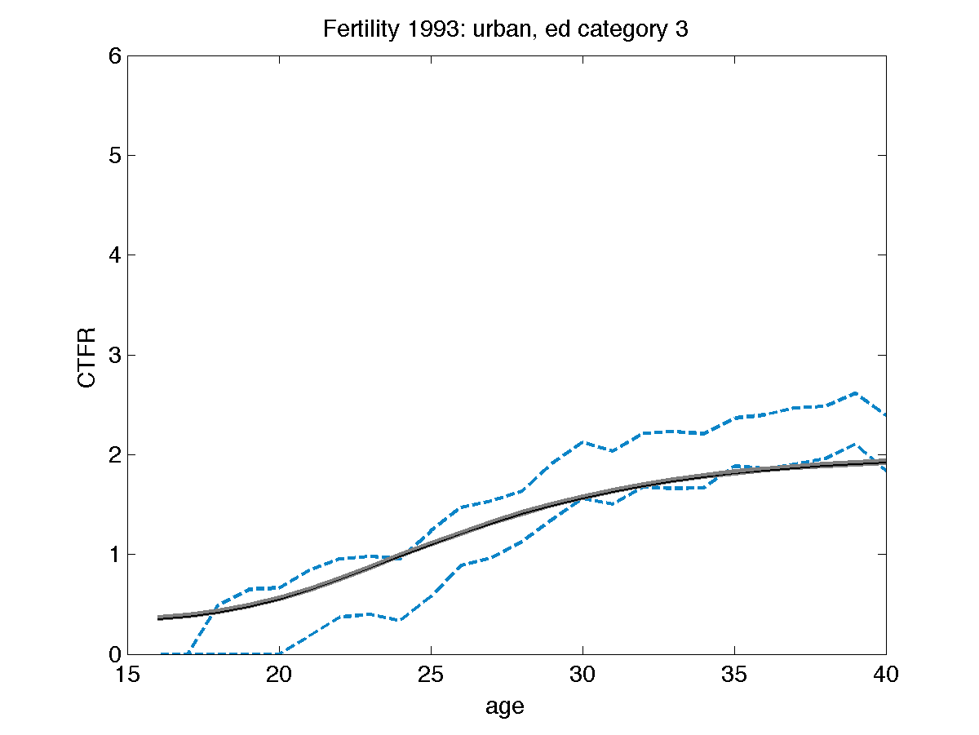
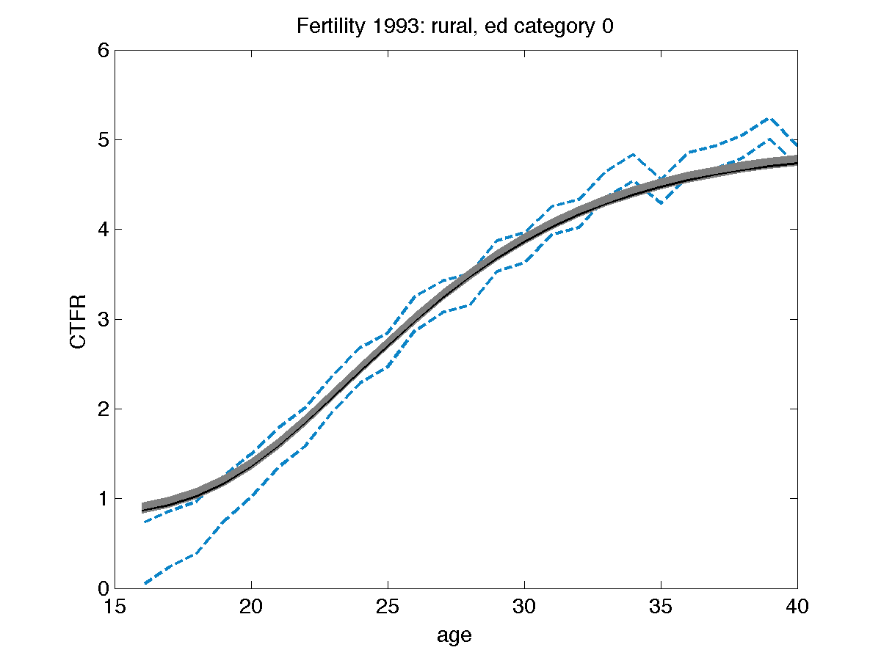
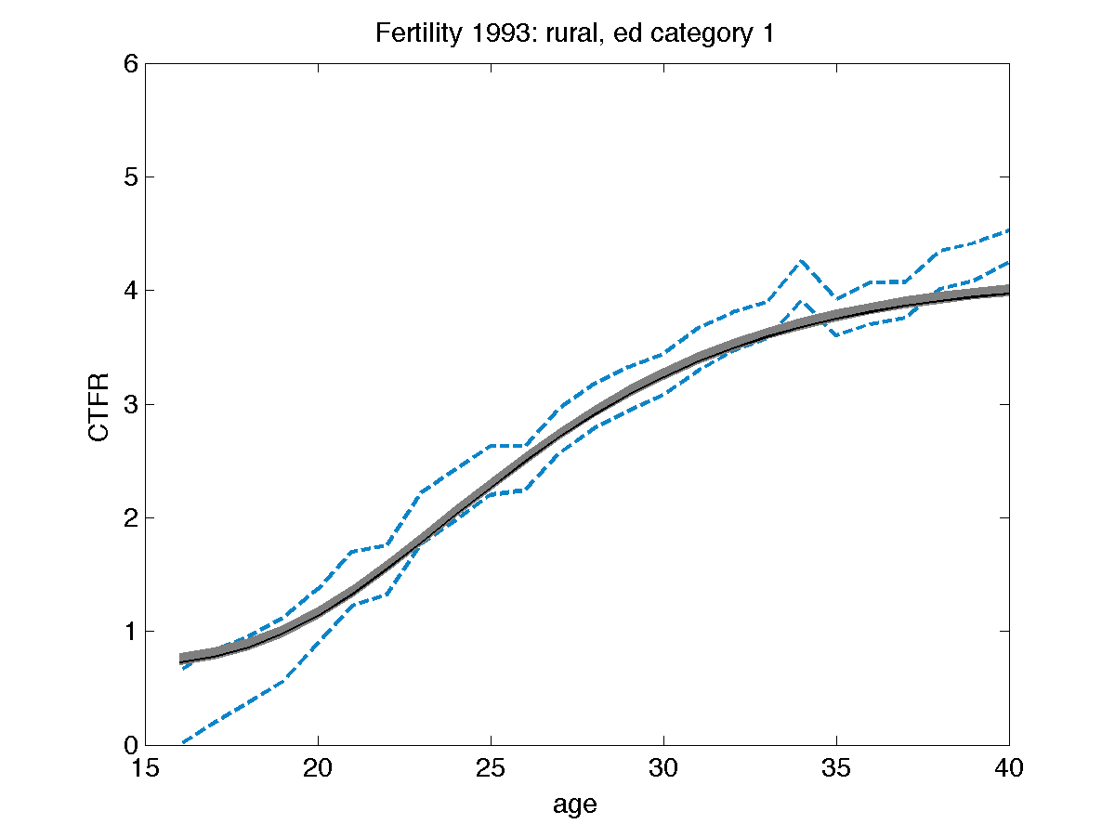
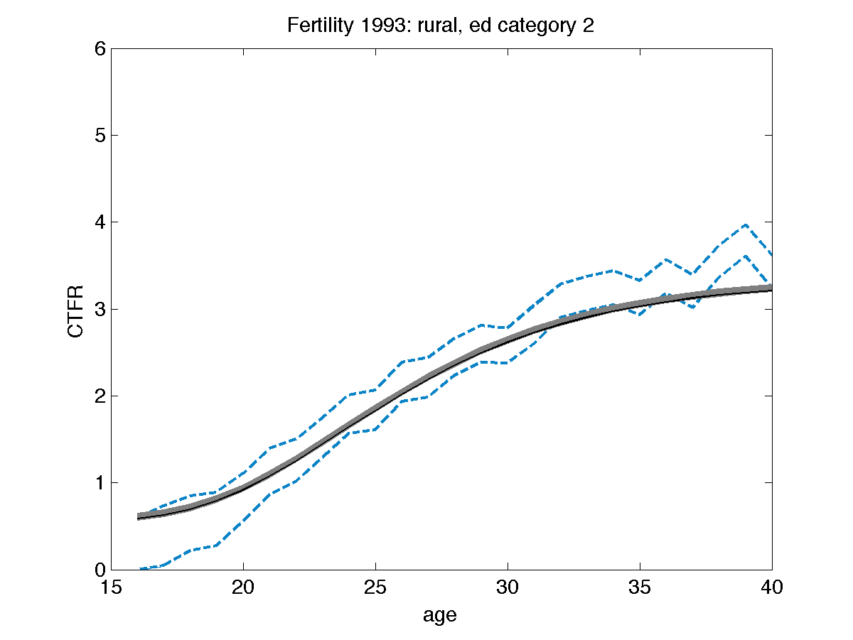
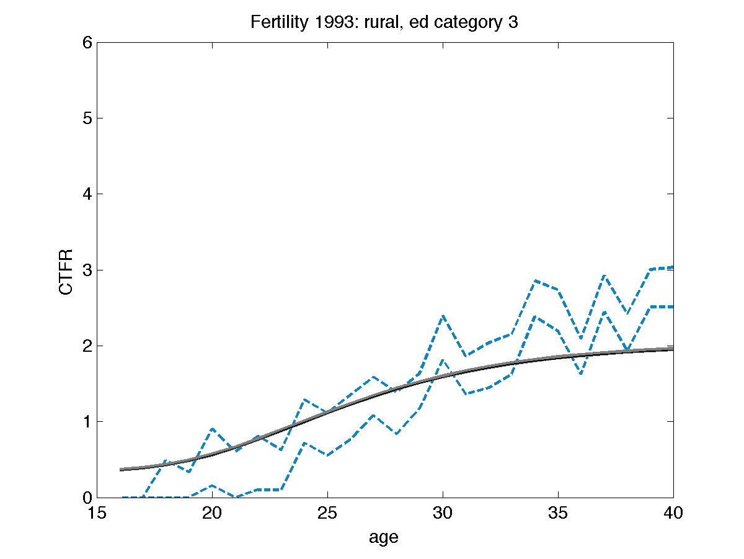
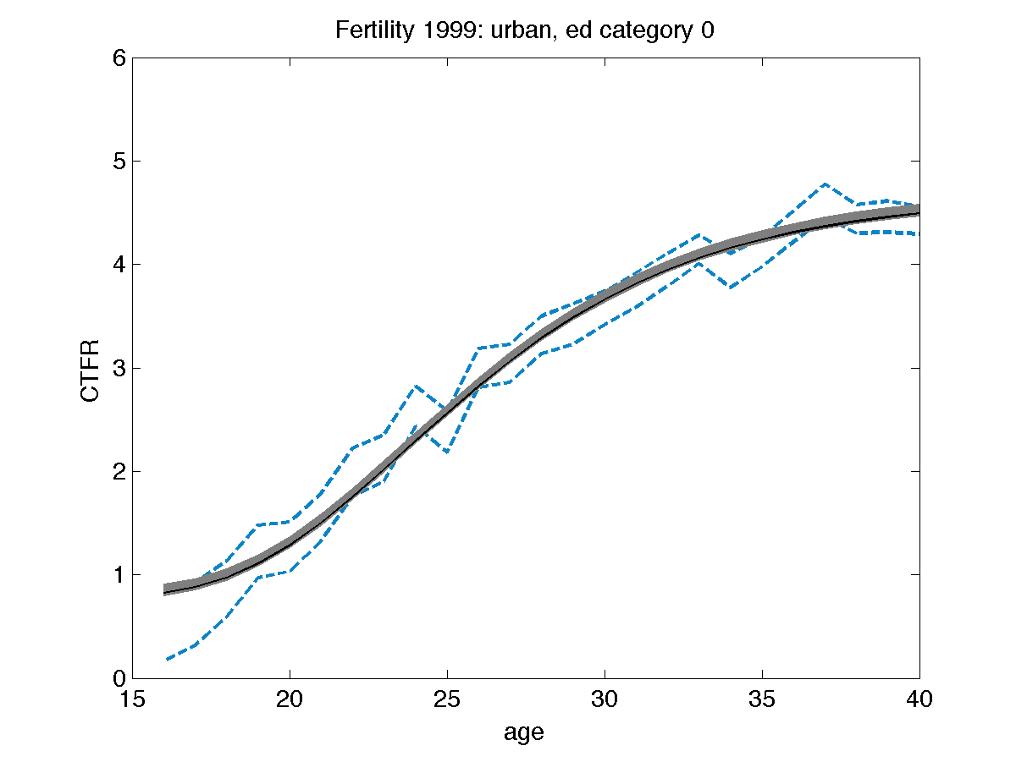
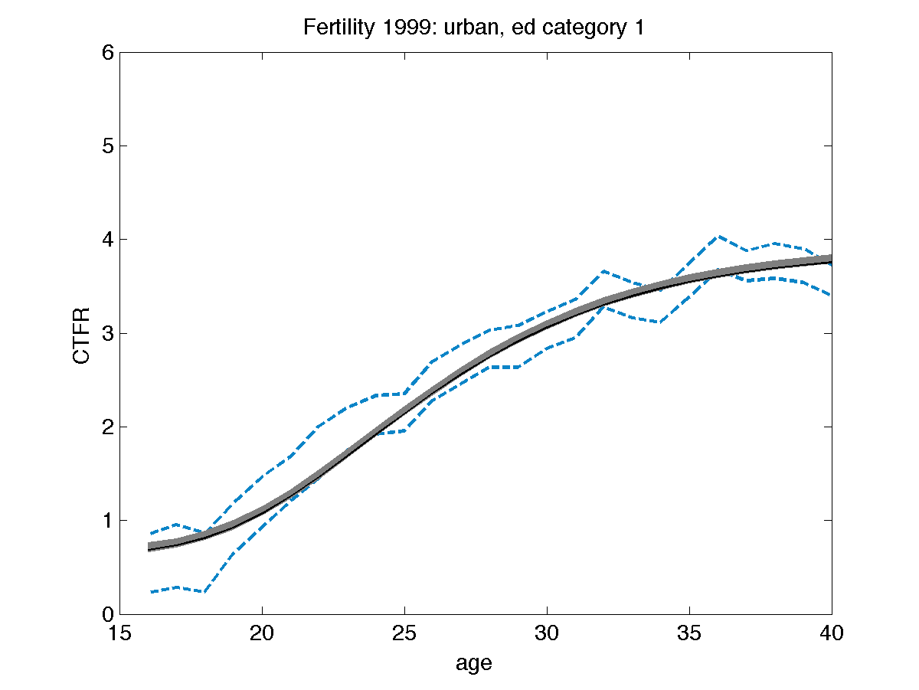
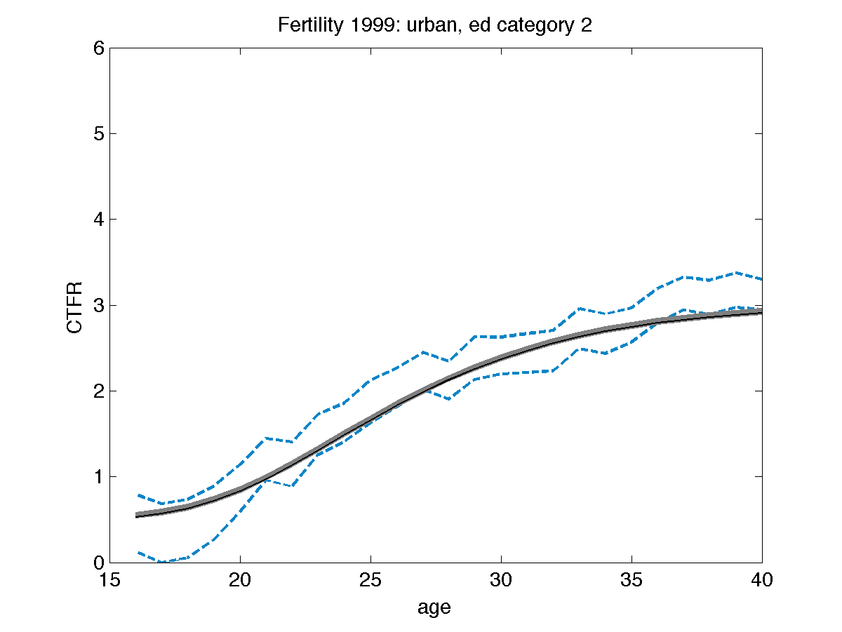
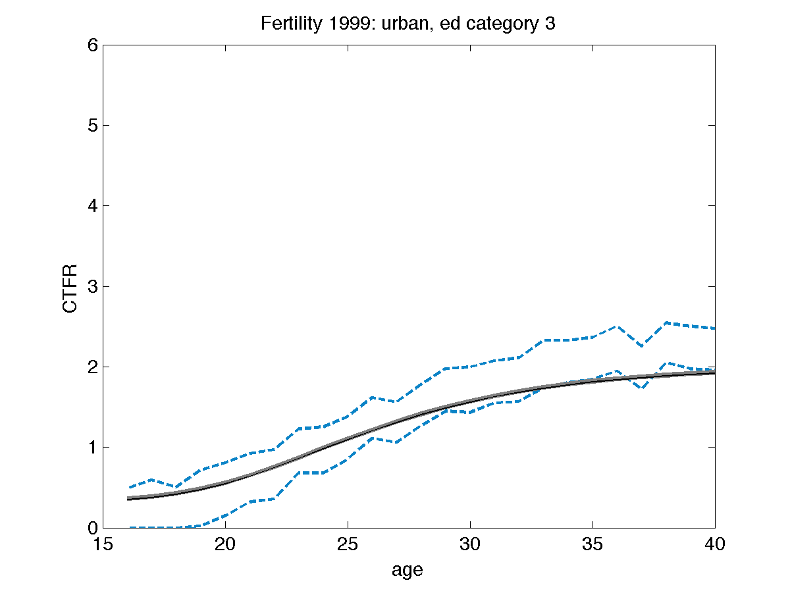
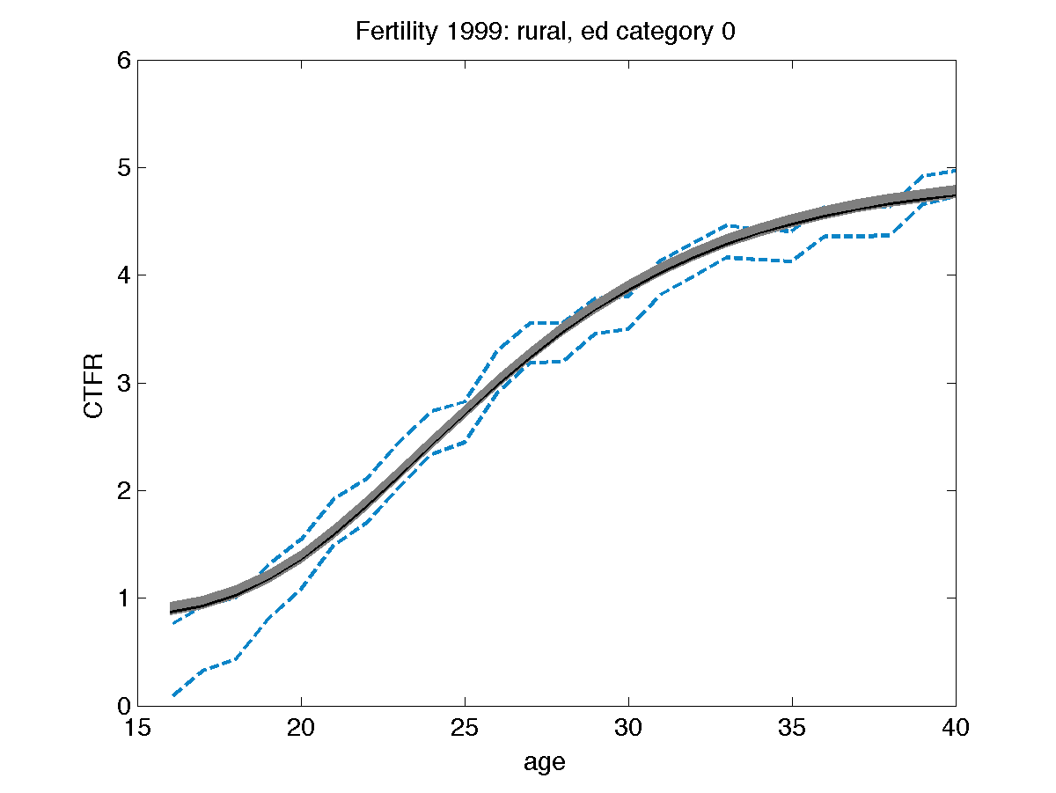
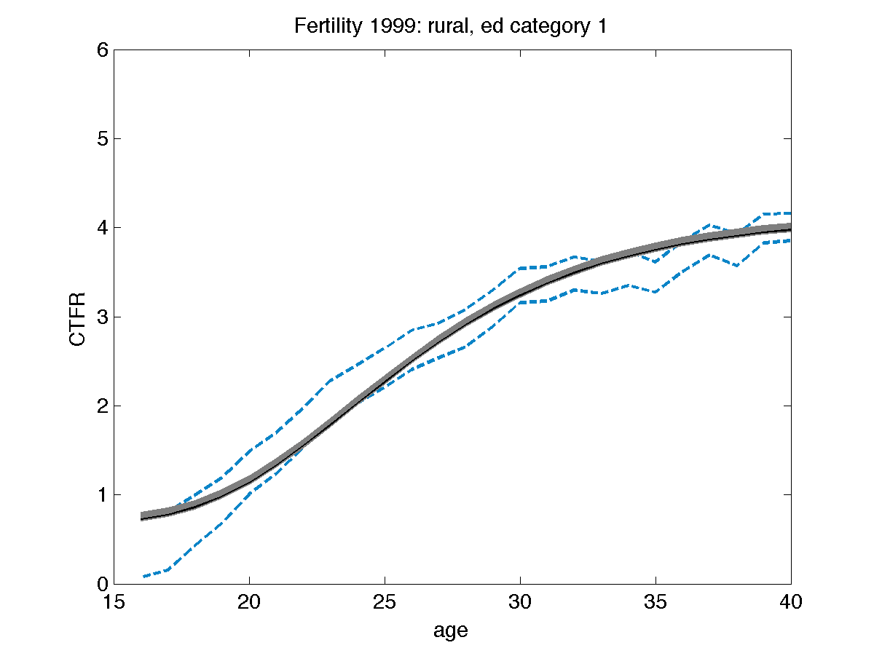
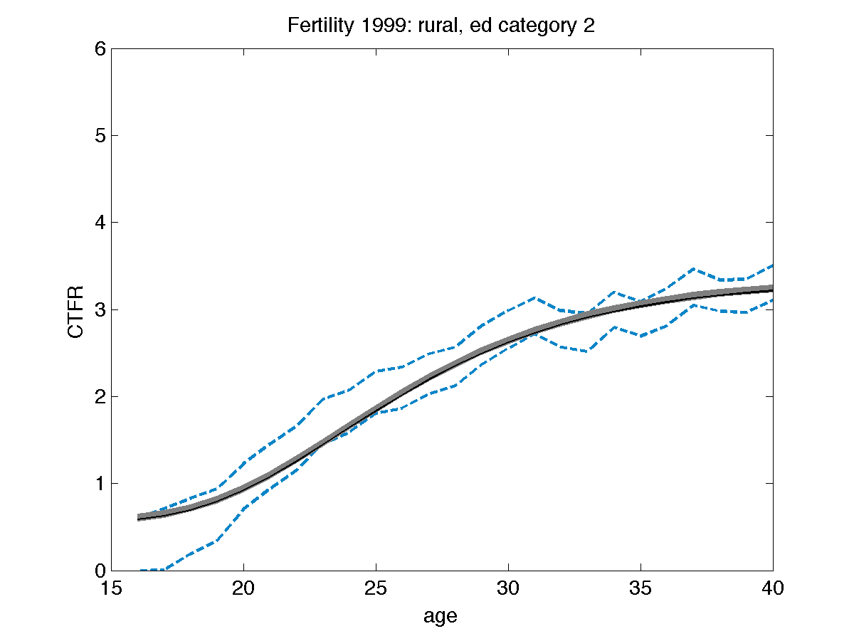
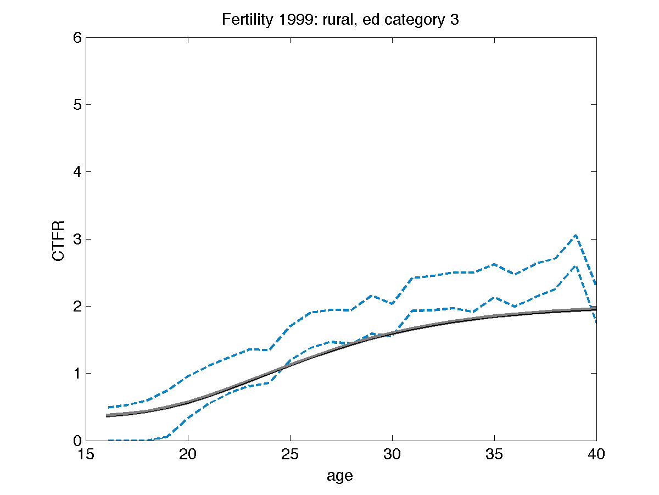
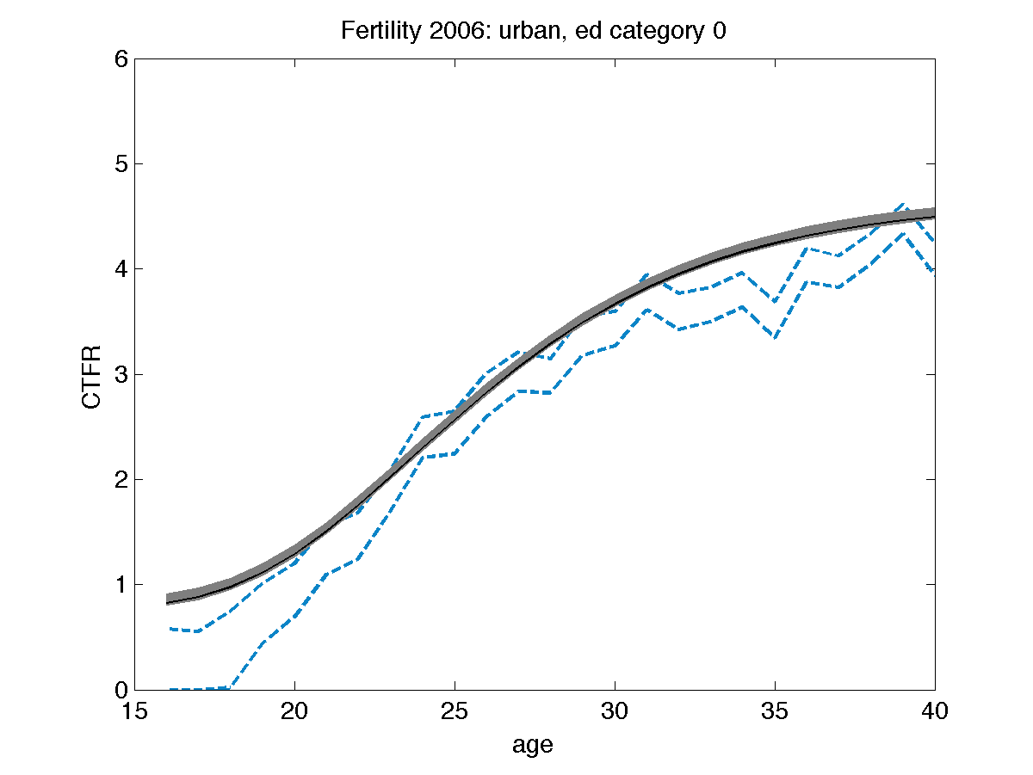
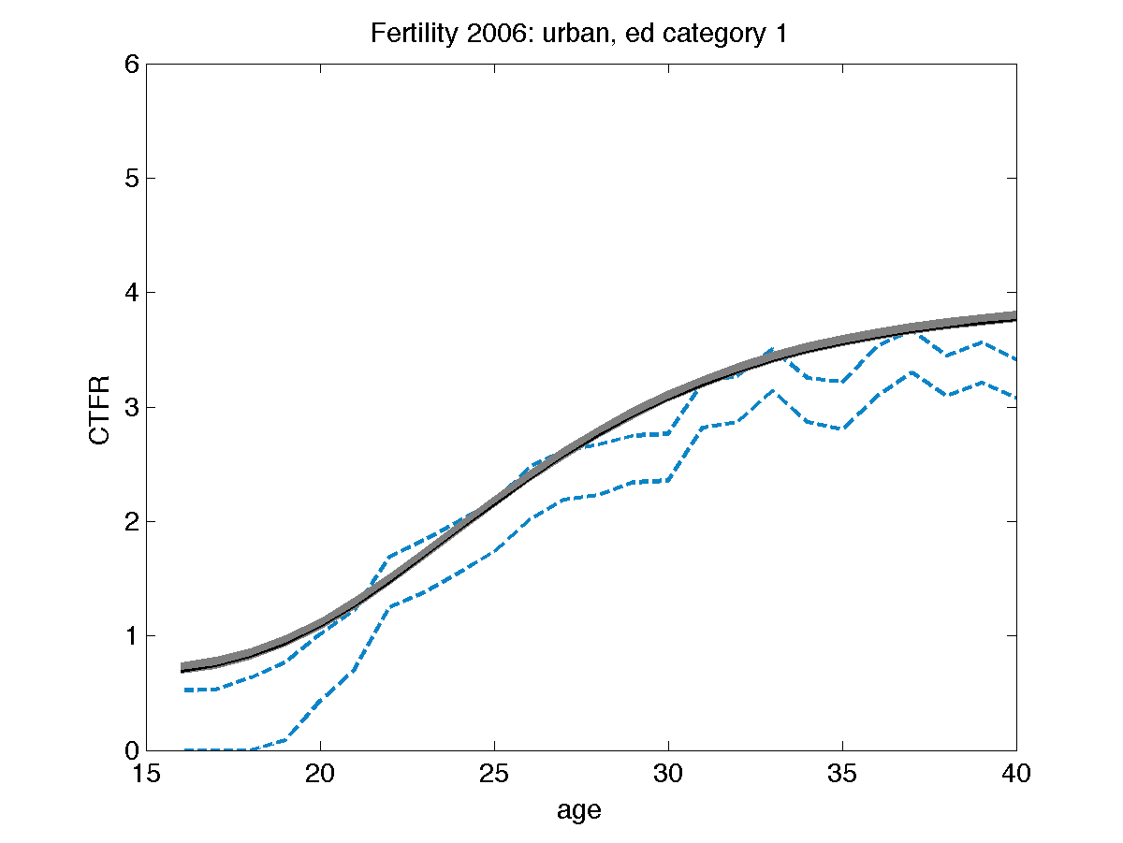
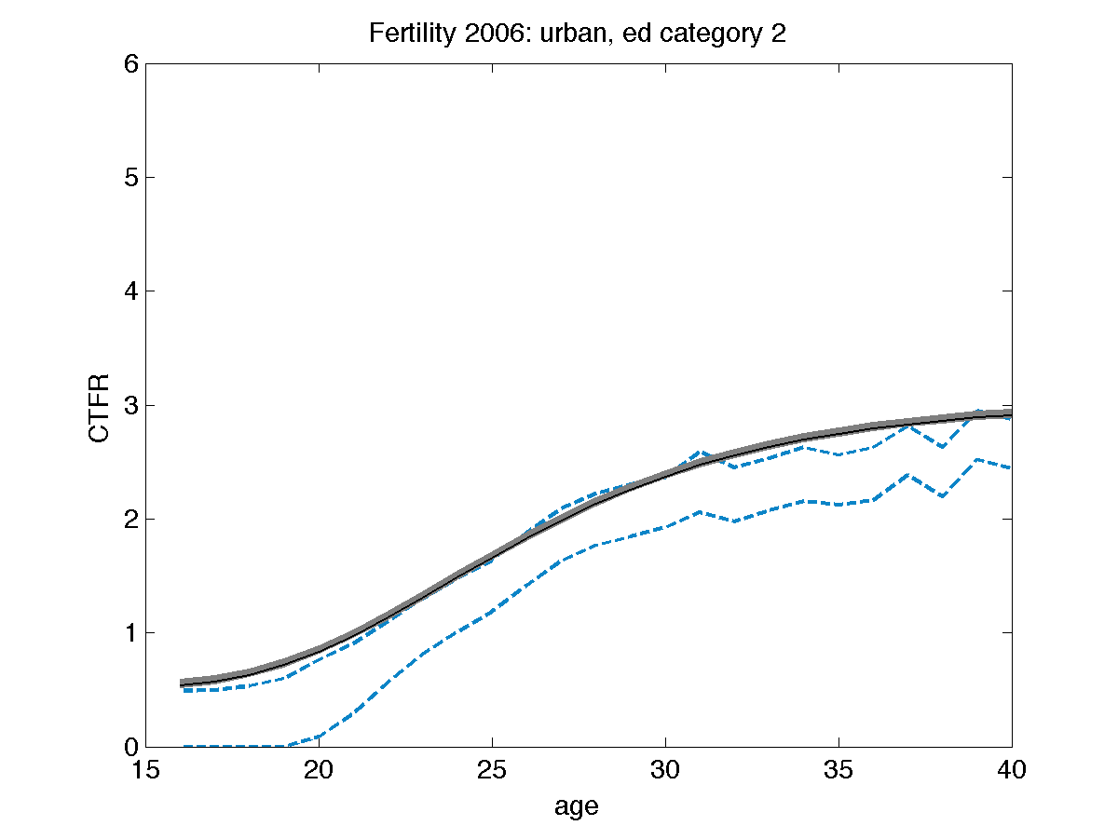
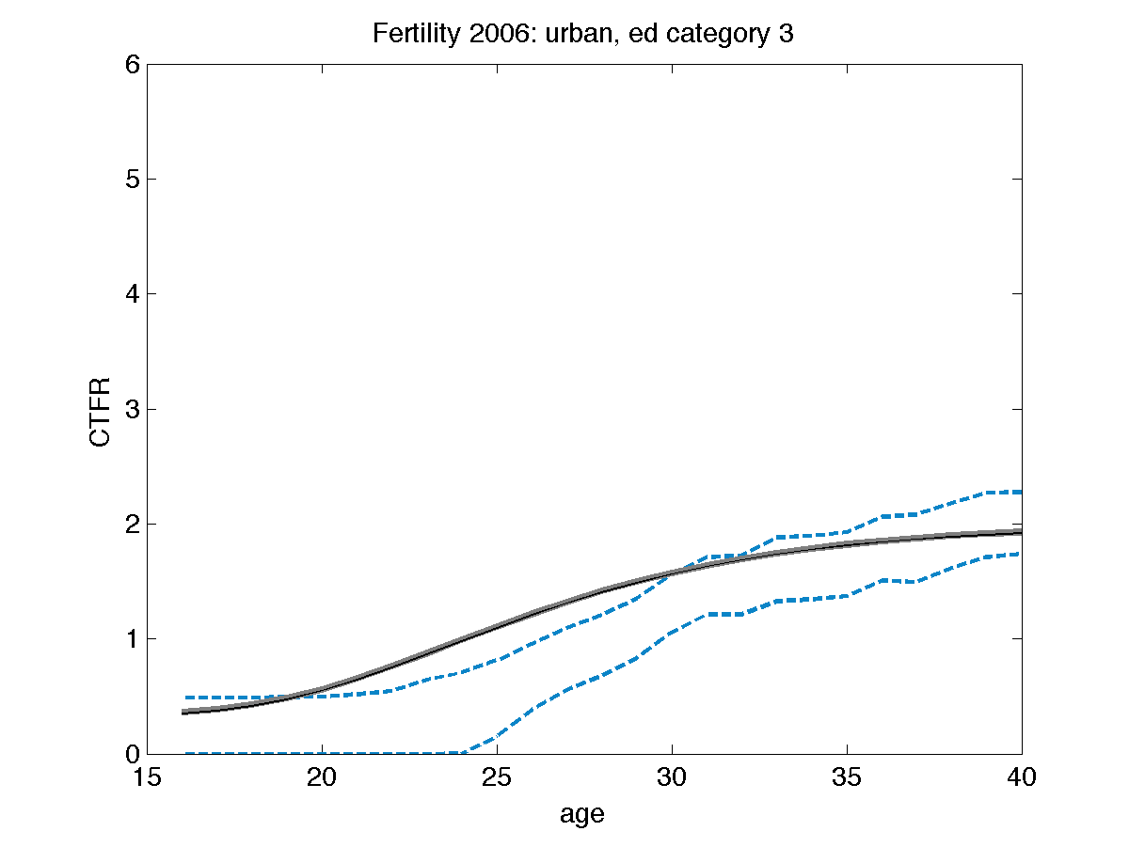
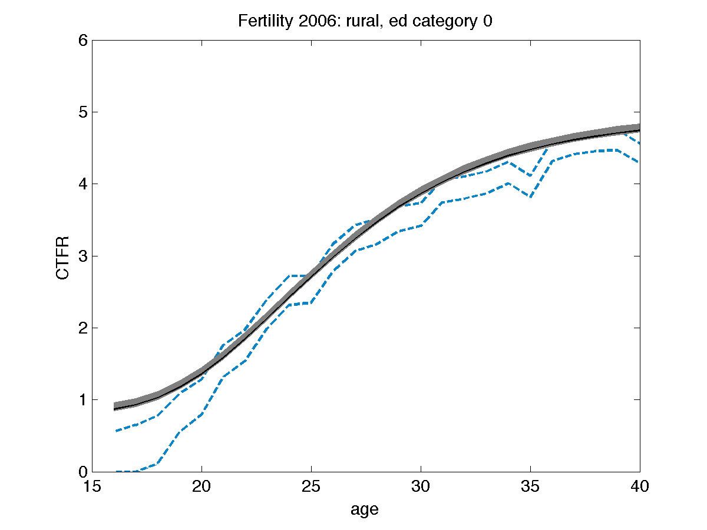
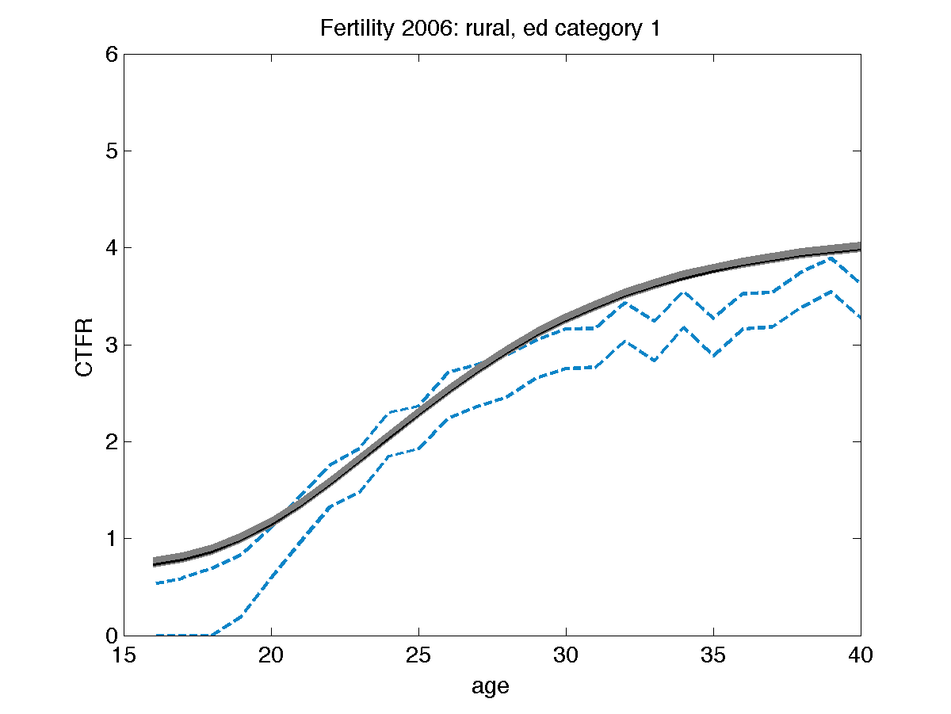
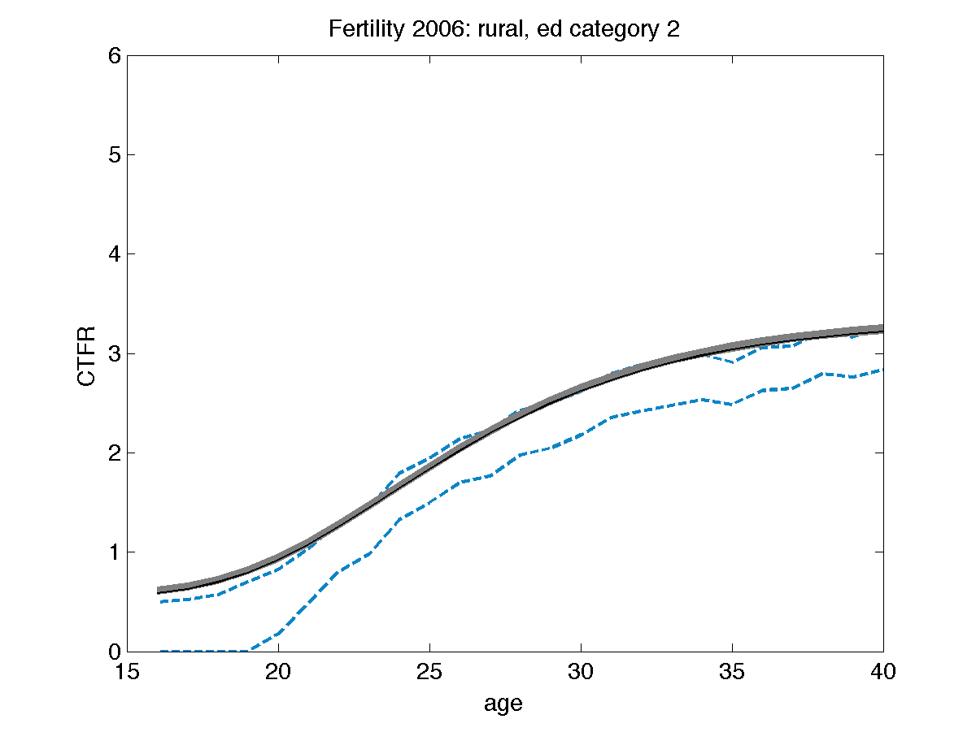
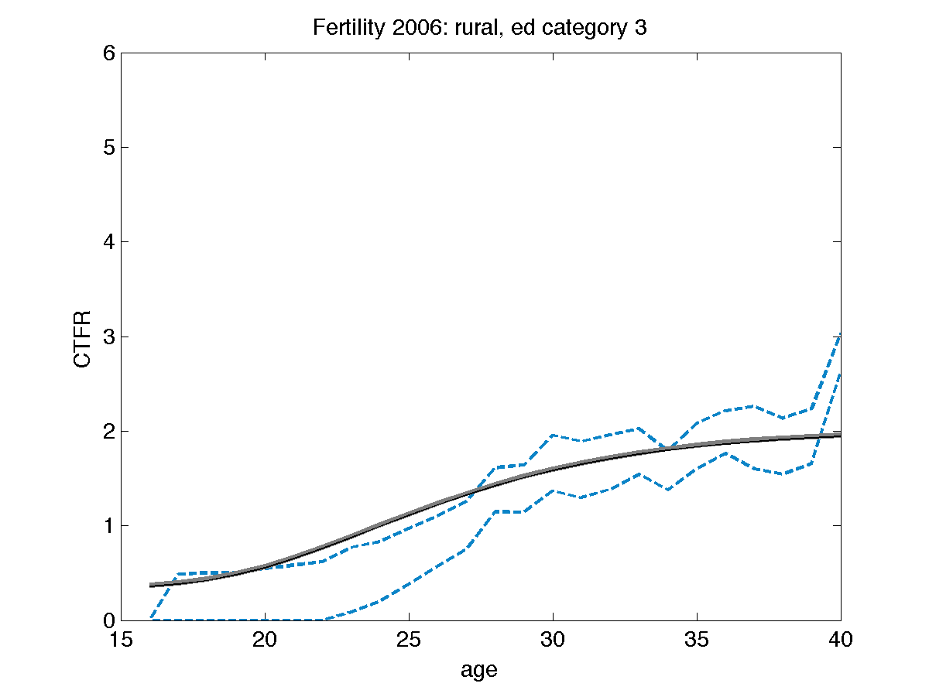

16 Figure AF3: Model fits to mortality data
Mortality data are provided in Table AF2. Educational categories are: 0: none; 1: 1 to 6 years; 2: >6 to 12 years; 3: >12 years. In all plots, gray shaded areas are results of 10,000 repeated samples from the posterior joint distribution of the fitted model (Figure 1C), with samples from the interquartile range as black lines and data displayed as dashed blue lines or circles reflecting the 95% confidence intervals of the input datasets.

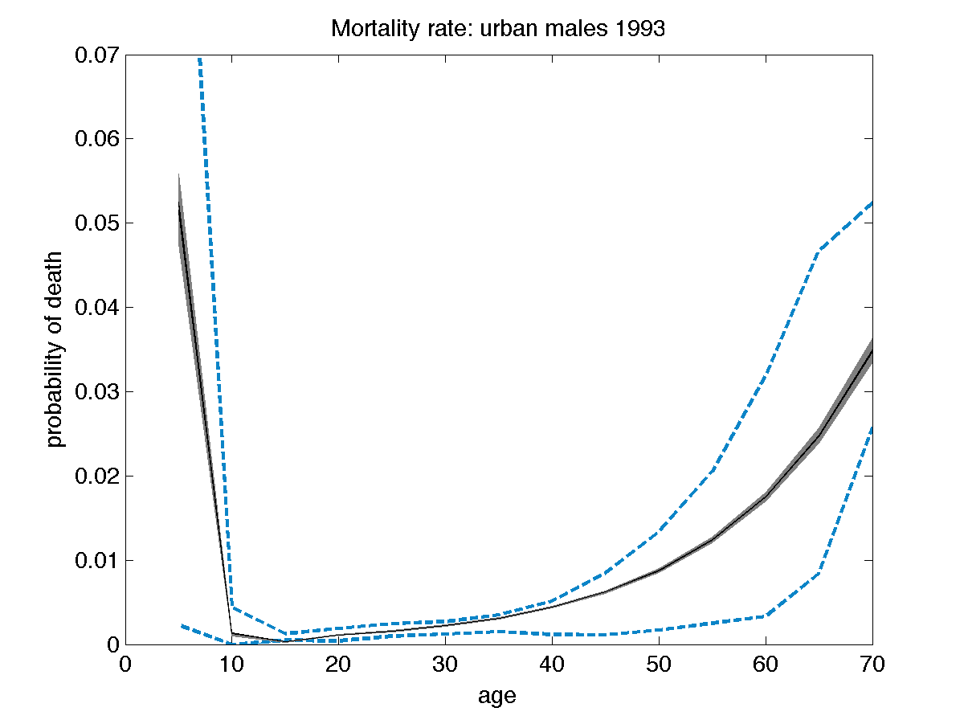
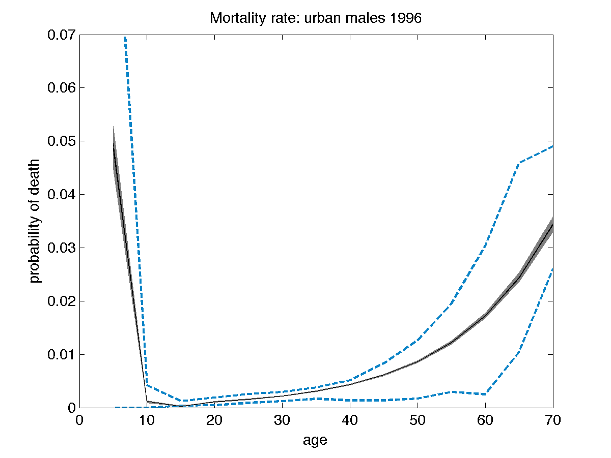
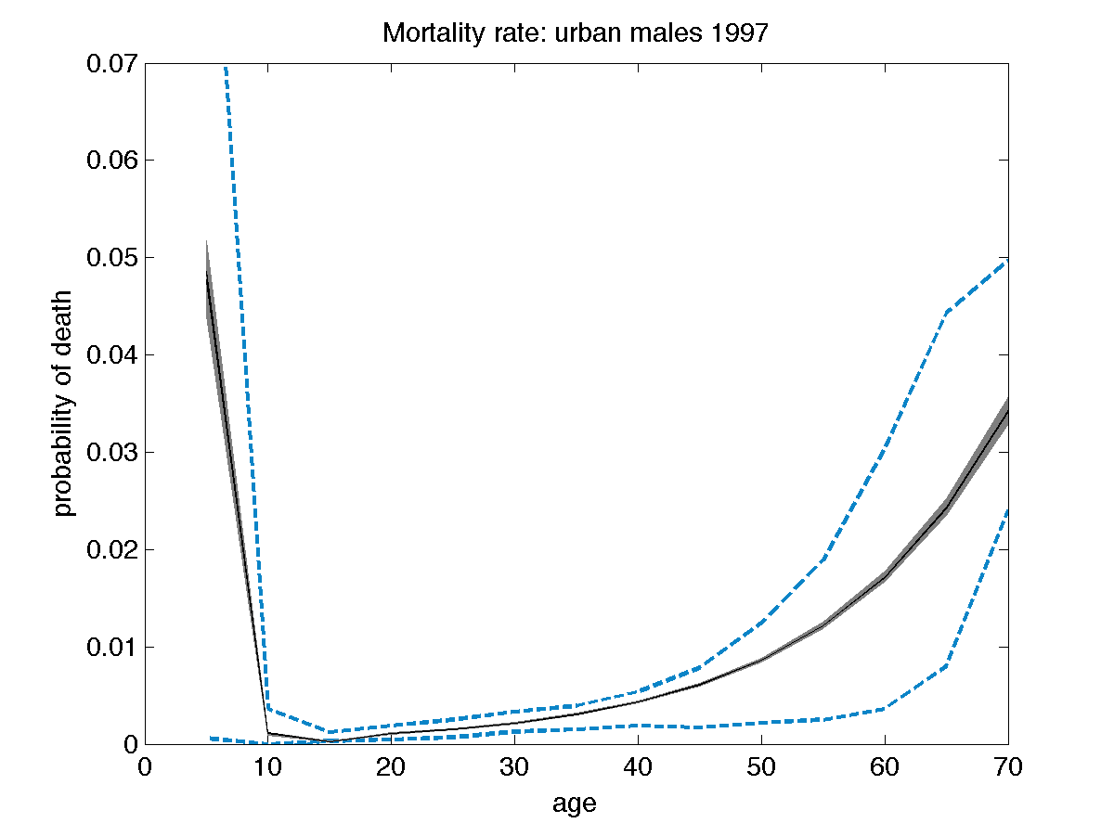
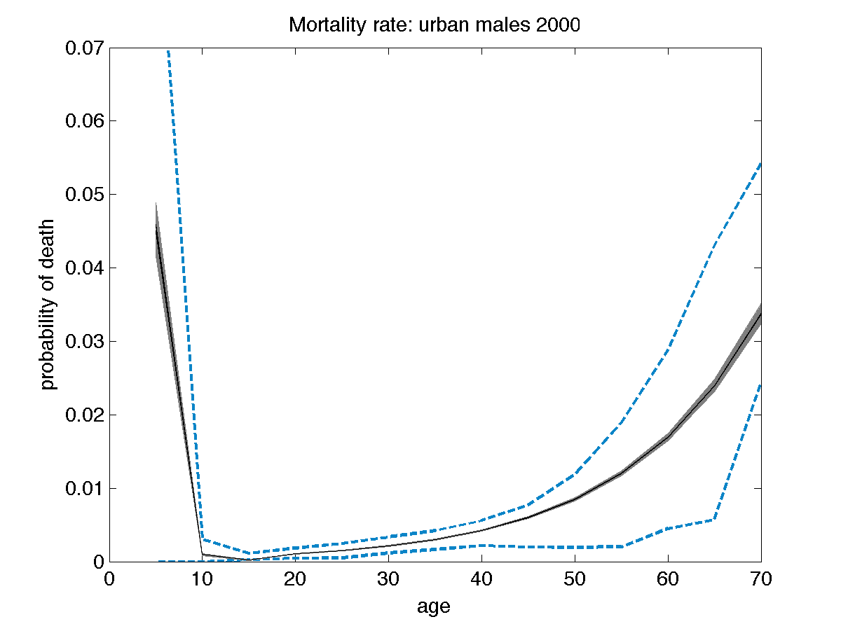
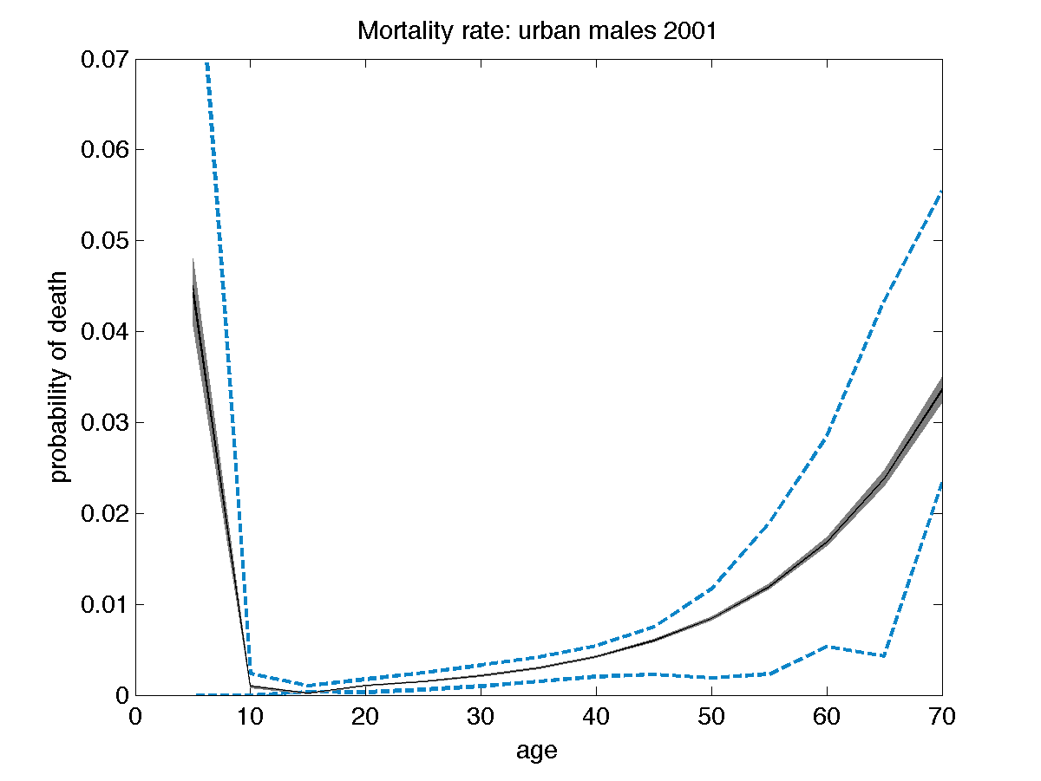
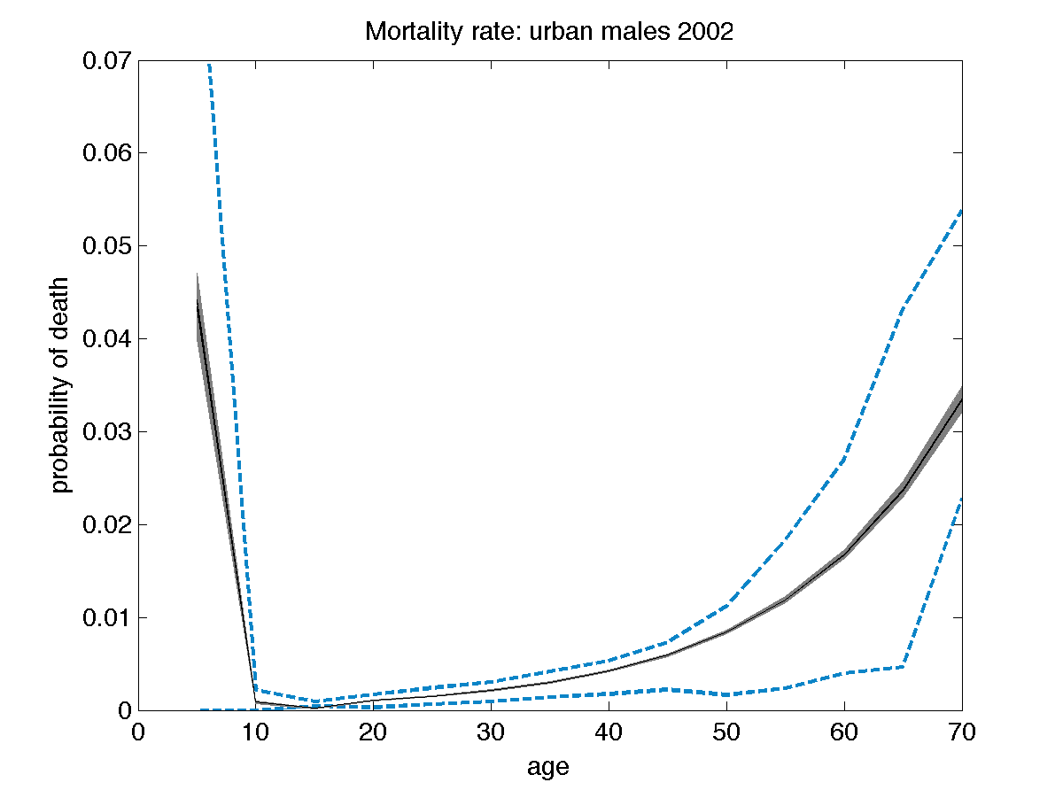
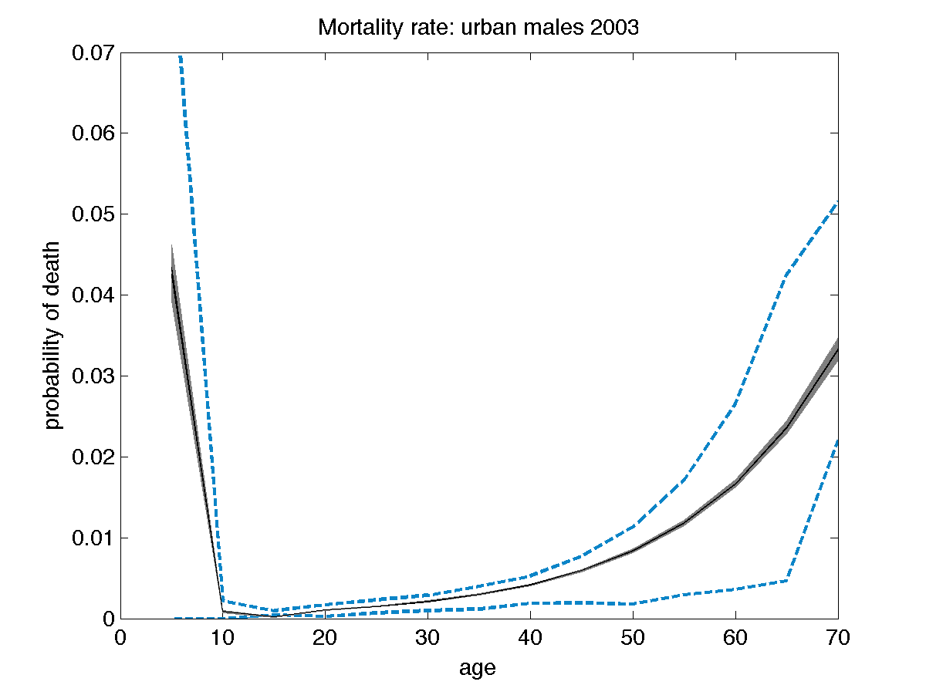
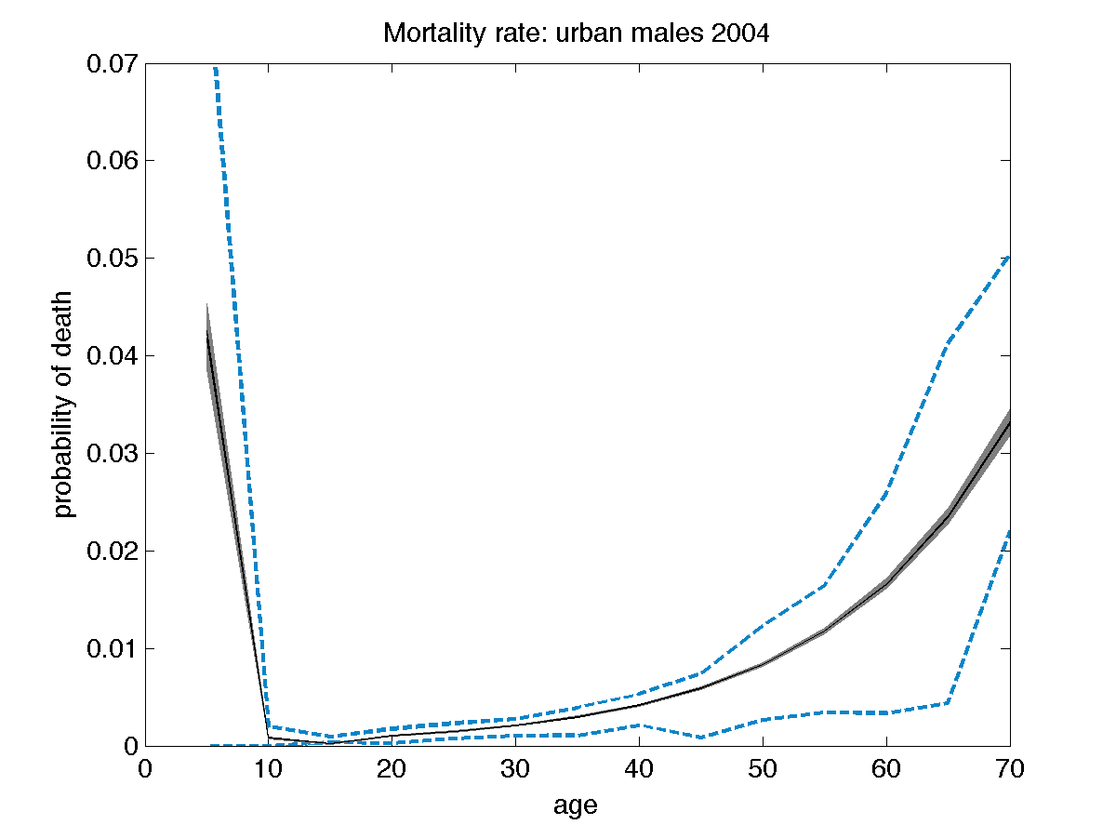
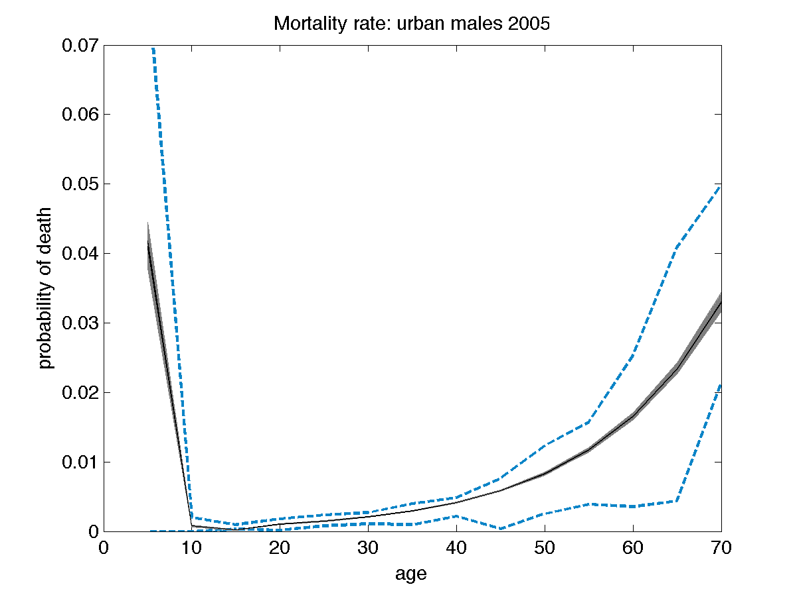
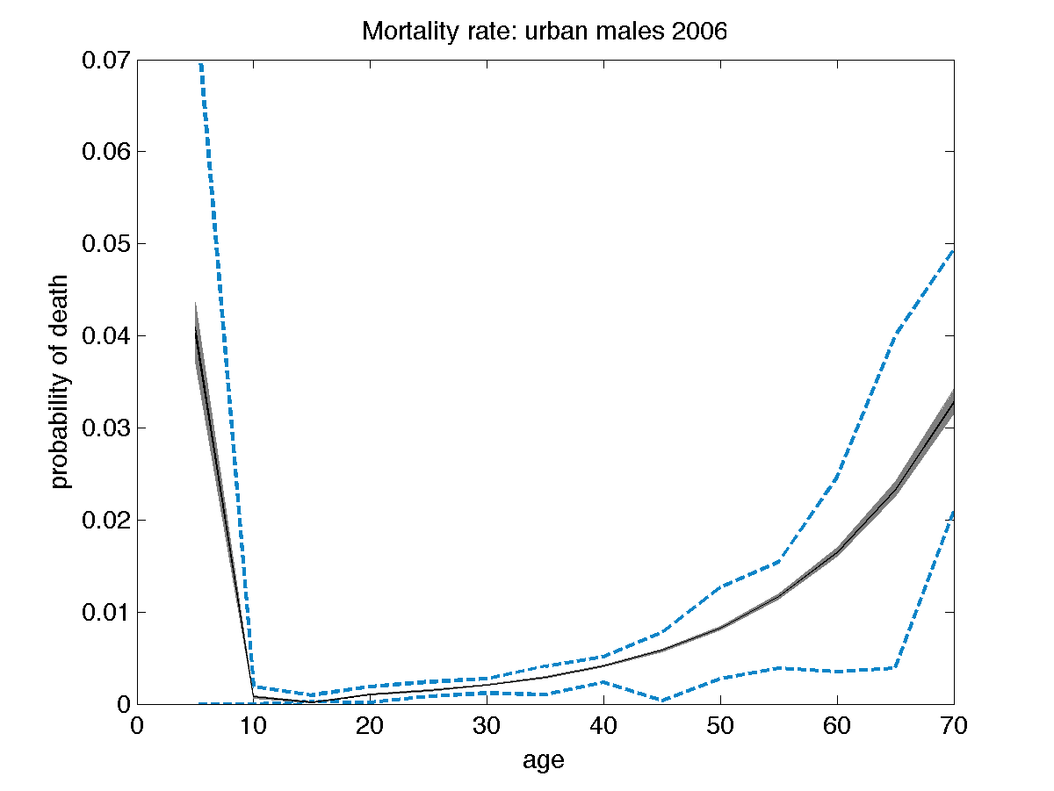
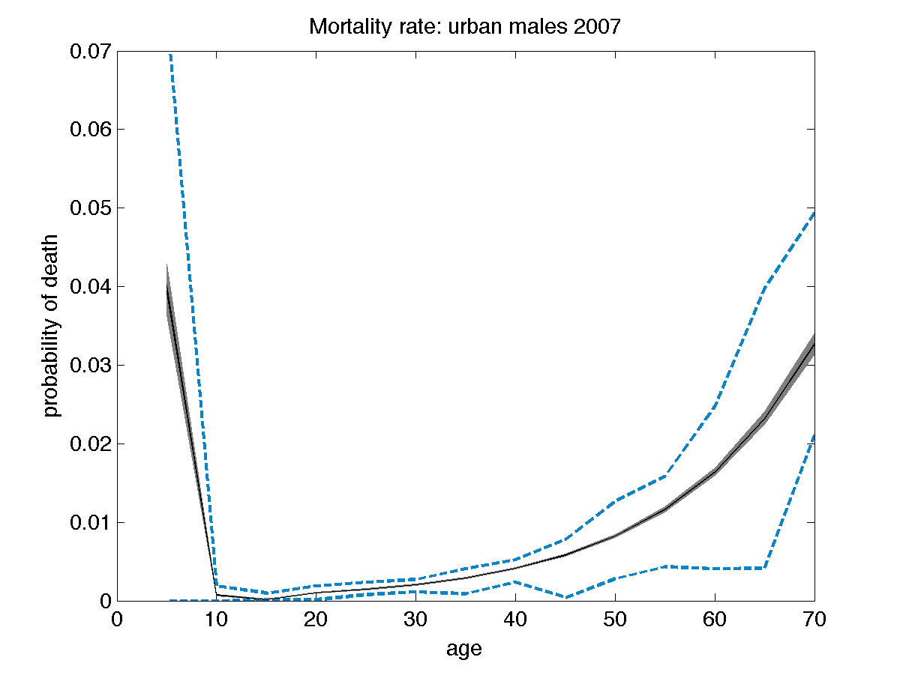
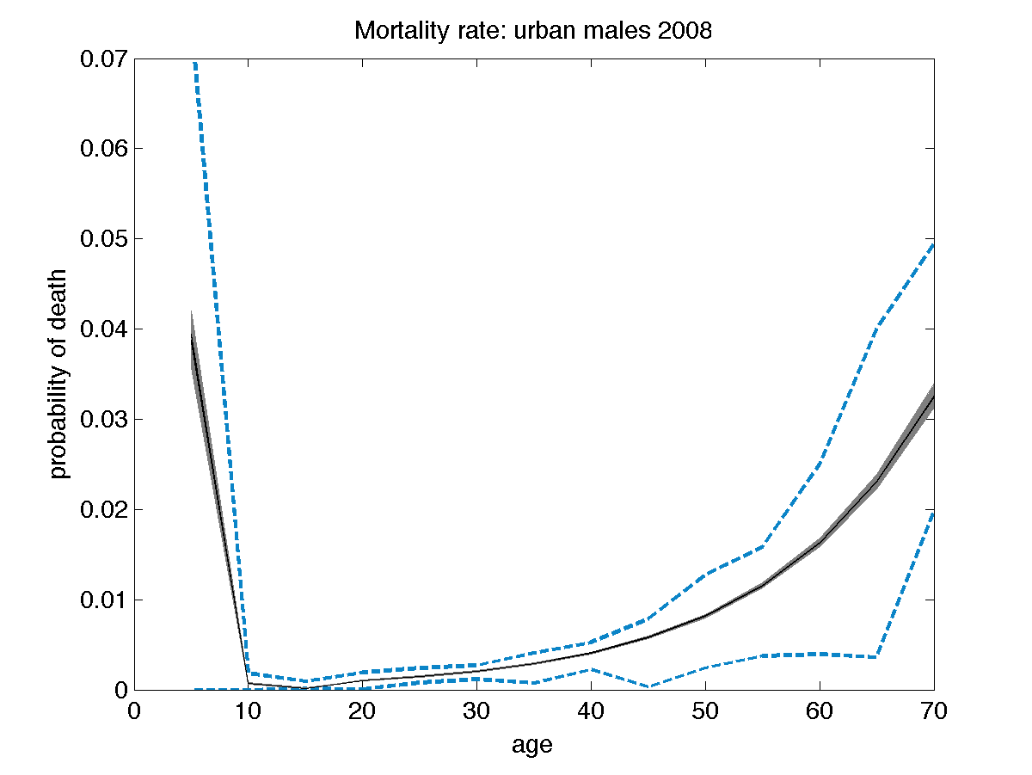
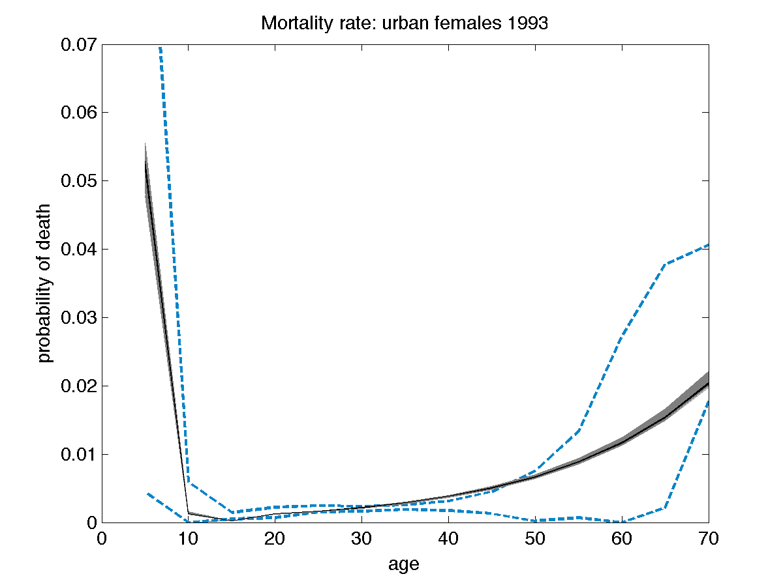
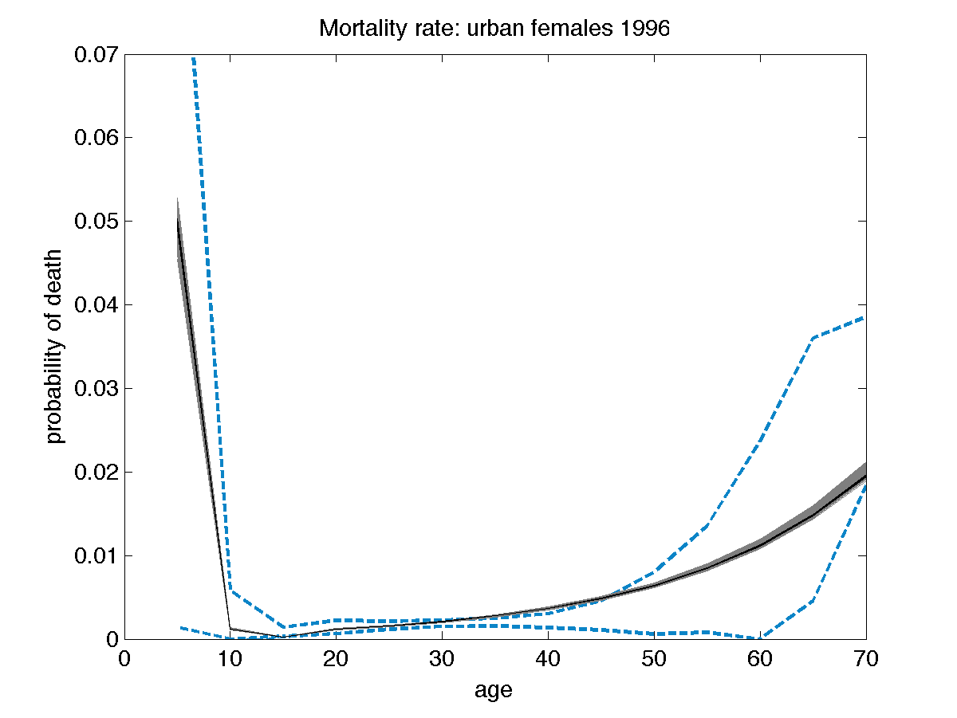
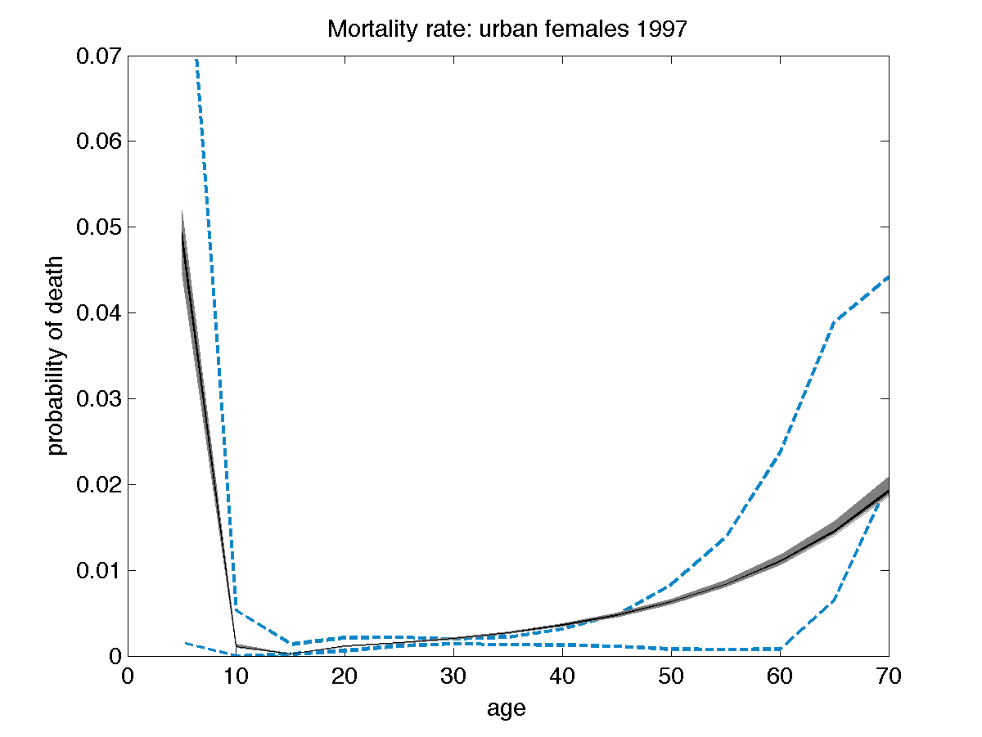
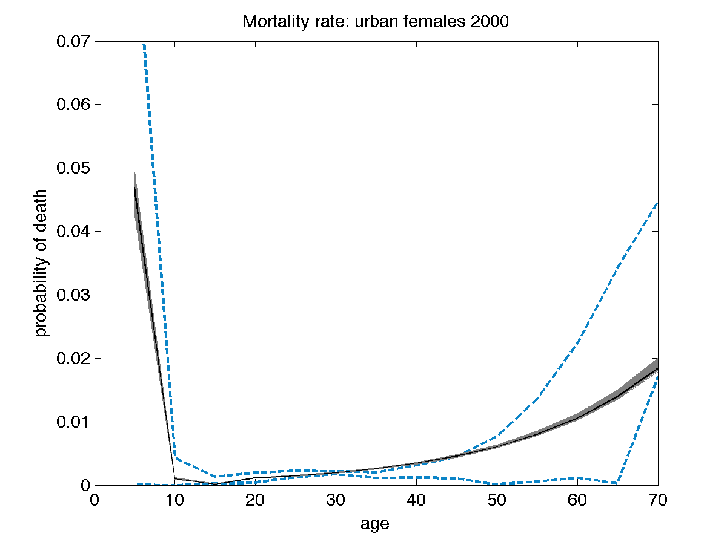
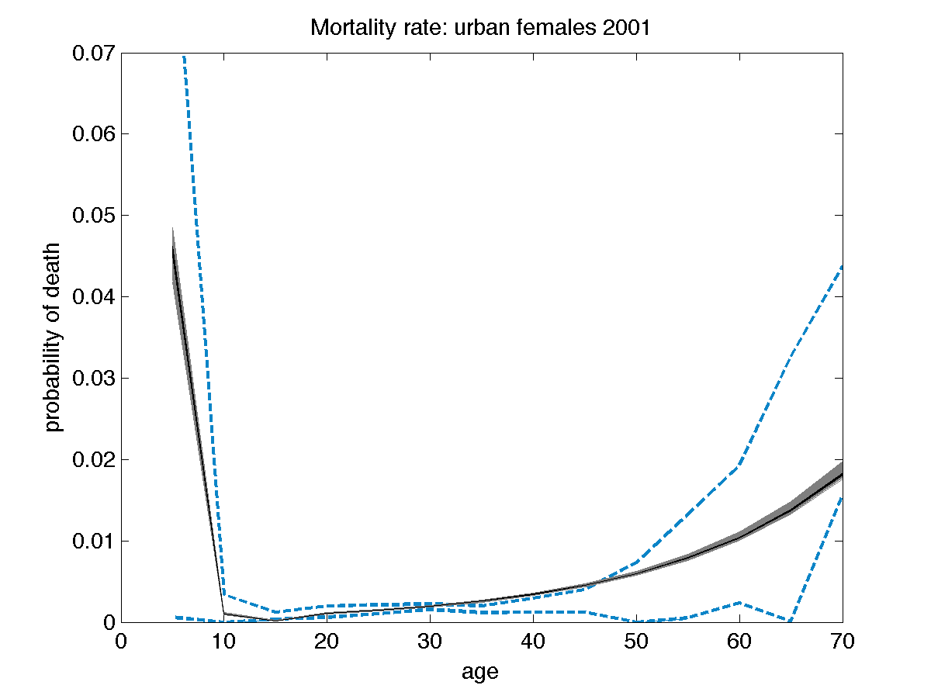
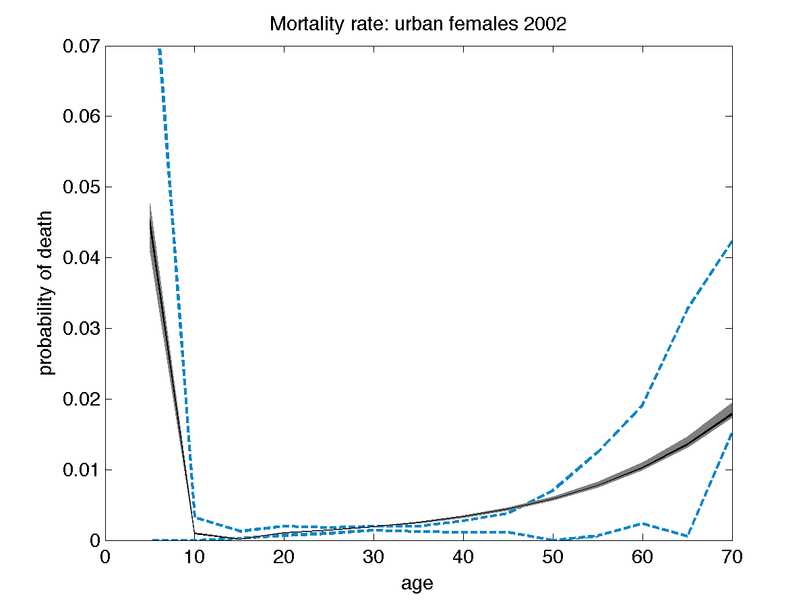
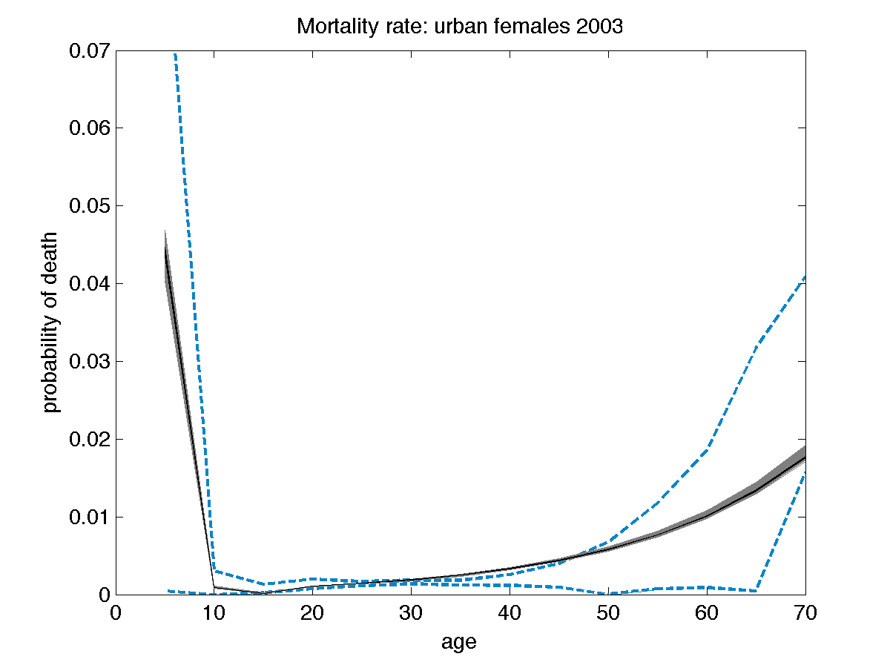
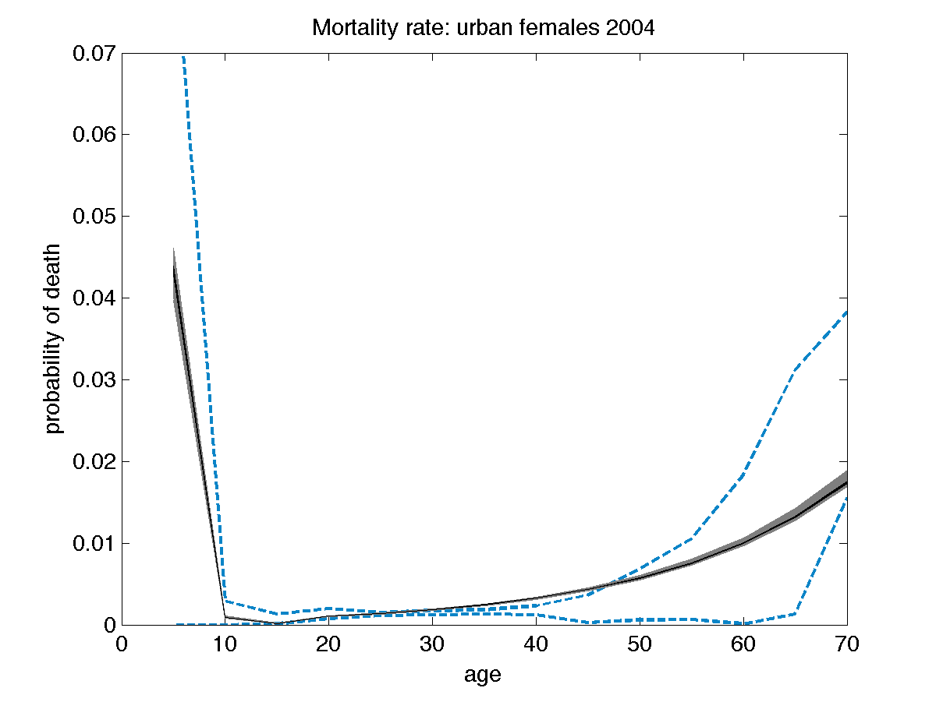
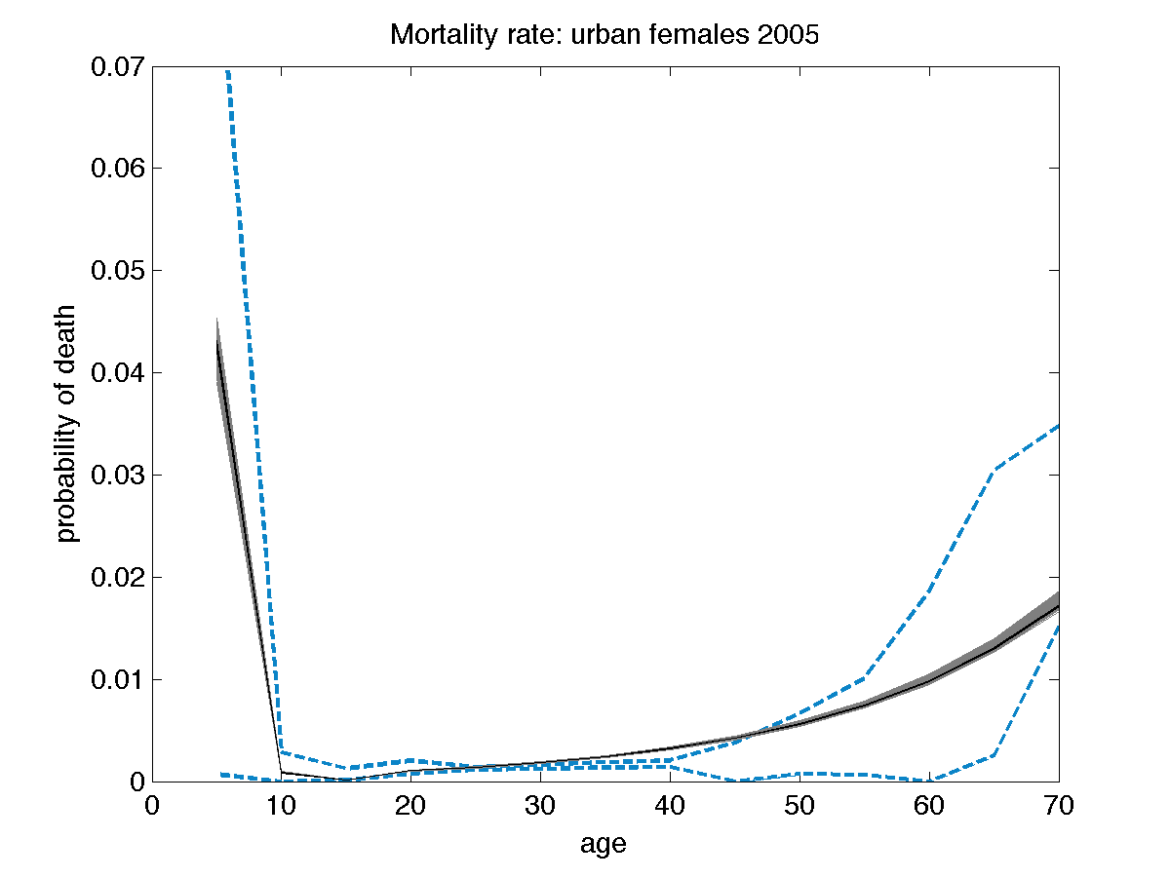
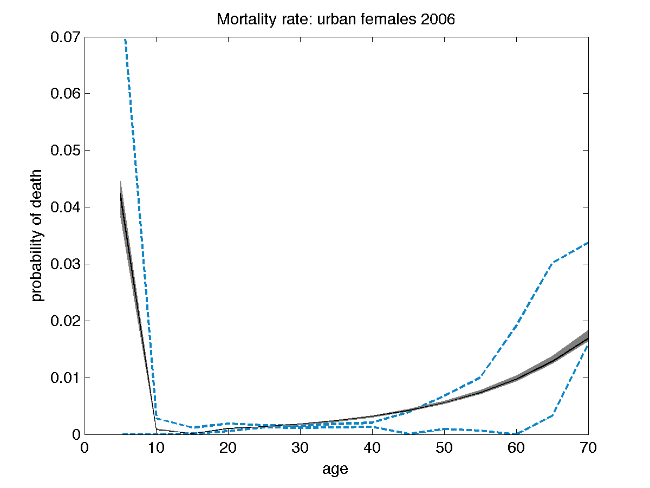
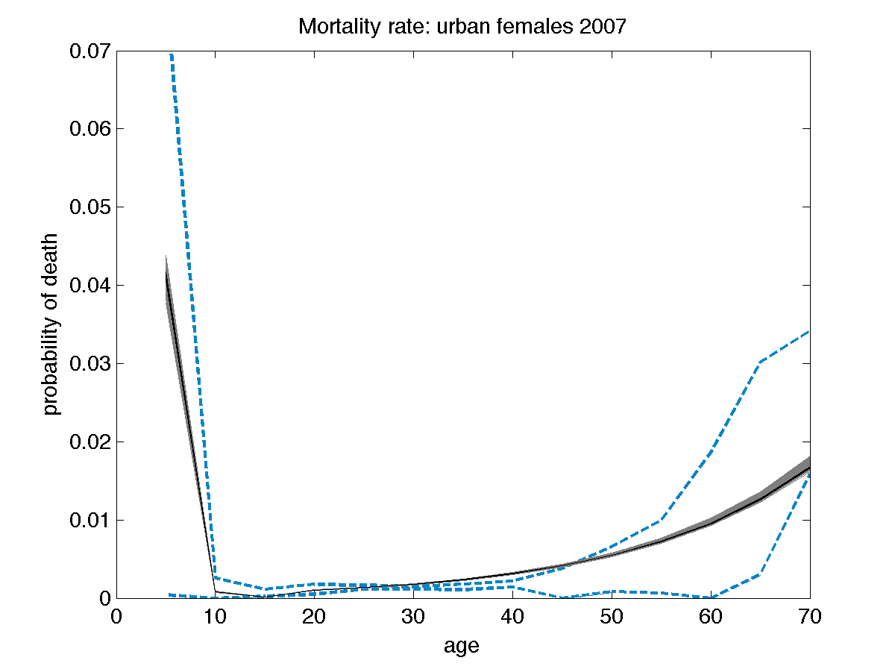
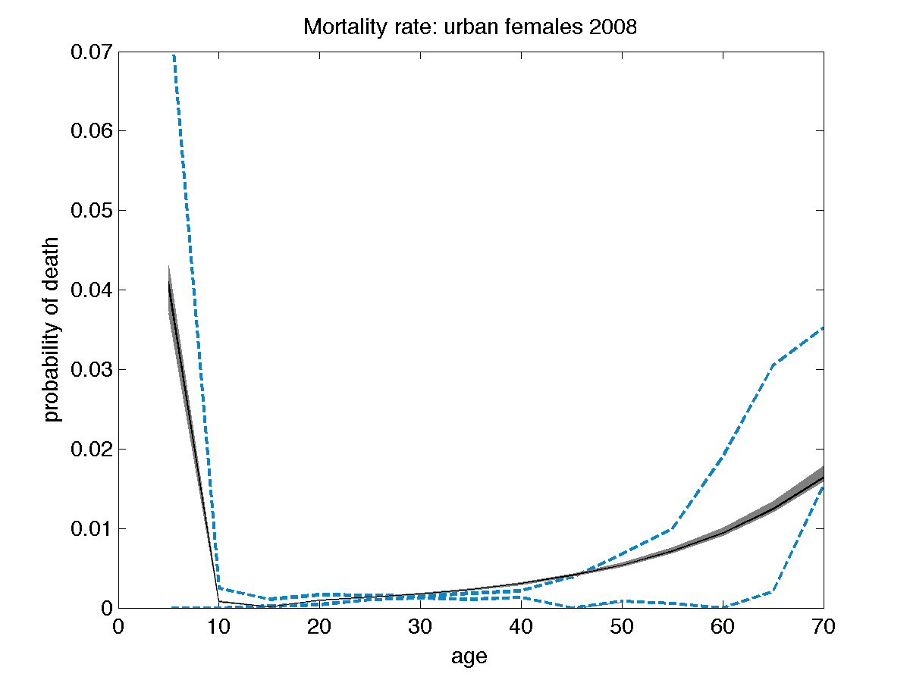
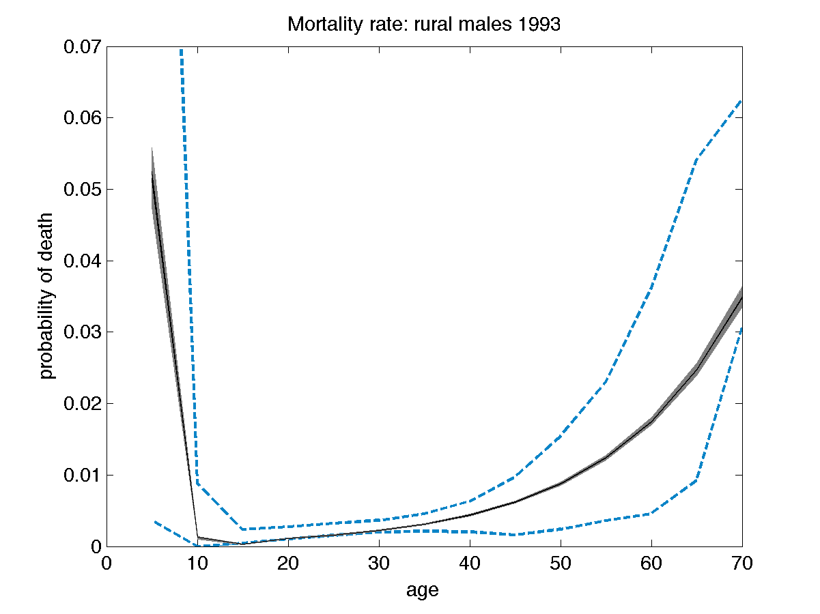
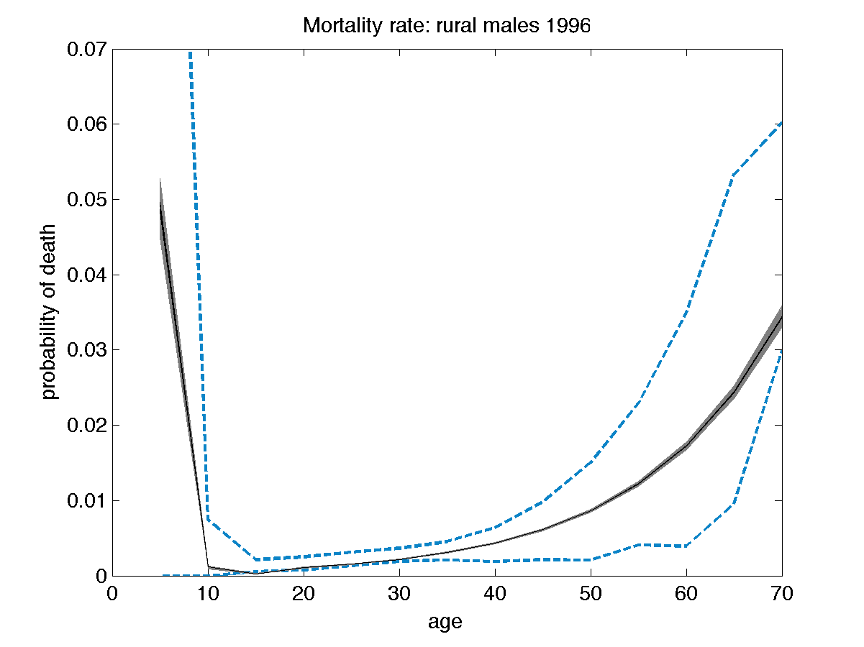
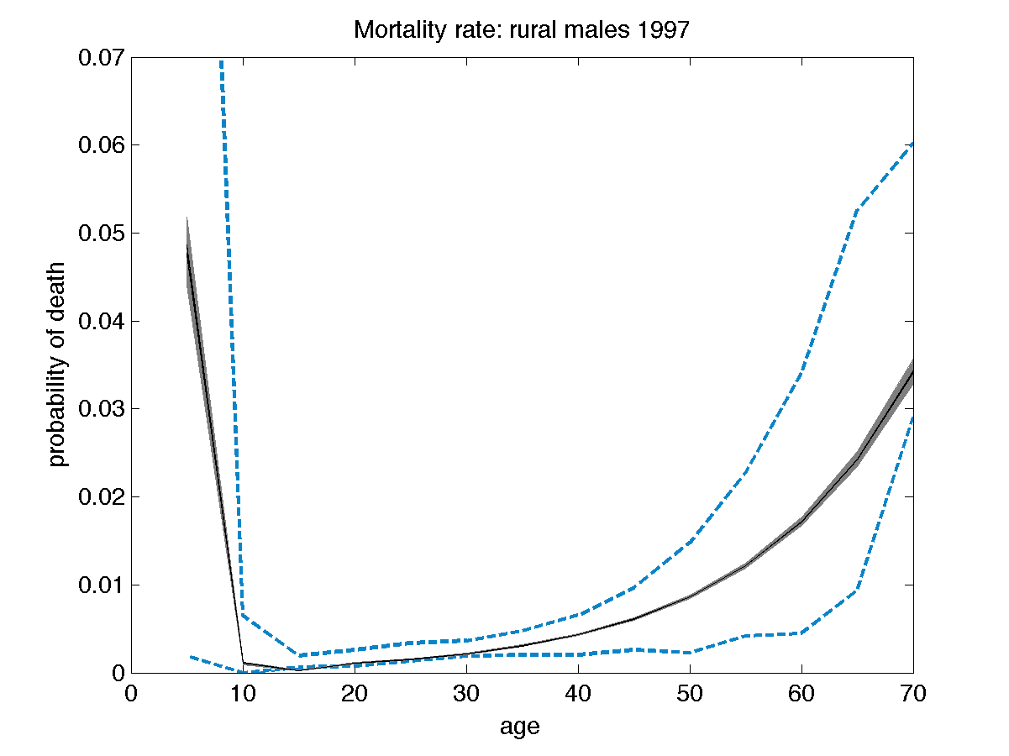
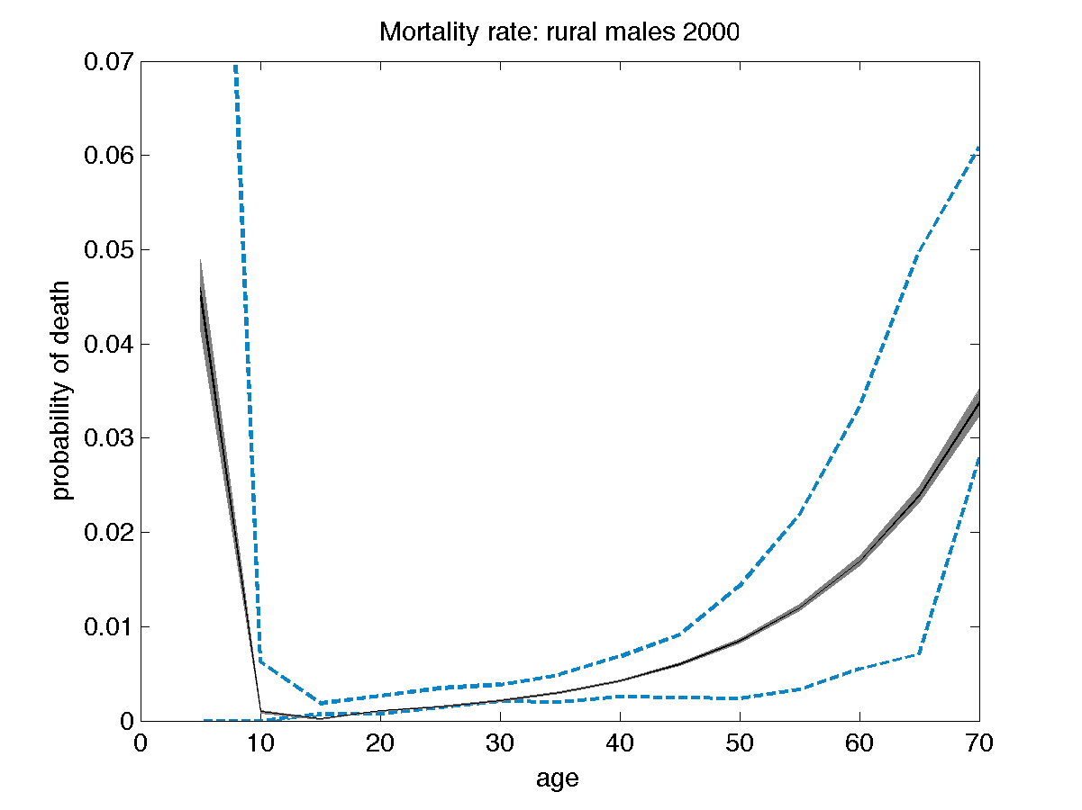
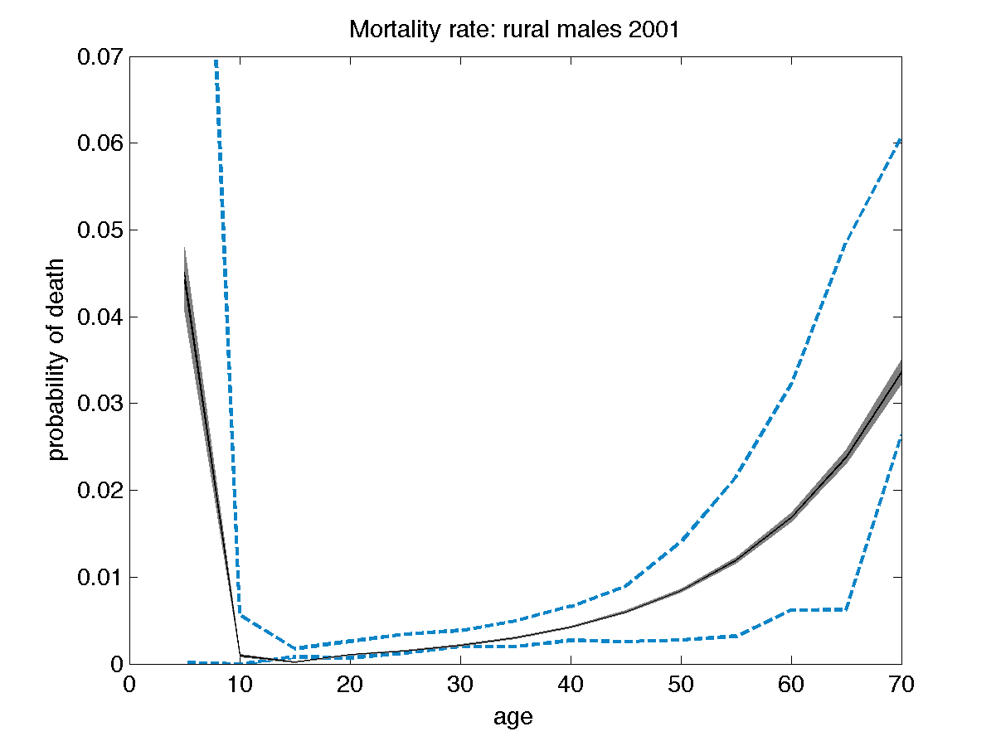
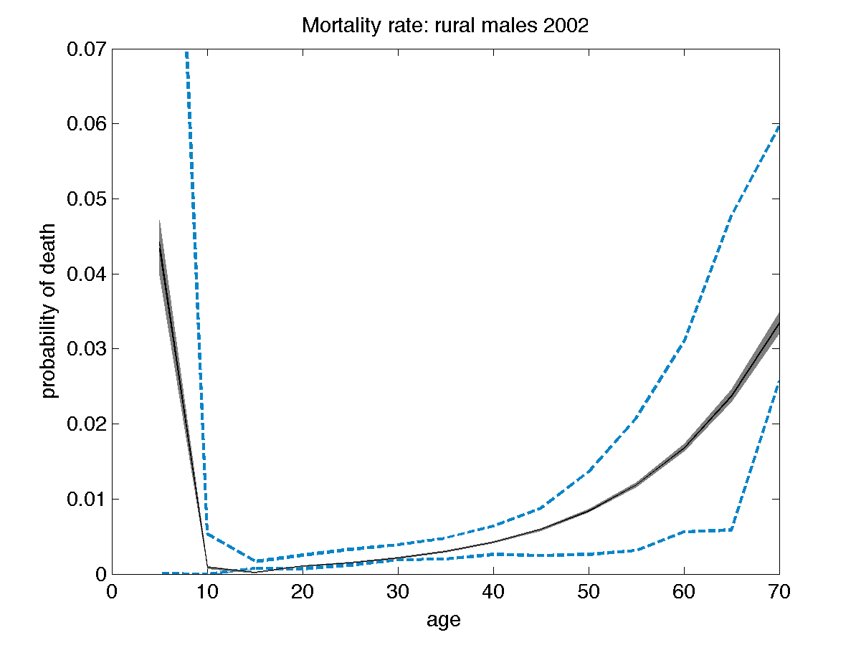
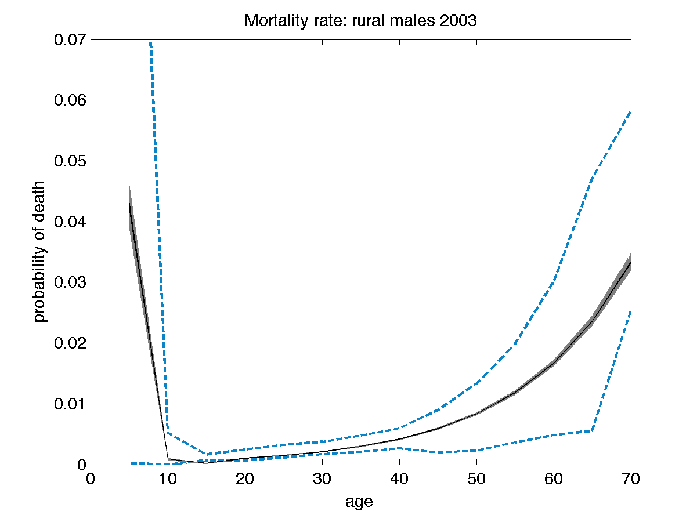
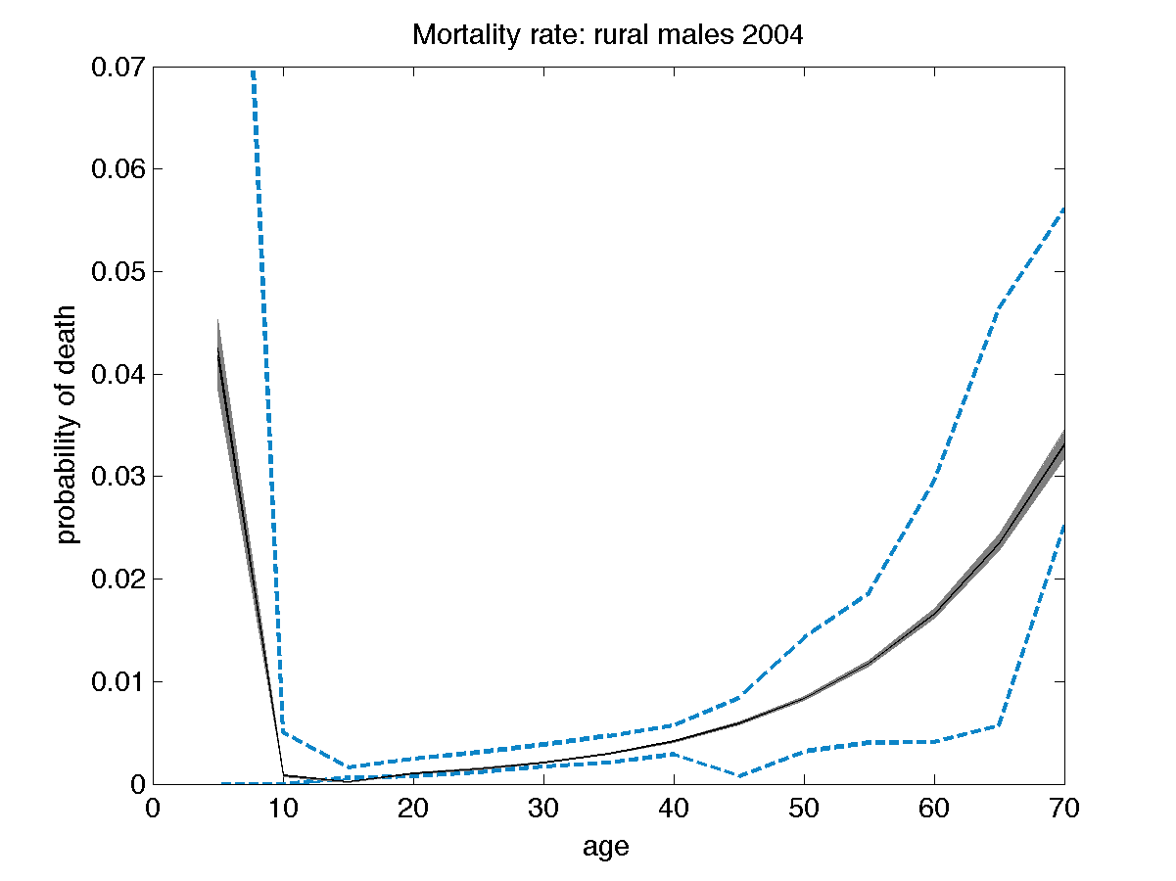
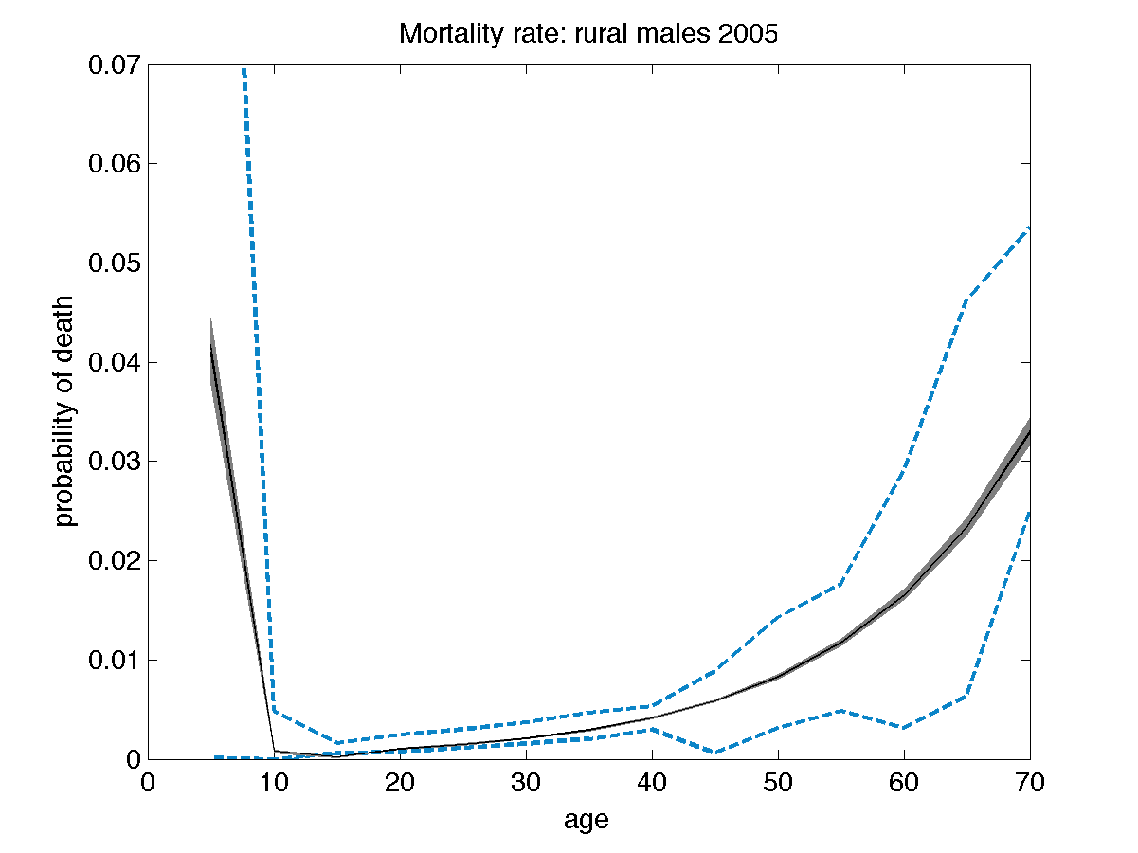
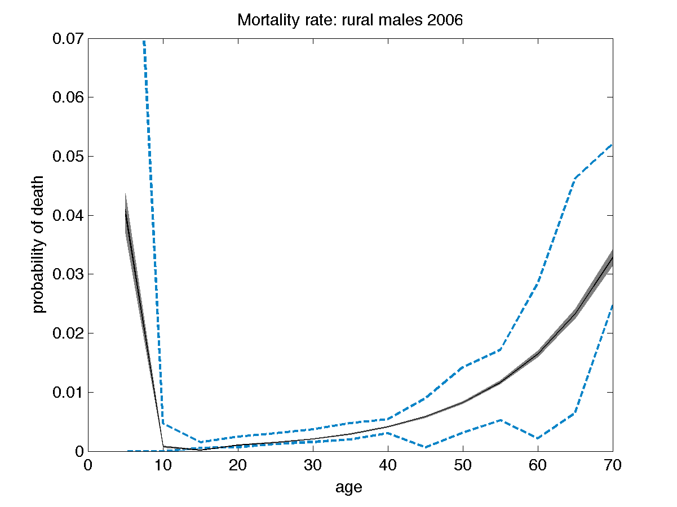
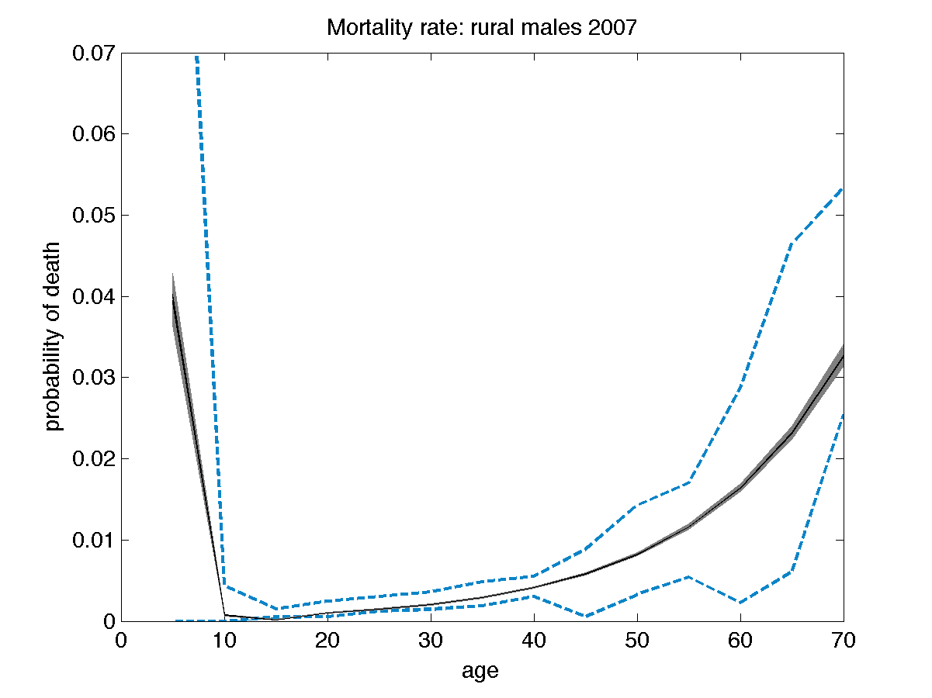
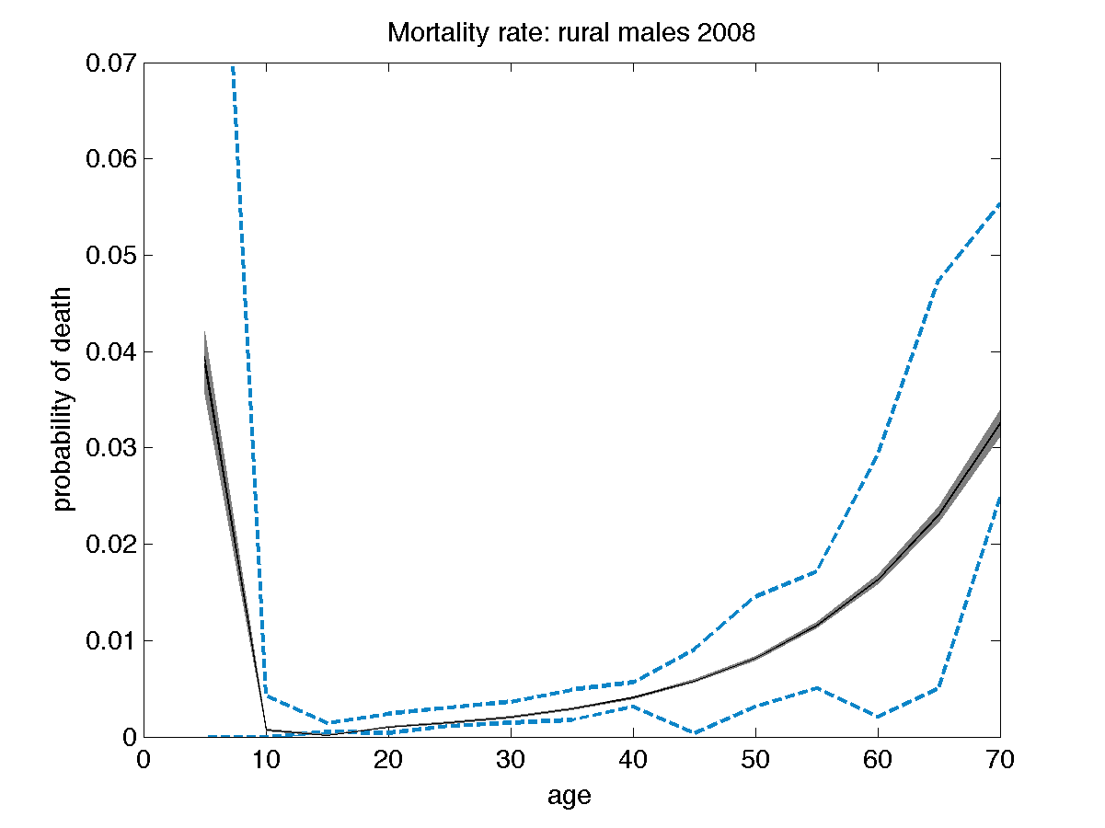
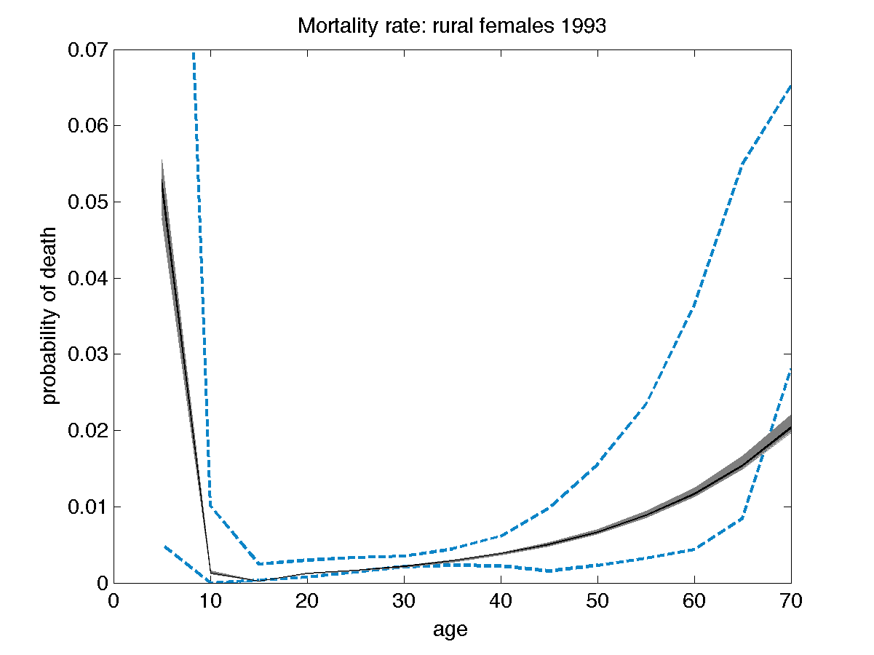
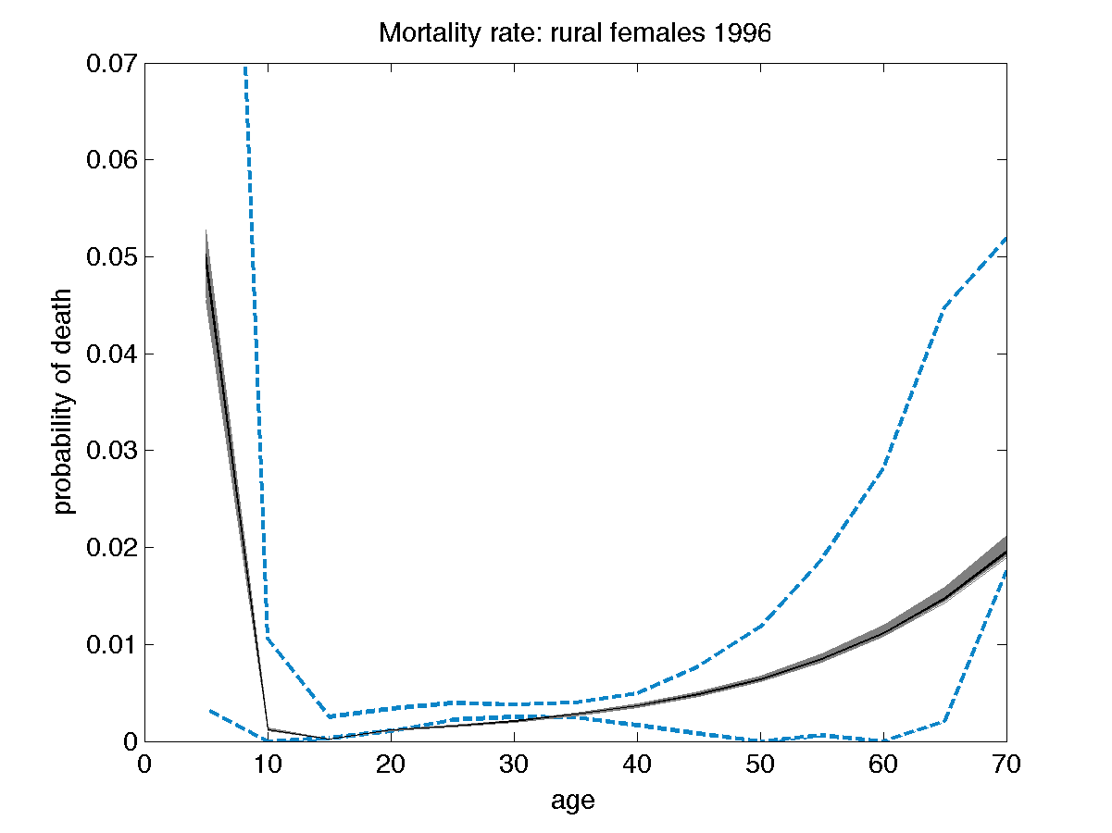
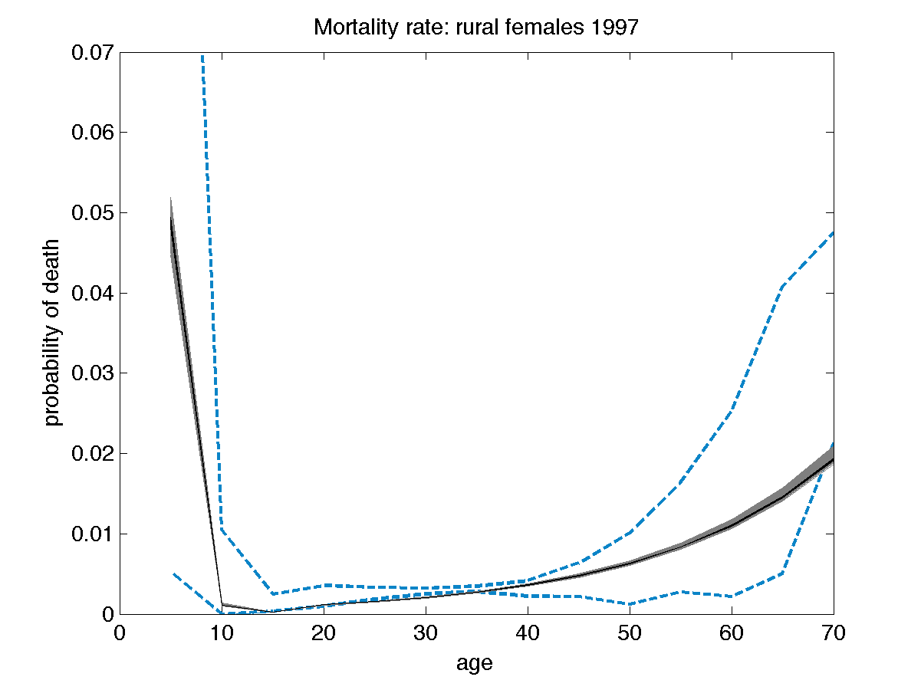
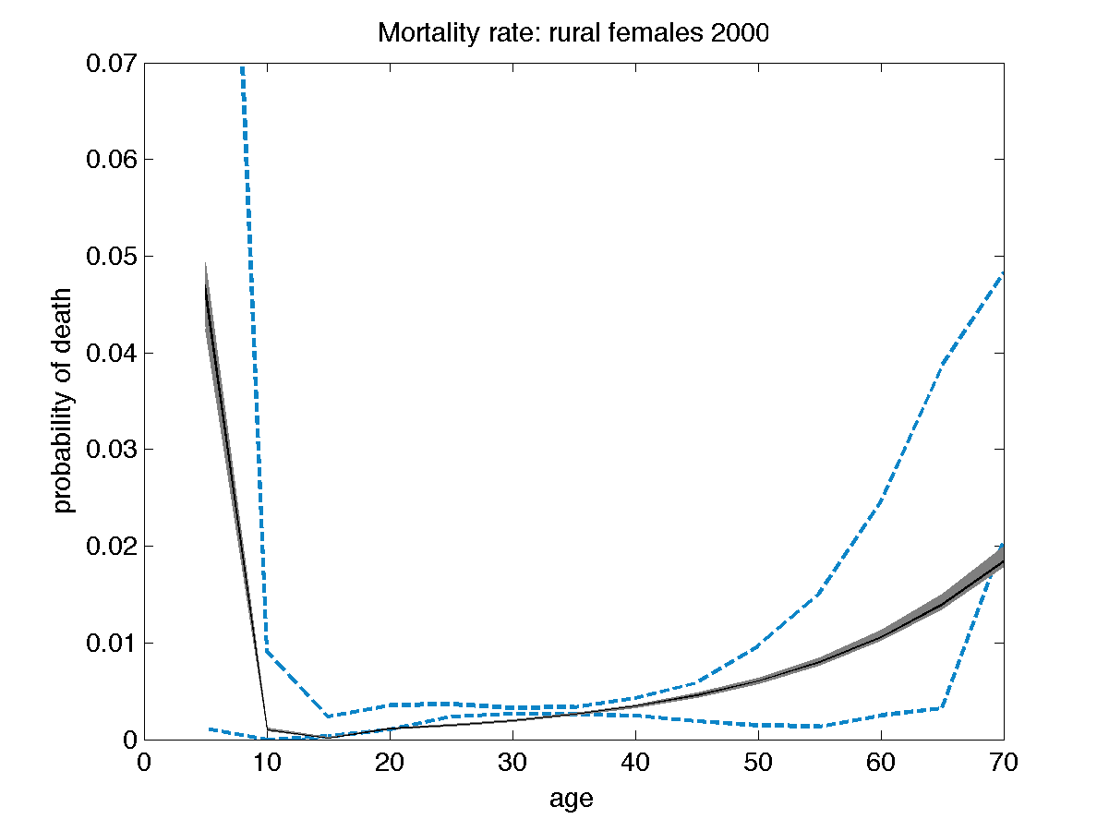
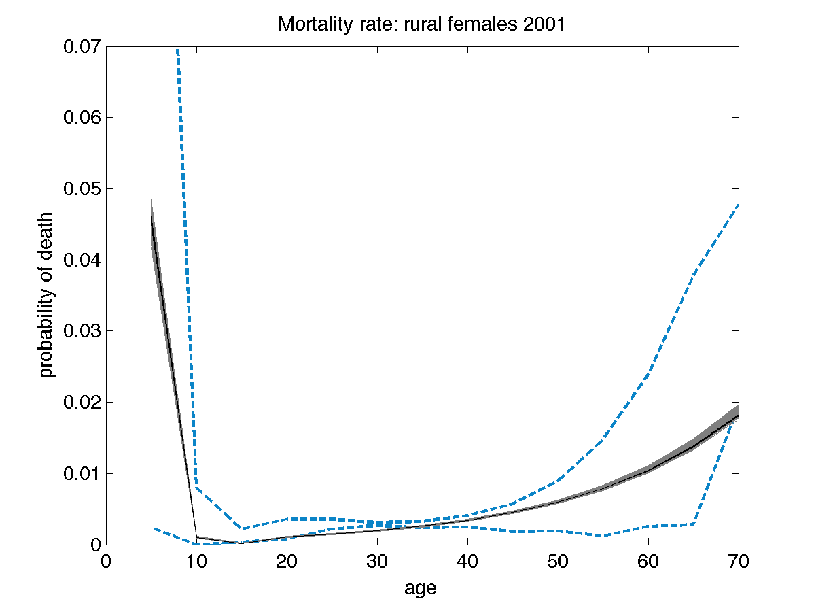
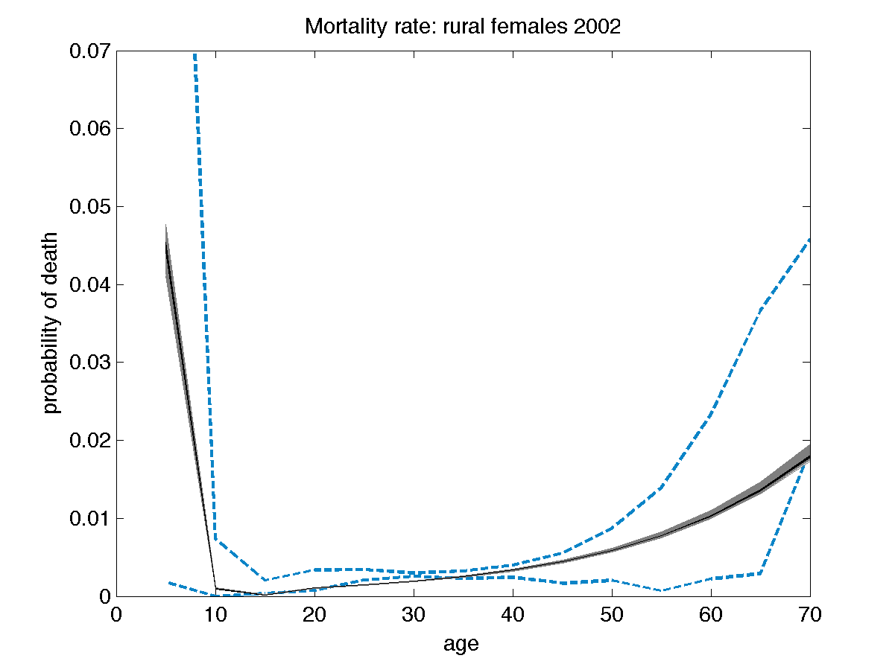
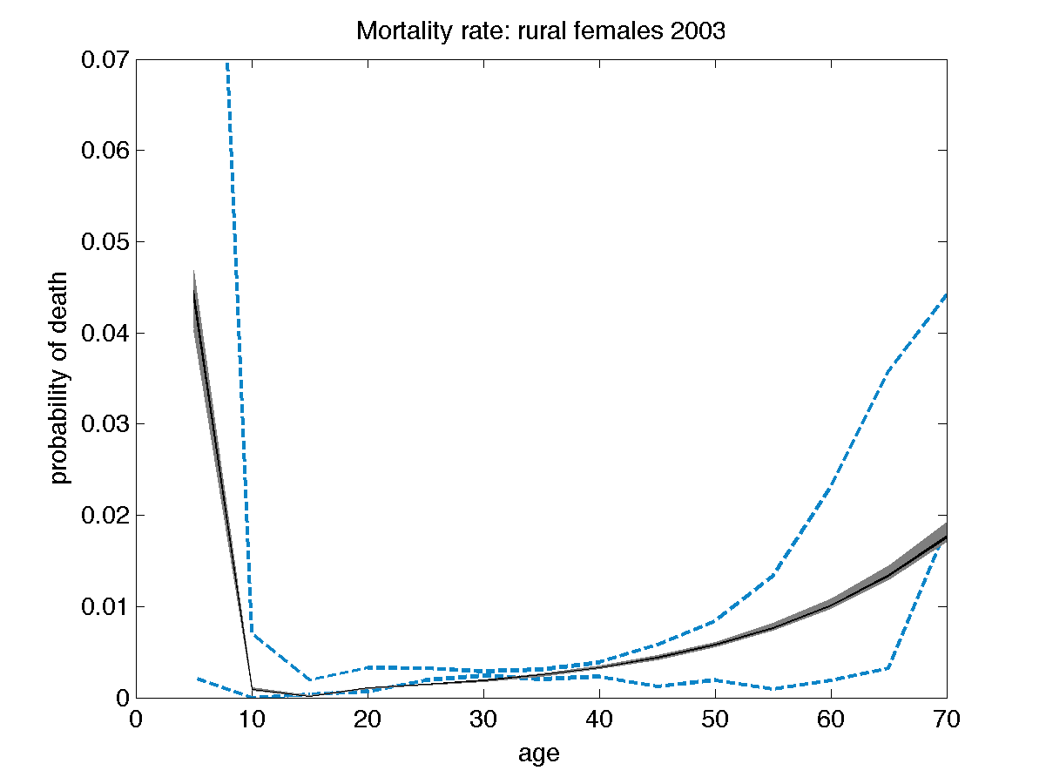
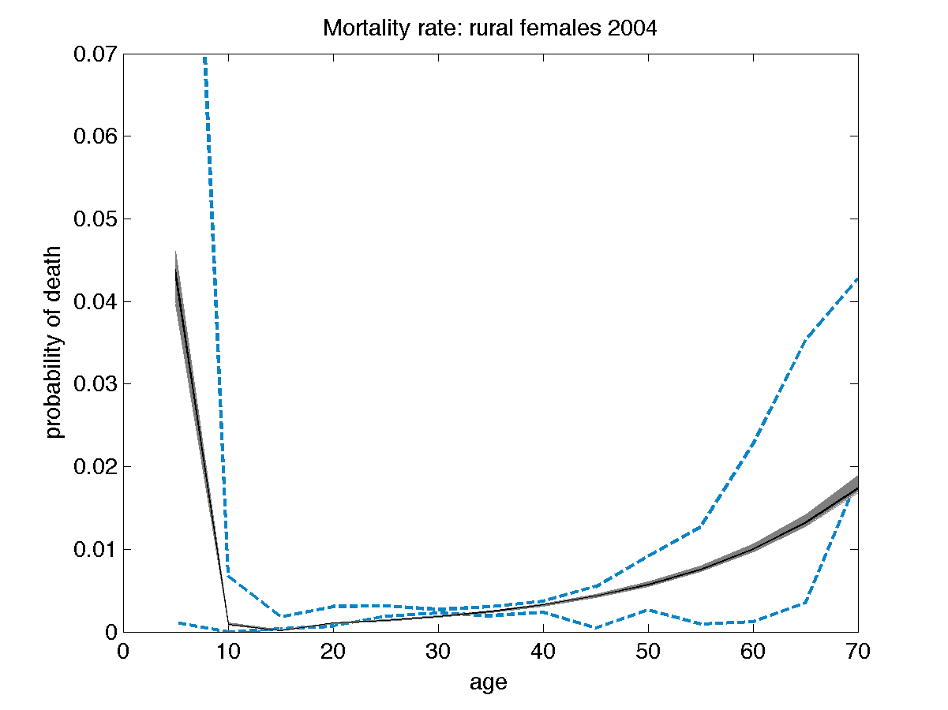
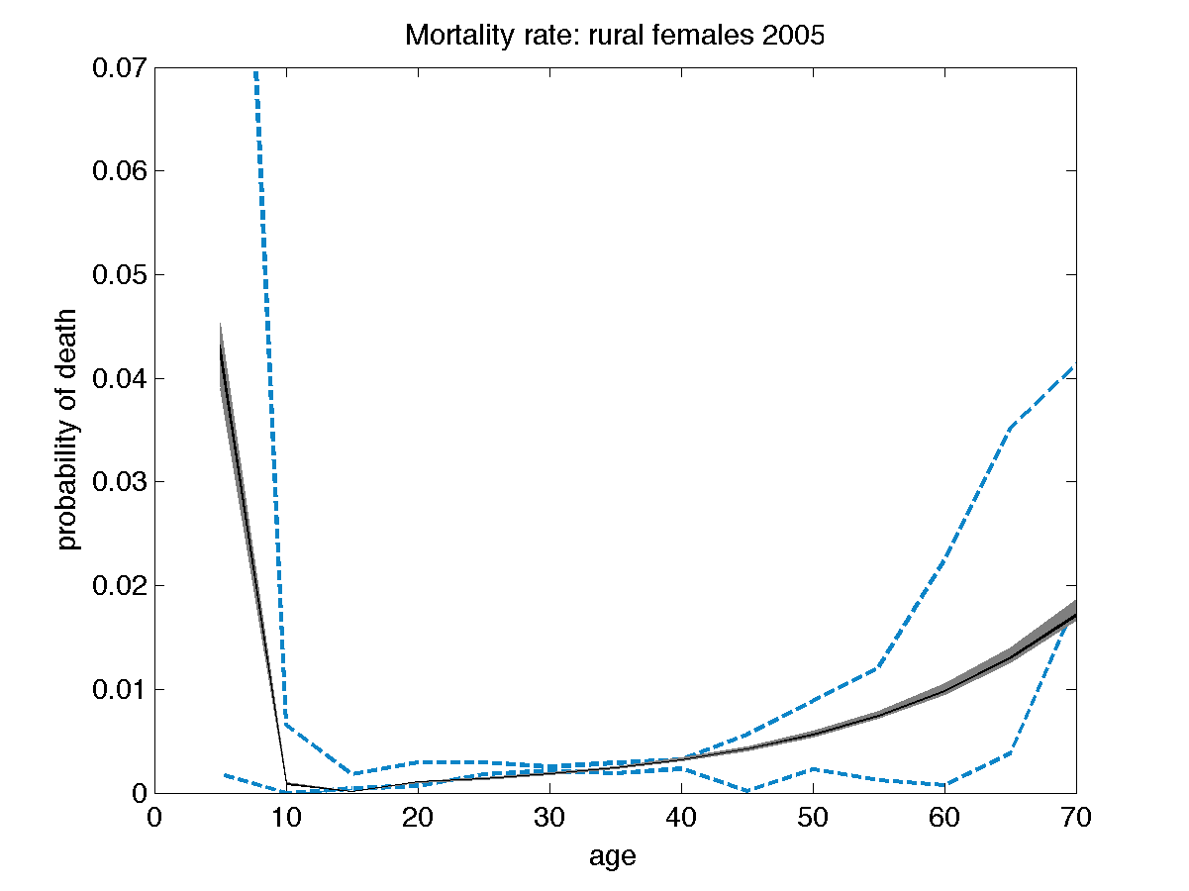
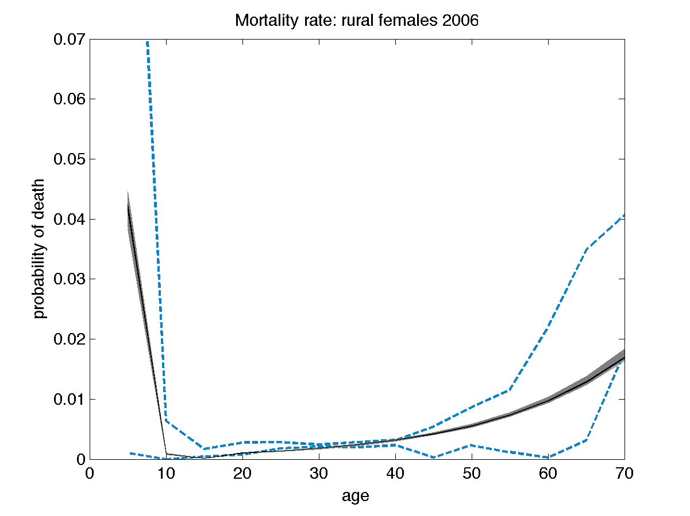
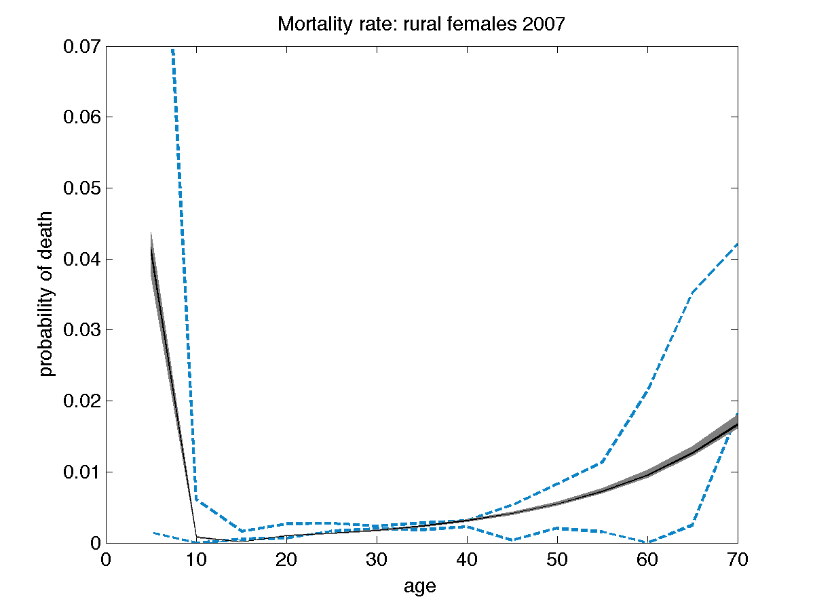
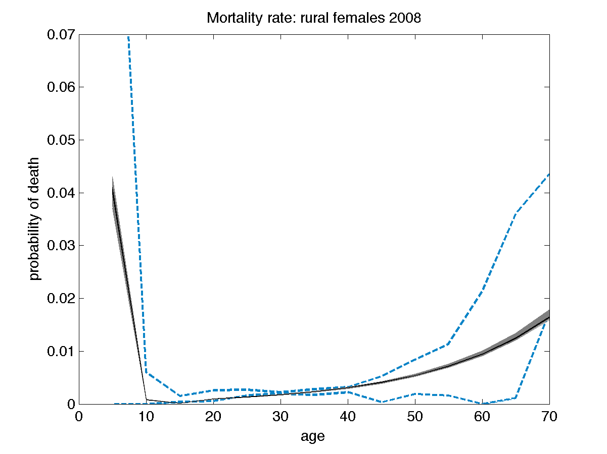

17 Figure AF4: Model fits to migration data
Migration data are provided in Table AF4. Educational categories are: 0: none; 1: 1 to 6 years; 2: >6 to 12 years; 3: >12 years. In all plots, gray shaded areas are results of 10,000 repeated samples from the posterior joint distribution of the fitted model (Figure 1C), with samples from the interquartile range as black lines and data displayed as dashed blue lines or circles reflecting the 95% confidence intervals of the input datasets.

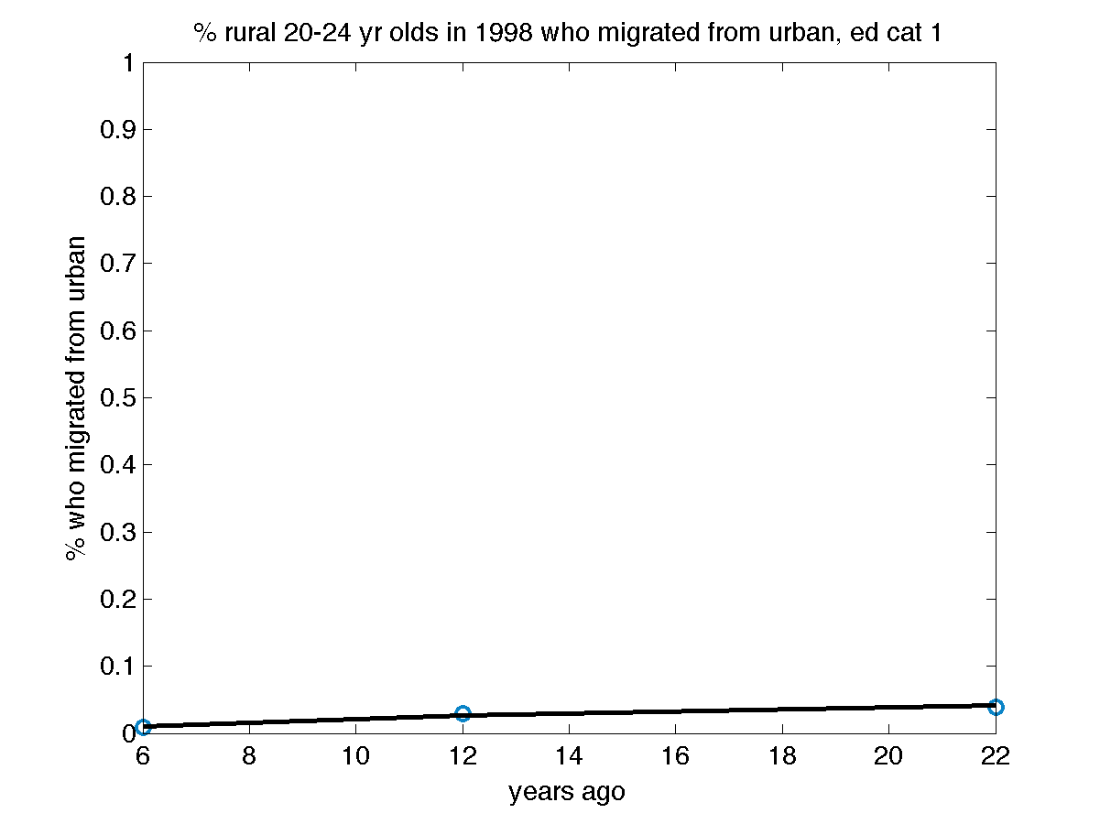
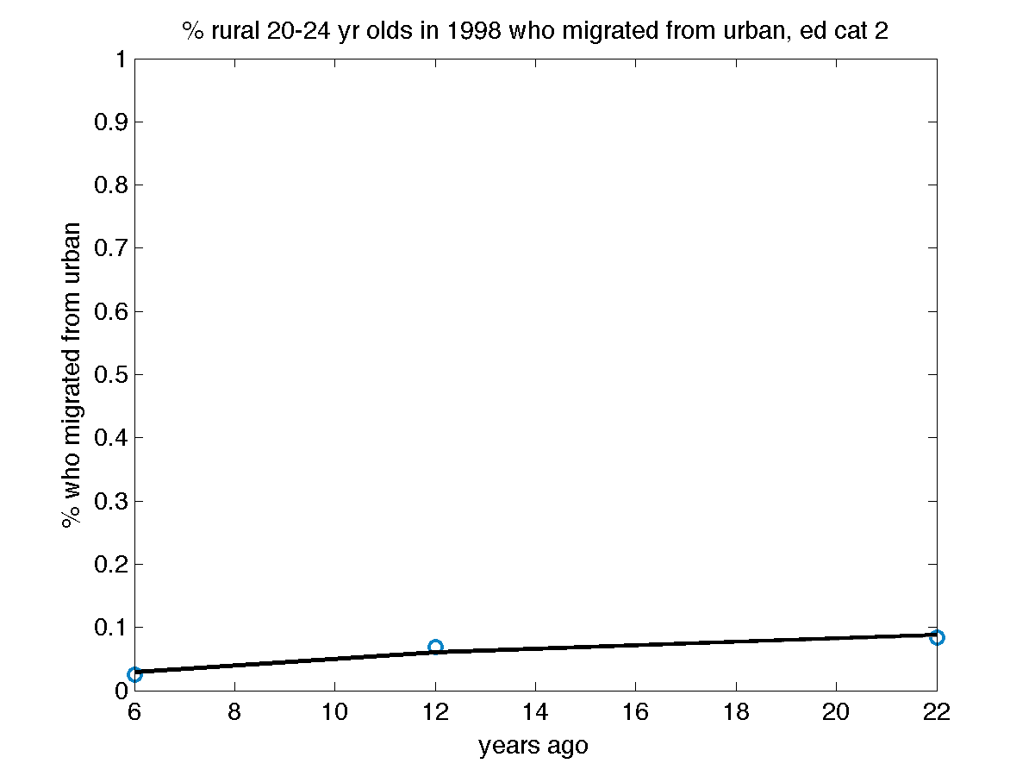
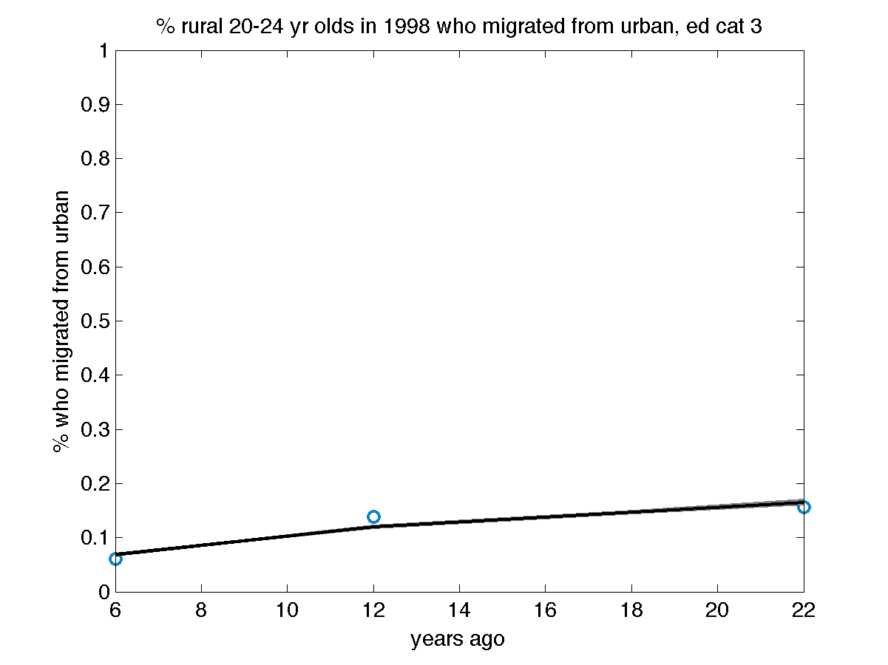
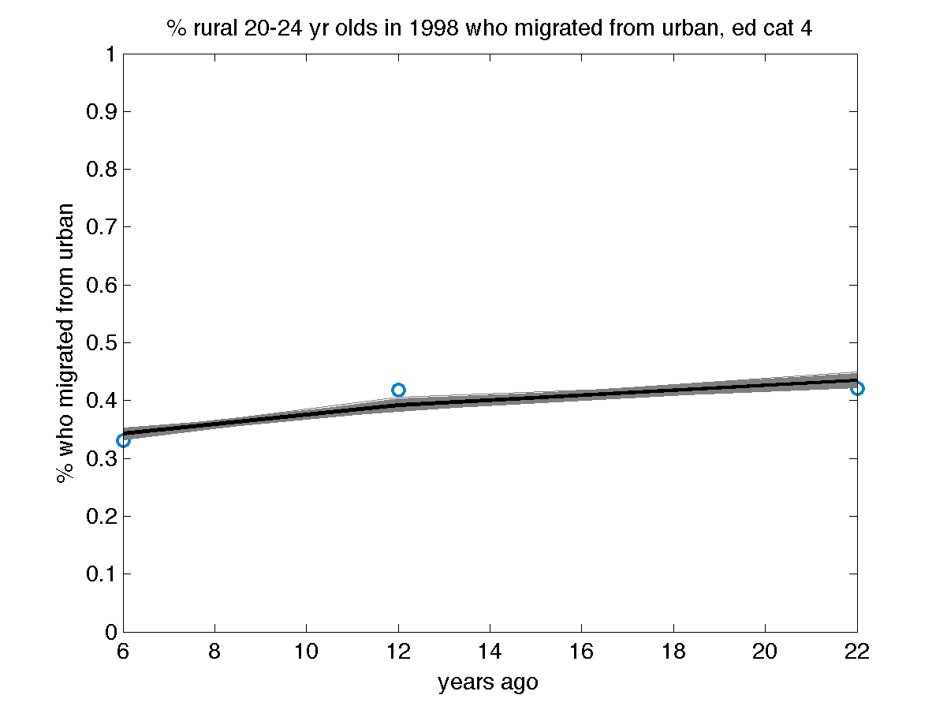
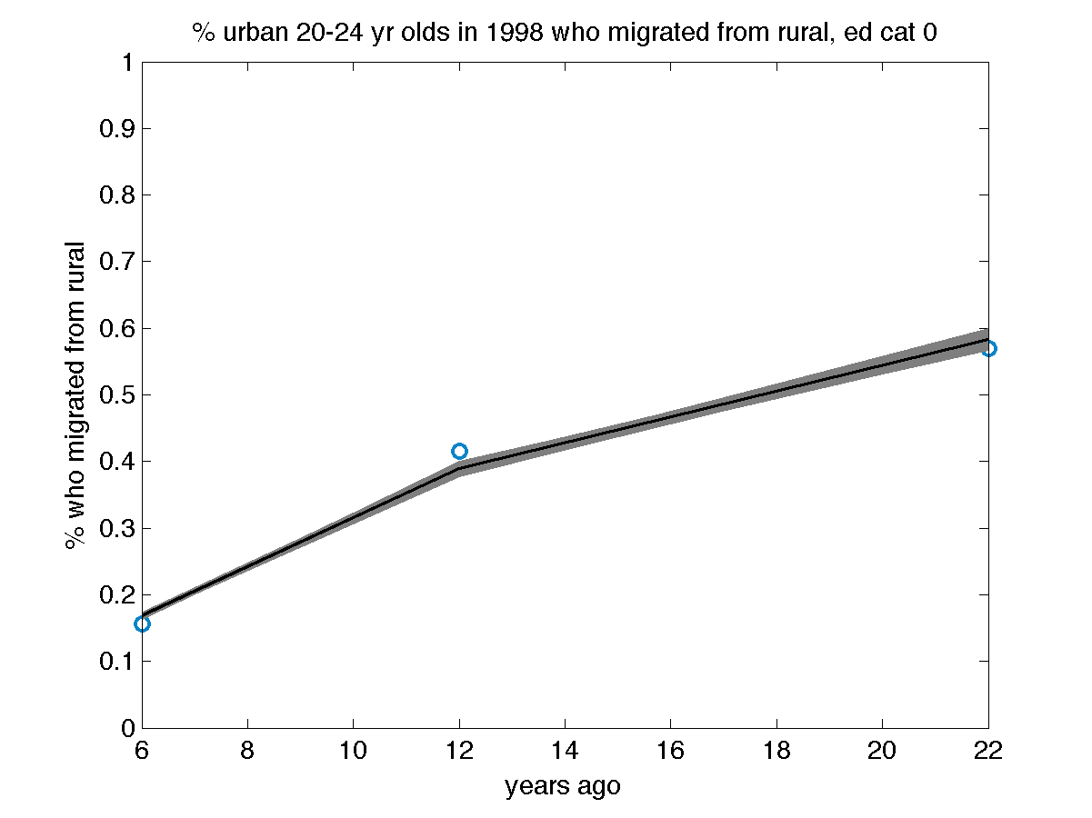
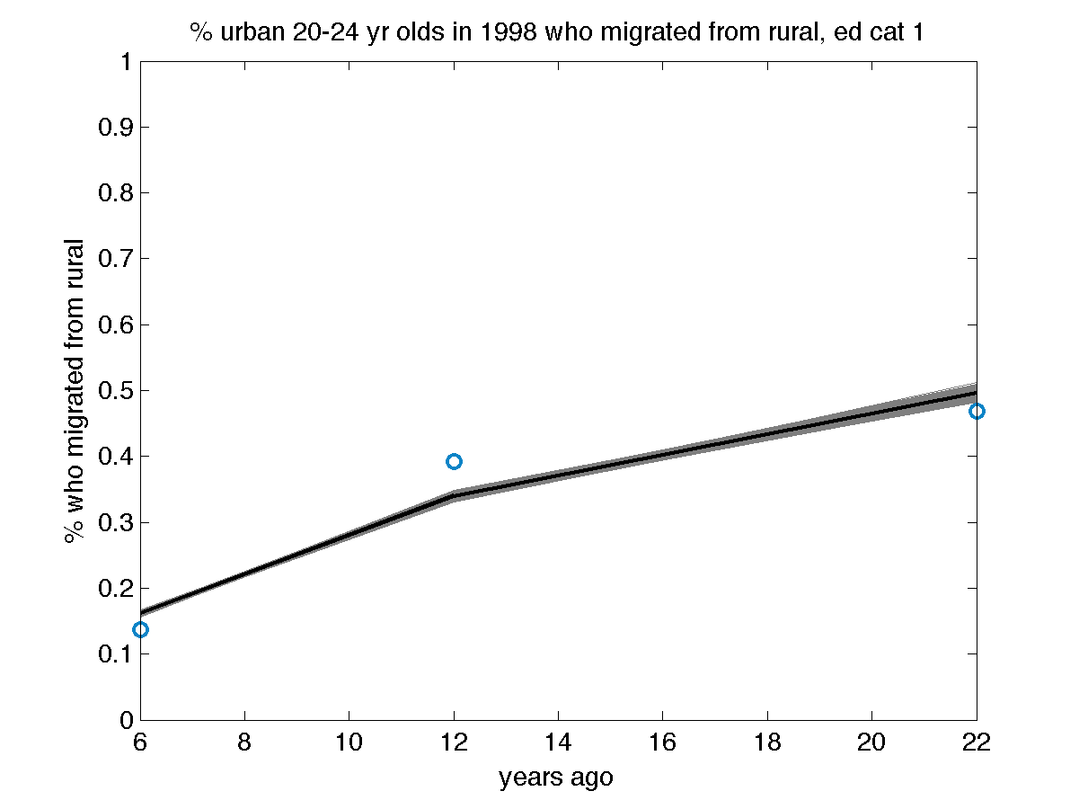
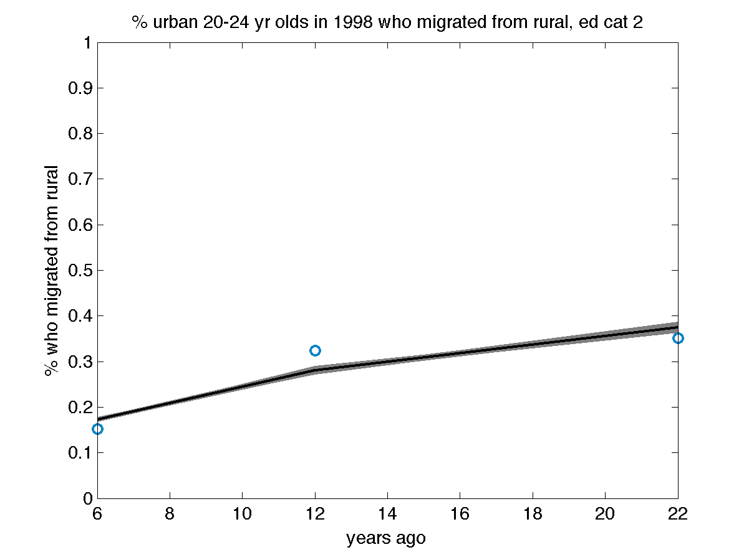
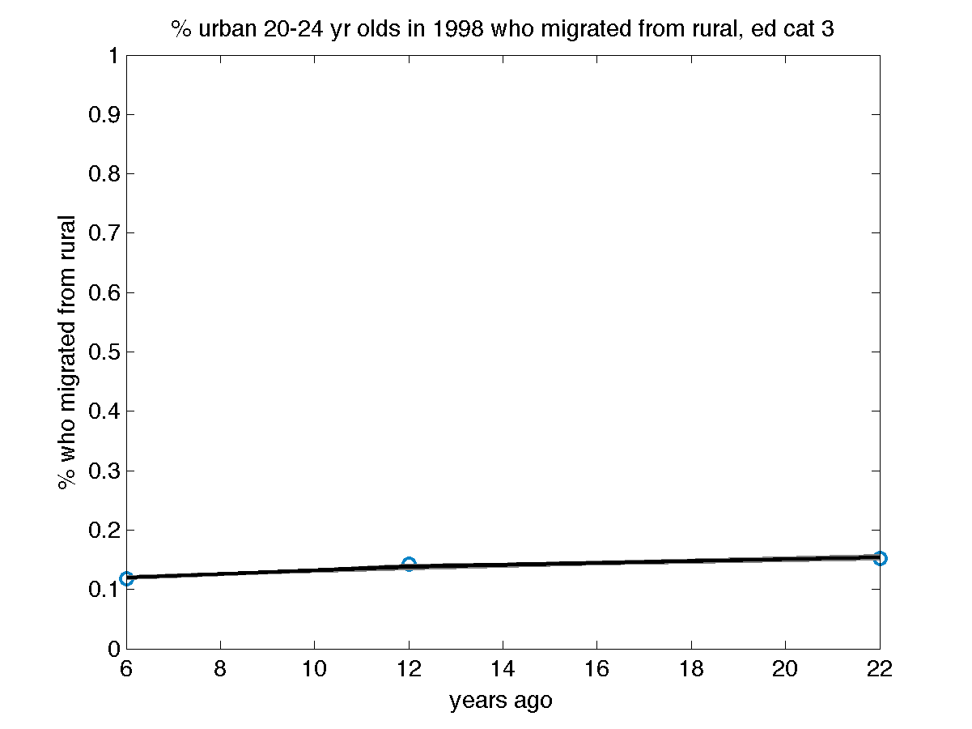
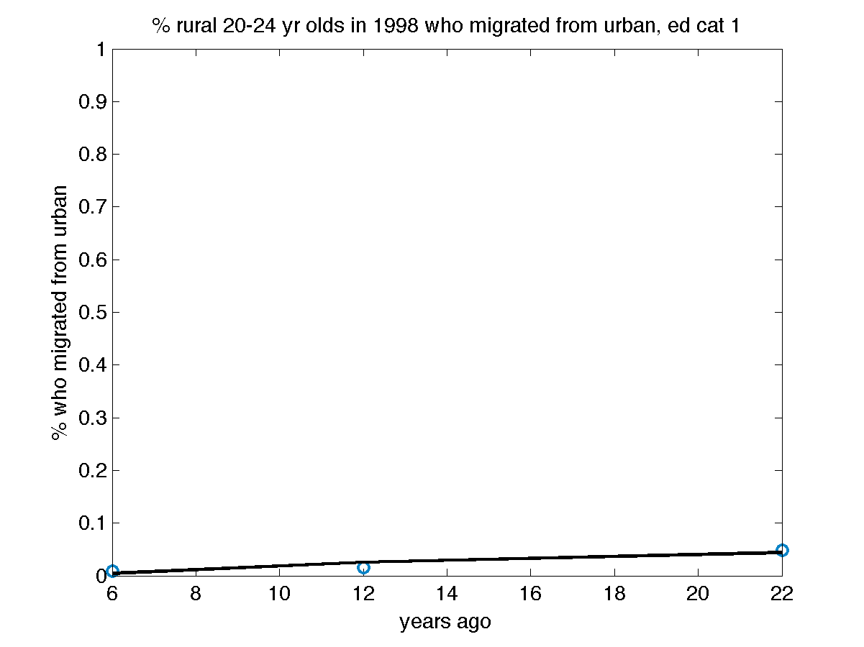
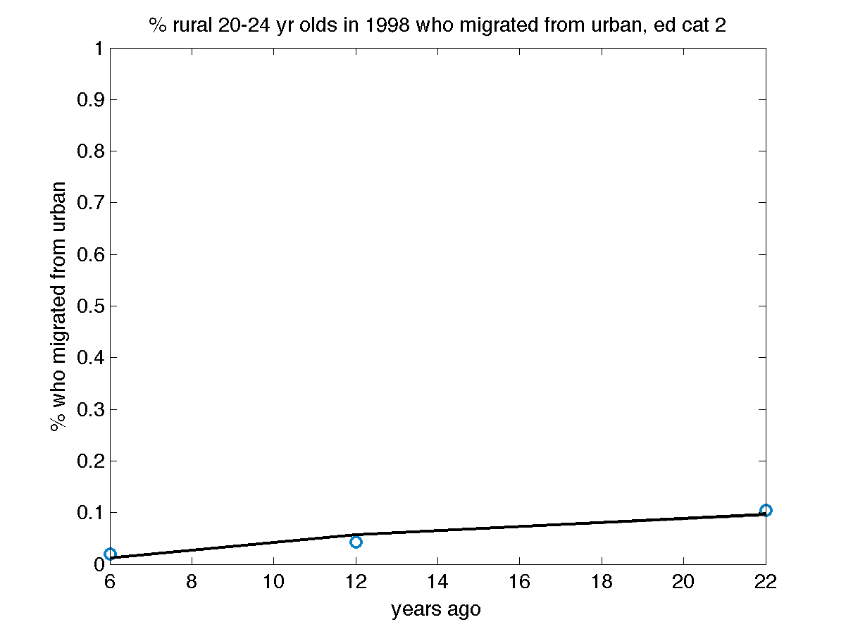
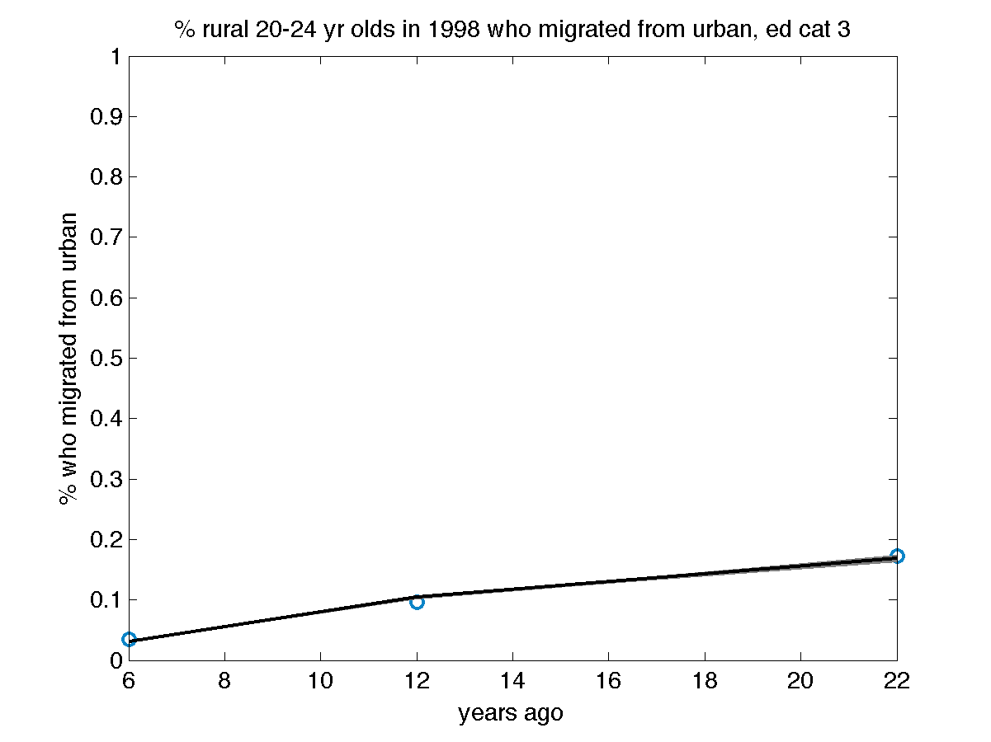
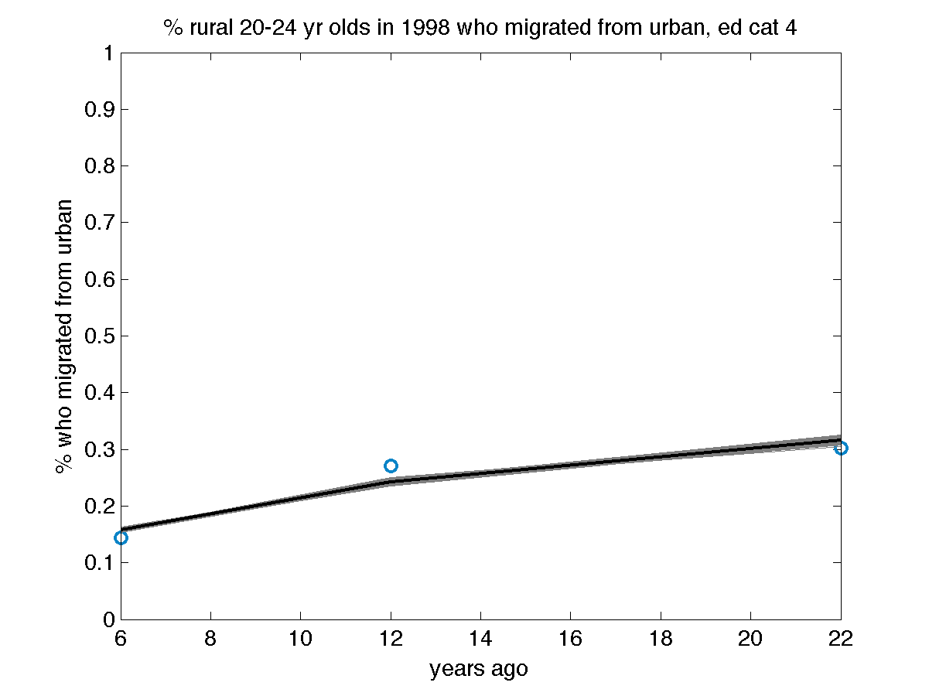
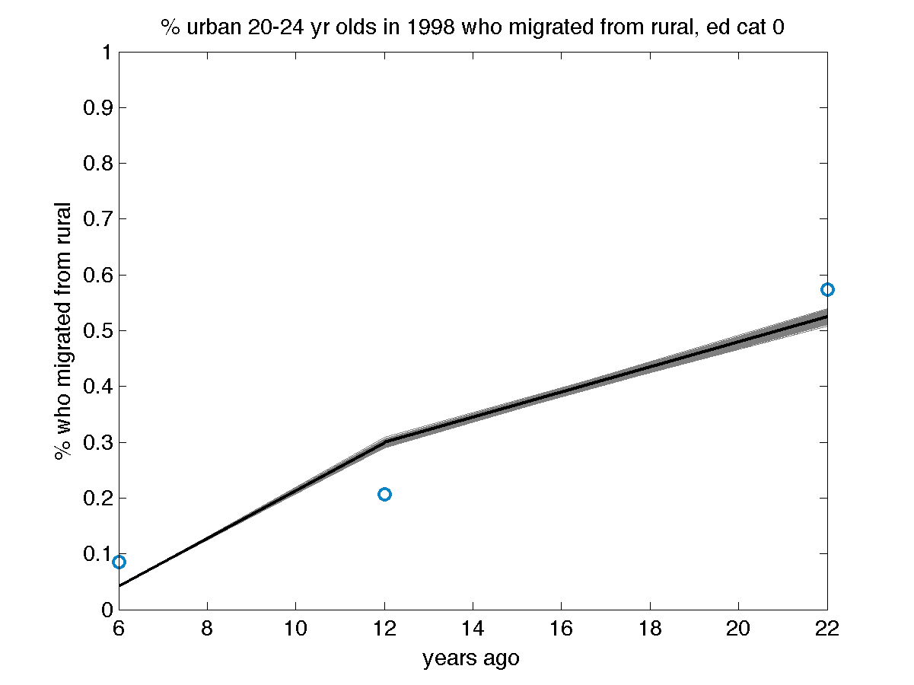
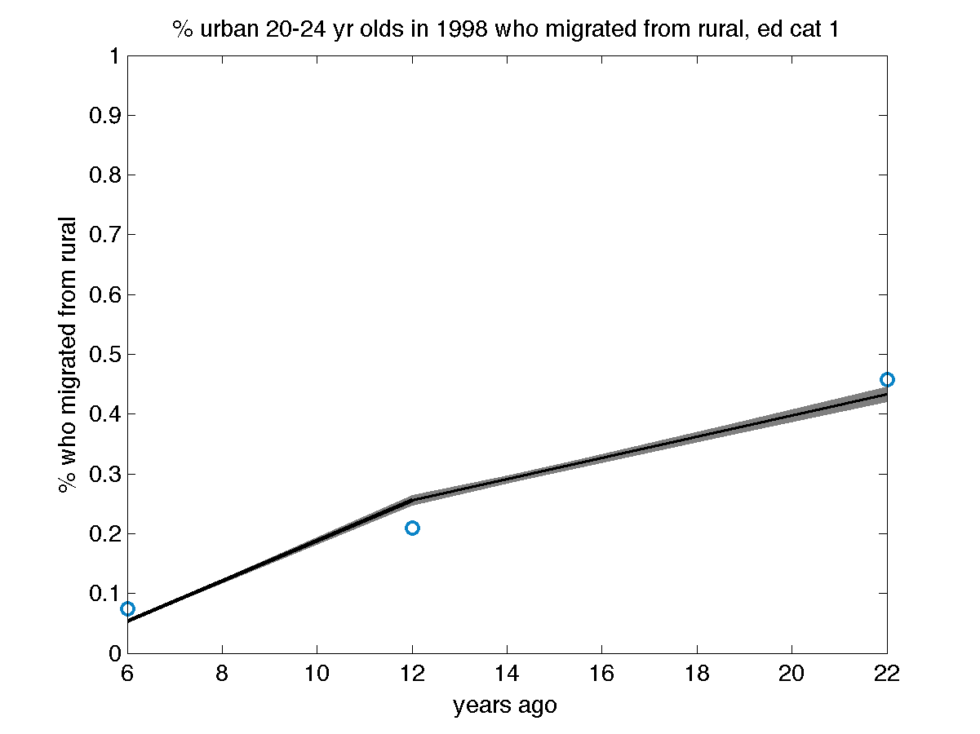
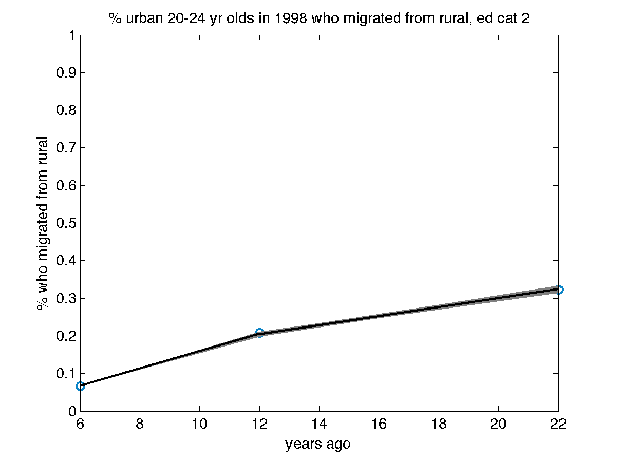
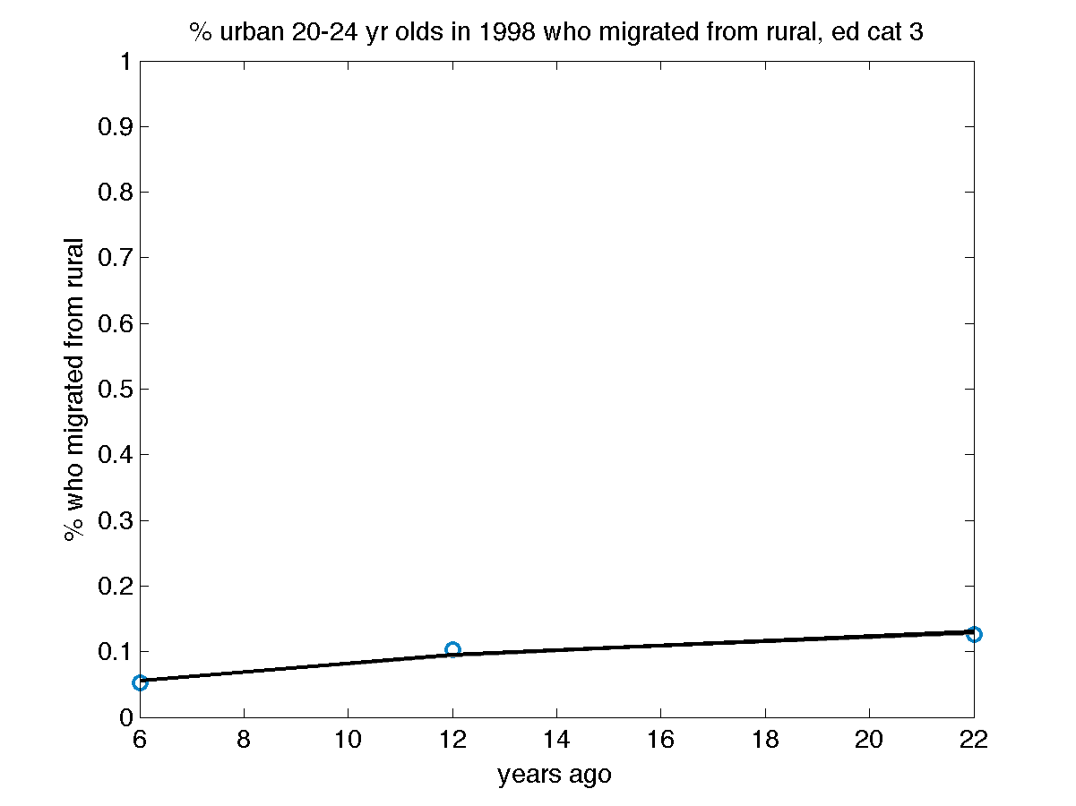
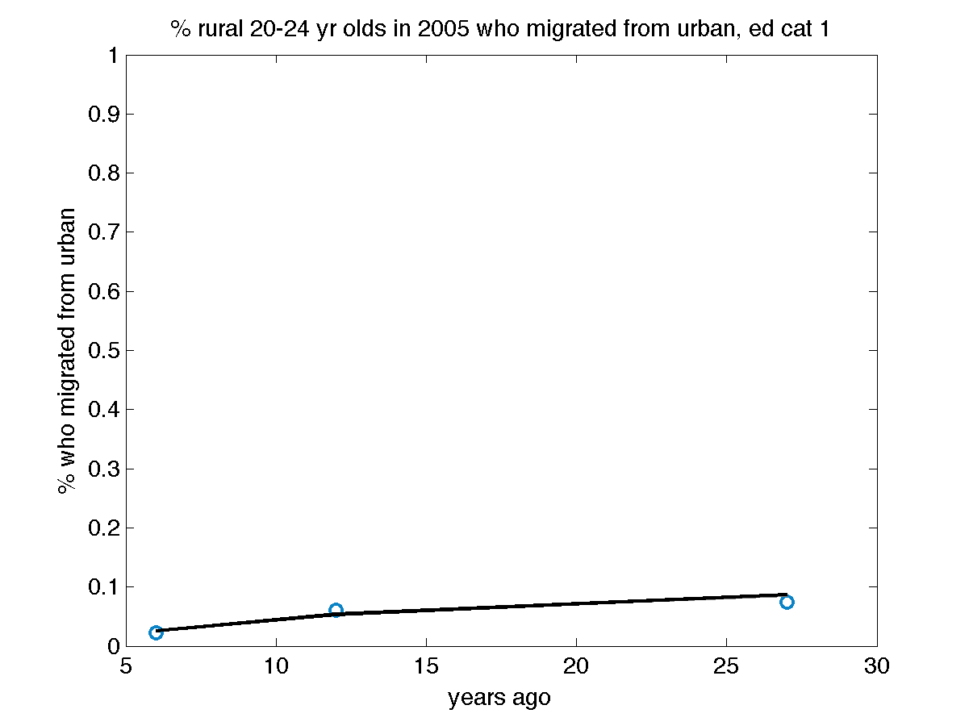
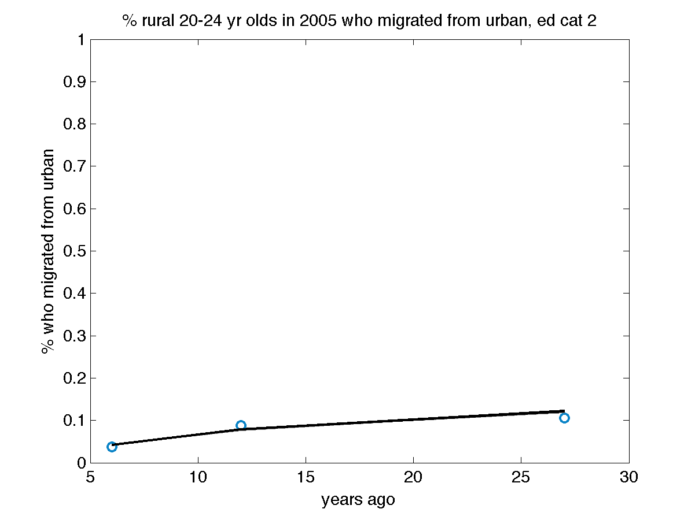
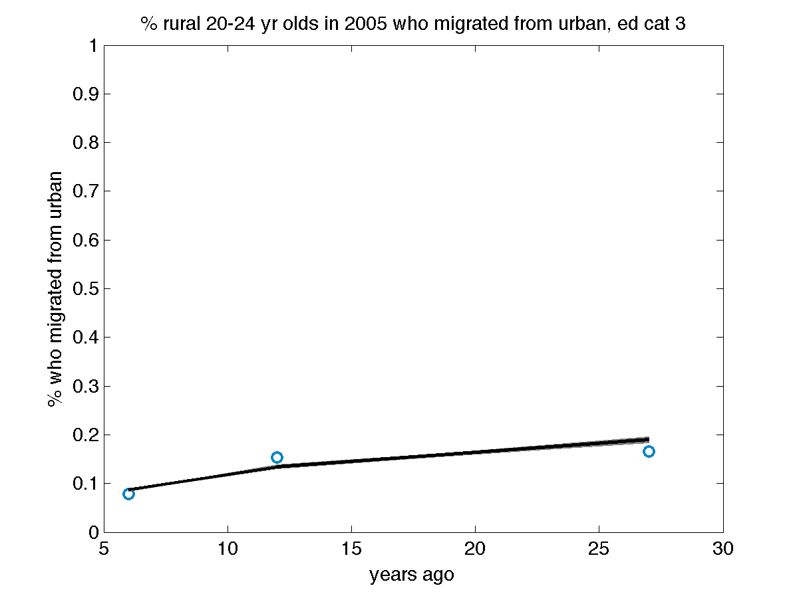
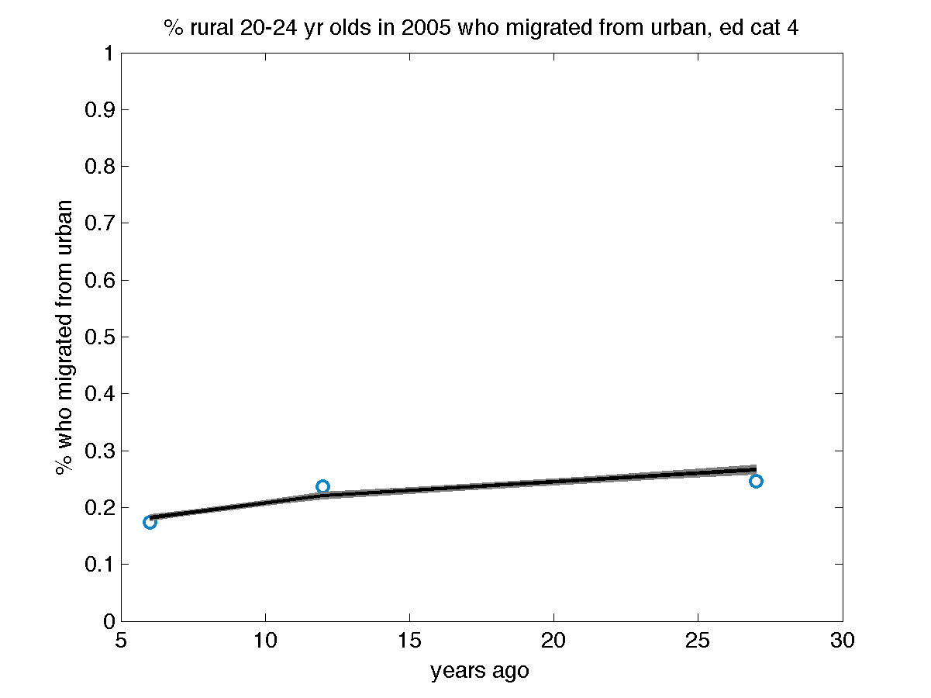
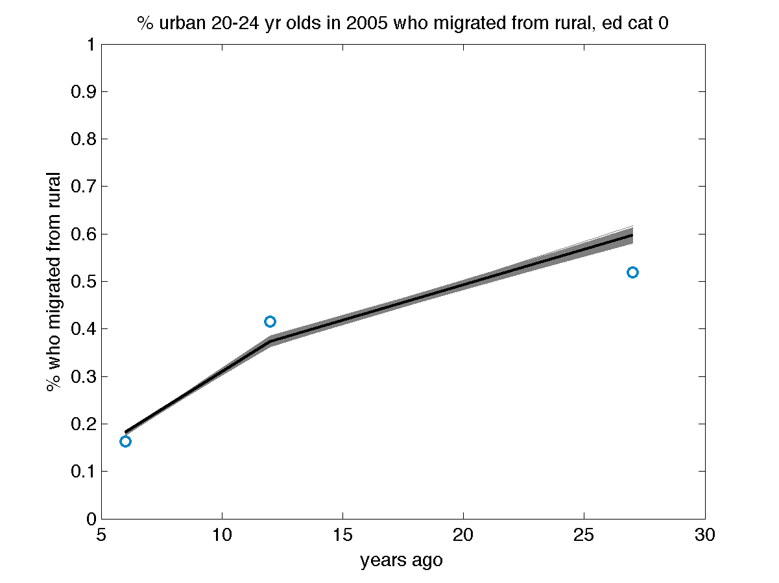
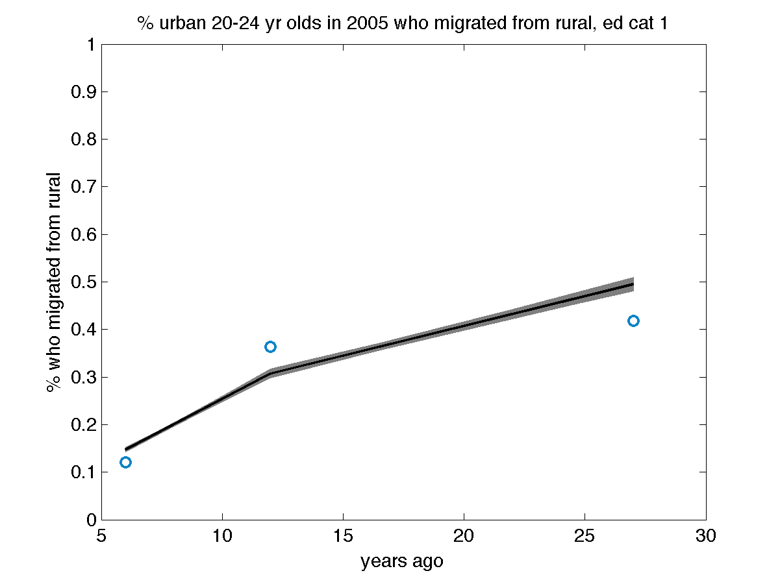
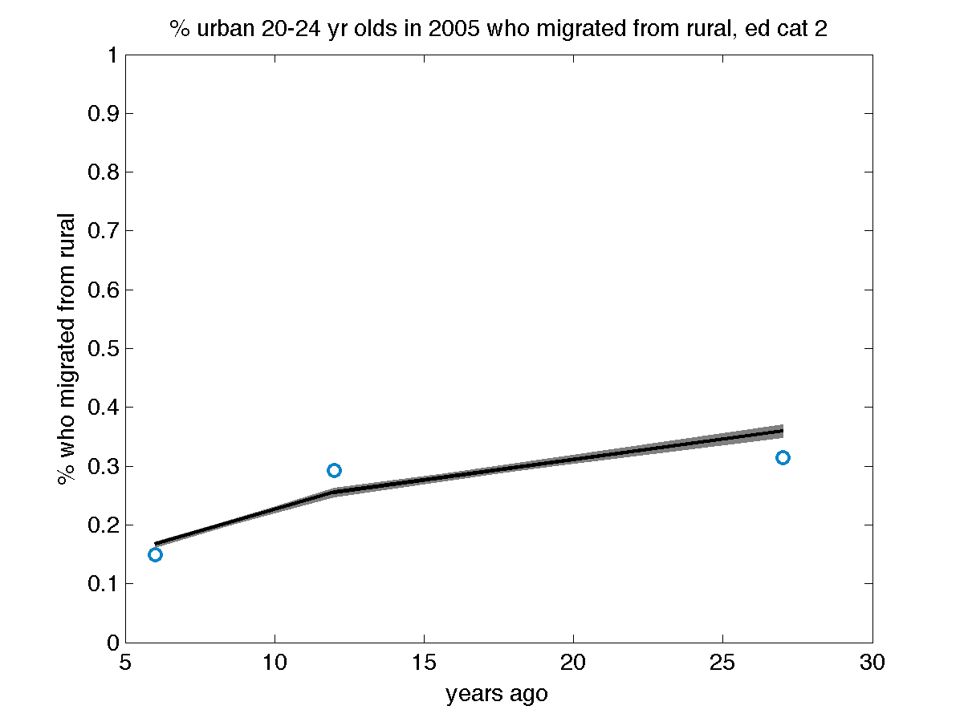
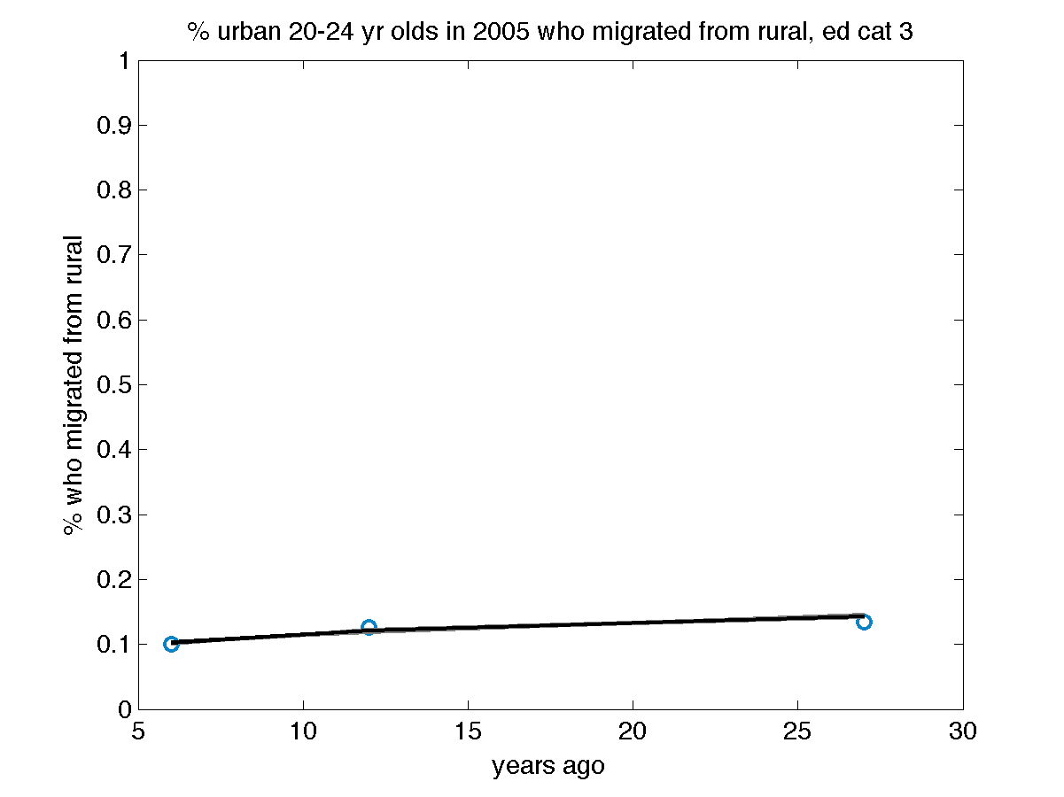
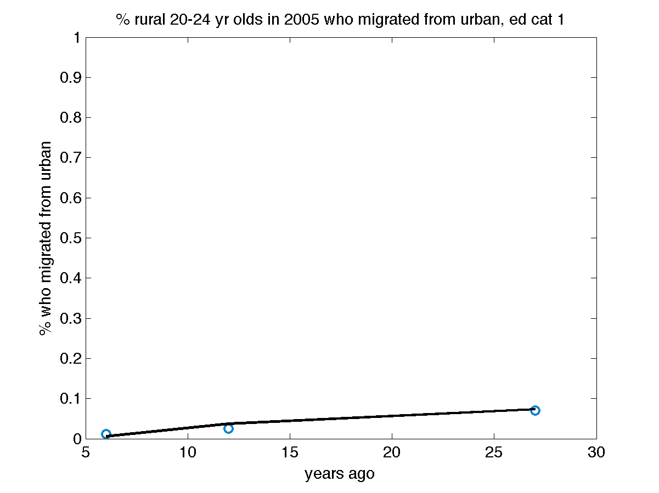
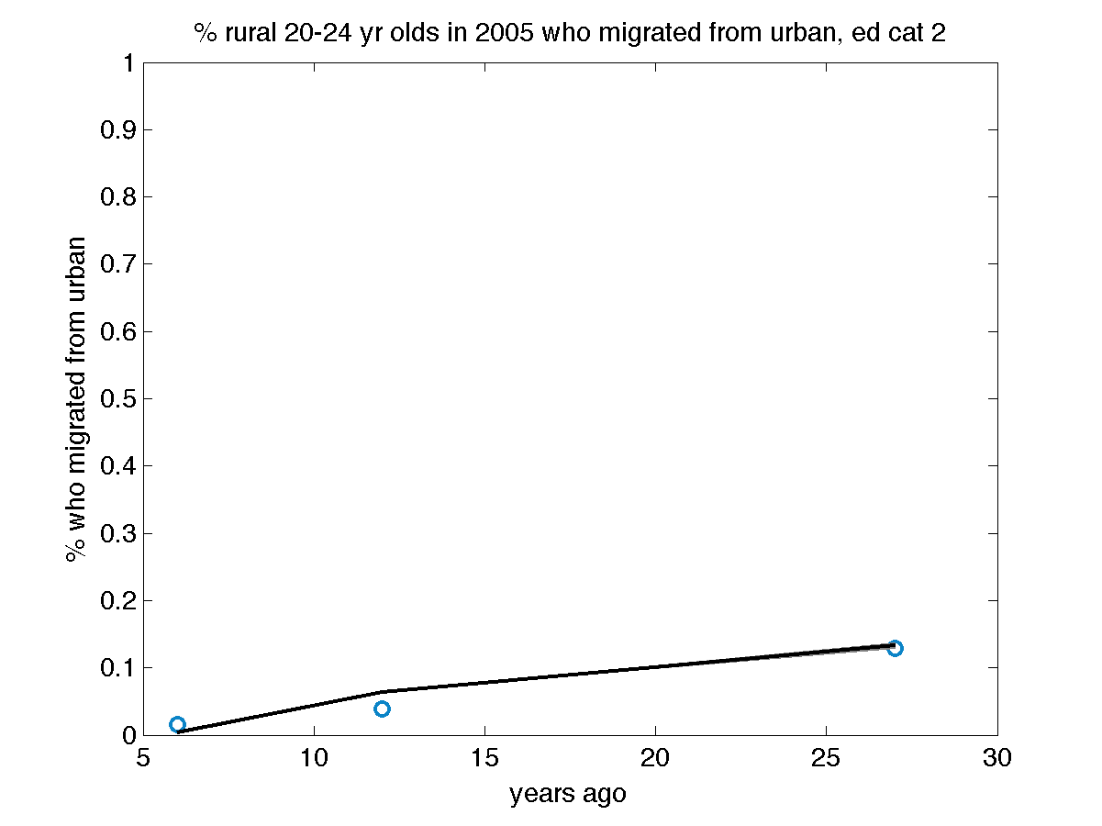
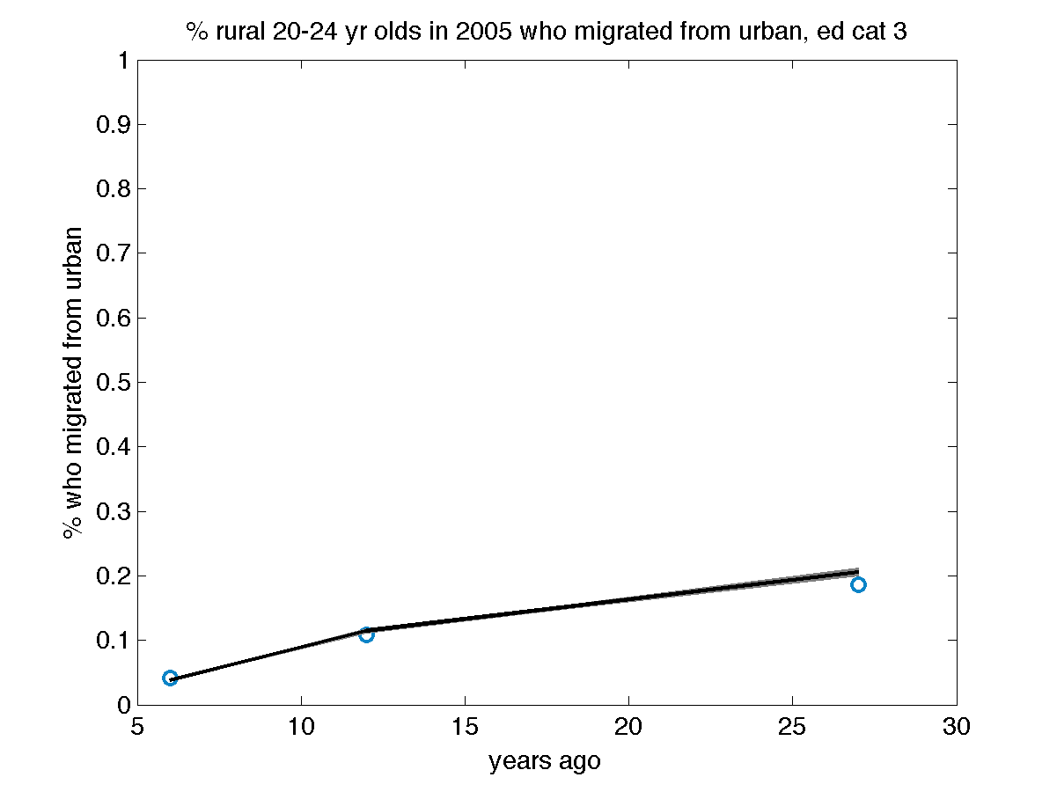
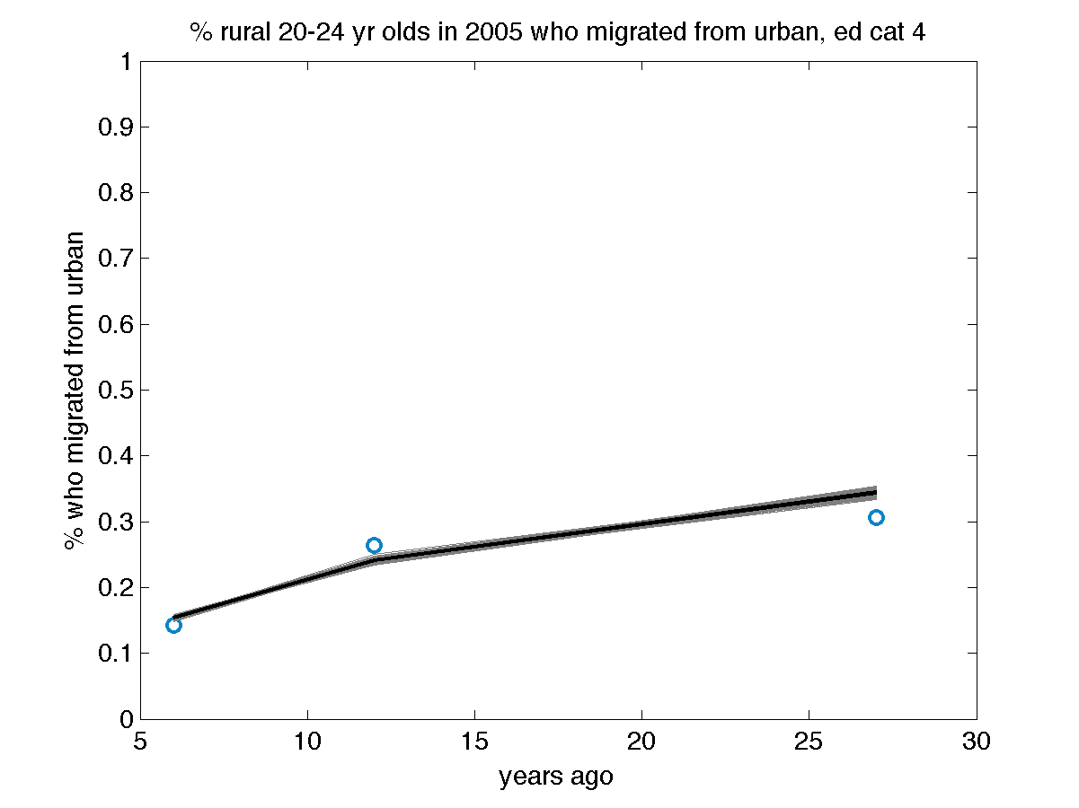
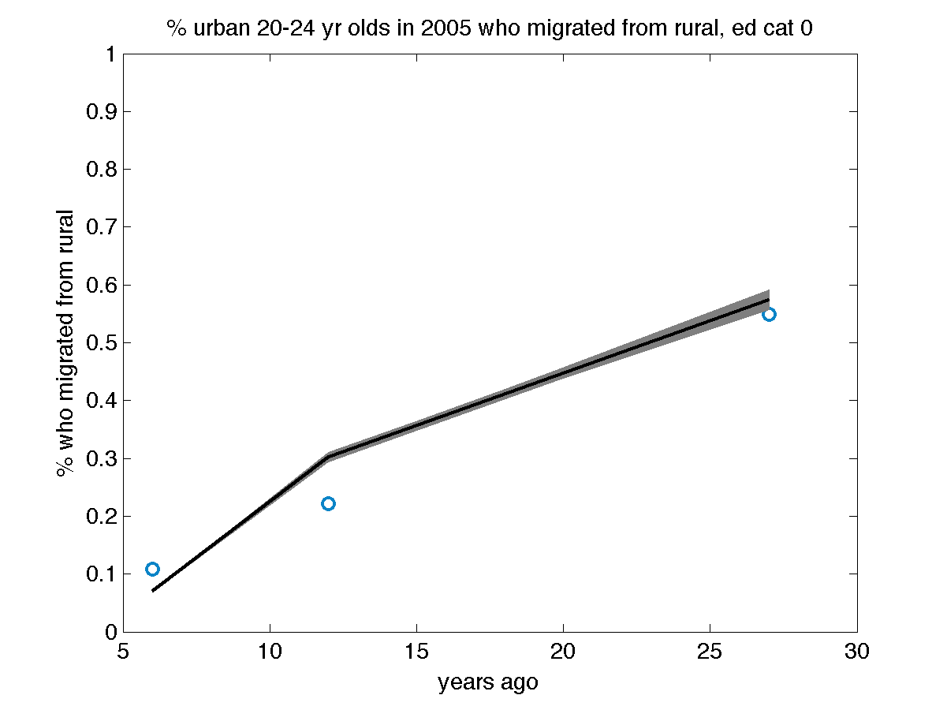
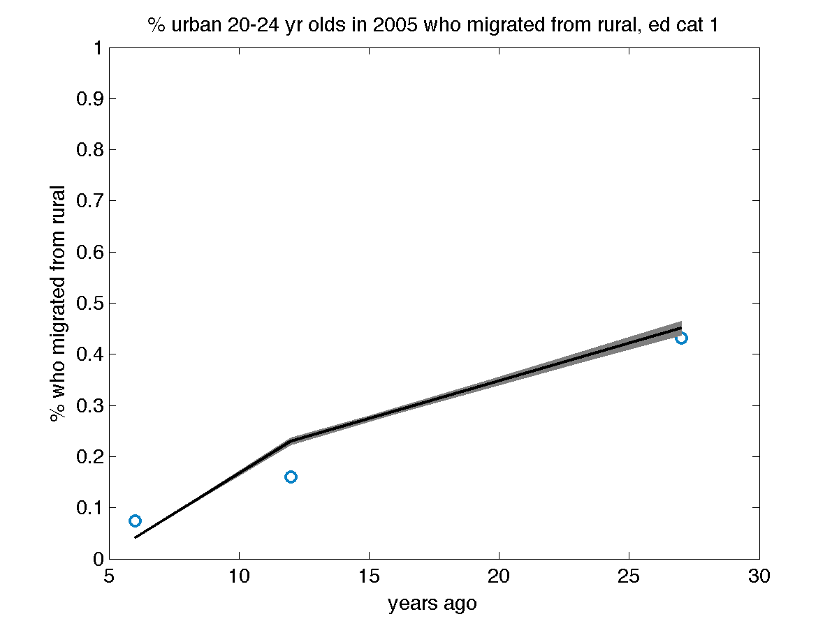
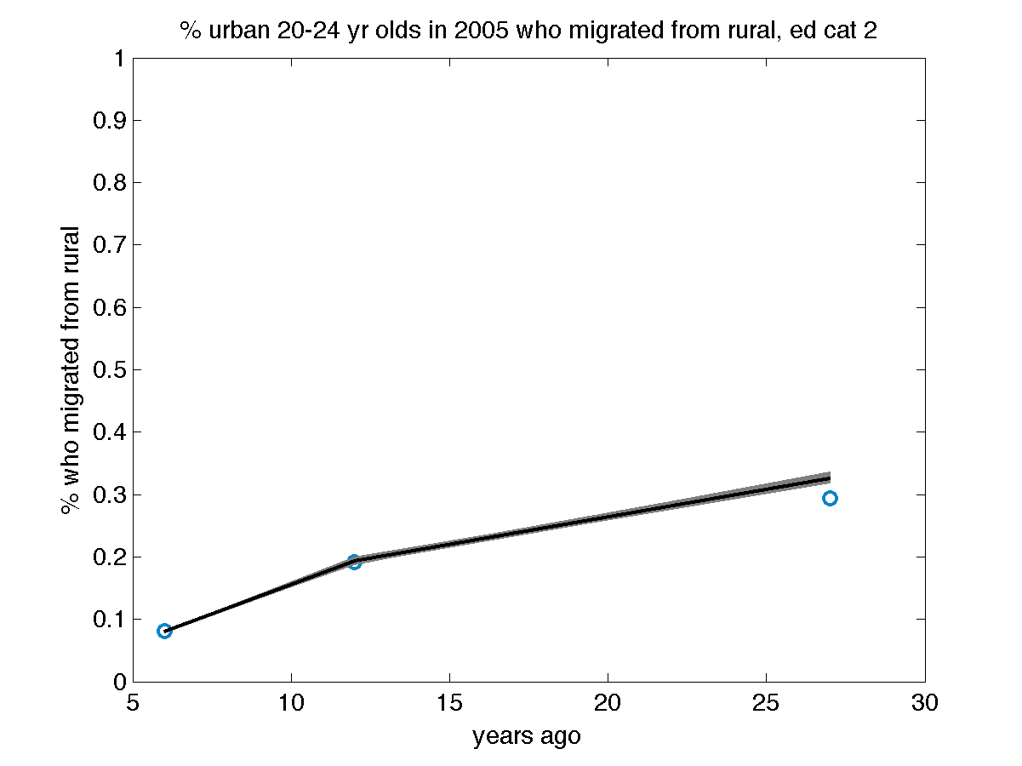
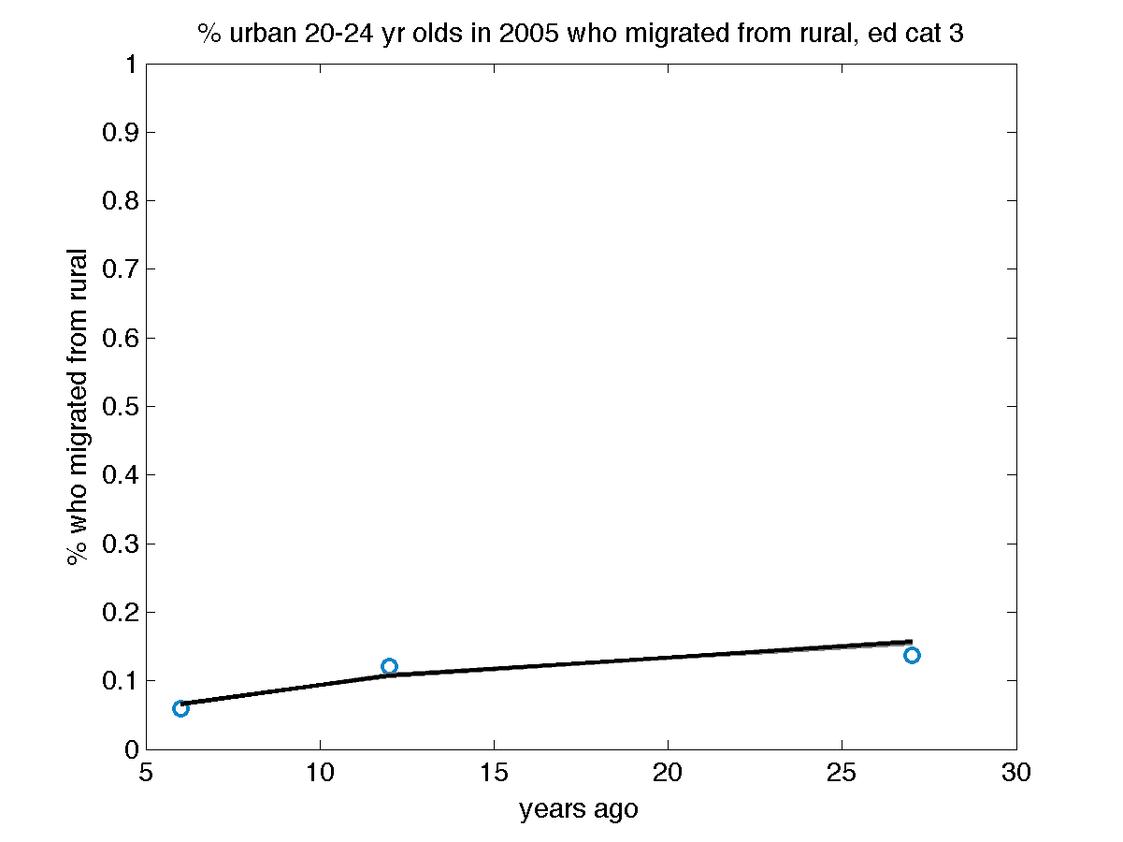

18 Figure AF5: Model fits to education data
Education data are provided in Table AF3. Educational categories are: 0: none; 1: 1 to 6 years; 2: >6 to 12 years; 3: >12 years. In all plots, gray shaded areas are results of 10,000 repeated samples from the posterior joint distribution of the fitted model (Figure 1C), with samples from the interquartile range as black lines and data displayed as dashed blue lines or circles reflecting the 95% confidence intervals of the input datasets. Note that educational attainment data from the first three years (1992, 1998, and 2005) are from the National Family Health Surveys [5–7], while for the final year (2008) the data are from the District Level Household Survey, which has slightly different sampling methodology but it also intended to be nationally-representative [9].

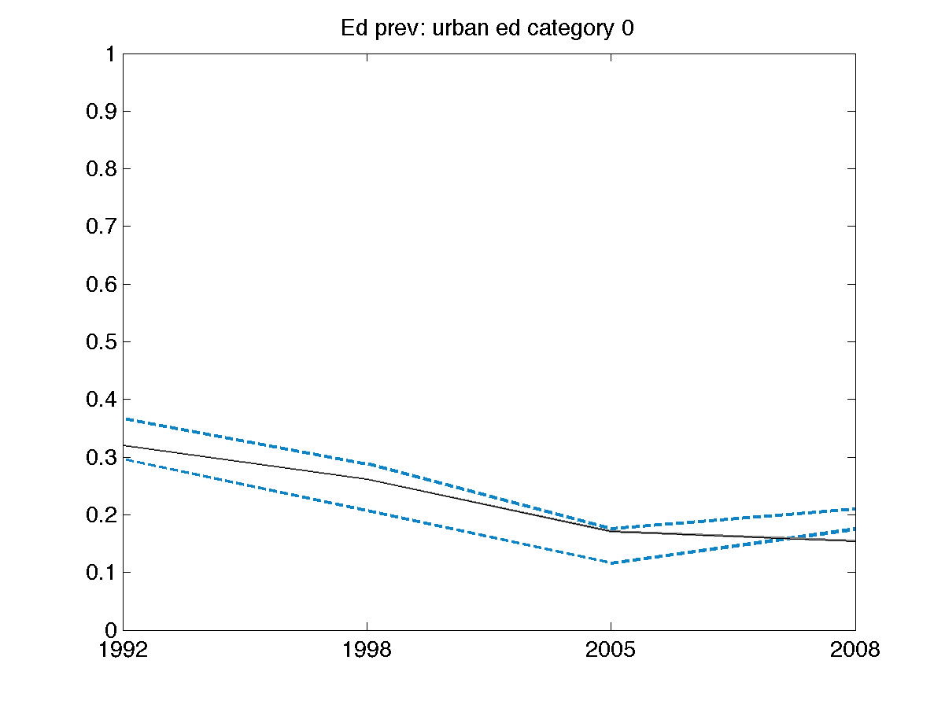
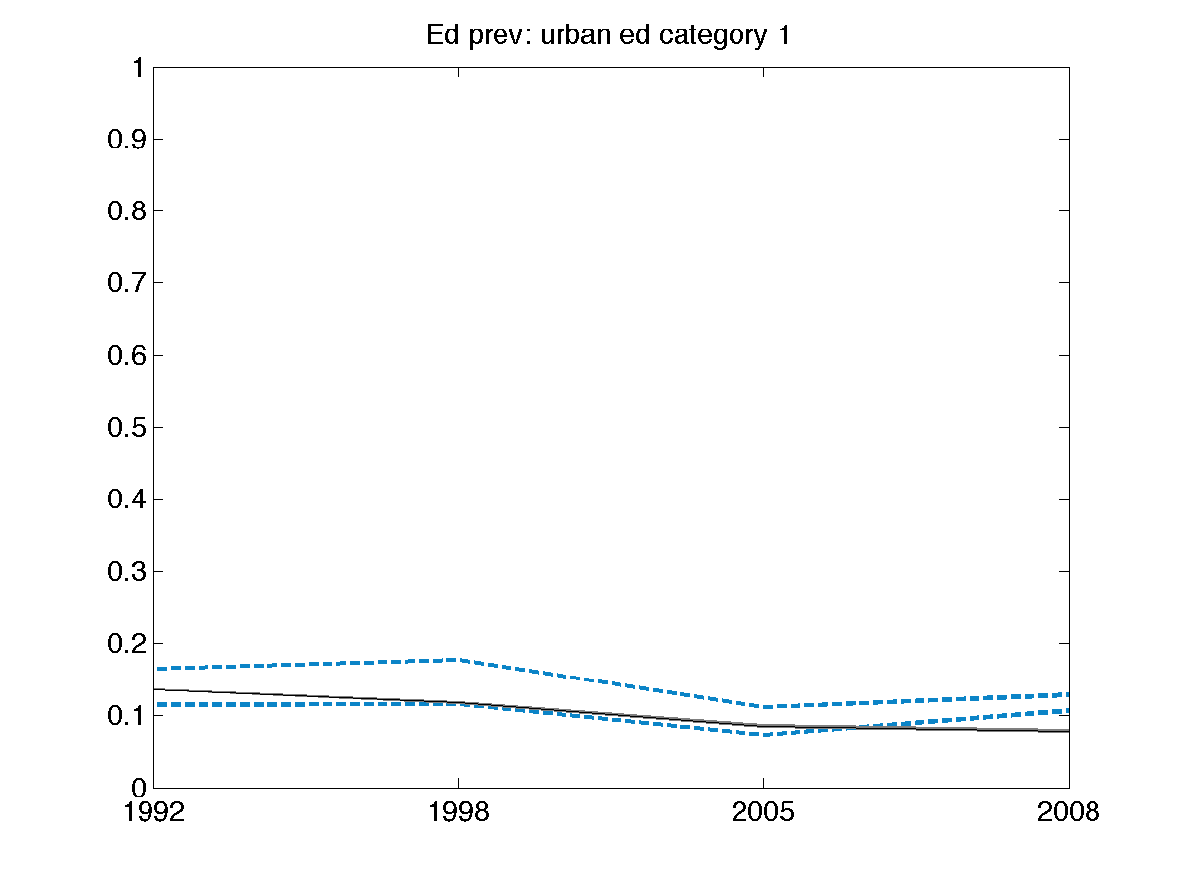
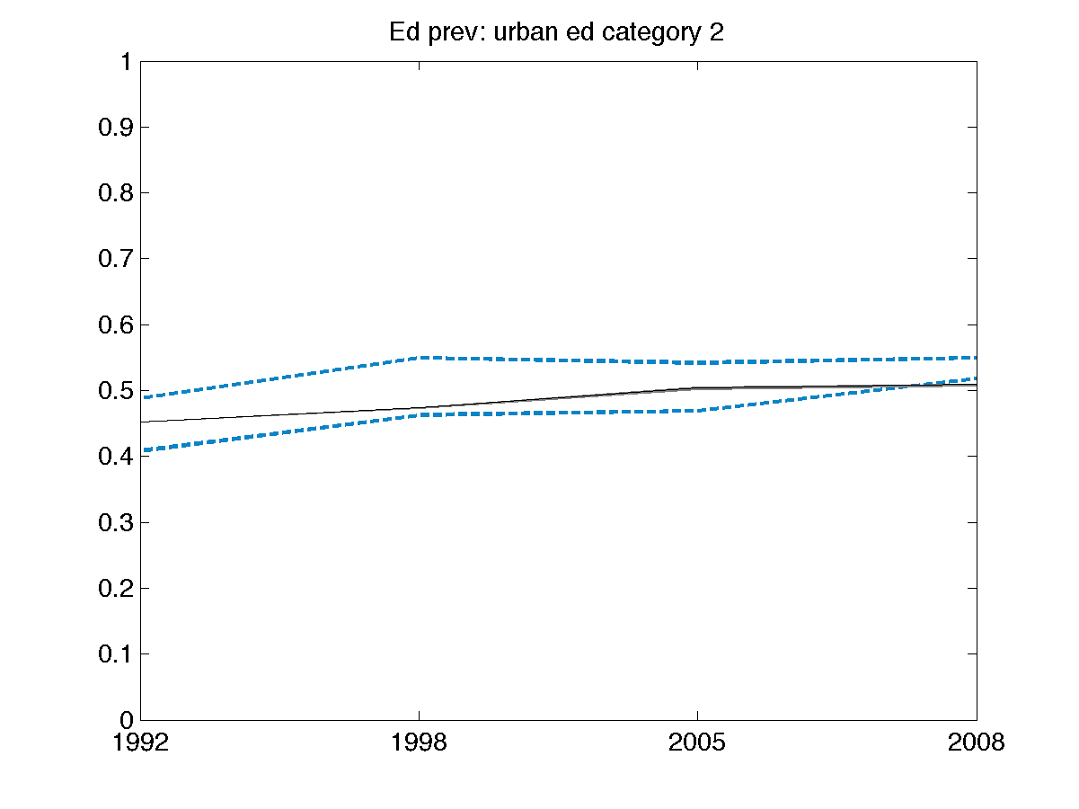
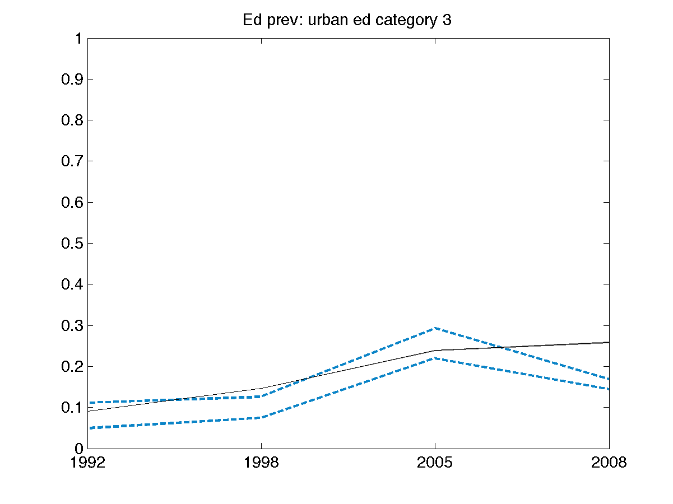
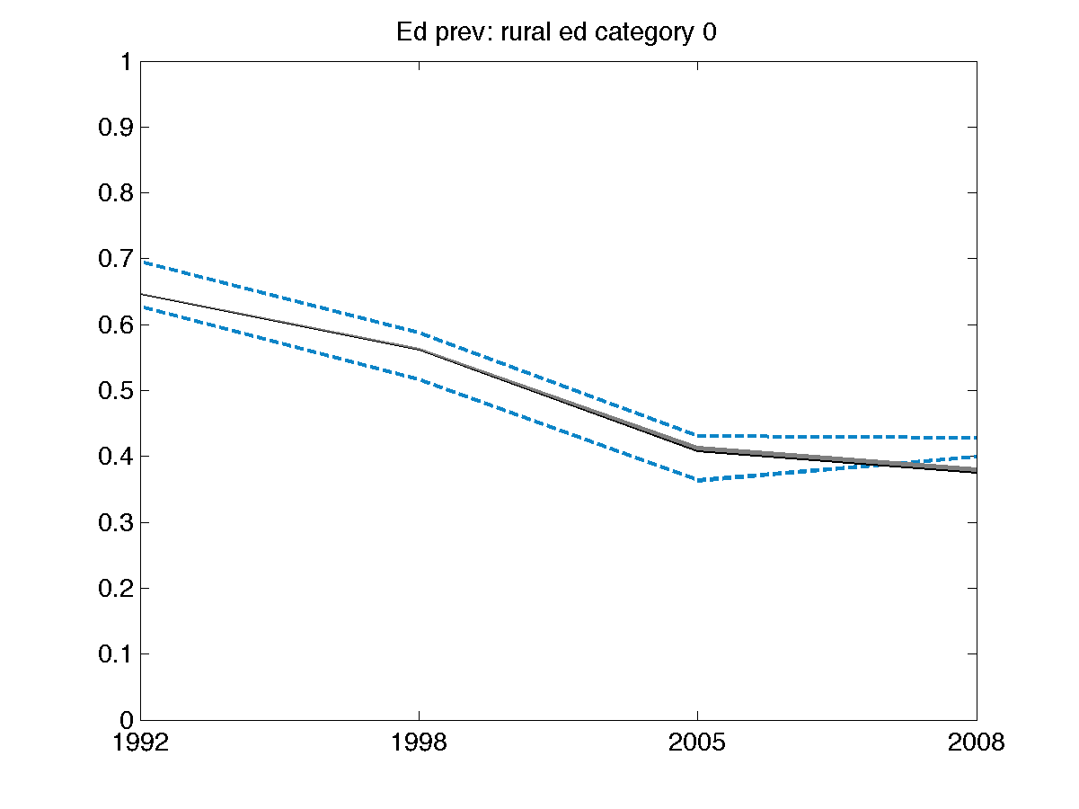
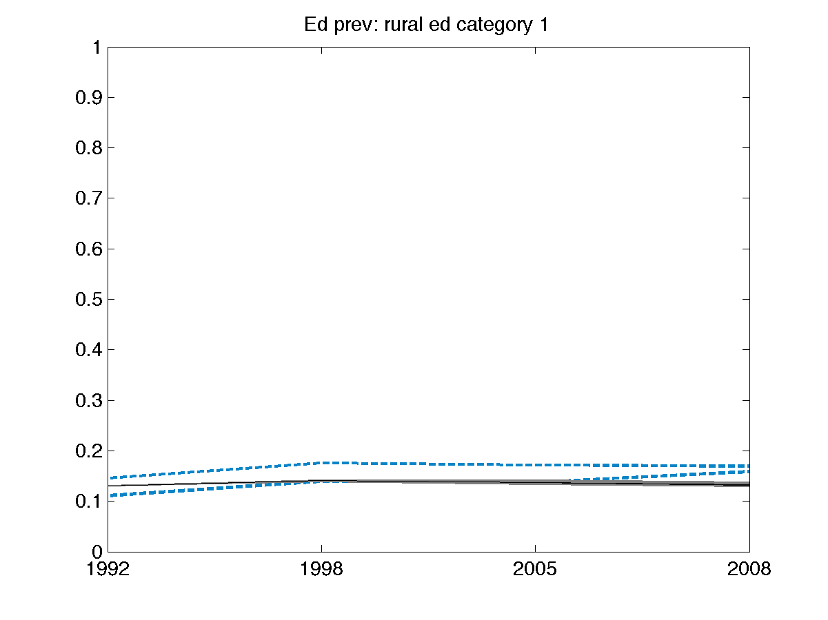
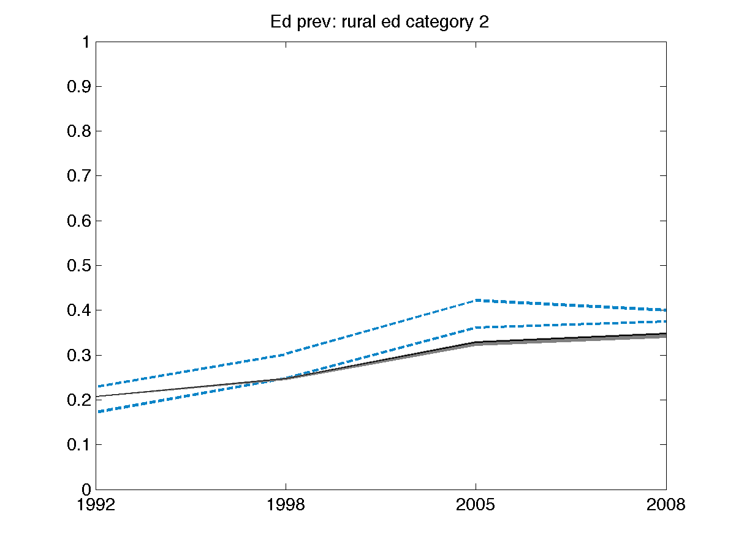
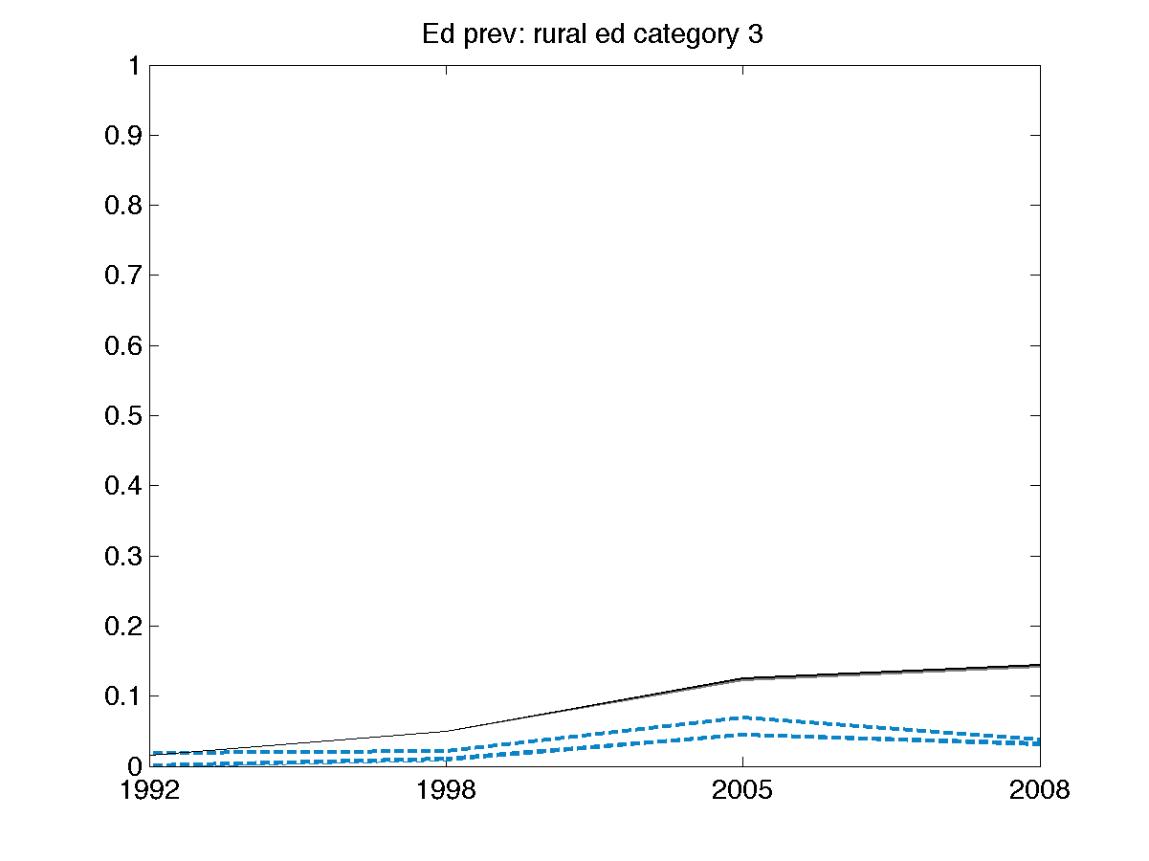

19 Figure AF6: Model fits to life expectancy data

Model-predicted life expectancy validated against independent estimated life expectancy (external validation) (World Bank 2014). Gray lines reflect results of 10,000 repeated samples from the posterior joint distribution of the fitted model (Figure 1C), black lines refer to the samples from the interquartile range of the probability distributions, and blue circles reflect data and its 95% confidence intervals (diameter of circles).

