Additional File 1: Sensitivity analyses

To accompany the article:
Title: The impact of individual-level heterogeneity on estimated infectious disease burden: a simulation study
Authors: Scott A. McDonald, Brecht Devleesschauwer, Jacco Wallinga

Sensitivity analysis 1: Varying annual transition probability parameters
The table below shows the sensitivity of estimated DALYs for no-heterogeneity and heterogeneity variants of model X₂, according to variation in two parameters: the population-averaged annual transition probabilities for progression from the chronic infection to the severe sequela stage, and for progression from the severe sequela stage to death. Shaded cells indicate the parameter values and the results reported in the main text.

Annual transition probability  parameter values | No-heterogeneity  DALY  (95% interval) | Heterogeneity  DALY  (95% interval) | Overestimation  of DALY  (95% interval)
CI Sequela = 1%/yr
Sequela Death = 2%/yr | 15660  (15040-16280) | 15530  (14930-16150) | 1.01  (0.97-1.05)
Sequela Death = 4%/yr | 16780  (16060-17480) | 16620  (16070-17240) | 1.01  (0.97-1.04)
Sequela Death = 6%/yr | 17520  (16720-18280) | 17260  (16570-17940) | 1.01  (0.98-1.06)
CI Sequela = 2%/year
Sequela Death = 2%/yr | 18950  (18130-19660) | 18490  (17850-19160) | 1.03  (0.99-1.06)
Sequela Death = 4%/yr | 20960  (20140-21740) | 20090  (19440- 20780) | 1.04  (1.01-1.08)
Sequela Death = 6%/yr | 22140  (21250-22980) | 21310  (20490-22030) | 1.04  (1.01-1.08)
CI Sequela = 3%/year
Sequela Death = 2%/yr | 21400  (20680-22110) | 20560  (19920-21270) | 1.04  (1.01-1.07)
Sequela Death = 4%/yr | 23924  (23035-24794) | 22790  (22030-23540) | 1.05  (1.02-1.09)
Sequela Death = 6%/yr | 25310  (24440-26200) | 24120  (23380-24950) | 1.05  (1.02-1.08)
CI Sequela = 4%/year
Sequela Death = 2%/yr | 23070  (22320-24060) | 21730  (21000-22550) | 1.06  (1.02-1.10)
Sequela Death = 4%/yr | 26020  (25140-26970) | 24290  (23470-25080) | 1.07  (1.04-1.11)
Sequela Death = 6%/yr | 27720  (26950-28750) | 25770  (25000-26660) | 1.08  (1.04-1.11)

Note. CI = chronic infection; DALY = disability-adjusted life year
Sensitivity analysis 2: Varying the shape of the frailty distribution
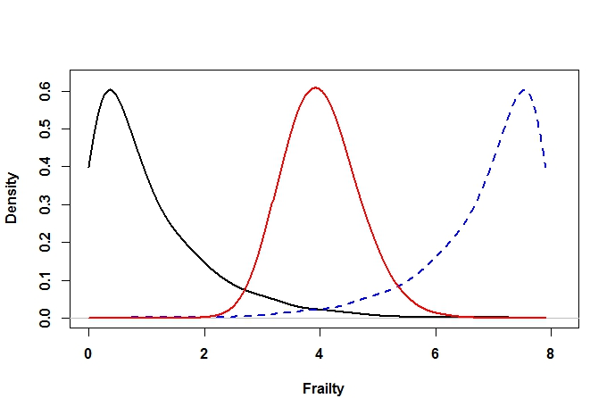
In this supplementary analysis conducted using disease model X₂, the effect on estimated DALYs of specifying (i) a frailty distribution skewed towards fast progressors (blue dashed line in below figure), and (ii) a centered frailty distribution (red line; Gamma(40,0.1), which is approximately Gaussian) are compared with the rightward-skewed frailty distribution used in the primary simulations (black line), is examined. The below table shows the sensitivity of estimated DALYs for no-heterogeneity and heterogeneity variants of model X₂, according to the shape manipulation.

Disease model  variant | YLD | YLL  (95% interval) | DALY  (95% interval) | Overestimation of DALY (95% interval)
No-heterogeneity | 10750 | 10210  (9380–11090) | 20960  (20140–21740) | 1.04  (1.01–1.08)
Heterogeneity (rightward-skewed)ª | 11010 | 9074  (8411–9887) | 20090  (19440-20780) | –
Heterogeneity (centred)^{b} | 10770 | 10160  (9283-11020) | 20930  (20130-21710) | 1.04  (1.01-1.08)
Heterogeneity (leftward-skewed)^{c} | 10740 | 10190  (9284-11010) | 20920  (20160-21660) | 1.04  (1.01-1.08)
Note. ª Sampled from Gamma(1,1); burden values identical to Table 1. ^{b} Sampled from Gamma(40,0.1). ^{c} Sampled from Gamma(1,1), then reversed by subtracting from the maximum sampled value. Overestimation of DALY is with respect to the heterogeneity (rightward-skewed) model variant.

