Manuscript: ‘Quantifying the global contribution of alcohol consumption to cardiomyopathy’
Title: Web figures presenting scatterplots and regression lines of outcomes and predictors
Web Figure 1: Scatterplot and regression line of total alcohol per capita (APC) with crude mortality rate and alcohol attributable fractions
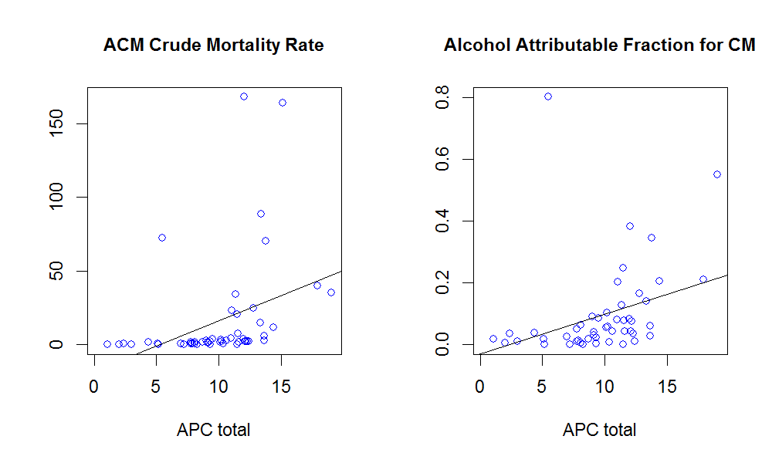

Web Figure 2: Scatterplot and regression line of alcohol per capita (APC) per drinker with crude mortality rate and alcohol attributable fractions
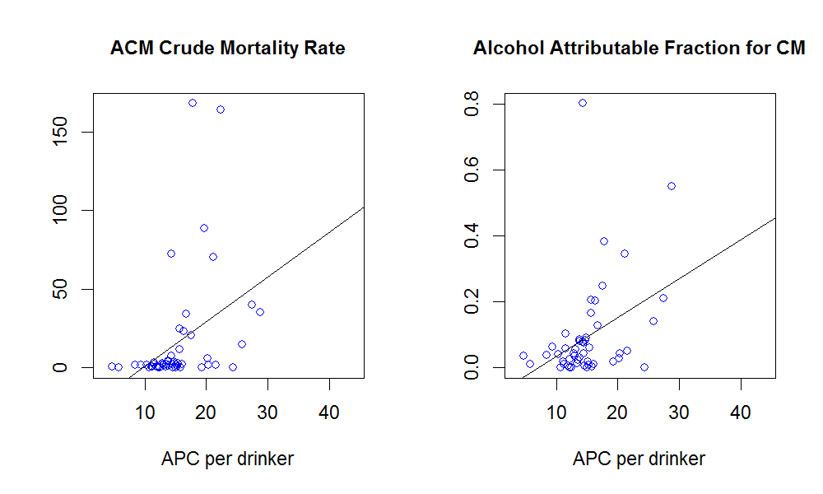

Web Figure 3: Scatterplot and regression line of alcohol use disorder prevalence with crude mortality rate and alcohol attributable fractions
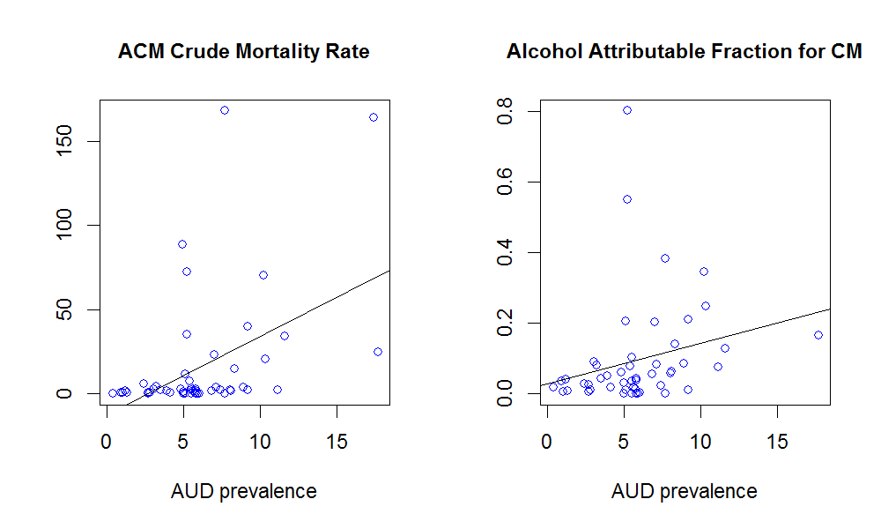

Web Figure 4: Scatterplot and regression line of heavy episodic drinking prevalence with crude mortality rate and alcohol attributable fractions
