Additional file 3A: Location of Demographic and Health Survey program countries and number of surveys, Phases I -IV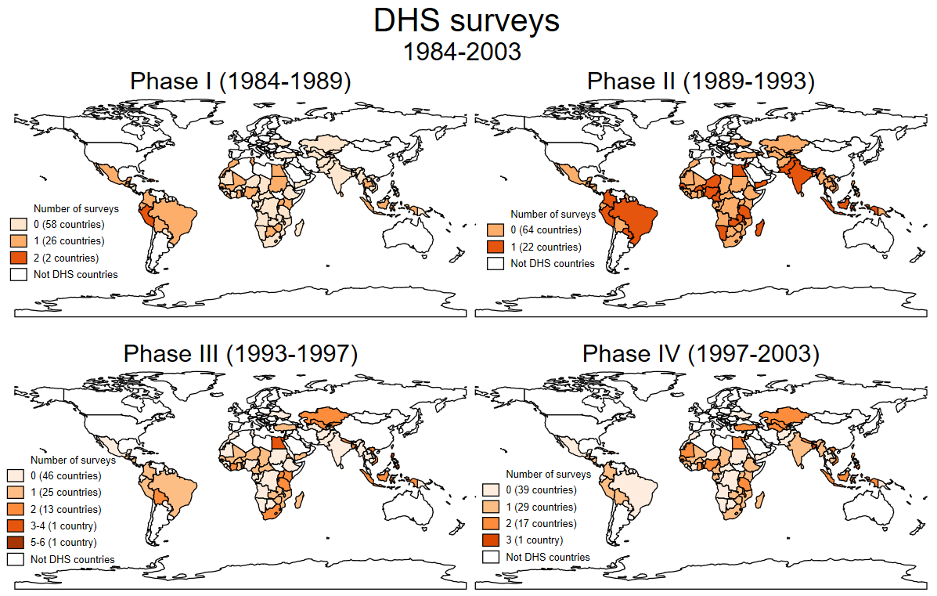

Additional file 3B: Location of Demographic and Health Survey program countries and number of surveys, Phases V- VII
- 