Levels of Missing Data for Essential Health Service Visits
There have been clear improvements in terms of reporting quality and consistency over time for the common infectious diseases (Additional file 1: Figure S.1) as well as the maternal health-related indicators (Additional file 1: Figure S.2), with only approximately 20% to 30% missing facility-month reports by 2020.

Additional file 1: Figure S.1: Missing percentages for common infectious diseases clinical visits
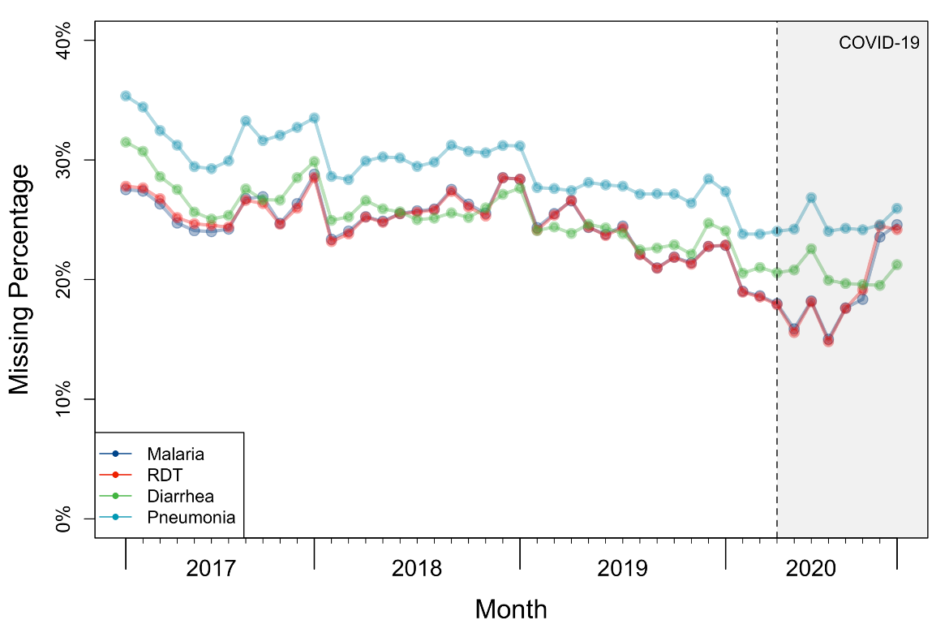

Additional file 1: Figure S.2: Missing percentages for the first antenatal consultation, institutional deliveries, and first postnatal consultation
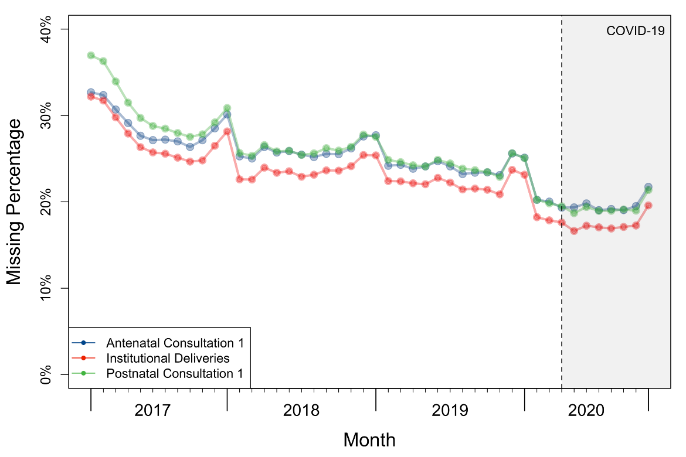
In terms of non-communicable diseases (NCDs) and vaccinations, we observed hospitals were always the major source of NCD visits in DRC (Figure S.3b), while most of the vaccinations took place in health facilities but not hospitals (Figure S.4b). The data quality has only been improved in hospitals for NCDs and in health centres for vaccinations, but not the other types of facilities.

Additional file 1: Figure S.3a: Missing percentages for NCDs (diabetes and hypertension) new diagnoses
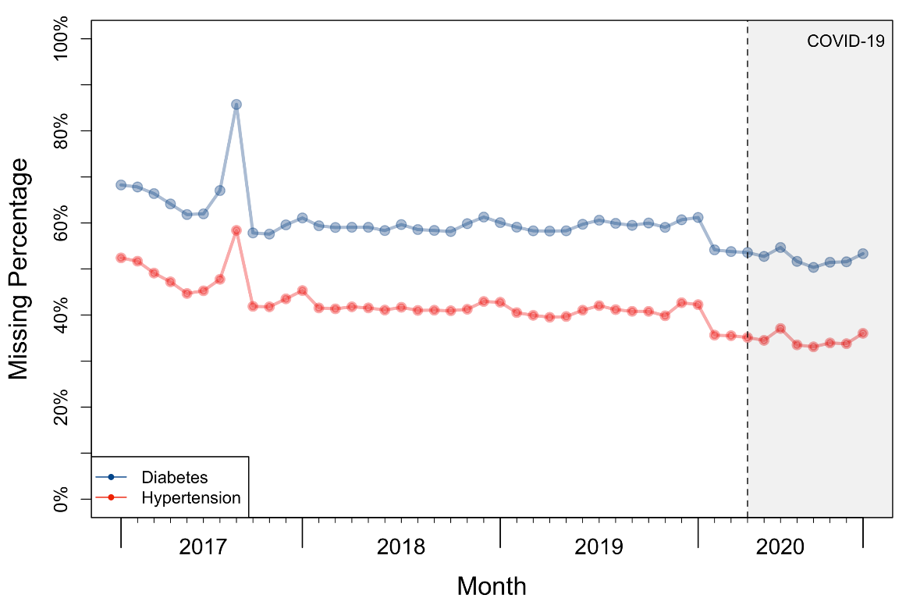

Additional file 1: Figure S.3b: Missing percentages for diabetes-related visits by facility level
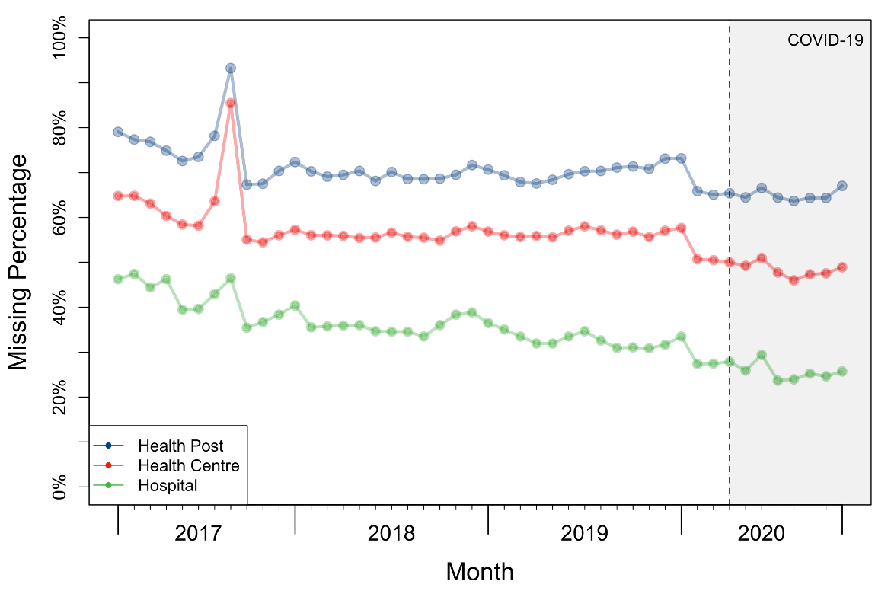

Additional file 1: Figure S.4a: Missing percentages for vaccinations (DTP, BCG, OPV, and PVC-13)
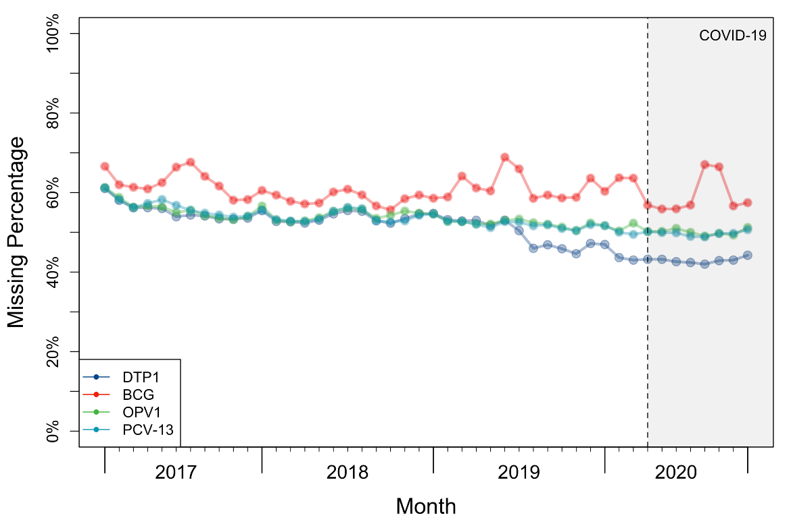

Additional file 1: Figure S.4b: Missing percentages for DTP vaccination visits by facility level
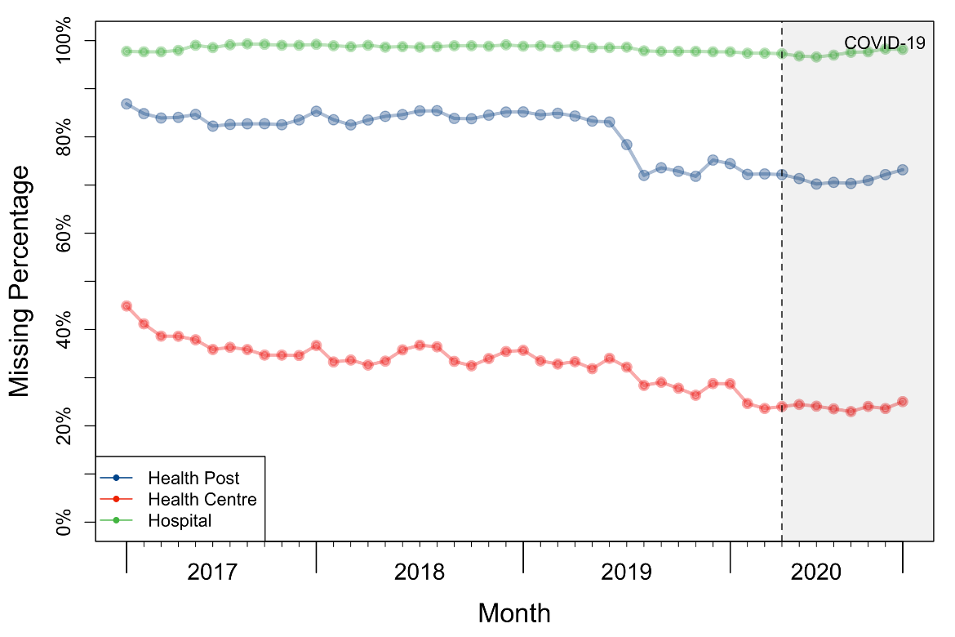

Estimated Coefficients Under MAR Assumption

Additional file 1: Figure S.5a: Estimated coefficients with 95% C.I.s for variable Time from linear regression
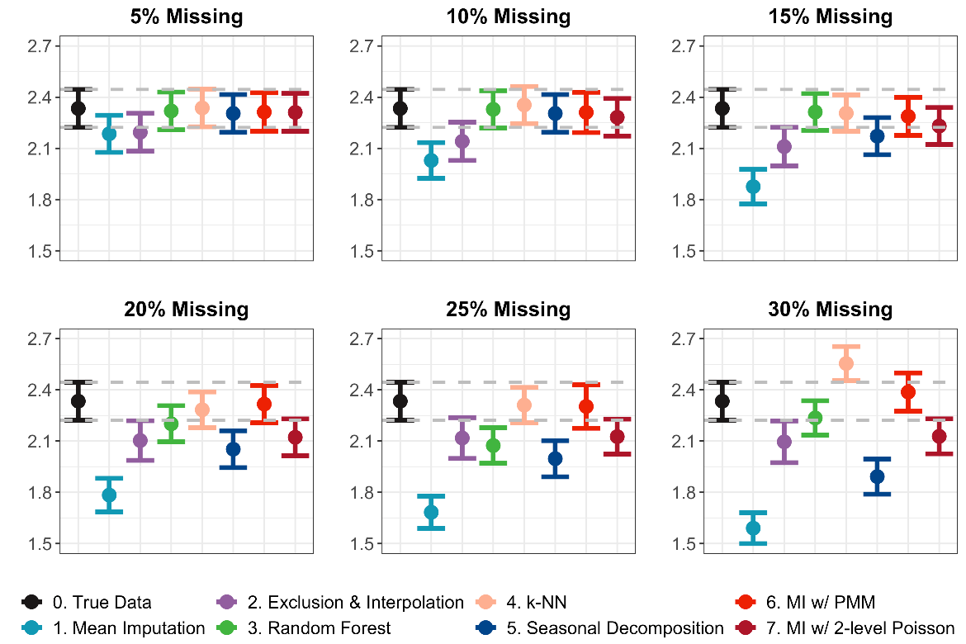

Additional file 1: Figure S.5b: Estimated coefficients with 95% C.I.s for variable log(Population) from linear regression
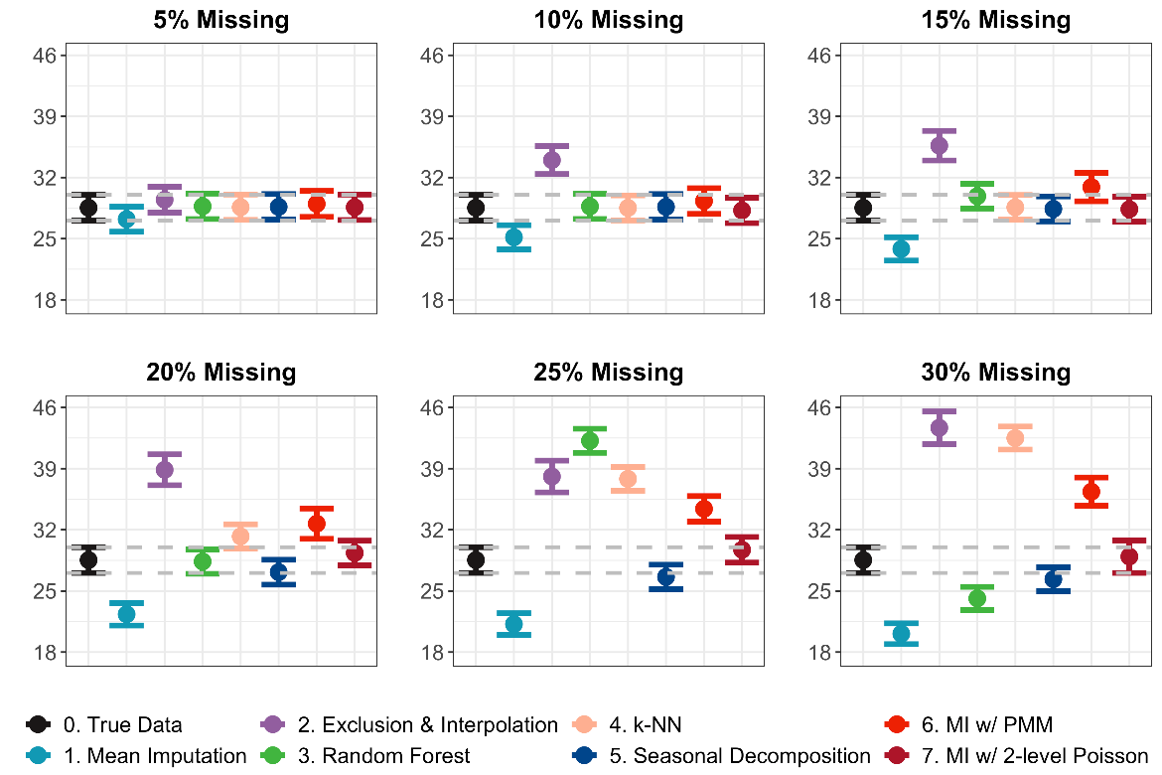

Additional file 1: Figure S.5c: Estimated coefficients with 95% C.I.s for the binary variable COVID from linear regression
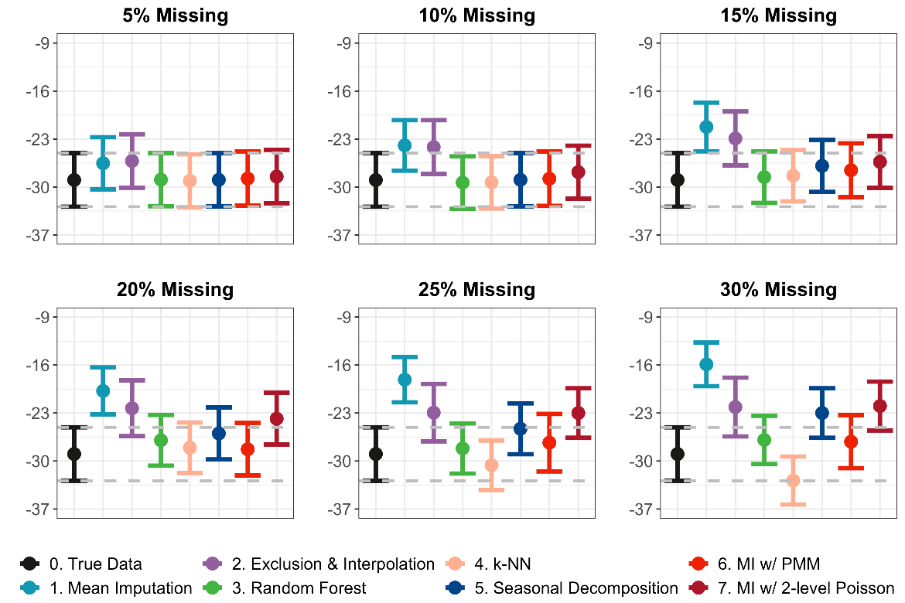

Additional file 1: Figure S.5d: Estimated coefficients with 95% C.I.s for variable Facility Type: Hospital from linear regression
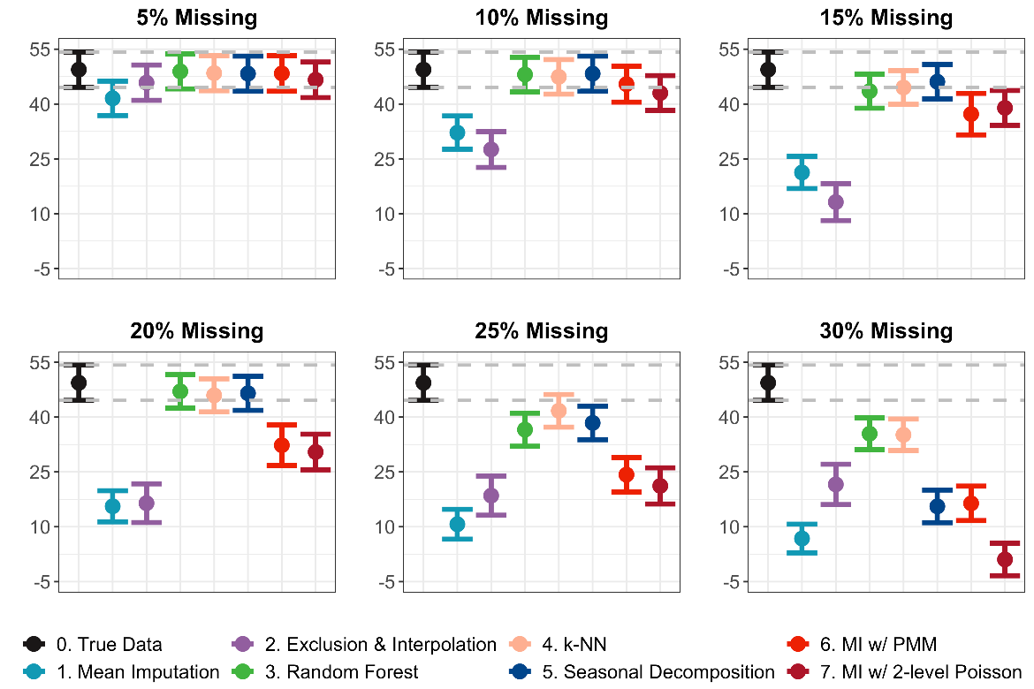

Additional file 1: Figure S.5e: Estimated coefficients with 95% C.I.s for variable Facility Type: Health Post from linear regression
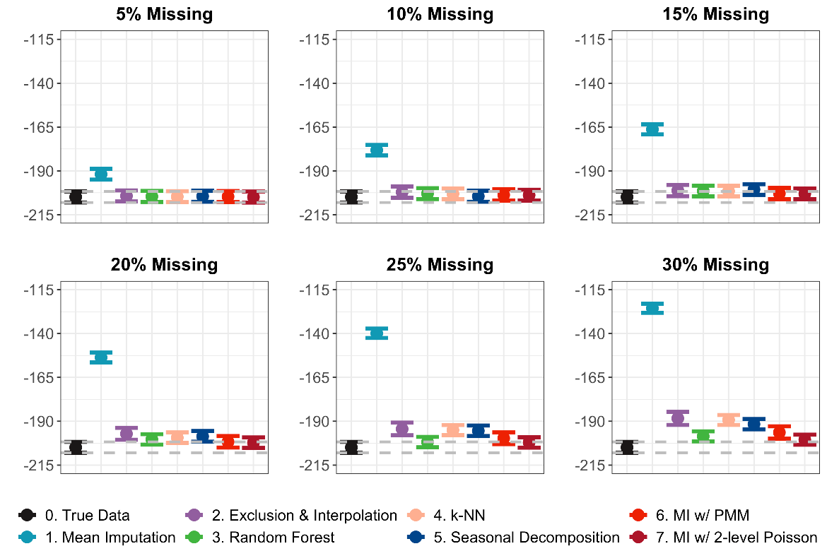

Consecutive Missingness and Stability
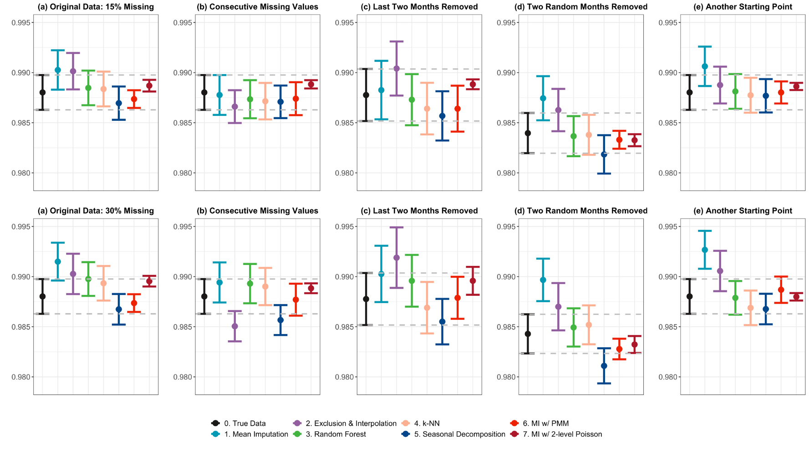
Additional file 1: Figure S.6: Estimated trend change IRRs and 95% C.I.s with missing values inserted under different scenarios
Pre-post Comparison
Paired t-test
As shown in Additional file 1: Table S.1, all methods except mean imputation have returned a p-value less than 0.05, agreeing with the true result that one would have obtained using the complete data.

Additional file 1: Table S.1: p-values obtained from comparing group means using paired t-tests
Imputation Method |  | 5% Missing | 10% Missing | 15% Missing | 20% Missing | 25% Missing | 30% Missing
 | Complete Data | 0.008 † | 0.008 † | 0.008 † | 0.008 † | 0.008 † | 0.008 †
SI | Mean Imputation | 0.044 * | 0.08 | 0.084 | 0.101 | 0.187 | 0.598
SI | Exclusion & Interpolation | 0.021 * | 0.096 | 0.118 | 0.162 | 0.103 | 0.058
SI | Random Forest | 0.005 † | 0.001 † | 0.003 † | 0.007 † | 0.001 † | 0.013 *
SI | k-NN | 0.006 † | 0.008 † | 0.009 † | 0.005 † | < 0.001 † | < 0.001 †
SI | Seasonal Decomposition | 0.001 † | 0.001 † | < 0.001 † | < 0.001 † | < 0.001 † | < 0.001 †
MI | MI with PMM | 0.009 † | 0.011 * | 0.025 * | 0.009 † | 0.038 * | 0.040 *
MI | MI with 2-level Poisson | 0.006 † | 0.004 † | 0.007 † | 0.006 † | 0.007 † | 0.009 †
† for p-value < 0.01, * for p-value <0.05, and no annotation for p-value greater than 0.05

R Codes
##############################################################################
### Load packages
library(data.table)
library(tidyverse)
library(zoo)
library(lubridate)
library(imputeTS)
library(doParallel)
library(missForest)
library(randomForest)
library(mice)
library(countimp)
library(DMwR2)
library(lme4)
##############################################################################
### self-defined functions
add_segments <- function(df) {
df[["cases.agg"]] <- round(df[["cases.agg"]])
df[["date"]] <- as.yearmon(as.character(df[["PERIOD"]]), "%Y %m")
df[["rmonth"]] <- month(df[["date"]])
df[["ryear"]] <- year(df[["date"]])

# index time from 0
df <- df %>% mutate(time=time-1)

df <- df %>%
group_by(facility_ID) %>%
mutate(level = ifelse(time %in% c(0:37), 0, 1),
trend = ifelse(time %in% c(0:37), 0, time-38),
month = as.factor(rmonth),
year = as.factor(ryear))

return(df)
}

fit_glmm <- function(df) {
glmm.fit <- glmer(cases.agg ~ time + level + trend
+ faclevel
+ month
+ log.pop
+ (1+time| facility_ID),
data=add_segments(df),
nAGQ = 0,
family=poisson(link = "log"))
return(glmm.fit) }
##############################################################################
# The codes on merging and aggregating the raw HMIS data files are not provided here, as the data are not available to the public.
##############################################################################
### Insert missing data
# Assume MAR
# Input: dataset_all, which is a cleaned dataset containing ALL facilities
# data_complete, which is a dataframe containing only those always-reporting facilities
# Output: data2, which is the dataset with the same facilities from data_complete, but with
# missing values inserted
# cases.agg is the column containing the number of outpatients (clinical) visits

m_tmp <- dataset_all %>% mutate(missing = ifelse(is.na(cases.agg), 1, 0))

# Create a logistic model that captures the patterns of the missingness from the original data
m_model <- glm(missing ~ time + factor(season) + covid + log.pop + factor(faclevel)
+ factor(province) + factor(health_zone),
data = m_tmp, family = binomial)

# Predict the chance of being missing in the complete dataset, using the patterns found in the
# entire dataset
data2 <- data_complete
data2$m_pct <- predict(m_model, data_complete, type="response")

# to calibrate a missing proportion of 10%
set.seed(123)
missing <- sapply(data2$m_pct, function(pct) {rbernoulli(1, pct*1.519)})

# introduce missing
data2$cases.agg[missing==1] <- NA
##############################################################################
### Missing handling
# 1. Mean Imputation
data_mean <- data2
data_mean$cases.agg[is.na(data_mean$cases.agg)] <- round(mean(data_mean$cases.agg, na.rm = T))

# 2. Exclusion - exclude facilities with more than 3 consecutive missing months,
# and fill the rest missing values with interpolation
data_exclude <- data2
data_exclude$m_cases <- 0
data_exclude$m_cases[is.na(data_exclude$cases)==TRUE] <- 1
setDT(data_exclude)[, cm_cases := ifelse(m_cases== 0, 0, cumsum(m_cases)), .(facility_ID, rleid(m_cases))]

data_exclude <- data_exclude %>%
group_by(province, health_zone, facility_ID) %>%
summarise(exclude = ifelse(max(cm_cases)>3, 1, 0))

# Interpolation on the remaining facilities
data_exclude <- data_exclude %>%
filter(exclude==0) %>%
group_by(facility_ID) %>%
mutate(cases.agg=na_interpolation(cases.agg))

# 3. Random Forest
data_rf <- subset(data2, select=c(cases.agg, time, covid, log.pop, season, province, faclevel))
data_rf <- data_rf %>%
group_by(facility_ID) %>%
mutate(cases.lag1 = shift(cases.agg, -1),
cases.lead1 = shift(cases.agg, 1))

cores <- 4
cl <- makeCluster(cores)
registerDoParallel(cores)
set.seed(123)
cases.rf.impute <- missForest(data_rf, maxiter = 20, ntree = 10, parallelize="forests")
stopCluster(cl)

data_rf <- data2
data_rf$cases.agg <- round(cases.rf.impute$ximp$cases.agg)

# 4. k-NN
data_knn <- subset(data2, select=c(cases.agg, time, covid, log.pop, season, province, faclevel))
data_knn <- data_knn %>%
group_by(facility_ID) %>%
mutate(cases.lag1 = shift(cases.agg, -1),
cases.lead1 = shift(cases.agg, 1))
set.seed(123)
data_knn.impute <- knnImputation(data_knn, k = 10, scale = T, meth = "weighAvg")

data_knn <- data2
data_knn$cases.agg <- round(data_knn.impute$cases.agg)

# 5. Seasonal Decomposition
data_seadec <- data2 %>%
group_by(province_ID) %>%
na_seadec(algorithm = "kalman", find_frequency=TRUE)
# 6. MICE
data_mice <- subset(data2, select=c(cases.agg, time, covid, log.pop, season, province, faclevel))
data_mice <- data_mice %>%
group_by(facility_ID) %>%
mutate(cases.lag1 = shift(cases.agg, -1),
cases.lead1 = shift(cases.agg, 1))

mi <- mice(data_mice, m=5, method="pmm", maxit = 10, seed=123)

# 7. two-level Poisson with MICE
data_mice_multilevel <- subset(data2, select=c(cases.agg, PERIOD, time, covid, log.pop, season,
province, facility_ID, faclevel))
data_mice_multilevel <- data_mice_multilevel %>%
group_by(facility_ID) %>%
mutate(cases.lag1 = shift(cases.agg, -1),
cases.lead1 = shift(cases.agg, 1))
data_mice_multilevel$province <- as.integer(as.factor(data_mice_multilevel$province))

ini <- countimp(data_mice_multilevel, maxit=0)
meth <- ini$method
meth[meth!=""] <- "2l.poisson"

pred <- ini$predictorMatrix
pred[, "PERIOD"] <- 0
pred["cases.agg", c("time", "covid", " facility_ID ")] <- c(2, 2, -2)
pred["cases.lag1", c("time", "covid", " facility_ID ")] <- c(2, 2, -2)
pred["cases.lead1", c("time", "covid", " facility_ID")] <- c(2, 2, -2)

mi_multilevel <- countimp(data_mice_multilevel, method=meth, predictorMatrix=pred, m=5, maxit=10)
##############################################################################
### ITS with mixed effect Poisson
glmm_true <- fit_glmm(data_complete)
glmm_mean <- fit_glmm(data_mean)
glmm_exclude <- fit_glmm(data_exclude)
glmm_rf <- fit_glmm(data_rf)
glmm_knn <- fit_glmm(data_knn)
glmm_seadec <-fit_glmm(data_seadec)
glmm_mice <- mice::complete(mi, action = "long", include = TRUE) %>%
mutate(PERIOD = sort(unique(data2$PERIOD))[time],
LEVEL_5_UID = rep(data2$LEVEL_5_UID, 6)) %>%
add_segments() %>%
as.mids() %>%
mice::complete("all") %>%
lapply(glmer, formula = cases.agg ~ time + level + trend + faclevel + month + log.pop + (1+time|LEVEL_5_UID), family=poisson(link = "log")) %>%
pool()

glmm_mice_multilevel <- mice::complete(mi_multilevel, action = "long", include = TRUE) %>%
add_segments() %>%
as.mids() %>%
mice::complete("all") %>%
lapply(glmer, formula = cases.agg ~ time + level + trend + faclevel + month + log.pop + (1+time|LEVEL_5_UID), family=poisson(link = "log")) %>%
pool()

