An innovative visual approach to the simultaneous study of two dimensions of progress in longevity: An application to French and German regions

Supplemental Material A
Links between national standardized death rate$(SDR)$, standard deviation of regional SDRs $(SD)$ and coefficient of variation of regional SDRs $(CV)$.
Let index by $t$ and $t+1$ the values in first and second periods. We can write:
$${CV}_{t}=\frac{{SD}_{t}}{\overline{{SDR}_{t}}} (1)$$
$${CV}_{t+1}=\frac{{SD}_{t+1}}{\overline{{SDR}_{t+1}}} \left(2\right)$$
By combining $\left(1\right)$ and $\left(2\right)$, we obtain:
$$\frac{{CV}_{t+1}}{{CV}_{t}}=\frac{\frac{{SD}_{t+1}}{{SDR}_{t+1}}}{\frac{{SD}_{t}}{{SDR}_{t+1}}}=\frac{\frac{{SD}_{t+1}}{{SD}_{t}}}{\frac{{SDR}_{t+1}}{{SDR}_{t}}} \left(3\right)$$
We call $∆x$ the absolute variation of $x$ between $t$ and $t+1$. Using this notation in (3), we obtain:
$$\frac{{CV}_{t}+∆CV}{{CV}_{t}}=\frac{\frac{{SD}_{t}+∆SD}{{SD}_{t}}}{\frac{{SDR}_{t}+∆SDR}{{SDR}_{t}}} (4)$$
$$1+\frac{∆CV}{{CV}_{t}}=\frac{1+\frac{∆SD}{{SD}_{t}}}{1+\frac{∆SDR}{{SDR}_{t}}} (5)$$
We transform $(5)$using the natural logarithm and its mathematical properties:
$$ln\left(1+\frac{∆CV}{{CV}_{t}}\right)=ln\left(\frac{1+\frac{∆SD}{{SD}_{t}}}{1+\frac{∆SDR}{{SDR}_{t}}}\right)=ln\left(1+\frac{∆SD}{{SD}_{t}}\right)-ln\left(1+\frac{∆SDR}{{SDR}_{t}}\right) (5)$$
When $x$ is small, $ln\left(1+x\right)≈x$. Using this approximation in $(5)$, we finally obtain:
$$\frac{∆CV}{{CV}_{t}}≈\frac{∆SD}{{SD}_{t}}-\frac{∆SDR}{{SDR}_{t}} \left(6\right)$$
In few words, the relative variation of CV is equal to the difference between the relative variation of SD minus the relative variation of SDR.

Additional figures
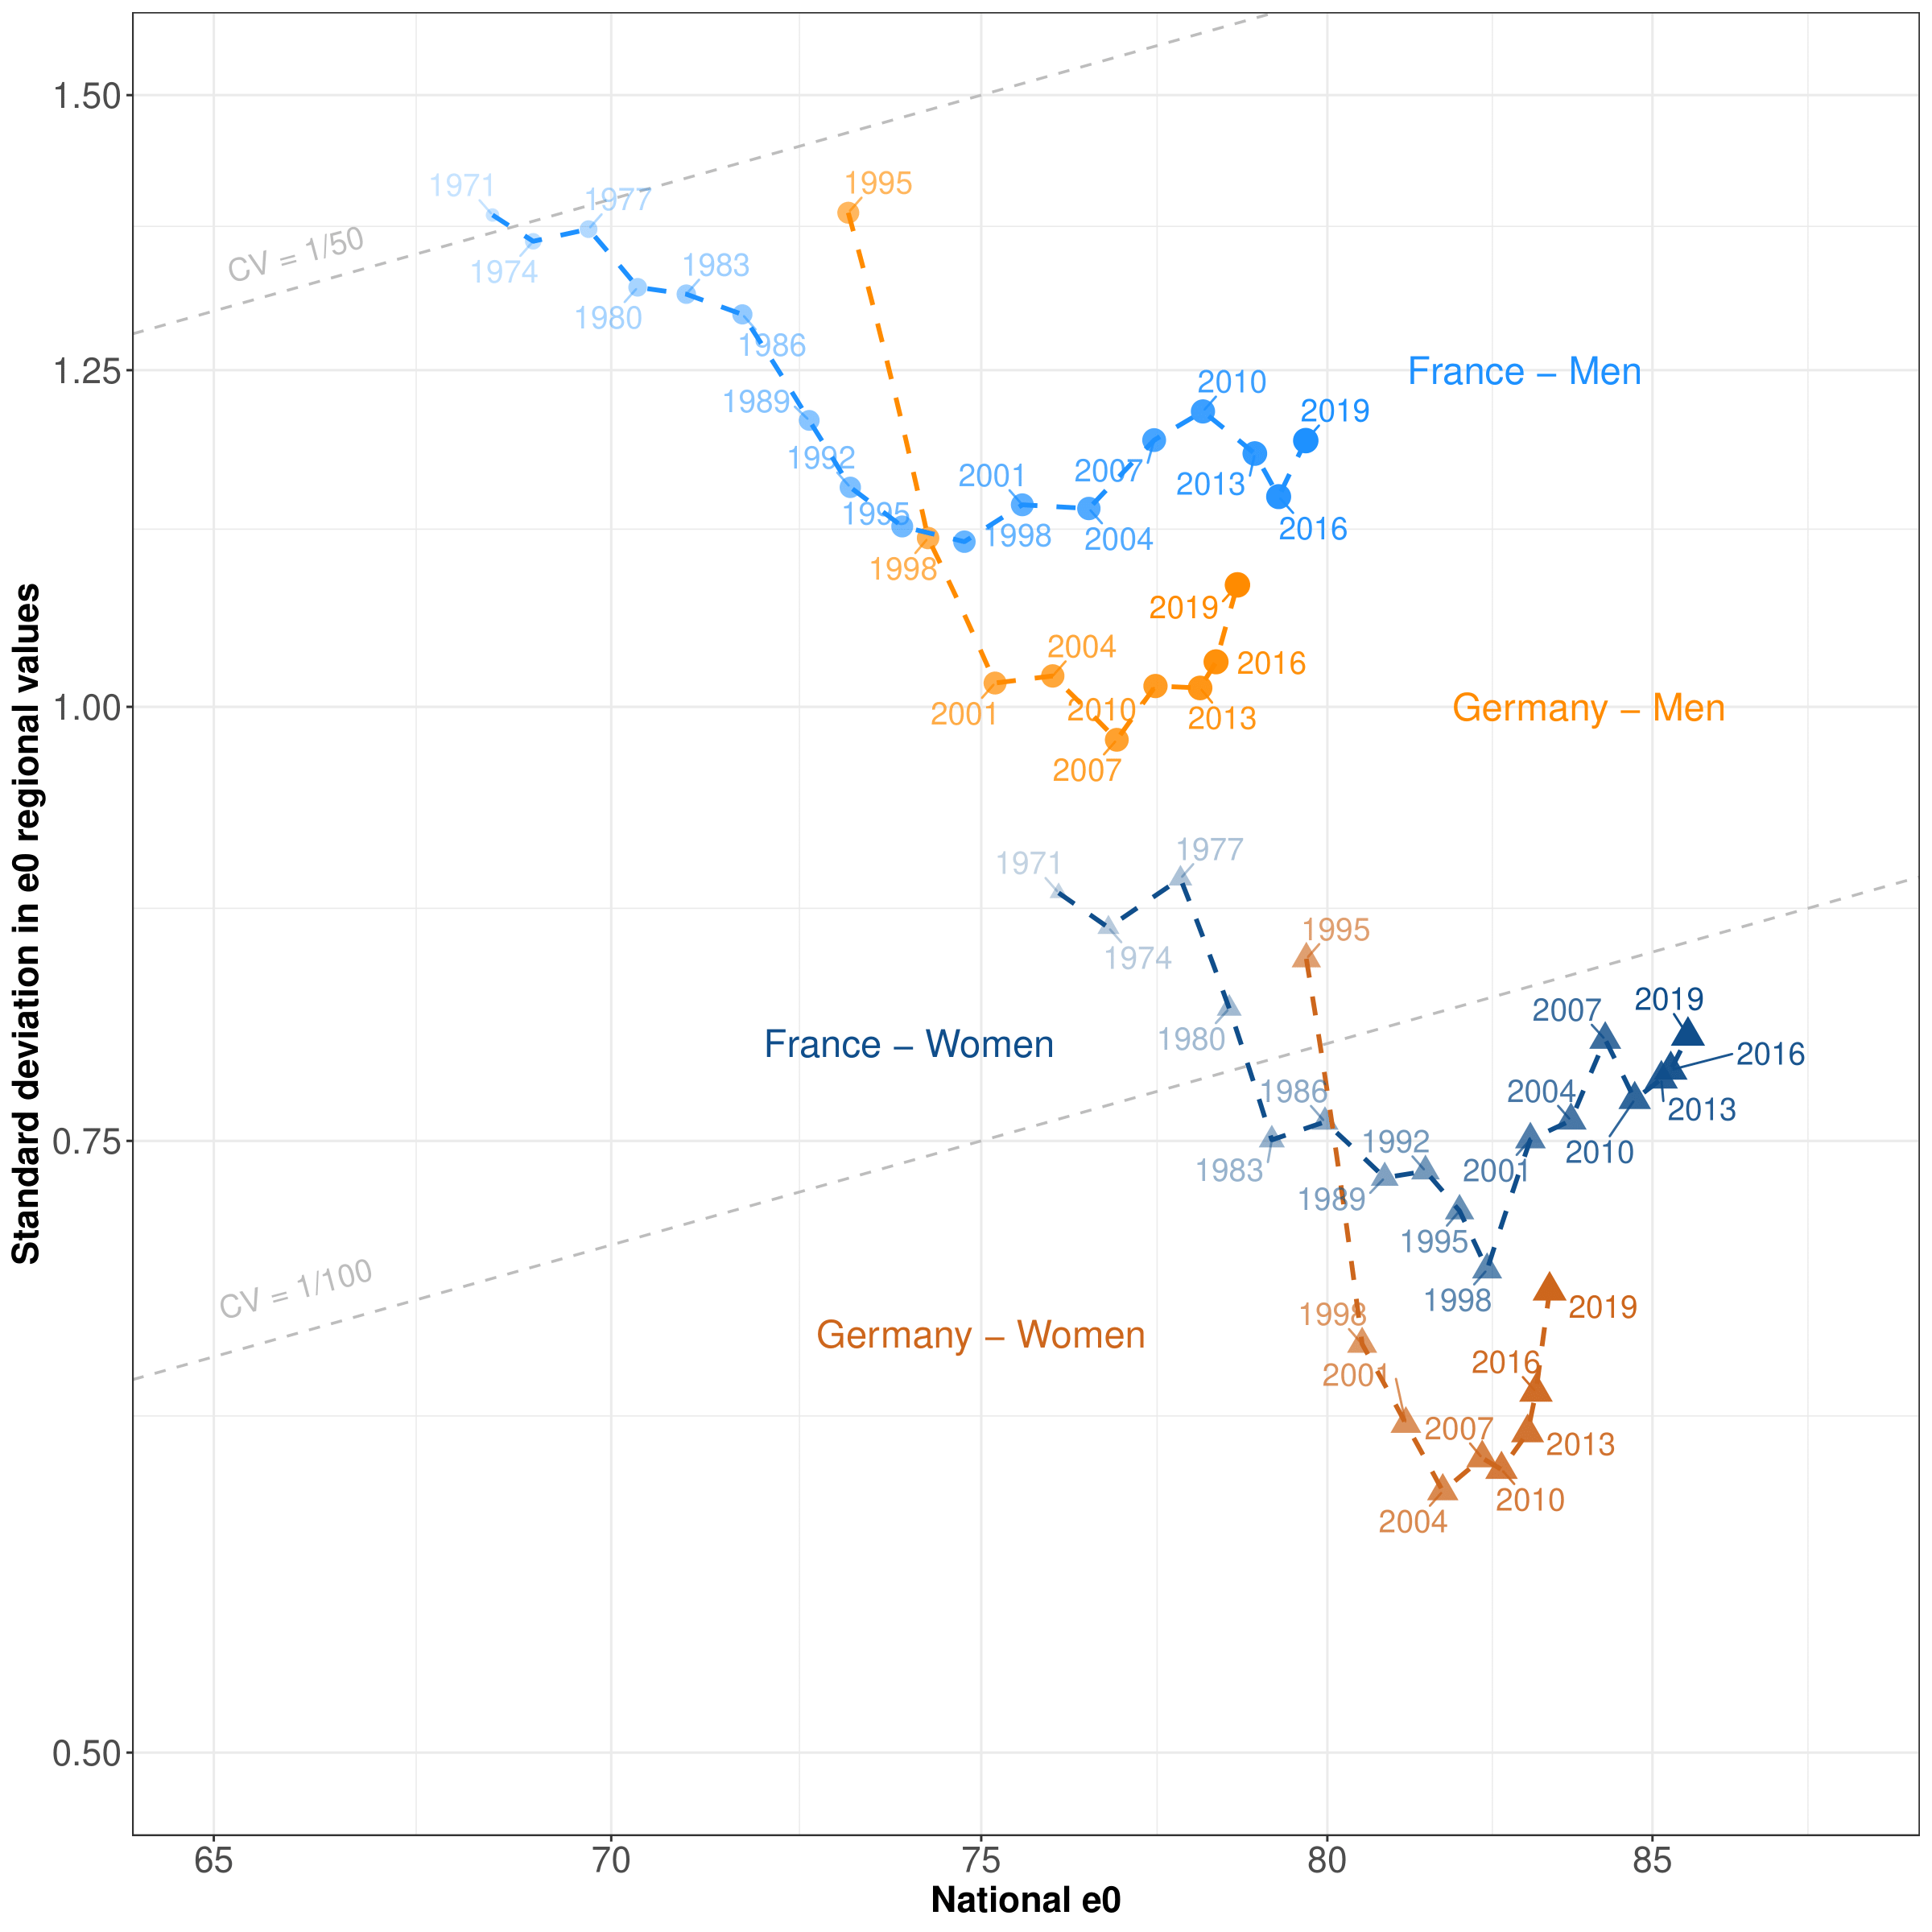
Figure A1 : Pathways of national life expectancy at birth (e0) and regional inequalities in France (1970–2019) and Germany (1995–2019).
Note: Societal progress in mortality occurs when the pathway moves downwards and to the right.

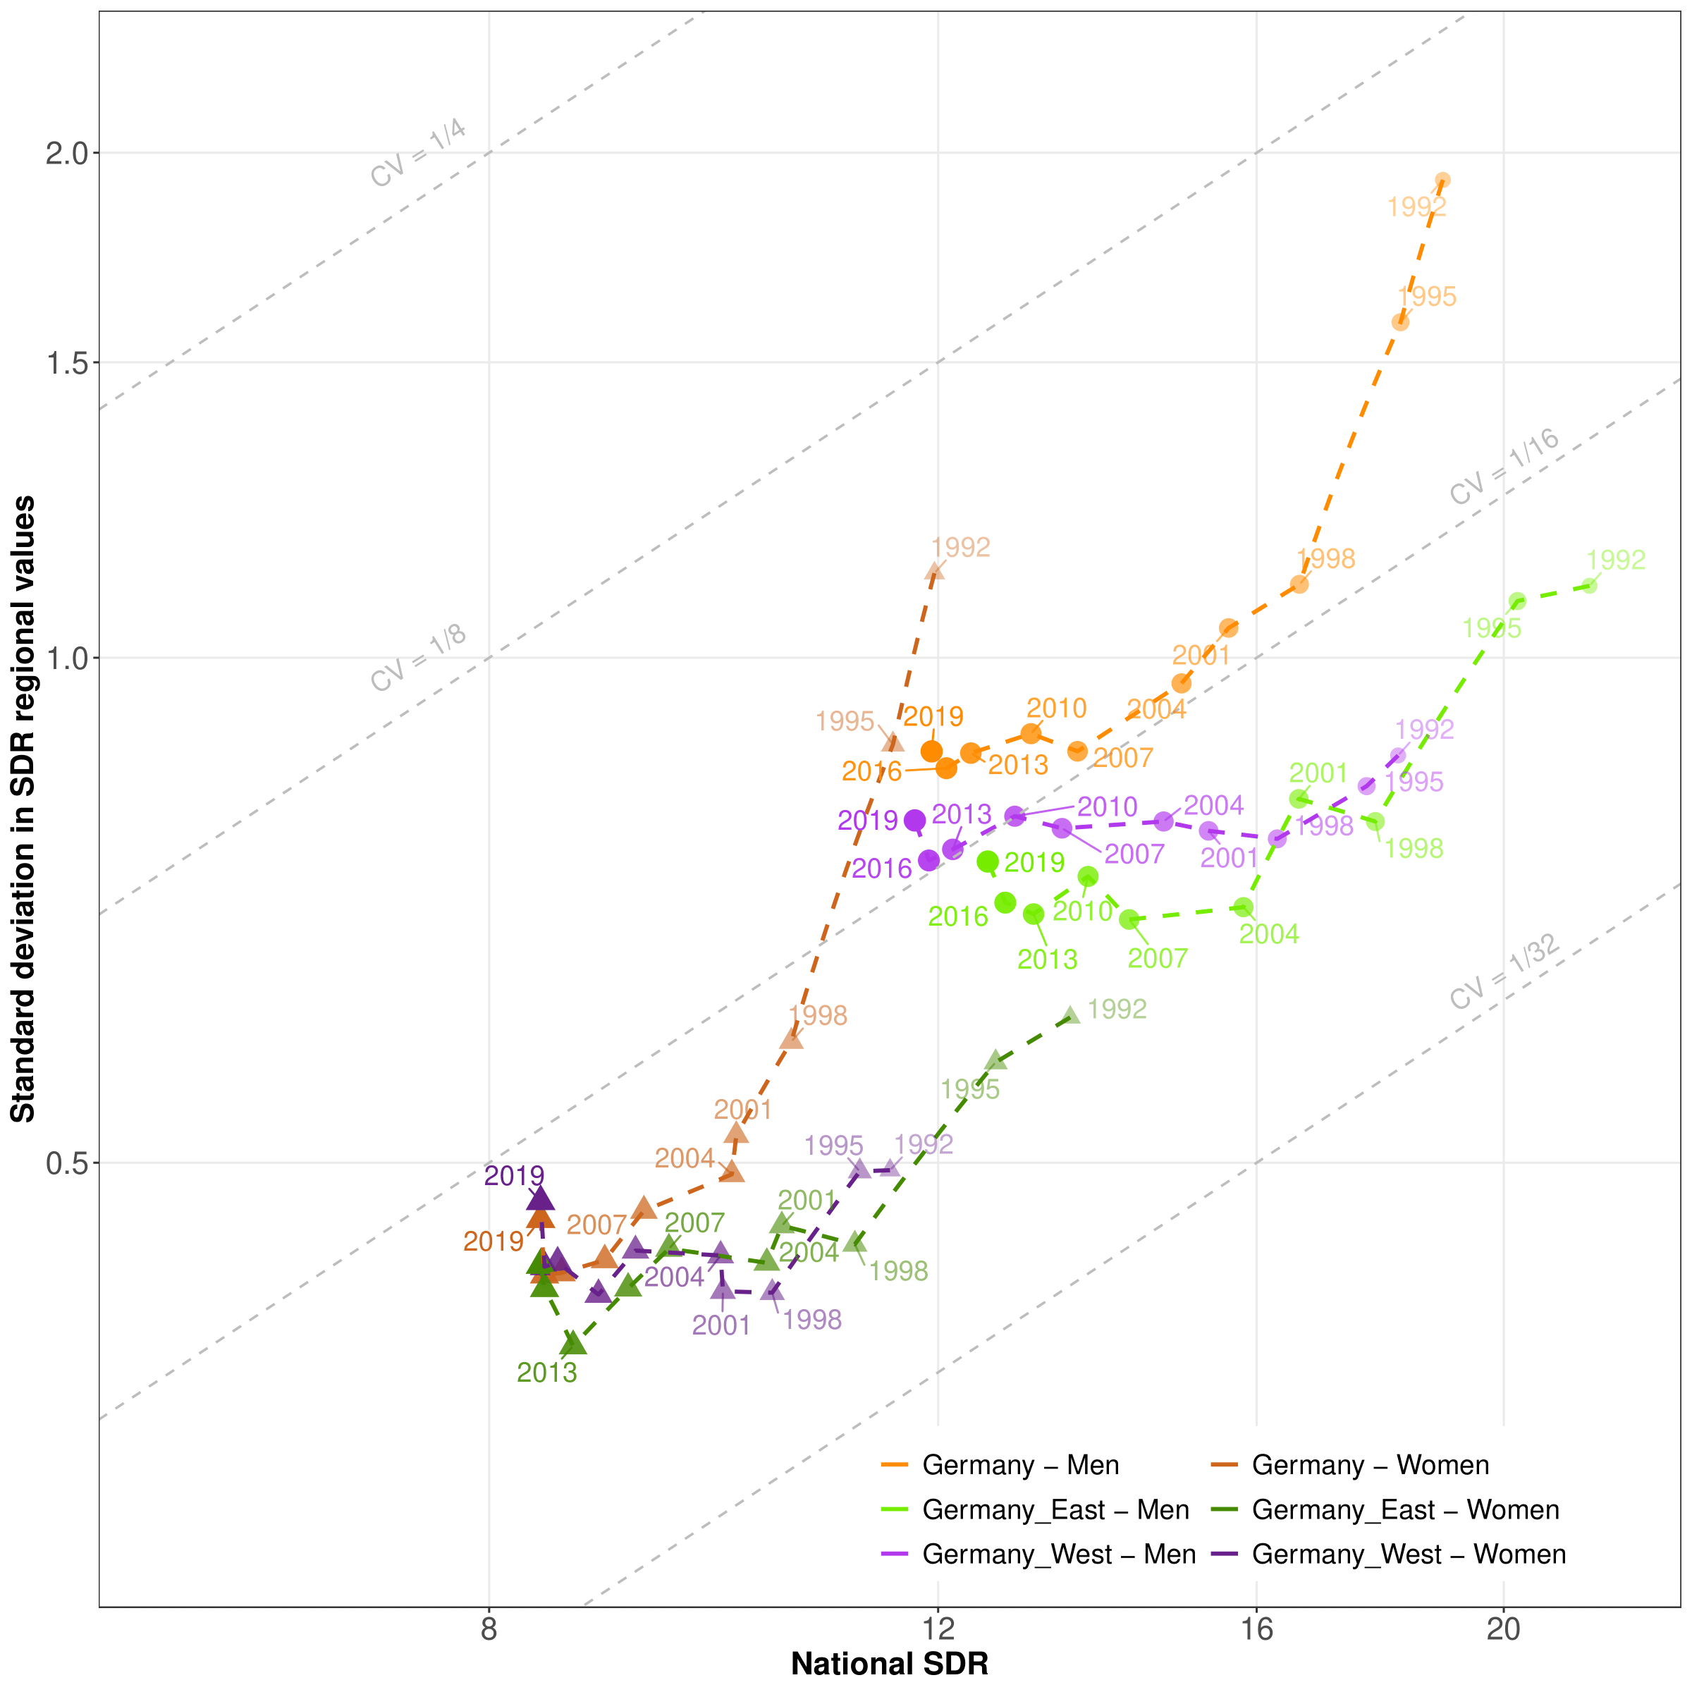
Figure A2 : Pathways of overall SDRs and regional inequalities in western, eastern and total Germany, 1992–2020.
Note: Societal progress in mortality occurs when the pathway moves downwards and to the left.

Supplemental Material B
Data and R code to replicate our figures are available at:
https://osf.io/h68wz/?view_only=47353f6f4b2e41cab3c761246e59d615
Please read first “Online Supplementary Appendix.pdf”.

