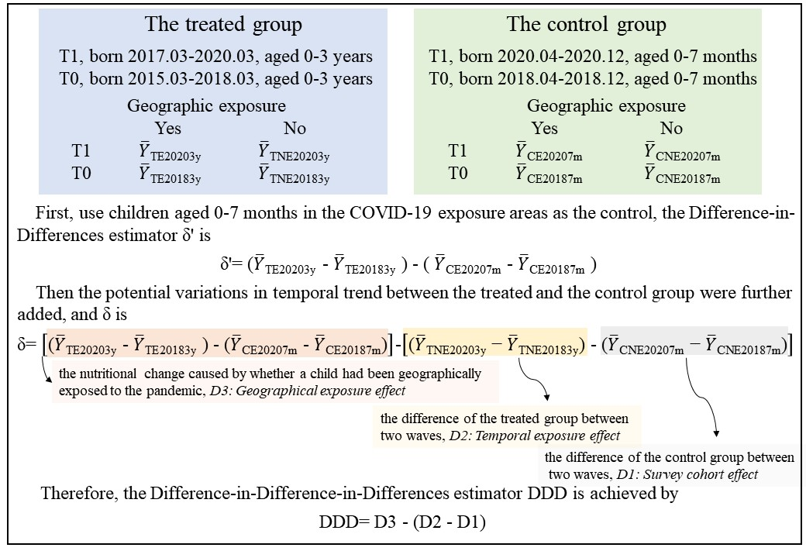
Supplementary Fig.1 The illustration diagram of our Difference-in-Difference-in-Differences estimation

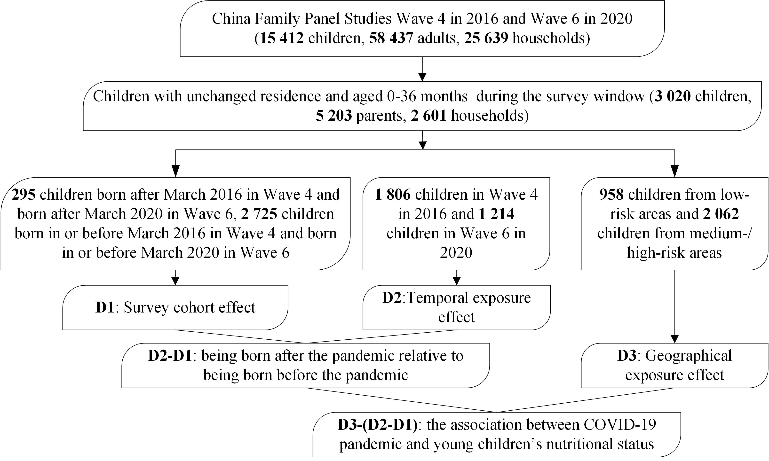
Supplementary Fig.2 Flowchart depicting the processing of analytical respondents of 2016 and 2020

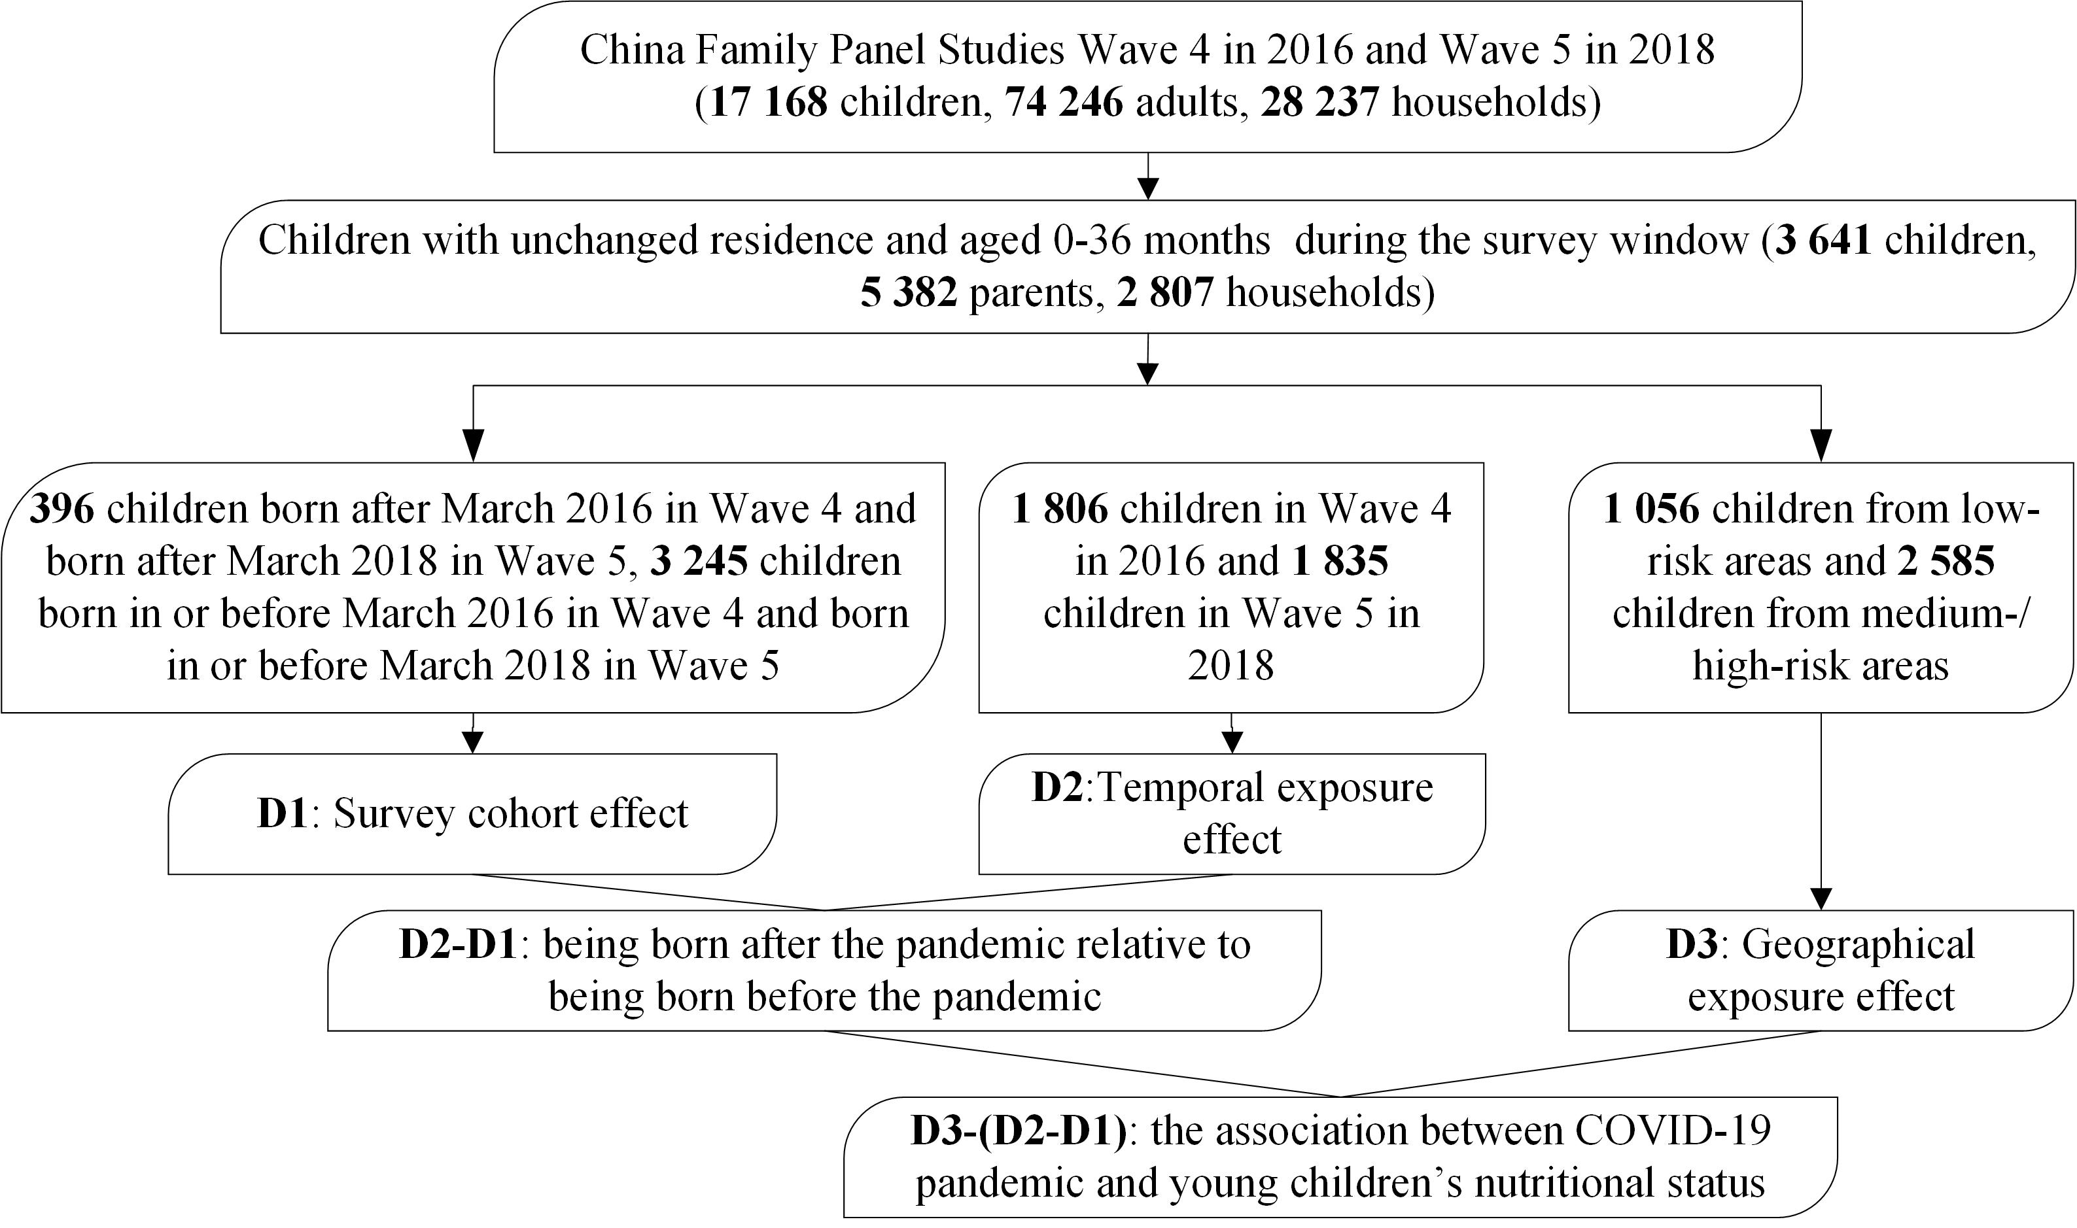
Supplementary Fig.3 Flowchart depicting the processing of analytical respondents of 2016 and 2018

Supplementary Table A1 Sensitivity analyses: the multilevel estimations of the relationships between COVID-19 exposure and the continuous nutritional indicators
Nutritional indicators | Regression models | Definition of risk areas | Coefficients (LCI-HCI) | P value
WAZ | Model 1 | C50 | 0.67 (-0.25-1.60) | 0.155
 |  | C15 | 0.87 (-0.02-1.76) | 0.058
 |  | C10 | 0.30 (-0.65-1.27) | 0.529
 | Model 2 | C50 | 0.66 (-0.26-1.59) | 0.159
 |  | C15 | 0.86 (-0.02-1.75) | 0.058
 |  | C10 | 0.31 (-0.64-1.27) | 0.525
 | Model 3 | C50 | 0.92 (-0.08-1.92) | 0.073
 |  | C15 | 1.19 (0.24-2.13) | 0.013
 |  | C10 | 0.34 (-0.06-1.34) | 0.051
HAZ | Model 1 | C50 | 0.05 (-1.52-1.62) | 0.951
 |  | C15 | 0.32 (-1.20-1.86) | 0.675
 |  | C10 | 0.90 (-0.72-2.53) | 0.275
 | Model 2 | C50 | 0.05 (-1.52-1.61) | 0.953
 |  | C15 | 0.35 (-1.17-1.88) | 0.649
 |  | C10 | 0.95 (-0.67-2.57) | 0.251
 | Model 3 | C50 | 0.20 (-1.50-1.91) | 0.815
 |  | C15 | 1.14 (-0.48-2.77) | 0.167
 |  | C10 | 2.10 (0.37-3.82) | 0.017
BAZ | Model 1 | C50 | -0.10 (-1.48-1.27) | 0.879
 |  | C15 | -0.07 (-1.44-1.29) | 0.916
 |  | C10 | -0.96 (-2.39-0.47) | 0.188
 | Model 2 | C50 | -0.11 (-1.49-1.26) | 0.871
 |  | C15 | -0.08 (-1.45-1.28) | 0.899
 |  | C10 | -0.97 (-2.40-0.45) | 0.183
 | Model 3 | C50 | 0.17 (-1.35-1.70) | 0.826
 |  | C15 | 0.10 (-1.38-1.59) | 0.892
 |  | C10 | -0.84 (-2.41-0.72) | 0.293
(Note: WAZ- weight-for-age z-score, HAZ- height/length-for-age z-score, BAZ- BMI-for-age z-score; C50, C15 and C10 imply respectively using 50, 15 and 10 accumulated confirmed cases as the thresholds of low-risk and medium-/high-risk areas)

Supplementary Table A2 Sensitivity analyses: the multilevel estimations of the relationships between COVID-19 exposure and the categorical nutritional indicators
Nutritional indicators | Regression models | Definition of risk areas | OR (LCI-HCI) | P value
Underweight | Model 1 | C50 | 0.20 (0.01-4.70) | 0.320
 |  | C15 | 0.05 (0.00-0.99) | 0.050
 |  | C10 | 0.09 (0.01-1.58) | 0.100
 | Model 2 | C50 | 0.20 (0.01-4.84) | 0.329
 |  | C15 | 0.06 (0.00-0.99) | 0.050
 |  | C10 | 0.09 (0.01-1.58) | 0.099
 | Model 3 | C50 | 0.13 (0.00-6.89) | 0.318
 |  | C15 | 0.03 (0.00-0.65) | 0.027
 |  | C10 | 0.07 (0.00-1.56) | 0.094
Stunting | Model 1 | C50 | 3.72 (0.26-5.17) | 0.328
 |  | C15 | 1.14 (0.16-7.96) | 0.895
 |  | C10 | 0.93 (0.12-7.04) | 0.950
 | Model 2 | C50 | 3.65 (0.26-5.75) | 0.335
 |  | C15 | 1.11 (0.16-7.81) | 0.910
 |  | C10 | 0.93 (0.12-7.03) | 0.949
 | Model 3 | C50 | 4.69 (0.30-7.04) | 0.269
 |  | C15 | 0.44 (0.05-3.87) | 0.465
 |  | C10 | 0.27 (0.02-2.69) | 0.267
Wasting | Model 1 | C50 | 3.19 (0.51-9.29) | 0.217
 |  | C15 | 0.97 (0.15-6.39) | 0.971
 |  | C10 | 1.31 (0.18-9.58) | 0.783
 | Model 2 | C50 | 3.19 (0.51-9.29) | 0.215
 |  | C15 | 0.98 (0.15-6.36) | 0.978
 |  | C10 | 1.34 (0.18-9.68) | 0.775
 | Model 3 | C50 | 3.12 (0.49-6.79) | 0.346
 |  | C15 | 0.99 (0.18-7.01) | 0.979
 |  | C10 | 1.35 (0.18-9.75) | 0.813
Overweight/obesity | Model 1 | C50 | 1.62 (0.26-9.97) | 0.604
 |  | C15 | 0.70 (0.12-3.90) | 0.684
 |  | C10 | 0.42 (0.07-2.59) | 0.352
 | Model 2 | C50 | 1.60 (0.26-9.87) | 0.613
 |  | C15 | 0.69 (0.12-3.82) | 0.668
 |  | C10 | 0.42 (0.07-2.59) | 0.348
 | Model 3 | C50 | 1.58 (0.21-8.76) | 0.654
 |  | C15 | 0.65 (0.12-3.45) | 0.513
 |  | C10 | 0.41 (0.07-2.39) | 0.317
(Note: C50, C15 and C10 imply respectively using 50, 15 and 10 accumulated confirmed cases as the thresholds of low-risk and medium-/high-risk areas)

Supplementary Table B1 Falsification tests: estimations of the relationships with the 2016 and 2020 cohorts (continuous nutritional indicators)
Nutritional indicators | Regression models | Definition of risk areas | Coefficients (LCI-HCI) | P value
WAZ | Model 1 | C50 | 0.68 (-0.21-1.58) | 0.136
 |  | C15 | 0.66 (-0.25-1.58) | 0.156
 |  | C10 | 0.48 (-0.50-1.48) | 0.336
 | Model 2 | C50 | 0.68 (-0.21-1.57) | 0.137
 |  | C15 | 0.66 (-0.25-1.58) | 0.158
 |  | C10 | 0.48 (-0.51-1.47) | 0.342
 | Model 3 | C50 | 0.97 (-0.09-2.03) | 0.073
 |  | C15 | 0.68 (-0.05-1.73) | 0.065
 |  | C10 | 0.21 (-0.20-1.32) | 0.071
HAZ | Model 1 | C50 | -0.26 (-1.78-1.25) | 0.731
 |  | C15 | -0.18 (-1.77-1.39) | 0.815
 |  | C10 | 0.37 (-1.33-2.08) | 0.668
 | Model 2 | C50 | -0.27 (-1.78-1.23) | 0.725
 |  | C15 | -0.19 (-1.77-1.38) | 0.809
 |  | C10 | 0.38 (-1.32-2.08) | 0.66
 | Model 3 | C50 | 0.50 (-1.21-2.22) | 0.563
 |  | C15 | 0.93 (-0.78-2.65) | 0.287
 |  | C10 | 1.73 (-0.12-3.59) | 0.067
BAZ | Model 1 | C50 | 0.47 (-0.84-1.79) | 0.477
 |  | C15 | 0.82 (-0.52-2.22) | 0.226
 |  | C10 | 0.55 (-0.91-2.02) | 0.46
 | Model 2 | C50 | 0.48 (-0.83-1.80) | 0.468
 |  | C15 | 0.86 (-0.51-2.23) | 0.22
 |  | C10 | 0.56 (-0.90-2.02) | 0.452
 | Model 3 | C50 | 0.31 (-1.24-1.87) | 0.695
 |  | C15 | -0.13 (-1.69-1.42) | 0.867
 |  | C10 | -0.6 (-2.26-1.06) | 0.479
(Note: WAZ- weight-for-age z-score, HAZ- height/length-for-age z-score, BAZ- BMI-for-age z-score; C50, C15 and C10 imply respectively using 50, 15 and 10 accumulated confirmed cases as the thresholds of low-risk and medium-/high-risk areas)

Supplementary Table B2 Falsification tests: estimations of the relationships with the 2016 and 2020 cohorts (categorical nutritional indicators)
Nutritional indicators | Regression models | Definition of risk areas | OR (LCI-HCI) | P value
Underweight | Model 1 | C50 | 0.08 (0.01-0.88) | 0.039
 |  | C15 | 0.23 (0.02-1.83) | 0.149
 |  | C10 | 0.30 (0.02-1.9) | 0.159
 | Model 2 | C50 | 0.08 (0.01-0.89) | 0.039
 |  | C15 | 0.23 (0.02-1.83) | 0.148
 |  | C10 | 0.30 (0.02-1.94) | 0.161
 | Model 3 | C50 | 0.06 (0.01-0.57) | 0.024
 |  | C15 | 0.20 (0.01-1.39) | 0.100
 |  | C10 | 0.54 (0.02-1.34) | 0.097
Stunting | Model 1 | C50 | 2.10 (0.18-24.05) | 0.548
 |  | C15 | 1.39 (0.23-8.58) | 0.723
 |  | C10 | 2.29 (0.31-17.12) | 0.417
 | Model 2 | C50 | 2.12 (0.19-24.29) | 0.546
 |  | C15 | 1.39 (0.23-8.58) | 0.721
 |  | C10 | 2.32 (0.31-7.29) | 0.413
 | Model 3 | C50 | 1.77 (0.12-6.58) | 0.676
 |  | C15 | 0.92 (0.11-7.54) | 0.94
 |  | C10 | 1.00 (0.09-10.59) | 0.999
Wasting | Model 1 | C50 | 0.44 (0.08-2.44) | 0.351
 |  | C15 | 0.19 (0.03-1.25) | 0.084
 |  | C10 | 0.17 (0.02-1.28) | 0.087
 | Model 2 | C50 | 0.44 (0.08-2.44) | 0.348
 |  | C15 | 0.19 (0.03-1.23) | 0.084
 |  | C10 | 0.17 (0.02-1.28) | 0.086
 | Model 3 | C50 | 1.19 (0.15-9.12) | 0.869
 |  | C15 | 1.01 (0.12-8.58) | 0.994
 |  | C10 | 1.20 (0.12-12.18) | 0.877
Overweight/obesity | Model 1 | C50 | 0.78 (0.15-3.90) | 0.758
 |  | C15 | 0.69 (0.12-3.82) | 0.666
 |  | C10 | 0.33 (0.05-2.16) | 0.245
 | Model 2 | C50 | 0.79 (0.16-3.94) | 0.758
 |  | C15 | 0.70 (0.12-3.86) | 0.674
 |  | C10 | 0.33 (0.05-2.18) | 0.25
 | Model 3 | C50 | 1.04 (0.15-7.46) | 0.968
 |  | C15 | 1.07 (0.15-7.69) | 0.94
 |  | C10 | 0.56 (0.07-4.66) | 0.59
(Note: C50, C15 and C10 imply respectively using 50, 15 and 10 accumulated confirmed cases as the thresholds of low-risk and medium-/high-risk areas)

Supplementary Table C1 Falsification tests: estimations of the relationships with the 2016 and 2018 cohorts (continuous nutritional indicators)
Nutritional indicators | Regression models | Definition of risk areas | Coefficients (LCI-HCI) | P value
WAZ | Model 1 | C50 | 0.06 (-0.71-0.83) | 0.882
 |  | C15 | -0.02 (-0.75-0.71) | 0.956
 |  | C10 | 0.34 (-0.43-1.12) | 0.381
 | Model 2 | C50 | 0.06 (-0.7-0.83) | 0.869
 |  | C15 | -0.03 (-0.76-0.70) | 0.937
 |  | C10 | 0.32 (-0.45-1.10) | 0.41
 | Model 3 | C50 | 0.06 (-0.83-0.96) | 0.888
 |  | C15 | -0.42 (-1.26-0.40) | 0.311
 |  | C10 | -0.08 (-0.96-0.80) | 0.854
HAZ | Model 1 | C50 | -0.29 (-1.58-0.98) | 0.651
 |  | C15 | -0.50 (-1.74-0.72) | 0.421
 |  | C10 | -0.45 (-1.81-0.89) | 0.506
 | Model 2 | C50 | -0.28 (-1.56-0.99) | 0.665
 |  | C15 | -0.53 (-1.76-0.70) | 0.4
 |  | C10 | -0.50 (-1.85-0.84) | 0.466
 | Model 3 | C50 | 0.22 (-1.28-1.73) | 0.768
 |  | C15 | -0.19 (-1.61-1.22) | 0.788
 |  | C10 | -0.27 (-1.83-1.28) | 0.726
BAZ | Model 1 | C50 | 0.60 (-0.51-1.71) | 0.29
 |  | C15 | 0.99 (-0.1-2.09) | 0.077
 |  | C10 | 1.52 (0.33-2.72) | 0.012
 | Model 2 | C50 | 0.61 (-0.50-1.72) | 0.28
 |  | C15 | 1.01(-0.09-2.10) | 0.073
 |  | C10 | 1.53 (0.34-2.73) | 0.012
 | Model 3 | C50 | 0.16 (-1.15-1.48) | 0.804
 |  | C15 | -0.17 (-1.45-1.10) | 0.791
 |  | C10 | 0.22 (-1.17-1.62) | 0.749
(Note: WAZ- weight-for-age z-score, HAZ- height/length-for-age z-score, BAZ- BMI-for-age z-score; C50, C15 and C10 imply respectively using 50, 15 and 10 accumulated confirmed cases as the thresholds of low-risk and medium-/high-risk areas)

Supplementary Table C2 Falsification tests: estimations of the relationships with the 2016 and 2018 cohorts (categorical nutritional indicators)
Nutritional indicators | Regression models | Definition of risk areas | OR (LCI-HCI) | P value
Underweight | Model 1 | C50 | 0.36 (0.02-5.31) | 0.455
 |  | C15 | 2.05 (0.34-12.3) | 0.429
 |  | C10 | 1.92 (0.33-11.25) | 0.467
 | Model 2 | C50 | 0.36 (0.02-5.37) | 0.462
 |  | C15 | 2.10 (0.35-12.68) | 0.415
 |  | C10 | 1.97 (0.34-11.59) | 0.447
 | Model 3 | C50 | 0.25 (0.00-5.18) | 0.985
 |  | C15 | 6.23 (0.52-75.94) | 0.151
 |  | C10 | 5.64 (0.50-64.07) | 0.163
Stunting | Model 1 | C50 | 0.57 (0.10-3.10) | 0.509
 |  | C15 | 1.22 (0.29-5.21) | 0.778
 |  | C10 | 2.44 (0.48-12.43) | 0.283
 | Model 2 | C50 | 0.57 (0.10-3.13) | 0.52
 |  | C15 | 1.25 (0.30-5.31) | 0.759
 |  | C10 | 2.46 (0.49-12.68) | 0.274
 | Model 3 | C50 | 0.43 (0.06-3.25) | 0.417
 |  | C15 | 2.18 (0.39-12.43) | 0.371
 |  | C10 | 3.53 (0.53-24.05) | 0.194
Wasting | Model 1 | C50 | 0.13 (0.03-0.59) | 0.008
 |  | C15 | 0.20 (0.04-0.90) | 0.037
 |  | C10 | 0.13 (0.02-0.77) | 0.024
 | Model 2 | C50 | 0.13 (0.03-0.57) | 0.007
 |  | C15 | 0.19 (0.04-0.89) | 0.034
 |  | C10 | 0.13 (0.02-0.76) | 0.023
 | Model 3 | C50 | 0.14 (0.06-2.05) | 0.243
 |  | C15 | 0.80 (0.13-4.85) | 0.807
 |  | C10 | 0.76 (0.10-6.05) | 0.796
Overweight/obesity | Model 1 | C50 | 0.47 (0.12-1.93) | 0.297
 |  | C15 | 1.03 (0.25-4.22) | 0.963
 |  | C10 | 0.78 (0.15-3.86) | 0.753
 | Model 2 | C50 | 0.47 (0.12-1.93) | 0.298
 |  | C15 | 1.04 (0.25-4.26) | 0.959
 |  | C10 | 0.78 (0.15-3.90) | 0.758
 | Model 3 | C50 | 0.56 (0.10-3.25) | 0.516
 |  | C15 | 1.13 (0.22-5.75) | 0.884
 |  | C10 | 1.05 (0.18-6.36) | 0.953
(Note: C50, C15 and C10 imply respectively using 50, 15 and 10 accumulated confirmed cases as the thresholds of low-risk and medium-/high-risk areas)

