Supplementary Information
Additional file 1
Table S1 Characteristics of the study population
Characteristic | Number  (n=33925) | Percentage  (%)
Age (years)
18-29 | 5799 | 17.1
30-49 | 21784 | 64.2
50-69 | 6342 | 18.7
Sex
Men | 12293 | 36.2
Women | 21632 | 63.8
Education level
Senior high school graduate or below | 12181 | 35.9
Junior college | 12831 | 37.8
College graduate or above | 8913 | 26.3
Annual household income
Low (<50,000 yuan) | 11309 | 33.3
Medium (50,000-200,000 yuan) | 21246 | 62.6
High (≥200,000 yuan) | 1370 | 4.1
Medical background
Yes | 24262 | 71.5
No | 9663 | 28.5

Table S2 Disability weights for 196 health states in Hubei Province, China.
Health state | Disability weight (95% UI)
Infectious disease
Infectious disease
Acute episode, mild | 0.018 (0.014-0.023)
Acute episode, moderate | 0.151 (0.125-0.181)
Acute episode, severe | 0.153 (0.127-0.183)
Post-acute consequences (fatigue, emotional lability,and insomnia) | 0.098 (0.079-0.120)
Diarrhoea
Mild | 0.069 (0.056-0.087)
Moderate | 0.192 (0.162-0.227)
Severe | 0.310 (0.267-0.355)
Epididymo-orchitis | 0.113 (0.092-0.137)
Herpes zoster | 0.021 (0.017-0.026)
HIV: symptomatic, pre-AIDS | 0.272 (0.234-0.315)
HIV/AIDS: receiving a ntiretroviral (ARV) treatment | 0.074 (0.059-0.091)
AIDS: not receiving antiretroviral (ARV) treatment | 0.368 (0.322-0.417)
Intestinal nematode infections: symptomatic | 0.108 (0.087-0.131)
Lymphatic filariasis: symptomatic | 0.168 (0.139-0.200)
Ear pain | 0.039 (0.032-0.049)
Tuberculosis
Not HIV infected | 0.392 (0.343-0.442)
HIV infected | 0.324 (0.281-0.370)
Lymphogranuloma Venereum-local infection | 0.089 (0.072-0.110)
Subacute sclerosing panencephalitis-phase 1 | 0.056 (0.045-0.070)
Subacute sclerosing panencephalitis-phase 2 | 0.186 (0.156-0.221)
Cancer
Cancer
Diagnosis and primary therapy | 0.309 (0.267-0.354)
Metastatic | 0.351 (0.306-0.398)
Terminal phase
With medication (for cancers and end-stage kidney  or liver disease) | 0.495 (0.437-0.554)
Without medication (for cancers and end-stage kidney  or liver disease) | 0.429 (0.379-0.483)
Cardiovascular and circulatory disease
Acute myocardial infarction
Days 1-2 | 0.289 (0.248-0.333)
Days 3-28 | 0.074 (0.060-0.092)
Angina pectoris
Mild | 0.023 (0.018-0.028)
Moderate | 0.044 (0.036-0.055)
Severe | 0.179 (0.149-0.212)
Cardiac conduction disorders and cardiac dysrhythmias | 0.265 (0.227-0.307)
Claudication | 0.011 (0.009-0.015)
Heart failure
Mild | 0.046 (0.037-0.058)
Moderate | 0.089 (0.071-0.110)
Severe | 0.200 (0.169-0.236)
Stroke
Long term consequences, mild | 0.040 (0.032-0.049)
Long term consequences, moderate | 0.046 (0.037-0.057)
Long term consequences, moderate plus cognition problems | 0.131 (0.108-0.158)
Long term consequences, severe | 0.350 (0.305-0.397)
Long term consequences, severe plus cognition problems | 0.397 (0.349-0.449)
Diabetes and digestive and genitourinary disease
Diabetic neuropathy | 0.102 (0.083-0.125)
Chronic kidney disease (stage IV) | 0.092 (0.074-0.113)
End-stage renal disease
With kidney transplant | 0.075 (0.060-0.093)
On dialysis | 0.609 (0.512-0.702)
Decompensated cirrhosis of the liver | 0.124 (0.102-0.149)
Gastric bleeding | 0.359 (0.313-0.407)
Crohn's disease or ulcerative colitis | 0.170 (0.142-0.202)
Benign prostatic hypertrophy: symptomatic | 0.079 (0.064-0.099)
Urinary incontinence | 0.258 (0.220-0.298)
Stress incontinence | 0.034 (0.027-0.043)
Impotence | 0.046 (0.037-0.057)
Infertility
Primary | 0.015 (0.012-0.020)
Secondary | 0.009 (0.007-0.013)
Constipation | 0.056 (0.045-0.070)
Vaginal discharge | 0.014 (0.011-0.018)
Dyspareunia | 0.032 (0.026-0.040)
Irritable bowel syndrome | 0.036 (0.029-0.045)
Chronic respiratory disease
Asthma
Controlled | 0.020 (0.016-0.025)
Partially controlled | 0.080 (0.064-0.099)
Uncontrolled | 0.252 (0.215-0.292)
Chronic obstructive pulmonary disease (COPD)
and other chronic respiratory problems
Mild | 0.013 (0.010-0.016)
Moderate | 0.217 (0.184-0.256)
Severe | 0.332 (0.289-0.379)
Neurological disorders
Dementia
Mild | 0.040 (0.032-0.050)
Moderate | 0.203 (0.171-0.240)
Severe | 0.327 (0.284-0.373)
Encephalopathy - moderate | 0.223 (0.188-0.260)
Encephalopathy - severe | 0.329 (0.286-0.375)
Headache
Migraine | 0.413 (0.362-0.464)
Tension-type | 0.170 (0.141-0.202)
Medication overuse | 0.213 (0.179-0.250)
Multiple sclerosis
Mild | 0.137 (0.114-0.166)
Moderate | 0.396 (0.347-0.446)
Severe | 0.603 (0.509-0.694)
Epilepsy
Seizures >= once a month | 0.437 (0.385-0.490)
Seizures 1-11 per year | 0.389 (0.341-0.439)
Parkinson’s disease
Mild | 0.021 (0.016-0.026)
Moderate | 0.344 (0.300-0.392)
Severe | 0.484 (0.427-0.541)
Trigeminal neuralgia | 0.086 (0.069-0.106)
Mental, behavioural, and substance use disorders
Harmful alcohol use | 0.099 (0.080-0.121)
Alcohol use disorder
Very mild | 0.045 (0.036-0.056)
Mild | 0.139 (0.115-0.168)
Moderate | 0.239 (0.203-0.278)
Severe | 0.315 (0.272-0.360)
Fetal alcohol syndrome
Mild | 0.016 (0.012-0.020)
Moderate | 0.121 (0.100-0.146)
Severe | 0.231 (0.196-0.269)
Cannabis dependence
Mild | 0.373 (0.326-0.422)
Severe | 0.551 (0.480-0.623)
Amphetamine dependence
Mild | 0.325 (0.282-0.371)
Severe | 0.589 (0.502-0.673)
Cocaine dependence
Mild | 0.298 (0.257-0.342)
Severe | 0.488 (0.431-0.546)
Heroin and other opioid dependence
Mild | 0.461 (0.408-0.516)
Severe | 0.663 (0.527-0.765)
Anxiety disorders
Mild | 0.017 (0.014-0.022)
Moderate | 0.137 (0.114-0.165)
Severe | 0.522 (0.460-0.586)
Major depressive disorder
Mild episode | 0.047 (0.037-0.058)
Moderate episode | 0.504 (0.445-0.565)
Severe episode | 0.634 (0.521-0.737)
Bipolar disorder
Manic episode | 0.506 (0.447-0.567)
Residual state | 0.053 (0.043-0.066)
Schizophrenia
Acute state | 0.657 (0.526-0.763)
Residual state | 0.548 (0.479-0.620)
Anorexia nervosa | 0.107 (0.087-0.130)
Bulimia nervosa | 0.064 (0.052-0.080)
Attention deficit hyperactivity disorder | 0.018 (0.014-0.023)
Conduct disorder | 0.312 (0.269-0.357)
Borderline intellectual functioning | 0.007 (0.005-0.011)
Intellectual disability/mental retardation
Mild | 0.063 (0.051-0.078)
Moderate | 0.086 (0.069-0.106)
Severe | 0.120 (0.099-0.145)
Profound | 0.252 (0.215-0.292)
Borderline personality disorder | 0.237 (0.201-0.275)
Somatoform disorder | 0.102 (0.083-0.125)
Hearing and vision loss
Hearing loss
Mild | 0.021 (0.016-0.026)
Moderate | 0.060 (0.048-0.074)
Severe | 0.275 (0.237-0.318)
Profound | 0.221 (0.187-0.259)
Complete | 0.163 (0.135-0.194)
Mild, with ringing | 0.029 (0.024-0.037)
Moderate, with ringing | 0.069 (0.056-0.086)
Severe, with ringing | 0.270 (0.233-0.312)
Profound, with ringing | 0.210 (0.177-0.248)
Complete, with ringing | 0.274 (0.235-0.316)
Distance vision
Mild impairment | 0.003 (0.002-0.008)
Moderate impairment | 0.028 (0.023-0.035)
Severe impairment | 0.241 (0.206-0.282)
Blindness | 0.230 (0.195-0.269)
Monocular | 0.036 (0.029-0.045)
Presbyopia | 0.007 (0.005-0.011)
Musculoskeletal disorders
Low back pain
Mild | 0.030 (0.024-0.038)
Moderate | 0.127 (0.105-0.153)
Severe, without leg pain | 0.185 (0.155-0.218)
With leg pain | 0.207 (0.174-0.243)
Most severe, without leg pain | 0.206 (0.173-0.243)
Most severe, with leg pain | 0.229 (0.194-0.268)
Neck pain
Mild | 0.030 (0.024-0.037)
Moderate | 0.096 (0.077-0.118)
Severe | 0.134 (0.111-0.161)
Most severe | 0.115 (0.094-0.139)
Musculoskeletal problems
Legs, mild | 0.029 (0.024-0.037)
Legs, moderate | 0.125 (0.103-0.150)
Legs, severe | 0.176 (0.147-0.208)
Arms, mild | 0.033 (0.027-0.042)
Arms, moderate | 0.119 (0.098-0.144)
Generalized, moderate | 0.154 (0.127-0.184)
Generalized, severe | 0.348 (0.304-0.396)
Gout, acute | 0.218 (0.183-0.256)
Osteomyelitis | 0.117 (0.096-0.142)
Shoulder lesions | 0.019 (0.015-0.024)
Injury
Amputation of one upper limb (long term, without treatment) | 0.112 (0.092-0.135)
Concussion (short term) | 0.088 (0.072-0.109)
Spinal cord lesion, below neck level (treated) | 0.364 (0.319-0.412)
Other
Abdominopelvic problem
Mild | 0.027 (0.021-0.034)
Moderate | 0.197 (0.166-0.233)
Severe | 0.433 (0.381-0.485)
Anemia
Mild | 0.004 (0.002-0.008)
Moderate | 0.101 (0.082-0.124)
Severe | 0.215 (0.182-0.253)
Periodontitis | 0.010 (0.008-0.014)
Dental caries: symptomatic | 0.009 (0.007-0.012)
Severe tooth loss | 0.034 (0.027-0.042)
Disfigurement
Level 1 | 0.042 (0.034-0.052)
Level 2 | 0.170 (0.141-0.201)
Level 3 | 0.550 (0.479-0.621)
Level 1, with itch or pain | 0.053 (0.043-0.066)
Level 2, with itch or pain | 0.211 (0.178-0.247)
Level 3, with itch or pain | 0.560 (0.487-0.636)
Generic uncomplicated disease
Worry and daily medication | 0.036 (0.029-0.045)
Anxiety about diagnosis | 0.009 (0.006-0.012)
Kwashiorkor | 0.092 (0.074-0.113)
Severe wasting | 0.155 (0.128-0.186)
Speech problems | 0.030 (0.024-0.038)
Motor impairment
Mild | 0.016 (0.012-0.020)
Moderate | 0.033 (0.026-0.041)
Severe | 0.291 (0.251-0.335)
Motor plus cognitive impairments
Mild | 0.023 (0.018-0.029)
Moderate | 0.064 (0.052-0.080)
Severe | 0.309 (0.268-0.355)
Rectovaginal fistula | 0.331 (0.288-0.378)
Vesicovaginal fistula | 0.250 (0.213-0.289)
Thrombocytopenic purpura | 0.153 (0.127-0.184)
Hypothyroidism | 0.021 (0.017-0.027)
Hyperthyroidism | 0.144 (0.119-0.173)
Vertigo and balance disorder (Menière, labyrinthitis) | 0.057 (0.046-0.071)
Haemorrhoids | 0.085 (0.069-0.105)
Anal fissure/abcess/fistula | 0.058 (0.046-0.072)
Allergic rhinitis (hay fever) | 0.008 (0.006-0.011)
Varicose veins | 0.028 (0.022-0.035)
Carpal tunnel syndrome | 0.017 (0.013-0.022)
Intensive care unit admission | 0.604 (0.509-0.694)
Invasive device/drain | 0.163 (0.136-0.194)
Insomnia | 0.031 (0.025-0.038)
Sleep apnoea | 0.092 (0.074-0.114)

Fig. S1 Response probabilities for paired comparisons in the web survey
The color in the heat map corresponds to the probability of choosing the first health state as the healthier condition. An orderly transition in colors from high to low between the upper left and lower right corners reflects the changes in the degree of measurement error. A heat map with a smooth color transition from blue to red along the diagonal indicates a small amount of measurement error and high internal consistency, whereas a completely random assortment of colors indicates substantial measurement error and low internal consistency.

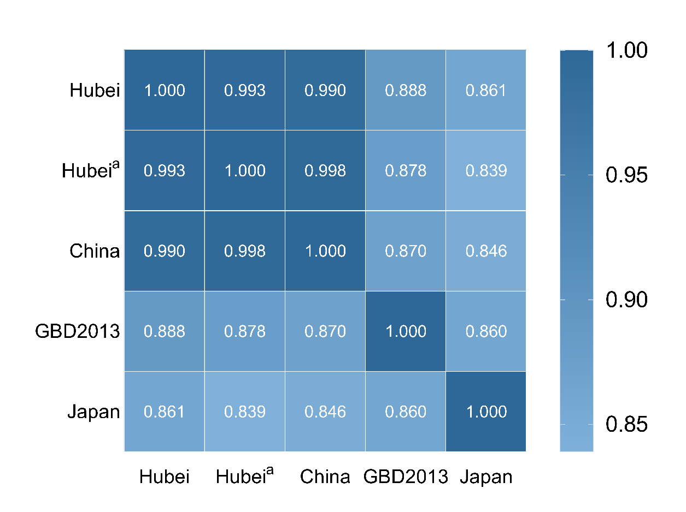
Fig. S2 Comparison of the disability weights in this study and Hubei-provincial results from the Chinese disability weight measurement study, the national results from the Chinese disability weight measurement study, the GBD 2013 study, and the Japanese study. P<0.001

