Association of loneliness and social isolation with excess risk of mental disorders in people with obesity: a prospective cohort study

Appendix:

Figure S1. Flow chart of the inclusion of participants 3
Figure S2. Associations of loneliness (A) and social isolation (B) with risk of mental disorders in the non-obese participants 4
Figure S3. The relative importance of loneliness and social isolation compared with other traditional risk factors in predicting different mental disorders in obese people. 6
Figure S4. The cumulative hazard of subtypes of mental disorders corresponding to weight status and loneliness index. 9
Figure S5. The cumulative hazard of subtypes of mental disorders corresponding to weight status and social isolation index. 12
Table S1. Definition of loneliness and social isolation in the UK Biobank 13
Table S2. Definition of mental disorders in the UK Biobank 14
Table S3. Definitions of lifestyles in the UK Biobank 15
Table S4. Components of diet quality score used in the UK Biobank 16
Table S5. Definitions of chronic diseases in the UK Biobank 18
Table S6. Baseline characteristics of non-obese participants 19
Table S7. Distribution of loneliness and social isolation in the obese and non-obese participants 20
Table S8. Associations of individual indicator of loneliness and social isolation with risk of mental disorders in the obese participants 21
Table S9. Associations of joint exposure of loneliness and social isolation with risk of mental disorders in the obese participants 25
Table S10. The standardized mean differencess of age, sex, and assessment center before and after propensity score matching 27
Table S11. Subgroup analyses of the associations between loneliness and the risk of mental disorders in the obese participants stratified by sociodemographic characteristics 28
Table S12. Subgroup analyses of the associations between social isolation and the risk of mental disorders in the obese participants stratified by sociodemographic characteristics 32
Table S13. Associations of loneliness and social isolation with risk of mental disorders in the obese participants after excluding patients who developed mental disorders within two years from baseline 36
Table S14. Associations of loneliness and social isolation with risk of mental disorders in the obese participants considering competing risk event 39
Table S15. Associations of loneliness and social isolation with risk of mental disorders in the obese participants with the imputation of exposure data 42

Exclusion:
- Without data for exposure (n = 35 710)
- Without data for obesity (n = 2 227)
- With mental disorders at baseline
(n = 10 015)
Participants accessed for eligibility (n = 454 449)
1:1 matched on age, sex, and center (n = 219 086)
Participants from the UK biobank (n = 502 401)
Without obesity at baseline (n = 344 906)
With obesity at baseline
(n = 109 543)
Exclusion:
- Underweight (BMI < 18.5 kg/m²) (n = 2 238)
- Overweight (BMI: 25.0~29.9 kg/m²) (n = 193 634)
- Unmatched (n = 39 491)
Matched cohort analysis
(n = 219 086)
No obesity cohort
(n = 109 543)
Obesity cohort
(n = 109 543)

Figure S1. Flow chart of the inclusion of participants

A. Loneliness
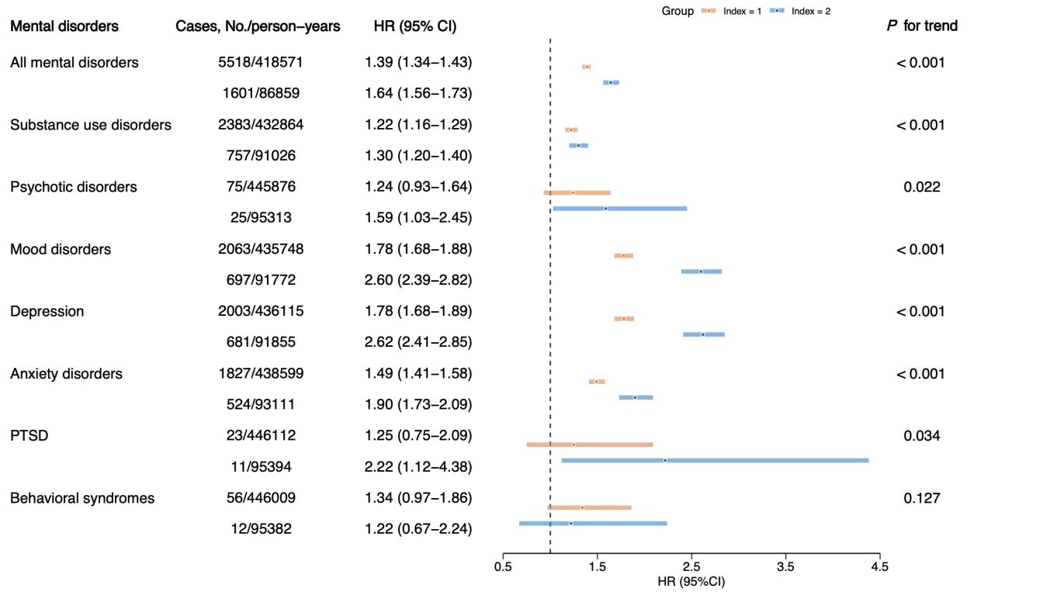
B. Social isolation
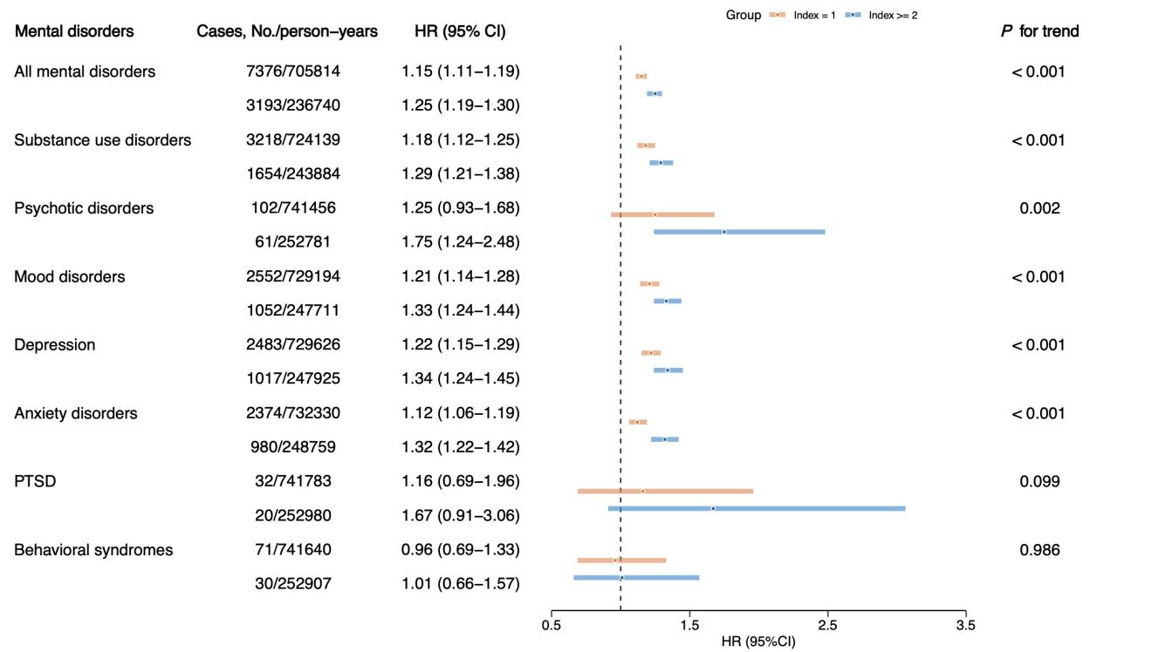

Figure S2. Associations of loneliness (A) and social isolation (B) with risk of mental disorders in the non-obese participants
Abbreviations: CI, Confidence interval; HR, Hazard ratio; PTSD: post-traumatic stress disorder. Adjusted for age, sex, ethnicity, Townsend deprivation index, education, diet, smoking status, alcohol consumption, exercise, sleep duration, and the number of chronic diseases.

A. Substance use disorders B. Psychotic disorders
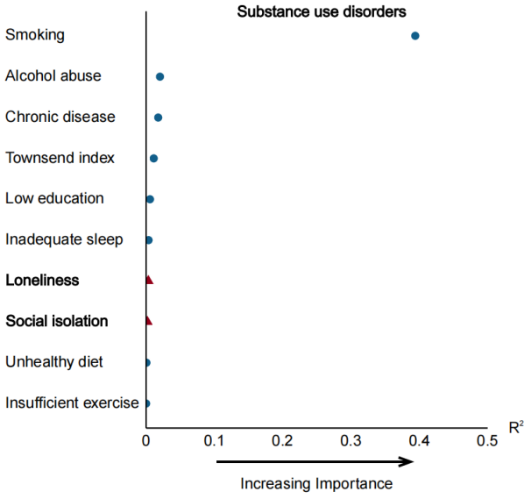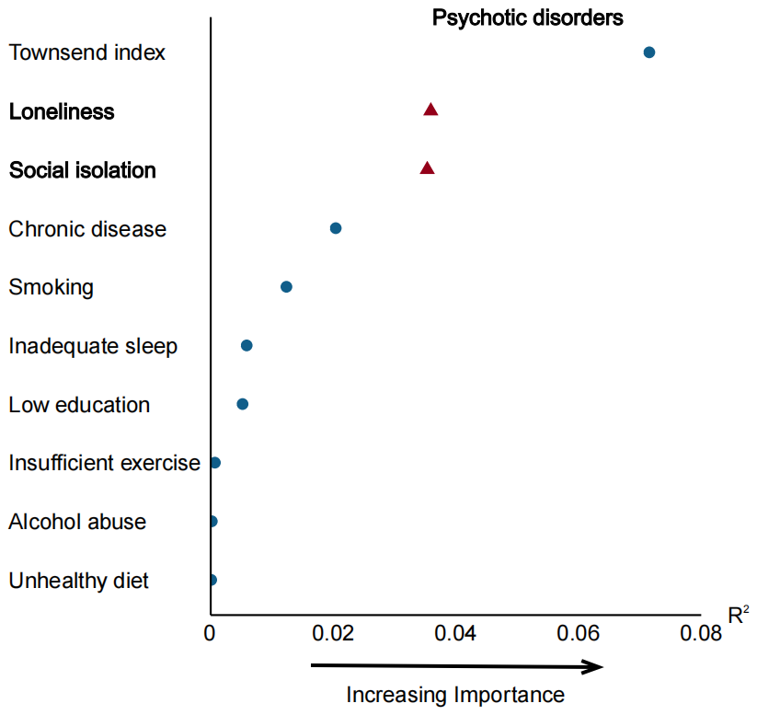

C. Mood disorders D. Depression
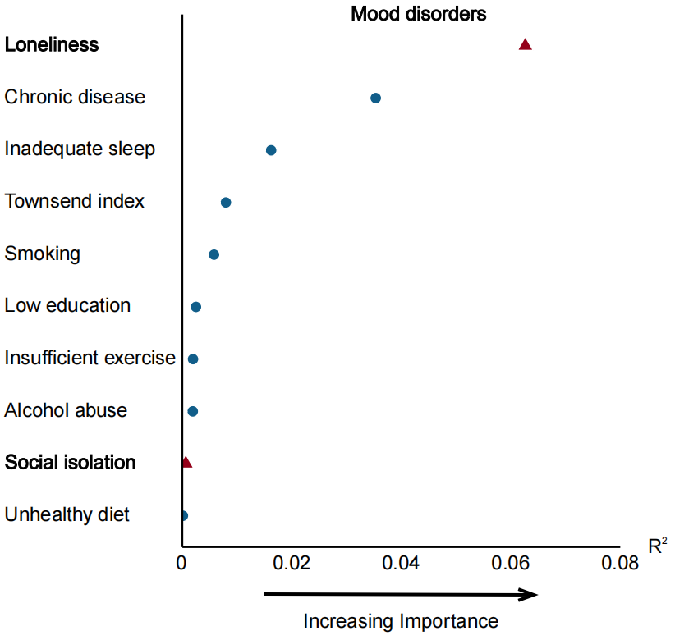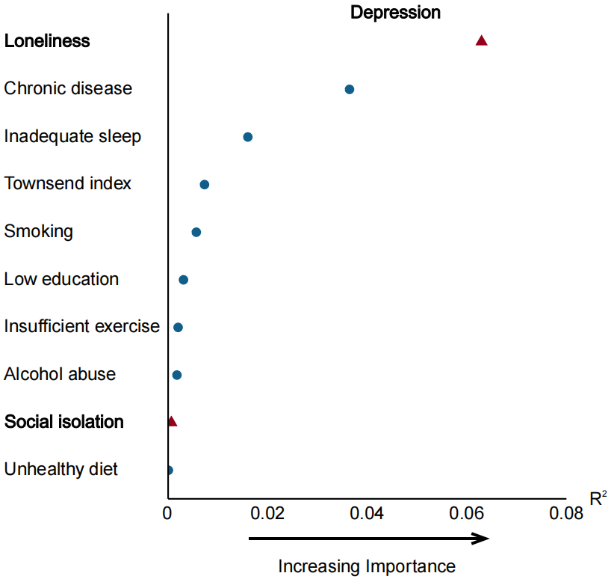

E. Anxiety disorders F. PTSD
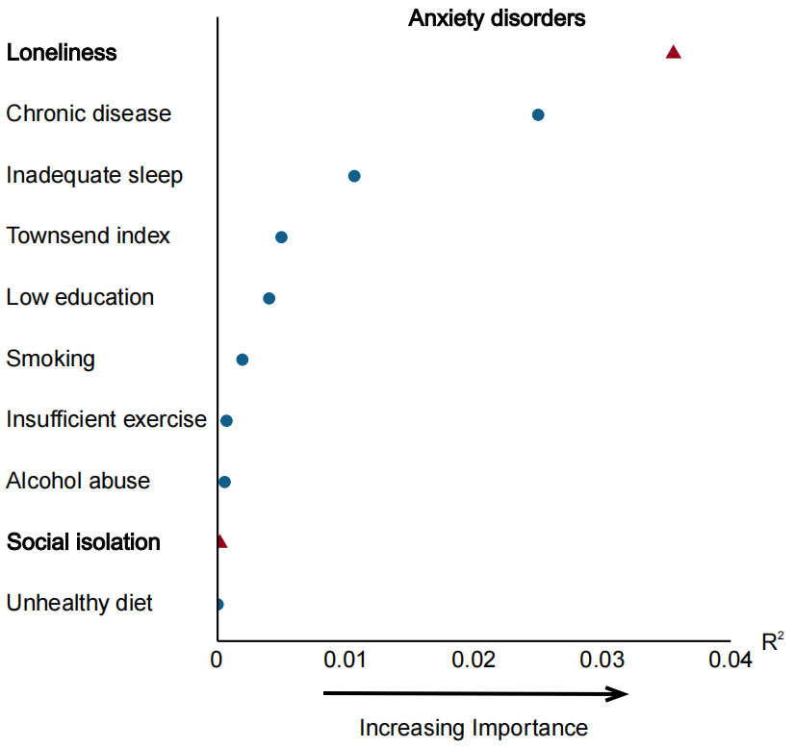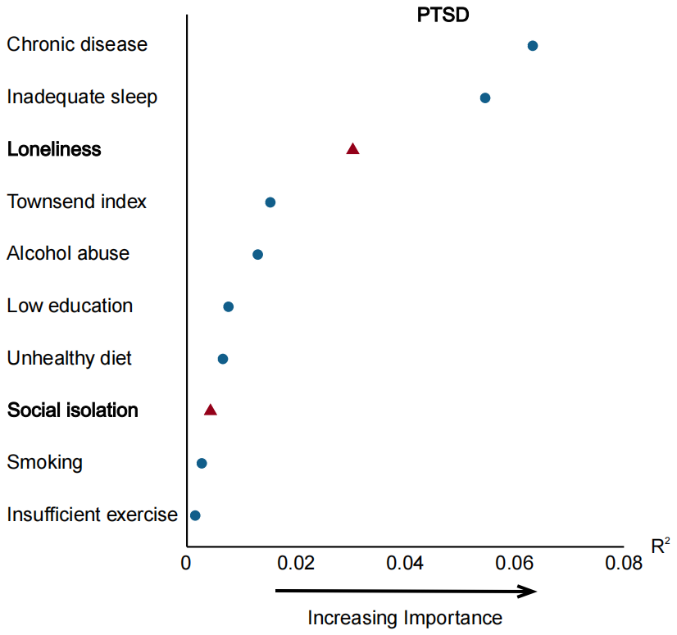

G. Behavioral syndromes
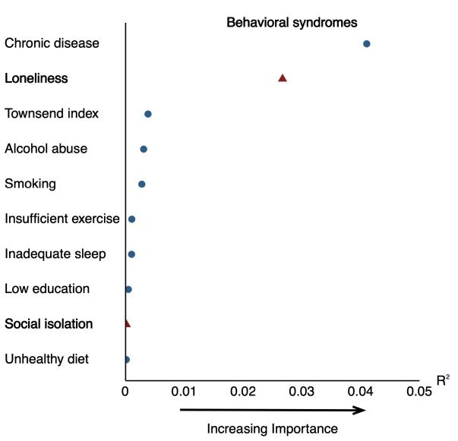

Figure S3. The relative importance of loneliness and social isolation compared with other traditional risk factors in predicting different mental disorders in obese people.
(A) Substance use disorders; (B) Psychotic disorders; (C) Mood disorders; (D) Depression; (E) Anxiety disorders; (F) PTSD; (G) Behavioral syndromes.
Abbreviations: PTSD: post-traumatic stress disorder.

A. Substance use disorders
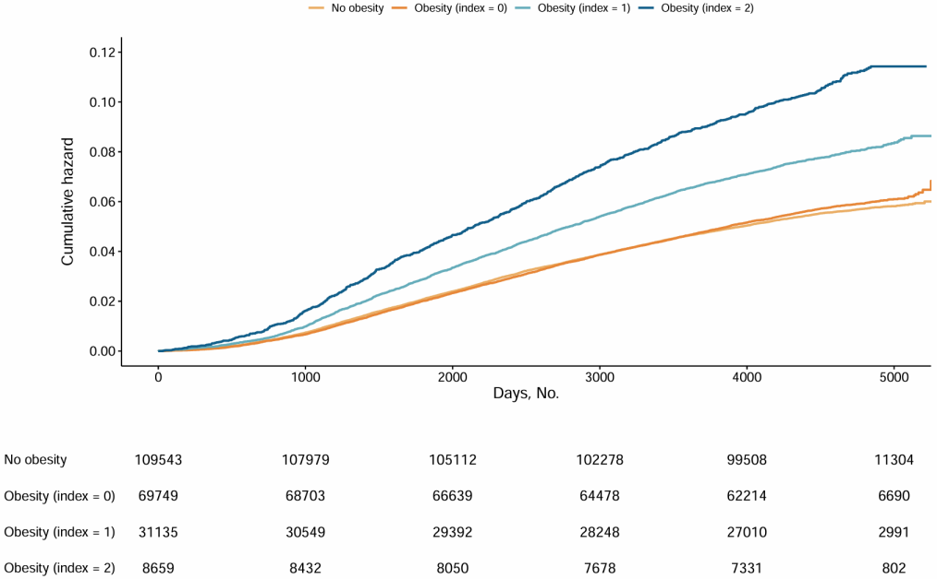

B. Psychotic disorders
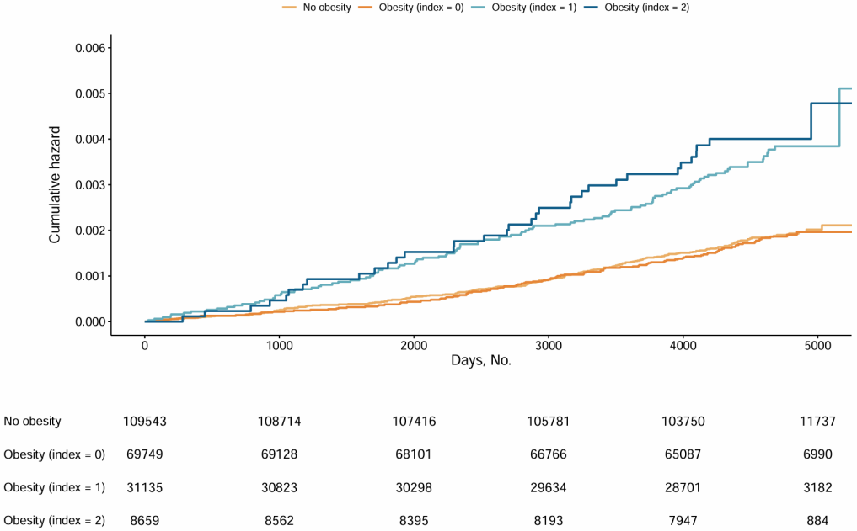

C. Mood disorders
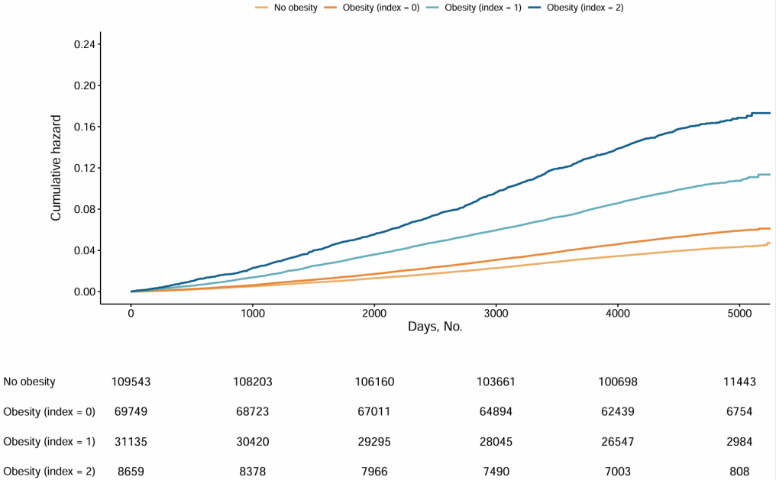
D. Depression
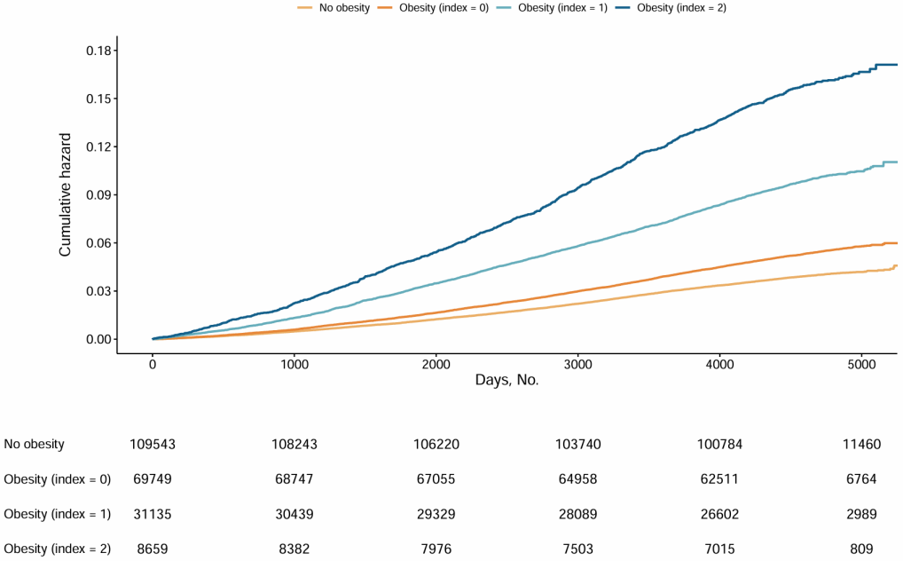

E. Anxiety disorders
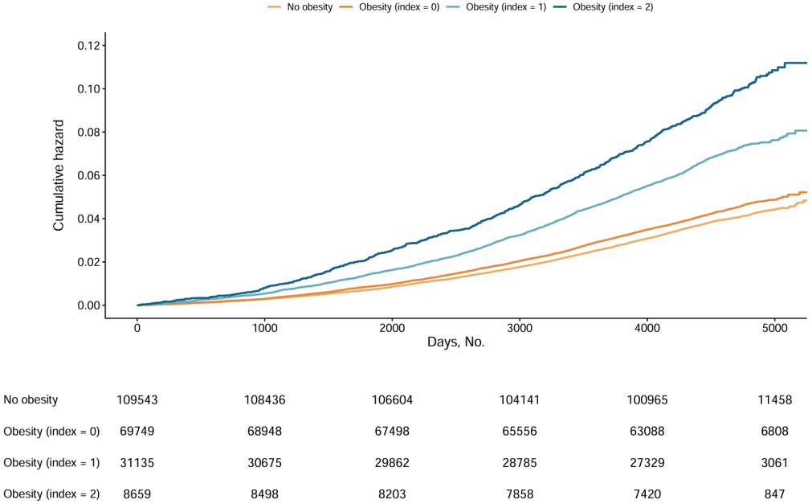

F. PTSD
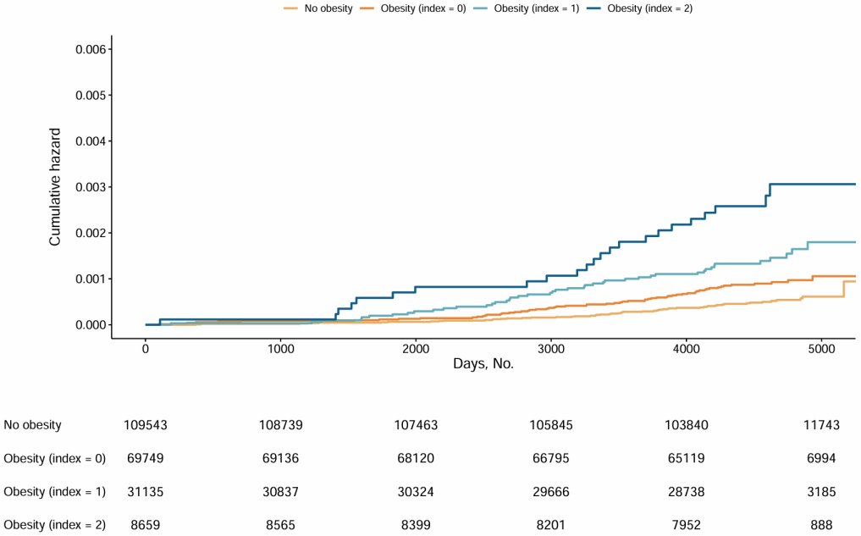
G. Behavioral syndromes
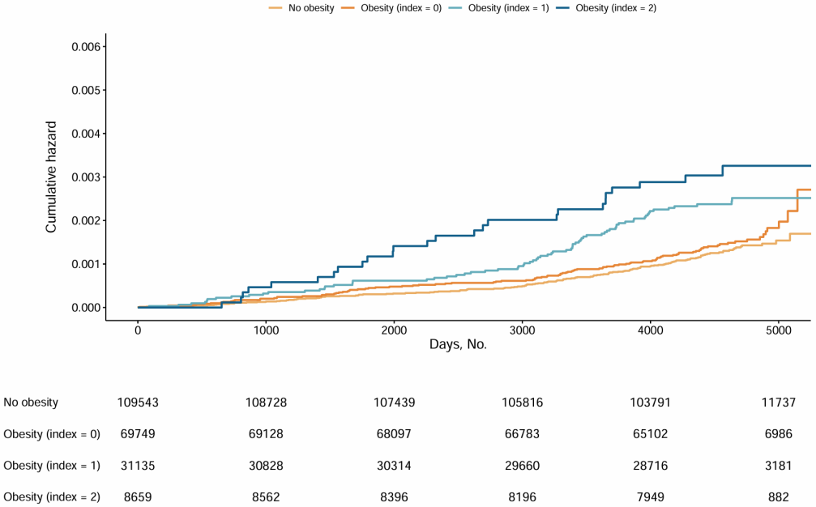

Figure S4. The cumulative hazard of subtypes of mental disorders corresponding to weight status and loneliness index.
(A) Substance use disorders; (B) Psychotic disorders; (C) Mood disorders; (D) Depression; (E) Anxiety disorders; (F) PTSD; (G) Behavioral syndromes.
Abbreviations: PTSD: post-traumatic stress disorder.

A. Substance use disorders
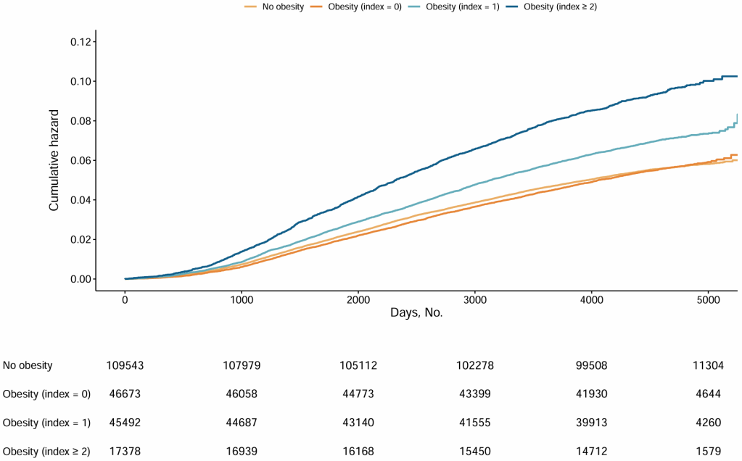

B. Psychotic disorders
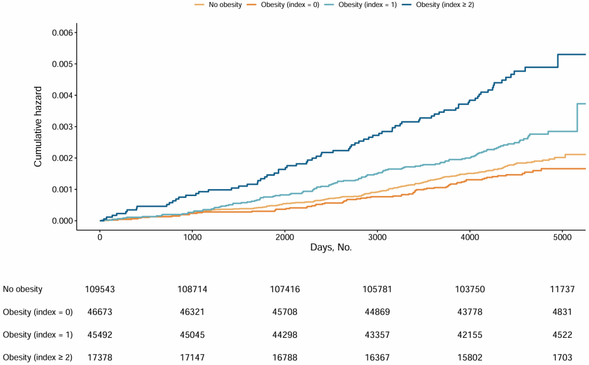

C. Mood disorders
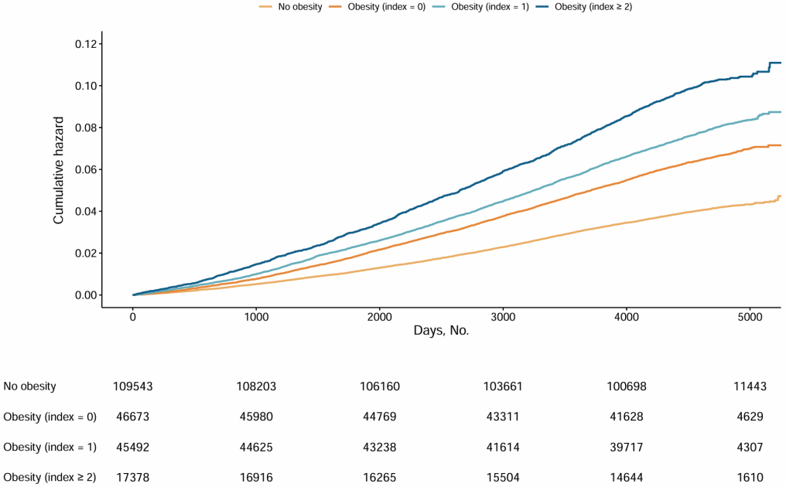
D. Depression
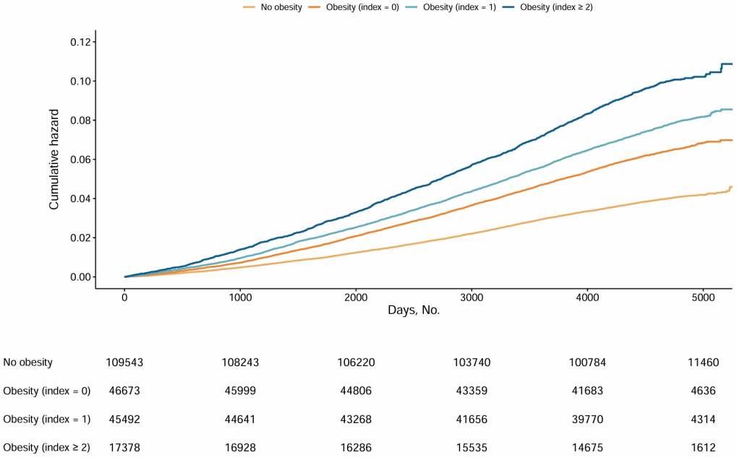

E. Anxiety disorders
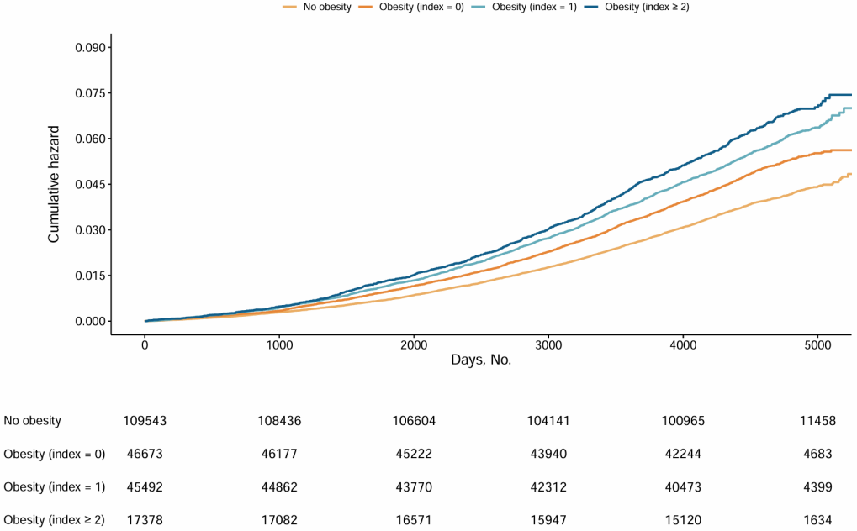

F. PTSD
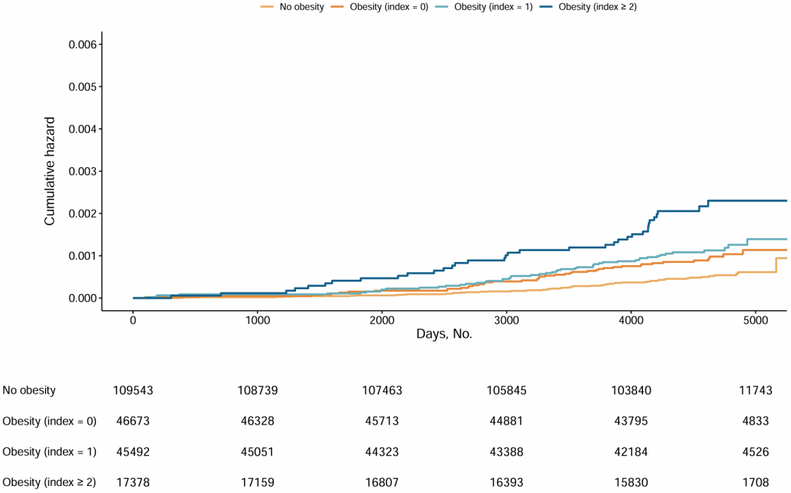
G. Behavioral syndromes
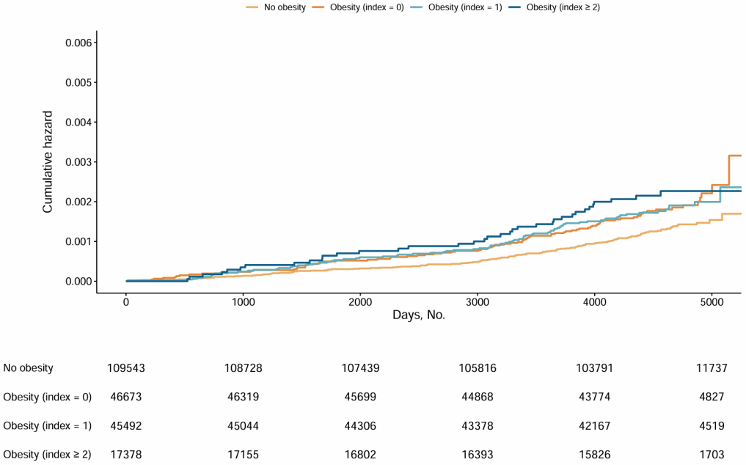

Figure S5. The cumulative hazard of subtypes of mental disorders corresponding to weight status and social isolation index.
(A) Substance use disorders; (B) Psychotic disorders; (C) Mood disorders; (D) Depression; (E) Anxiety disorders; (F) PTSD; (G) Behavioral syndromes.
Abbreviations: PTSD: post-traumatic stress disorder.

Table S1. Definition of loneliness and social isolation in the UK Biobank
Data field IDs | ACE touchscreen questions | Responses | Score
Loneliness
2020 | Do you often feel lonely? | No | 0
2020 | Do you often feel lonely? | Yes | 1
2110 | How often are you able to confide in someone close to you? | Almost daily | 0
2110 | How often are you able to confide in someone close to you? | 2-4 times a week | 0
2110 | How often are you able to confide in someone close to you? | About once a week | 0
2110 | How often are you able to confide in someone close to you? | About once a month | 0
2110 | How often are you able to confide in someone close to you? | Once every few months | 1
2110 | How often are you able to confide in someone close to you? | Never or almost never | 1
Social isolation
709 | Including yourself, how many people are living together in your household? | Not living alone | 0
709 |  | Living alone | 1
1031 | How often do you visit friends or family or have them visit you? | Almost daily | 0
1031 |  | 2-4 times a week | 0
1031 |  | About once a week | 0
1031 |  | About once a month | 1
1031 |  | Once every few months | 1
1031 |  | Never or almost never | 1
1031 |  | No friends/family outside household | 1
6160 | Which of the following (sports club or gym, pub or social club, religious group, adult education class, other group activity) do you attend once a week or more often? | Sports club or gym | 0
6160 |  | Pub or social club | 0
6160 |  | Religious group | 0
6160 |  | Adult education class | 0
6160 |  | Other group activity | 0
6160 |  | None of the above | 1

Table S2. Definition of mental disorders in the UK Biobank
Mental disorders | ICD 10
All mental disorders | F00-F99
Substance use disorders | F10-F19
Psychotic disorders | F20-F29
Mood disorders | F30-F39
Depression | F32-F33
Anxiety disorders | F40-F48
Posttraumatic stress disorder (PTSD) | F43.1
Behavioral syndromes | F50-F59

Table S3. Definitions of lifestyles in the UK Biobank
Lifestyles | Definition
Diet | Healthy diet was defined as an adequate intake of at least 5 of the 10 dietary components (details were shown in Table S4)
Smoking status | The participants' current smoking status (current, previous, and never) was recorded, and no current smoking was on target.
Alcohol intake | Participants were asked about their drinking frequency and then further asked the amount of red wine (glasses), champagne plus white wine (glasses), beer plus cider (pints), spirits (measures), fortified wine (glasses), and other alcoholic drinks (glasses) they consumed on average in a week or a month. Alcohol intake in units per day was calculated by summing the average individual drinks per day according to alcohol unit reference. The units were then converted to grams assuming that one unit equals 8 g. No more than 14 g/day for women and 28 g/day for men was on target.
Physical activity | The number of days of moderate/vigorous physical activity in a typical week and duration of moderate/vigorous physical activity on a typical day was recorded. The number of days was multiplied by the time duration per day to calculate the weekly total amount of moderate or vigorous physical activity. Sufficient physical activity was defined as ≥150 minutes of moderate activity or ≥75 minutes of vigorous activity per week.
Sleep | Sleep duration was recorded by asking "About how many hours sleep do you get in every 24 hours? (please include naps)". Adequate sleep duration was defined as 7-8 hours/day.
Detailed information on questionnaires can be obtained through the UK Biobank website (https://biobank.ndph.ox.ac.uk/showcase/).

Table S4. Components of diet quality score used in the UK Biobank
Components | Data field IDs | Amount per serving | Intake goal
Fruit | 1309 (pieces fresh fruit/day)  1319 (pieces dried fruit/day) | 1309: 1 piece  1319: 5 pieces | ≥3 servings/day
Vegetable | 1289 (tablespoons cooked vegetables/day)  1299 (salad/raw vegetables/day) | 3 heaped tablespoons | ≥3 servings/day
Fish | 1329 (oily fish/week)  1339 (non-oily fish/week) | Once/week | ≥2 servings/week
Processed meats | 1349 (processed meat/week or daily)  3680 (age when last ate meat) | 1349: 1 piece/day  3680: 0 pieces/day if indicated having never eaten meat | ≤1 serving/week
Unprocessed red meats | 1369 (beef/week or day)  1379 (lamb or mutton/week or day)  1389 (pork/week or day)  3680 (age when last ate meat) | 1359~1389: once/week  3680: 0 pieces/day if indicated having never eaten meat | ≤2 serving/week
Whole grains | 1438, 1448 (whole meal/whole grain bread slices/week)  1458, 1468 (bran/oat/muesli cereal bowls/week) | 1438/1448: 1 slice/day  1458/1468: 1 bowl/day | ≥3 servings/day
Refined grains | 1438  1448 (white, brown, other bread slices/week)  1458  1468 (biscuit, other cereals/week) | 1438/1448: 1 slice/day  1458/1468: 1 bowl/day | ≤2 servings/day
Vegetable oils | 1428 (Flora Pro-Active/Benecol spread)  2654 (Flora Pro-Active/Benecol, soft margarine-, olive oil based-, polyunsaturated/sunflower oil based-, other low/reduced fat spread)  1438 (bread slices/week) | 1 serving/day if in combination with eating at least 2 slices of bread (ID 1438) | ≥2 servings/day
Dairy | 1408 (cheese/week)  1418 (milk type) | 1408: 1 piece/day  1418: 1 glass/day if consumption of any type of milk | ≥2 servings/day
Sugar-  sweetened beverages | 6144 (never consumes drinks containing sugar) | 0 servings | Don’t drink

Table S5. Definitions of chronic diseases in the UK Biobank
Chronic diseases | Self-reported | ICD 9 | ICD 10
Cardiovascular Disease* | 6150 (1, 2, 3), 20002 (1074, 1075, 1081, 1583, 1086, 1491) | 410-414, 430-434, 436 | I20-I25, I60-I64
Hypertension | 6150 (4), 20002 (1065, 1072), 6153 (2), 6177 (2) | 401-405 | I10-I13,  I15, O10
Cancer | 20001 | 140-208 | C00-C97
Respiratory disease† | 20002 (1112, 1113, 1472), 6152 (6) | 491, 492, 496 | J40-J44, J47
Type 2 diabetes | Participants with type 2 diabetes were identified according to the algorithm developed by the UK Biobank. This algorithm takes into account multiple aspects of information such as self-reported medical history and medication, and has been proven valid with 96% accuracy.^{[1]}
* Contains coronary heart disease and stroke.
† Contains chronic obstructive pulmonary disease and emphysema.

References
[1] Eastwood SV, Mathur R, Atkinson M, et al. (2016) Algorithms for the capture and adjudication of prevalent and incident diabetes in UK Biobank. PLOS ONE 11: e162388

Table S6. Baseline characteristics of non-obese participants
 | Overall  (N = 149034) | Loneliness |  |  |  | Social isolation
 | Overall  (N = 149034) | Index = 0  (N = 105043) | Index = 1  (N = 36242) | Index = 2  (N = 7749) | P value | Index = 0  (N = 68180) | Index = 1  (N = 60100) | Index ≥ 2  (N = 20754) | P value
Age, years | 49.0 [57.0, 62.0] | 56.0 [49.0, 62.0] | 57.0 [49.0, 63.0] | 56.0 [49.0, 62.0] | < 0.001 | 57.0 [49.0, 63.0] | 56.0 [49.0, 62.0] | 56.0 [49.0, 62.0] | < 0.001
Female | 97873 (65.7%) | 70235 (66.9%) | 22999 (63.5%) | 4639 (59.9%) | < 0.001 | 46899 (68.8%) | 39213 (65.2%) | 11761 (56.7%) | < 0.001
White British | 133276 (89.4%) | 94905 (90.3%) | 31728 (87.5%) | 6643 (85.7%) | < 0.001 | 61882 (90.8%) | 53600 (89.2%) | 17794 (85.7%) | < 0.001
Townsend deprivation index | -3.8 [-2.4, 0.0] | -2.5 [-3.8, -0.2] | -2.1 [-3.6, 0.5] | -1.7 [-3.5, 1.4] | < 0.001 | -2.7 [-3.9, -0.7] | -2.2 [-3.7, 0.3] | -1.4 [-3.3, 1.6] | < 0.001
College/university degree | 60455 (40.6%) | 45157 (43.0%) | 12870 (35.5%) | 2428 (31.3%) | < 0.001 | 27588 (40.5%) | 24318 (40.5%) | 8549 (41.2%) | 0.140
Healthy diet | 30026 (20.1%) | 21513 (20.5%) | 7089 (19.6%) | 1424 (18.4%) | < 0.001 | 13610 (20.0%) | 12177 (20.3%) | 4239 (20.4%) | 0.230
No current smoking | 133201 (89.4%) | 95568 (91.0%) | 31356 (86.5%) | 6277 (81.0%) | < 0.001 | 62852 (92.2%) | 53144 (88.4%) | 17205 (82.9%) | < 0.001
Moderate alcohol consumption | 111049 (74.5%) | 78017 (74.3%) | 27181 (75.0%) | 5851 (75.5%) | 0.003 | 49185 (72.1%) | 45467 (75.7%) | 16397 (79.0%) | < 0.001
Sufficient physical activity | 86869 (58.3%) | 61934 (59.0%) | 20702 (57.1%) | 4233 (54.6%) | < 0.001 | 42659 (62.6%) | 33906 (56.4%) | 10304 (49.6%) | < 0.001
Healthy sleep duration | 107127 (71.9%) | 78355 (74.6%) | 24143 (66.6%) | 4629 (59.7%) | < 0.001 | 50664 (74.3%) | 42627 (70.9%) | 13836 (66.7%) | < 0.001
The number of chronic diseases |  |  |  |  | < 0.001 |  |  |  | < 0.001
0 | 109310 (73.3%) | 77935 (74.2%) | 25972 (71.7%) | 5403 (69.7%) |  | 50469 (74.0%) | 44074 (73.3%) | 14767 (71.2%)
1-2 | 38721 (26.0%) | 26507 (25.2%) | 9960 (27.5%) | 2254 (29.1%) |  | 17315 (25.4%) | 15621 (26.0%) | 5785 (27.9%)
≥3 | 1003 (0.7%) | 601 (0.6%) | 310 (0.9%) | 92 (1.2%) |  | 396 (0.6%) | 405 (0.7%) | 202 (1.0%)
Data are n (%) for categorical variables, mean (SD) for normally distributed continuous variables, and median [IQR] for nonnormally distributed continuous variables.

Table S7. Distribution of loneliness and social isolation in the obese and non-obese participants
 | Obesity (n = 109543) | No obesity (n = 149034) | P value
Loneliness |  |  | < 0.001
Index = 0 | 69749 (63.67%) | 105043 (70.48%)
Index = 1 | 31135 (28.42%) | 36242 (24.32%)
Index = 2 | 8659 (7.90%) | 7749 (5.20%)
Social isolation |  |  | < 0.001
Index = 0 | 46673 (42.61%) | 68180 (45.75%)
Index = 1 | 45492 (41.53%) | 60100 (40.33%)
Index ≥ 2 | 17378 (15.86%) | 20754 (13.93%)

Table S8. Associations of individual indicator of loneliness and social isolation with risk of mental disorders in the obese participants
 | Cases/  Person-Years | HR (95% CI) | PAF (%) (95% CI)
All mental disorders
Items of loneliness
Often feel lonely |  |  | 11.7 (11.0, 12.5)
No | 12201/989510 | Ref.
Yes | 6079/257689 | 1.71 (1.66-1.76)
Able to confide |  |  | 2.9 (2.2, 3.6)
Once a month or more | 13492/972024 | Ref.
Less than once a month | 4788/275176 | 1.15 (1.11-1.19)
Items of social isolation
Live alone |  |  | 3.3 (2.6, 4.0)
No | 13658/1007967 | Ref.
Yes | 4622/239233 | 1.18 (1.14-1.23)
Contact with family/friends |  |  | 1.3 (0.6, 1.9)
Once a week or more | 14350/988593 | Ref.
Less than once a week | 3930/258607 | 1.07 (1.04-1.11)
Engaging in group activities once a week or more often |  |  | 2.4 (1.5, 3.3)
Yes | 11432/828787 | Ref.
No | 6848/418413 | 1.08 (1.04-1.11)
Substance use disorders
Items of loneliness
Often feel lonely |  |  | 6.2 (5.0, 7.4)
No | 4877/1021773 | Ref.
Yes | 2075/279298 | 1.32 (1.25-1.39)
Able to confide |  |  | 2.5 (1.3, 3.7)
Once a month or more | 5020/1012114 | Ref.
Less than once a month | 1932/288957 | 1.11 (1.06-1.18)
Items of social isolation
Live alone |  |  | 4.0 (2.8, 5.2)
No | 5026/1049011 | Ref.
Yes | 1926/252060 | 1.21 (1.15-1.28)
Contact with family/friends |  |  | 1.3 (0.2, 2.4)
Once a week or more | 5358/1030957 | Ref.
Less than once a week | 1594/270114 | 1.07 (1.01-1.13)
Engaging in group activities once a week or more often |  |  | 3.6 (2.0, 5.2)
Yes | 4276/862706 | Ref.
No | 2676/438365 | 1.12 (1.06-1.17)
Psychotic disorders
Items of loneliness
Often feel lonely |  |  | 22.7 (14.7, 30.7)
No | 153/1047646 | Ref.
Yes | 108/290663 | 2.18 (1.69-2.82)
Able to confide |  |  | 0.8 (-6.4, 8.0)
Once a month or more | 193/1039040 | Ref.
Less than once a month | 68/299269 | 1.03 (0.78-1.36)
Items of social isolation
Live alone |  |  | 31.7 (23.8, 39.6)
No | 138/1076078 | Ref.
Yes | 123/262232 | 2.98 (2.31-3.85)
Contact with family/friends |  |  | 6.1 (-1.0, 13.1)
Once a week or more | 191/1059792 | Ref.
Less than once a week | 70/278517 | 1.29 (0.97-1.70)
Engaging in group activities once a week or more often |  |  | -0.2 (-9.7, 9.4)
Yes | 167/885284 | Ref.
No | 94/453026 | 0.99 (0.76-1.28)
Mood disorders
Items of loneliness
Often feel lonely |  |  | 24.3 (22.9, 25.7)
No | 4372/1026650 | Ref.
Yes | 3306/272865 | 2.41 (2.30-2.53)
Able to confide |  |  | 4.9 (3.6, 6.1)
Once a month or more | 5652/1010391 | Ref.
Less than once a month | 2026/289124 | 1.23 (1.17-1.30)
Items of social isolation
Live alone |  |  | 4.6 (3.4, 5.9)
No | 5735/1046991 | Ref.
Yes | 1943/252524 | 1.23 (1.17-1.30)
Contact with family/friends |  |  | 2.1 (1.0, 3.3)
Once a week or more | 5998/1029411 | Ref.
Less than once a week | 1680/270104 | 1.11 (1.05-1.17)
Engaging in group activities once a week or more often |  |  | 3.1 (1.4, 4.8)
Yes | 4701/861576 | Ref.
No | 2977/437939 | 1.09 (1.04-1.14)
Depression
Items of loneliness
Often feel lonely |  |  | 24.3 (22.9, 25.7)
No | 4276/1027338 | Ref.
Yes | 3236/273314 | 2.41 (2.30-2.53)
Able to confide |  |  | 5.1 (3.9, 6.4)
Once a month or more | 5515/1011308 | Ref.
Less than once a month | 1997/289344 | 1.25 (1.18-1.31)
Items of social isolation
Live alone |  |  | 4.5 (3.3, 5.8)
No | 5619/1047757 | Ref.
Yes | 1893/252896 | 1.23 (1.16-1.30)
Contact with family/friends |  |  | 2.1 (1.0, 3.2)
Once a week or more | 5873/1030272 | Ref.
Less than once a week | 1639/270381 | 1.11 (1.05-1.17)
Engaging in group activities once a week or more often |  |  | 3.3 (1.6, 5.0)
Yes | 4588/862369 | Ref.
No | 2924/438283 | 1.09 (1.04-1.15)
Anxiety disorders
Items of loneliness
Often feel lonely |  |  | 17.4 (15.8, 19.0)
No | 3522/1033385 | Ref.
Yes | 2106/281816 | 1.91 (1.81-2.02)
Able to confide |  |  | 3.4 (2.0, 4.9)
Once a month or more | 4222/1021745 | Ref.
Less than once a month | 1406/293457 | 1.16 (1.09-1.23)
Items of social isolation
Live alone |  |  | 2.2 (0.8, 3.6)
No | 4314/1057911 | Ref.
Yes | 1314/257290 | 1.11 (1.04-1.18)
Contact with family/friends |  |  | 1.4 (0.1, 2.7)
Once a week or more | 4459/1041400 | Ref.
Less than once a week | 1169/273802 | 1.07 (1.01-1.15)
Engaging in group activities once a week or more often |  |  | 2.6 (0.6, 4.6)
Yes | 3509/870987 | Ref.
No | 2119/444215 | 1.07 (1.02-1.13)
PTSD
Items of loneliness
Often feel lonely |  |  | 24.0 (12.4, 35.5)
No | 73/1048018 | Ref.
Yes | 55/290937 | 2.24 (1.56-3.22)
Able to confide |  |  | 3.9 (-6.5, 14.4)
Once a month or more | 93/1039525 | Ref.
Less than once a month | 35/299430 | 1.16 (0.78-1.72)
Items of social isolation
Live alone |  |  | 7.3 (-2.6, 17.2)
No | 94/1076290 | Ref.
Yes | 34/262664 | 1.36 (0.91-2.05)
Contact with family/friends |  |  | 9.4 (-1.2, 19.9)
Once a week or more | 89/1060249 | Ref.
Less than once a week | 39/278706 | 1.44 (0.98-2.11)
Engaging in group activities once a week or more often |  |  | 3.9 (-10.1, 18.0)
Yes | 78/885673 | Ref.
No | 50/453282 | 1.11 (0.77-1.59)
Behavioral syndromes
Items of loneliness
Often feel lonely |  |  | 10.2 (2.7, 17.7)
No | 147/1047689 | Ref.
Yes | 54/290914 | 1.59 (1.15-2.19)
Able to confide |  |  | 12.2 (3.3, 21.1)
Once a month or more | 131/1039349 | Ref.
Less than once a month | 70/299253 | 1.53 (1.14-2.05)
Items of social isolation
Live alone |  |  | 0.2 (-6.9, 7.2)
No | 161/1075951 | Ref.
Yes | 40/262652 | 1.01 (0.70-1.44)
Contact with family/friends |  |  | 4.6 (-3.5, 12.7)
Once a week or more | 147/1060026 | Ref.
Less than once a week | 54/278576 | 1.20 (0.88-1.65)
Engaging in group activities once a week or more often |  |  | -1.3 (-10.9, 8.3)
Yes | 139/885403 | Ref.
No | 62/453199 | 0.95 (0.70-1.30)
Abbreviations: CI, Confidence interval; HR, Hazard ratio; PTSD: post-traumatic stress disorder; PAF: population attributed fraction.
Adjusted for age, sex, ethnicity, Townsend deprivation index, education, diet, smoking status, alcohol consumption, exercise, sleep duration, and the number of chronic diseases.

Table S9. Associations of joint exposure of loneliness and social isolation with risk of mental disorders in the obese participants
 | Cases/Person-Years | HR (95% CI) (model 1) | HR (95% CI) (model 2) | HR (95% CI) (model 3)
All mental disorders
No loneliness & No isolated | 4388/390550 | Ref. | Ref. | Ref.
No loneliness & Isolated | 5328/416490 | 1.14 (1.10-1.19) | 1.11 (1.07-1.15) | 1.06 (1.02-1.10)
Loneliness & No isolated | 2508/149291 | 1.50 (1.43-1.58) | 1.46 (1.39-1.53) | 1.40 (1.33-1.47)
Loneliness & Isolated | 6056/290869 | 1.87 (1.80-1.95) | 1.72 (1.65-1.79) | 1.55 (1.49-1.61)
P value for trend |  | < 0.001 | < 0.001 | < 0.001
Substance use disorders
No loneliness & No isolated | 1635/402875 | Ref. | Ref. | Ref.
No loneliness & Isolated | 2168/430502 | 1.24 (1.16-1.32) | 1.18 (1.10-1.26) | 1.11 (1.04-1.19)
Loneliness & No isolated | 825/157945 | 1.29 (1.18-1.40) | 1.22 (1.12-1.32) | 1.14 (1.04-1.24)
Loneliness & Isolated | 2324/309748 | 1.85 (1.74-1.97) | 1.59 (1.50-1.70) | 1.38 (1.30-1.48)
P value for trend |  | < 0.001 | < 0.001 | < 0.001
Psychotic disorders
No loneliness & No isolated | 42/411582 | Ref. | Ref. | Ref.
No loneliness & Isolated | 77/442027 | 1.71 (1.17-2.49) | 1.59 (1.09-2.31) | 1.54 (1.05-2.24)
Loneliness & No isolated | 27/162349 | 1.63 (1.01-2.64) | 1.52 (0.94-2.47) | 1.47 (0.91-2.39)
Loneliness & Isolated | 115/322352 | 3.51 (2.46-4.99) | 2.87 (2.00-4.11) | 2.64 (1.84-3.79)
P value for trend |  | < 0.001 | < 0.001 | < 0.001
Mood disorders
No loneliness & No isolated | 1620/403699 | Ref. | Ref. | Ref.
No loneliness & Isolated | 1953/432532 | 1.13 (1.05-1.20) | 1.08 (1.01-1.15) | 1.03 (0.97-1.10)
Loneliness & No isolated | 1213/155796 | 1.95 (1.81-2.10) | 1.88 (1.74-2.02) | 1.80 (1.67-1.94)
Loneliness & Isolated | 2892/307488 | 2.36 (2.22-2.51) | 2.16 (2.03-2.30) | 1.97 (1.85-2.09)
P value for trend |  | < 0.001 | < 0.001 | < 0.001
Depression
No loneliness & No isolated | 1577/403998 | Ref. | Ref. | Ref.
No loneliness & Isolated | 1914/432815 | 1.13 (1.06-1.21) | 1.09 (1.02-1.16) | 1.04 (0.97-1.11)
Loneliness & No isolated | 1194/155949 | 1.97 (1.83-2.12) | 1.90 (1.76-2.04) | 1.82 (1.68-1.96)
Loneliness & Isolated | 2827/307890 | 2.37 (2.22-2.52) | 2.18 (2.04-2.32) | 1.98 (1.86-2.11)
P value for trend |  | < 0.001 | < 0.001 | < 0.001
Anxiety disorders
No loneliness & No isolated | 1341/406010 | Ref. | Ref. | Ref.
No loneliness & Isolated | 1532/435896 | 1.07 (0.99-1.15) | 1.03 (0.96-1.11) | 1.01 (0.93-1.08)
Loneliness & No isolated | 845/158784 | 1.62 (1.48-1.76) | 1.57 (1.44-1.71) | 1.52 (1.39-1.66)
Loneliness & Isolated | 1910/314511 | 1.85 (1.73-1.99) | 1.74 (1.62-1.86) | 1.62 (1.51-1.74)
P value for trend |  | < 0.001 | < 0.001 | < 0.001
PTSD
No loneliness & No isolated | 22/411676 | Ref. | Ref. | Ref.
No loneliness & Isolated | 39/442200 | 1.66 (0.98-2.80) | 1.55 (0.92-2.61) | 1.47 (0.87-2.49)
Loneliness & No isolated | 21/162373 | 2.42 (1.33-4.40) | 2.30 (1.26-4.18) | 2.14 (1.17-3.90)
Loneliness & Isolated | 46/322706 | 2.68 (1.61-4.46) | 2.38 (1.42-3.98) | 2.06 (1.22-3.46)
P value for trend |  | < 0.001 | < 0.001 | 0.007
Behavioral syndromes
No loneliness & No isolated | 47/411582 | Ref. | Ref. | Ref.
No loneliness & Isolated | 56/442100 | 1.11 (0.75-1.64) | 1.15 (0.78-1.70) | 1.16 (0.78-1.71)
Loneliness & No isolated | 38/162288 | 2.05 (1.34-3.14) | 2.10 (1.37-3.22) | 2.07 (1.35-3.18)
Loneliness & Isolated | 60/322632 | 1.63 (1.12-2.39) | 1.65 (1.12-2.43) | 1.62 (1.10-2.41)
P value for trend |  | 0.011 | 0.011 | 0.014
Abbreviations: CI, Confidence interval; HR, Hazard ratio; PTSD: post-traumatic stress disorder.
Adjusted for age, sex, ethnicity, Townsend deprivation index, education, diet, smoking status, alcohol consumption, exercise, sleep duration, and the number of chronic diseases.

Table S10. The standardized mean differences of age, sex, and assessment center before and after propensity score matching
 | Before PSM | After PSM
Age | 0.151 | 0.031
Sex | 0.267 | 0.014
Assessment center | 0.213 | 0.117

Table S11. Subgroup analyses of the associations between loneliness and the risk of mental disorders in the obese participants stratified by sociodemographic characteristics
 | Cases/N | Loneliness, HR (95% CI) |  |  | P value for interaction
 | Cases/N | Index = 0 | Index = 1 | Index = 2 | P value for interaction
All mental disorders
Age, years |  |  |  |  | < 0.001
< 60 | 9433/60987 | Ref. | 1.46 (1.39-1.52) | 1.88 (1.77-2.00)
≥ 60 | 8847/48556 | Ref. | 1.31 (1.25-1.37) | 1.60 (1.49-1.72)
Sex |  |  |  |  | 0.162
Female | 9925/57676 | Ref. | 1.42 (1.36-1.48) | 1.78 (1.67-1.89)
Male | 8355/51867 | Ref. | 1.34 (1.28-1.41) | 1.74 (1.62-1.86)
Ethnicity |  |  |  |  | 0.085
White British | 16386/97698 | Ref. | 1.40 (1.35-1.45) | 1.75 (1.66-1.84)
Others | 1894/11845 | Ref. | 1.27 (1.15-1.40) | 1.79 (1.57-2.05)
Townsend deprivation index |  |  |  |  | 0.978
Low | 7689/54766 | Ref. | 1.39 (1.32-1.46) | 1.76 (1.63-1.90)
High | 10591/54777 | Ref. | 1.38 (1.32-1.44) | 1.75 (1.65-1.85)
Education |  |  |  |  | 0.095
College/university degree | 3577/27854 | Ref. | 1.39 (1.29-1.49) | 1.95 (1.75-2.17)
Others | 14703/81689 | Ref. | 1.38 (1.33-1.43) | 1.72 (1.63-1.81)
Substance use disorders
Age, years |  |  |  |  | 0.701
< 60 | 3903/60987 | Ref. | 1.20 (1.12-1.28) | 1.41 (1.28-1.55)
≥ 60 | 3049/48556 | Ref. | 1.20 (1.11-1.29) | 1.38 (1.22-1.56)
Sex |  |  |  |  | 0.230
Female | 2863/57676 | Ref. | 1.22 (1.12-1.32) | 1.33 (1.18-1.49)
Male | 4089/51867 | Ref. | 1.18 (1.10-1.26) | 1.45 (1.31-1.60)
Ethnicity |  |  |  |  | 0.157
White British | 6173/97698 | Ref. | 1.22 (1.15-1.29) | 1.41 (1.30-1.53)
Others | 779/11845 | Ref. | 1.05 (0.90-1.23) | 1.30 (1.05-1.61)
Townsend deprivation index |  |  |  |  | 0.422
Low | 2542/54766 | Ref. | 1.16 (1.06-1.26) | 1.36 (1.18-1.58)
High | 4410/54777 | Ref. | 1.22 (1.14-1.30) | 1.42 (1.30-1.55)
Education |  |  |  |  | 0.697
College/university degree | 1211/27854 | Ref. | 1.20 (1.06-1.37) | 1.50 (1.24-1.82)
Others | 5741/81689 | Ref. | 1.19 (1.13-1.26) | 1.38 (1.27-1.50)
Psychotic disorders
Age, years |  |  |  |  | 0.299
< 60 | 133/60987 | Ref. | 2.07 (1.43-3.00) | 1.64 (0.94-2.85)
≥ 60 | 128/48556 | Ref. | 1.55 (1.06-2.26) | 2.15 (1.25-3.70)
Sex |  |  |  |  | 0.001
Female | 123/57676 | Ref. | 1.12 (0.76-1.66) | 1.21 (0.66-2.20)
Male | 138/51867 | Ref. | 2.80 (1.94-4.06) | 2.79 (1.66-4.70)
Ethnicity |  |  |  |  | 0.834
White British | 215/97698 | Ref. | 1.78 (1.34-2.38) | 1.74 (1.13-2.70)
Others | 46/11845 | Ref. | 1.95 (1.02-3.72) | 2.42 (1.03-5.66)
Townsend deprivation index |  |  |  |  | 0.061
Low | 83/54766 | Ref. | 1.75 (1.11-2.73) | 0.69 (0.21-2.22)
High | 178/54777 | Ref. | 1.86 (1.34-2.57) | 2.25 (1.46-3.45)
Education |  |  |  |  | 0.039
College/university degree | 50/27854 | Ref. | 2.01 (1.14-3.54) | 0.33 (0.04-2.43)
Others | 211/81689 | Ref. | 1.77 (1.32-2.38) | 2.18 (1.45-3.26)
Mood disorders
Age, years |  |  |  |  | 0.002
< 60 | 4610/60987 | Ref. | 1.83 (1.71-1.95) | 2.61 (2.40-2.84)
≥ 60 | 3068/48556 | Ref. | 1.57 (1.46-1.70) | 2.33 (2.09-2.60)
Sex |  |  |  |  | 0.060
Female | 5042/57676 | Ref. | 1.69 (1.59-1.80) | 2.38 (2.19-2.58)
Male | 2636/51867 | Ref. | 1.78 (1.64-1.94) | 2.77 (2.48-3.09)
Ethnicity |  |  |  |  | 0.247
White British | 6899/97698 | Ref. | 1.74 (1.65-1.83) | 2.48 (2.31-2.66)
Others | 779/11845 | Ref. | 1.59 (1.35-1.86) | 2.67 (2.20-3.25)
Townsend deprivation index |  |  |  |  | 0.359
Low | 3240/54766 | Ref. | 1.65 (1.53-1.78) | 2.40 (2.15-2.67)
High | 4438/54777 | Ref. | 1.77 (1.66-1.89) | 2.58 (2.37-2.80)
Education |  |  |  |  | 0.758
College/university degree | 1606/27854 | Ref. | 1.72 (1.55-1.92) | 2.60 (2.24-3.02)
Others | 6072/81689 | Ref. | 1.72 (1.63-1.82) | 2.48 (2.30-2.67)
Depression
Age, years |  |  |  |  | 0.004
< 60 | 4508/60987 | Ref. | 1.82 (1.70-1.94) | 2.64 (2.42-2.86)
≥ 60 | 3004/48556 | Ref. | 1.58 (1.46-1.71) | 2.35 (2.11-2.63)
Sex |  |  |  |  | 0.056
Female | 4948/57676 | Ref. | 1.69 (1.59-1.79) | 2.40 (2.21-2.61)
Male | 2564/51867 | Ref. | 1.78 (1.63-1.94) | 2.80 (2.51-3.14)
Ethnicity |  |  |  |  | 0.217
White British | 6762/97698 | Ref. | 1.73 (1.64-1.82) | 2.49 (2.32-2.67)
Others | 750/11845 | Ref. | 1.61 (1.37-1.90) | 2.80 (2.30-3.42)
Townsend deprivation index |  |  |  |  | 0.248
Low | 3178/54766 | Ref. | 1.64 (1.52-1.77) | 2.41 (2.16-2.69)
High | 4334/54777 | Ref. | 1.78 (1.67-1.90) | 2.61 (2.40-2.84)
Education |  |  |  |  | 0.656
College/university degree | 1551/27854 | Ref. | 1.71 (1.54-1.92) | 2.67 (2.30-3.11)
Others | 5961/81689 | Ref. | 1.72 (1.62-1.82) | 2.50 (2.32-2.69)
Anxiety disorders
Age, years |  |  |  |  | 0.001
< 60 | 3119/60987 | Ref. | 1.61 (1.49-1.74) | 2.10 (1.89-2.33)
≥ 60 | 2509/48556 | Ref. | 1.36 (1.25-1.49) | 1.75 (1.53-1.99)
Sex |  |  |  |  | 0.966
Female | 3785/57676 | Ref. | 1.48 (1.38-1.59) | 1.94 (1.76-2.14)
Male | 1843/51867 | Ref. | 1.51 (1.37-1.67) | 1.98 (1.72-2.28)
Ethnicity |  |  |  |  | 0.627
White British | 5073/97698 | Ref. | 1.49 (1.40-1.58) | 1.93 (1.77-2.10)
Others | 555/11845 | Ref. | 1.53 (1.27-1.84) | 2.16 (1.70-2.75)
Townsend deprivation index |  |  |  |  | 0.377
Low | 2517/54766 | Ref. | 1.53 (1.40-1.66) | 1.86 (1.63-2.13)
High | 3111/54777 | Ref. | 1.47 (1.36-1.59) | 1.99 (1.80-2.21)
Education |  |  |  |  | 0.294
College/university degree | 1154/27854 | Ref. | 1.51 (1.33-1.72) | 2.24 (1.86-2.69)
Others | 4474/81689 | Ref. | 1.49 (1.39-1.59) | 1.89 (1.73-2.07)
PTSD
Age, years |  |  |  |  | 0.030
< 60 | 99/60987 | Ref. | 1.72 (1.09-2.69) | 3.00 (1.76-5.09)
≥ 60 | 29/48556 | Ref. | 0.94 (0.41-2.15) | 0.50 (0.07-3.72)
Sex |  |  |  |  | 0.644
Female | 59/57676 | Ref. | 1.26 (0.71-2.23) | 1.71 (0.80-3.65)
Male | 69/51867 | Ref. | 1.67 (0.98-2.86) | 3.13 (1.64-5.97)
Ethnicity |  |  |  |  | 0.696
White British | 111/97698 | Ref. | 1.57 (1.04-2.38) | 2.38 (1.40-4.06)
Others | 17/11845 | Ref. | 0.95 (0.31-2.94) | 2.20 (0.64-7.52)
Townsend deprivation index |  |  |  |  | 0.221
Low | 52/54766 | Ref. | 2.17 (1.21-3.91) | 2.72 (1.17-6.37)
High | 76/54777 | Ref. | 1.10 (0.65-1.86) | 2.16 (1.19-3.93)
Education |  |  |  |  | 0.488
College/university degree | 38/27854 | Ref. | 1.36 (0.64-2.87) | 3.60 (1.55-8.35)
Others | 90/81689 | Ref. | 1.50 (0.95-2.38) | 2.03 (1.12-3.71)
Behavioral syndromes
Age, years |  |  |  |  | 0.960
< 60 | 93/60987 | Ref. | 1.59 (1.01-2.49) | 1.97 (1.07-3.62)
≥ 60 | 108/48556 | Ref. | 1.51 (1.00-2.28) | 2.01 (1.07-3.77)
Sex |  |  |  |  | 0.734
Female | 28/57676 | Ref. | 1.36 (0.59-3.17) | 2.47 (0.87-7.01)
Male | 173/51867 | Ref. | 1.59 (1.15-2.20) | 1.91 (1.18-3.10)
Ethnicity |  |  |  |  | 0.950
White British | 174/97698 | Ref. | 1.59 (1.14-2.20) | 2.03 (1.26-3.26)
Others | 27/11845 | Ref. | 1.35 (0.59-3.11) | 1.81 (0.58-5.62)
Townsend deprivation index |  |  |  |  | 0.153
Low | 88/54766 | Ref. | 1.12 (0.69-1.80) | 1.44 (0.65-3.16)
High | 113/54777 | Ref. | 2.02 (1.35-3.04) | 2.54 (1.48-4.36)
Education |  |  |  |  | 0.482
College/university degree | 51/27854 | Ref. | 1.17 (0.62-2.21) | 2.28 (0.99-5.24)
Others | 150/81689 | Ref. | 1.71 (1.21-2.42) | 1.95 (1.17-3.26)
Abbreviations: CI, Confidence interval; HR, Hazard ratio; PTSD: post-traumatic stress disorder.
Adjusted for age, sex, ethnicity, Townsend deprivation index, education, diet, smoking status, alcohol consumption, exercise, sleep duration, and the number of chronic diseases.

Table S12. Subgroup analyses of the associations between social isolation and the risk of mental disorders in the obese participants stratified by sociodemographic characteristics
 | Cases/N | Social isolation, HR (95% CI) |  |  | P value for interaction
 | Cases/N | Index = 0 | Index = 1 | Index ≥ 2 | P value for interaction
All mental disorders
Age, years |  |  |  |  | 0.525
< 60 | 9433/60987 | Ref. | 1.08 (1.03-1.13) | 1.24 (1.17-1.31)
≥ 60 | 8847/48556 | Ref. | 1.15 (1.09-1.20) | 1.29 (1.22-1.38)
Sex |  |  |  |  | 0.415
Female | 9925/57676 | Ref. | 1.09 (1.04-1.14) | 1.21 (1.14-1.28)
Male | 8355/51867 | Ref. | 1.13 (1.08-1.19) | 1.34 (1.26-1.42)
Ethnicity |  |  |  |  | 0.764
White British | 16386/97698 | Ref. | 1.11 (1.07-1.15) | 1.26 (1.20-1.31)
Others | 1894/11845 | Ref. | 1.08 (0.97-1.20) | 1.27 (1.13-1.44)
Townsend deprivation index |  |  |  |  | 0.001
Low | 7689/54766 | Ref. | 1.05 (1.00-1.10) | 1.16 (1.09-1.25)
High | 10591/54777 | Ref. | 1.16 (1.11-1.21) | 1.33 (1.26-1.40)
Education |  |  |  |  | 0.089
College/university degree | 3577/27854 | Ref. | 1.06 (0.98-1.14) | 1.32 (1.20-1.44)
Others | 14703/81689 | Ref. | 1.12 (1.08-1.16) | 1.25 (1.19-1.31)
Substance use disorders
Age, years |  |  |  |  | 0.430
< 60 | 3903/60987 | Ref. | 1.11 (1.03-1.19) | 1.25 (1.15-1.37)
≥ 60 | 3049/48556 | Ref. | 1.23 (1.13-1.33) | 1.45 (1.31-1.60)
Sex |  |  |  |  | 0.178
Female | 2863/57676 | Ref. | 1.11 (1.02-1.21) | 1.27 (1.15-1.41)
Male | 4089/51867 | Ref. | 1.18 (1.10-1.27) | 1.36 (1.25-1.48)
Ethnicity |  |  |  |  | 0.538
White British | 6173/97698 | Ref. | 1.17 (1.10-1.24) | 1.34 (1.25-1.44)
Others | 779/11845 | Ref. | 1.04 (0.88-1.23) | 1.27 (1.05-1.53)
Townsend deprivation index |  |  |  |  | 0.066
Low | 2542/54766 | Ref. | 1.10 (1.01-1.19) | 1.26 (1.12-1.42)
High | 4410/54777 | Ref. | 1.21 (1.12-1.29) | 1.38 (1.28-1.50)
Education |  |  |  |  | 0.372
College/university degree | 1211/27854 | Ref. | 1.10 (0.97-1.25) | 1.42 (1.21-1.65)
Others | 5741/81689 | Ref. | 1.17 (1.10-1.24) | 1.32 (1.22-1.42)
Psychotic disorders
Age, years |  |  |  |  | 0.189
< 60 | 133/60987 | Ref. | 1.18 (0.78-1.81) | 2.22 (1.42-3.46)
≥ 60 | 128/48556 | Ref. | 2.10 (1.36-3.24) | 2.97 (1.81-4.90)
Sex |  |  |  |  | 0.003
Female | 123/57676 | Ref. | 1.24 (0.83-1.86) | 1.35 (0.81-2.25)
Male | 138/51867 | Ref. | 2.06 (1.31-3.25) | 4.39 (2.73-7.03)
Ethnicity |  |  |  |  | 0.057
White British | 215/97698 | Ref. | 1.34 (0.97-1.85) | 2.26 (1.58-3.23)
Others | 46/11845 | Ref. | 4.42 (1.69-11.58) | 5.91 (2.14-16.33)
Townsend deprivation index |  |  |  |  | 0.030
Low | 83/54766 | Ref. | 1.01 (0.63-1.63) | 1.57 (0.85-2.88)
High | 178/54777 | Ref. | 2.16 (1.43-3.25) | 3.44 (2.23-5.30)
Education |  |  |  |  | 0.767
College/university degree | 50/27854 | Ref. | 1.65 (0.84-3.21) | 2.19 (1.01-4.74)
Others | 211/81689 | Ref. | 1.55 (1.10-2.17) | 2.61 (1.80-3.77)
Mood disorders
Age, years |  |  |  |  | 0.525
< 60 | 4610/60987 | Ref. | 1.07 (1.00-1.15) | 1.32 (1.21-1.42)
≥ 60 | 3068/48556 | Ref. | 1.15 (1.06-1.25) | 1.35 (1.22-1.49)
Sex |  |  |  |  | 0.001
Female | 5042/57676 | Ref. | 1.07 (1.00-1.13) | 1.22 (1.13-1.32)
Male | 2636/51867 | Ref. | 1.17 (1.07-1.28) | 1.53 (1.37-1.70)
Ethnicity |  |  |  |  | 0.752
White British | 6899/97698 | Ref. | 1.10 (1.04-1.16) | 1.31 (1.23-1.40)
Others | 779/11845 | Ref. | 1.14 (0.96-1.34) | 1.42 (1.17-1.71)
Townsend deprivation index |  |  |  |  | 0.049
Low | 3240/54766 | Ref. | 1.06 (0.98-1.14) | 1.22 (1.09-1.35)
High | 4438/54777 | Ref. | 1.14 (1.07-1.23) | 1.41 (1.30-1.52)
Education |  |  |  |  | 0.252
College/university degree | 1606/27854 | Ref. | 1.05 (0.94-1.17) | 1.38 (1.21-1.58)
Others | 6072/81689 | Ref. | 1.12 (1.05-1.18) | 1.31 (1.22-1.41)
Depression
Age, years |  |  |  |  | 0.545
< 60 | 4508/60987 | Ref. | 1.07 (1.01-1.15) | 1.32 (1.22-1.43)
≥ 60 | 3004/48556 | Ref. | 1.15 (1.06-1.25) | 1.35 (1.21-1.49)
Sex |  |  |  |  | 0.001
Female | 4948/57676 | Ref. | 1.07 (1.01-1.14) | 1.22 (1.13-1.33)
Male | 2564/51867 | Ref. | 1.16 (1.06-1.27) | 1.52 (1.37-1.69)
Ethnicity |  |  |  |  | 0.417
White British | 6762/97698 | Ref. | 1.09 (1.04-1.16) | 1.31 (1.22-1.40)
Others | 750/11845 | Ref. | 1.17 (0.99-1.39) | 1.50 (1.24-1.82)
Townsend deprivation index |  |  |  |  | 0.037
Low | 3178/54766 | Ref. | 1.05 (0.97-1.13) | 1.22 (1.10-1.35)
High | 4334/54777 | Ref. | 1.15 (1.08-1.24) | 1.41 (1.30-1.53)
Education |  |  |  |  | 0.147
College/university degree | 1551/27854 | Ref. | 1.04 (0.93-1.17) | 1.41 (1.24-1.62)
Others | 5961/81689 | Ref. | 1.12 (1.06-1.18) | 1.31 (1.21-1.40)
Anxiety disorders
Age, years |  |  |  |  | 0.684
< 60 | 3119/60987 | Ref. | 1.08 (1.00-1.17) | 1.18 (1.06-1.30)
≥ 60 | 2509/48556 | Ref. | 1.08 (0.99-1.18) | 1.18 (1.05-1.32)
Sex |  |  |  |  | 0.024
Female | 3785/57676 | Ref. | 1.04 (0.97-1.12) | 1.08 (0.99-1.19)
Male | 1843/51867 | Ref. | 1.16 (1.05-1.29) | 1.37 (1.21-1.56)
Ethnicity |  |  |  |  | 0.325
White British | 5073/97698 | Ref. | 1.09 (1.03-1.16) | 1.16 (1.07-1.26)
Others | 555/11845 | Ref. | 0.99 (0.81-1.20) | 1.24 (0.99-1.54)
Townsend deprivation index |  |  |  |  | 0.207
Low | 2517/54766 | Ref. | 1.06 (0.97-1.15) | 1.10 (0.98-1.25)
High | 3111/54777 | Ref. | 1.11 (1.02-1.20) | 1.22 (1.11-1.35)
Education |  |  |  |  | 0.125
College/university degree | 1154/27854 | Ref. | 1.01 (0.89-1.15) | 1.28 (1.09-1.50)
Others | 4474/81689 | Ref. | 1.10 (1.03-1.17) | 1.15 (1.05-1.25)
PTSD
Age, years |  |  |  |  | 0.905
< 60 | 99/60987 | Ref. | 1.04 (0.65-1.65) | 1.56 (0.93-2.63)
≥ 60 | 29/48556 | Ref. | 1.33 (0.56-3.16) | 2.89 (1.11-7.50)
Sex |  |  |  |  | 0.634
Female | 59/57676 | Ref. | 0.91 (0.51-1.65) | 1.33 (0.67-2.63)
Male | 69/51867 | Ref. | 1.29 (0.73-2.30) | 2.28 (1.22-4.26)
Ethnicity |  |  |  |  | 0.635
White British | 111/97698 | Ref. | 1.08 (0.70-1.66) | 1.62 (0.98-2.66)
Others | 17/11845 | Ref. | 1.27 (0.36-4.52) | 3.05 (0.88-10.60)
Townsend deprivation index |  |  |  |  | 0.992
Low | 52/54766 | Ref. | 1.08 (0.58-1.99) | 1.72 (0.82-3.62)
High | 76/54777 | Ref. | 1.11 (0.64-1.93) | 1.83 (1.02-3.30)
Education |  |  |  |  | 0.669
College/university degree | 38/27854 | Ref. | 1.37 (0.63-3.00) | 2.52 (1.09-5.81)
Others | 90/81689 | Ref. | 1.00 (0.61-1.62) | 1.54 (0.89-2.67)
Behavioral syndromes
Age, years |  |  |  |  | 0.823
< 60 | 93/60987 | Ref. | 1.07 (0.68-1.69) | 1.18 (0.66-2.09)
≥ 60 | 108/48556 | Ref. | 0.97 (0.64-1.47) | 1.09 (0.62-1.91)
Sex |  |  |  |  | 0.856
Female | 28/57676 | Ref. | 0.90 (0.39-2.10) | 1.25 (0.45-3.46)
Male | 173/51867 | Ref. | 1.03 (0.74-1.43) | 1.12 (0.73-1.73)
Ethnicity |  |  |  |  | 0.235
White British | 174/97698 | Ref. | 0.91 (0.65-1.27) | 1.12 (0.73-1.72)
Others | 27/11845 | Ref. | 1.98 (0.80-4.89) | 1.34 (0.42-4.33)
Townsend deprivation index |  |  |  |  | 0.805
Low | 88/54766 | Ref. | 0.88 (0.56-1.40) | 1.09 (0.57-2.08)
High | 113/54777 | Ref. | 1.12 (0.73-1.70) | 1.21 (0.72-2.02)
Education |  |  |  |  | 0.034
College/university degree | 51/27854 | Ref. | 1.88 (0.97-3.63) | 2.06 (0.94-4.53)
Others | 150/81689 | Ref. | 0.84 (0.59-1.19) | 0.93 (0.58-1.50)
Abbreviations: CI, Confidence interval; HR, Hazard ratio; PTSD: post-traumatic stress disorder.
Adjusted for age, sex, ethnicity, Townsend deprivation index, education, diet, smoking status, alcohol consumption, exercise, sleep duration, and the number of chronic diseases.

Table S13. Associations of loneliness and social isolation with risk of mental disorders in the obese participants after excluding patients who developed mental disorders within two years from baseline
 | Cases/Person-Years | HR (95% CI) (model 1) | HR (95% CI) (model 2) | HR (95% CI) (model 3)
All mental disorders
Loneliness
Index = 0 | 9040/806251 | Ref. | Ref. | Ref.
Index = 1 | 5723/346884 | 1.48 (1.44-1.53) | 1.41 (1.37-1.46) | 1.36 (1.31-1.40)
Index = 2 | 2078/92473 | 2.04 (1.95-2.14) | 1.91 (1.82-2.00) | 1.71 (1.62-1.79)
P value for trend |  | < 0.001 | < 0.001 | < 0.001
Social isolation
Index = 0 | 6395/539273 | Ref. | Ref. | Ref.
Index = 1 | 7191/515365 | 1.18 (1.14-1.22) | 1.14 (1.10-1.18) | 1.10 (1.06-1.14)
Index ≥ 2 | 3255/190969 | 1.45 (1.39-1.52) | 1.35 (1.29-1.41) | 1.22 (1.17-1.27)
P value for trend |  | < 0.001 | < 0.001 | < 0.001
Substance use disorders
Loneliness
Index = 0 | 3506/828463 | Ref. | Ref. | Ref.
Index = 1 | 2088/362815 | 1.36 (1.29-1.44) | 1.26 (1.19-1.33) | 1.18 (1.12-1.25)
Index = 2 | 764/98829 | 1.83 (1.69-1.98) | 1.60 (1.48-1.73) | 1.36 (1.25-1.47)
P value for trend |  | < 0.001 | < 0.001 | < 0.001
Social isolation
Index = 0 | 2270/556761 | Ref. | Ref. | Ref.
Index = 1 | 2724/534232 | 1.25 (1.18-1.32) | 1.19 (1.12-1.25) | 1.13 (1.07-1.20)
Index ≥ 2 | 1364/199114 | 1.68 (1.58-1.80) | 1.46 (1.37-1.57) | 1.27 (1.18-1.36)
P value for trend |  | < 0.001 | < 0.001 | < 0.001
Psychotic disorders
Loneliness
Index = 0 | 101/846280 | Ref. | Ref. | Ref.
Index = 1 | 88/373575 | 1.98 (1.49-2.63) | 1.77 (1.33-2.37) | 1.71 (1.28-2.29)
Index = 2 | 28/102714 | 2.29 (1.51-3.48) | 1.93 (1.26-2.95) | 1.78 (1.16-2.72)
P value for trend |  | < 0.001 | < 0.001 | < 0.001
Social isolation
Index = 0 | 61/568359 | Ref. | Ref. | Ref.
Index = 1 | 91/548129 | 1.55 (1.12-2.14) | 1.44 (1.04-1.99) | 1.41 (1.02-1.96)
Index ≥ 2 | 65/206081 | 2.96 (2.08-4.19) | 2.46 (1.73-3.52) | 2.36 (1.64-3.38)
P value for trend |  | < 0.001 | < 0.001 | < 0.001
Mood disorders
Loneliness
Index = 0 | 3236/831992 | Ref. | Ref. | Ref.
Index = 1 | 2539/361836 | 1.81 (1.72-1.91) | 1.75 (1.66-1.84) | 1.68 (1.59-1.77)
Index = 2 | 1072/97599 | 2.86 (2.67-3.06) | 2.67 (2.49-2.87) | 2.42 (2.26-2.60)
P value for trend |  | < 0.001 | < 0.001 | < 0.001
Social isolation
Index = 0 | 2558/556542 | Ref. | Ref. | Ref.
Index = 1 | 2922/534916 | 1.19 (1.13-1.26) | 1.13 (1.07-1.20) | 1.09 (1.03-1.15)
Index ≥ 2 | 1367/199969 | 1.50 (1.40-1.60) | 1.39 (1.31-1.49) | 1.28 (1.20-1.37)
P value for trend |  | < 0.001 | < 0.001 | < 0.001
Depression
Loneliness
Index = 0 | 3168/832397 | Ref. | Ref. | Ref.
Index = 1 | 2479/362166 | 1.81 (1.72-1.91) | 1.74 (1.65-1.84) | 1.68 (1.59-1.77)
Index = 2 | 1060/97688 | 2.88 (2.69-3.09) | 2.70 (2.52-2.90) | 2.45 (2.28-2.63)
P value for trend |  | < 0.001 | < 0.001 | < 0.001
Social isolation
Index = 0 | 2505/556872 | Ref. | Ref. | Ref.
Index = 1 | 2863/535225 | 1.19 (1.13-1.26) | 1.13 (1.08-1.20) | 1.09 (1.03-1.15)
Index ≥ 2 | 1339/200154 | 1.50 (1.40-1.60) | 1.40 (1.31-1.49) | 1.28 (1.20-1.37)
P value for trend |  | < 0.001 | < 0.001 | < 0.001
Anxiety disorders
Loneliness
Index = 0 | 2648/836284 | Ref. | Ref. | Ref.
Index = 1 | 1794/366833 | 1.55 (1.46-1.65) | 1.50 (1.41-1.60) | 1.46 (1.37-1.55)
Index = 2 | 676/100029 | 2.15 (1.98-2.34) | 2.05 (1.88-2.23) | 1.91 (1.76-2.08)
P value for trend |  | < 0.001 | < 0.001 | < 0.001
Social isolation
Index = 0 | 2001/560639 | Ref. | Ref. | Ref.
Index = 1 | 2197/539809 | 1.15 (1.08-1.22) | 1.10 (1.03-1.17) | 1.07 (1.01-1.14)
Index ≥ 2 | 920/202698 | 1.28 (1.19-1.39) | 1.22 (1.13-1.32) | 1.16 (1.07-1.25)
P value for trend |  | < 0.001 | < 0.001 | < 0.001
PTSD
Loneliness
Index = 0 | 51/846488 | Ref. | Ref. | Ref.
Index = 1 | 39/373792 | 1.73 (1.14-2.63) | 1.68 (1.10-2.55) | 1.56 (1.02-2.37)
Index = 2 | 20/102741 | 3.24 (1.93-5.43) | 2.91 (1.73-4.91) | 2.42 (1.42-4.11)
P value for trend |  | < 0.001 | < 0.001 | < 0.001
Social isolation
Index = 0 | 38/568446 | Ref. | Ref. | Ref.
Index = 1 | 43/548321 | 1.18 (0.76-1.82) | 1.13 (0.73-1.75) | 1.06 (0.68-1.65)
Index ≥ 2 | 29/206254 | 2.13 (1.31-3.45) | 1.94 (1.19-3.16) | 1.70 (1.03-2.79)
P value for trend |  | 0.003 | 0.009 | 0.038
Behavioral syndromes
Loneliness
Index = 0 | 94/846305 | Ref. | Ref. | Ref.
Index = 1 | 63/373730 | 1.52 (1.10-2.09) | 1.51 (1.10-2.09) | 1.50 (1.09-2.07)
Index = 2 | 24/102696 | 2.11 (1.34-3.30) | 2.14 (1.36-3.36) | 2.05 (1.30-3.23)
P value for trend |  | < 0.001 | < 0.001 | < 0.001
Social isolation
Index = 0 | 75/568339 | Ref. | Ref. | Ref.
Index = 1 | 73/548185 | 1.01 (0.73-1.40) | 1.04 (0.75-1.44) | 1.05 (0.76-1.46)
Index ≥ 2 | 33/206207 | 1.22 (0.81-1.84) | 1.18 (0.78-1.78) | 1.20 (0.79-1.84)
P value for trend |  | 0.373 | 0.454 | 0.397
Abbreviations: CI, Confidence interval; HR, Hazard ratio; PTSD: post-traumatic stress disorder.
Model 1: without adjustment.
Model 2: adjusted for age, sex, ethnicity, Townsend deprivation index, and education.
Model 3: adjusted for age, sex, ethnicity, Townsend deprivation index, education, diet, smoking status, alcohol consumption, exercise, sleep duration, and the number of chronic diseases.

Table S14. Associations of loneliness and social isolation with risk of mental disorders in the obese participants considering competing risk event
 | Cases/Person-Years | HR (95% CI) (model 1) | HR (95% CI) (model 2) | HR (95% CI) (model 3)
All mental disorders
Loneliness
Index = 0 | 9716/807040 | Ref. | Ref. | Ref.
Index = 1 | 6261/347454 | 1.50 (1.45-1.55) | 1.43 (1.38-1.47) | 1.37 (1.32-1.41)
Index = 2 | 2303/92705 | 2.08 (1.99-2.18) | 1.93 (1.85-2.02) | 1.73 (1.65-1.81)
P value for trend |  | < 0.001 | < 0.001 | < 0.001
Social isolation
Index = 0 | 6896/539841 | Ref. | Ref. | Ref.
Index = 1 | 7804/516031 | 1.18 (1.14-1.22) | 1.14 (1.10-1.17) | 1.09 (1.05-1.13)
Index ≥ 2 | 3580/191327 | 1.46 (1.40-1.52) | 1.35 (1.29-1.40) | 1.20 (1.15-1.26)
P value for trend |  | < 0.001 | < 0.001 | < 0.001
Substance use disorders
Loneliness
Index = 0 | 3803/833377 | Ref. | Ref. | Ref.
Index = 1 | 2291/367132 | 1.36 (1.29-1.44) | 1.26 (1.19-1.32) | 1.18 (1.12-1.24)
Index = 2 | 858/100562 | 1.86 (1.73-2.01) | 1.62 (1.50-1.74) | 1.37 (1.27-1.48)
P value for trend |  | < 0.001 | < 0.001 | < 0.001
Social isolation
Index = 0 | 2460/560820 | Ref. | Ref. | Ref.
Index = 1 | 2984/538749 | 1.26 (1.19-1.32) | 1.19 (1.13-1.25) | 1.13 (1.07-1.19)
Index ≥ 2 | 1508/201501 | 1.69 (1.58-1.80) | 1.46 (1.36-1.55) | 1.25 (1.16-1.34)
P value for trend |  | < 0.001 | < 0.001 | < 0.001
Psychotic disorders
Loneliness
Index = 0 | 119/853609 | Ref. | Ref. | Ref.
Index = 1 | 108/379469 | 2.03 (1.57-2.64) | 1.81 (1.39-2.35) | 1.74 (1.34-2.27)
Index = 2 | 34/105232 | 2.30 (1.57-3.37) | 1.92 (1.32-2.81) | 1.75 (1.19-2.58)
P value for trend |  | < 0.001 | < 0.001 | < 0.001
Social isolation
Index = 0 | 69/573931 | Ref. | Ref. | Ref.
Index = 1 | 114/554832 | 1.70 (1.26-2.29) | 1.56 (1.16-2.11) | 1.52 (1.12-2.05)
Index ≥ 2 | 78/209547 | 3.06 (2.21-4.22) | 2.50 (1.81-3.46) | 2.33 (1.68-3.22)
P value for trend |  | < 0.001 | < 0.001 | < 0.001
Mood disorders
Loneliness
Index = 0 | 3573/836231 | Ref. | Ref. | Ref.
Index = 1 | 2878/364578 | 1.84 (1.76-1.94) | 1.78 (1.69-1.87) | 1.71 (1.62-1.79)
Index = 2 | 1227/98706 | 2.91 (2.73-3.11) | 2.71 (2.54-2.90) | 2.46 (2.30-2.63)
P value for trend |  | < 0.001 | < 0.001 | < 0.001
Social isolation
Index = 0 | 2833/559495 | Ref. | Ref. | Ref.
Index = 1 | 3275/538395 | 1.20 (1.14-1.26) | 1.13 (1.08-1.19) | 1.09 (1.04-1.15)
Index ≥ 2 | 1570/201625 | 1.52 (1.43-1.62) | 1.41 (1.33-1.50) | 1.29 (1.21-1.38)
P value for trend |  | < 0.001 | < 0.001 | < 0.001
Depression
Loneliness
Index = 0 | 3491/836813 | Ref. | Ref. | Ref.
Index = 1 | 2809/365020 | 1.84 (1.76-1.94) | 1.78 (1.69-1.87) | 1.70 (1.61-1.79)
Index = 2 | 1212/98819 | 2.94 (2.77-3.14) | 2.74 (2.57-2.92) | 2.49 (2.33-2.65)
P value for trend |  | < 0.001 | < 0.001 | < 0.001
Social isolation
Index = 0 | 2771/559947 | Ref. | Ref. | Ref.
Index = 1 | 3205/538818 | 1.20 (1.14-1.26) | 1.14 (1.08-1.19) | 1.09 (1.04-1.15)
Index ≥ 2 | 1536/201887 | 1.52 (1.42-1.62) | 1.41 (1.33-1.50) | 1.29 (1.21-1.38)
P value for trend |  | < 0.001 | < 0.001 | < 0.001
Anxiety disorders
Loneliness
Index = 0 | 2873/841906 | Ref. | Ref. | Ref.
Index = 1 | 1998/371318 | 1.57 (1.49-1.67) | 1.52 (1.44-1.61) | 1.48 (1.40-1.57)
Index = 2 | 757/101978 | 2.17 (2.00-2.35) | 2.06 (1.90-2.24) | 1.92 (1.77-2.08)
P value for trend |  | < 0.001 | < 0.001 | < 0.001
Social isolation
Index = 0 | 2186/564794 | Ref. | Ref. | Ref.
Index = 1 | 2421/544873 | 1.14 (1.08-1.21) | 1.10 (1.03-1.16) | 1.07 (1.01-1.13)
Index ≥ 2 | 1021/205534 | 1.27 (1.18-1.37) | 1.21 (1.12-1.30) | 1.14 (1.05-1.23)
P value for trend |  | < 0.001 | < 0.001 | < 0.001
PTSD
Loneliness
Index = 0 | 61/853875 | Ref. | Ref. | Ref.
Index = 1 | 44/379793 | 1.61 (1.09-2.38) | 1.54 (1.04-2.29) | 1.44 (0.97-2.14)
Index = 2 | 23/105287 | 3.03 (1.88-4.90) | 2.69 (1.66-4.35) | 2.28 (1.40-3.72)
P value for trend |  | < 0.001 | < 0.001 | < 0.001
Social isolation
Index = 0 | 43/574049 | Ref. | Ref. | Ref.
Index = 1 | 50/555109 | 1.20 (0.80-1.80) | 1.13 (0.75-1.70) | 1.08 (0.71-1.62)
Index ≥ 2 | 35/209797 | 2.20 (1.41-3.44) | 1.93 (1.23-3.05) | 1.73 (1.08-2.79)
P value for trend |  | < 0.001 | 0.006 | 0.028
Behavioral syndromes
Loneliness
Index = 0 | 103/853682 | Ref. | Ref. | Ref.
Index = 1 | 72/379674 | 1.56 (1.16-2.11) | 1.55 (1.15-2.10) | 1.54 (1.14-2.09)
Index = 2 | 26/105246 | 2.03 (1.32-3.12) | 2.05 (1.33-3.16) | 1.98 (1.29-3.04)
P value for trend |  | < 0.001 | < 0.001 | < 0.001
Social isolation
Index = 0 | 85/573870 | Ref. | Ref. | Ref.
Index = 1 | 80/554966 | 0.97 (0.71-1.31) | 0.99 (0.73-1.35) | 0.99 (0.73-1.35)
Index ≥ 2 | 36/209766 | 1.14 (0.77-1.69) | 1.08 (0.73-1.60) | 1.09 (0.74-1.61)
P value for trend |  | 0.570 | 0.710 | 0.690
Abbreviations: CI, Confidence interval; HR, Hazard ratio; PTSD: post-traumatic stress disorder.
Model 1: without adjustment.
Model 2: adjusted for age, sex, ethnicity, Townsend deprivation index, and education.
Model 3: adjusted for age, sex, ethnicity, Townsend deprivation index, education, diet, smoking status, alcohol consumption, exercise, sleep duration, and the number of chronic diseases.

Table S15. Associations of loneliness and social isolation with risk of mental disorders in the obese participants with the imputation of exposure data
 | Cases/Person-Years | HR (95% CI) (model 1) | HR (95% CI) (model 2) | HR (95% CI) (model 3)
All mental disorders
Loneliness
Index = 0 | 10900/874706 | Ref. | Ref. | Ref.
Index = 1 | 6736/370727 | 1.47 (1.42-1.51) | 1.40 (1.36-1.44) | 1.34 (1.30-1.38)
Index = 2 | 2489/100816 | 2.01 (1.92-2.10) | 1.87 (1.79-1.96) | 1.68 (1.61-1.76)
P value for trend |  | < 0.001 | < 0.001 | < 0.001
Social isolation
Index = 0 | 7626/581165 | Ref. | Ref. | Ref.
Index = 1 | 8603/559372 | 1.18 (1.14-1.21) | 1.13 (1.10-1.17) | 1.09 (1.05-1.12)
Index ≥ 2 | 3896/205712 | 1.46 (1.40-1.51) | 1.35 (1.30-1.40) | 1.21 (1.17-1.26)
P value for trend |  | < 0.001 | < 0.001 | < 0.001
Substance use disorders
Loneliness
Index = 0 | 4278/904393 | Ref. | Ref. | Ref.
Index = 1 | 2469/391776 | 1.33 (1.27-1.40) | 1.23 (1.17-1.30) | 1.16 (1.11-1.22)
Index = 2 | 929/109296 | 1.80 (1.68-1.93) | 1.57 (1.46-1.69) | 1.34 (1.24-1.44)
P value for trend |  | < 0.001 | < 0.001 | < 0.001
Social isolation
Index = 0 | 2733/604350 | Ref. | Ref. | Ref.
Index = 1 | 3299/584391 | 1.25 (1.19-1.31) | 1.19 (1.13-1.25) | 1.13 (1.07-1.19)
Index ≥ 2 | 1644/216724 | 1.68 (1.58-1.78) | 1.46 (1.37-1.55) | 1.26 (1.18-1.34)
P value for trend |  | < 0.001 | < 0.001 | < 0.001
Psychotic disorders
Loneliness
Index = 0 | 139/927164 | Ref. | Ref. | Ref.
Index = 1 | 121/404998 | 1.99 (1.56-2.55) | 1.79 (1.40-2.29) | 1.73 (1.35-2.21)
Index = 2 | 42/114317 | 2.45 (1.74-3.47) | 2.07 (1.46-2.93) | 1.90 (1.34-2.70)
P value for trend |  | < 0.001 | < 0.001 | < 0.001
Social isolation
Index = 0 | 80/618884 | Ref. | Ref. | Ref.
Index = 1 | 138/602042 | 1.78 (1.35-2.34) | 1.64 (1.24-2.16) | 1.59 (1.21-2.10)
Index ≥ 2 | 84/225552 | 2.89 (2.13-3.93) | 2.37 (1.74-3.23) | 2.21 (1.62-3.03)
P value for trend |  | < 0.001 | < 0.001 | < 0.001
Mood disorders
Loneliness
Index = 0 | 4005/907666 | Ref. | Ref. | Ref.
Index = 1 | 3090/389156 | 1.81 (1.72-1.89) | 1.74 (1.66-1.82) | 1.67 (1.59-1.75)
Index = 2 | 1318/107340 | 2.80 (2.63-2.98) | 2.62 (2.46-2.79) | 2.38 (2.24-2.54)
P value for trend |  | < 0.001 | < 0.001 | < 0.001
Social isolation
Index = 0 | 3110/603085 | Ref. | Ref. | Ref.
Index = 1 | 3604/584058 | 1.20 (1.14-1.26) | 1.14 (1.09-1.20) | 1.09 (1.04-1.15)
Index ≥ 2 | 1699/217020 | 1.52 (1.44-1.62) | 1.42 (1.33-1.50) | 1.30 (1.22-1.38)
P value for trend |  | < 0.001 | < 0.001 | < 0.001
Depression
Loneliness
Index = 0 | 3906/908344 | Ref. | Ref. | Ref.
Index = 1 | 3018/389621 | 1.81 (1.72-1.90) | 1.74 (1.66-1.83) | 1.67 (1.59-1.75)
Index = 2 | 1302/107456 | 2.84 (2.67-3.02) | 2.66 (2.50-2.83) | 2.42 (2.27-2.57)
P value for trend |  | < 0.001 | < 0.001 | < 0.001
Social isolation
Index = 0 | 3042/603582 | Ref. | Ref. | Ref.
Index = 1 | 3524/584547 | 1.20 (1.14-1.26) | 1.14 (1.09-1.20) | 1.10 (1.04-1.15)
Index ≥ 2 | 1660/217293 | 1.52 (1.43-1.62) | 1.42 (1.33-1.51) | 1.30 (1.22-1.38)
P value for trend |  | < 0.001 | < 0.001 | < 0.001
Anxiety disorders
Loneliness
Index = 0 | 3210/914020 | Ref. | Ref. | Ref.
Index = 1 | 2147/396254 | 1.55 (1.47-1.64) | 1.50 (1.42-1.58) | 1.45 (1.38-1.54)
Index = 2 | 818/110810 | 2.12 (1.96-2.29) | 2.02 (1.87-2.18) | 1.88 (1.74-2.03)
P value for trend |  | < 0.001 | < 0.001 | < 0.001
Social isolation
Index = 0 | 2399/608784 | Ref. | Ref. | Ref.
Index = 1 | 2670/591129 | 1.15 (1.09-1.22) | 1.10 (1.04-1.17) | 1.07 (1.01-1.13)
Index ≥ 2 | 1106/221170 | 1.28 (1.19-1.37) | 1.21 (1.13-1.30) | 1.14 (1.06-1.22)
P value for trend |  | < 0.001 | < 0.001 | < 0.001
PTSD
Loneliness
Index = 0 | 67/927507 | Ref. | Ref. | Ref.
Index = 1 | 48/405376 | 1.64 (1.13-2.38) | 1.58 (1.09-2.29) | 1.48 (1.02-2.15)
Index = 2 | 24/114419 | 2.91 (1.83-4.64) | 2.58 (1.61-4.13) | 2.21 (1.37-3.55)
P value for trend |  | < 0.001 | < 0.001 | < 0.001
Social isolation
Index = 0 | 48/619037 | Ref. | Ref. | Ref.
Index = 1 | 56/602433 | 1.20 (0.82-1.77) | 1.14 (0.77-1.67) | 1.09 (0.74-1.61)
Index ≥ 2 | 35/225833 | 2.02 (1.30-3.12) | 1.78 (1.15-2.77) | 1.61 (1.03-2.51)
P value for trend |  | 0.002 | 0.011 | 0.039
Behavioral syndromes
Loneliness
Index = 0 | 122/927249 | Ref. | Ref. | Ref.
Index = 1 | 73/405274 | 1.37 (1.03-1.83) | 1.36 (1.02-1.82) | 1.34 (1.00-1.80)
Index = 2 | 27/114377 | 1.80 (1.18-2.73) | 1.79 (1.17-2.72) | 1.72 (1.12-2.62)
P value for trend |  | 0.002 | 0.002 | 0.004
Social isolation
Index = 0 | 95/618832 | Ref. | Ref. | Ref.
Index = 1 | 87/602275 | 0.94 (0.71-1.26) | 0.97 (0.72-1.30) | 0.97 (0.72-1.30)
Index ≥ 2 | 40/225792 | 1.16 (0.80-1.68) | 1.11 (0.76-1.61) | 1.12 (0.76-1.63)
P value for trend |  | 0.512 | 0.650 | 0.626
Abbreviations: CI, Confidence interval; HR, Hazard ratio; PTSD: post-traumatic stress disorder.
Model 1: without adjustment.
Model 2: adjusted for age, sex, ethnicity, Townsend deprivation index, and education.
Model 3: adjusted for age, sex, ethnicity, Townsend deprivation index, education, diet, smoking status, alcohol consumption, exercise, sleep duration, and the number of chronic diseases.

