Supplementary Materials
Survivor and death density function

In this study, we employed the following form of the Siler mortality model.
$$μ_{x}={Ae}^{-Bx}+C+De^{Ex}$$
The first component of the Siler model represents infant mortality, the second component captures background mortality, and the third component reflects senescent mortality. $x$ refers to age. Based on the infant mortality component, the cumulative hazard function $H_{1}\left(x\right)$ and the survival function $S_{1}\left(x\right)$ are given by:
$$H_{1}\left(x\right)=\frac{A}{B}\left(1-e^{-Bx}\right), S_{1}\left(x\right)=exp⁡[-H_{1}\left(x\right)]$$
For the second component (background mortality) and the third component (senescent mortality), the cumulative hazard functions ($H_{2}\left(x\right),H_{3}(x)$)) and survival functions ($S_{2}\left(x\right), S_{3}(x)$) are given as follows:
$$H_{2}\left(x\right)=Cx, S_{2}\left(x\right)=exp⁡[-H_{2}\left(x\right)]$$
$$H_{3}\left(x\right)=\frac{D}{E}\left(e^{Ex}-1\right), S_{3}\left(x\right)=exp⁡[-H_{3}\left(x\right)]$$
The cumulative hazard function and survival function for the full age range, obtained by combining all three components, are:
$$H\left(x\right)=H_{1}\left(x\right)+H_{2}\left(x\right)+H_{3}\left(x\right), S\left(x\right)=S_{1}\left(x\right)S_{2}\left(x\right)S_{3}\left(x\right)=exp⁡[-H\left(x\right)]$$
All components of the cumulative hazard function are defined to be zero at age zero. The death density function $f\left(x\right)$for the total and each component was defined as the product of the number of survivors ($l_{x}$) and the force of mortality at each age ($μ_{x})$. The equation is as follows.
$$f_{1}\left(x\right)=μ_{1}\left(x\right)S_{1}\left(x\right)$$
$$f_{2}\left(x\right)=μ_{2}\left(x\right)S_{2}\left(x\right)$$
$$f_{3}\left(x\right)=μ_{3}\left(x\right)S_{3}\left(x\right)$$
$$f\left(x\right)=f_{1}\left(x\right)S_{2}\left(x\right)S_{3}\left(x\right)+f_{2}\left(x\right)S_{1}\left(x\right)S_{3}\left(x\right)+f_{3}\left(x\right)S_{1}\left(x\right)S_{2}\left(x\right)$$

Modal age at death and lifespan variation indicators
- Life expectancy at birth ($e_{0}$): Defined as the average number of years a newborn would live under the age-specific mortality conditions of a given period.
$$e_{x}=\frac{\int_{x}^{ω}{S\left(a\right)da}}{S(x)}$$
- Modal age at death ($M$): Defined as the central value of the death density distribution with the highest density, occurring within the range between the minimum and maximum lifespans determined by the biological limits of human life (1).
$$M=\frac{lnE-lnD}{E}$$
- Standard deviation around the mode ($SDM)$: Defined as the standard deviation, centered on the modal age at death, calculated over ages 0 to the highest age.
$$SDM=\sqrt{\int_{0}^{ω}{{\left(x-M\right)}^{2}f\left(x\right)dx}}$$
- Life disparity $(e^{†})$: Defined as the weighted average of the remaining life expectancy ($e\left(x\right))$ at the time of death, using the death density as weights (3).
$$e^{†}=\int_{0}^{ω}{e\left(x\right)f\left(x\right)dx}$$
- Theil index ($T$): Grounded in the concept of entropy from information theory, it measures the relative deviation of individual ages at death from life expectancy at birth using a weighted average.
$$T=\int_{0}^{ω}{f\left(x\right)\frac{x}{e_{0}}\ln\left(\frac{x}{e_{0}}\right)dx}$$
- Gini coefficient ($G$): The weighted average, using the death density as weights, of the absolute differences in ages at death between individuals relative to the mean length of life.
$$G=\frac{1}{2e_{0}}\int_{0}^{ω}{\int_{0}^{ω}{\left|x-y\right|}f\left(x\right)f\left(y\right)dxdy}$$

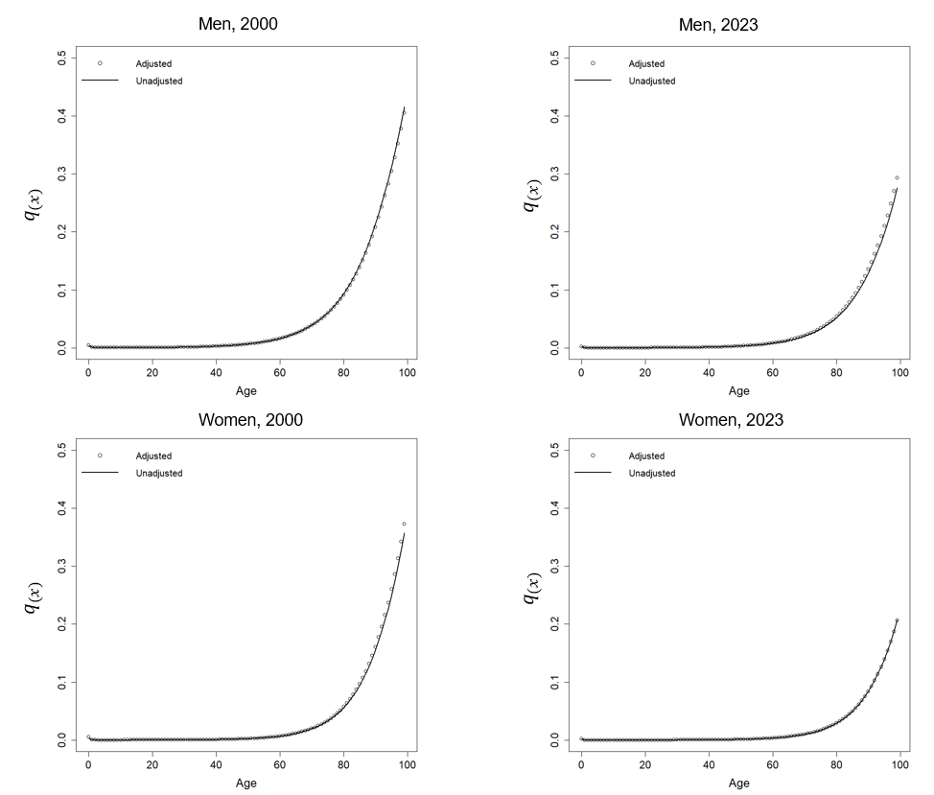
Supplementary Figure 1. Comparison of adjusted and unadjusted age-specific probabilities of death by sex, 2000 and 2023: Findings from the Korean Statistical Information Service.
Notes. $q_{x}=$Probability of dying.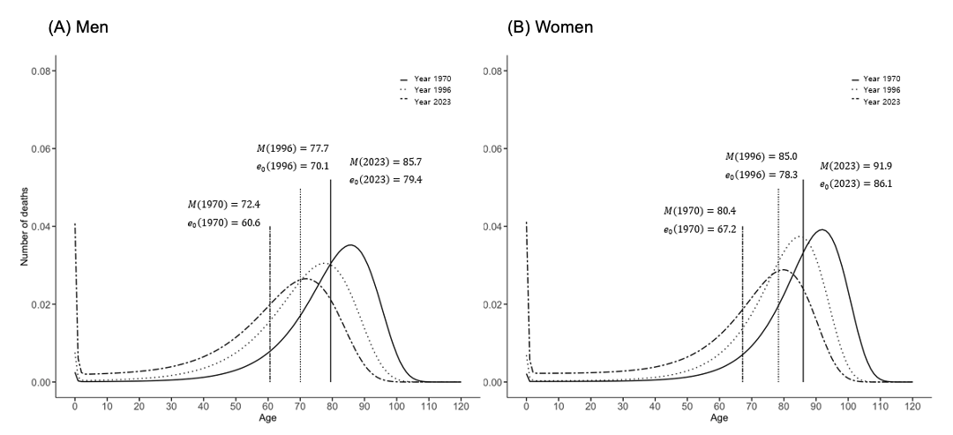
Supplementary Figure 2. Death density distributions, modal age at death, and life expectancy for (A) men and (B) women in 1970, 1996, and 2023: Findings from the Korean Statistical Information Service, 1970–2023.
Notes. M = Modal age at death; $e_{0}$= Life expectancy at age 0.
Each vertical line represents life expectancy at birth in the corresponding year.
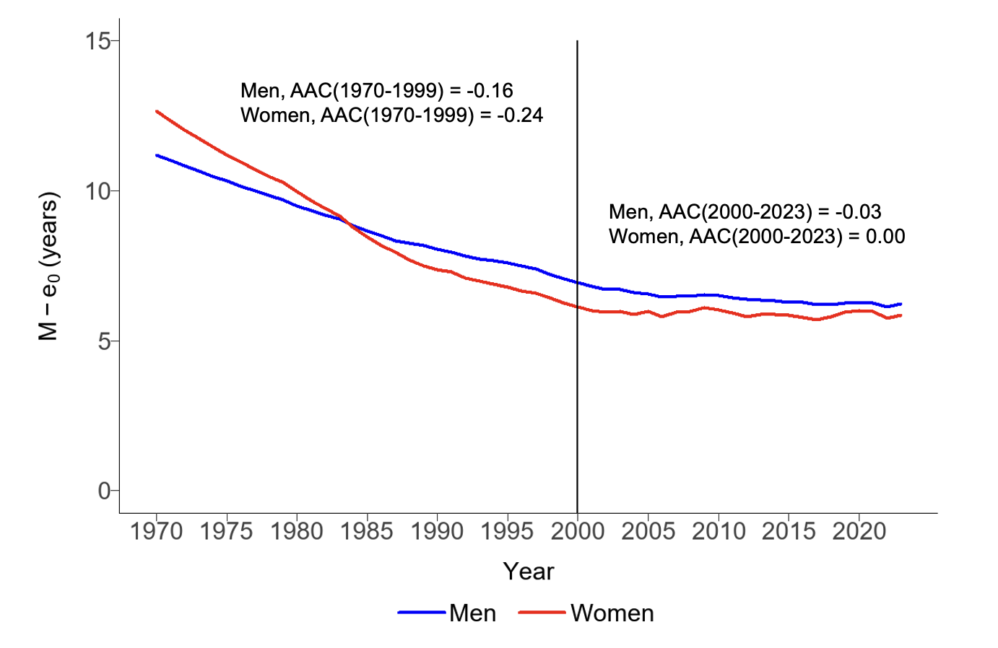
Supplementary Figure 3. Annual trends and average annual changes in the gap between modal age at death and life expectancy at age 0 for men and women, 1970-2023: Findings from the Korean Statistical Information Service, 1970–2023.
Notes. AAC = Average annual changes in years.
Average annual changes were estimated using regression analyses, stratified by periods before and after 2000 to capture differing trends.
Supplementary Table 1. Average annual changes in life expectancy at birth, modal age at death and lifespan variation indicators, by sex, before and after 2000: Findings from the Korean Statistical Information Service, 1970–2023.
 | 1970-1999 |  | 2000-2023
 | β  (95% CI) | P-value | β  (95% CI) | P-value
Men
$$e_{0}$$ | 0.39  (0.37, 0.41) | <.001 | 0.33  (0.30, 0.35) | <.001
$$M$$ | 0.23  (0.21, 0.25) | <.001 | 0.30  (0.27, 0.33) | <.001
SDM | -0.08  (-0.08, -0.08) | <.001 | -0.02  (-0.03, -0.01) | <.001
$${ e}^{†}$$ | -0.07  (-0.08, -0.07) | <.001 | -0.02  (-0.03, -0.02) | <.001
T | -0.09  (-0.09, -0.09) | <.001 | -0.02  (-0.02, -0.02) | <.001
G | -0.08  (-0.08, -0.08) | <.001 | -0.03  (-0.03, -0.02) | <.001
Women
$${ e}_{0}$$ | 0.43  (0.41, 0.44) | <.001 | 0.30  (0.28, 0.32) | <.001
$$M$$ | 0.18  (0.17, 0.20) | <.001 | 0.30  (0.27, 0.32) | <.001
SDM | -0.10  (-0.10, -0.10) | <.001 | 0.00  (-0.01, 0.00) | 0.050
$$e^{†}$$ | -0.11  (-0.11, -0.10) | <.001 | 0.00  (0.00, 0.01) | 0.542
T | -0.10  (-0.11, -0.10) | <.001 | -0.01  (-0.02, 0.00) | 0.002
G | -0.10  (-0.11, -0.10) | <.001 | -0.01  (-0.01, -0.01) | 0.002
Notes. CI = Confidence interval; $e_{0}$= Life expectancy at age 0; $e_{30}$= Life expectancy at age 30; $e_{65}$= Life expectancy at age 65; $e_{85}$= Life expectancy at age 85; M = Modal age at death.
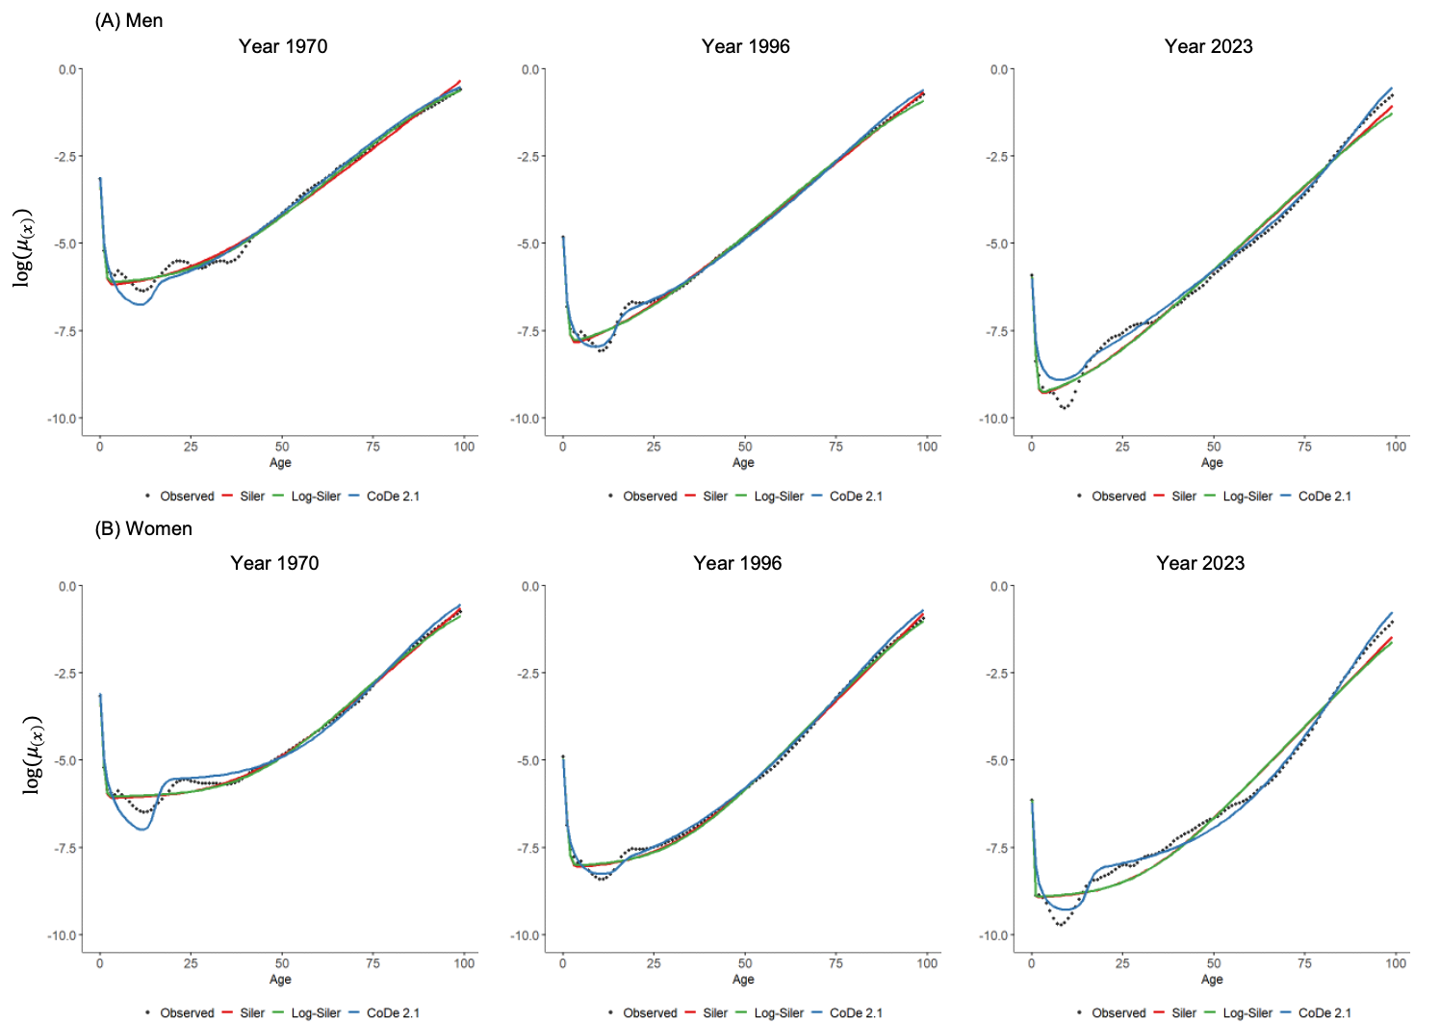
Supplementary Figure 4. Comparison of observed force of mortality (dots) and estimates from Siler, log-Siler, and CoDe 2.1 models for (A) men and (B) women in 1970, 1996, and 2023: Findings from the Korean Statistical Information Service.
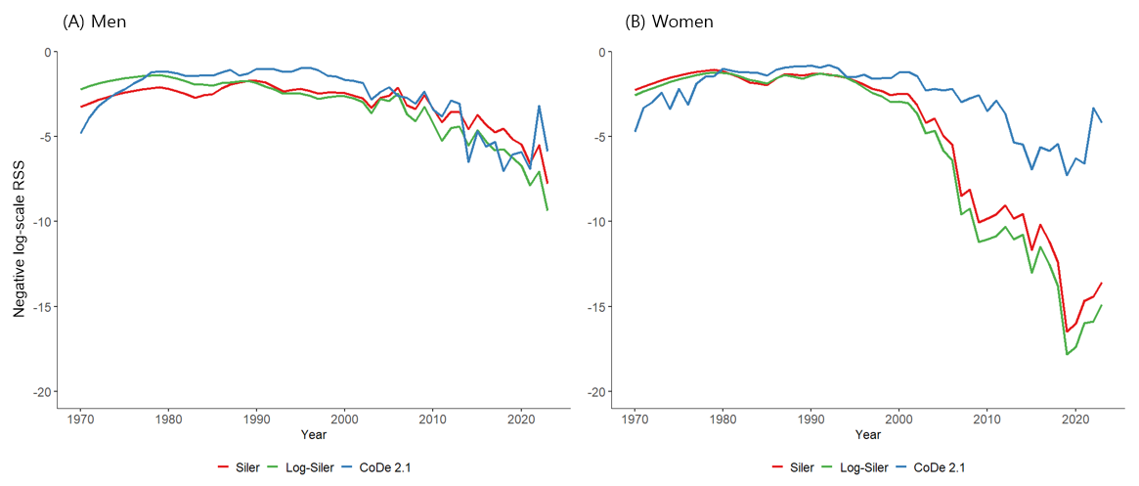
Supplementary Figure 5. Sensitivity analysis of negative log-scale residual sum of squares by sex and year: Comparison of Siler, log-Siler, and CoDe 2.1 models.
Notes. RSS = Residual sum of squares.
The loss function (L) was defined as the negative sum of log-scale residuals; values closer to zero indicate a better fit to the observed data.
$$L=-\sum_{x}{{[log\left({\hat{μ}}_{x}\right)-log\left(μ_{x}\right)]}^{2}}$$
where $x$ denotes age, ${\hat{μ}}_{x}$ denotes model-fitted force of mortality at age $x$, $μ_{x}$ denotes observed force of mortality at age$x$.
Supplementary Table 2. Sensitivity analysis of average annual changes in life expectancy at birth, modal age at death, and lifespan variation indicators, by sex, before and after 2000: Results based on the CoDe 2.1 model
 | 1970-1999 |  | 2000-2023
 | β  (95% CI) | P-value | β  (95% CI) | P-value
Men
$$e_{0}$$ | 0.41  (0.39, 0.42) | <.001 | 0.33  (0.31, 0.36) | <.001
$$M$$ | 0.31  (0.29, 0.33) | <.001 | 0.30  (0.30, 0.36) | <.001
SDM | -0.08  (-0.08, -0.07) | <.001 | -0.02  (-0.03, -0.02) | <.001
$${ e}^{†}$$ | -0.07  (-0.07, -0.6) | <.001 | -0.04  (-0.05, -0.04) | <.001
T | -0.09  (-0.09, -0.09) | <.001 | -0.02  (-0.03, -0.02) | <.001
G | -0.08  (-0.08, -0.07) | <.001 | -0.04  (-0.04, -0.03) | <.001
Women
$${ e}_{0}$$ | 0.40  (0.38, 0.41) | <.001 | 0.31  (0.29, 0.33) | <.001
$$M$$ | 0.13  (0.11, 0.15) | <.001 | 0.27  (0.24, 0.30) | <.001
SDM | -0.09  (-0.10, -0.09) | <.001 | -0.02  (-0.03, -0.02) | <.001
$$e^{†}$$ | -0.09  (-0.09, -0.08) | <.001 | -0.03  (-0.04, -0.03) | <.001
T | -0.10  (-0.11, -0.10) | <.001 | -0.01  (-0.02, -0.01) | <.001
G | -0.09  (-0.10, -0.09) | <.001 | -0.03  (-0.03, -0.02) | <.001
Notes. CI = Confidence interval; $e_{0}$= Life expectancy at age 0; M = Modal age at death.

Supplementary Table 3. Sensitivity analysis of the association of changes in life expectancy at birth with modal age at death and lifespan variation indicators, by sex, before and after 2000: Results based on the CoDe 2.1 model.
 | 1970-1999 |  | 2000-2023
 | $$β_{1}$$(95% CI) | P-value | $$β_{1}+β_{3}$$(95% CI) | P-value
Men
$M$ | 0.141  (0.137, 0.145) | <.001 | 0.185  (0.179, 0.192) | <.001
$SDM$ | -0.187  (-0.196, -0.177) | <.001 | -0.073  (-0.089, -0.057) | <.001
$e^{†}$ | -0.162  (-0.169, -0.156) | <.001 | -0.130  (-0.140, -0.119) | <.001
$T$ | -0.215  (-0.223, -0.206) | <.001 | -0.068  (-0.093, -0.053) | <.001
$G$ | -0.184  (-0.190, -0.179) | <.001 | -0.106  (-0.115, -0.096) | <.001
Women
$M$ | 0.096  (0.085, 0.107) | <.001 | 0.249  (0.230, 0.269) | <.001
$SDM$ | -0.240  (-0.248, -0.233) | <.001 | -0.066  (-0.079, -0.053) | <.001
$e^{†}$ | -0.217  (-0.224, -0.210) | <.001 | -0.099  (-0.110, 0.087) | <.001
$T$ | -0.259  (-0.268, -0.251) | <.001 | -0.048  (-0.063, -0.032) | <.001
$G$ | -0.231  (-0.238, -0.224) | <.001 | -0.088  (-0.100, -0.076) | <.001
Notes. CI = Confidence interval; M = Modal age at death; SDM = Standard deviation around the mode; $e^{†}$ = Life disparity; T = Theil index; G = Gini coefficient.
$β_{1}$ represents the association between life expectancy at birth and M or lifespan variation indicators during 1970–1999, while $β_{1}+β_{3}$ represents the association for 2000–2023.
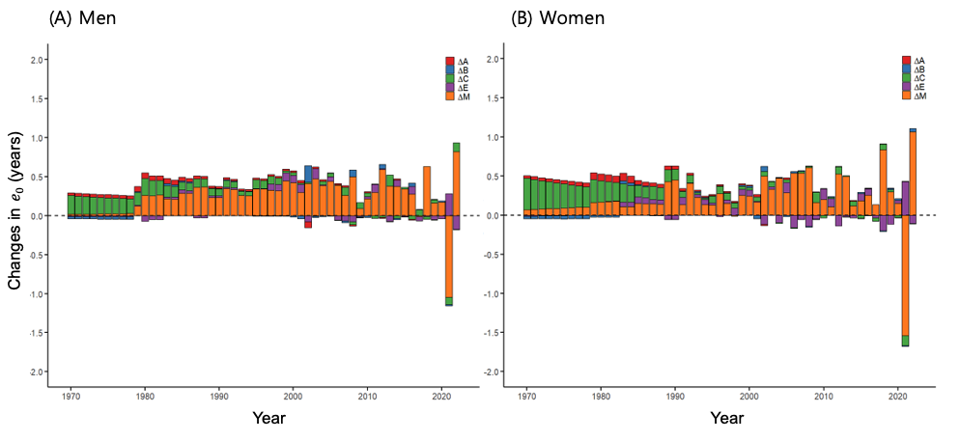
Supplementary Figure 6. Contributions of the five components of the log-Siler model to annual increases in life expectancy at birth for (A) men and (B) women: Findings from the Korean Statistical Information Service, 1970-2023.
Notes. The five components of the log-Siler model are: A, representing the initial level of infant mortality; B, controlling the age-related decline rate in infant mortality; C, denoting the level of background mortality; E, determining the steepness of its exponential increase with age; and M, representing the changes in modal age at death.
References
1. Cheung SL, Robine JM, Tu EJ, Caselli G. Three dimensions of the survival curve: horizontalization, verticalization, and longevity extension. Demography. 2005;42(2):243-58.
2. Kannisto V. Measuring the compression of mortality. Demogr Res. 2000;3:[24] p.
3. Shkolnikov VM, Andreev EM, Zhang Z, Oeppen J, Vaupel JW. Losses of expected lifetime in the United States and other developed countries: methods and empirical analyses. Demography. 2011;48(1):211-39.

