Supplementary Information

bFGF-mediated pluripotency maintenance in human induced pluripotent stem cells is associated with NRAS-MAPK signaling

Fereshteh Haghighi¹, Julia Dahlmann^{2,3}, Saeideh Nakhaei-Rad¹, Alexander Lang^{1#}, Ingo Kutschka², Martin Zenker⁴, George Kensah^{2,3}, Roland P. Piekorz¹, Mohammad Reza Ahmadian^{1@}

¹Institute of Biochemistry and Molecular Biology II, Medical Faculty of the Heinrich Heine University, Düsseldorf, Germany; ²Department of Thoracic and Cardiovascular Surgery, University of Göttingen, Germany; ³Department of Cardiothoracic Surgery, University Clinic, Otto von Guericke-University, Magdeburg, Germany; ⁴Institute of Human Genetics, Otto von Guericke-University, Magdeburg, Germany.

Table S1. Primer sequences (5´ to 3´) for qPCR using the SYBR Green system obtained from PrimerBank (https://pga.mgh.harvard.edu/primerbank/).
Genes | Forward primers | Reverse primers
POU5F1 | CTGGGTTGATCCTCGGACCT | CACAGAACTCATACGGCGGG
SOX2 | GCCGAGTGGAAACTTTTGTCG | GGCAGCGTGTACTTATCCTTCT
NANOG | CCCCAGCCTTTACTCTTCCTA | CCAGGTTGAATTGTTCCAGGTC
BRACHYURY | TATGAGCCTCGAATCCACATAGT | CCTCGTTCTGATAAGCAGTCAC
PAX6 | TGGGCAGGTATTACGAGACTG | ACTCCCGCTTATACTGGGCTA
AFP | CTTTGGGCTGCTCGCTATGA | GCATGTTGATTTAACAAGCTGCT
GAPDH | GGAAGGTGAAGGTCGGAGTCA | GTCATTGATGGCAACAATATCCACT
HRAS | CAGATCAAACGGGTGAAGGAC | GCCTGCCGAGATTCCACAG
NRAS | TGAGAGACCAATACATGAGGACA | CCCTGTAGAGGTTAATATCCGCA
KRAS4A | ACAGAGAGTGGAGGATGCTTT | TTTCACACAGCCAGGAGTCTT
KRAS4B | GATTTGCCTTCTAGAACAGTAGACAC | CAACACCCTGTCTTGTCTTTGC
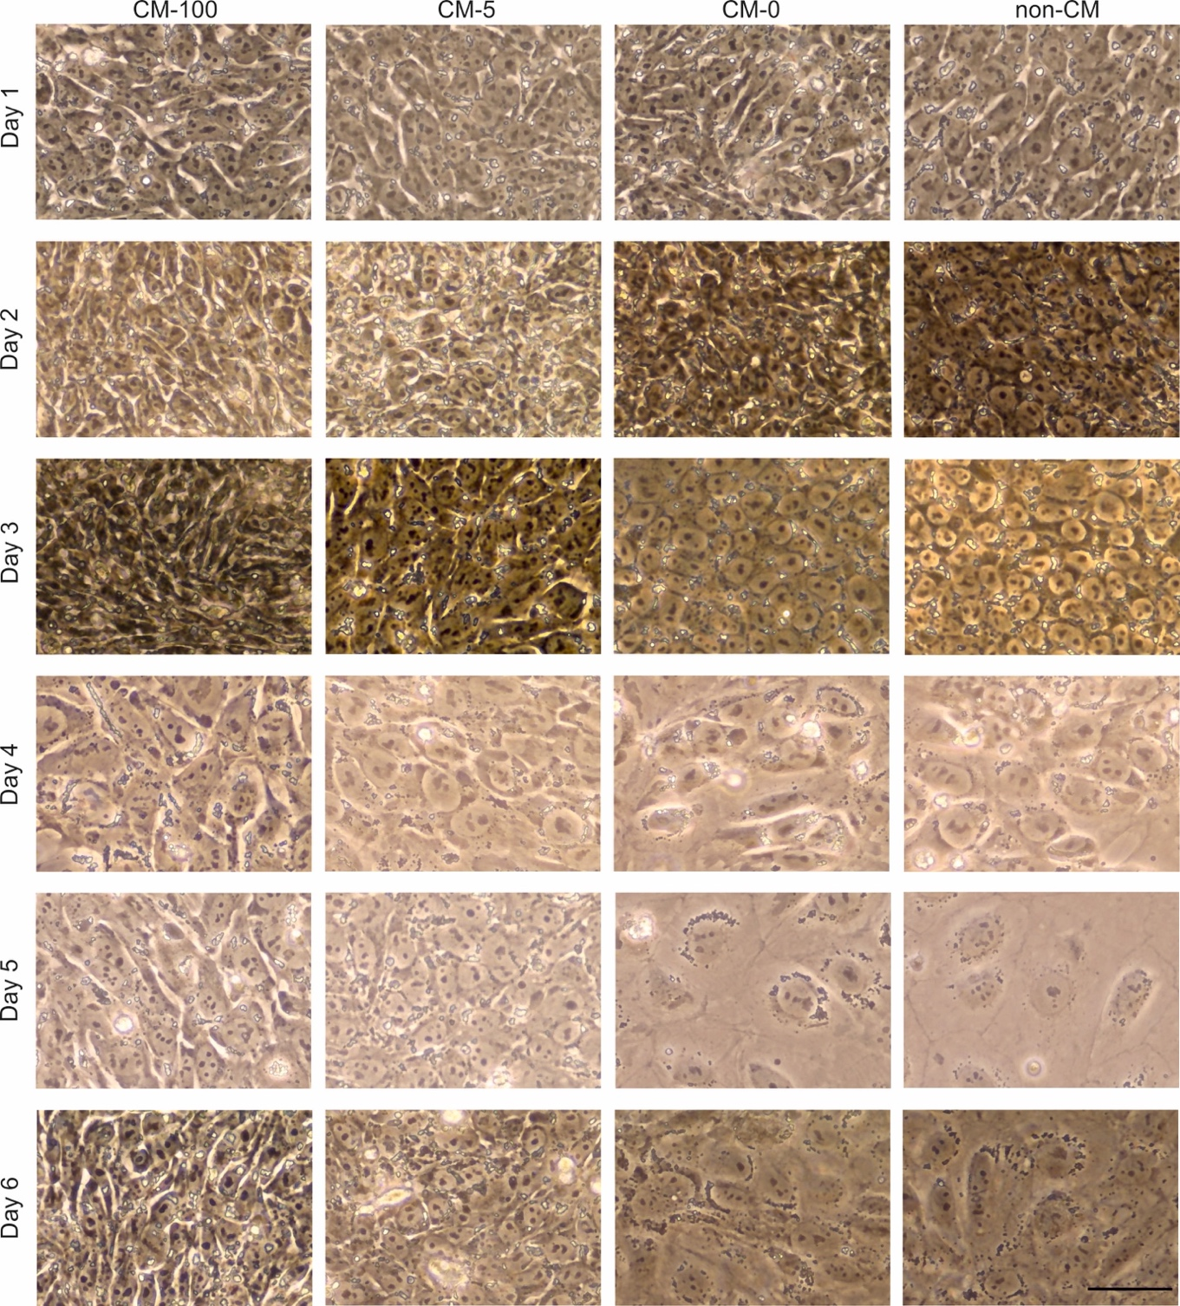

Figure S1: Morphological changes of hiPSCs during 6 day culture of bFGF starvation. hiPSCs were cultured with CM-100 at the density of 5 x 10⁴ cells/cm². The day after, they were washed with PBS^{-/-} and treated with the CM-100, CM-5, CM-0 and non-CM and were kept in culture for 6 days. Cells treated with CM-0 and non-CM started to spread out and flattened at day 4 which was correlated with the loss of pluripotency. Scale bar, 50 μm.

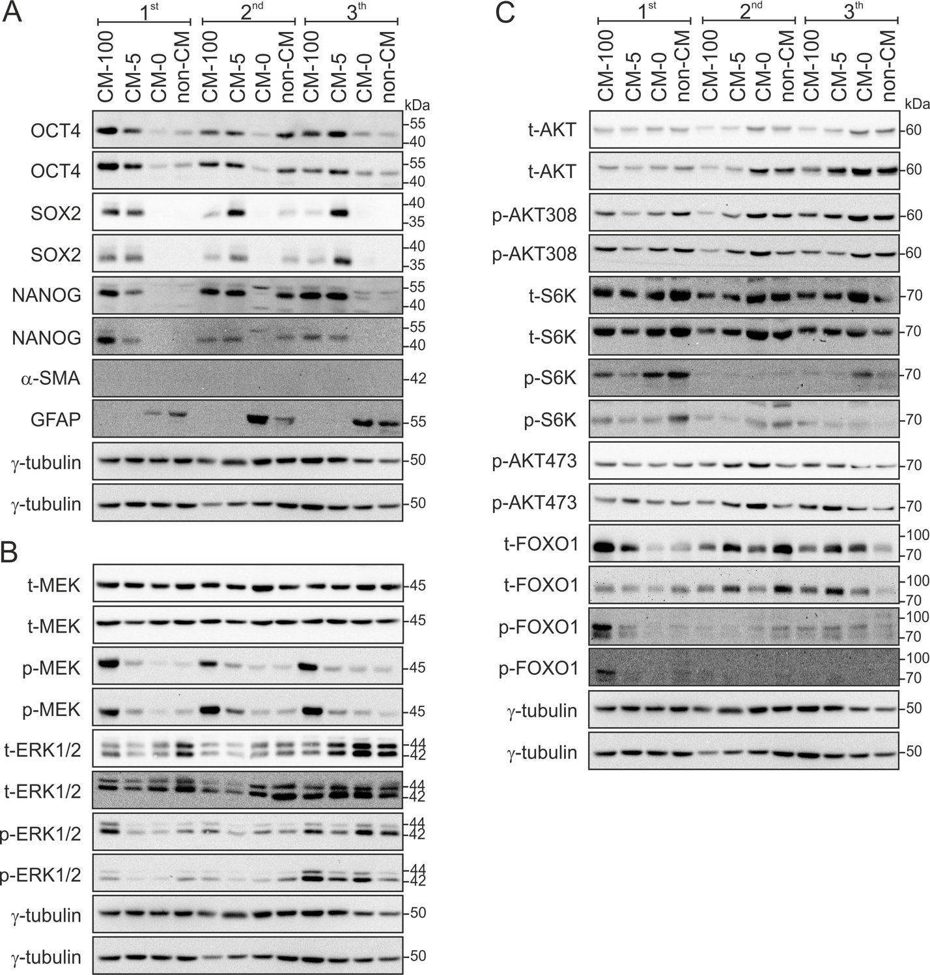

Figure S2: Quantitative western blot analysis of cell signaling in hiPSCs with different culture conditions. Quantitative western blots were probed with antibodies against pluripotency and differentation markers (A), against components of the RAS-RAF-MEK-ERK pathway (B) and PI3K-AKT-S6K/FOXO1 pathway (C).

Figure S3: Subcellular distribution of ERK1/2. Another clone of hiPSCs (A) and NT2 cells (B) were used as pluripotent stem cells. Both cells showed the same pattern of dominant cytoplasmic localization of ERK1/2 and p-EKR1/2.

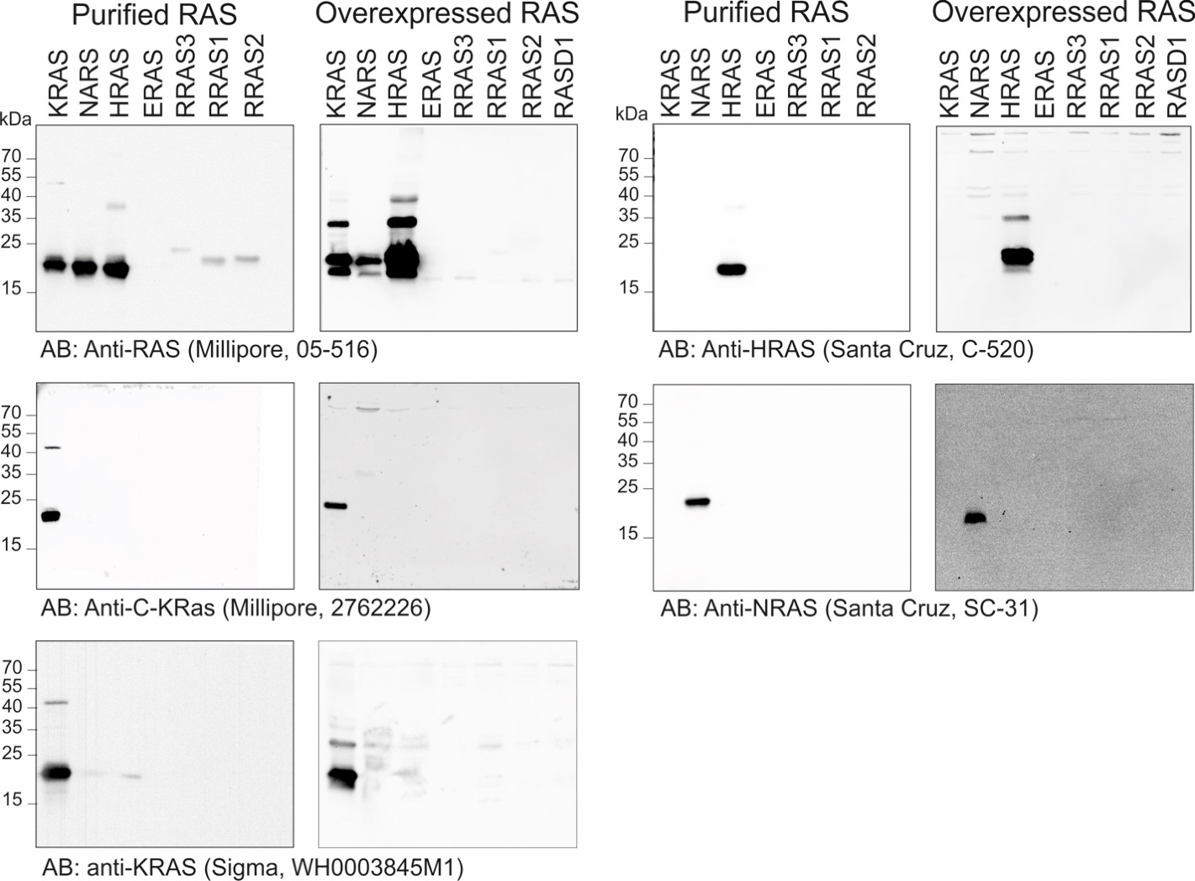

Figure S4: Specification and validation of RAS antibodies. Purified RAS proteins and overexpressed RAS in HEK cells were used for validation of different antibodies. Mouse anti-pan-RAS (Millipore, #05-516), mouse anti-KRAS (Sigma, WH0003845M1), mouse anti-NRAS (Santa Cruz, sc-31) and rabbit anti-HRAS (Santa Cruz, sc-520) were used as validated antibodies which could only recognize three canonical RAS paralogs, KRAS, NRAS and HRAS, respectively.

