Figure S1. The endo- and exo-metabolome assignment of GL261 cell line. Full region of the ¹H-NMR spectra of cell lysates (A) and growing media (B) along with the assignment of the most intense metabolites, with the exclusion of water region.

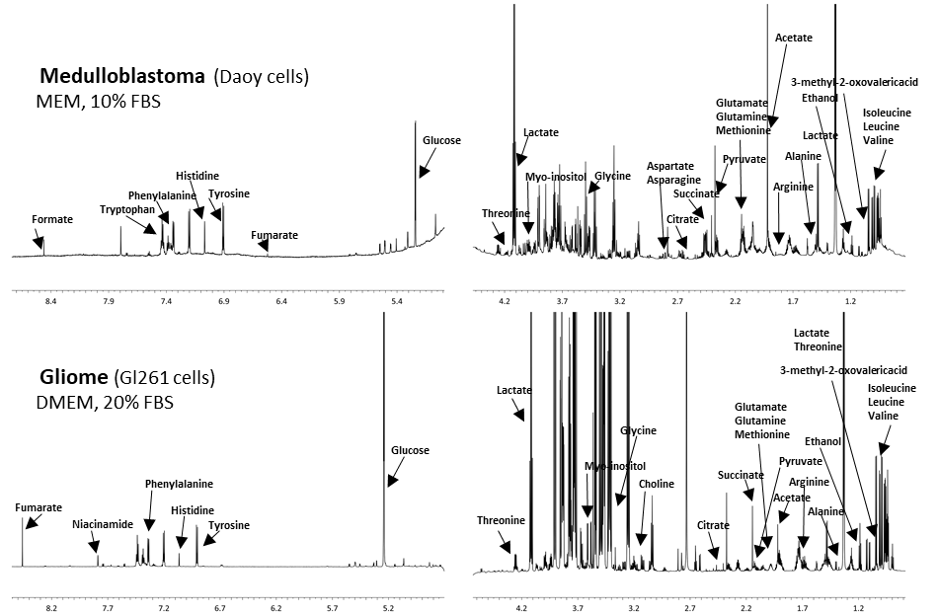
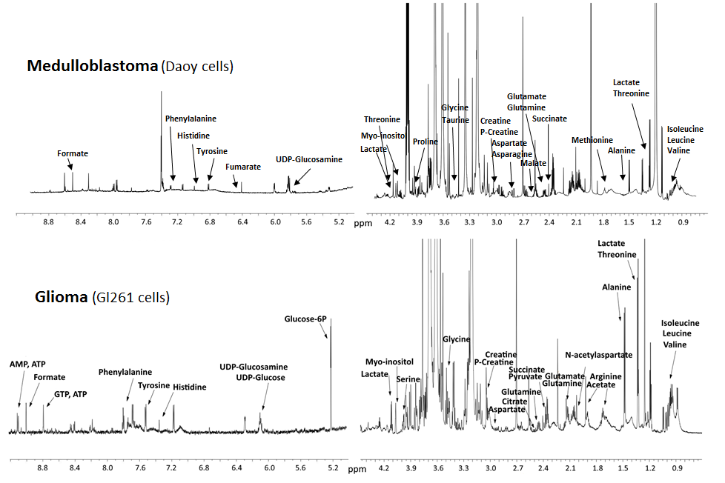
A) Endo-metabolome
B) Exo-metabolome
ppm

A B
LOQ UV: 1.48 ng on column LOQ MS: 0.62 ng on column
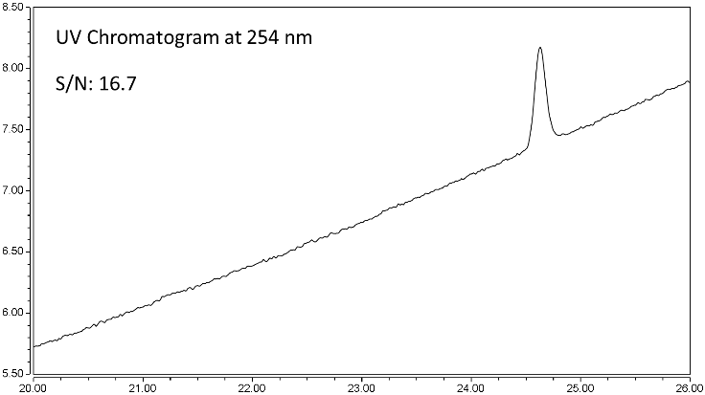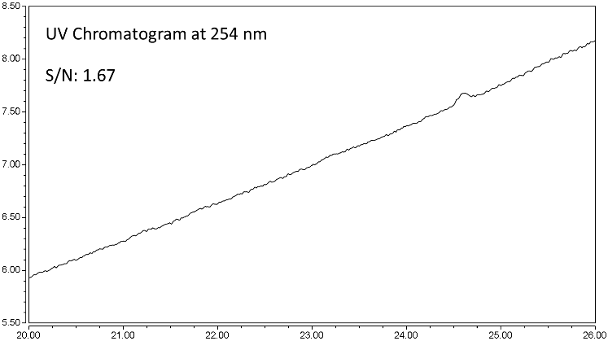
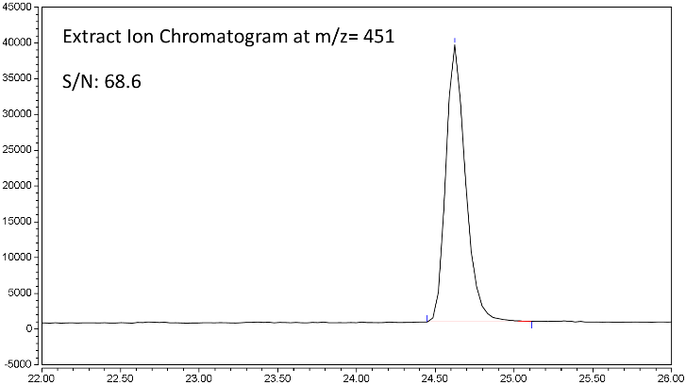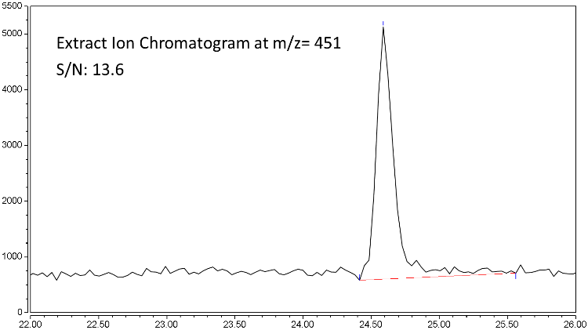

Figure S2. Chromatograms for estimated LOQ in UV and MS. (A) LOQ in UV determination is 1.48 ng of GlaB on column with a S/N= 16.7 for UV chromatogram and a S/N= 68.6 for MS trace. (B) LOQ in MS determination is 0.62 ng of GlaB on column with a S/N= 1.67 for UV chromatogram and a S/N= 13.6 for MS trace.

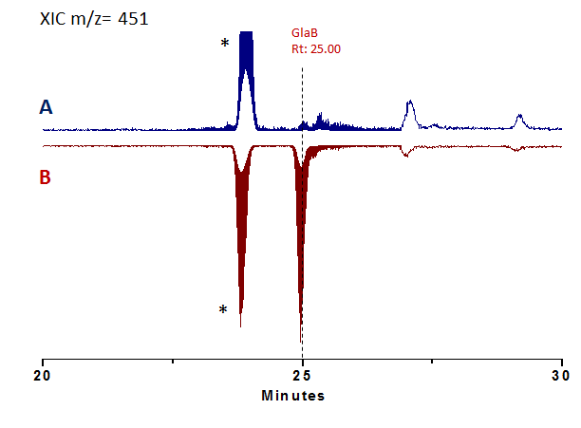

Figure S3. Extract ion chromatograms (XIC) referred to IN treated sample (A) and spiked IN (0.45 μg/ml, 9 ng on column) treated sample (B). Both traces show the presence of GlaB peak (Rt:25.00). * The peak at Rt: 23.90 min is the isotopic abundance with m/z=451 of an unknown peak with m/z=449, present in all brain extracts.

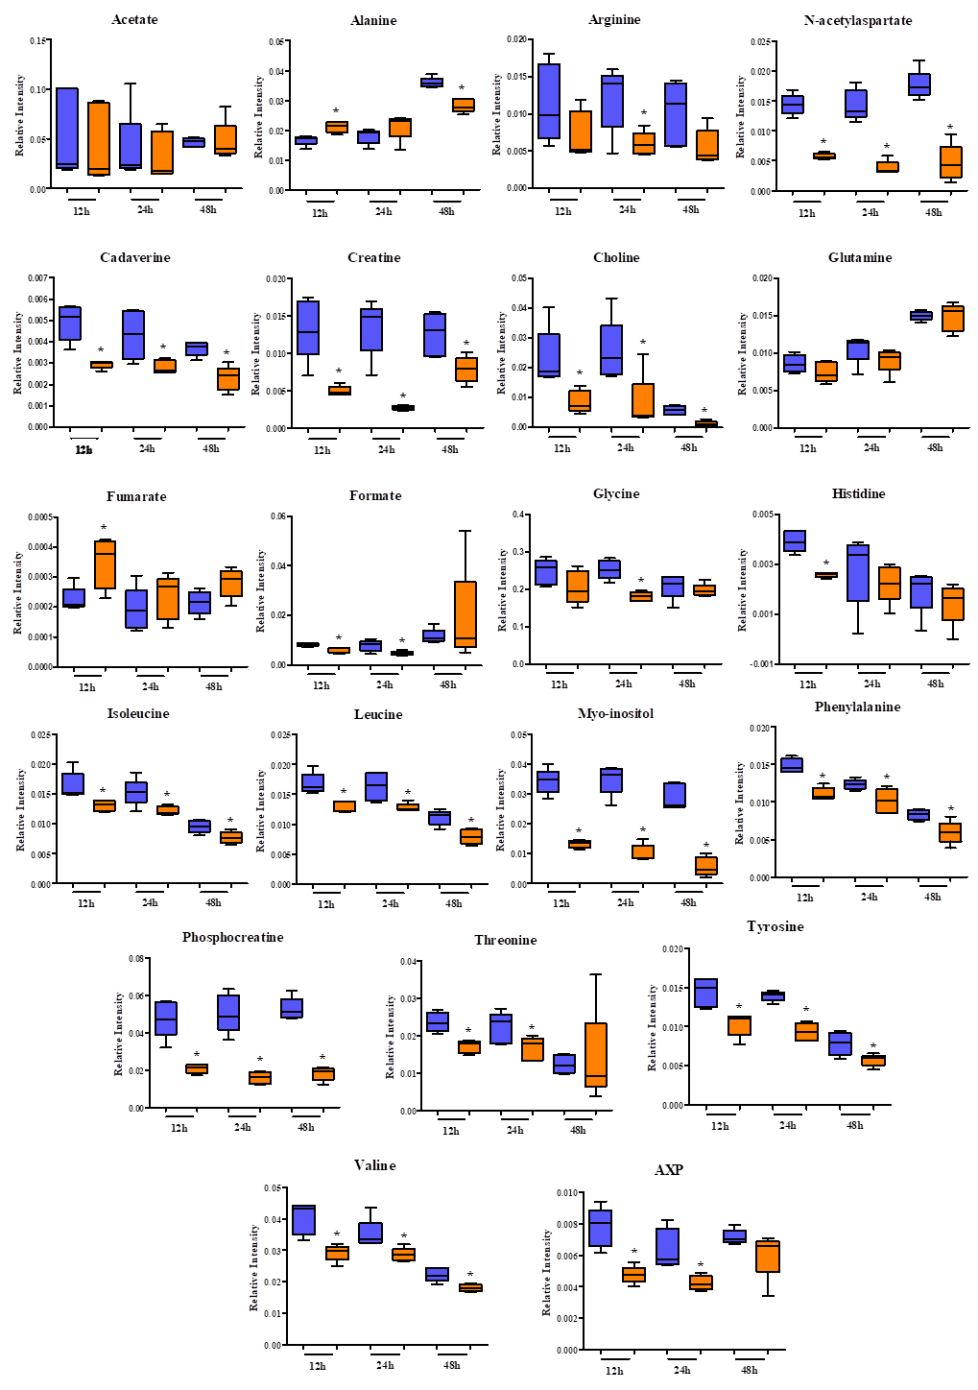
Figure S4. Univariate analysis of the relative concentration levels of characteristic GL261 endo-metabolites. The box plots show the comparison of the relative intensities of the indicated metabolites between the untreated (CTR, light blue boxes) and treated (GlaB, orange boxes) groups at each time point. Metabolites whose concentration is significantly different (p-value < 0.05, by non-parametric Wilcoxon test) are marked with *.

SK1 expression in ovarian cancer cells affects
the metabolomic proﬁles
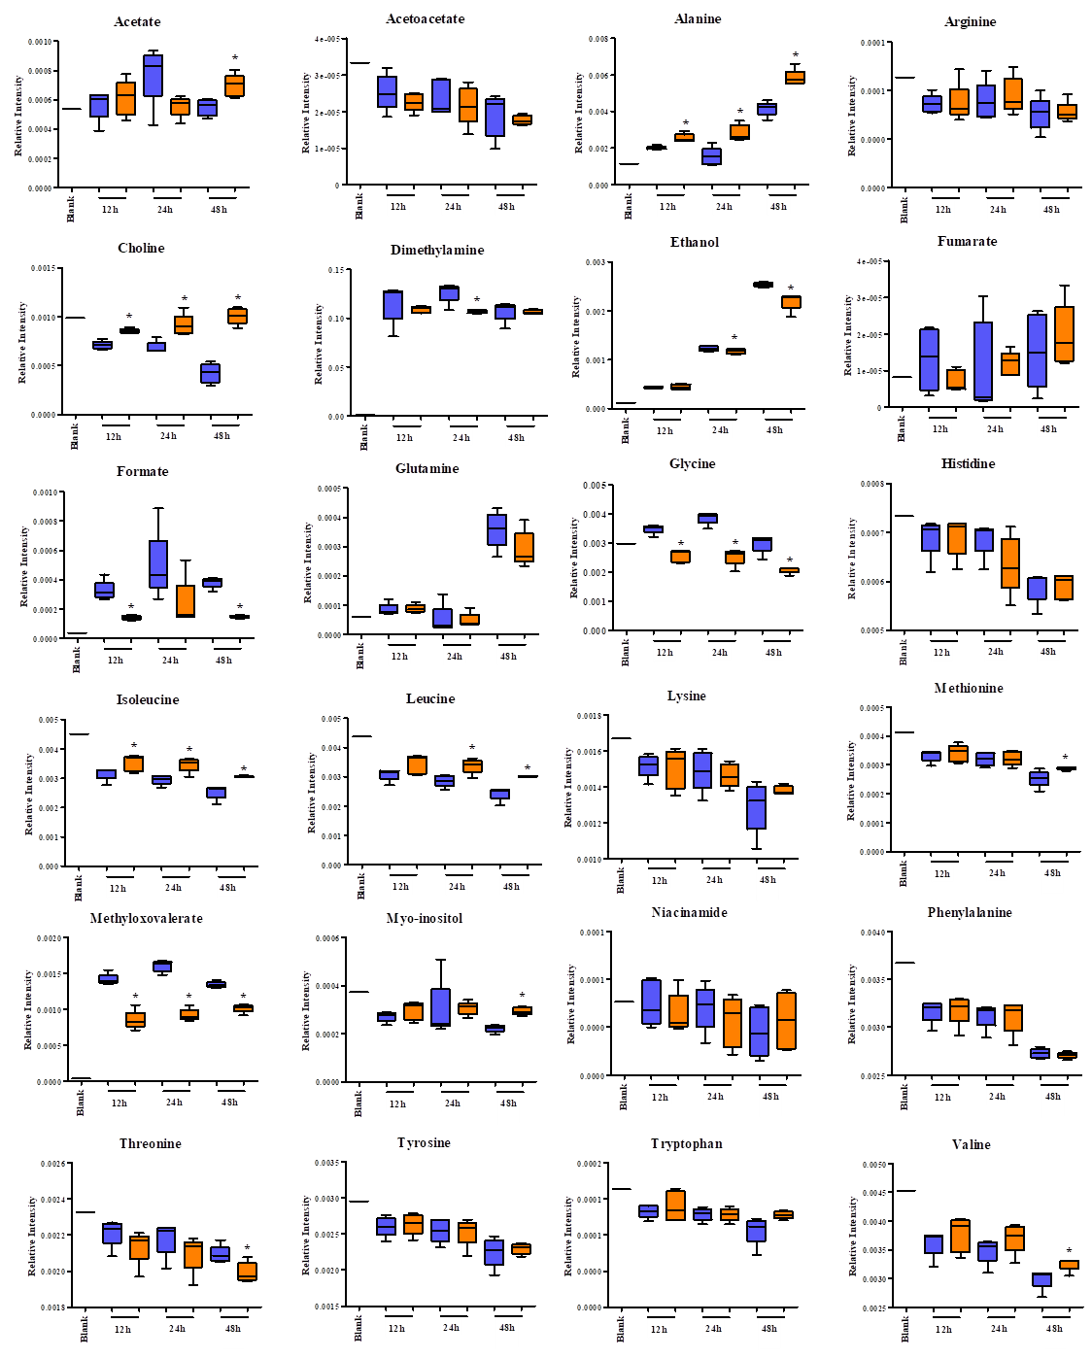

Figure S5. Univariate analysis of the relative concentration levels of GL261 exo-metabolites. The box plots show the comparison of the relative intensities of the indicated metabolites between the untreated (CTR, light blue boxes) and treated (GlaB, orange boxes) groups at each time point. Metabolites whose concentration is significantly different (p-value < 0.05, by non-parametric Wilcoxon test) are marked with *. The relative concentration levels of DMEM medium are also reported as Blank.

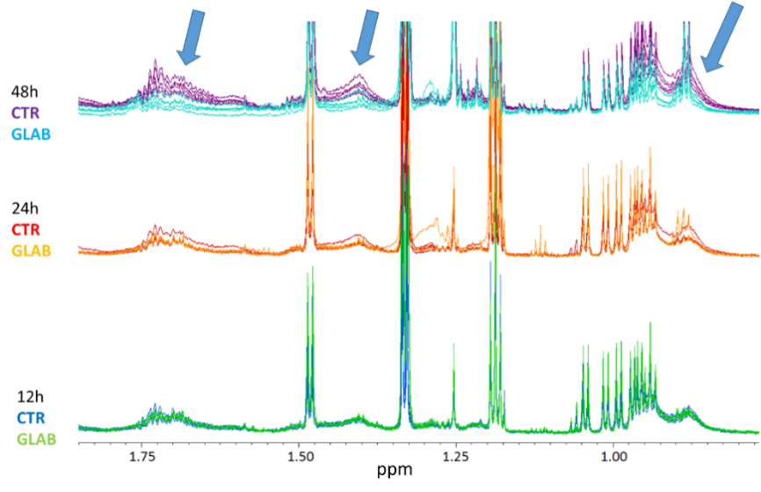
Figure S6. Upfield region (0.75 – 1.8 ppm) of ¹H-NMR CPMG spectra of cell lysates (endo-metabolome). Blue tracks, 12-CTR; red tracks, 24-CTR; purple tracks, 48-CTR; green tracks, 12-GLAB; orange tracks, 24-GLAB; cyan tracks, 48-GLAB.

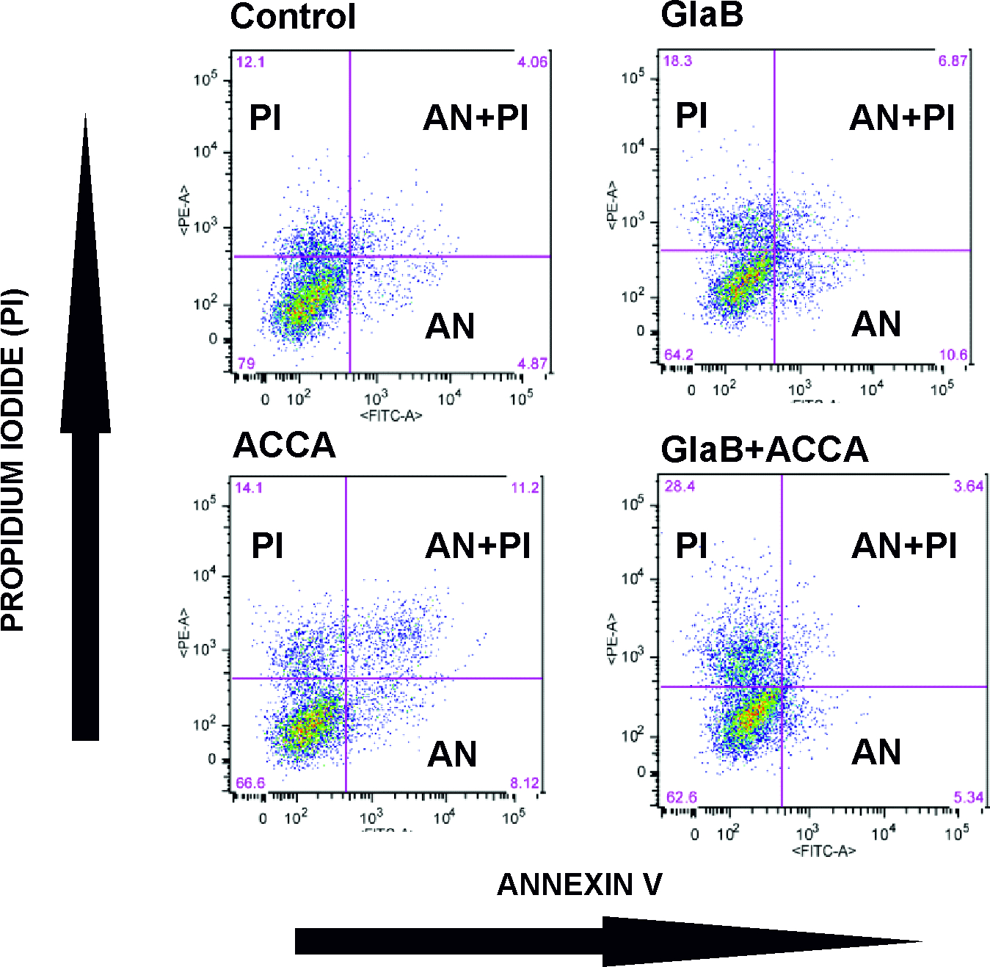

Figure S7. Representative FACS analyses showing the percentage of Annexin V/Propidium Iodide of cell population in GL261 untreated, treated with GlaB (5 µm), ACCA (250 µm) or both for 48h.

