Supplementary table1. Details of the primers used in the RT-PCR analysis

Primer | Forward | Reverse
NQO1  NQO2  HO1  SOD2  CAT  IL1B  IL6  IL8  TNFα  ICAM-1  VCAM-1  Keap1  Nox4  GAPDH | GAAGAGCACTGATCGTACTGGC  GTACTCATTGTCTATGCACACCA  GCCCCAGGATTTGTCAGAGG  GTCACCGAGGAGAAGTACCAGGAGGCG  CCTTCTTGTTCAGGATGTGGTTTTC  TGGGAGTAGATAAGGTACAGCCC  ACTCACCTCTTCAGAACGAATTG  GCCAACACAGAAATTATTGTAAAGCTT  CATCTTCTCAAAACTCGAGTGACAA  TCTTCCTCGGCCTTCCCATA  CCCTTGACCGGCTGGAGATT  CAACCGACAACCAAGACCCC  TGGCTGCCCATC TGGTGAATG  ATGGTGAAGGTCGGTGTGAA | GGATACTGAAAGTTCGCAGGG  TGCCTGCTCAGTTCATCTACA  GGAGGCCATCACCAGCTTGAA  CGCCTCCTGGTACTTCTCCTCGGTGAC  CATGTGTGACCTCAAAGTAGCCAAA  GTAGTGGTGGTCGGAGATTCG  CCATCTTTGGAAGGTTCAGGTTG  AATTCTCAGCCCTCTTCAAAAACTT  TGGGAGTAGATAAGGTACAGCCC  AGGTACCATGGCCCCAAATG  CTGGGGGCAACATTGACATAAAGTG  TCAGTGGAGGCGTACATCAC  CAGCAGCCCTCCTG AAACATGC  TGGAAGATGGTGATGGGCTT

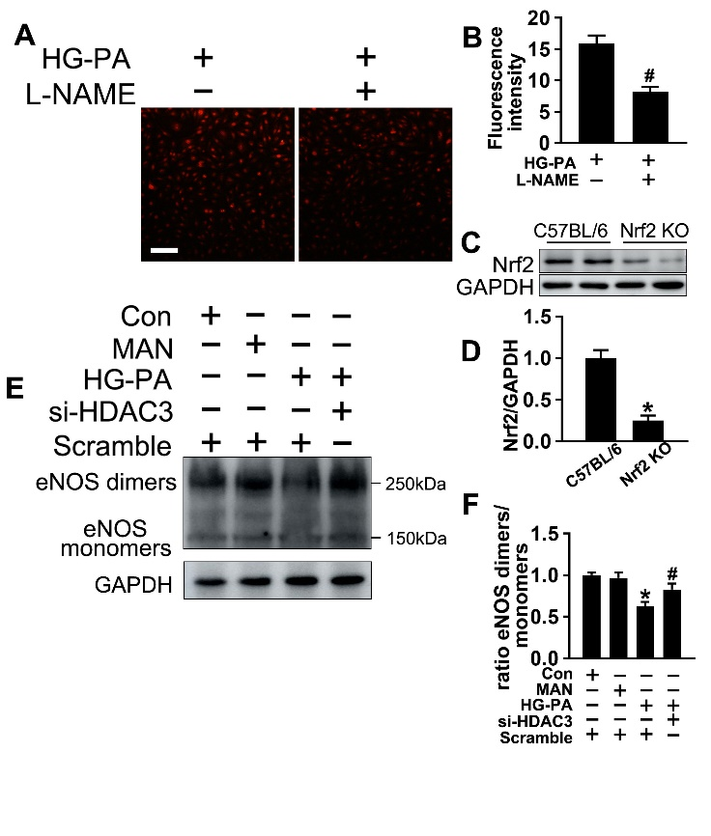
Supplementary Figure 1. A Superoxide was determined with DHE. Scale bars: 100 μm. B The quantitative analysis of fluorescent intensity in (A). C and D The immunoblotting and quantitative analysis of Nrf2 protein level relative to GAPDH protein levels in the the endothelial cells isolated from C57BL/6 mice or Nrf2 KO mice. Values displayed are means ± SEM (n = 5). Significance (D): * P < 0.05 vs. C57BL/6 mice. E The ratio of eNOS dimer/monomers in HUVECs was detected by immunoblotting. F The quantitative analysis of the ratio of eNOS dimer/monomers immunoblotting, values displayed are means ± SEM (n = 3). Significance (F): * P < 0.05 vs. Con or MAN in scrambled HUVECs; # P < 0.05 vs. HG-PA in scrambled HUVECs. All above results in graphs were normalized to the first group.

