Effect of HSP90AB1 and CC domain interaction on Bcr-Abl protein cytoplasm localization and function in chronic myeloid leukemia cells
SUPPLEMENTARY MATERIAL

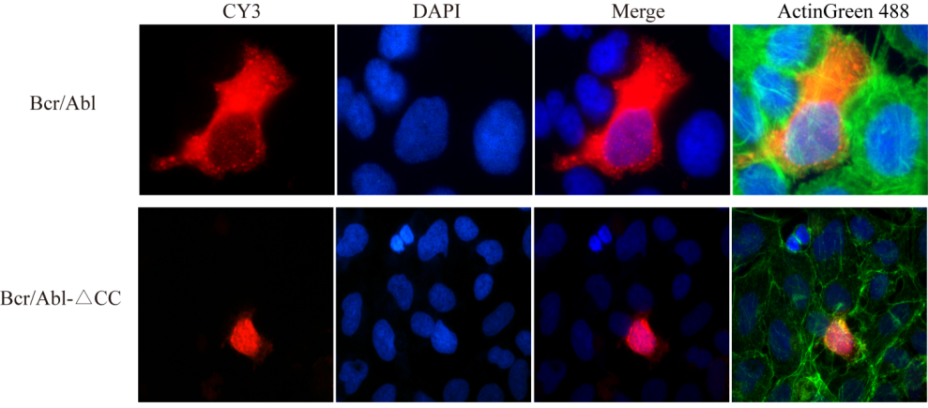

Supplementary Figure 1: Effects of CC domain on subcellular localization of BCR-ABL protein. The changes of BCR-ABL subcellular localization in 293T cells transfected with pAdTrack-BCR/ABL and pAdTrack-BCR/ABL-ΔCC were observed by indirect immunofluorescence.

Supplementary Table 1: List of related proteins specifically bound to the CC domain of BCR/ABL protein was screened by mass spectrometry.

Supplementary Table 1-ProteinSummary.xlsx

Supplementary Table 2: The primers of HSP90AB1 and HSP90AB1-ΔNTD amplification.

