ChIP-seq data analysis from Cistrome DB database (http://cistrome.org/).
Since there was no TOP2β ChIP-seq public data of human kidney-derived cells or tissues in the database, we included three kinds of mouse TOP2β ChIP-seq data, as well as the only two human TOP2β ChIP-seq data. And other three CTCF ChIP-seq public data in the human kidney-derived cell line HEK293 were also included.

TOP2β ChIP-seq in Mus musculus
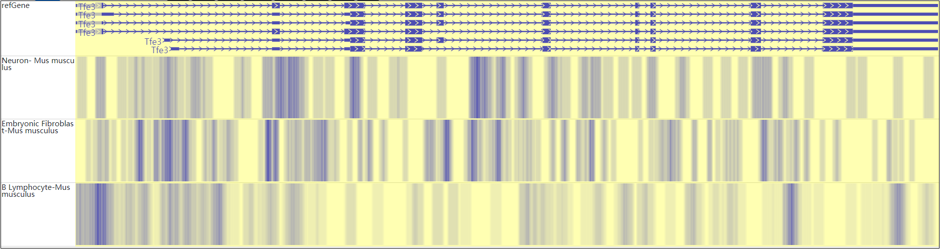
TFE3
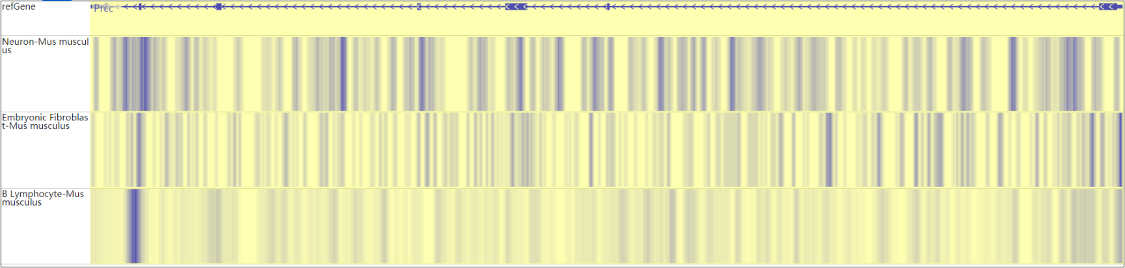
PRCC

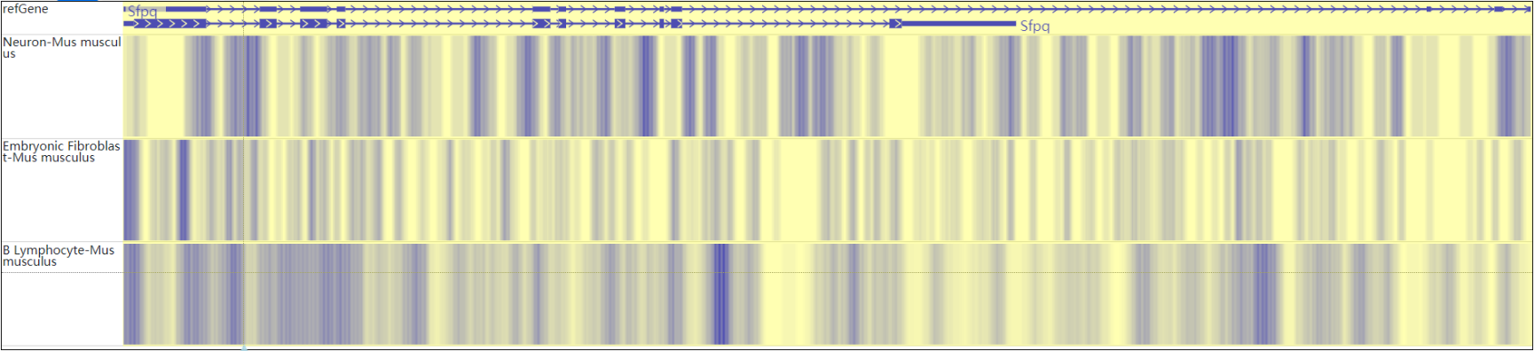
SFPQ
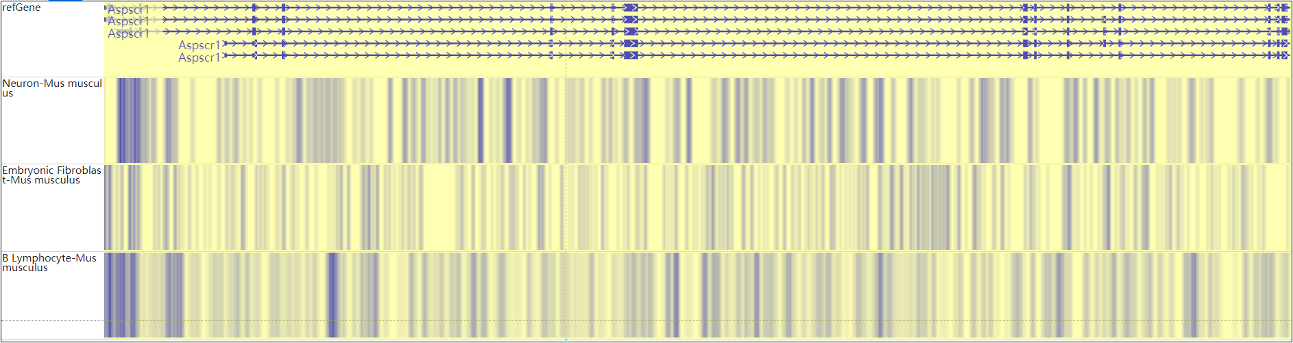
ASPSCR1

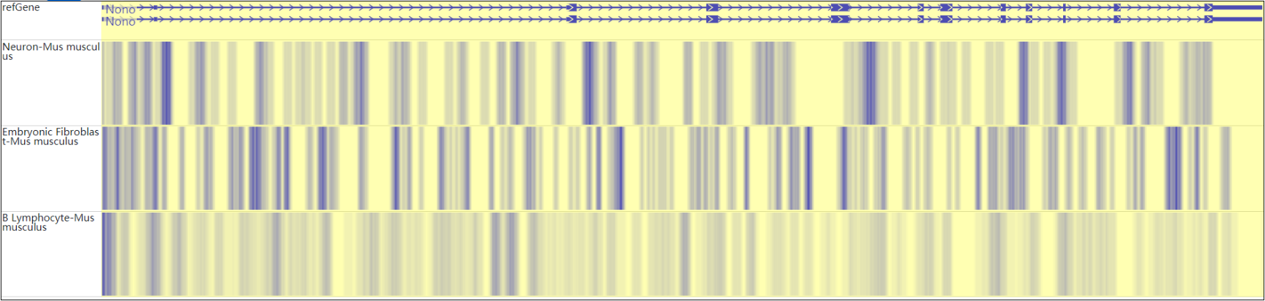
NONO
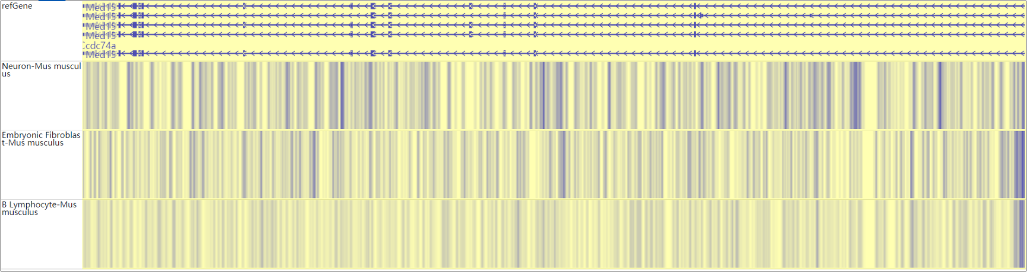
MED15

TOP2β ChIP-seq in Homo sapiens
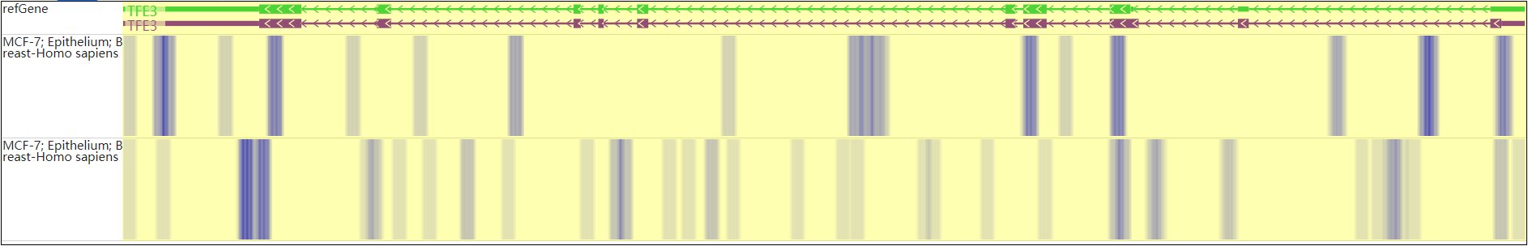
TFE3
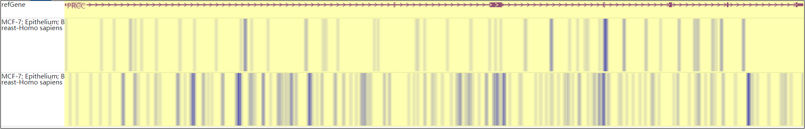
PRCC
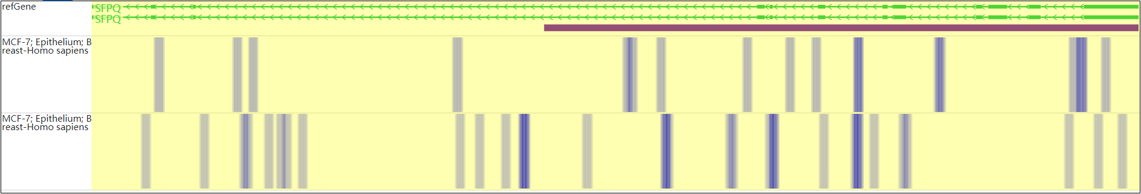
SFPQ

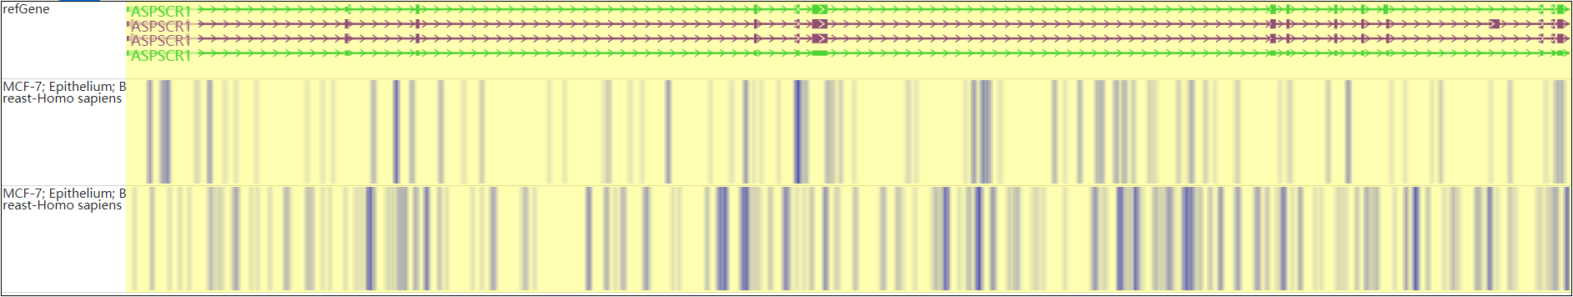
ASPSCR1
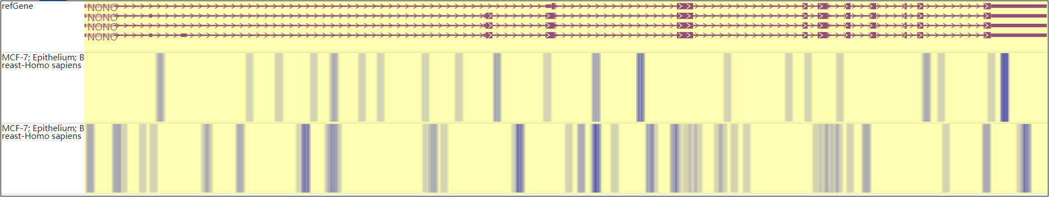
NONO
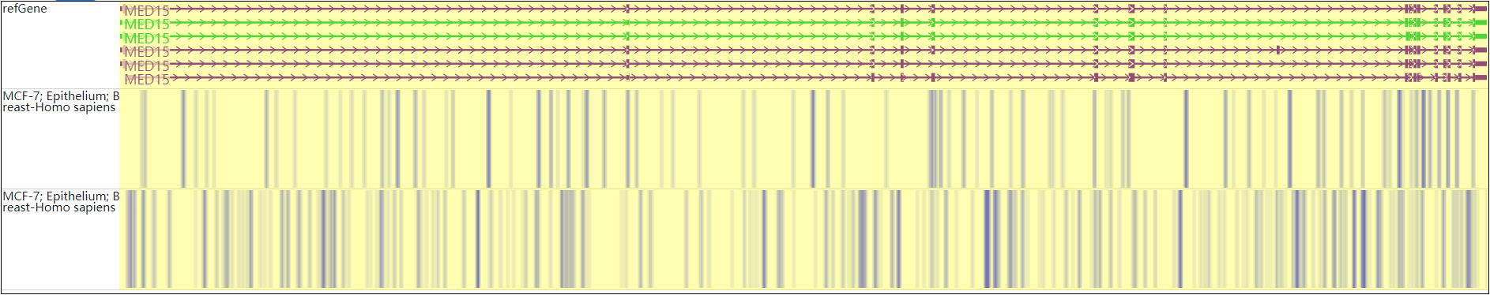
MED15

CTCF ChIP-seq in Homo sapiens HEK293
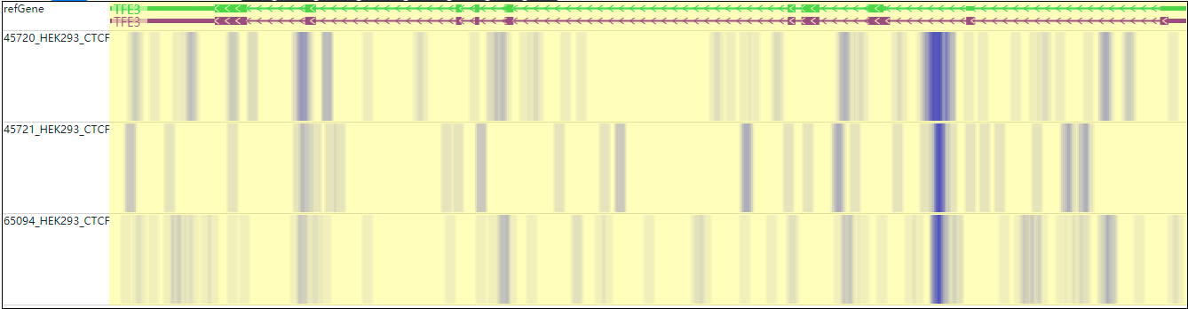
TFE3
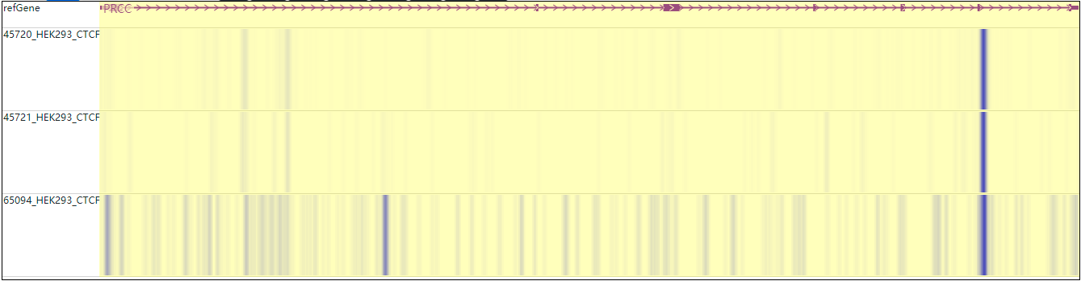
PRCC

SFPQ
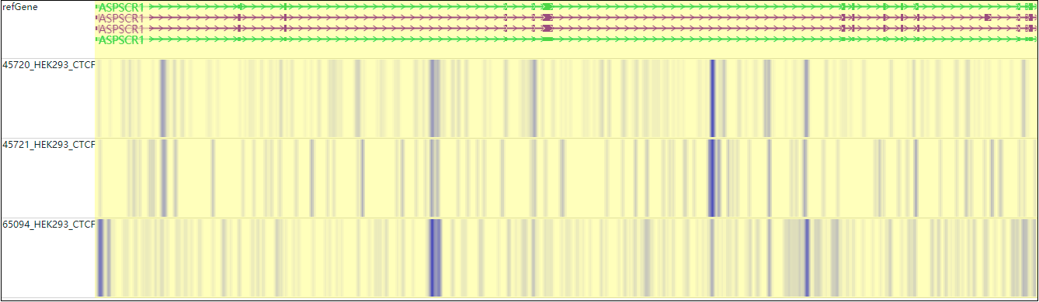
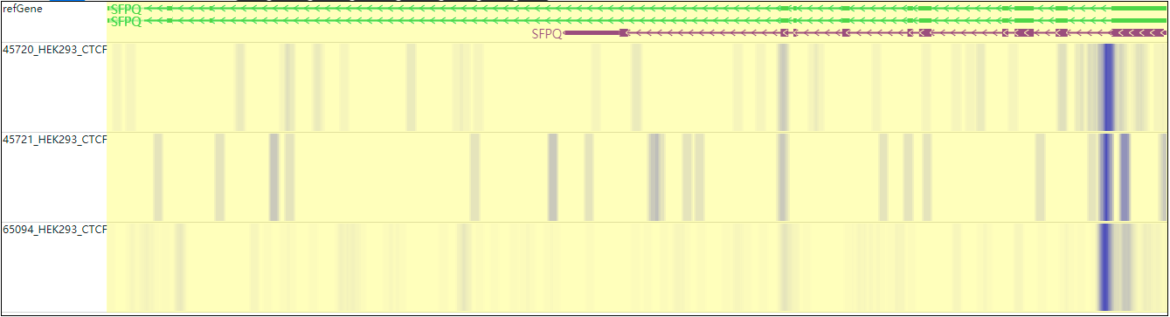
ASPSCR1

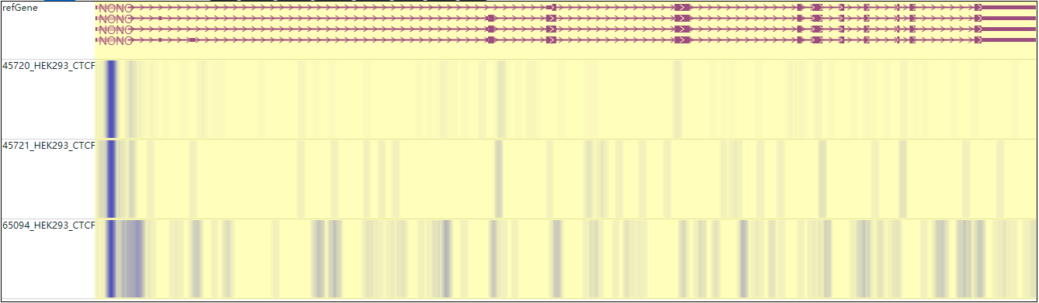
NONO
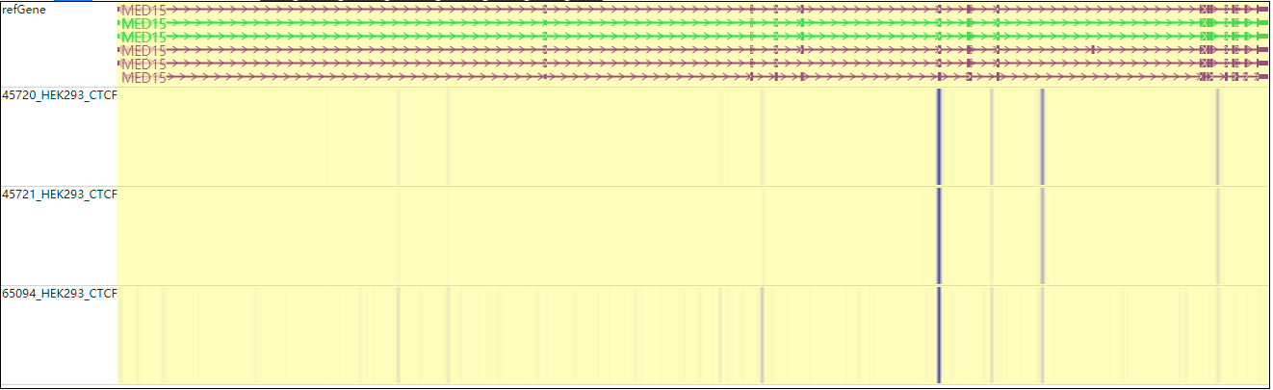
MED15

