Supplementary Information for:

Galectins use N-glycans of FGFs to capture growth factors at the cell surface and fine-tune their signaling
Aleksandra Gedaj¹, Dominika Zukowska¹, Natalia Porebska¹, Marta Pozniak¹, Mateusz Krzyscik¹, Aleksandra Czyrek², Daniel Krowarsch², Malgorzata Zakrzewska¹, Jacek Otlewski¹ and Lukasz Opalinski¹*

¹Faculty of Biotechnology, Department of Protein Engineering, University of Wroclaw, Joliot-Curie 14a, 50-383 Wroclaw, Poland
²Faculty of Biotechnology, Department of Protein Biotechnology, University of Wroclaw, Joliot-Curie 14a, 50-383 Wroclaw, Poland

*Correspondence should be addressed to L.O (lukasz.opalinski@uwr.edu.pl)

Supplementary Figure Legends:

Fig. S1. Galectin dot blot experiments with FGF4-Fc in the presence of lactose. Recombinant galectins were spotted onto the PVDF membrane and incubated with FGF4-Fc in the presence or absence of 50 mM lactose. After extensive washing, FGF4-Fc interacting with individual galectins was detected with anti-Fc-HRP antibodies and chemiluminescence.

Fig. S2. BLI measurements of the interaction between FGF23-Fc and galectin-1, -3, -7, -8 and -13. FGF23-Fc was immobilized on Protein-A biosensors in a pairwise manner with equimolar concentrations of Fc and incubated with recombinant galectins to record the association and dissociation phases. Fc control values were subtracted from the signal obtained for FGFs-Fc.

Fig. S3. BLI measurements of galectins’ interaction with FGF4-Fc in the presence of lactose. FGF4-Fc (10 μg/mL) was immobilized on BLI biosensors and incubated recombinant galectin-1, -3, -7 and -8 in PBS (control) or in PBS with 25 mM lactose.

Fig. S4. BLI measurements of the interaction between GST-galectin-9 and GST. FGF4-Fc (10 μg/mL) was immobilized on BLI biosensors and incubated with recombinant GST-galectin-9 (10 μg/mL) or GST (10 μg/mL).

Fig. S5. Fluorescence microscopy analysis of FGF4-Fc co-localization with EEA1. Serum-starved U2OS-R1 cells were incubated in DMEM supplemented with heparin (40U/mL) and FGF4-Fc (20 μg/mL) for 30 min. Cells were subsequently washed with ice cold PBS, fixed in 4% paraformaldehyde solution and permeabilized with 0.1% Triton in PBS. Nuclei were stained with NucBlue Live dye, Zenon AF-488 was used for detection of FGF4-Fc. Early endosomes were detected with rabbit anti-human polyclonal antibody specific for early endosome antigen 1 (EEA1) and anti-rabbit IgG secondary antibody conjugated to Alexa Fluor 594. Scale bar represents 20 μm.

Fig. S6. The effect of lactose on cell proliferation induced by FGF4-Fc/galectins. The effect of 50 mM lactose on the NIH3T3 cell proliferation induced by a mixture of FGF4-Fc (5 ng/mL)/ galectin (5 μg/mL) assessed with the Presto Blue Cell Viability Reagent.

Fig. S7. Antiapoptotic activity of galectins. Ratio of caspase 3/7 activity in serum-starved NIH3T3 cells stimulated with distinct concentrations of galectin-1, -3, -7 and -8 to cell viability. The data shown are mean values ±SD of four independent experiments normalized toward untreated cells.

Fig. S8. Cell viability upon treatment with high concentrations of galectins. NIH3T3 cells were stimulated for 24h with galectins (20 μg/mL and 50 μg/mL) and cell viability was assessed with Presto Blue Cell Viability Reagent.

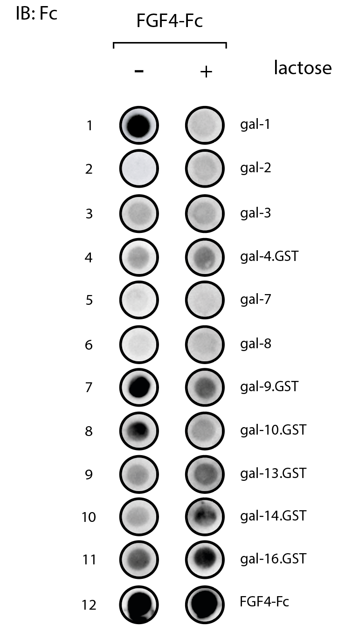

Figure S1
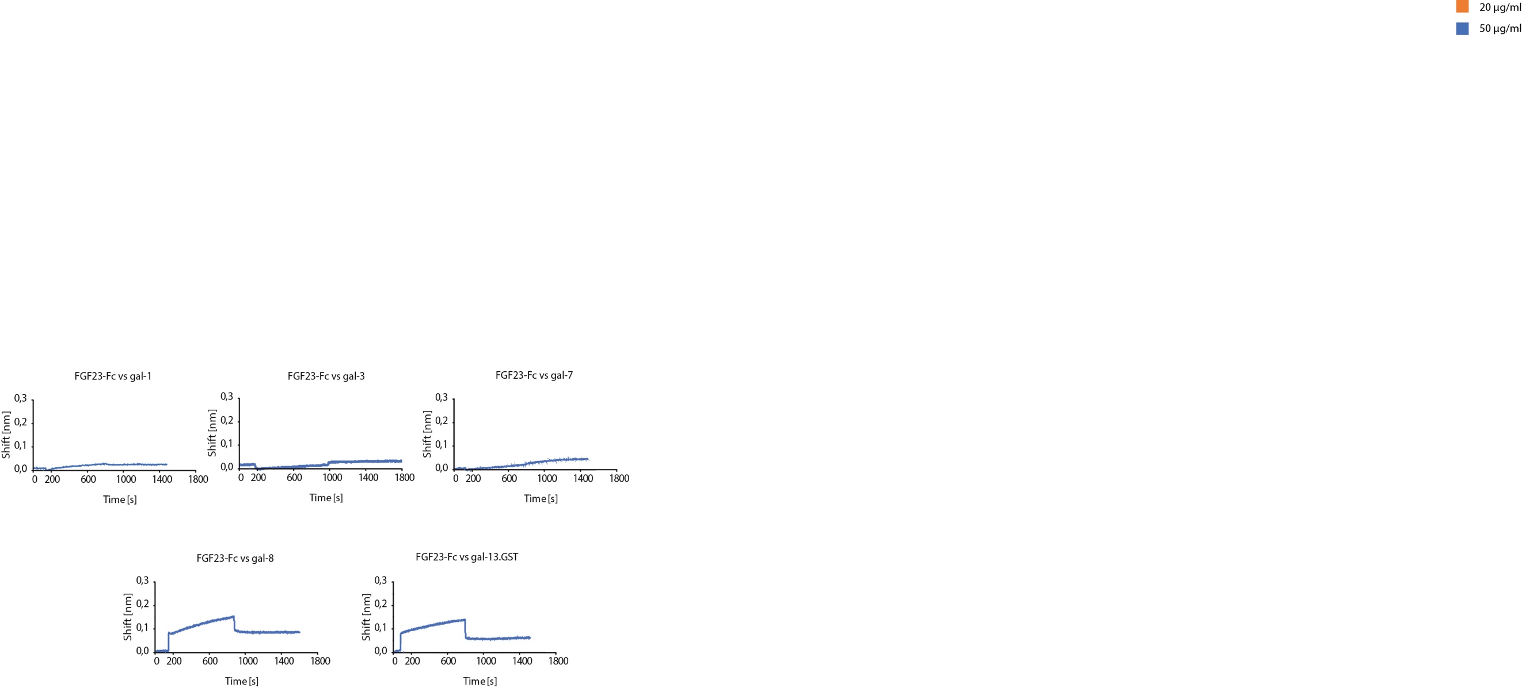

Figure S2
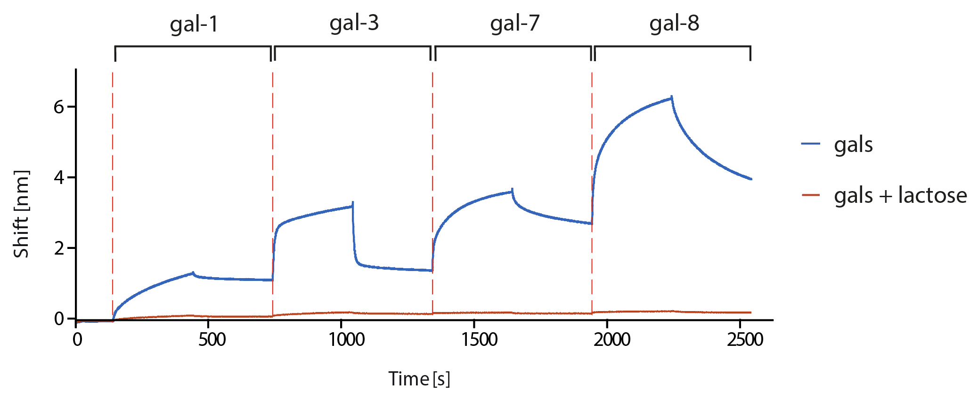

Figure S3

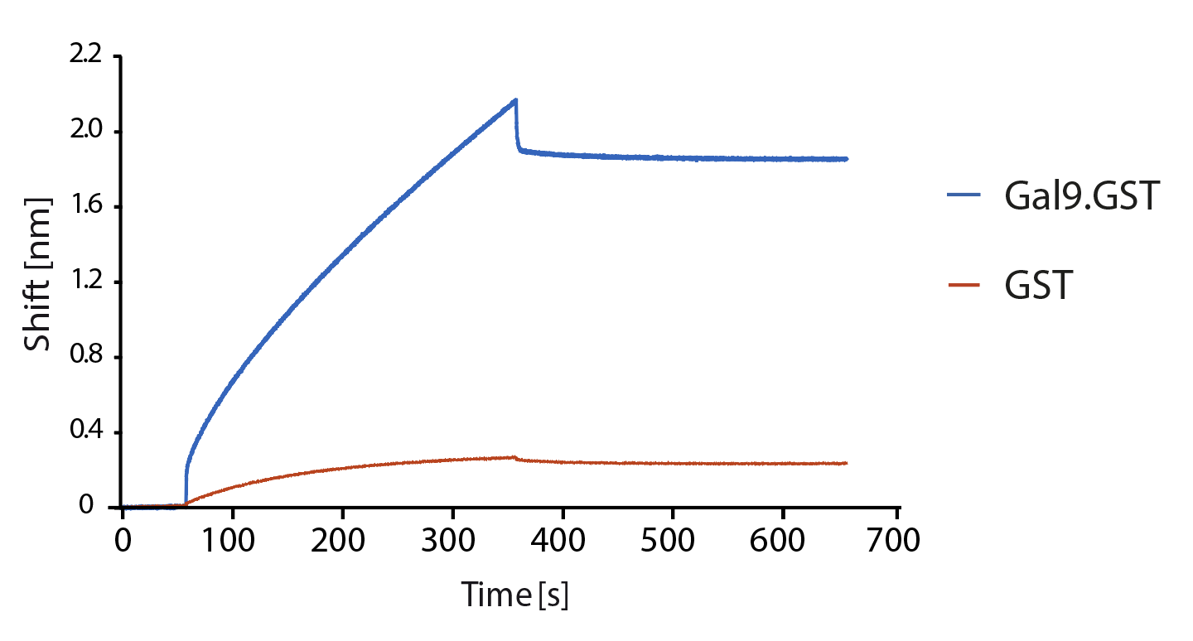

Figure S4
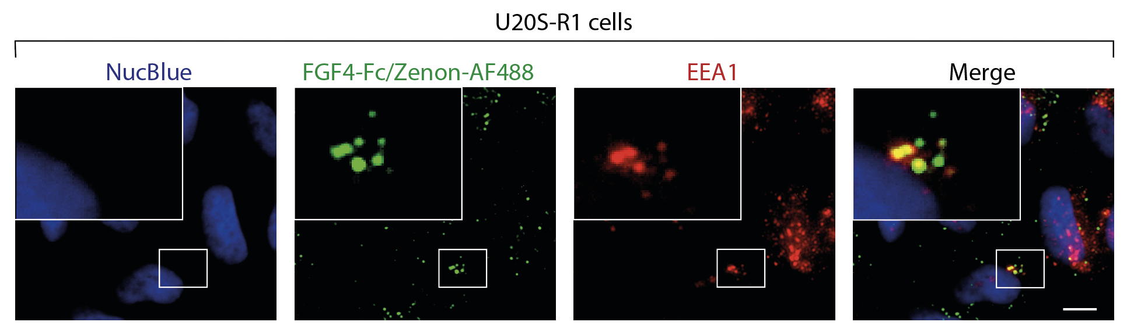

Figure S5

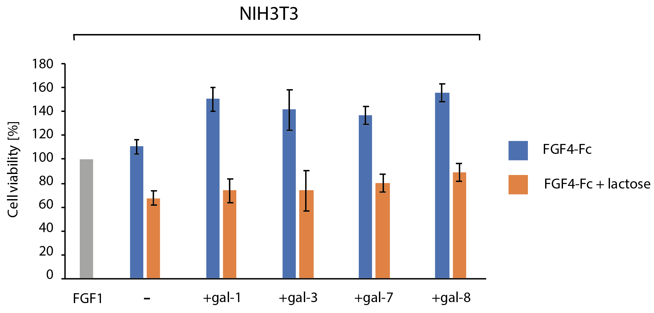

Figure S6
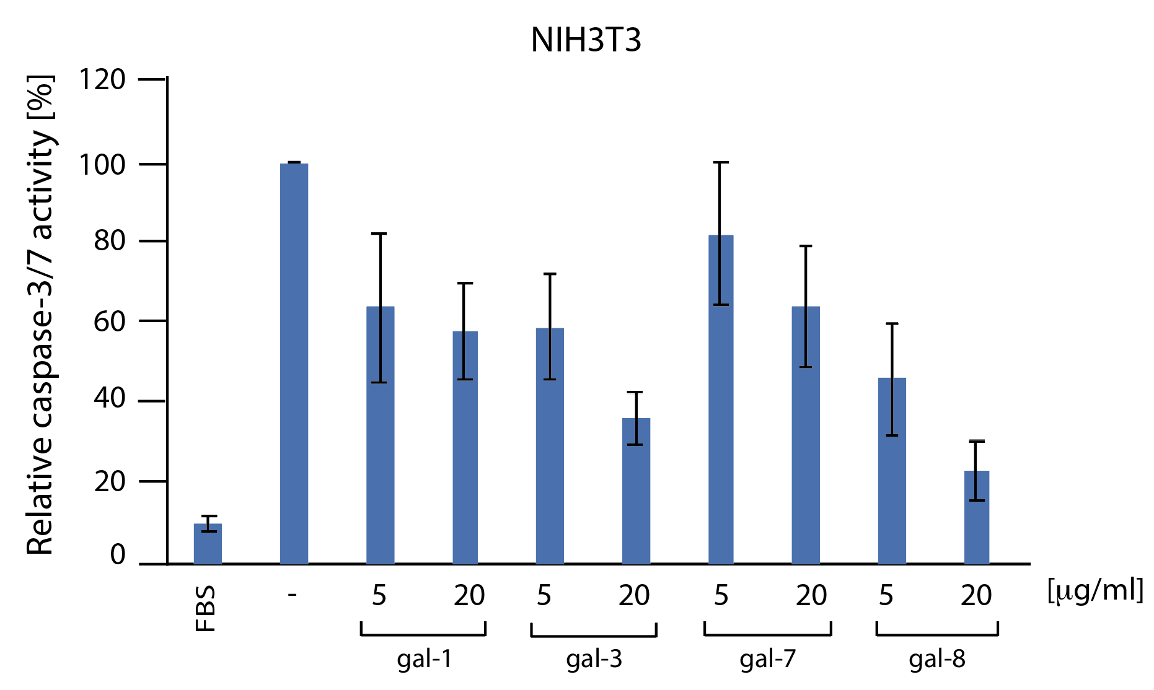

Figure S7
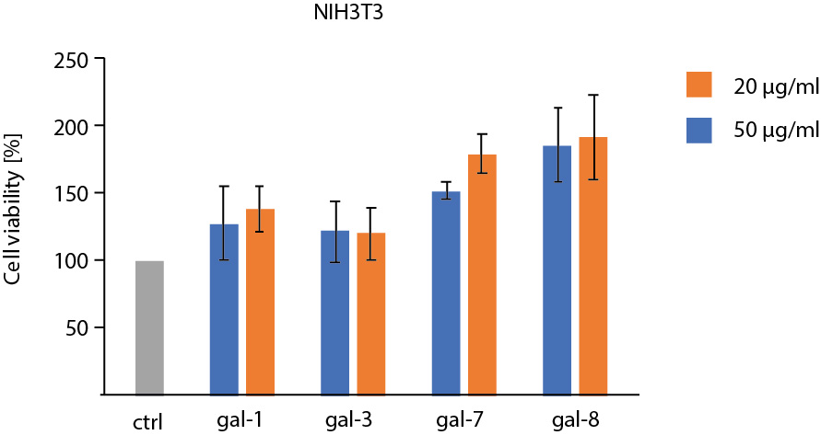

Figure S8

Table S1. Plasmids, bacterial strains and expression conditions used for production of recombinant galectins.

Protein name | Plasmid | E. coli strain | Expression conditions
Galectin-1 | pETM11 | BL21 CodonPlus (DE3)-RIL | LB media, 37°C, 4h
Galectin-2 | pDEST17 | BL21 (DE3)-pLysS | LB media,16°C, ON
Galectin-2.GST | pDEST15 | BL21 (DE3)-pLysS | LB media,16°C, ON
Galectin-3 | pETM11 | BL21 CodonPlus (DE3)-RIL | LB media, 37°C, 4h
Galectin-4.GST | pDEST15 | BL21 CodonPlus (DE3)-RIL | LB media, 25°C, ON
Galectin-7 | pDEST17 | BL21 CodonPlus (DE3)-RIL | LB media,16°C, ON
Galectin-8 | pDEST17 | BL21 CodonPlus (DE3)-RIL | LB media,16°C, ON
Galectin-9.GST | pDEST15 | BL21 CodonPlus (DE3)-RIL | LB media, 25°C, ON
Galectin-10 | pDEST17 | BL21 CodonPlus (DE3)-RIL | LB media,16°C, ON
Galectin-10.GST | pDEST15 | BL21 CodonPlus (DE3)-RIL | LB media, 25°C, ON
Galectin-13.GST | pDEST15 | BL21 CodonPlus (DE3)-RIL | LB media, 25°C, ON
Galectin-14 | pDEST17 | BL21 (DE3)-pLysS | LB media,16°C, ON
Galectin-14.GST | pDEST15 | BL21 (DE3)-pLysS | LB media,16°C, ON
Galectin-16 | pDEST17 | BL21 CodonPlus (DE3)-RIL | LB media,16°C, ON
Galectin-16.GST | pDEST15 | BL21 CodonPlus (DE3)-RIL | LB media, 25°C, ON

