Additional file 1
Fig. S1 The hematoxylin-eosin (HE) staining and the proportion of tumor-infiltrating immune cells after different treatments in lewis lung carcinoma (LLC) mouse model. (A) Representative HE staining of liver of the different treatments. Black arrow means infiltration of inflammatory cells. IgG: immunoglobulin G isotype control; PD-1: programmed death-1 (PD-1) immune-checkpoint blockade antibody; SMI: shenmai injection (SMI) monotherapy; PD-1+SMI: combination of anti-PD-1 and SMI. (B) Representative HE staining of lung in the different treatments. (C) The proportion of tumor-infiltrating CD8⁺ T, CD4⁺ T, regulatory T cells (Tregs), and B cells in the different treatments.

Fig. S2 The biochemical indices of the different treatments in LLC mouse model. Indices of ATL, AST, n = 5; others, n = 7. IgG: immunoglobulin G isotype control; PD-1: PD-1 immune-checkpoint blockade antibody; SMI: SMI monotherapy; PD-1+SMI: combination of anti-PD-1 and SMI.

Fig. S3 Representative HE staining of heart, kidney, and spleen of the different treatments in LLC mouse model. IgG: immunoglobulin G isotype control; PD-1: PD-1 immune-checkpoint blockade antibody; SMI: SMI monotherapy; PD-1+SMI: combination of anti-PD-1 and SMI.

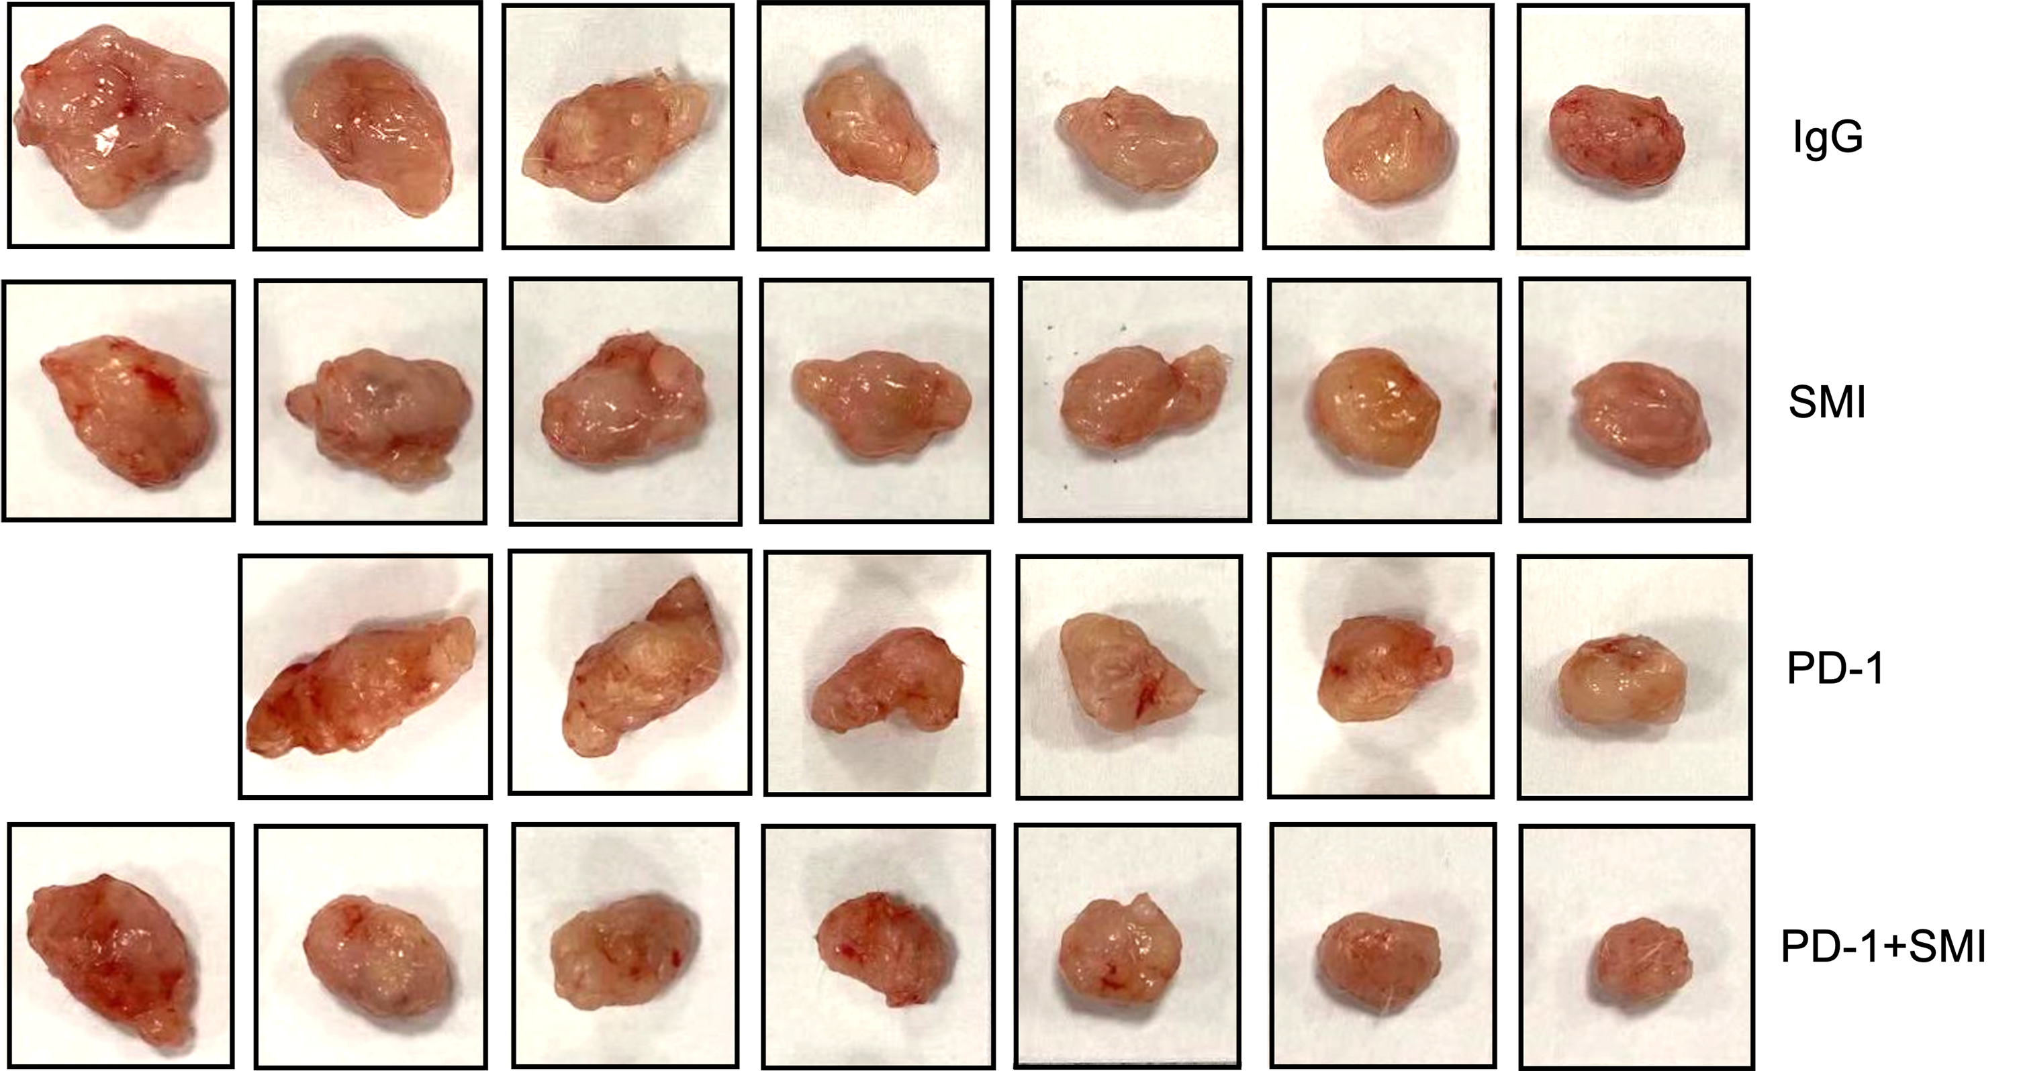
Fig. S4 Photographs of all tumors after the different treatments in the lung squamous cell carcinoma humanized mouse model. IgG: immunoglobulin G isotype control; PD-1: PD-1 immune-checkpoint blockade antibody; SMI: SMI monotherapy; PD-1+SMI: combination of anti-PD-1 and SMI. IgG, SMI, and PD-1+SMI groups, n = 7; PD-1 group, n = 6.
Fig. S5 Representative HE staining of liver of the different treatments in humanized mouse model. IgG: immunoglobulin G isotype control; PD-1: PD-1 immune-checkpoint blockade antibody; SMI: SMI monotherapy; PD-1+SMI: combination of anti-PD-1 and SMI.

Fig. S6 Representative HE staining of lung of the different treatments in humanized mouse model. IgG: immunoglobulin G isotype control; PD-1: PD-1 immune-checkpoint blockade antibody; SMI: SMI monotherapy; PD-1+SMI: combination of anti-PD-1 and SMI.

Fig. S7 The biochemical indices of the different treatments in the humanized mouse model. IgG: immunoglobulin G isotype control; PD-1: PD-1 immune-checkpoint blockade antibody; SMI: SMI monotherapy; PD-1+SMI: combination of anti-PD-1 and SMI. IgG, SMI, and PD-1+SMI groups, n = 7; PD-1 group, n = 6.
Fig. S8 Single-cell transcriptome profiles of different treatments in the humanized mouse model. (A) The expression of marker genes for eight cell types. (B) Uniform manifold approximation and projection (UMAP) projection within each sample origin. IgG: immunoglobulin G isotype control; PD-1: PD-1 immune-checkpoint blockade antibody; SMI: SMI monotherapy; PD-1+SMI: combination of anti-PD-1 and SMI.

Fig. S9 Seven subclusters of malignant epithelial cells were identified upon different treatments. (A) Dot plot showing the expression of KRT8, KRT18, and KRT19 in eight cell types. (B) Heatmap of differentially expressed genes (DEGs) among seven malignant epithelial subclusters. NEAT1⁺: NEAT1⁺ tumor cells; FOSB⁺: FOSB⁺ tumor cells; NNMT⁺: NNMT⁺ tumor cells; S100A4⁺: S100A4⁺ tumor cells; XIST⁺: XIST⁺ tumor cells; FSTL1⁺: FSTL1⁺ tumor cells; H3F3B⁺: H3F3B⁺ tumor cells. (C) Heatmap showing the expression of cancer stem cells (CSCs) genes in seven malignant epithelial subclusters. (D) Dot plot showing the expression of CD44, ALCAM, and FSTL1 in seven malignant epithelial subclusters. (E) Violin plot showing the FSTL1⁺ tumor cells had higher CSCs score compared with that in other subclusters except for NEAT1⁺ and XIST⁺ tumor cells.

Fig. S10 Transcriptome heterogeneous and dynamics in seven malignant epithelial subclusters. (A) Top 10 biological pathways of seven malignant epithelial clusters based on DEGs using Metascape analysis. NEAT1⁺: NEAT1⁺ tumor cells; FOSB⁺: FOSB⁺ tumor cells; NNMT⁺: NNMT⁺ tumor cells; S100A4⁺: S100A4⁺ tumor cells; XIST⁺: XIST⁺ tumor cells; FSTL1⁺: FSTL1⁺ tumor cells; H3F3B⁺: H3F3B⁺ tumor cells. (B) Unsupervised transcriptional trajectory of seven malignant epithelial subsets predicted by Monocle 3. (C) High level of FOSB⁺ tumor cell-associated genes (FSTL3 and VTN), NEAT1⁺ tumor cell-associated genes (PAPPA, CCN1, and RRAD), and XIST⁺ tumor cell-associated genes (GPRIN3) predicted poor prognosis in TCGA-LUSC.htseq_counts.tsv (n = 550 samples), whereas high level of NNMT⁺ tumor cell-associated genes (ERH) exhibited higher overall survival. Log-rank P < 0.05 was considered as statistically significant.

Fig. S11 The top 10 Transcription factors (TFs) in each malignant epithelial subcluster were inferred using SCENIC analysis. NEAT1⁺: NEAT1⁺ tumor cells; FOSB⁺: FOSB⁺ tumor cells; NNMT⁺: NNMT⁺ tumor cells; S100A4⁺: S100A4⁺ tumor cells; XIST⁺: XIST⁺ tumor cells; FSTL1⁺: FSTL1⁺ tumor cells; H3F3B⁺: H3F3B⁺ tumor cells.

Fig. S12 Single-cell transcriptome profiles of NK and T cells. (A) Heatmap of DEGs among four NK cell subclusters. (B) Dot plot showing expression of PDCD1, TIGIT, CTLA4, LAG3, and HAVCR2 in four NK clusters. (C) Dot plot showing expression of FASLG, TNFSF10, and FLT3LG in GZMA^{high} NK, HLA-DRB1^{high} NK, XCL1^{high} NK clusters. (D) Dot plot showing expression of GZMA and CMC1 in four different treatments. IgG: immunoglobulin G isotype control; PD-1: PD-1 immune-checkpoint blockade antibody; SMI: SMI monotherapy; PD-1+SMI: combination of anti-PD-1 and SMI. (E) Heatmap of T cell respective markers among thirteen T cell subclusters. (F) Dot plot showing expression of FOXP3, IL2RA, and IKZF2 in four different treatments of Tregs. (G) Heatmap showing express of CCR6 and RORC among thirteen T cell subclusters. (H) Top biological pathways of KLRB1⁺ CD4⁺ T helper 17-like T cells (KLRB1⁺ Th17-like CD4⁺ T cells) based on DEGs using Metascape analysis. (I) Violin plot showing the mean score of the cytotoxic or exhausted signature across four different treatments in T and NK cells. ***P < 0.001, ****P < 0.0001.

Fig. S13 Single-cell transcriptome profiles of myeloid cells. (A) Heatmap of DEGs among macrophages, monocytes, classical DCs, and plasmacytoid DCs (pDCs). (B) Violin plot showing expression of ITGAE, ITGAM, and ICOSLG in classical DCs and pDCs. (C) Heatmap of DEGs among six macrophages subclusters. (D) Heatmap describing the expression of M1 and M2 feature genes in six macrophage subclusters. (E) Dot plot showing expression of CD33, CD14, ITGAM, HLA-DRA, and HLA-DRB1 in myeloid subclusters. (F) Chord diagram showing the ligand-receptor pair FTL3-FTL3LG involved in GZMA^{high} NK cells and DCs and between XCL1^{high} NK cells and DCs, and the ligand-receptor pair CD40-CD40LG involved in DCs and CD69⁺ CD4⁺ T_{RM}, KLRB1⁺ CD4⁺ Th17-like T, and SELL⁺ CD4⁺ T_{N} cells.

Fig. S14 Single-cell transcriptome profiles of fibroblast and endothelial cells. (A) Heatmap of DEGs among fibroblast sublcusters. (B) Top biological pathways of based on DEGs of ACTA2⁺ myofibroblasts from the PD-1+SMI group using Metascape analysis. (C) Heatmap of DEGs among endothelial sublcusters.

