Original, uncropped blots for Figure 2 b:
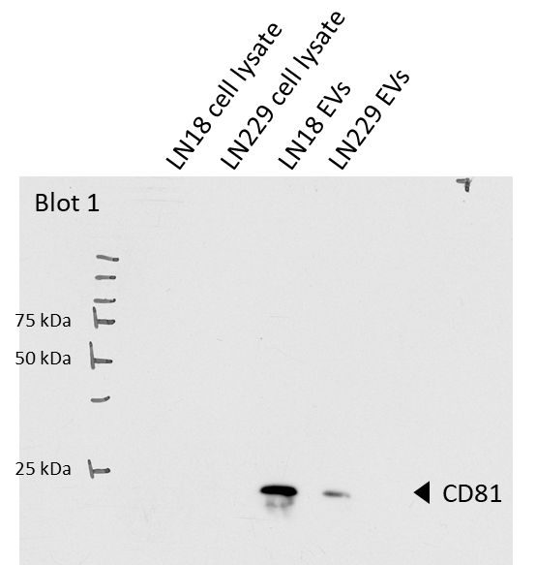
Blot 1.1: Original blot and staining of bands shown for CD81 in LN18 and LN229 EVs, exposure time: 5 s.
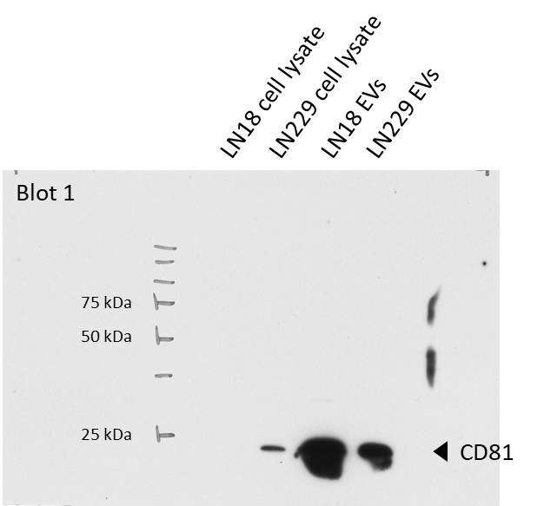
Blot 1.2: Original blot and staining of bands shown for CD81 in LN18 and LN229 cell lysates, exposure time: 2 min.

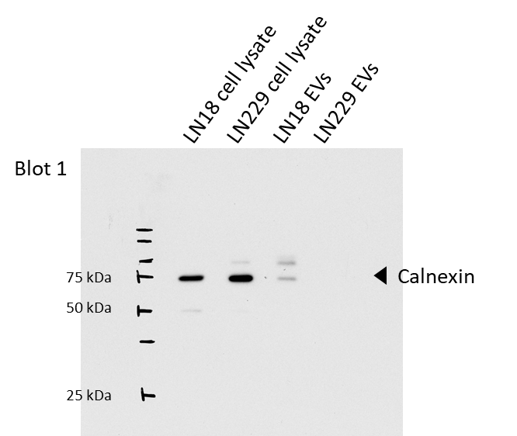
Blot 1.3: Original blot and staining of bands shown for Calnexin in LN18 and LN229 cell lysates and EVs, exposure time: 5 s.

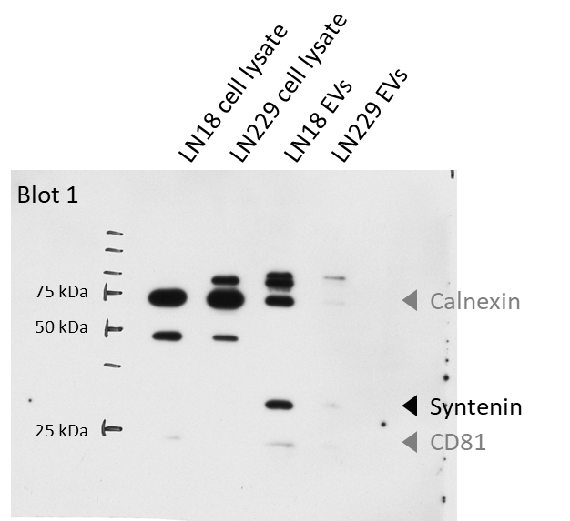
Blot 1.4: Original blot and staining of bands shown for Syntenin in LN18 and LN229 cell lysates and EVs, exposure time: 2 min.

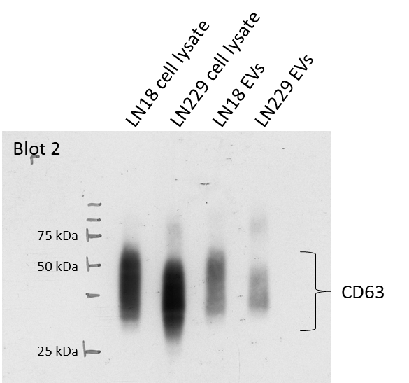
Blot 2.1: Original blot and staining of bands shown for CD63 in LN18 and LN229 cell lysates and EVs, exposure time: 5 s.

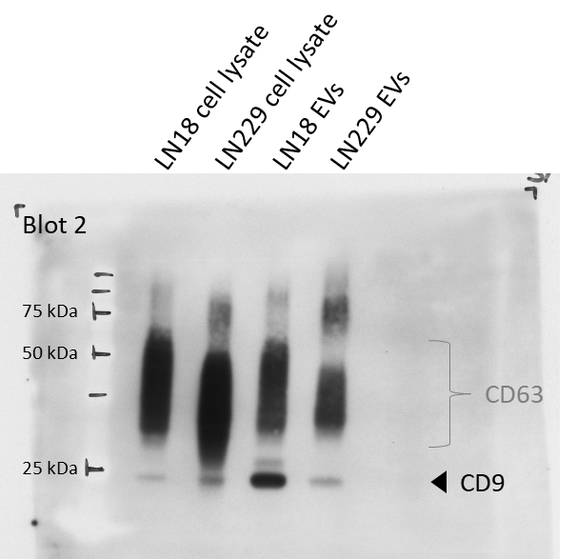
Blot 2.2: Original blot and staining of bands shown for CD9 in LN18 and LN229 cell lysates and EVs, exposure time: 3 s.

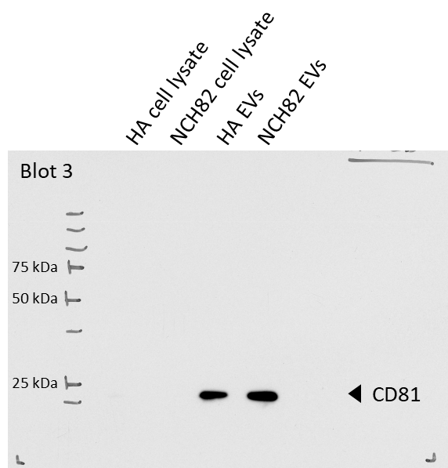
Blot 3.1: Original blot and staining of bands shown for CD81 in HA and NCH82 EVs, exposure time: 5 s.
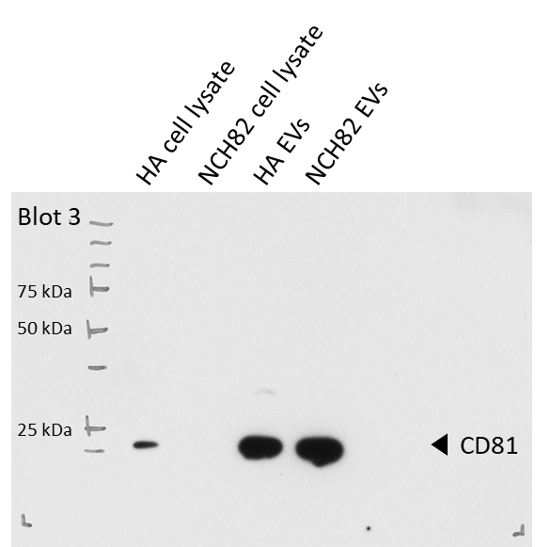
Blot 3.2: Original blot and staining of bands shown for CD81 in HA and NCH82 cell lysates, exposure time: 2 min.
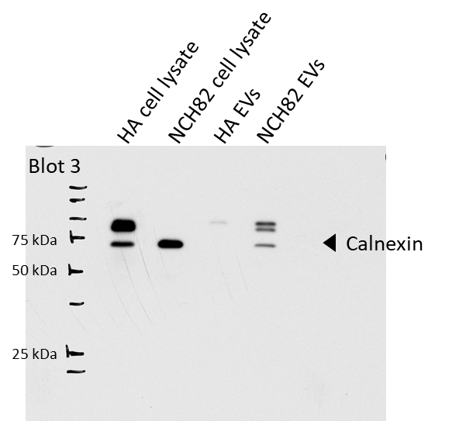
Blot 3.3: Original blot and staining of bands shown for Calnexin in HA and NCH82 cell lysates and EVs, exposure time: 10 s.
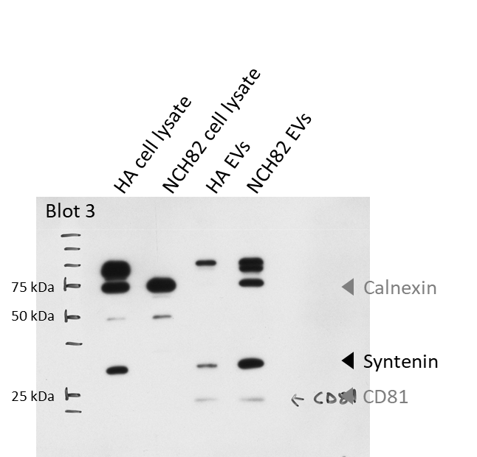
Blot 3.4: Original blot and staining of bands shown for Syntenin in HA and NCH82 cell lysates and EVs, exposure time: 2 min
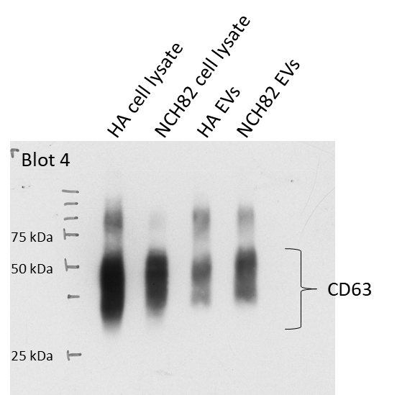
Blot 4.1: Original blot and staining of bands shown for CD63 in HA and NCH82 cell lysates and EVs, exposure time: 5 s.
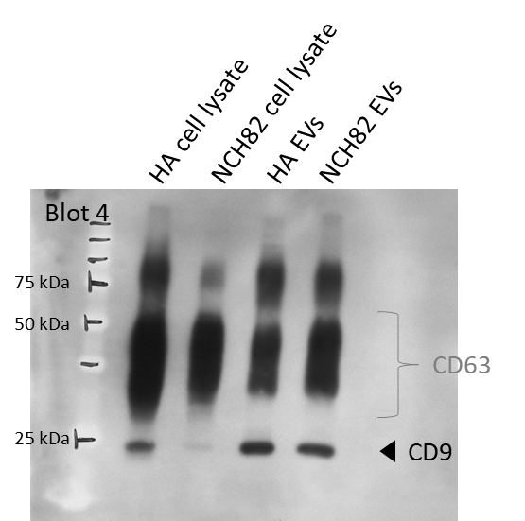
Blot 4.2: Original blot and staining of bands shown for CD9 in HA and NCH82 cell lysates and EVs, exposure time: 5 s.

