Supplementary Data
NAT10 mediated ac4C acetylation driven m⁶A modification via involvement of YTHDC1-LDHA/PFKM regulates glycolysis and promotes osteosarcoma

Zhongting Mei^{2*}, Zhihua Shen^{3,5*}, Jiaying Pu^{3,5*}, Qian Liu², Guoxin Liu², Xuting He^{3,5}, Yang Wang^{3,5}, Jinrui Yue^{3,5}, Shiyu Ge², Tao Li², Ye Yuan^{3,4,5}, Lei Yang^{1,6,7}

Correspondence to:
Prof. Lei Yang, Department of Orthopedics, The First Affiliated Hospital of Harbin Medical University, Harbin 150001; yangray83@vip.qq.com;
Dr. Ye Yuan, Department of Pharmacy (The University Key Laboratory of Drug Research, Heilongjiang Province), The Second Affiliated Hospital of Harbin Medical University, Harbin, China; yuanye_hmu@126.com;

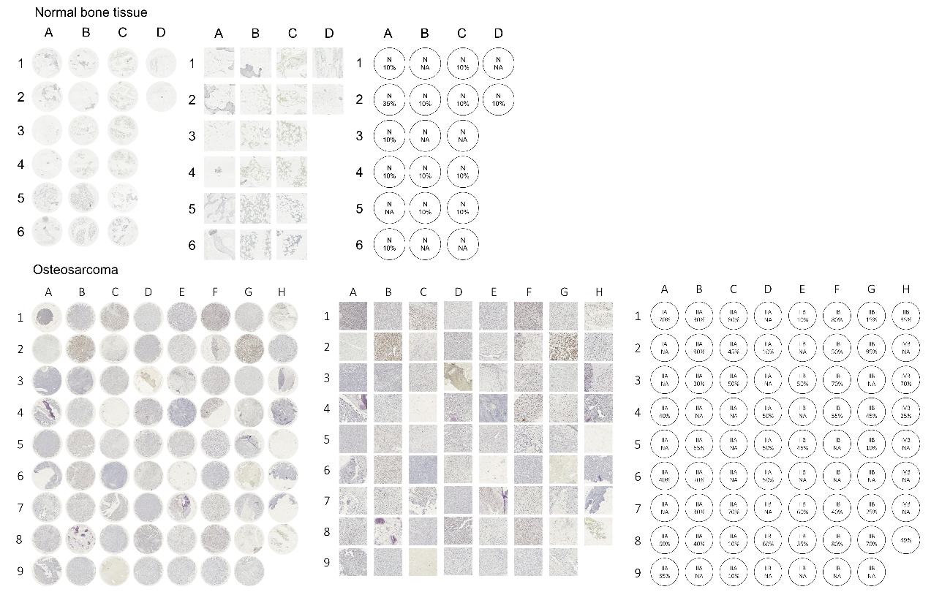

Supplementary Figure 1.

Immunohistochemistry (IHC) analysis of NAT10 protein expression in normal bone tissues (n=20) and osteosarcoma (n=71) tissue microarrays (TMAs).
B
A
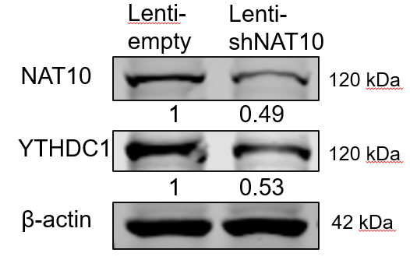
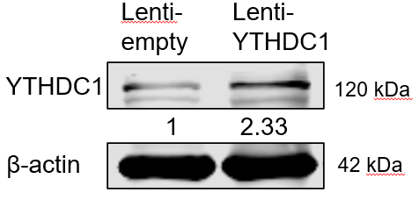

Supplementary Figure 2.

A The 143B cells were transfected with lentiviral vectors containing either empty or shNAT10 for 48 h. The protein levels of NAT10 and YTHDC1 were evaluated by western blotting. B The 143B cells were transfected with lentiviral vectors containing either empty or YTHDC1 for 48 h. The overexpression efficiency of YTHDC1 was evaluated by western blotting.

Supplementary Table 1. Primer sequences for qRT-PCR
Primers | Primer sequences (5'-3')
Human-GLUT1 | F-GAAGTAGGTGAAGATGAAGAACAGAAC  R-CATCCCATGGTTCATCGTGGCTGAACT
Human-PFKM | F-ATTGTGCCAGCATCTTCAGCATGAG  R-GGAGAAGCTGCGCGAGGTTTAC
Human-GAPDH | F- CAAAGGTGGAGGAGTGGGTGTCGC  R-TTCCGTGTCCCCACTGCCAACGT
Human-PGK1 | F-GCGGAGGTTCTCCAGCA  R-ATGTCGCTTTCTAACAAGCTGA
Human-PGM1 | F-TTCCATGGCTTTGCGCACCGTCT  R-GGAAACGTGTACTGATTGCAGCCC
Human-ENO1 | F-GGTCATCGGGAGACTTGAA  R-GACTTGGCTGGCAACTCTG
Human-ENO2 | F-ATGTCCGGCAAAGCGAGCTTCATC  R-TCATGGTGAGTCATCGCTCAGGAG
Human-PKM2 | F-TGGTGAGGACGATTATGGCCC  R-GCCCGTGAGGCAGAGGCTGC
Human-LDHA | F-GCAACTTGCAGTTCGGGC  R-ATGGCAACTCTAAAGGATCA
Human-HK2 | F-GTGAGGATGTAGCTTGTAGAGGGTCCC  R-GCCATCCTGCAACACTTAGGGCTTGAG
Human-PFKM | F-ATTGTGCCAGCATCTTCAGCATGAG  R-GGAGAAGCTGCGCGAGGTTTAC
Human-PGAM1 | F-TTCCATGGCTTTGCGCACCGTCT  R-GGAAACGTGTACTGATTGCAGCCC
Human-YTHDC1 | F-AACTGGTTTCTAAGCCACTGAGC  R-GGAGGCACTACTTGATAGACGA
18S | F-CCTGGATACCGCAGCTAGGA  R-GCGGCGCAATACGAATGCCC

