The raw western blotting images:

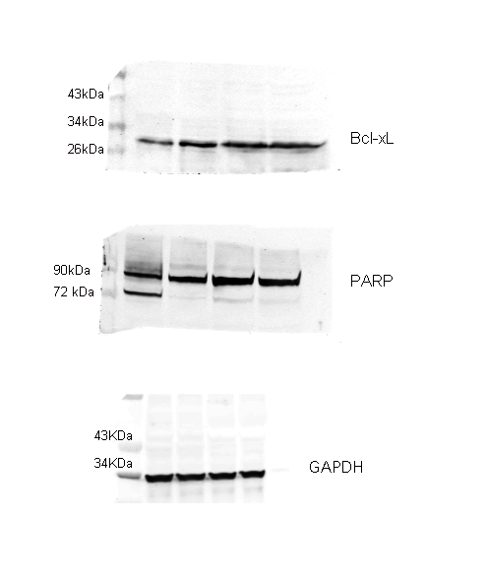
Figure 1 (C) TF-1(WT) and TF-1(R140Q) cells were cultured in the absence or presence of 5 ng/mL GM-CSF for 24h, and PARP and Bcl-xL expression levels were analyzed by western blotting. GAPDH was used as a loading control.

Figure 2 (A) TF-1(WT) and TF-1(R140Q) cells were cultured in the absence or presence of 5 ng/mL GM-CSF for 24h and subjected to western blotting for detection of the indicated proteins. β-Actin was used as a loading control.

Figure 3 (A) TF-1(R140Q) cells were treated with AGI6780 for 2 days and subjected to western blotting for detection of the indicated proteins. GAPDH was used as a loading control.

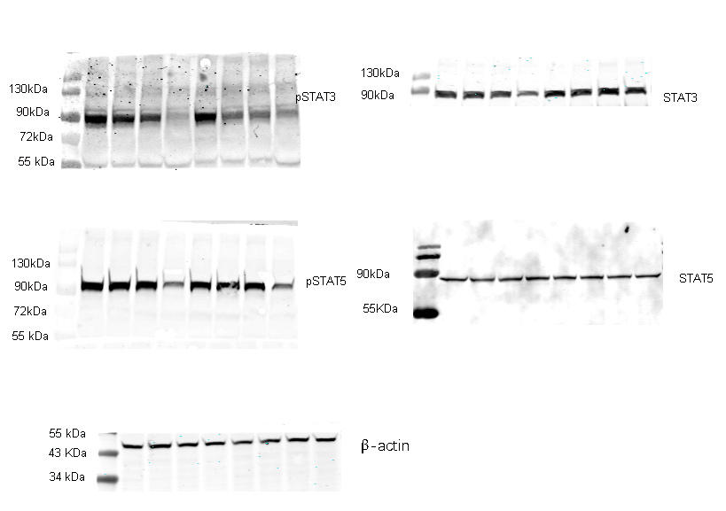
Figure 4 (A) TF-1(R140Q) cells were treated with C188-9 or NSC74859 for 24 h and subjected to western blotting for detection of the indicated proteins. β-Actin was used as a loading control.

