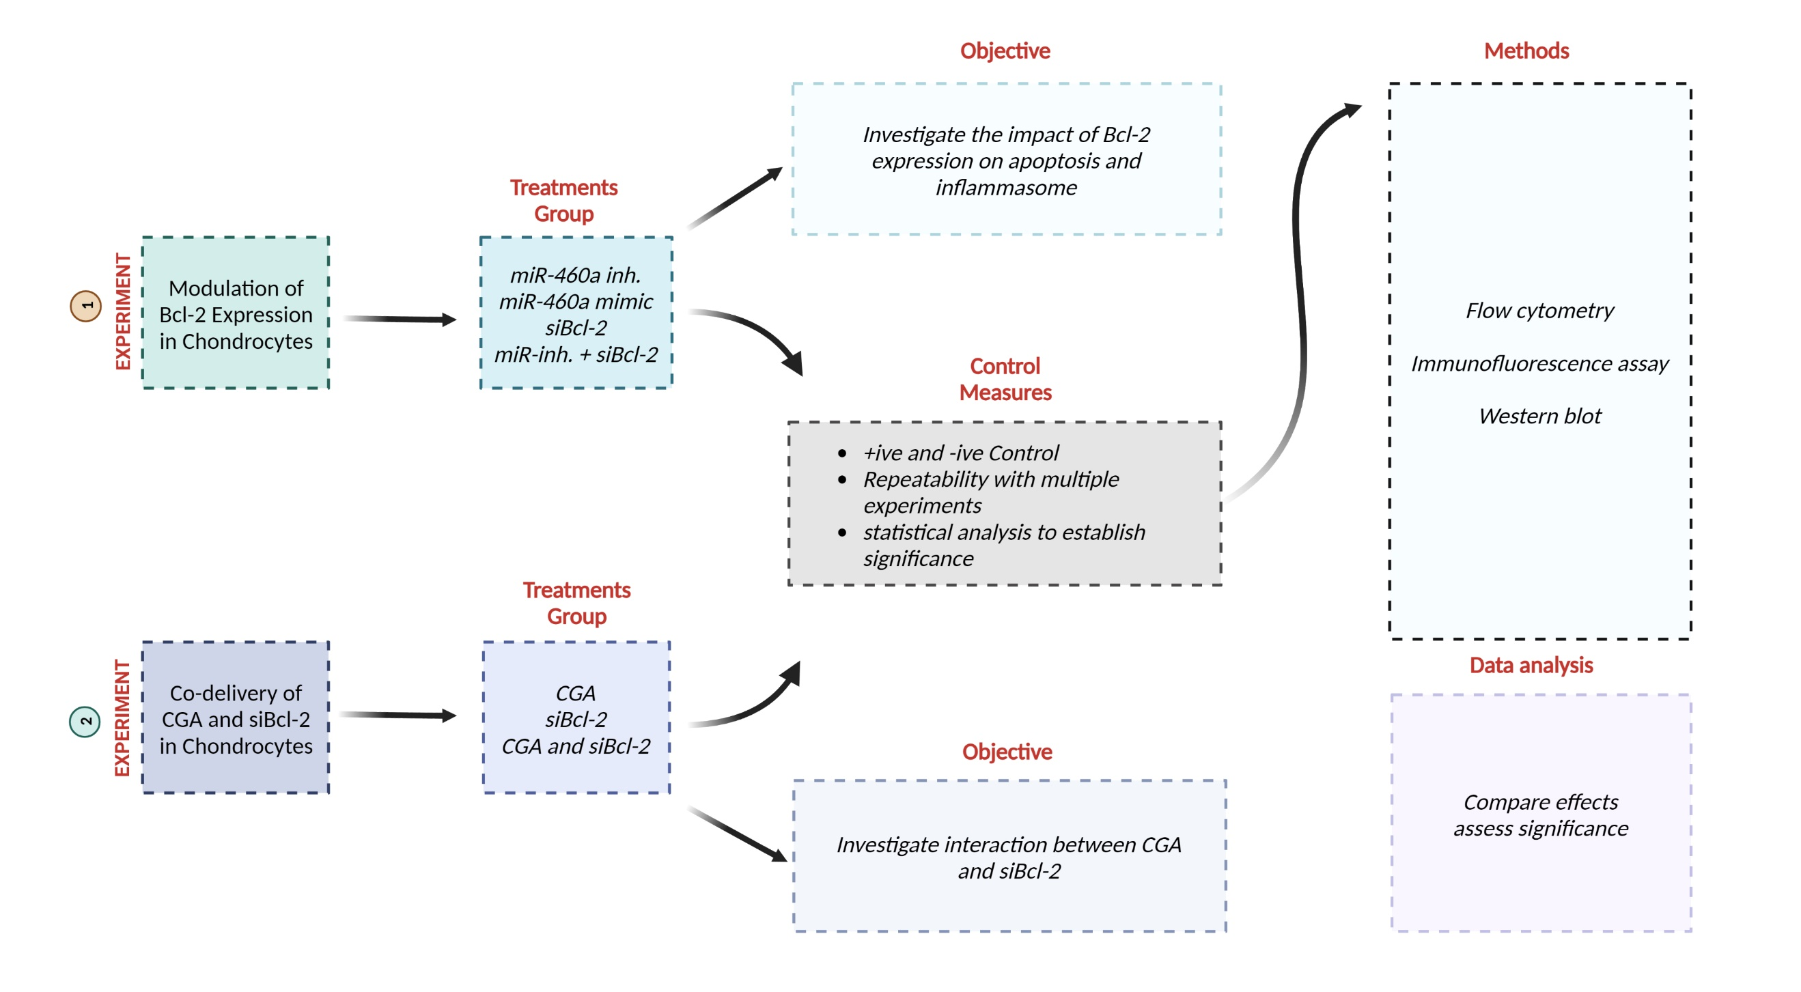
Supplementary Figure. 1 The research layout of in vitro experiment for investigating Bcl-2 role in Apoptosis and inflammasome activation.

Supplementary Table 1: Primers used in this study.
Gene | Forward Primer Sequence (5′ to 3′) | Reverse Primer Sequence (5′ to 3′)
miR-460a | GTATACTTAGAAATGCAAATT | GTGCAGGGTCCGAGGT
Collagen | GCCCTTCTCACGACCACCAT | GGCTCCGTTGACCTCCCATA
Aggrecan | CTGGCTGCAAGAGAGACC | GCCCTCCTATTTCCCCCT
Bcl-2 | GCAGGCAGCTTGAAAGAAAC | GCTGGCCTTTCATGACTCTC
Bcl.xL | CATCGTGGCTTTCTTCTCCTT | CAGCGTTGTTCCCATACAGA
Cyto C | TTCCCAGTGCCATACGGTTG | GCTTGTCCTGTTTTGCGTCC
Bax | GTGATGGCATGGGACATAGCTC | TGGCGTAGACCTTGCGGATAA
Bak | ACCCGGAGATCATGGAGA | GATGCCTTGCTGGTAGACG
Caspase-3 | TGGCGATGAAGGACTCTTCT | TCATCTGGTCCACTGTCTGC
Caspase-7 | CTGGCTGTTTCTCTGCCC | GTGGATGGAACGCACTGG
NLRP3 | GGTTCCCTTCCCCTCACT | CTCGGGTAGGCTGGAGTT
IL-1β | CACACGAAGCTCGGACAC | GAGATGGCGTTCGTTCCC
GAPDH | GCCCAGAACATCATCCCA | CGGCAGGTCAGGTCAACA
U6 | AAGTGTGTGAGGAGAGGCCC | CCGGGGGCGCCACAT

Supplementary Table. 2 Sequences for siRNA-BCL2
siRNA-BCL2 | Sense | 5’- GGAGAAGAGGCUACGACAATT-3’
siRNA-BCL2 | Antisense | 5’- UUGUCGUAGCCUCUUCUCCTT-3’
siRNA-NC | Sense | 5’- UUCUCCGAACGUGUCACGUTT-3’
siRNA-NC | Antisense | 5’- ACGUGACACGUUCGGAGAATT-3’

