Systematic assessment of chemokine ligand bias at the human chemokine receptor CXCR2 indicates G protein bias over β-arrestin recruitment and receptor internalization

Katrijn Boon¹, Nathan Vanalken¹, Martyna Szpakowska², Andy Chevigné², Dominique Schols¹, Tom Van Loy¹*
¹KU Leuven, Department of Microbiology, Immunology and Transplantation, Rega Institute for Medical Research, Laboratory of Virology and Chemotherapy, B-3000 Leuven, Belgium.
²Department of Infection and Immunity, Immuno-Pharmacology and Interactomics, Luxembourg Institute of Health (LIH), Esch-sur-Alzette, Luxembourg
*corresponding author

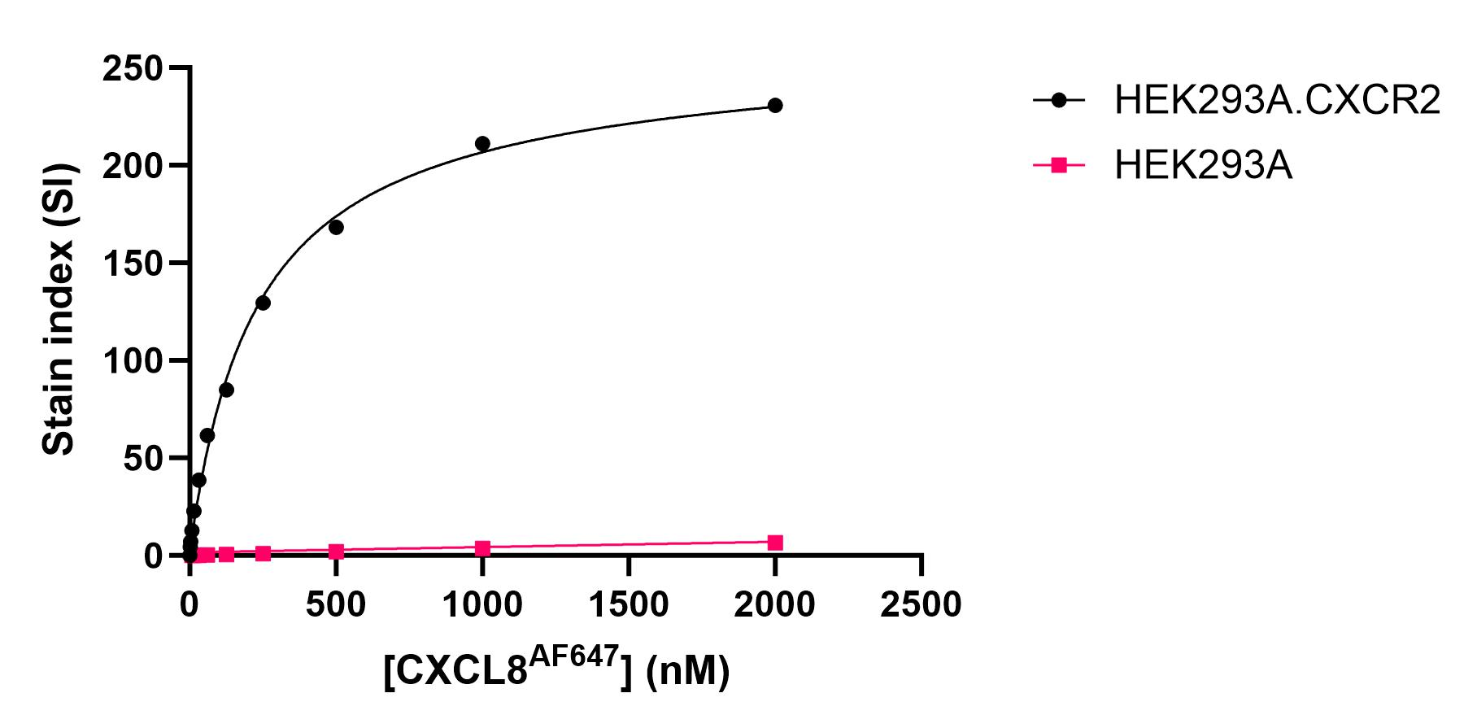
Figure S1: CXCL8^{AF647} titration. Concentration-response curves showing CXCL8^{AF647} binding towards HEK293A.CXCR2 cells and HEK293A.WT cells. Kd value was determined by fitting the curve to One Site- Total and non-specific binding in GraphPad V9.3.1 (GraphPad Software, San Diego, CA, USA). Data represents the mean stain index (SI).

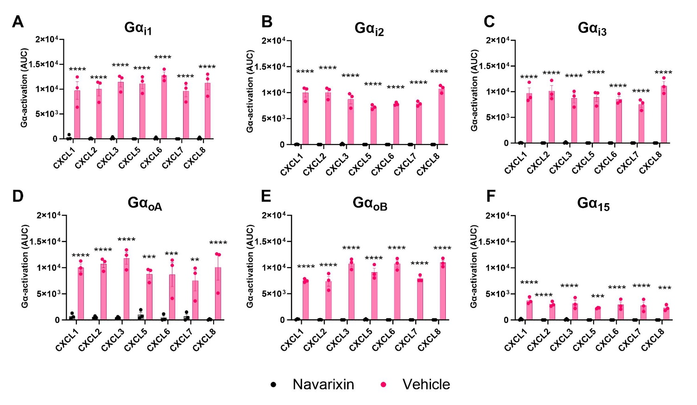
Figure S2: G protein activation by CXCR2 upon stimulation with its endogenous chemokine ligands pre-treated with CXCR2 inhibitor or vehicle. BRET signals were measured in real-time in HEK293.CXCR2 cells transfected with a REGA-SIGN donor-acceptor pair, upon stimulation with CXCL1,-2,-3,-5,-6, 7, or CXCL8 (EC₈₀), in presence or absence of navarixin. Results are expressed as G protein activation using baseline-corrected Neg AUC as a read-out. Data represents the mean ± SEM of three independent experiments. Statistical significance compared to the navarixin response was calculated with two-way ANOVA followed by a Dunnet’s test: **** (P<0.0001), ***(P<0.001), **(P<0.01)

