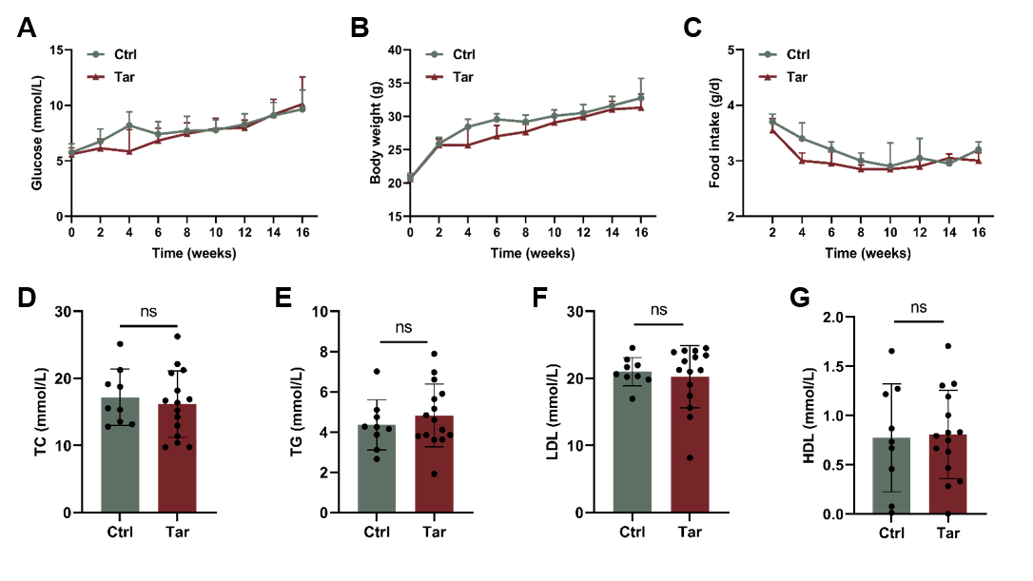
Supplement Figure 1. Baseline characteristics of mice.
ApoE^{-/-} mice were fed with high-fat diet and injected intraperitoneally with or without cigarette tar (40 mg/kg/day) for 16 weeks. A. Blood glucose of mice. B. The body weight of mice. C. Food intake of mice. D-E. Cholesterol and triglycerides levels of mice. F-G. LDL and HDL levels of mice. Data were expressed as mean ± SD. ^{ns}p >0.05.

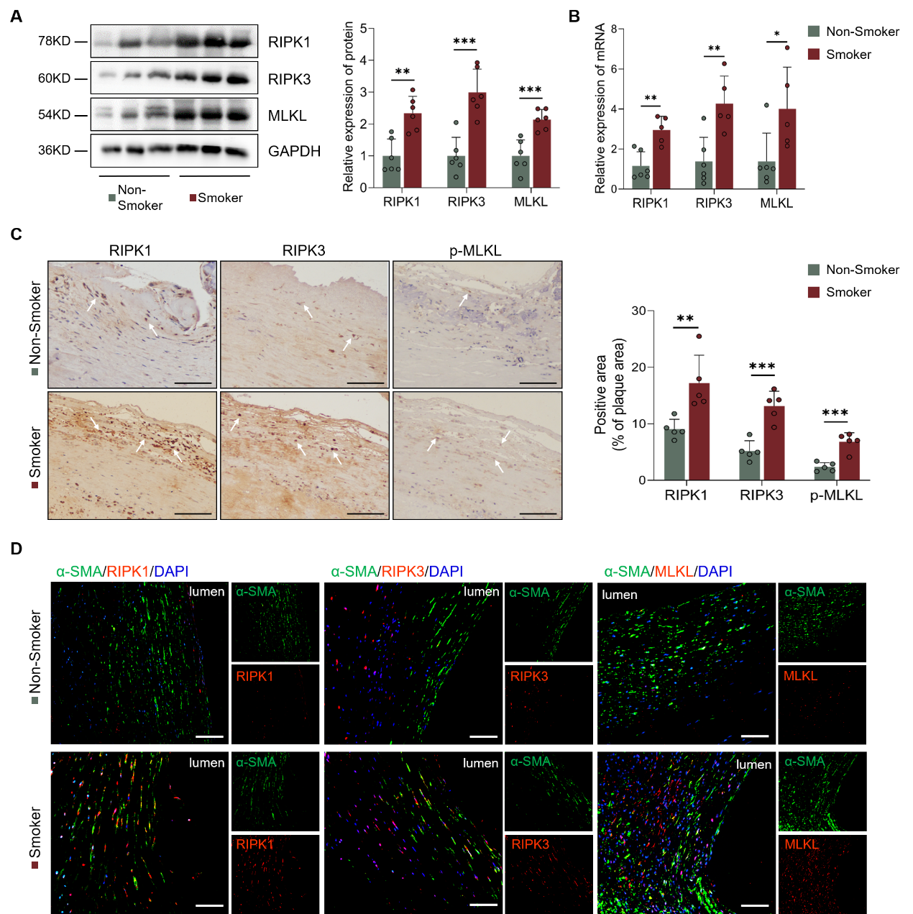
Supplement Figure 2. Necroptosis is activated in the atherosclerotic plaque of smokers.
A. Representative immunoblots of necroptotic proteins (RIPK1, RIPK3, MLKL) and quantified protein levels in carotid plaques from smokers and non-smokers with atherosclerosis. n=6. B. The mRNA expression levels of RIPK1, RIPK3, and MLKL in carotid plaques with atherosclerosis. n=5-6. C. Representative images and quantification of RIPK1, RIPK3, and p-MLKL staining on human carotid plaques with atherosclerosis. Scale bar: 100 μm. n=5. D. Immunofluorescent staining to detect the co-localization of α-SMA and RIPK1, RIPK3, MLKL in human carotid plaques. Scale bar: 100 μm. n=5. Data were expressed as mean ± SD. *p < 0.05, **p < 0.01, ***p < 0.001.

Supplement Figure 3. Nec-1 or GSK872 reversed the cell viability decreased by tar.
VSMCs were pretreated with Nec-1 (10 μM), GSK872 (10 μM), zVAD (10 μM), VX765 (10 μM), and Fer1 (5 μM) respectively, then treated with tar (100 μg/ml) for 12 hr. The graph showed the relative cell viability detected by the CCK8 kit. n=3. Data were expressed as mean ± SD. ***p < 0.001, compared with the Ctrl group; #p < 0.05, ^{ns}p > 0.05, compared with the Tar group.

Supplement Figure 4. RIPK3 deletion decreased the expression of RIPK1 and MLKL in VSMCs.
A-D. Immunofluorescent staining images and quantification of the co-localization of α-SMA and RIPK1, RIPK3, MLKL in aortic roots of mice. Scale bar: 100 μm. n=8. Data were expressed as mean ± SD. ***p < 0.001.

