Supplementary Table S2. Detailed information of tissue array.
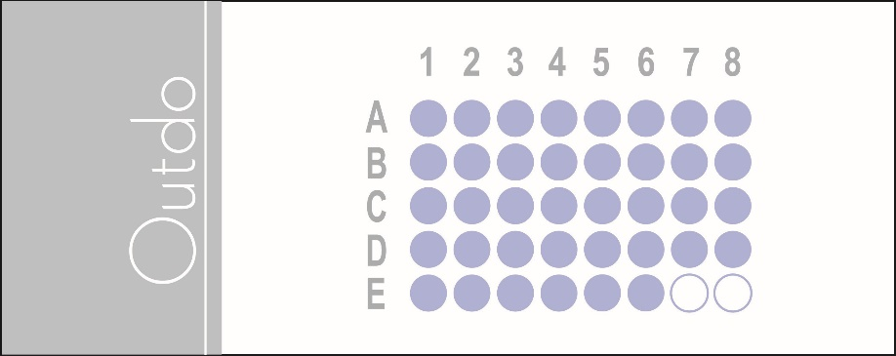
Position | Gender | Age | Pathological type | Pathological stage
(A,1) | male | 64 | Hepatocellular carcinoma | Ⅰ
(A,2) | female | 59 | Hepatocellular carcinoma | Ⅰ
(A,3) | male | 42 | Hepatocellular carcinoma | Ⅰ-Ⅱ
(A,4) | male | 48 | Hepatocellular carcinoma | Ⅰ-Ⅱ
(A,5) | male | 37 | Hepatocellular carcinoma | Ⅰ-Ⅱ
(A,6) | male | 56 | Hepatocellular carcinoma | Ⅰ-Ⅱ
(A,7) | male | 54 | Hepatocellular carcinoma | Ⅰ-Ⅱ
(A,8) | female | 57 | Hepatocellular carcinoma | Ⅰ-Ⅱ
(B,1) | male | 45 | Hepatocellular carcinoma | Ⅰ-Ⅱ
(B,2) | male | 43 | Hepatocellular carcinoma | Ⅰ-Ⅱ
(B,3) | male | 58 | Hepatocellular carcinoma | Ⅰ-Ⅱ
(B,4) | male | 61 | Hepatocellular carcinoma | Ⅰ-Ⅱ
(B,5) | male | 63 | Hepatocellular carcinoma | Ⅰ-Ⅱ
(B,6) | female | 19 | Hepatocellular carcinoma | Ⅱ
(B,7) | male | 39 | Hepatocellular carcinoma | Ⅱ
(B,8) | male | 77 | Hepatocellular carcinoma | Ⅱ
(C,1) | male | 71 | Hepatocellular carcinoma | Ⅱ
(C,2) | male | 53 | Hepatocellular carcinoma | Ⅱ
(C,3) | male | 72 | Hepatocellular carcinoma | Ⅱ
(C,4) | male | 50 | Hepatocellular carcinoma | Ⅱ
(C,5) | male | 48 | Hepatocellular carcinoma | Ⅱ
(C,6) | male | 52 | Hepatocellular carcinoma | Ⅱ
(C,7) | female | 63 | Hepatocellular carcinoma | Ⅱ
(C,8) | male | 50 | Hepatocellular carcinoma | Ⅱ
(D,1) | female | 58 | Hepatocellular carcinoma | Ⅱ
(D,2) | male | 39 | Hepatocellular carcinoma | Ⅱ
(D,3) | male | 41 | Hepatocellular carcinoma | Ⅱ-Ⅲ
(D,4) | female | 38 | Hepatocellular carcinoma | Ⅱ-Ⅲ
(D,5) | male | 51 | Hepatocellular carcinoma | Ⅱ-Ⅲ
(D,6) | male | 49 | Hepatocellular carcinoma | Ⅱ-Ⅲ
(D,7) | male | 32 | Hepatocellular carcinoma | Ⅱ-Ⅲ
(D,8) | male | 55 | Hepatocellular carcinoma | Ⅱ-Ⅲ
(E,1) | male | 31 | Hepatocellular carcinoma | Ⅲ
(E,2) | male | 60 | Hepatocellular carcinoma | Ⅲ
(E,3) | male | 40 | Hepatocellular carcinoma | Ⅲ
(E,4) | male | 38 | Hepatocellular carcinoma | Ⅲ
(E,5) | male | 36 | Hepatocellular carcinoma | Ⅲ
(E,6) | male | 71 | Hepatocellular carcinoma | Ⅲ

