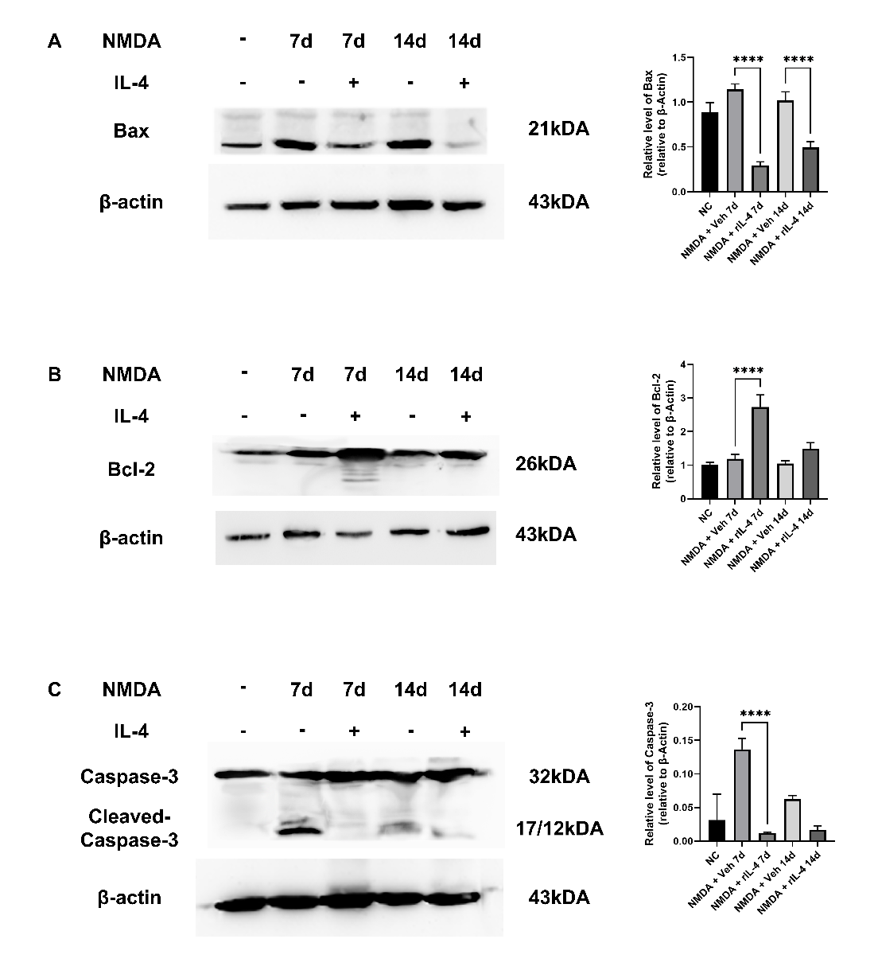 Figure S1. Western blot analysis revealed that the administration of exogenous recombinant IL-4 protein (rIL-4) significantly upregulated the expression of Bcl-2, while concurrently suppressing the levels of BAX and Caspase-3 in the retina of the NMDA-induced injury model.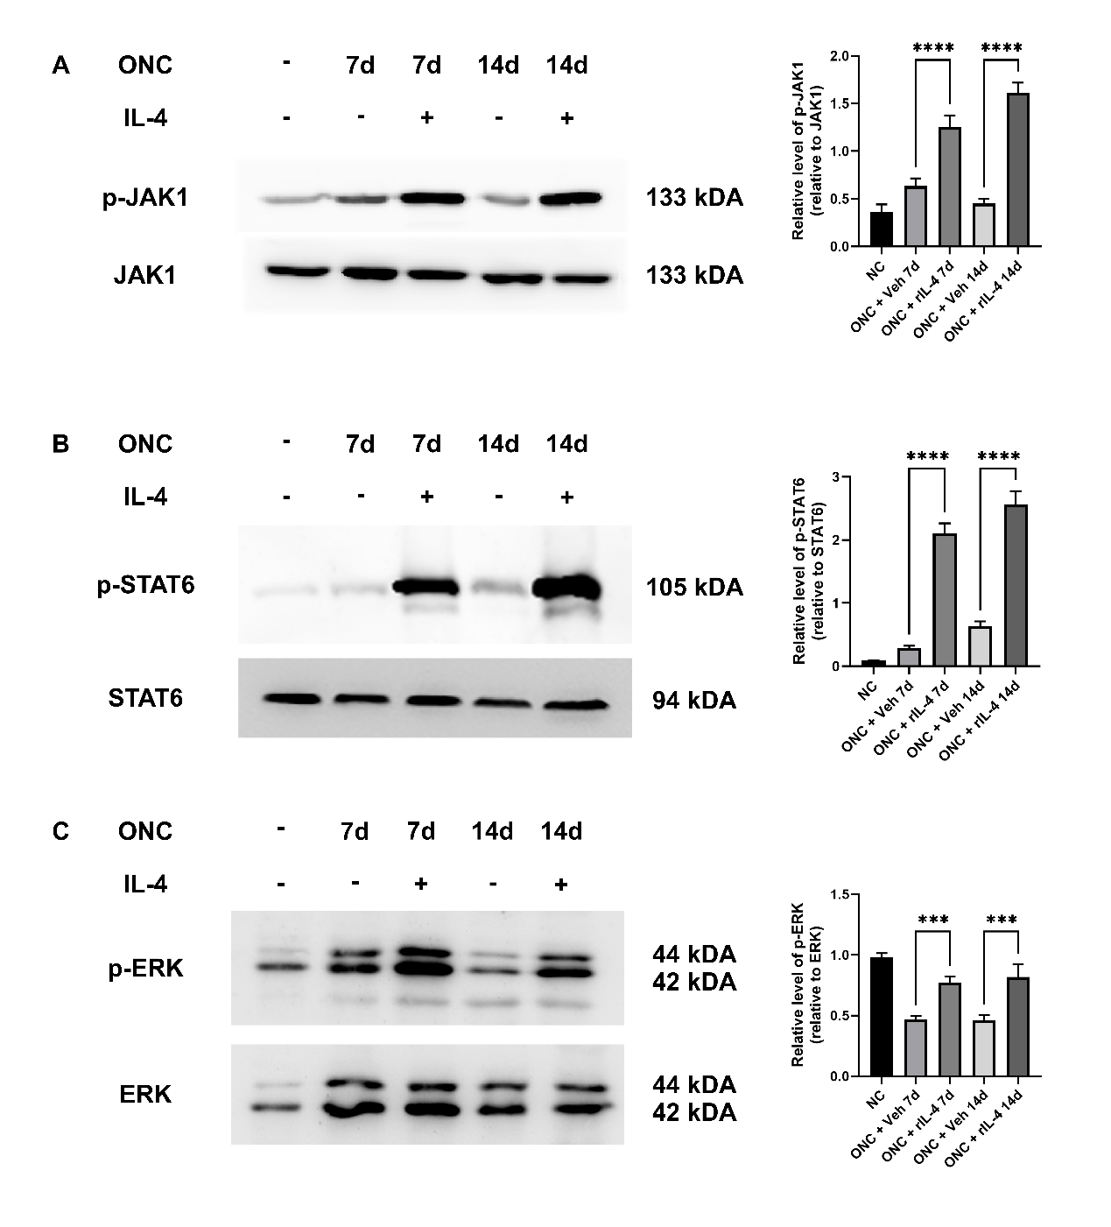
Figure S2. Western blot analysis indicated that rIL-4 treatment promoted the phosphorylation of JAK1/STAT3 and ERK1/2 in the retina of the ONC model, resulting in the activation of the associated signaling cascades.

Table 1. Chemicals and reagents used in the study
Chemicals | Source | Identifier | Dosage
Staurosporine | Abmole (Beijing, China) | Cat# M2066
N-methyl-D-aspartic Acid (NMDA) | Abmole | Cat# M2884
4’,6-diamidino-2-phenylindole (DAPI) | Solarbio (Beijing, China) | Cat# C0065
Antifading mounting medium | Solarbio | Cat# S2100
Cholera Toxin Subunit B (CTB) conjugated Alexa Fluor 488 | Thermo Fisher Scientific (MA, USA) | Cat# C34775
recombinant murine IL-4 protein | PeproTech (Rocky Hill, NJ, USA) | Cat# 214-14
Reagents for cell histology | Source | Identifier | Dosage
mouse anti-βIII-Tubulin | Beyotime (Shanghai, China) | Cat# AT809 | 1:100
rabbit anti-NeuN | Abcam (Cambridge, UK) | Cat# ab177487 | 1:400
DyLight 488, anti-mouse IgG | Abbkine (Shanghai, China) | Cat# A23210 | 1:400
Cy3, anti-rabbit IgG | Abbkine | Cat# A22220 | 1:400
Reagents for Western blot | Source | Identifier | Dosage
mouse anti-β-III Tubulin | Beyotime | Cat# AT809 | 1:2000
rabbit anti-NeuN | Abcam | Cat# ab177487 | 1:5000
mouse anti-β-actin | Signalway (Pearland, TX, USA) | Cat# 21800 | 1:8000
anti-rabbit IgG, HRP conjugated | Signalway | Cat# L3012 | 1:8000
anti-mouse IgG, HRP conjugated | Signalway | Cat# L3032 | 1:8000
Reagents for tissue histology | Source | Identifier | Dosage
rabbit anti-RBPMS | OmnimAbs (California, USA) | Cat# OM165217 | 1:200
rabbit anti-GAP43 | Beyotime | Cat# AF0153 | 1:200
mouse anti-β-III Tubulin | Beyotime | Cat# AT809 | 1:100
rabbit anti-IL4R | Affinity Biosciences | Cat# DF8567 | 1:200
DyLight 488, anti-rabbit IgG | Abbkine | Cat# A23220 | 1:400
DyLight 488, anti-mouse IgG | Abbkine | Cat# A23210 | 1:400
Cy3, anti-rabbit IgG | Abbkine | Cat# A22220 | 1:400

