Supporting Information

1 Supplementary Materials and Methods

BM-MSCs characterization
Osteogenic, adipogenic, and chondrogenic differentiation abilities of BM-MSCs were respectively identified by mMSC osteogenic differentiation kit (MUXMX-90021, China), adipogenic differentiation kit (MUXMX-90031, China) and chondrogenic differentiation kit (MUXMX-90041, China) according to the instructions.

Cell culture
MLE-12 cells were maintained in DMEM-F12 (Gibco, USA) supplemented with 10% FBS (ExCell, China), 1% penicillin and streptomycin (Gibco, USA) and incubated at 37 °C in 5% CO2.

Detection of LPS concentration
LPS concentrations in LPS-EVs samples with different particle numbers were detected using a bacterial LPS concentration detection kit (MEIMIAN, China). A second round of ultracentrifugation (200,000 × g at 4 °C for 2 hours) was performed to precipitate EVs, and the supernatant of the LPS-EVs group after the second ultracentrifugation was taken as the positive control.

2 Supplementary Figures

Fig. S1 Observation of the morphology and identification of differentiation capabilities of BM-MSCs. A Morphological observation of BM-MSCs. Scale bar: 100 μm. B Osteogenic differentiation of BM-MSCs. Scale bar: 100 μm. C Adipogenic differentiation of BM-MSCs. Scale bar: 100 μm. D Chondrogenic differentiation of BM-MSCs. Scale bar: 200 μm.

Fig. S2 Dynamic uptake assay shows the ability of of BM-MSCs to take up Control-EVs and LPS-EVs. A Representative images of DiD-labeled iMPMEC-EVs uptake by BM-MSCs. Scale bar: 50 μm. B Cumulative fluorescent intensity of DiD-labeled iMPMEC-EVs uptake by BM-MSCs over a 24-hour period. (n = 3).

Fig. S3 The effect of EV treatment on the viability and migration of MLE-12. The migration of MLE-12 was examined by in vitro scratch assay. A-B The wound areas were photographed at 0 and 12 hours and quantified by measuring the wound area in each group. (n = 3). Scale bar: 200 μm. C Cell viability of MLE-12 incubated with Control-EVs or LPS-EVs was measured using the CCK-8 assay. (n = 3). Data are presented as mean ± SD using one-way ANOVA followed by the Tukey’s multiple comparisons test.

Fig. S4 LPS-EVs weaken the repair effect of BM-MSCs in ALI mice. A-C Il1b, Il6, and Tnf expression 24 hours post BM-MSCs treatment in the lung tissue of ALI mice were measured using RT-qPCR. (n = 3). D The ratios of LWW/BW 24 hours post BM-MSCs treatment in the lung tissue of ALI mice. (n = 3). E The ratios of LWW/BW 72 hours post BM-MSCs treatment in the lung tissue of ALI mice. (n = 3). Data are presented as mean ± SD using one-way ANOVA followed by the Tukey’s multiple comparisons test. *P＜0.05, **P＜0.01, ***P＜0.001, ****P<0.0001.
Fig. S5 LPS-EVs have no effect on Tet1, Tet2, or Tet3 expression in BM-MSCs. A Immunofluorescence staining demonstrates the expression of TET1, TET2, and TET3 in BM-MSCs. (n = 3). Scale bar: 50 μm. B Representative western blot of TET1, TET2, and TET3 in BM-MSCs incubated with Control-EVs or LPS-EVs for 24 hours. (n = 3). C-E Tet1, Tet2, and Tet3 expressions in BM-MSCs after treated with Control-EVs or LPS-EVs for 24 hours were measured using RT-qPCR. (n = 3). Data are presented as mean ± SD using one-way ANOVA followed by the Tukey’s multiple comparisons test.
Fig. S6 LPS-EVs have no effect on Idh1 and Idh3a expression of BM-MSCs. Idh1 (A) and Idh3a (B) expressions in BM-MSCs after treated with Control-EVs and LPS-EVs for 24 hours were measured using RT-qPCR. (n = 3). Data are presented as mean ± SD using one-way ANOVA followed by the Tukey’s multiple comparisons test.

Fig. S7 Measurement of Idh2 expression in BM-MSCs after Idh2 gene knockdown or overexpression. Representative western blot (A) and quantitative analysis (B) of IDH2 protein levels in the Control, siCtrl, and siIdh2 groups. (n = 3). C Idh2 expression in the Control, siCtrl, and siIdh2 groups in BM-MSCs. (n = 3). D Representative fluorescence images of Vector-MSCs and OE-Idh2-MSCs. Scale bar: 50 μm. Representative western blot (E) and quantitative analysis (F) of IDH2 protein levels in the Control, Vector, and OE-Idh2 groups in BM-MSCs. (n = 3). G Idh2 expression in the Control, Vector, and OE-Idh2 groups. (n = 3). H Representative images of BM-MSCs after Idh2 gene knockdown or overexpression. (n = 3). Scale bar: 100 μm and 25 μm (insert). Data are presented as mean ± SD using one-way ANOVA followed by the Tukey’s multiple comparisons test. *P＜0.05, **P＜0.01, ****P＜0.0001.

Fig. S8 Knockdown of Idh2 in BM-MSCs has no effect on Tet1, Tet2, or Tet3 expression. Tet1 (A), Tet2 (B), and Tet3 (C) expressions in BM-MSCs after treatment with siCtrl and siIdh2 for 48 hours were measured using RT-qPCR. (n = 3). Data are presented as mean ± SD using one-way ANOVA followed by the Tukey’s multiple comparisons test.
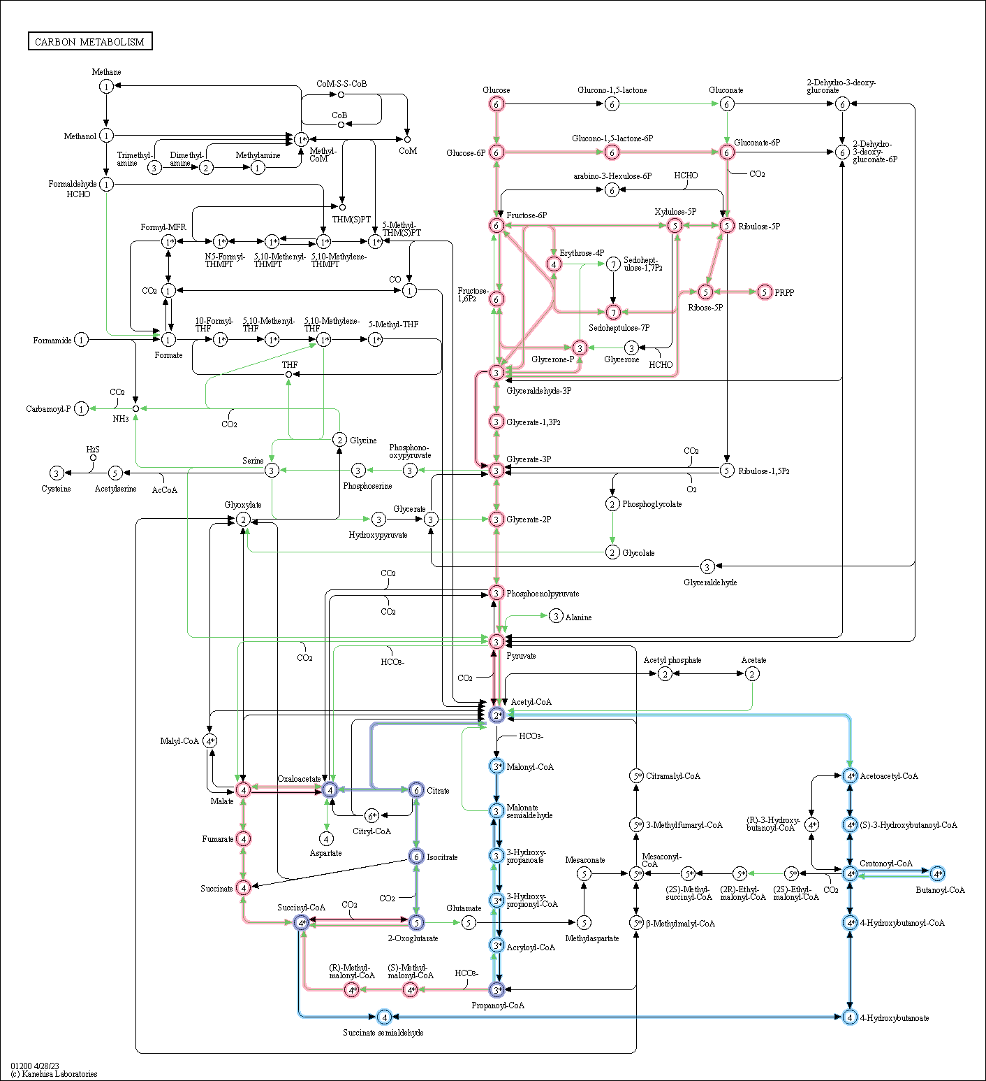
Fig. S9 Pathways enriched by DEGs in carbon metabolism.

3 Supplementary Tables
Supplementary Table 1. Antibodies used in this study.
Antibody | Source | Catalog number
TSG101 | Santa Cruz | sc-6037
CD63 | Abcam | Ab217345
CD63 | Abcam | Ab134045
Calnexin | Cell Signaling Technology | 2679S
ALIX | Abcam | ab88743
ZO-1 | Proteintech | 21773-1-AP
Occludin | Abcam | ab216327
Claudin-5 | Abcam | ab131259
TET1 | ABclonal | A1506
TET2 | Proteintech | 21207-1-AP
TET3 | ABclonal | A7612
5-hmC | Abcam | Ab214728
IDH2 | Proteintech | 15932-1-AP
GAPDH | Proteintech | 60004-Ig
Beta Actin | Proteintech | 66009-1-Ig
HRP-conjugated Affinipure Goat Anti Mouse IgG(H+L) | Proteintech | SA00001-1
HRP-conjugated Affinipure Goat Anti Rabbit IgG(H+L) | Proteintech | SA00001-2
Alexa Fluor 555-conjugated goat anti-rabbit IgG (H+L) | Invitrogen | A32732
FITC anti-mouse CD31 | Biolegend | 102405
FITC anti-human CD31 | Biolegend | 303103

Supplementary Table 2. Primer sequences used in this study.
Gene | Forward primer | Reverse primer | usage
Il1b | GAAATGCCACCTTTTGACAGTG | TGGATGCTCTCATCAGGACAG | qPCR
Il6 | CTGCAAGAGACTTCCATCCAG | AGTGGTATAGACAGGTCTGTTGG | qPCR
Tnf | CAGGCGGTGCCTATGTCTC | CGATCACCCCGAAGTTCAGTAG | qPCR
Tet1 | TGGGAGAGCTCCCTTTGATGGTTT | TTGGGTCAATTGTGCTGCGACATC | qPCR
Tet2 | TGTTGTTGTCAGGGTGAGAATC | TCTTGCTTCTGGCAAACTTACA | qPCR
Tet3 | AACCAGAACGCCAAGGTCAGTAGT | TTGATCTTCTCTGGCGTGCTCAGT | qPCR
Idh1 | GAGCTCTCTTGGACCGACTTC | CAACCCTCTTCTCATCGGGG | qPCR
Idh2 | GTACAACACCGACGAGTCCAT | AGCCTCAGCCTCAATTGTCT | qPCR
Idh3a | CCTTTATGCCAATGTCCGGC | ACAACCCCATCAACGATCACA | qPCR
Actb | GGCTGTATTCCCCTCCATCG | CCAGTTGGTAACAATGCCATGT | qPCR
Gapdh | CCAGTTGGTAACAATGCCATGT | CCAGTTGGTAACAATGCCATGT | qPCR

Supplementary Table 3. Sequences of Small interfering RNA (siRNA).
Gene | Name | Sequence
Control | siCtrl | sense (5’ to 3’)  UUCUCCGAACGUGUCACGUTT
Control | siCtrl | antisense (5’ to 3’)  ACGUGACACGUUCGGAGAATT
Idh2 | siIdh2 | sense (5’ to 3’)  GGUAUGAACAUCGGCUCAUTT
Idh2 | siIdh2 | antisense (5’ to 3’)  AUGAGCCGAUGUUCAUACCTT

Supplementary Table 4. Clinical characteristics of patients with ARDS and non-ARDS controls
characteristic | Non-ARDS (n = 4) | ARDS (n = 5)
Age (year) | 60.5 ± 23.5 | 72.0 ± 5.7
Gender, male, n (%) | 0 (0.0) | 4 (80.0)
Cause of pneumonia
Gram-negative bacilli | - | 2 (40.0)
Gram-positive bacilli | - | 1 (20.0)
Unknow | - | 2 (40.0)
SOFA score | 3.5 ± 1.0 | 7.4 ± 2.1
PaO₂/FiO₂ (mmHg) | 360.4 ± 43.4 | 199.9 ± 48.9
ICU length of stay (day) | 16.3 ± 18.9 | 21.4 ± 11.3
Mortality, n (%) | 0 (0.0) | 1 (20.0)
Categorical variables are expressed as n (%), and continuous variables are presented as the mean ± SD. ICU, intensive care unit; PaO₂/FiO₂, the ratio of partial pressure of oxygen of fractional inspired oxygen; SOFA, sequential organ failure assessment.

Supplementary Table 5. The concentrations of LPS in the LPS-EV samples
Group | EVs (particles/ml) | LPS concentration (EU/ml)
Control-EVs | 10^8 | <0.001
Control-EVs | 10^8 | <0.001
Control-EVs | 10^8 | <0.001
LPS-EVs | 10^8 | <0.001
LPS-EVs | 10^8 | <0.001
LPS-EVs | 10^8 | <0.001
LPS-EVs | 10^9 | <0.001
LPS-EVs | 10^9 | <0.001
LPS-EVs | 10^9 | <0.001
LPS-EVs | 10^10 | <0.001
LPS-EVs | 10^10 | <0.001
LPS-EVs | 10^10 | <0.001
Positive Control | - | 0.057
Positive Control | - | 0.064
Positive Control | - | 0.046
The supernatant of the LPS-EVs group after the second ultracentrifugation was taken as the positive control.

